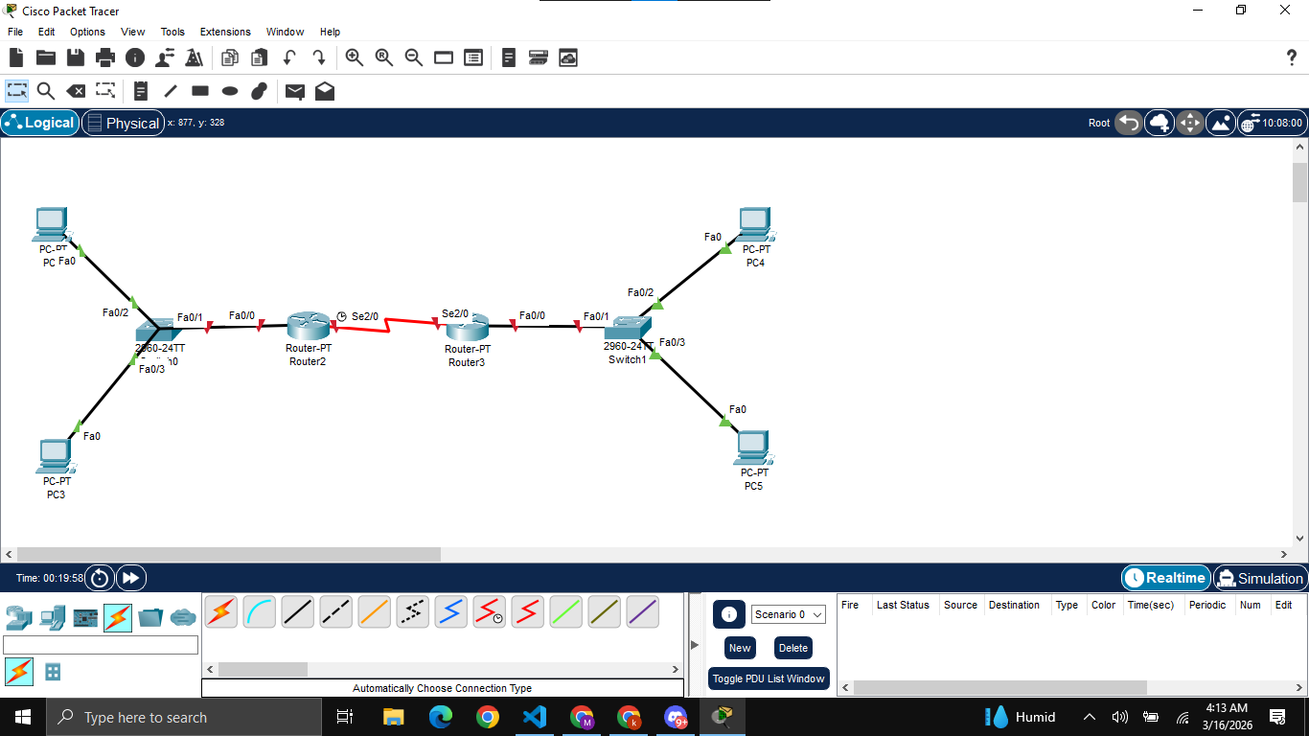
Building the initial topology

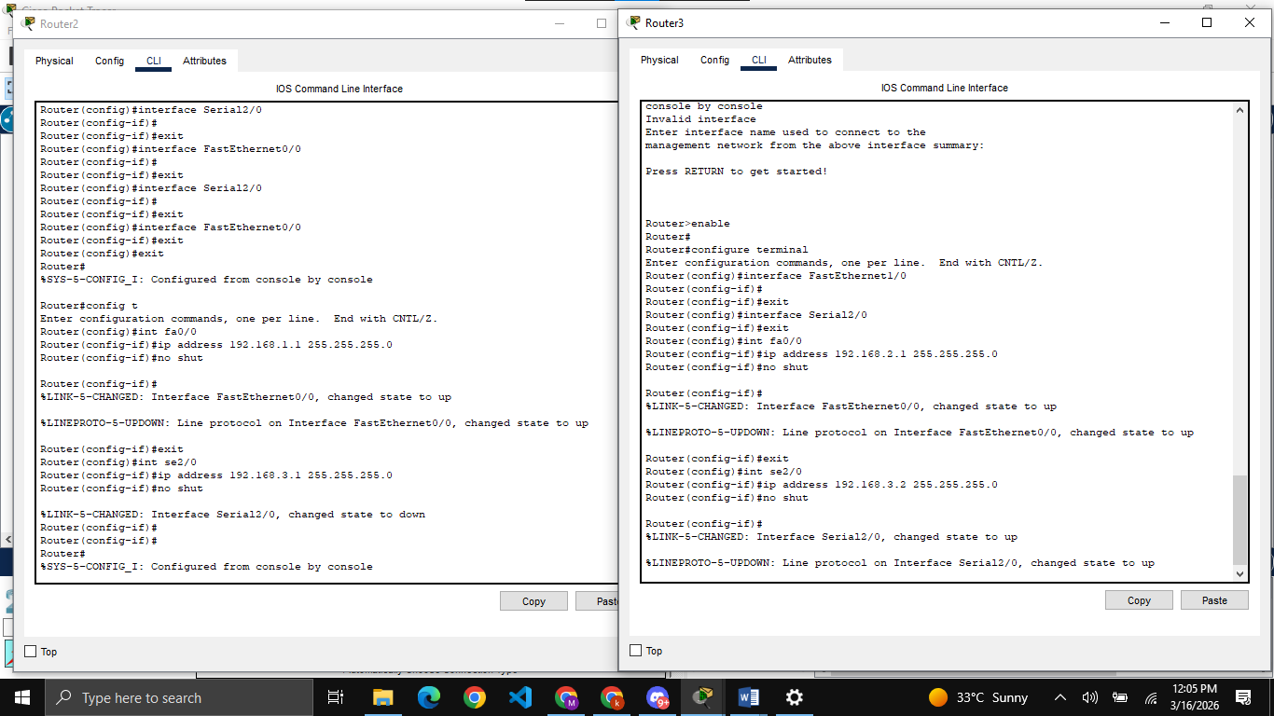
Assigning IP addresses to all router ports using CLI

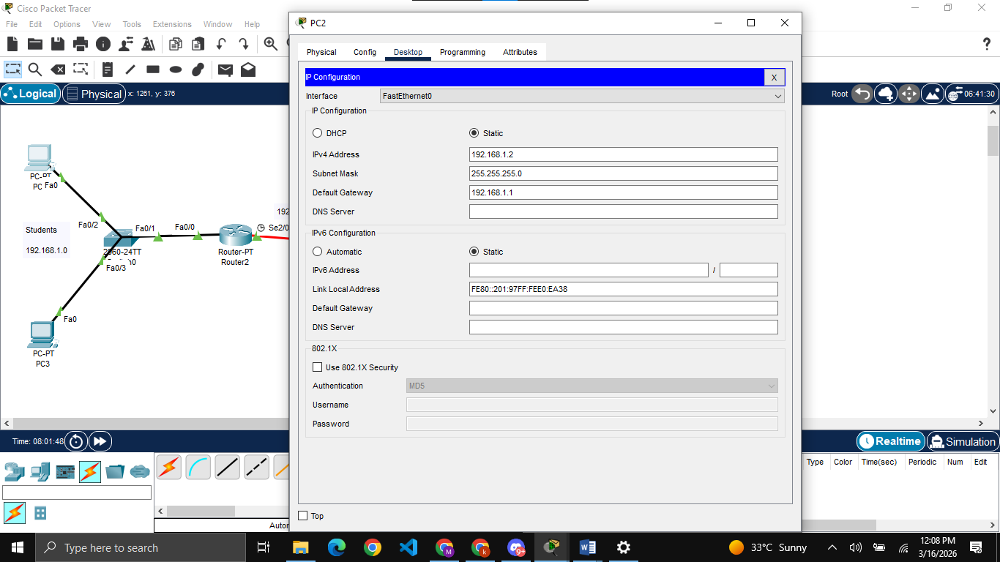
Assigning IPs and default gateways to all PCs

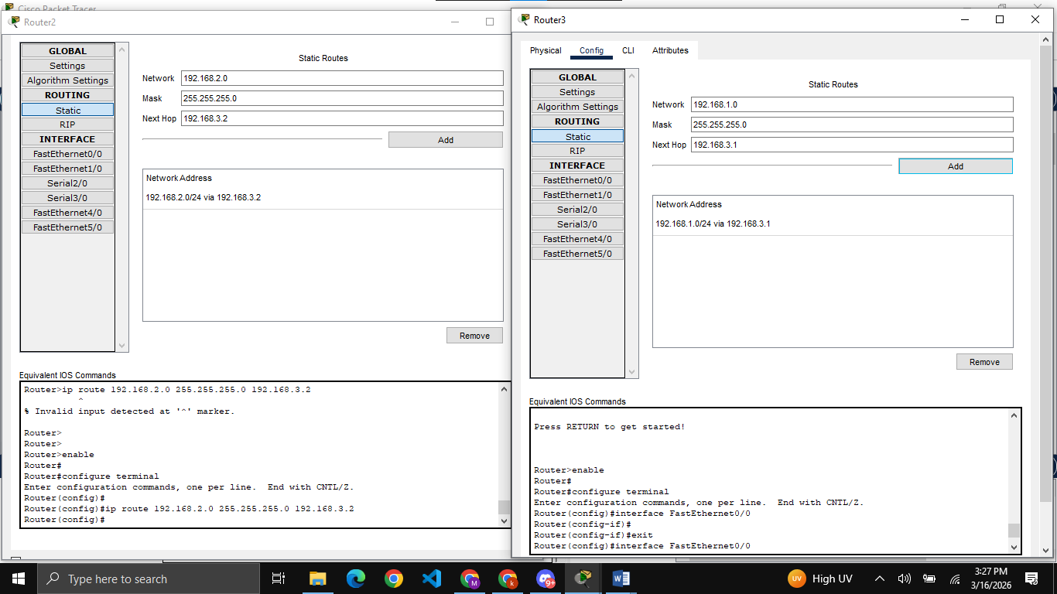
Configuring static routing on both routers

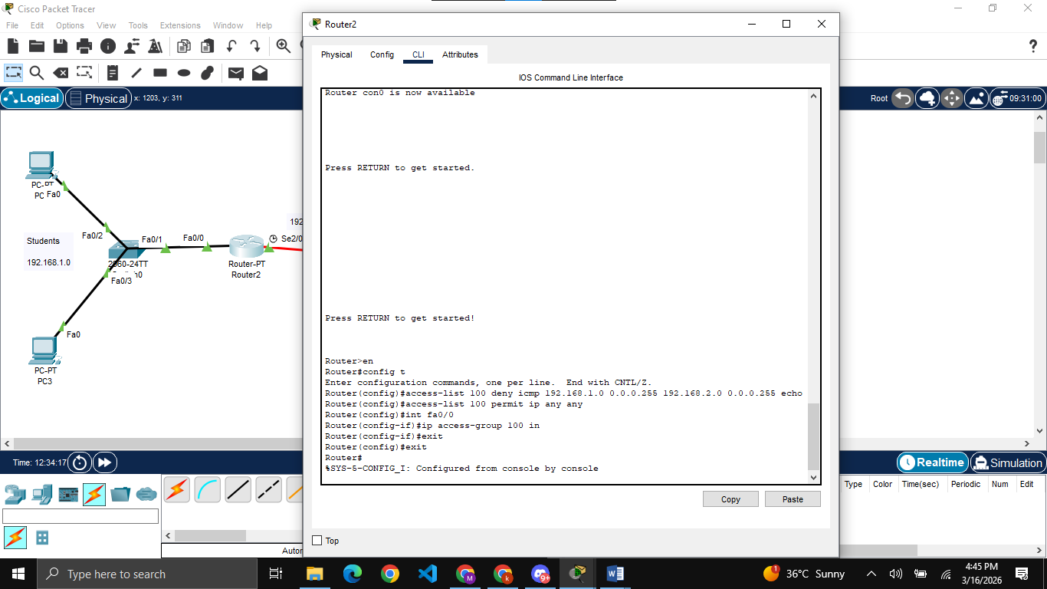
Performing task1 i.e. preventing all students from communicating with any of the teachers while teachers can communicate with students

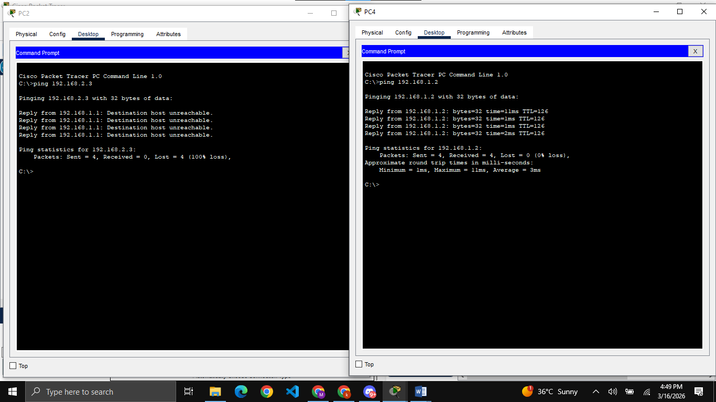
Trying to communicate from PC2 (student) to PC5 (teacher) which fails while when PC4 (teacher) tries to communicate with PC2 (student), they were able to do that.
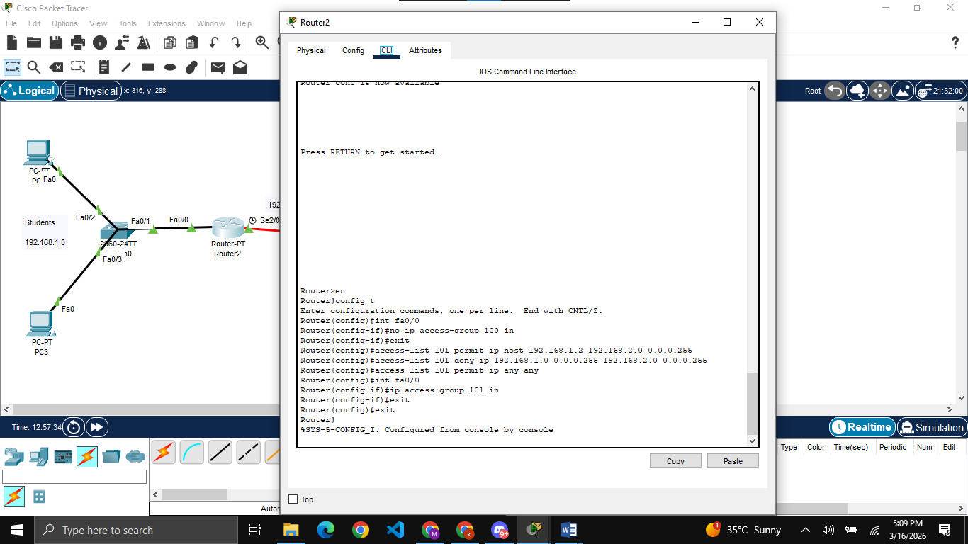
Performing task2 i.e. only PC2 (student) which is CR can communicate and access teachers while other student PCs cannot. For performing this task, first I have removed the previous task’s ACL

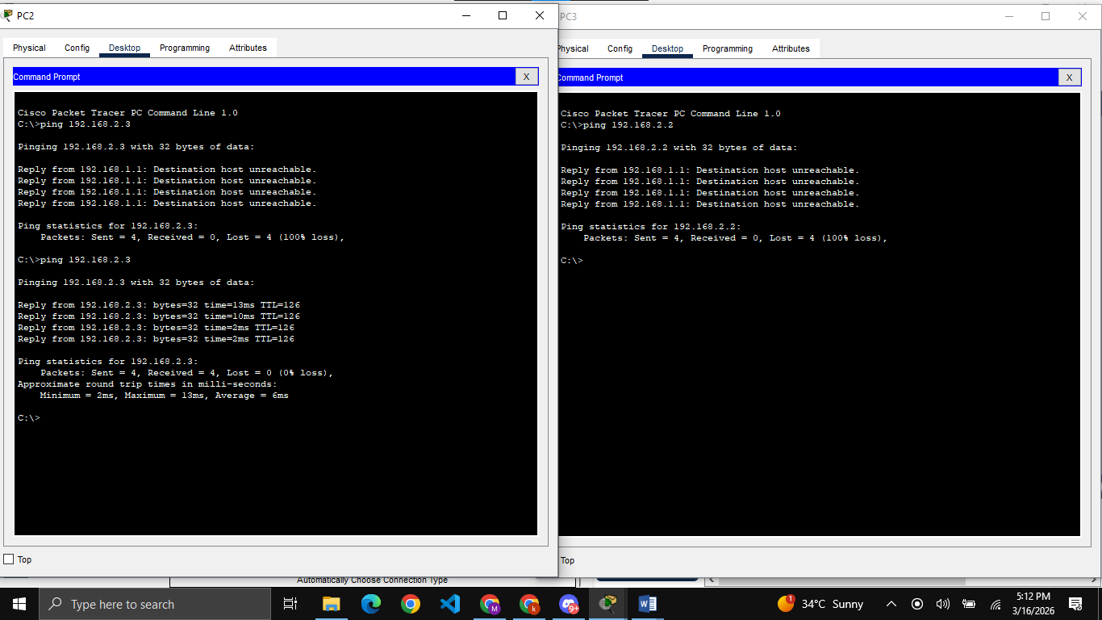
Now PC2 (CR) is able to communicate and access PC5 (teacher) while the PC3 (student which is not CR) cannot access the PC4 (teacher)

