Task 1:
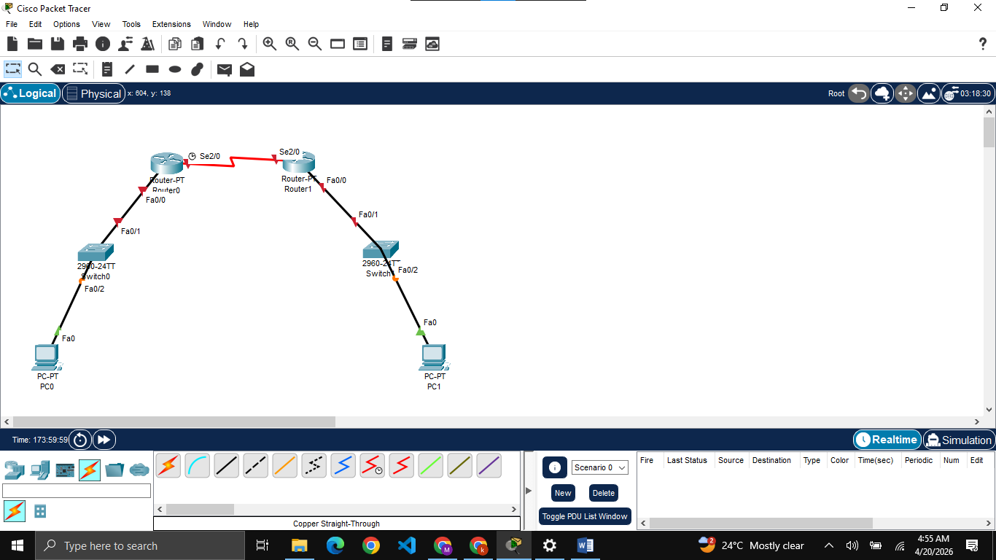
Building topology

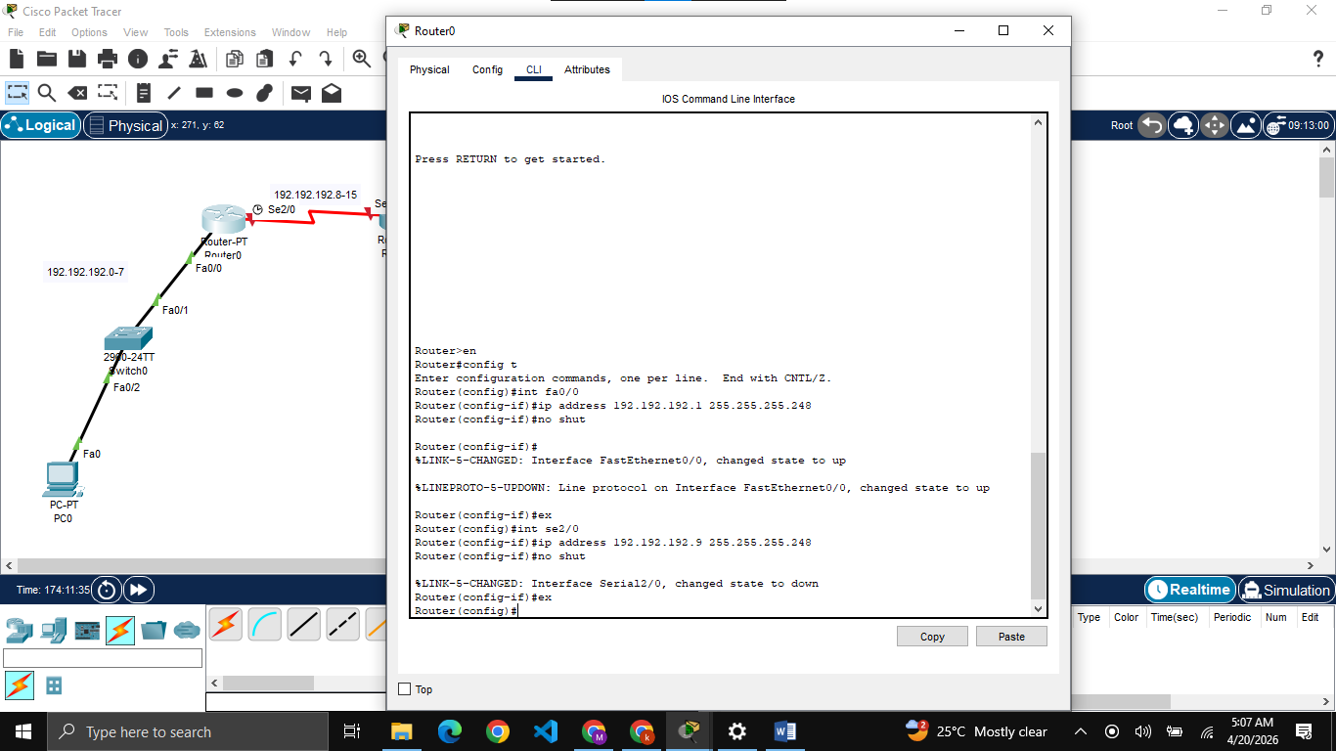
Configuring Router0
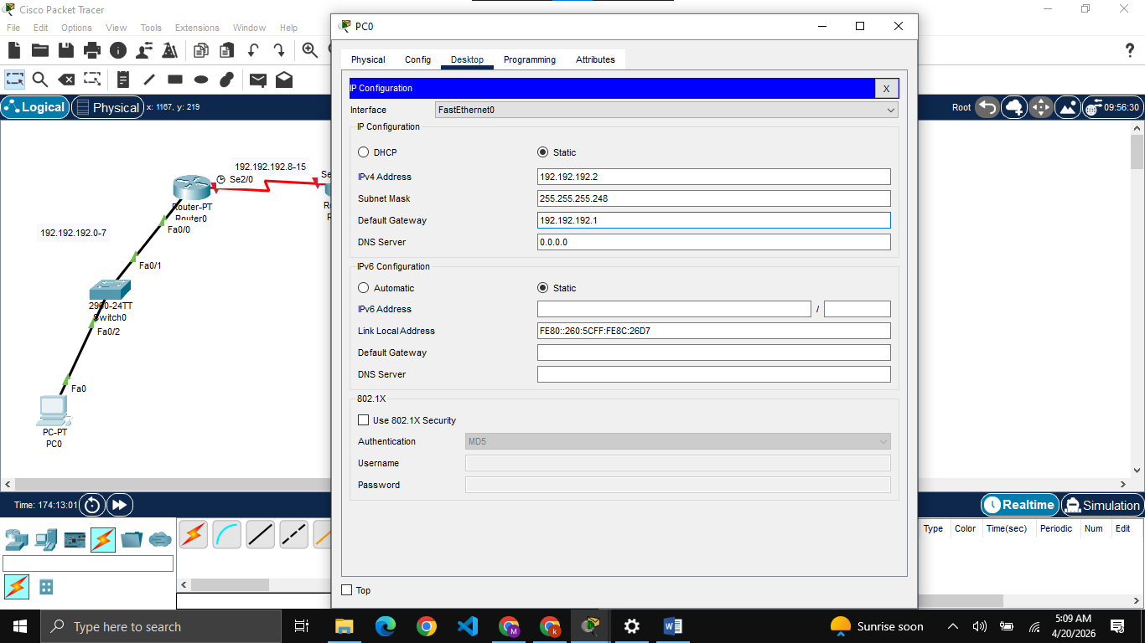
Configuring PC0

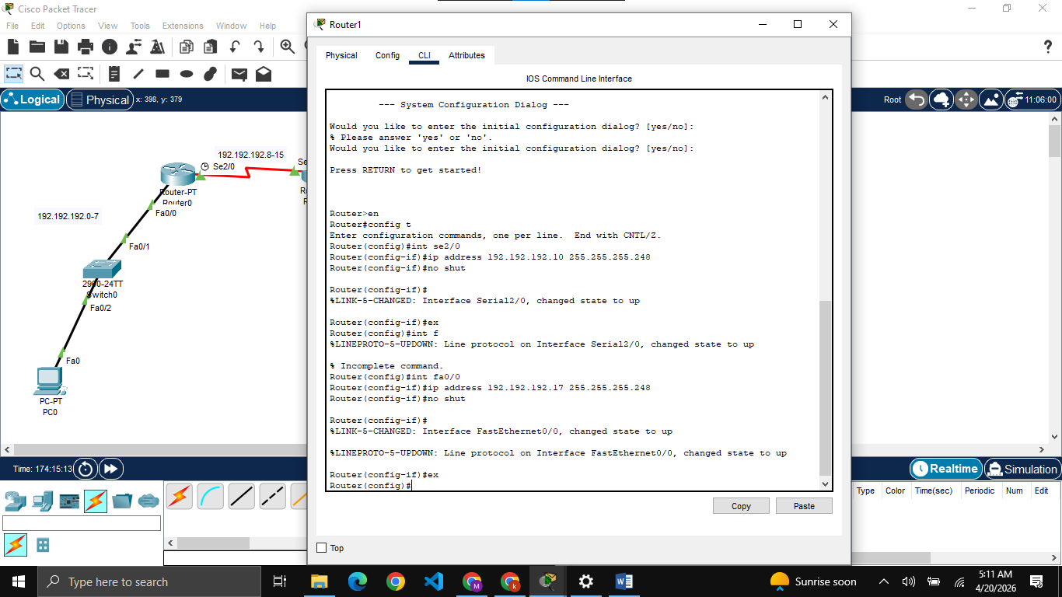
Configuring Router1

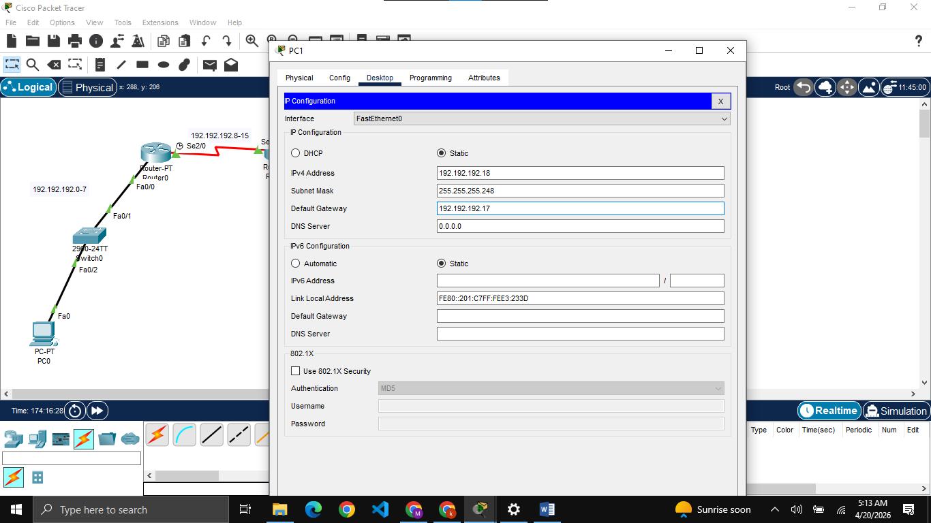
Configuring PC1

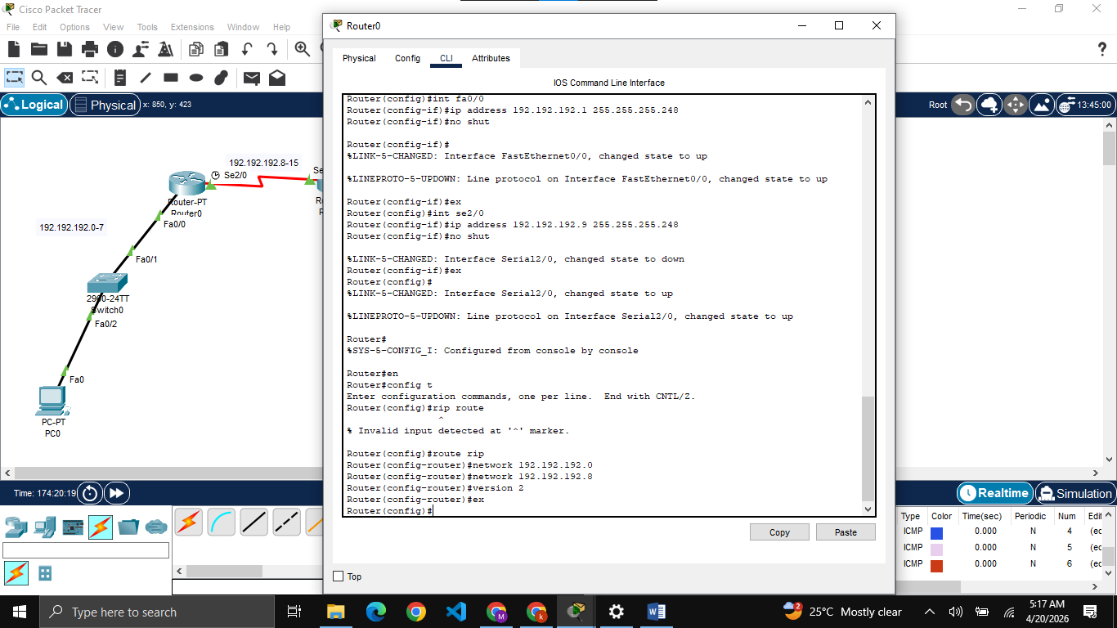
Configuring RIPv2 on Router0

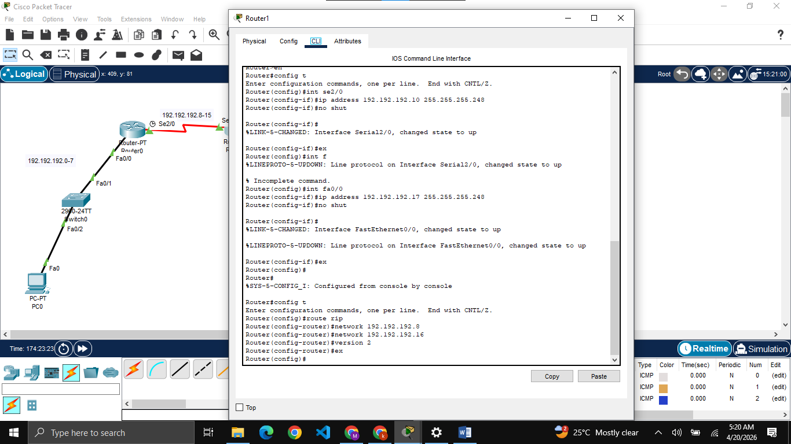
Configuring RIPv2 on Router1

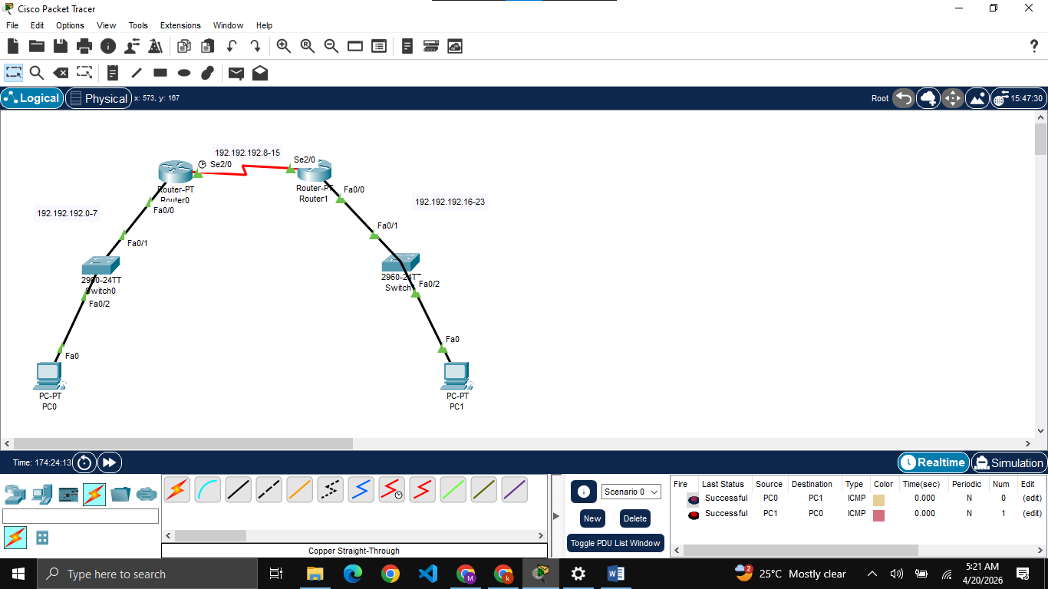
Now packet send is successful to each other

Task 2:
We cannot borrow only one bit as we need min 3 networks. We also cannot 3 bits as it will give 30 assignable IPs to all networks while one department needs 32, also similar issue for more than 3 bits so we will borrow 2 bits here.
Subnet Mask: 255.255.255.192
Bits to borrow: 2
Total Networks: 4
Ranges:
- Development: 200.16.100.0 - 200.16.100.63
- Finance: 200.16.100.64 - 200.16.100.127
- HR: 200.16.100.128 - 200.16.100.191

Task 3:
This scenario is mathematically impossible using FLSM because the EE department requires 32 IPs (31 PCs + 1 Router’s IP), forcing a /26 mask. A /26 mask only provides 4 subnets, but the topology contains total 5 networks. Because we have only studied FLSM, this scenario is impossible to implement.

