**Department of Software Engineering**

**Mehran University of Engineering and Technology, Jamshoro**

|  |  |  |  |
| --- | --- | --- | --- |
| **Course: SWE425 – Cloud Computing** | | | |
| **Instructor** | Ms. Shafiya Qadeer | **Practical/Lab No.** | 02 |
| **Date** |  | **CLOs** | 3 |
| **Signature** |  | **Assessment Score** |  |

|  |  |
| --- | --- |
| **Topic** | **Installing a Linux Environment/Setting up a Virtual Environment for Linux** |
| **Objectives** | - To enable students to set up a Linux environment using VMware |

**Lab Discussion: Theoretical concepts and Procedural steps**

**Virtualization**

Virtualization is the ability to simulate a hardware platform, such as a server,

storage device or network resource, in software. All of the functionality is separated from the hardware and simulated as a “virtual instance,” with the ability to operate just like the traditional, hardware solution would.

Virtualization is technology that allows you to create multiple simulated environments or dedicated resources from a single, physical hardware system. Software called a hypervisor connects directly to that hardware and allows you to split 1 system into separate, distinct, and secure environments known as virtual machines (VMs). These VMs rely on the hypervisor’s ability to separate the machine’s resources from the hardware and distribute them appropriately. Virtualization helps you get the most value from previous investments.

The physical hardware, equipped with a hypervisor, is called the host, while the many VMs that use its resources are guests. These guests treat computing resources—like CPU, memory, and storage—as a pool of resources that can easily be relocated.

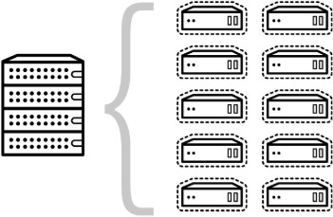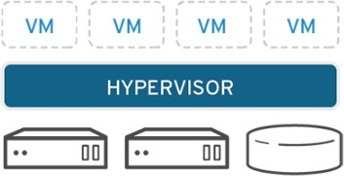

# Types of Virtualization

1. **Data Virtualization:** Data virtualization integrates data from disparate sources, locations and formats, without replicating the data, to create a single "virtual" data layer that delivers unified data services to support multiple applications and users. The result is faster access to all data, less replication and cost, more agility to change.
2. **Server Virtualization: Server virtualization** is a virtualization technique that involves partitioning a physical server into a number of small, virtual servers with the help of virtualization software.
3. **Desktop Virtualization:** Desktop virtualization allows a central administrator (or automated administration tool) to deploy simulated desktop environments to hundreds of physical machines at once. Unlike traditional desktop environments that are physically installed, configured, and updated on each machine, desktop virtualization allows admins to perform mass configurations, updates, and security checks on all virtual desktops.
4. **Operating System Virtualization:** Operating system virtualization happens at the [kernel](https://www.linux.com/blog/what-linux-kernel)—the central task managers of operating systems. It’s a useful way to run Linux and Windows environments side-by-side.
5. **Network Virtualization:** Network virtualization likewise replicates the components of network and security services in a software container. Consequently, the virtualized network is provisioned and managed independent of your hardware, and the physical networking devices simply become a vehicle for forwarding packets. With network virtualization, your network administrators can create and provision virtual networks—logical switches, routers, firewalls, load balancers, VPN, and workload security—in minutes rather than days or even weeks.

# VMware Workstation Player

VMware Workstation Player is an ideal utility for running a single virtual machine on a Windows or Linux PC. Organizations use Workstation Player to deliver managed corporate desktops, while students and educators use it for learning and training.

The free version is available for non-commercial, personal and home use. We also encourage students and non-profit organizations to benefit from this offering. Commercial organizations require paid licenses to use Workstation Player.

We are going to install Linux on a virtual machine this means that a software environment replicates the conditions of a hardware environment: a personal computer. The environment is based on the hardware of your physical PC and limited only by the components within. For instance, you couldn’t have a virtual four core CPU on a processor with two cores.

However, while virtualization can be achieved on many systems, the results will be far superior on [**computers equipped with a CPU that supports it**.](https://www.makeuseof.com/tag/hyper-v-linux-windows-10/)

Several virtualization tools are available that make it easy to install Linux operating systems (OS) and there are many in Windows.

[**VMware**](http://www.anrdoezrs.net/click-7251228-10870526) produces the most accomplished [**virtual machine**](http://i.viglink.com/?key=4b45dd1cb408b0f2f4016dbd8342032a&amp;insertId=b58a78b9ef5e9212&amp;type=CD&amp;exp=-100%3ACILITE%3A9&amp;u=https%3A%2F%2Fwww.parallels.com%2Fproducts%2Fdesktop%2Fbuy%2F) applications. Let’s find out how to install Linux in Windows with VMware Workstation Player.

# Step#01: Install VMWare Workstation Player

To start, head to the [**VMware website**](http://www.tkqlhce.com/click-7251228-10941197) and download the latest version of their Workstation Player tool.

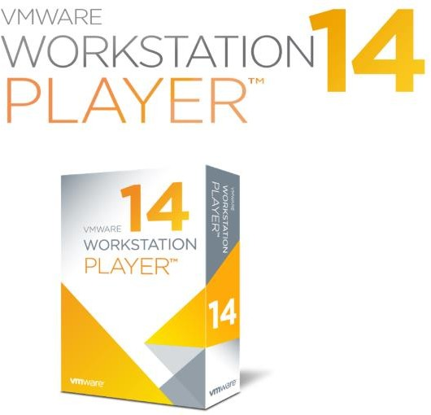

[**VMware**](http://i.viglink.com/?key=4b45dd1cb408b0f2f4016dbd8342032a&amp;insertId=210d4e5188602d44&amp;type=CD&amp;exp=-100%3ACILITE%3A9&amp;u=https%3A%2F%2Fwww.vmware.com%2F) Workstation Player is free and available as an evaluation version non- commercial, personal, and home use. In terms of functionality, VMware Workstation Player includes everything you could need for the standard [**virtual machine**](http://i.viglink.com/?key=4b45dd1cb408b0f2f4016dbd8342032a&amp;insertId=b58a78b9ef5e9212&amp;type=CD&amp;exp=-100%3ACILITE%3A9&amp;u=https%3A%2F%2Fwww.parallels.com%2Fproducts%2Fdesktop%2Fbuy%2F) tasks.

Once [**VMware**](http://i.viglink.com/?key=4b45dd1cb408b0f2f4016dbd8342032a&amp;insertId=210d4e5188602d44&amp;type=CD&amp;exp=-100%3ACILITE%3A9&amp;u=https%3A%2F%2Fwww.vmware.com%2F) Workstation Player has downloaded, it’s time to install. A standard installation wizard will guide you through, with the option of installing an Enhanced Keyboard Driver. This feature offers better handling of international keyboards. You probably won’t need it initially, but it’s worth installing, just in case. Proceed through the installation wizard, and restart Windows when prompted.

# Step#02: Choose your preferred Linux OS

Some Linux distros are particularly [**suited to running in a VM**,](https://www.makeuseof.com/tag/linux-operating-systems-try-virtual-machine/) but others are not. We are going to use Ubuntu as it is easier to use for novice users. Download the Ubuntu ISO file to install on the virtual machine

# Step#03: Configure your Virtual Machine

Launch VMware Workstation Player and input your email address when prompted.

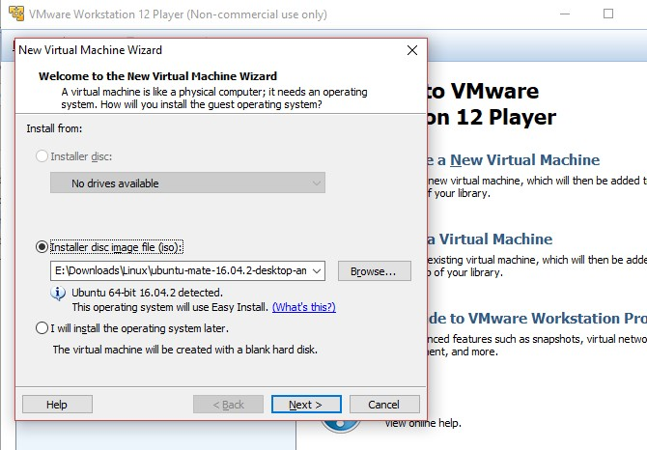

Once this is done, the main VMware Workstation Player app will load. Click **Create a New Virtual Machine** to proceed. Select the default option, **Installer disc image file (iso)**. (It is possible to simply create a virtual system with a blank hard disk using the “**I will install the operating system later”** option.)

With the OS you plan to install (known as the “guest” OS) selected, click **Next**. Look out for a message about VMware Easy Install, which will automate the installation of your chosen guest OS.

# Step#04: Create an account

In the next screen, enter your preferred name, username, and password, click **Next**, and give the VM a name. Default names often follow the name of the OS you’re installing. You can also select a location for the VM.

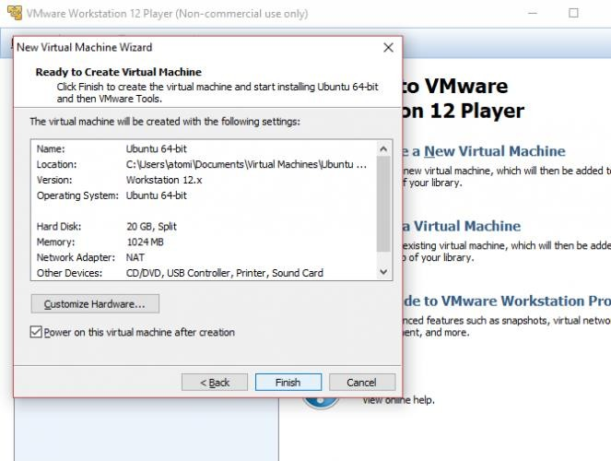

Click **Next** once again and select the VM’s disk capacity. This is a virtual hard disk that will be saved on your computer’s physical disk as a file or series of files. You can choose either option. Meanwhile, a recommended size will be used for your virtual HDD, which you can choose to accept or alter. Increasing is a safer option than shrinking! Whatever your choice, click **Next**, to see the “Ready to create virtual machine” screen, and the option to **Finish**. Click on this, and as long as **Power on this virtual machine after creation** is checked, the VM will start.

When the ISO boots in the virtual machine, it will appear as if you’re installing an OS on a physical desktop machine. Using the Easy Install method will completely automate this, using your Windows host OS configuration to apply regional settings in the virtual, guest OS.

**Lab Tasks**

1. Follow the handout and install Ubuntu on a virtual machine using VMWare.
2. Demonstrate the difference between virtualization and cloud computing.
3. What is Linux? Show your understanding of the term “Linux Distros”? Also, Name at least five of them.