

**Course: SWE 425 – Cloud Computing**



**Department of Software Engineering**

**Mehran University of Engineering and Technology, Jamshoro**

|  |  |  |  |
| --- | --- | --- | --- |
| **Instructor** | Ms. Shafiya Qadeer | **Practical/Lab No.** | 03 |
| **Date** | 19/ 20 August 2020 | **CLOs** | 3 |
| **Signature** |  | **Assessment Score** |  |

|  |  |
| --- | --- |
| **Topic** | **Getting familiar with Control Panel & Task Scheduler** |
| **Objectives** | Installation and Configuration of virtualization using **Kernel** based Virtual Machine (KVM) |



**Lab Discussion: Theoretical concepts and Procedural steps**

1. **Aim:** Installation and Configuration of virtualization using KVM
2. **Objectives:** From this experiment, the student will be able to,
   * Understand the concepts of virtualization.
   * Understand KVM architecture and its configuration.
3. **Outcomes:** The learner will be able**,**
   * To analyze user models and develop user centric interfaces
   * To analyze the local and global impact of computing on individuals, organizations, and society.
   * To engage in life-long learning development and higher studies.
   * To understand, identify, analyze and design the problem, implement and validate the solution including both hardware and software.
4. **Hardware / Software Required:** Ubuntu operating system, open source software KVM, Internet.

# Theory:

Virtualization is software that separates physical infrastructures to create various dedicated resources. It is the fundamental technology that powers cloud computing.

The technology behind virtualization is known as a virtual machine monitor (VMM) or virtual manager, which separates compute environments from the actual physical infrastructure.

Virtualization makes servers, workstations, storage and other systems independent of the physical hardware layer. This is done by installing a Hypervisor on top of the hardware layer, where the systems are then installed.

There are three areas of IT where virtualization is making headroads, network virtualization, storage virtualization and server virtualization:

* Network virtualization is a method of combining the available resources in a network by splitting up the available bandwidth into channels, each of which is independent from the others, and each of which can be assigned (or reassigned) to a particular server or device in real time. The idea is that virtualization disguises the true

complexity of the network by separating it into manageable parts, much like your partitioned hard drive makes it easier to manage your files.

* Storage virtualization is the pooling of physical storage from multiple network storage devices into what appears to be a single storage device that is managed from a central console. Storage virtualization is commonly used in storage area networks (SANs).
* Server virtualization is the masking of server resources (including the number and identity of individual physical servers, processors, and operating systems) from server users. The intention is to spare the user from having to understand and manage complicated details of server resources while increasing resource sharing and utilization and maintaining the capacity to expand later.

Virtualization can be viewed as part of an overall trend in enterprise IT that includesautonomic computing, a scenario in which the IT environment will be able to manage itself based on perceived activity, and utility computing, in which computer processing power is seen as a utility that clients can pay for only as needed. The usual goal of virtualization is to centralize administrative tasks while improving scalability and work loads.

# Procedure:

Installation Steps :

1. #sudo grep -c "svm\|vmx" /proc/cpuinfo
2. #sudo apt-get installqemu-kvmlibvirt-bin bridge-utilsvirt-manager
3. #sudoadduserrait #sudoadduserraitlibvirtd

After running this command, log out and log back in as rait

1. Run following command after logging back in as rait and you should see an empty list of virtual machines. This indicates that everything is working correctly.

#virsh -c qemu:///system list

1. Open Virtual Machine Manager application and Create Virtual Machine #virt-manager

# Result:

SNAPSHOTS

Step 1 :#sudo grep -c "svm\|vmx" /proc/cpuinfo

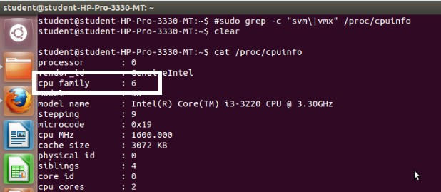

Step 2 :#sudo apt-get install qemu-kvmlibvirt-bin bridge-utilsvirt-manager

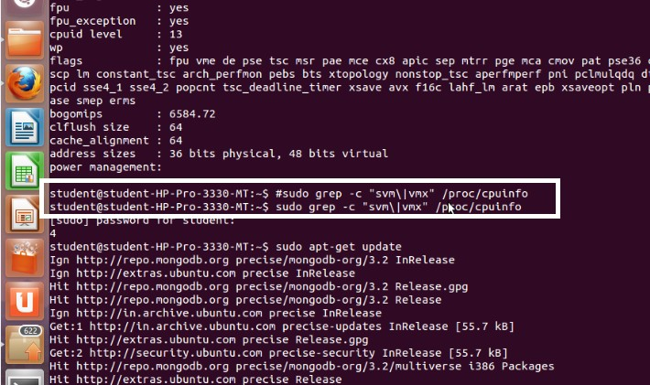

Step 3 :#sudoadduserrait

After running this command, log out and log back in as rait

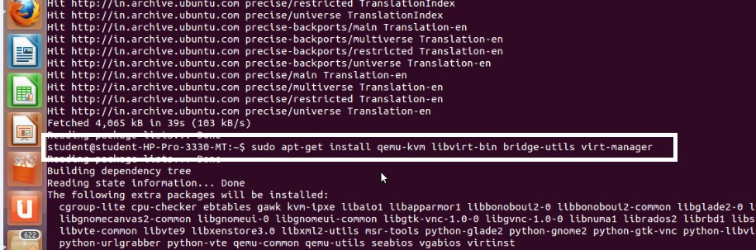

Step 4 :#sudoadduserraitlibvirtd

After running this command, log out and log back in as rait

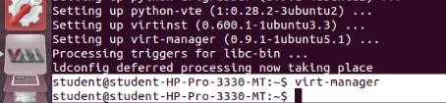

Step 5 :Open Virtual Machine Manager application and Create Virtual Machine #virt-manager as shown below

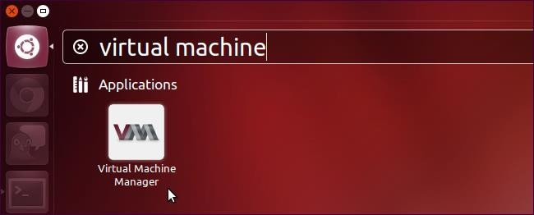

Step 6 : Create a new virtual machine as shown below

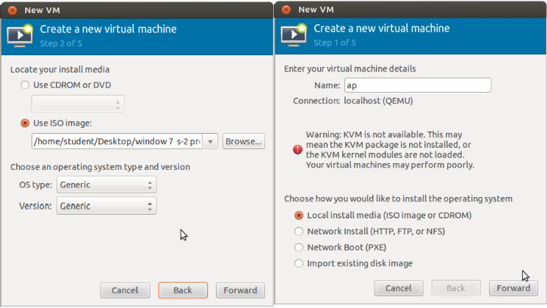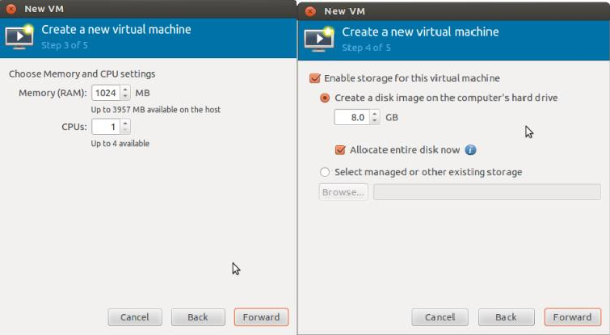

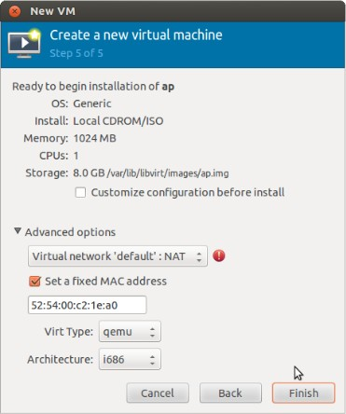

Step 7 : Install windows operating system on virtual machine

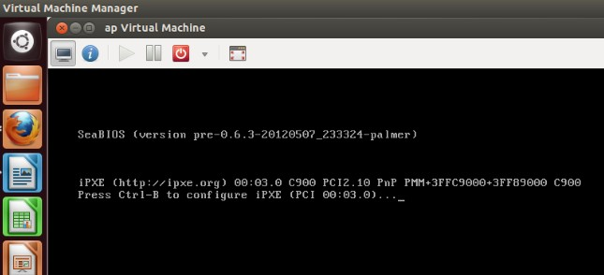

Step 8: Installation of windows on virtual machine

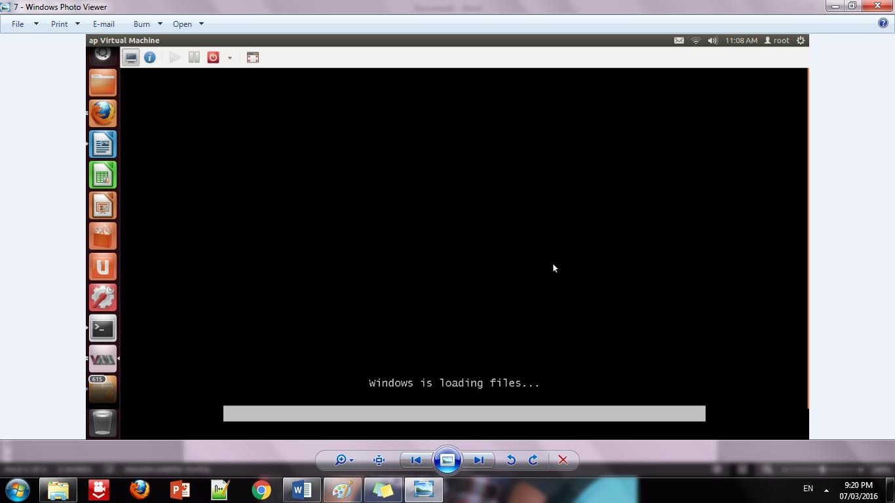

Step 9: Installation of windows 7 on virtual machine

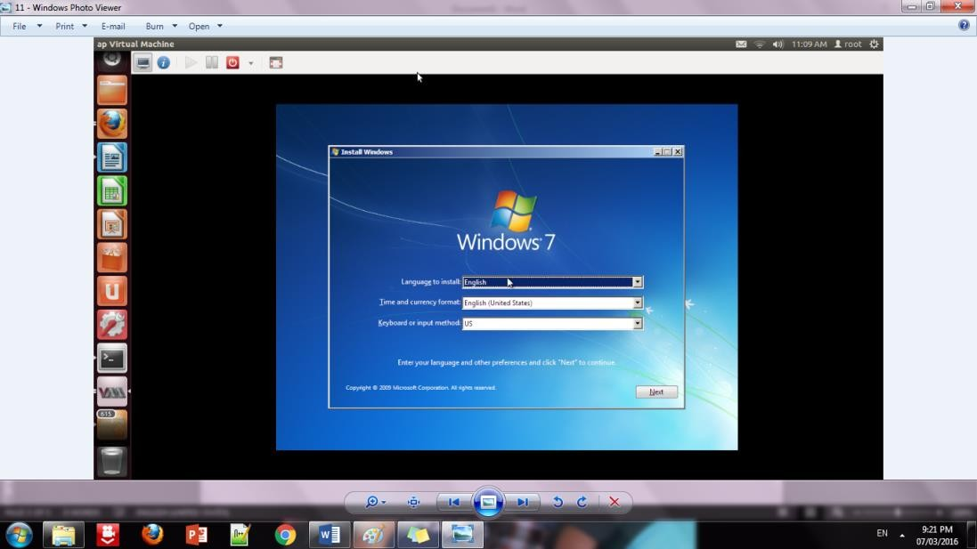

Step 10: Initialization of windows on virtual machine

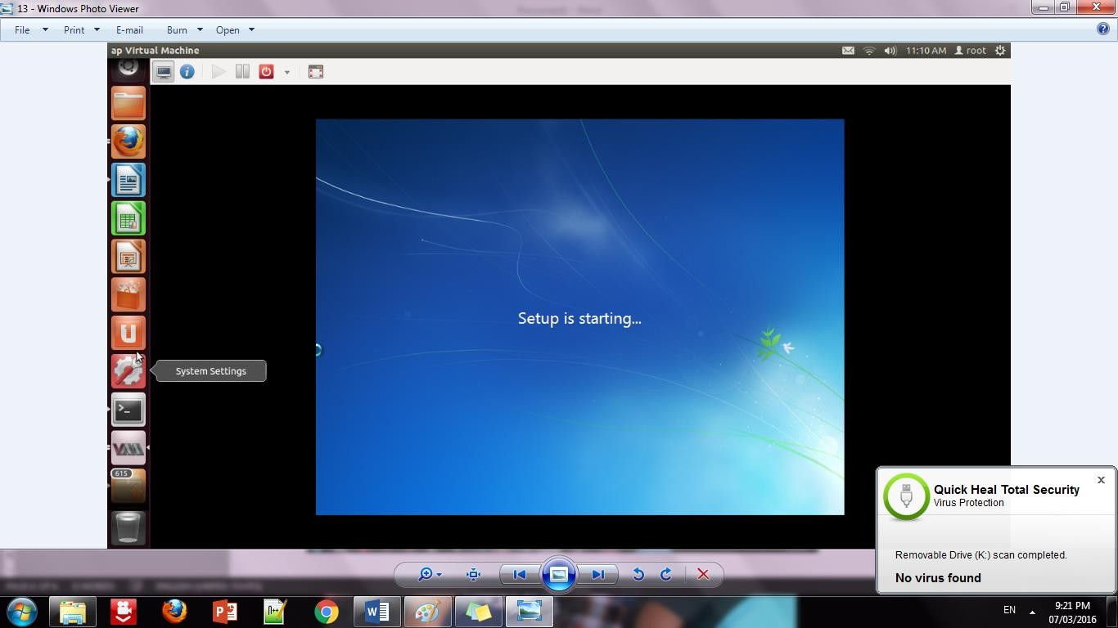

# Conclusion:

Installation and configuration of KVM have been done successfully onto Ubantu and users added. Like this we can create as many virtual machines as possible on OS and can install any windows onto it.

# Viva Questions:

* + What is virtualization ?
  + What is the benefit of desktop virtualization?
  + What are the different virtual machines available?

# References:

1. Enterprise Cloud Computing by Gautam Shroff, Cambridge,2010
2. Cloud Security by Ronald Krutz and Russell Dean Vines, Wiley - India, 2010 ISBN:978-0-470-58987-8
3. Getting Started with OwnCloud by Aditya Patawar , Packt Publishing Ltd, 2013