

|  |  |
| --- | --- |
| **Brand Name** | GrandGlow Homeware |
| **Brand Owners** | * Mir Zulqarnain **SP23-BAI-023** * Muhammad Uzair **SP23-BAI-038** |
| **E-Commerce Type** | Business to Consumer  **(B2C)** |
| **Revenue Model** | Sales |
| **Business Model** | E-Tailer |
| **Domain &**  **Web Link** | furnishvista.shop  https://www.furnishvista.shop |

* **Brand Information:-**
* **Brand Description:-**

"At GrandGlow Homeware, we curate more than furniture; we curate lifestyles. Elevate your space with our blend of timeless designs and contemporary flair. Discover elegance, comfort, and a touch of your unique style in every piece. Welcome home to GrandGlow Homeware – where your story begins in style."

* **Grand Glow Furniture Store Background:-**

**Introduction:** At Grandglow Homeware, we curate timeless pieces that redefine your living spaces. Elevate every corner with our blend of elegance and functionality. Welcome to a world where your home's story is told through Grandglow's distinctive touch..

**Affordable Quality:** At Grandglow Homeware, we blend timeless elegance with modern living. Discover curated pieces that transform spaces into havens, where every detail speaks of comfort and style. Grandglow – where homeware meets grand living

**User-Friendly Website:** Discover comfort and style effortlessly on our user-friendly WordPress site at Grandglow Homeware. Secure transactions, curated collections—where elegance meets simplicity.

**Customer-Centric Approach:** At Grandglow Homeware, you're at the heart of our commitment. Our dedicated support team is here to assist you, and your feedback fuels our relentless pursuit of continuous improvement.

**Vision for the Future:** At Grandglow Homeware, we envision becoming your trusted choice in home essentials. We aspire to broaden our product offerings and embrace emerging trends to elevate your customer experience.

* **Business Objectives:-**

1. **Market Expansion:**
   * At Grandglow Homeware, we aim to grow by reaching new regions and untapped audiences, sharing the essence of our quality products with more homes.
2. **Revenue Growth:**

* At Grandglow Homeware, we strive for continual revenue growth through increased sales and innovative new product lines

1. **Brand Awareness:**

* At Grandglow Homeware, we aim to be your trusted and innovative brand, enhancing visibility and recognition in the world of homeware

1. **Customer Acquisition:**
   * At Grandglow Homeware, we're growing our customer base with targeted marketing, reaching new audiences and expanding our reach.
2. **Customer Retention:**
   * At Grandglow Homeware, we build loyalty through excellent service, personalized communication, and exclusive loyalty programs.
3. **Product Innovation:**
   * At Grandglow Homeware, we're committed to constant innovation. Expect new and advanced homeware products that align with market trends and your preferences.
4. **E-commerce Optimization:**
   * Experience enhanced shopping at Grandglow Homeware with our optimized platform—seamless navigation, mobile responsiveness, and efficient checkout.
5. **Competitive Positioning:**
   * Grandglow Homeware aims to fortify its competitive position by distinguishing the brand through unique design elements, features, and innovative pricing strategies

* **System\Website Drawbacks:-**

1. **Domain Misalignment:** The website domain may not align closely with the store name, potentially causing brand confusion.
2. **Mobile Appearance Issues:** Mobile viewing experience needs improvement, contrasting with a well-designed desktop version.
3. **Editing and Design Challenges:** Drawbacks in editing and design aspects impact overall website consistency and user experience.
4. **Imaginary Product Representation:** Products presented as imaginary may create confusion, hindering transparency and trust.

**Targeted Audience:-**

1. **Couples:** Your audience may include couples who are either newlyweds or have been together for some time. Consider offering furniture that suits shared spaces and reflects both individuals' tastes.
2. **New Homeowners:** This group may be seeking a variety of furniture pieces to furnish their new space, ranging from essential items to decorative pieces.
3. **Working Professionals:** Busy working professionals may prioritize functional and low-maintenance furniture that complements their modern and dynamic lifestyle
4. **Interior Design Enthusiasts:** People passionate about interior design may be interested in unique and statement pieces to showcase their personal style.
5. **Downsizers:** Individuals or couples who have recently downsized their living spaces and need furniture that maximizes space without compromising style.
6. **Home Office Setups:** With the rise of remote work, individuals looking to set up a home office may be in need of functional and aesthetically pleasing office furniture.
7. **Eco-Conscious Consumers:** Environmentally conscious individuals who prioritize sustainable and eco-friendly furniture options.
8. **Home Renovators:** Individuals planning home renovations may be interested in a range of furniture styles to complement their overall design vision.
9. **Multigenerational Families:** Families with multiple generations living under one roof may require versatile and durable furniture that caters to different age groups.

* **Products Offered:-**

CLOCKS

CORNER TABLES

TEA TABLES

Beds

Sofa Sets

* **Business Model:-**
* **Overview:**

**1. Value Proposition:**

* At Grandglow Wardrobe, we redefine storage solutions with elegance and innovation. Our wardrobes are more than furniture; they are a statement of sophistication and functionality, curated for those who seek not just storage but a seamless blend of style and practicality..

**2. Customer Segments:**

* Grandglow Homeware caters to couples, new homeowners, and design enthusiasts, providing stylish and functional furniture for those seeking quality and comfort in their living spaces. Our customer segments include professionals, empty nesters, and individuals with a focus on sustainability and customizable options..

**3. Channels:**

* Online e-commerce platform for global accessibility.
* Social media platforms for marketing and engagement.

**4. Customer Relationships:**

* Online customer support for inquiries and assistance.
* Social media engagement for feedback and updates.

**5. Revenue Streams:**

* Direct sales through the e-commerce platform.
* Potential revenue from partnerships and collaborations.

**6. Key Resources:**

* Supply chain for product sourcing and distribution.
* Research and development for continuous innovation.

**7. Key Activities:**

* Product design, development, and manufacturing.
* Marketing and promotional activities for brand awareness.

**8. Key Partnerships:**

* Suppliers and manufacturers for a diverse product range..

**9. Cost Structure:**

* Product development and manufacturing costs.
* Marketing and advertising expenses.
* Operational costs, including staff salaries.

**10. Innovation and Differentiation:** -

* Regular introduction of new and innovative products. - Focus on unique design elements, features, and functionality.
* **Competitive Environment:**
* GrandGlow Homeware faces fierce competition in the home decor market, contending with major players such as Daraz, Ali Express, and various other online stores. • The industry is marked by rapid technological advancements and evolving consumer preferences, necessitating agility and innovation to stay ahead in the dynamic landscape..
* **Competitive Advantage:**
* GrandGlow Homeware excels in seamless integration, blending advanced technology with chic design.
* Continuous innovation and a diverse product range set GrandGlow apart in the market.
* With a robust online presence and global accessibility, GrandGlow Homeware reaches a wide customer base.
* **Benefits of E-commerce:-**

1. **24/7 Availability:** The online platform is accessible around the clock, providing convenience and boosting sales opportunities.
2. **Cost-Effective Operations:** E-commerce reduces overhead costs, optimizing resource allocation for GrandGlow Homeware.
3. **Data Analytics:** Insights from e-commerce analytics enhance decision-making for marketing, inventory, and product development.
4. **Marketing Opportunities:** Digital tools enable efficient promotion, social engagement, and targeted campaigns for GrandGlow homeware.
5. **Efficient Inventory Management:** Real-time tracking streamlines inventory control, improving supply chain management.
6. **Personalized Customer Experience:** E-commerce allows GrandGlow homeware to offer personalized recommendations based on customer preferences.
7. **Quick and Secure Transactions:** Secure payment gateways ensure customer confidence and a positive online shopping experience.
8. **Customer Reviews and Feedback:** Online platforms provide space for customer feedback, contributing to product credibility and improvement.
9. **Adaptability to Trends:** E-commerce enables GrandGlow homeware to swiftly adapt to market trends, introducing new products and promotions.

* **Business Support:-**

**a) Product Source:**

* GrandGlow homeware sources its products from reputable suppliers and manufacturers known for producing high-quality electronics. Our selection process ensures that each product aligns with our commitment to innovation, style, and affordability.

**b) Product Delivery:**

* GrandGlow homeware offers reliable and efficient product delivery services. We strive to ensure timely shipping to our customers globally, providing tracking information for transparency and convenience. Our partnerships with trusted shipping providers contribute to a seamless delivery experience.

**c) Exchange/Return Policy:**

* At GrandGlow homeware, customer satisfaction is paramount. We have a hassle-free exchange and return policy to address any concerns or issues with the products. Customers can initiate returns or exchanges within a specified period, and our customer support team is ready to assist throughout the process.

**d) Payment Type:**

* GrandGlow homeware supports a variety of payment methods to enhance convenience for our customers. Accepted payment types include major credit/debit cards, online payment gateways, and other secure payment options. Our checkout process is designed to ensure a secure and smooth transaction experience.

**e) Customer Support:**

* GrandGlow homeware is dedicated to providing excellent customer support. Our knowledgeable and responsive support team is available to assist with product inquiries, order tracking, and any concerns customers may have. Contact options include online chat, email, and a customer support hotline.
* **Digital Marketing Plan:-**

**a) Search Engine Optimization (SEO):**

* Conduct keyword research to identify relevant and high-search-volume terms related to electronics and gadgets.
* Optimize product pages and website content with relevant keywords to improve organic search rankings.
* Create and share valuable, shareable content such as product reviews, guides, and tech tips.
* Focus on local SEO to capture regional markets if applicable.
* Regularly monitor and update the website to comply with SEO best practices.
* 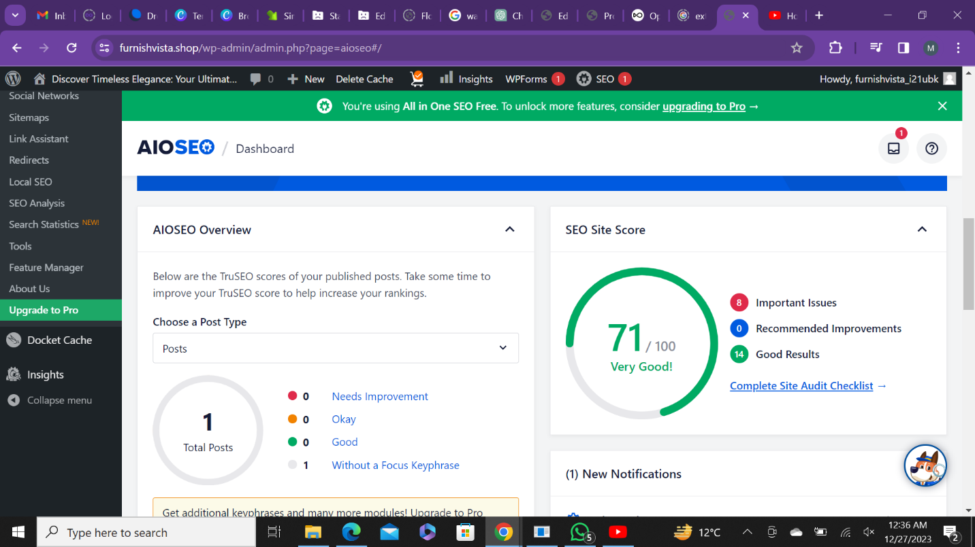

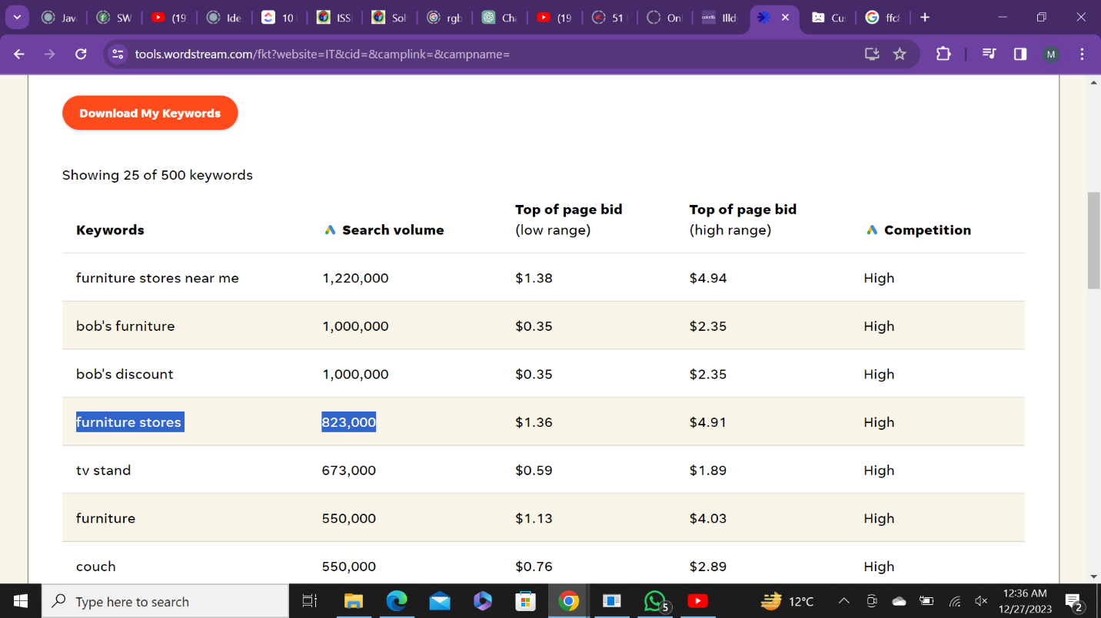

**b) Search Engine Marketing (SEM):**

* Run targeted pay-per-click (PPC) campaigns on search engines like Google to promote key products and boost visibility.
* Utilize ad extensions and compelling ad copy to enhance click-through rates.
* Implement remarketing strategies to re-engage visitors who showed interest in specific products.
* Monitor campaign performance through analytics and adjust bids and targeting as needed.

**c) Email Marketing:**

* Build and segment an email subscriber list to deliver personalized content and promotions.
* Implement automated email campaigns for product launches, special promotions, and abandoned cart recovery.
* Create engaging newsletters with product highlights, tech trends, and exclusive offers.
* Encourage customer reviews and feedback through email communications.

**d) Pricing Strategies:**

* Implement competitive pricing strategies, considering market trends and competitors.
* Offer bundled deals, discounts, or promotional pricing during specific periods to drive sales.
* Highlight the value proposition of GrandGlow homeware products in marketing materials to justify pricing.

**e) Social Media Marketing:**

* Develop a strong social media presence on platforms like Facebook, Instagram, Twitter, and LinkedIn.
* Share visually appealing content showcasing products, features, and customer testimonials.
* Run targeted social media advertising campaigns to reach specific demographics.
* Engage with the audience through comments, direct messages, and social media contests.
* Leverage influencers and brand ambassadors to extend reach and credibility.
* **Future Enhancement:-**

1. **Sustainability Focus:**
   * Embrace eco-friendly practices in manufacturing, packaging, and sourcing.
2. **Global Expansion:**
   * Enter new international markets, tailoring strategies to diverse consumer demographics.
3. **E-commerce Optimization:**
   * Continuously enhance the online shopping experience with the latest technologies and improved responsiveness.
4. **Data-Driven Decisions:**
   * Strengthen data analytics for deeper insights into customer behavior and market trends.
5. **Augmented Reality (AR):**
   * Explore AR integration for virtual product experiences and increased customer confidence.
6. **Strategic Partnerships:**
   * Forge collaborations with influencers and brands to amplify marketing efforts and reach new audiences.
7. **Customer Engagement Platforms:**
   * Develop forums, communities, or loyalty programs to foster a sense of community among customers.

* **Conclusion:-**

In conclusion, GrandGlow Homeware stands at the forefront of the home decor industry, offering innovative and stylish products at competitive prices. Committed to customer satisfaction, global accessibility, and ongoing design ingenuity, GrandGlow Homeware aspires to redefine home aesthetics for enthusiasts and everyday consumers alike. Our business objectives, including market expansion, revenue growth, and a dedication to customer-centric strategies, position us for sustained success in the dynamic world of home decor. As we continually evolve, GrandGlow Homeware remains steadfast in our mission to enrich lives through thoughtfully crafted designs, shaping a future where homes are adorned with seamless beauty and cutting-edge decor. Join us on this exciting journey with GrandGlow Homeware, where innovation meets accessibility, and your living spaces transform into havens of elegance and comfort

.**GrandGlow Homeware Link:-**

[**https://www.furnishvista.shop**](https://www.furnishvista.shop)

