KPI’s

1: Total Revenue

select SUM(total_price) as [Total Revenue] from pizza_sales

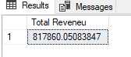

2: Average Order Value

select SUM(total_price)/ count(distinct order_id) from pizza_sales

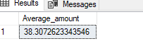

3: Total Pizza sold

select sum(quantity) from pizza_sales

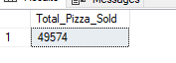

4:Total Orders

select count(distinct(order_id )) AS total_orders from pizza_sales

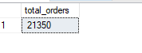

5: Average Pizza Sale Per Order

select cast(cast (SUM(quantity )AS decimal(10,2)) / count(distinct (order_id)) AS decimal(10,2)) AS Average_pizza_per_Order from pizza_sales

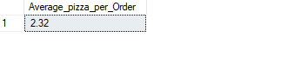

6: Daily Trend For Total Orders

select DATENAME(DW , order_date) AS Order_day, count(distinct(order_id)) AS Total_Orders from pizza_sales

GROUP BY DATENAME(DW, Order_date)

order by Total_Orders desc

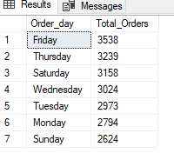

7: Month Trend for Total Orders

select DATENAME(MONTH , order_date) AS Order_Month, count(distinct(order_id)) AS Total_Orders from pizza_sales

GROUP BY DATENAME(MONTH, Order_date)

order by Total_Orders desc

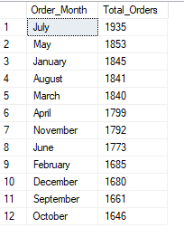

8: Percentage of Pizza by Sale Category

select pizza_category,sum(total_price) AS Total_Purchase,SUM(total_price)*100/(select SUM(total_price) from pizza_sales) AS pct from pizza_sales

group by pizza_category

order by pct desc

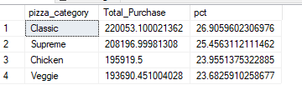

8: Percentage of Pizza by Pizza Size

select pizza_size,cast(SUM(total_price)AS decimal(10,2)) AS Total,cast(SUM(total_price) * 100/(select (sum(total_price)) from pizza_sales) AS decimal(10,2)) AS Percentage from pizza_sales

group by pizza_size

