|  |
| --- |
| [Company name] |
| ICT 162 - OOP |
| [Document subtitle] |

|  |
| --- |
| Student Name  [Date] |

Table of Contents

1. Question 1 4

a. Customer Class 4

b. Tour Class 4

c. Tour objects 5

Output 6

2. Question 2 6

a. ScheduledTour 6

c. ScheduledTour objects 8

Output 9

3. Question 3 9

a. BookingException 9

b. Booking 9

c. 2 subclasses of Booking 11

d. main() function with exception handling 12

4. Question 4 13

a. TourAgency Class 13

b. Application for Staff 16

Table of Figures

Figure 1: Printing Tour Objects 6

Figure 2: Printing ScheduledTour Objects 9

Figure 3: Tour Management 23

Figure 4: Schedule Tour Option 1 at Schedule Tour 24

Figure 5: Open/Close Schedule Option 2 at Tour at Schedule Tour 24

Figure 6: Removal Schedule Tour Option 3 at Schedule Tour 25

Figure 7: List Scheduled Tours Option 4 at Schedule Tour 25

Figure 8: Booking Management 26

Figure 9: Create Booking Option 1 at Booking Management 26

Figure 10: Cancel Booking Option 2 at Booking Management 27

Figure 11: Add Seats to Booking Option 3 at Booking Management 27

Figure 12: List Bookings Option 4 at Booking Management 28

# Question 1

## Customer Class

|  |
| --- |
| from datetime import datetime  class Customer:      def __init__(self, passportNumber, name, dob, contact):          self._passportNumber = passportNumber          self._name = name          self._dob = dob          self._contact = contact        @property      def passportNumber(self):          return self._passportNumber        @property      def name(self):          return self._name        @property      def contact(self):          return self._contact        @contact.setter      def contact(self, value):          self._contact = value        def getAge(self):          current_year = datetime.now().year          return current_year - self._dob.year        def __str__(self):          return f"Passport: {self._passportNumber} Name: {self._name} Age: {self.getAge()} Contact: {self._contact}" |

## Tour Class

|  |
| --- |
| class Tour:      def __init__(self, code, name, days, nights, cost):          self._code = code          self._name = name          self._days = days          self._nights = nights          self._cost = cost        @property      def code(self):          return self._code        @property      def name(self):          return self._name        @property      def cost(self):          return self._cost        @cost.setter      def cost(self, value):          self._cost = value        @property      def daysNights(self):          return f"{self._days}D/{self._nights}N"        def __str__(self):          return f"Tour Code: {self._code} Name: {self._name} ({self.daysNights}) Base Cost: ${self._cost:.2f}" |

## Tour objects

|  |
| --- |
| tour1 = Tour("JPHA08", "Best of Hokkaido", 8, 7, 2699.08)  tour2 = Tour("KMBK08", "Mukbang Korea", 8, 6, 1699.36)  tour3 = Tour("VNDA06", "Discover Vietnam", 6, 5, 999.00)  # Print string representations of Tour objects  print(tour1)  print(tour2)  print(tour3) |

## Output

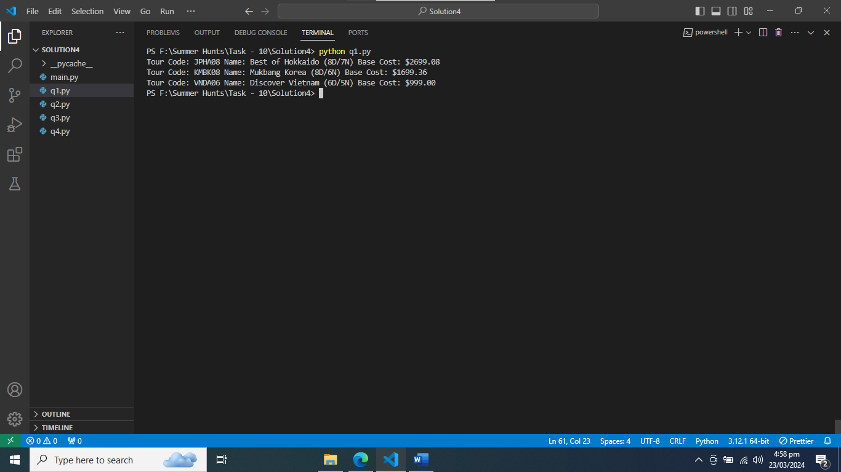

Figure : Printing Tour Objects

# Question 2

## ScheduledTour

|  |
| --- |
| from q1 import tour1  from q1 import tour2  from q1 import tour3  from datetime import datetime, timedelta  class ScheduledTour:      handling_fee = 120        @classmethod      def getHandlingFee(cls):          return cls.handling_fee        def __init__(self, scheduleCode, tour, departureDateTime, lang, capacity):          self._scheduleCode = scheduleCode          self._tour = tour          self._departureDateTime = departureDateTime          self._lang = lang          self._capacity = capacity          self._seatsAvailable = capacity          self._status = True        @property      def departureDateTime(self):          return self._departureDateTime        @property      def capacity(self):          return self._capacity        @property      def seatsAvailable(self):          return self._seatsAvailable        @property      def status(self):          return self._status        @status.setter      def status(self, value):          self._status = value        @property      def code(self):          return f"{self._tour.code}-{self._scheduleCode}"        @property      def cost(self):          return self._tour.cost        def bookSeats(self, quantity):          if quantity > self._seatsAvailable:              return False          self._seatsAvailable -= quantity          return True        def cancelSeats(self, quantity):          if self._seatsAvailable + quantity > self._capacity:              return False          self._seatsAvailable += quantity          return True        def getPenaltyRate(self):          days_before_tour = (self._departureDateTime - datetime.now()).days          if days_before_tour >= 46:              return 0.1          elif 14 <= days_before_tour <= 45:              return 0.5          elif 7 <= days_before_tour <= 13:              return 1          else:              return 1        def __str__(self):          return f"Name: {self._tour.name} ({self._tour.daysNights}) Base Cost: ${self._tour.cost:.2f}\n" \                 f"Code: {self.code} Departure: {self._departureDateTime.strftime('%d-%b-%Y %H:%M')} " \                 f"Language: {self._lang}\n" \                 f"Capacity: {self._capacity} Available: {self._seatsAvailable} Open: {'Yes' if self._status else 'No'}" |

1. PeakScheduledTour

|  |
| --- |
| class PeakScheduledTour(ScheduledTour):      surcharge = 0.15      handling_charges = 200        def __init__(self, scheduleCode, tour, departureDateTime, lang, capacity):          super().__init__(scheduleCode, tour, departureDateTime, lang, capacity)          self._cost = self._tour.cost * (1 + self.surcharge)        @property      def cost(self):          return self._cost        def getPenaltyRate(self):          base_penalty_rate = super().getPenaltyRate()          max_penalty_rate = 1  # 100%          return min(base_penalty_rate + 0.1, max_penalty_rate) |

## ScheduledTour objects

|  |
| --- |
| scheduled_tour1 = ScheduledTour("505", tour1, datetime(2024, 5, 5, 10, 30), "English", 30)  scheduled_tour2 = ScheduledTour("408", tour1, datetime(2024, 4, 8, 8, 45), "English", 25)  scheduled_tour3 = ScheduledTour("503", tour2, datetime(2024, 5, 3, 8, 5), "English", 32)  scheduled_tour4 = ScheduledTour("403", tour2, datetime(2024, 4, 3, 10, 5), "Mandarin", 25)  scheduled_tour5 = ScheduledTour("503", tour3, datetime(2024, 5, 3, 11, 8), "Mandarin", 28)  # Create PeakScheduledTour objects  peak_scheduled_tour1 = PeakScheduledTour("505", tour1, datetime(2024, 5, 5, 10, 30), "English", 30)  peak_scheduled_tour2 = PeakScheduledTour("503", tour2, datetime(2024, 5, 3, 8, 5), "English", 32)  peak_scheduled_tour3 = PeakScheduledTour("503", tour3, datetime(2024, 5, 3, 11, 8), "Mandarin", 28) |

## Output

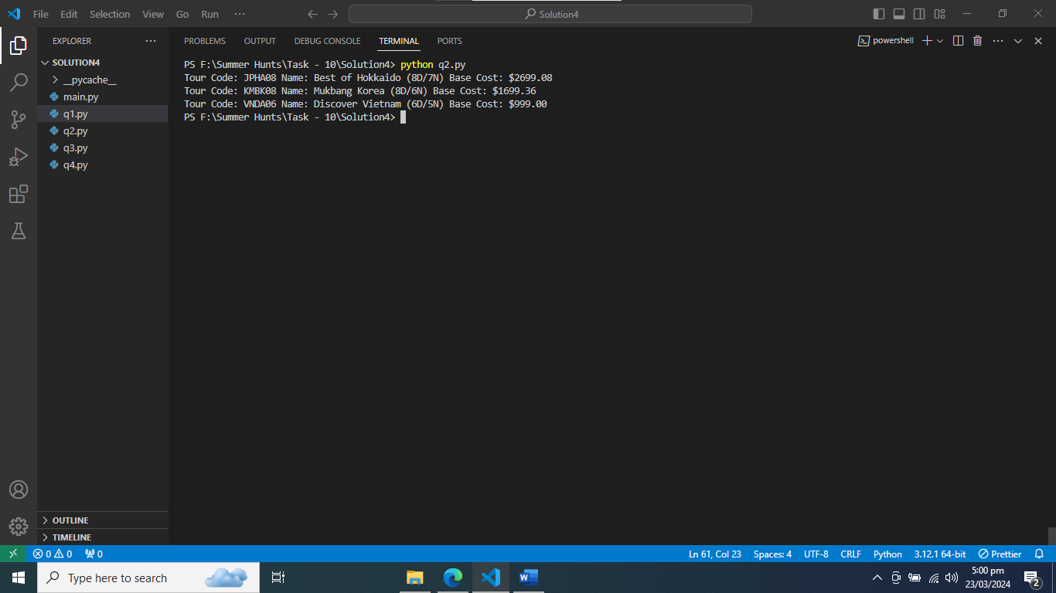

Figure : Printing ScheduledTour Objects

# Question 3

## BookingException

|  |
| --- |
| class BookingException(Exception):      pass |

## Booking

|  |
| --- |
| from q1 import Customer  from q2 import ScheduledTour  from q1 import tour1  from abc import ABC, abstractmethod  from datetime import datetime  from q2 import scheduled_tour1  class Booking(ABC):      _NEXT_ID = 1      def __init__(self, scheduledTour, customers):          if not scheduledTour.bookSeats(len(customers)):              raise BookingException("Not enough seats available for booking.")          self._bookingId = Booking._NEXT_ID          Booking._NEXT_ID += 1          self._scheduledTour = scheduledTour          self._customers = customers      @property      def bookingId(self):          return self._bookingId      @property      def scheduledTour(self):          return self._scheduledTour      @property      def customers(self):          return self._customers      @property      def seats(self):          return len(self._customers)      @abstractmethod      def cost(self):          pass      @abstractmethod      def addSeats(self, customers):          pass      def searchCustomer(self, passport_numbers):          return any(customer.passportNumber in passport_numbers for customer in self._customers)      def getPenaltyAmount(self):          days_difference = (self._scheduledTour.departureDateTime - datetime.now()).days          penalty_rate = self._scheduledTour.getPenaltyRate()          handling_charges = ScheduledTour.getHandlingFee()          base_cost = self.cost()          penalty_amount = handling_charges + (penalty_rate * base_cost)          return min(penalty_amount, base_cost)      def __str__(self):          output = f"Booking Id: {self._bookingId} Seats: {self.seats} Final Cost: ${self.cost():,.2f}\n"          output += str(self._scheduledTour) + "\n"          output += "\n".join(str(customer) for customer in self._customers)          return output |

## 2 subclasses of Booking

|  |
| --- |
| class IndividualBooking(Booking):      _SINGLE = 0.5      def __init__(self, scheduledTour, customer, single=False):          if datetime.now().year - customer._dob.year < 20:              raise BookingException("Customer must be at least 20 years old for individual booking.")          super().__init__(scheduledTour, [customer])          self._single = single      def cost(self):          base_cost = self._scheduledTour.cost          if self._single:              return base_cost * (1 + self._SINGLE)          return base_cost      def addSeats(self, customers):          raise BookingException("It is not possible to add seats for individual booking.")  class GroupBooking(Booking):      _DISCOUNT = {6: 0.05, 10: 0.10}      def __init__(self, scheduledTour, customers):          if len(customers) < 2:              raise BookingException("Group size must be at least 2.")          for customer in customers:              if datetime.now().year - customer._dob.year < 20:                  raise BookingException("All customers must be at least 20 years old for group booking.")          super().__init__(scheduledTour, customers)      def getDiscount(self):          group_size = len(self._customers)          if group_size < 6:              return 0          for size, discount in sorted(self._DISCOUNT.items(), reverse=True):              if group_size >= size:                  return discount      def cost(self):          base_cost = self._scheduledTour.cost          discount = self.getDiscount()          if discount:              return base_cost * (1 - discount) * len(self._customers)          return base_cost * len(self._customers)      def addSeats(self, customers):          existing_passports = {customer.passportNumber for customer in self._customers}          if any(customer.passportNumber in existing_passports for customer in customers):              raise BookingException("One or more customers are already in this booking.")          if not self._scheduledTour.bookSeats(len(customers)):              raise BookingException("The scheduled tour may have reached full capacity.")          self._customers.extend(customers)          return True |

## main() function with exception handling

|  |
| --- |
| def main():      try:          print("Individual Booking:")          customer1 = Customer("E2714897X", "Henry Tan", datetime(1980, 5, 10), 97777777)            individual_booking1 = IndividualBooking(scheduled_tour1, customer1, single=True)          print(individual_booking1)          individual_booking1.addSeats([customer1])      except BookingException as e:          print(e)      try:          print("\nIndividual Booking:")          customer2 = Customer("E1234567G", "Alice Oh", datetime(2005, 1, 15), 98989898)          individual_booking2 = IndividualBooking(scheduled_tour1, customer2, single=True)          print(individual_booking2)      except BookingException as e:          print(e)      try:          print("\nGroup Booking:")          customers3 = [              Customer("E1234567G", "Alice Oh", datetime(2005, 1, 15), 98989898),              Customer("E2323232Y", "Joyce Seetoh", datetime(2007, 9, 23), 62349000)          ]          group_booking1 = GroupBooking(scheduled_tour1, customers3)          print(group_booking1)      except BookingException as e:          print(e)      try:          print("\nGroup Booking:")          customers4 = [              Customer("E1234567G", "Alice Oh", datetime(2005, 1, 15), 98989898),              Customer("E2323232Y", "Joyce Seetoh", datetime(2007, 9, 23), 62349000),              Customer("K1234771H", "Marvin Heng", datetime(1980, 3, 25), 89699090),              Customer("K5324732Y", "Mary Tham", datetime(2009, 7, 8), 87112345),              Customer("E2714897X", "Henry Tan", datetime(1980, 5, 10), 97777777)          ]          group_booking2 = GroupBooking(scheduled_tour1, customers4)          print(group_booking2)          additional_customers = [              Customer("E1234568G", "Bob Lee", datetime(1987, 11, 20), 99999999),              Customer("E5432101A", "David Lim", datetime(1985, 6, 7), 88888888)          ]          group_booking2.addSeats(additional_customers)          print(group_booking2)      except BookingException as e:          print(e)  if __name__ == "__main__":      main() |

# Question 4

## TourAgency Class

|  |
| --- |
| from datetime import datetime  from q1 import Customer  from q1 import Tour  from q2 import ScheduledTour  from q3 import BookingException  from q3 import IndividualBooking  from q3 import GroupBooking  class TourAgency:      def __init__(self):          self._tours = []          self._customers = []          self._scheduled_tours = []          self._bookings = []      def searchCustomer(self, passport_number):          for customer in self._customers:              if customer.passportNumber == passport_number:                  return customer          return None      def searchTour(self, tour_code):          for tour in self._tours:              if tour.code == tour_code:                  return tour          return None      def searchScheduledTour(self, schedule_code):          for scheduled_tour in self._scheduled_tours:              if scheduled_tour.code == schedule_code:                  return scheduled_tour          return None      def searchBooking(self, booking_id):          for booking in self._bookings:              if booking.bookingId == booking_id:                  return booking          return None      def formatTours(self):          return "\n".join(str(tour) for tour in self._tours)      def formatBookings(self):          return "\n".join(str(booking) for booking in self._bookings)      def formatScheduledTours(self):          return "\n".join(str(scheduled_tour) for scheduled_tour in self._scheduled_tours)      def formatOpenScheduledTours(self):          return "\n".join(str(scheduled_tour) for scheduled_tour in self._scheduled_tours if scheduled_tour.status)      def addCustomer(self, customer):          if customer not in self._customers:              self._customers.append(customer)          else:              raise BookingException("Customer already exists.")      def addTour(self, tour):          if tour not in self._tours:              self._tours.append(tour)          else:              raise BookingException("Tour already exists.")      def addScheduledTour(self, scheduled_tour):          if scheduled_tour not in self._scheduled_tours:              self._scheduled_tours.append(scheduled_tour)          else:              raise BookingException("Scheduled tour already exists.")      def removeScheduledTour(self, schedule_code):          scheduled_tour = self.searchScheduledTour(schedule_code)          if scheduled_tour:              if not scheduled_tour._status:                  self._scheduled_tours.remove(scheduled_tour)              else:                  raise BookingException("Scheduled tour has bookings and cannot be removed.")          else:              raise BookingException("Scheduled tour not found.")        def updateScheduledTourStatus(self, scheduled_tour_code, status):          scheduled_tour = self.searchScheduledTour(scheduled_tour_code) #..........          if scheduled_tour:              scheduled_tour.status = status              print("Status updated!!")              print(scheduled_tour)          else:              print("Scheduled Tour not found.")      def addBooking(self, scheduled_tour, customers, booking_type, single=False):          if not scheduled_tour.status:              raise BookingException("Scheduled tour is not open for booking.")            for customer in customers:              if not any(self.searchCustomer(customer.passportNumber) for scheduled_tour in self._scheduled_tours):                  raise BookingException("Customer already booked for this scheduled tour.")          if booking_type == "I":              booking = IndividualBooking(scheduled_tour, customers[0], single)          elif booking_type == "G":              booking = GroupBooking(scheduled_tour, customers)          else:              raise ValueError("Invalid booking type.")            self._bookings.append(booking)          return booking      def cancelBooking(self, booking_id):          booking = self.searchBooking(booking_id)          if booking:              if booking.scheduledTour.status:                  booking.scheduledTour.cancelSeats(booking.seats)                  self._bookings.remove(booking)              else:                  raise BookingException("Scheduled tour associated with the booking is not open for booking.")          else:              raise BookingException("Booking not found.")      def addSeats(self, booking_id, customers):          booking = self.searchBooking(booking_id)          if booking:              if booking.scheduledTour.status:                  additional_cost = booking.addSeats(customers)                  return additional_cost              else:                  raise BookingException("Scheduled tour associated with the booking is not open for booking.")          else:              raise BookingException("Booking not found.") |

## Application for Staff

|  |
| --- |
| # Main function  def main():      # Creating TourAgency object      tour_agency = TourAgency()        # Adding customers      customer1 = Customer("E2000444N", "John Doe", datetime(1990, 5, 20), "1234567890")      customer2 = Customer("EC4744643", "Jane Smith", datetime(1985, 9, 15), "9876543210")      tour_agency.customers.extend([customer1, customer2])        # Adding tours      tour1 = Tour("JPHA08", "Best of Hokkaido", 8, 7, 2699.08)      tour2 = Tour("KMBK08", "Mukbang Korea", 8, 6, 1699.36)      tour3 = Tour("VNDA06", "Discover Vietnam", 6, 5, 999.00)      tour_agency.tours.extend([tour1, tour2, tour3])        # Adding scheduled tours      scheduled_tour1 = ScheduledTour("505", tour1, datetime(2024, 5, 5, 10, 30), "English", 30, True)      scheduled_tour2 = ScheduledTour("408", tour1, datetime(2024, 4, 8, 8, 45), "English", 25, False)      scheduled_tour3 = ScheduledTour("503", tour2, datetime(2024, 5, 3, 8, 5), "English", 32, True)      scheduled_tour4 = ScheduledTour("403", tour2, datetime(2024, 4, 3, 10, 5), "Mandarin", 25, False)      scheduled_tour5 = ScheduledTour("503", tour3, datetime(2024, 5, 3, 11, 8), "Mandarin", 28, True)      tour_agency.scheduled_tours[tour1.code].extend([scheduled_tour1, scheduled_tour2])      tour_agency.scheduled_tours[tour2.code].extend([scheduled_tour3, scheduled_tour4])      tour_agency.scheduled_tours[tour3.code].append(scheduled_tour5)        # Menu loop      while True:          print("<<<< Main Menu >>>>")          print("1. Tour management")          print("2. Booking management")          print("0. Quit")          choice = input("Enter choice: ")            if choice == "1":              tour_management_menu(tour_agency)          elif choice == "2":              booking_management_menu(tour_agency)          elif choice == "0":              print("Exiting...")              break          else:              print("Invalid choice. Please try again.")  # Tour management menu function  def tour_management_menu(tour_agency):      while True:          print("\n<< Tour Menu >>")          print("1. Schedule Tour")          print("2. Open/Close Scheduled Tour")          print("3. Remove Scheduled Tour")          print("4. List Scheduled Tours")          print("0. Back to main menu")          choice = input("Enter choice: ")            if choice == "1":              schedule_tour(tour_agency)          elif choice == "2":              open_close_scheduled_tour(tour_agency)          elif choice == "3":              remove_scheduled_tour(tour_agency)          elif choice == "4":              list_scheduled_tours(tour_agency)          elif choice == "0":              break          else:              print("Invalid choice. Please try again.")  # Booking management menu function  def booking_management_menu(tour_agency):      while True:          print("\n<< Booking Menu >>")          print("1. Create Booking")          print("2. Cancel Booking")          print("3. Add Seats to Booking")          print("4. List Bookings")          print("0. Back to main menu")          choice = input("Enter choice: ")            if choice == "1":              create_booking(tour_agency)          elif choice == "2":              cancel_booking(tour_agency)          elif choice == "3":              add_seats_to_booking(tour_agency)          elif choice == "4":              list_bookings(tour_agency)          elif choice == "0":              break          else:              print("Invalid choice. Please try again.")  # Function to schedule a tour  def schedule_tour(tour_agency):      print("\n<< Schedule Tour >>")      tour_code = input("Enter Tour Code: ")      tour = tour_agency.searchTour(tour_code)      if not tour:          print("Tour not found.")          return        print("Available scheduled tours:")      print(tour_agency.listScheduledTours())      schedule_code = input("Enter Schedule Code: ")      departure_date = input("Enter Departure Date and Time (YYYY-MM-DD HH:MM): ")      lang = input("Enter Language: ")      capacity = int(input("Enter Capacity: "))      peak = input("Is it Peak (Yes/No): ").lower() == "yes"        try:          departure_datetime = datetime.strptime(departure_date, "%Y-%m-%d %H:%M")      except ValueError:          print("Invalid date and time format. Please enter in YYYY-MM-DD HH:MM format.")          return        scheduled_tour = ScheduledTour(schedule_code, tour, departure_datetime, lang, capacity, peak)      tour_agency.scheduled_tours[tour_code].append(scheduled_tour)      print("Scheduled tour added successfully.")  # Function to open/close scheduled tour  def open_close_scheduled_tour(tour_agency):      print("\n<< Open/Close Scheduled Tour >>")      schedule_code = input("Enter Scheduled Tour Code: ")      scheduled_tour = tour_agency.searchScheduledTour(schedule_code)      if not scheduled_tour:          print("Scheduled tour not found.")          return        if scheduled_tour.status == "Yes":          action = input("This scheduled tour is currently open. Do you want to close it? (Yes/No): ")          if action.lower() == "yes":              scheduled_tour._status = False              print("Scheduled tour closed successfully.")      else:          action = input("This scheduled tour is currently closed. Do you want to open it? (Yes/No): ")          if action.lower() == "yes":              scheduled_tour._status = True              print("Scheduled tour opened successfully.")  # Function to remove a scheduled tour  def remove_scheduled_tour(tour_agency):      print("\n<< Remove Scheduled Tour >>")      schedule_code = input("Enter Scheduled Tour Code to remove: ")      scheduled_tour = tour_agency.searchScheduledTour(schedule_code)      if not scheduled_tour:          print("Scheduled tour not found.")          return        print(scheduled_tour)      confirmation = input("Are you sure you want to remove this scheduled tour? (Yes/No): ")      if confirmation.lower() == "yes":          if scheduled_tour.seatsAvailable == scheduled_tour.capacity:              del tour_agency.scheduled_tours[scheduled_tour._tour.code][schedule_code]              print("Scheduled tour removed successfully.")          else:              print("Cannot remove scheduled tour. Some seats are already booked.")      else:          print("Operation cancelled.")  # Function to list all scheduled tours  def list_scheduled_tours(tour_agency):      print("\n<< List Scheduled Tours >>")      print(tour_agency.listScheduledTours())  # Function to create a booking  def create_booking(tour_agency):      print("\n<< Create Booking >>")      passport_number = input("Enter Passport Number: ")      customer = tour_agency.searchCustomer(passport_number)      if not customer:          print("Customer not found.")          return        print("List of open scheduled tours:")      print(tour_agency.listOpenScheduledTours())      schedule_code = input("Enter Scheduled Tour Code: ")      scheduled_tour = tour_agency.searchScheduledTour(schedule_code)      if not scheduled_tour:          print("Scheduled tour not found.")          return        booking_type = input("Enter Booking Type (I for Individual, G for Group): ").upper()      if booking_type == "I":          single = input("Is Single Room required? (Yes/No): ").lower() == "yes"          booking = IndividualBooking(scheduled_tour, customer, single)      elif booking_type == "G":          customers = [customer]          while True:              passport_number = input("Enter Passport Number (<enter> to stop): ")              if not passport_number:                  break              customer = tour_agency.searchCustomer(passport_number)              if not customer:                  print("Customer not found.")                  continue              customers.append(customer)          booking = GroupBooking(scheduled_tour, customers)      else:          print("Invalid booking type.")          return        tour_agency.bookings.append(booking)      print("Booking created successfully.")  # Function to cancel a booking  def cancel_booking(tour_agency):      print("\n<< Cancel Booking >>")      booking_id = int(input("Enter Booking Id: "))      booking = tour_agency.searchBooking(booking_id)      if not booking:          print("Booking not found.")          return        print(booking)      cancellation_date = datetime.today()      penalty_rate = booking.scheduledTour.getPenaltyRate(cancellation_date)      penalty_amount = min(penalty_rate * booking.cost(), booking.cost())      print(f"Penalty Amount: ${penalty_amount:.2f}")      confirmation = input("Are you sure you want to cancel this booking? (Yes/No): ")      if confirmation.lower() == "yes":          tour_agency.bookings.remove(booking)          booking.scheduledTour.cancelSeats(booking.seats)          print("Booking cancelled successfully.")      else:          print("Operation cancelled.")  # Function to add seats to a booking  def add_seats_to_booking(tour_agency):      print("\n<< Add Seats to Booking >>")      booking_id = int(input("Enter Booking Id: "))      booking = tour_agency.searchBooking(booking_id)      if not booking:          print("Booking not found.")          return        if isinstance(booking, IndividualBooking):          print("Individual booking cannot add more travelers.")          return        print("List of customers already booked:")      print("\n".join(str(customer) for customer in booking.customers))      passport_numbers = []      while True:          passport_number = input("Enter Passport Number (<enter> to stop): ")          if not passport_number:              break          customer = tour_agency.searchCustomer(passport_number)          if not customer:              print("Customer not found.")              continue          if customer in booking.customers:              print("Customer already booked.")              continue          passport_numbers.append(passport_number)        customers = [booking.scheduledTour.searchCustomer(passport_number) for passport_number in passport_numbers]      if not all(customers):          print("Some customers not found.")          return        if not booking.scheduledTour.bookSeats(len(customers)):          print("No available seats for additional customers.")          return        booking.customers.extend(customers)      print("Seats added to booking successfully.")      additional_cost = booking.scheduledTour.cost() * len(customers)      print(f"Additional Cost: ${additional_cost:.2f}")  # Function to list all bookings  def list_bookings(tour_agency):      print("\n<< List Bookings >>")      if not tour_agency.bookings:          print("No bookings found.")          return      print("\n".join(str(booking) for booking in tour_agency.bookings))  if __name__ == "__main__":      main() |

## Tour Management

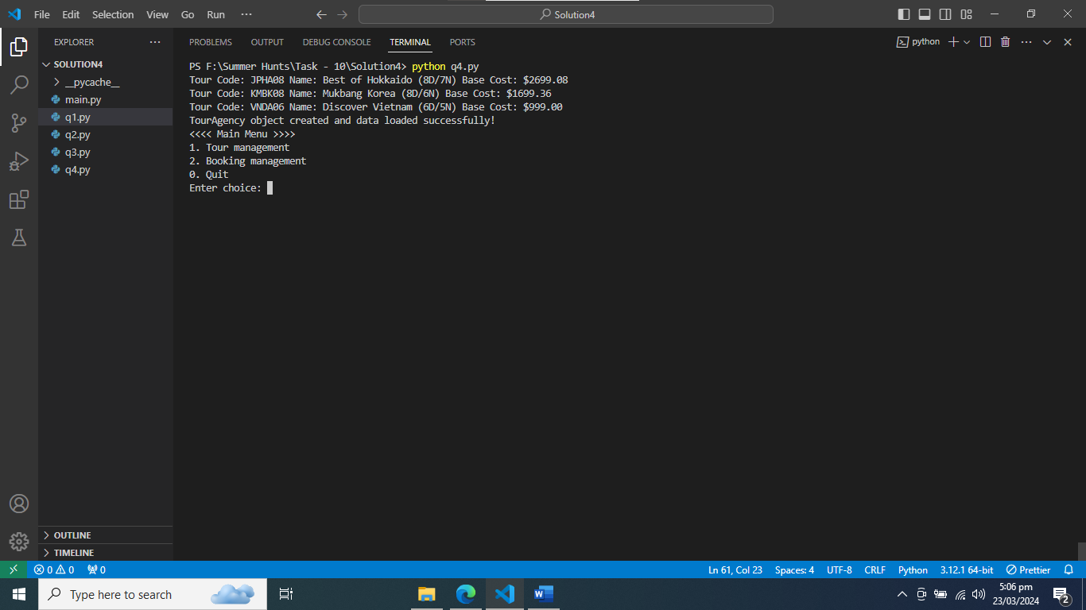

Figure : Tour Management

## Tour Menu Option 1: Schedule Tour

### Schedule Tour Option 1 at Schedule Tour

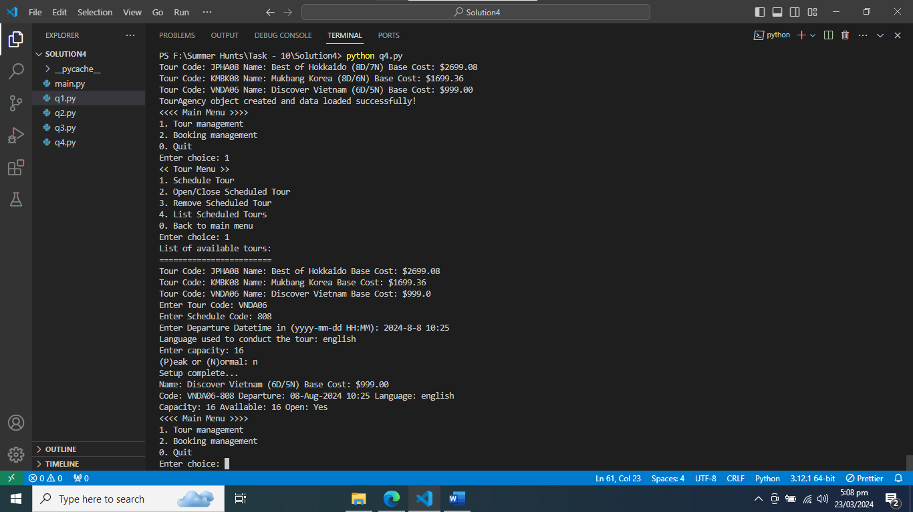

Figure : Schedule Tour Option 1 at Schedule Tour

### Open/Close Schedule Option 2 at Tour at Schedule Tour

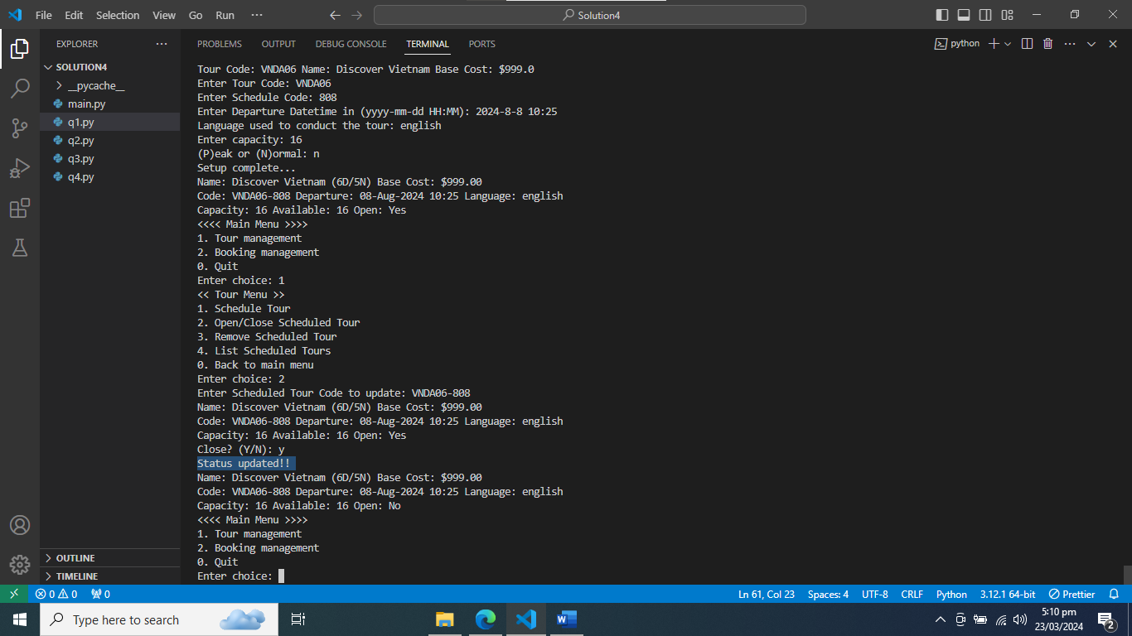

Figure : Open/Close Schedule Option 2 at Tour at Schedule Tour

### Remove Schedule Tour Option 3 at Schedule Tour

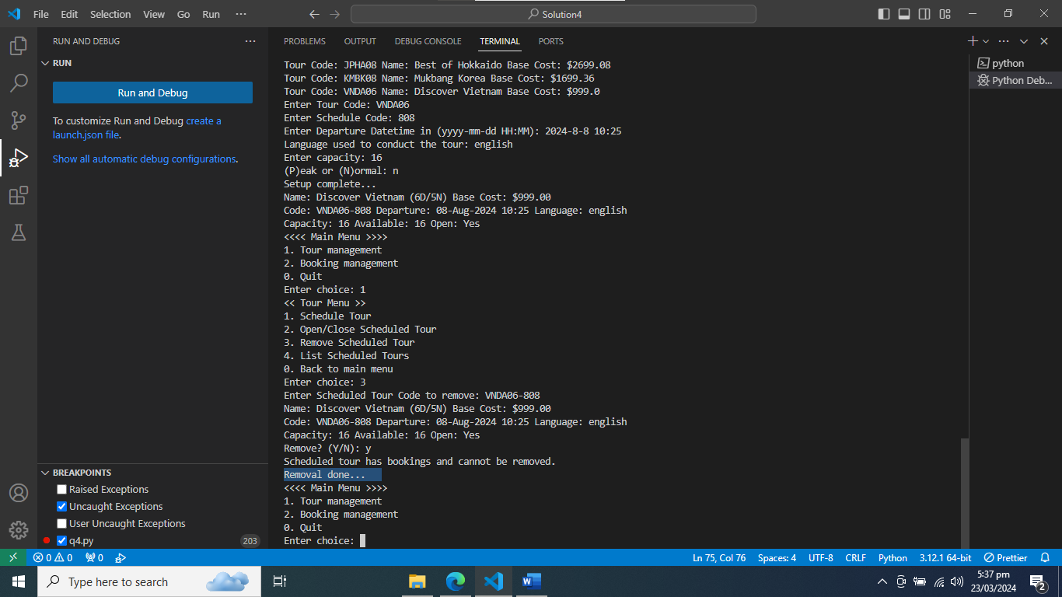

Figure : Removal Schedule Tour Option 3 at Schedule Tour

### List Scheduled Tours

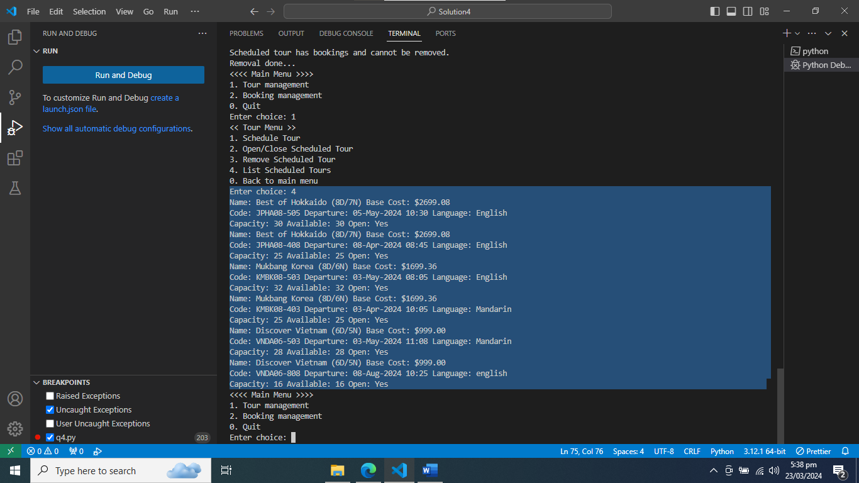

Figure : List Scheduled Tours Option 4 at Schedule Tour

## Booking management

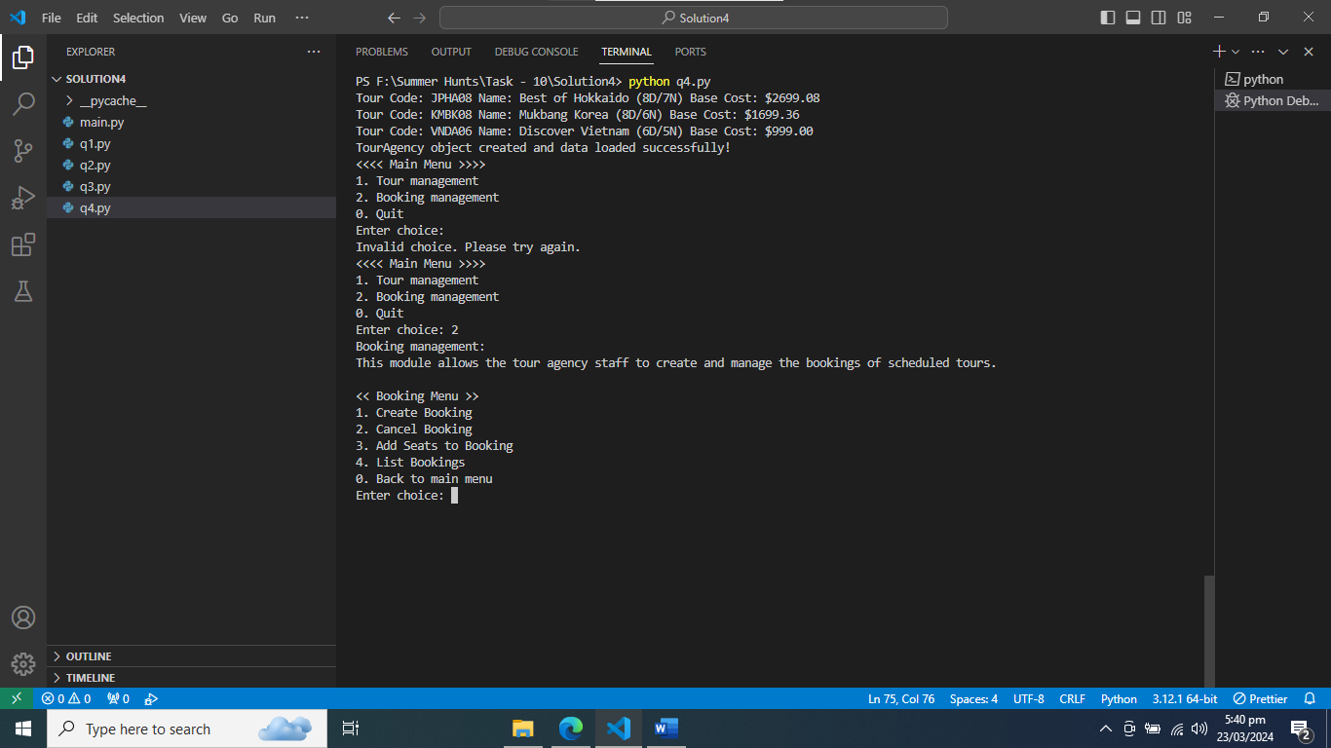

Figure : Booking Management

### Create Booking Option 1 at Booking Management

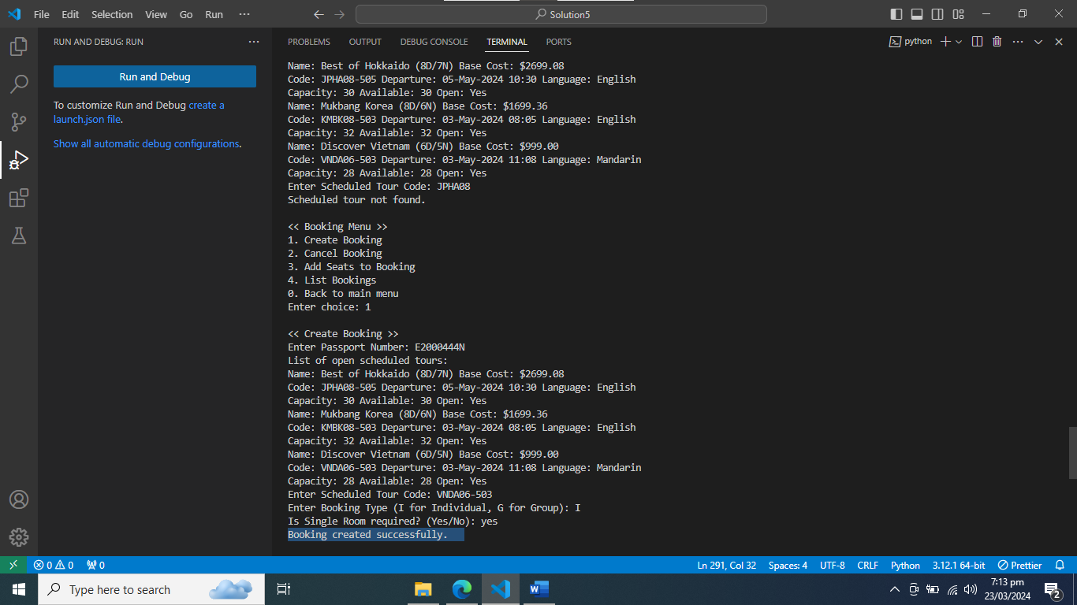

Figure : Create Booking Option 1 at Booking Management

### Cancel Booking Option 2 at Booking Management

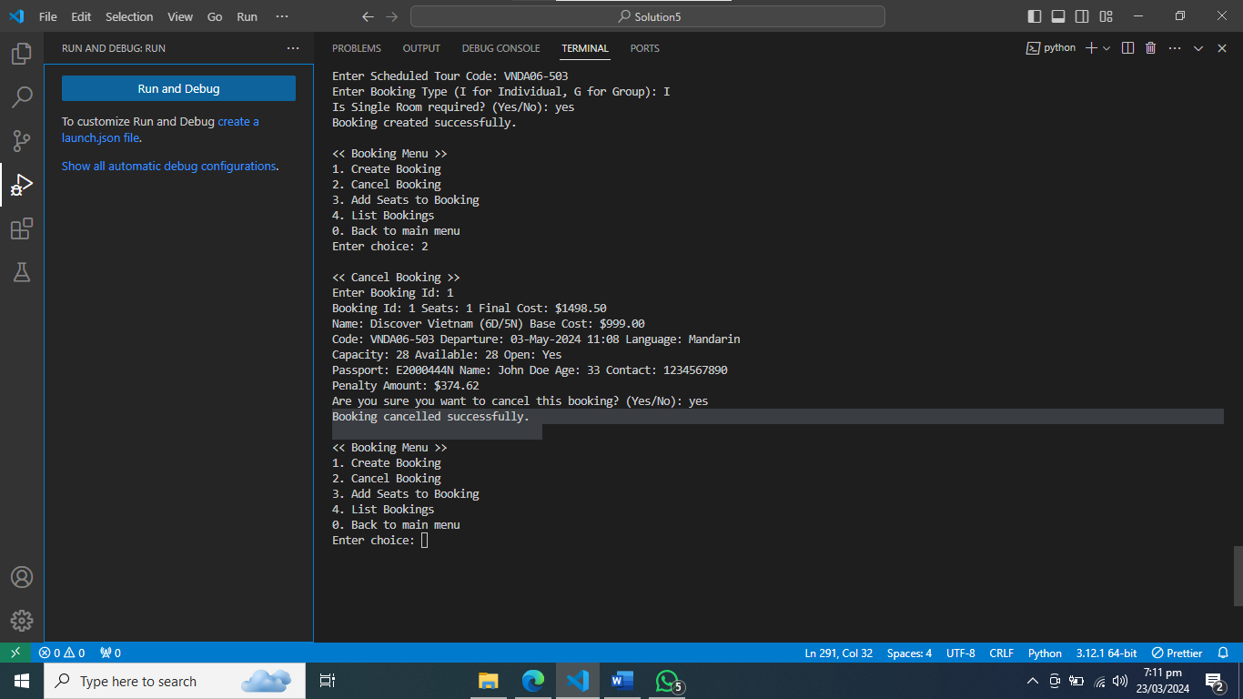

Figure : Cancel Booking Option 2 at Booking Management

### Add Seats to Booking

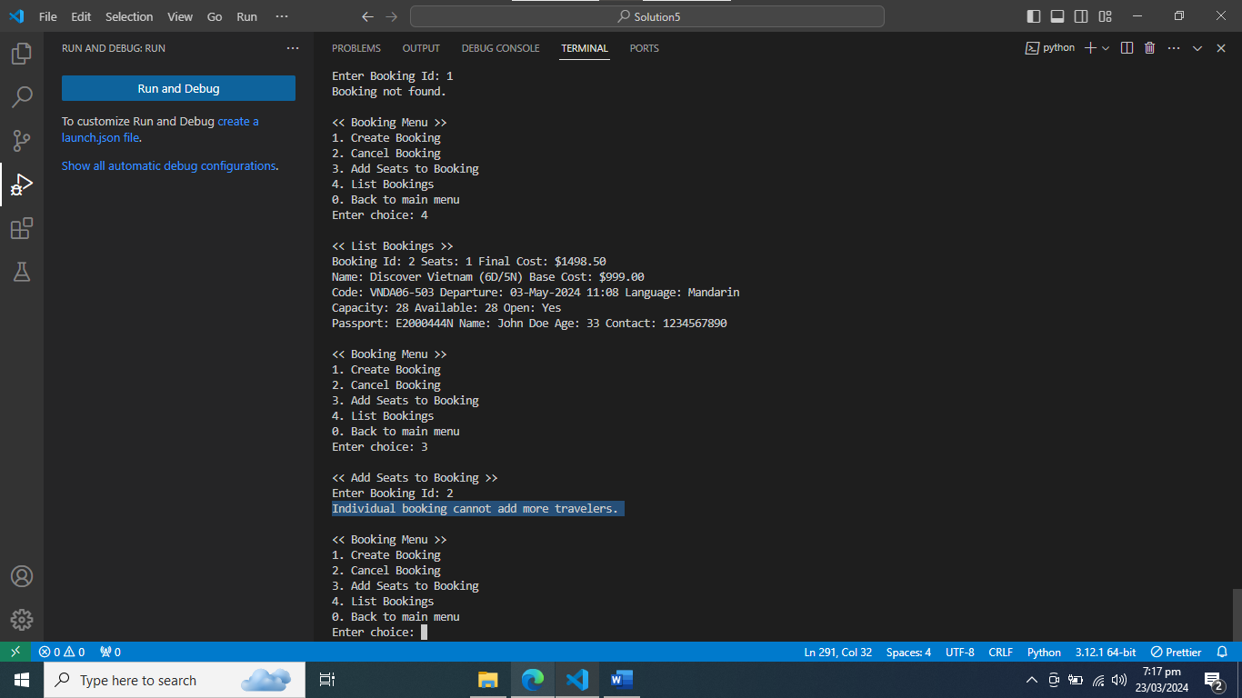

Figure : Add Seats to Booking Option 3 at Booking Management

### List Bookings Option 4 at Booking Management

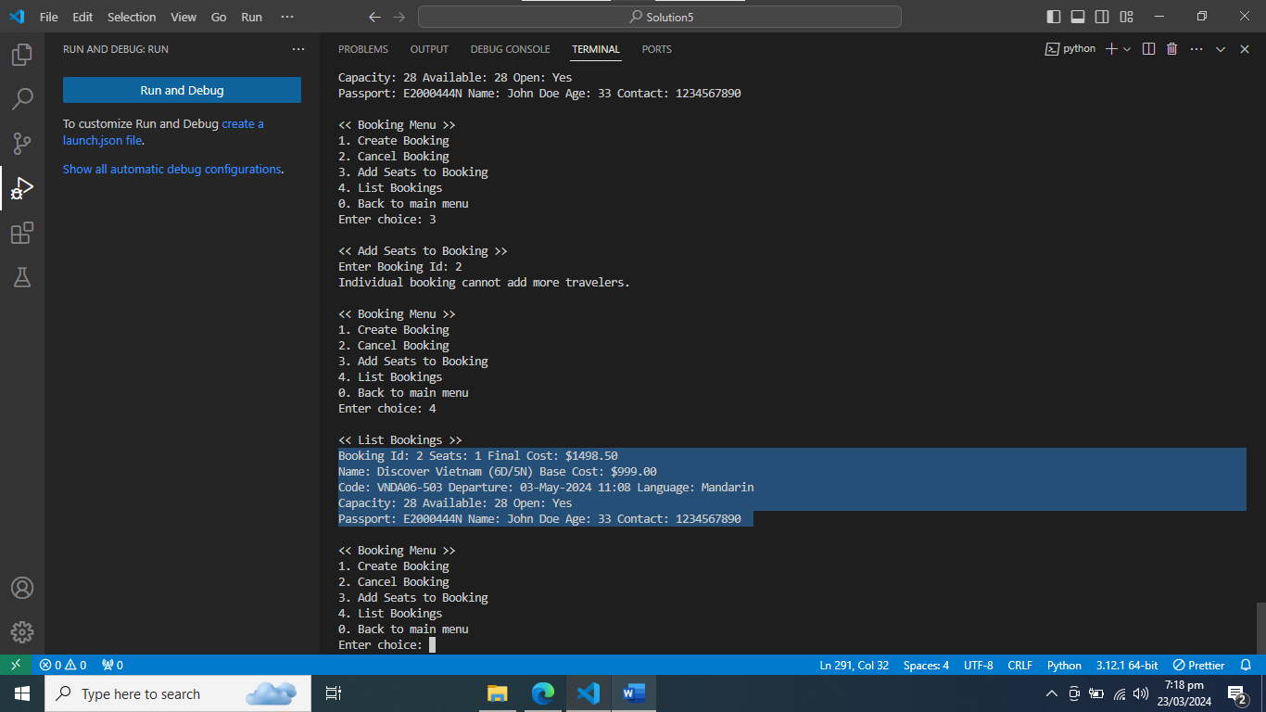

Figure : List Bookings Option 4 at Booking Management