Retrieving Facebook Data Using the Graph API

Introduction

Methodology

Insights

Insights in the Data Downloaded

Potential Use Cases Of Collected Data

Challenges

Conclusion

Retrieving YouTube Comments Using the YouTube Data API

Introduction

Methodology

Insights

Insights in the Data Downloaded

Potential Use Cases of Collected Data

Challenges

Conclusion

Scraping TikTok Comments Using Selenium

Introduction

Methodology

Insights

Insights in the Data Downloaded

Potential Use Cases of Collected Data

Challenges

Conclusion

# Retrieving Facebook Data Using the Graph API

## Introduction

This project entails gathering data from Facebook employing the Graph API and saving the data in a CSV file. The data is downloaded and can be further processed and analyzed or put to other uses depending on the user’s preference. The Graph API is the essential tool to choose when working with Facebook; it is the main API that enables the data exchange between the application and Facebook.

## Methodology

**First step:** The API Endpoint and the Parameters to be used must be set. Let’s determine how the API is going to be accessed and what input it is going to require from us. Endpoint is the combination of user ID and the fields, which we wish to get. Here we’re pulling out only the id field, strictly speaking, along with the name and email subfields.

**Step 2:** All that is left is for the user to make the API request to be able to bring up the form. With the help of requests library installed in Python we make ‘GET’ requests to the Graph API with defined parameters and fields. This is done to ascertain that the given request has gone through.

**Step 3:** write data to a csv file. In case of a successful request, the data is stored in a JSON file format For More details click Here Indeed, in the Google Colab environment, the file is saved in the /content directory by default.

**Step 4:** CSV file will automatically be downloaded after executing the code. There are some keys that you need to provide. Download the JSON File The final step will be to download the converted csv file into your system from where you can parse it easily.

## Insights

The main insights of this project that i observed are:

* Gets it clarified as to how the Facebook Graph API can be utilized.
* For the extraction and collection of a specific user’s data from another site, which is Facebook in this case.
* To store the extracted data into a JSON file.
* To allow the downloaded CSV file to be easily accessed when working in a Google Colab environment.

## Insights in the Data Downloaded

The data retrieved from Facebook and saved into the CSV file includes the following fields:

* Comment ID: This parameter is essentially the user’s serial number assigned to distinguish the user among all the others.
* Created Time and Date
* Name (From): The identifier of the user consisting of the name.
* Comment Text: The comments from the users on the page.

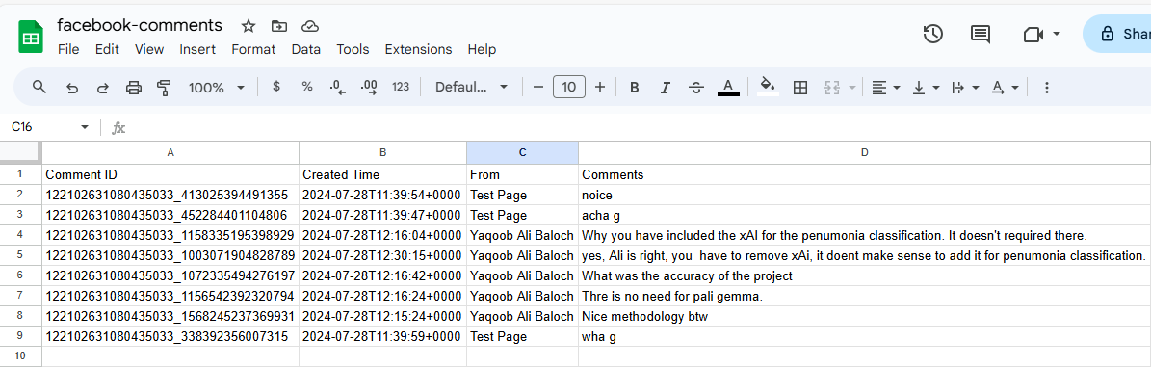

## Potential Use Cases Of Collected Data

* One major use of the data will be, we can use the data for the sentiment analysis of the post. We can get the analysis in seconds from the large language models.
* We can further refine the reviews and can use it for many purposes. We can make a dataset for natural language processing.

## Challenges

**API Access and Permissions**: Obtaining the necessary permissions and access tokens from Facebook was a complex process. This involved navigating Facebook’s app review process and ensuring that the correct permissions were granted for accessing specific user data.

**Data Privacy and Compliance**: Adhering to Facebook’s data privacy policies and regulations was a critical challenge. Ensuring that the data retrieval and handling processes comply with privacy laws and Facebook's terms of service required careful planning and adherence to best practices in data protection.

**Rate Limits**: The Facebook Graph API imposes rate limits on the number of requests that can be made. Managing these limits effectively to avoid disruptions in data retrieval and ensuring that the data collection process remains within acceptable usage thresholds was a significant challenge.

## Conclusion

In this project creating an application of the Facebook Graph API it shows how to fetch the data of a user and write that data into a CSV file in the environs of a Google Colab. It can also be expanded to get other fields and work with more complicated data types if required. The data that is stored can be used for analysis and reporting as well as feeding to other applications or systems.

# Retrieving YouTube Comments Using the YouTube Data API

## Introduction

This project centers on utilizing the YouTube Data API to extract comments of a particular YouTube video and then store the obtained data into a CSV file. It is from the interface of the YouTube Data API v3 that one can access and interact with various services of YouTube whereby one can for instance pull comments for some videos efficiently. With the help of this API users can receive comments for different aims like the sentiment analysis, rate of engagement or the content search.

## Methodology

**Step 1:** First of all, the required settings of the YouTube Data API are configured. This includes defining the service parameter, the API version, and the developer key that is used to allow for access to the API. The video ID of the target video is also determined in order to extract comments from a particular video only.

**Step 2:** As a second step, the googleapiclient. It also includes a discovery library, for which an instance of the YouTube API client is developed. This client helps in interfacing with the YouTube API.

**Step 3:** A call is made to the commentThreads id of the YouTube Data API to get up to 100 comments for the video in question. The part parameter is set to “snippet” to get such information associated with comment including, comment id, time of creation, user and the text of the comment.

**Step 4:** Detailed comment ID is obtained and pre-processing of the response of API request is done to extract the actual comment details. A CSV file they named it youtube_comments. It is for this reason that details such as the above are stored in csv. The columns written in the fields of CSV file are Comment ID, Created time, Author, and Comment texts. This information is written on to a new row of the file for each comment.

**Step 5:** Once the comments are saved, the computer prints a message to the effect that the entire exercise has been successfully completed.

## Insights

* The key insights from this project include:
* Knowing about the basic process by which the comments of the YouTube videos can be retrieved using YouTube Data API.
* Acquainting with APIs and scripting to manage them as well as writing the resulting data to a CSV file.
* Getting the understandings of the structure and contents of the YouTube comments for the later breakdown and analysis.

## Insights in the Data Downloaded

The CSV file youtube_comments. csv contains the following fields:

* **Comment ID:** The comment has a unique id/number so that the user can easily refer to it when making a comment on the tab.
* **Created Time:** It is the date and time when the comment was posted by the user on the news articles.
* **From:** The name that is shown in the comment’s input where the comment author typed his comment.
* **Comment:** Written text of the comment.

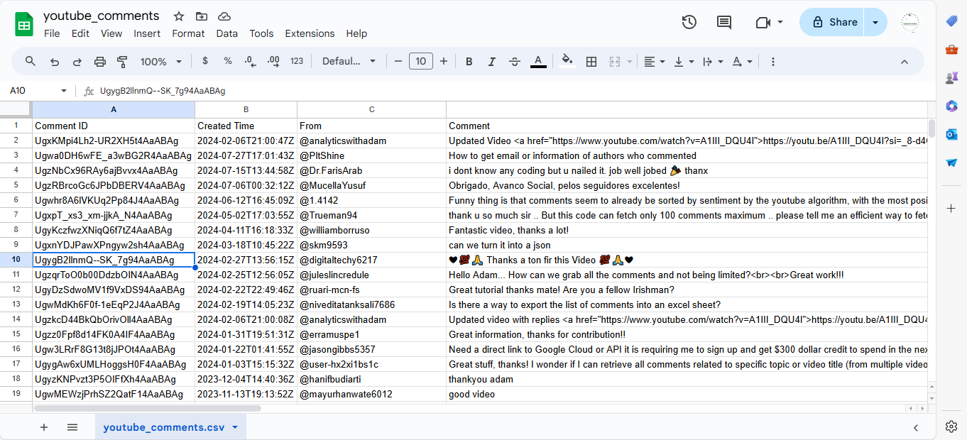

## Potential Use Cases of Collected Data

**Sentiment Analysis:** To understand the impressions about the video or even the content in the video from the general public.

**Content Analysis:** Determining the comments’ content focus in terms of categories of recurrence.

**Engagement Metrics:** Examining responses and interactions that the users give to the particular post or to the video in general.

## Challenges

**API Rate Limits:** One of the main issues the authors faced was the uniqueness and scope of the problems that can be solved by using the API within a specific time frame limited by the rate of requests in the YouTube Data API. These restrictions fetter the number of requests that can be made in a given time frame; consequently, the amount of comments that may be fetched is also limited. Amidst this, there is a need to plan to undertake the frequency of requests and manage the errors likely to arise concerning rate limiting.

**Pagination:** There were stumbling blocks while managing pagination because, depending on the comment’s service, an API may return a limited number of comments per page. When deciding to incorporate a way to paginate and to get all comments necessary, the decision was made to spend some time to think through how to do it without missing any comment and getting duplicates of some if needed.

**Data Consistency:** It was important to make sure that the comments actually correspond to the retrieved data and are accurate with the texts from other web-pages. The different formats of the data or changes that may occur in the API responses might have an impact on the quality of the gathered data hence the need for the program to validate this data and also look for ways of handling errors.

## Conclusion

This project explains how to fetch comments of a Youtube video Using the youtube data api and export the resultant data to a csv file. Thus, it can be used for the development of new hypotheses and research objectives, as well as providing the necessary materials for further analysis and discussion of the results obtained through the processing of YouTube comments data. We have demonstrated a detailed process to roll out the application of such an approach and as a result, any additional data collection or integration of the approach with other data analysis pipelines can be easily incorporated.

# Scraping TikTok Comments Using Selenium

## Introduction

This project will help in scraping comments from a given TikTok video through the use of Selenium with the undetected_chromedriver. The purpose is to isolate the comment’s username and a corresponding text and store it as a CSV file. Selenium is used for application automation of web browsers, which is perfect for dynamic content present in the social sites.

## Methodology

**Step 1:** The script first and foremost requires the required libraries such as undetected_chromedriver that helps to escape from the detection barriers, selenium for web automation activities, and pandas for data analysis. There are also CSS selectors for finding elements on the TikTok page used for the current selection.

**Step 2:** The scrape_commenters function is defined to perform the following tasks:Step 2: The scrape_commenters function is defined to perform the following tasks:

* **Initialize WebDriver:** A chrome instance is initialized with undetected_chromedriver Please refer to the image below for the chrome path After running the cell image below(~)
* **Navigate to Post**: It starts the specified TikTok video link in a script.
* Wait for Page Elements: With the help of WebDriverWait the script waits for the loading of the comments container.
* **Scroll and Load Comments:** The script scrolls down the page to load the further comments until display of new comments is ended or an error message is received.

**Step 3:** On the comments loading, the script identifies the all comment container on the page. From each of these containers it extracts the username and the comment text. The data is stored in a list of dictionaries. The quality of the written text is developed, increasing students’ critical thinking and other cognitive skills.

**Step 4:** collected comment data is transferred to a pandas DataFrame called Tiktok_comment on the application and also stored as a CSV file named tiktok_comments. csv.

**Step 5:** Lastly the browser instance for the bot runtime is closed once the data from the website is collected by the bot and saved in a database.

## Insights

The main insights from this project are:

* Demonstrates how to use Selenium for web scraping of dynamic content on TikTok.
* Illustrates how to handle common issues such as waiting for elements to load and handling exceptions.
* Provides a method for extracting and saving data into a structured format for further analysis.

## Insights in the Data Downloaded

The CSV file tiktok_comments.csv contains the following fields:

* **commenter_name**: The username of the person who commented.
* **comment_text**: The text content of the comment.

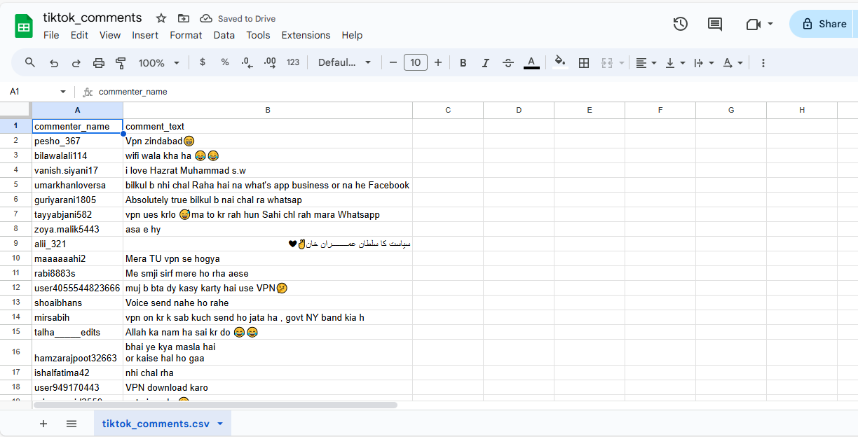

## Potential Use Cases of Collected Data

**Sentiment Analysis**: Analyzing the sentiment of TikTok comments to understand viewer reactions.

**Content Analysis**: Identifying trends or common topics in comments.

**Engagement Metrics**: Assessing user engagement with the video based on comment frequency and content.

## Challenges

**Dynamic Content**: TikTok's dynamic loading of comments posed a challenge as it required continuous interaction with the page, such as scrolling, to load more comments. Managing these interactions and ensuring that all comments are loaded before extraction required a well-structured approach to handle the dynamic nature of the content.

**Element Detection**: Detecting and interacting with the correct elements on the page was challenging due to potential changes in the website's structure or CSS selectors. This required frequent updates to the selectors used for locating comment elements to ensure accurate data extraction.

**Rate Limiting and Detection**: TikTok's mechanisms to detect and restrict automated scraping activities presented another challenge. Overcoming these detection mechanisms while adhering to ethical guidelines required careful management of request rates and implementation of strategies to mimic human behavior.

## Conclusion

This project successfully demonstrates how to scrape comments from a TikTok video using Selenium. It provides a practical approach to extracting and saving social media data for various analytical purposes. The script can be adapted for other social media platforms or additional data fields as needed.