# Lab Manual 10

## **Implementation of DNS, Http Server**

Using packet tracer :

1- We connect the figure .

2- We put the IP address for each device as the following :

We have in the figure 5 networks :

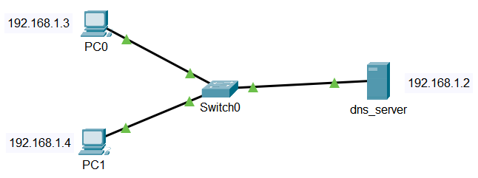

**Configure DNS service on the generic server.**

To do this, click on the server, then Click on**Services**tab. Click on **DNS server** from the menu. First  turn **ON** the DNS service, then define **names** of the hosts and their corresponding **IP addresses.**

For example, to specify the DNS entry for PC0: In the**name**and **address**fields, type:

**Name:** PC0     **Address:**192.168.1.3

Click on **add**then **save**.

Once you’re done, your DNS entries will look like this:

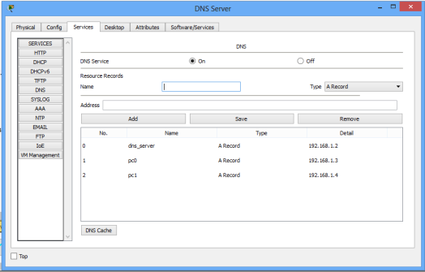

**Configuration of Http Server:**

We have to open services and click on HTTP service. This service is enabled by default and we can see that server is hosting some files already. These files are present by default and when we point the web browser to this server, this server will serve the web page to our browser.

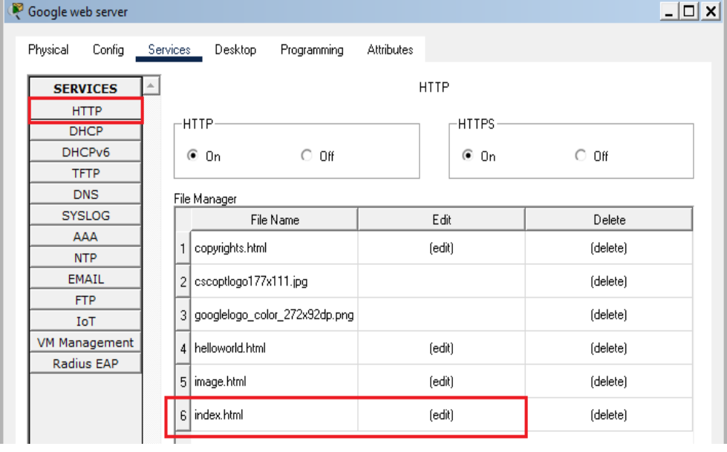

To change the content of the webpage, we have to edit the index file present in the web server.

For testing purposes, we can copy the source code of any side that you want the webserver to show and paste it into the index file. After saving the file, the web server will show sites according to the source code.

Now, we can test the web server by opening the browser on the PC and pointing it to the server.

