# Lab Manual 12

**CLO2**

## **Understanding packet sniffers/protocol analyzers (Using Wireshark)**

Understanding HTTP working with Wireshark

In this lab, we will explore several aspects of the HTTP protocol: the basic GET/response interaction, HTTP message formats, retrieving large HTML files, retrieving HTML files with embedded objects, and HTTP authentication and security. Before beginning these labs.1

###### The Basic HTTP GET/response interaction

Let us begin our exploration of HTTP by downloading a very simple HTML file - one that is very short and contains no embedded objects. Do the following:

* 1. Start up your web browser.
  2. Start up the Wireshark packet sniffer (but don’t yet begin packet capture). Enter “http” (just the letters, not the quotation marks) in the display-filter-specification window, so that only captured HTTP messages will be displayed later in the packet-listing window. (We are only interested in the HTTP protocol here, and do not want to see the clutter of all captured packets).
  3. Wait a bit more than one minute (we will see why shortly), and then begin Wireshark packet capture.
  4. Enter the following to your browser [http://gaia.cs.umass.edu/wireshark-labs/HTTP-wireshark- file1.html](http://gaia.cs.umass.edu/wireshark-labs/HTTP-wireshark-file1.html)

Your browser should display the very simple, one-line HTML file.

* 1. Stop Wireshark packet capture.

Your Wireshark window should look similar to the window shown in Figure 1. If you are unable to run Wireshark on a live network connection, you can download a packet trace that was created when the steps above were followed.2

1 References to figures and sections are for the 6th edition of our text, *Computer Networks, A Top-down Approach, 6th ed., J.F. Kurose and K.W. Ross, Addison-Wesley/Pearson, 2012.*

2 Download the zip file [http://gaia.cs.umass.edu/wireshark-labs/wireshark-traces.zip](http://gaia.cs.umass.edu/ethereal-labs/ethereal-traces.zip) and extract the file http- ethereal-trace-1. The traces in this zip file were collected by Wireshark running on one of the author’s computers, while performing the steps indicated in the Wireshark lab. Once you have downloaded the trace, you can load it into Wireshark and view the trace using the *File* pull down menu, choosing *Open*, and then selecting the http-ethereal- trace-1 trace file. The resulting display should look similar to Figure 1. (The Wireshark user interface displays just a bit differently on different operating systems, and in different versions of Wireshark).

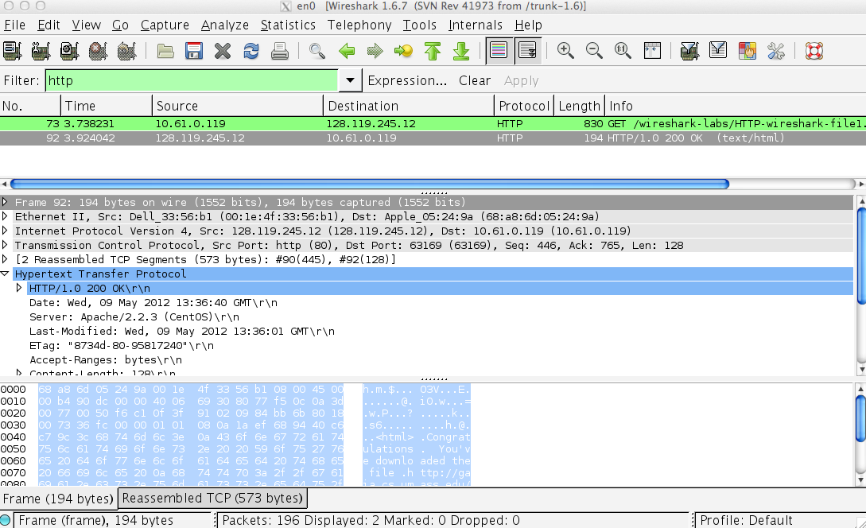

**Figure 1:** Wireshark Display after <http://gaia.cs.umass.edu/wireshark-labs/>HTTP-wireshark-file1.html has been retrieved by your browser

The example in Figure 1 shows in the packet-listing window that two HTTP messages were captured: the GET message (from your browser to the gaia.cs.umass.edu web server) and the response message from the server to your browser. The packet-contents window shows details of the selected message (in this case the HTTP OK message, which is highlighted in the packet-listing window). Since the HTTP message was carried inside a TCP segment, which was carried inside an IP datagram, which was carried within an Ethernet frame, Wireshark displays the Frame, Ethernet, IP, and TCP packet information as well. We want to minimize the amount of non-HTTP data displayed (we’re interested in HTTP here, and will be investigating these other protocols is later labs), so make sure the boxes at the far left of the Frame, Ethernet, IP and TCP information have a plus sign or a right-pointing triangle (which means there is hidden, undisplayed information), and the HTTP line has a minus sign or a down-pointing triangle (which means that all information about the HTTP message is displayed).

(*Note:* You should ignore any HTTP GET and response for favicon.ico. If you see a reference to this file, it is your browser automatically asking the server if it (the server) has a small icon file that should be displayed next to the displayed URL in your browser. We will ignore references to this pesky file in this lab.).

By looking at the information in the HTTP GET and response messages, answer the following questions. When answering the following questions, you should print out the GET and response messages (see the online introductory Wireshark lab for an explanation of how to do this) and indicate where in the message you’ve found the information that answers the following questions.

1. Is your browser running HTTP version 1.0 or 1.1? What version of HTTP is the server running?
2. What languages (if any) does your browser indicate that it can accept to the server?
3. What is the IP address of your computer? Of the gaia.cs.umass.edu server?
4. What is the status code returned from the server to your browser?
5. When was the HTML file that you are retrieving last modified at the server?
6. How many bytes of content are being returned to your browser?
7. By inspecting the raw data in the packet content window, do you see any headers within the data that are not displayed in the packet-listing window? If so, name one.

In your answer to question 5 above, you might have been surprised to find that the document you just retrieved was last modified within a minute before you downloaded the document. That’s because (for this particular file), the gaia.cs.umass.edu server is setting the file’s last-modified time to be the current time and is doing so once per minute. Thus, if you wait a minute between accesses, the file will appear to have been recently modified, and hence your browser will download a “new” copy of the document.

Reference: http://gaia.cs.umass.edu/wireshark-labs/