## Lab # 4

## Objective:

1. Knowledge of Cisco Packet Tracer commands for routing etc
2. In-depth understanding of the OSI model

## Reading Material:

1. <https://www.netwrix.com/cisco_commands_cheat_sheet.html>

## Lab Task:

* Understand and implement the commands of routing and configuration on the Cisco packet tracer, take screenshots of minimum 20 commands, and paste the output into a Word file.

The commands must include the following commands:

1. **Ping**: Imagine "ping" as a way to check if a friend is there by sending a quick message. In networking, it's like saying, "Hey, are you online?" You use it to see if another device on the network is reachable. If it replies, it's online; if not, it might be offline or have a problem.

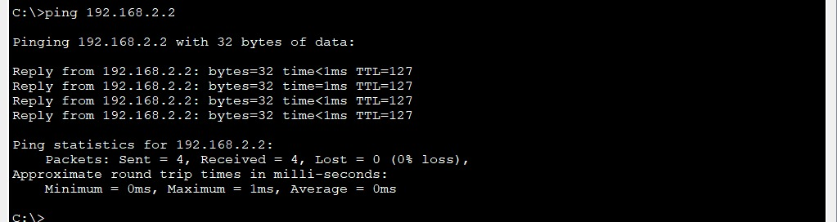

(After connecting the PCs with a router and assigning them an IP address, Go to the command line interface of the PC and ping the other PC by giving its IP along with ping command.)

1. **Enable**: Enabling is like unlocking a secret door. It gets you into a special area on a network device where you can make important changes. Think of it as getting permission to access advanced settings.

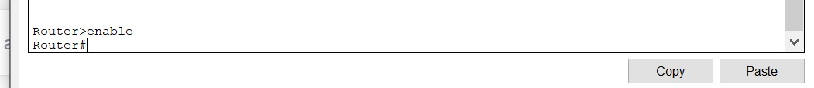

(Write this command in the command line interface of router to enter the privileged exec mode)

1. **Configure Terminal**: Think of "configure terminal" as entering the control room. It's where you can change how the device works. Like adjusting settings on a TV, but for network devices.
2. **Hostname**: Imagine your computer as a person, and the hostname is their name tag. It's the device's name on the network, making it easy to identify among other devices.
3. **Shutdown**: Think of "shutdown" as turning off a light switch. It stops a network interface (like a door) from working. Data can't go through when it's off.
4. **Show VLAN**: "Show VLAN" is like opening a box to see what's inside. It displays the virtual networks (VLANs) configured on a switch, so you know how things are organized.
5. **Exit**: When you're done in a room, you leave, right? "Exit" is like that. It takes you out of the current mode or place you're working in, so you can go back to the main menu.
6. **Write Memory**: Think of "write memory" as saving a video game. After making changes to a device, you use this command to save those changes, so they stick even if the device restarts. It's like saving your work in a document.

Read the technical description of the commands from blogs for a deep understanding as a quiz will be conducted about these in the lab.

## Submission:

A Word file with all the commands and a screenshot of their output along with 2-3 lines description. Plagiarism will result in negative marking. The file name should be according to the following format:

“2021-CS-000-Name-SectionX-Lab4”. Submit the file on Google Classroom.

## Home Task:

Read the blogs about the OSI model. Describe its layers and their working in your own words. Write the responsibility of each layer. Also, compare the OSI model and TCP/IP. Submit a Word file of the format : “2021-CS-000-Name-Section X-Home4”.