**SOLID principles**

SOLID is an acronym representing five design principles intended to make software designs more understandable, flexible, and maintainable.These principles establish practices that lend to developing software with considerations for maintaining and extending as the project grows. Adopting these practices can also contribute to avoiding code smells, refactoring code, and Agile or Adaptive software development.

**Single Responsibility Principle (SRP):**

**Introduction:**

The Single Responsibility Principle (SRP) is a fundamental principle in object-oriented programming (OOP) that emphasizes creating well-structured, maintainable, and understandable code. It states that:

A class should have one, and only one, reason to change.

In essence, SRP suggests that each class should focus on a single, well-defined set of functionalities. This helps to:

Improve code organization: Classes become more cohesive, with responsibilities aligned and focused.

Enhance maintainability: Changes to a class are less likely to have unintended consequences in other parts of the codebase.

Promote reusability: Classes with a single responsibility can be more easily reused in different contexts.

Increase testability: Smaller, focused classes are easier to test in isolation.

**What it means:** A class should have one, and only one, reason to change. This principle encourages focused classes that handle a specific set of functionalities.

**Definition:** A class should have only one reason to change, meaning it should have only one responsibility.

**Diagram:**

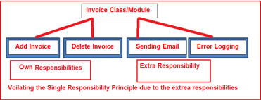

**Technical Example:**

EX 1: Having a class that handles both user authentication and data validation violates SRP. It's better to have separate classes for each responsibility.

EX 2: Imagine a Customer class that handles the following tasks:

Storing customer data (name, address, email)

Generating reports on customer purchases

Sending email notifications to customers

While this approach might seem convenient at first glance, it violates SRP for the following reasons:

Multiple reasons to change: If the format of customer data changes, the report generation logic needs to be updated as well (not directly related).

Loose cohesion: The functionalities are not tightly bound. Sending emails is a separate concern from managing customer data.

Following SRP, you could break down the Customer class into separate, more focused classes:

CustomerManager: Responsible for storing and managing customer data.

ReportGenerator: Responsible for generating customer purchase reports.

EmailNotifier: Responsible for sending email notifications to customers.

This separation results in more modular, maintainable, and easier-to-test code.

**Layman Example:**

EX 1:Imagine a chef who not only cooks but also cleans the restaurant. It's better to have separate chefs for cooking and cleaning to maintain efficiency.

EX 2:Think of a multi-tool that combines a knife, screwdriver, and bottle opener. While it offers multiple functionalities, it's not ideal for maintenance or specific tasks:

Sharpening the knife becomes more complex with the other tools attached.

Using a dedicated screwdriver provides better control and torque.

A dedicated bottle opener is more ergonomic and efficient.

Separate tools for each task are easier to maintain, use, and specialize.

**Benefits:** Easier to understand, test, maintain, extend and modify code. More cohesive classes lead to less code duplication and error-prone changes.

Improved Code Quality: SRP promotes well-structured, maintainable, and readable code.

Enhanced Reusability: Smaller, focused classes are easier to reuse in different contexts.

Increased Testability: SRP leads to smaller classes that are easier to test in isolation.

Reduced Complexity: Simplifies code structure and reduces the likelihood of unintended side effects.

**Breach Situation:** A class that performs multiple unrelated tasks (e.g., a Customer class handling data, reports, and emails).

A class violates SRP if it handles multiple, unrelated functionalities. For example, a Product class that manages product data, calculates discounts, and generates shipping labels. Changes to any of these aspects would lead to potential changes in the entire class, making it difficult to maintain and test.

**Open/Closed Principle (OCP):**

**Introduction:**

The Open-Closed Principle (OCP) is another foundational principle in object-oriented design (OOP) that emphasizes code flexibility and maintainability. It states:

Software entities (classes, modules, functions) should be open for extension, but closed for modification.

In simpler terms, OCP advocates for designing code that can be easily extended with new functionalities without altering the existing codebase. This promotes:

Flexibility: You can add new features without modifying existing classes.

Maintainability: Changes are localized, reducing the risk of unintended consequences elsewhere.

Reusability: Well-designed code that adheres to OCP can be reused in various contexts.

**What it means:** Software entities (classes, modules) should be open for extension, but closed for modification. This allows adding new functionalities without altering existing code.

**Definition:** Software entities (classes, modules, functions, etc.) should be open for extension but closed for modification.

**Diagram:**

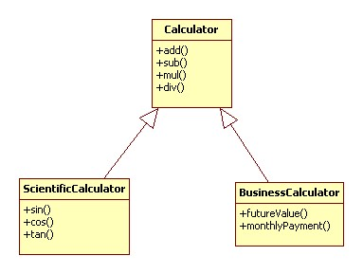

**Technical Example:**

EX 1:Using inheritance or interfaces to add new functionality without modifying existing code.

EX 2:Imagine a Shape class that calculates the area of shapes like squares and circles. The Shape class has a method calculateArea(), which implements the specific area calculation logic for each shape type.

This approach violates OCP if you want to add a new shape type, say a triangle. You'd need to modify the Shape class to include a new calculation for triangles.

Following OCP:

Create an abstract base class Shape with a method abstract double calculateArea().

Define subclasses like Square, Circle, and Triangle that inherit from Shape and implement their specific area calculation logic in the calculateArea() method override.

This approach allows adding new shapes (like triangles) without modifying the existing Shape class.

**Layman Example:**

EX 1:Adding new toppings to a pizza without changing the recipe or altering the existing ingredients.

EX 2:Think of a house. Following a traditional, closed approach, adding a new room (extension) would require modifying the existing house structure.

OCP is like building a modular house. You can easily add an extension (new room) or sunroom without needing to modify the existing structure. Walls, foundations, and the overall design remain the same, but the functionality (number of rooms) is extended.

**Benefits:** Easier to extend functionality without breaking existing code. Promotes loose coupling and flexibility.Reduces the risk of introducing bugs when extending functionality.

Enhanced Flexibility: OCP allows for easy extension of functionalities without modifying existing code.

Improved Maintainability: Changes are localized, reducing the risk of introducing bugs or regressions.

Increased Reusability: Well-designed and extendable code can be reused in various scenarios.

Promotes Loose Coupling: OCP encourages using interfaces and abstractions, leading to less tightly coupled code.

**Breach Situation:** A class violates OCP if adding new functionalities requires modifying the existing code itself. This often leads to tight coupling and makes the code difficult to maintain and extend over time. For example, a PaymentProcessor class that has specific methods for handling credit cards and debit cards. To add support for PayPal payments, you'd likely need to modify the PaymentProcessor class directly, breaking the OCP.

**Liskov Substitution Principle (LSP):**

**Introduction:**

The Liskov Substitution Principle (LSP) is another cornerstone principle in object-oriented programming (OOP) that ensures consistent behavior within object hierarchies. It states:

Objects of a superclass should be replaceable with objects of its subclasses without altering the program's correctness.

In simpler terms, if you have a superclass and its subclasses, any code that works with the superclass should also work seamlessly with the subclasses, as long as the subclasses adhere to the expected behavior defined by the superclass. This principle promotes:

Predictability: You can expect consistent behavior within a class hierarchy.

Reusability: Code written for the superclass can be reused with subclasses.

Robustness: Code that relies on the superclass contract remains functional with subclasses.

**What it means:** Objects of a superclass should be replaceable with objects of its subclasses without altering the program's correctness. Subclasses should be consistent with the behavior expected from the superclass.

**Definition:** Objects of a superclass should be replaceable with objects of its subclasses without affecting the correctness of the program.

**Diagram:**

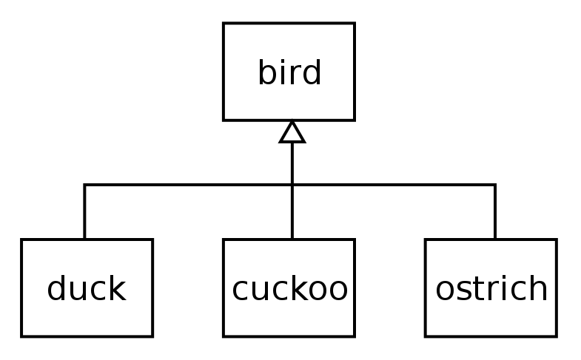

**Technical Example:**

EX 1: If you have a superclass Animal with a method makeSound(), any subclass like Dog or Cat should also implement makeSound() without changing its behavior.

EX 2: Imagine a Shape class with a method getArea(). Subclasses like Square and Circle inherit from Shape and implement their specific area calculations in getArea(). This adheres to LSP because the subclasses provide the functionality expected by the superclass (getArea()).

However, let's say you introduce a Rectangle subclass that inherits from Shape. If Rectangle.getArea() doesn't correctly calculate the area based on its width and height (e.g., always returns 0), it violates LSP. Code expecting a Shape to provide a valid area calculation would break when using a Rectangle object.

**Layman Example:**

EX 1:If a parent can read, all its children should also be able to read.

EX 2:Square meals should fit into round plates (subclass of plates) designed for holding food. However, a triangular object wouldn't necessarily fit (violation of LSP).

Think of a set of plates (superclass). You expect all plates (subclasses), like dinner plates or bowls, to hold food. LSP is like using any plate to serve food, regardless of its specific shape (round, square) as long as it fulfills the basic function of holding food. However, a colander (subclass) with holes wouldn't follow LSP as it wouldn't hold food effectively.

**Benefits:** Predictable behavior and easier testing. Ensures subclasses adhere to the contract established by their superclass.Ensures consistency and interoperability in polymorphic code.

Improved Code Reliability: LSP ensures that subclasses don't introduce unexpected behavior that breaks existing code.

Enhanced Maintainability: Code written using superclasses can be easily extended using subclasses without worrying about breaking functionality.

Promotes Reusability: Code designed around the superclass contract can be reused with subclasses that adhere to LSP.

**Breach Situation:** A class violates LSP when its behavior deviates from what's expected from the superclass. This can happen if:

A subclass throws new exceptions not declared by the superclass.

A subclass weakens the preconditions or postconditions established by the superclass.

A subclass introduces methods irrelevant to the superclass functionality.

By following LSP, you create a more predictable and reliable object hierarchy that promotes reusability and code maintainability.

**Interface Segregation Principle (ISP):**

**Introduction:**

The Interface Segregation Principle (ISP) is another important principle in object-oriented design (OOP) that focuses on creating smaller, more specific interfaces. It states:

Clients (code that uses an interface) shouldn't be forced to depend on methods they don't use.

In essence, ISP emphasizes breaking down large, general interfaces into smaller, more targeted ones that cater to specific functionalities. This promotes:

Improved Code Modularity: Smaller interfaces lead to more modular and focused code components.

Reduced Coupling: Clients only depend on the specific functionality they need.

Enhanced Flexibility: Easier to add new functionalities without affecting existing clients.

Increased Maintainability: Smaller interfaces are easier to understand and modify.

**What it means:** Clients (code that uses an interface) shouldn't be forced to depend on methods they don't use. Favor many, smaller, specific interfaces over one large, general interface.

**Definition:** Clients should not be forced to depend on interfaces they do not use.

**Diagram:**

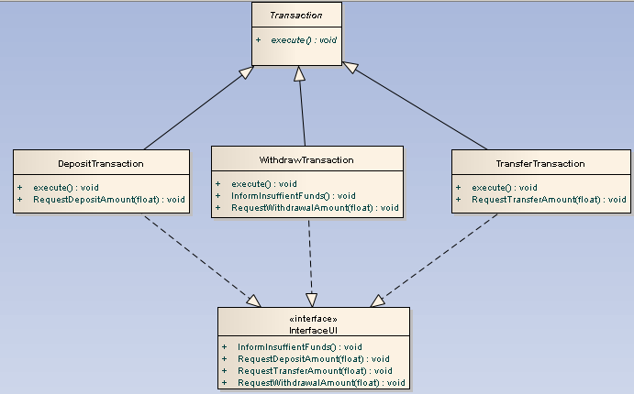

**Technical Example:**

EX 1:Breaking down large interfaces into smaller, more specific ones so that clients only need to implement the methods they use.

EX 2:Imagine a PaymentProcessor interface that has methods for handling credit cards, debit cards, and cash payments. If you only need credit card processing, you're forced to implement unused methods for debit cards and cash in your CreditCardProcessor class.

Following ISP:

Create separate interfaces: CreditCardProcessor, DebitCardProcessor, and CashPaymentProcessor with specific methods for each payment type.

Clients (e.g., OrderManager) can now depend on the interface that matches their needs (CreditCardProcessor).

**Layman Example:**

EX 1:Imagine a smartphone with various features, but you only use calling and texting. It's unnecessary for you to have access to features like NFC or GPS.

EX 2:Think of a remote control. Following a large interface approach, it might have buttons for a TV, DVD player, stereo, and VCR (even if you don't own all these devices). This makes the remote cluttered and forces you to interact with buttons you don't need.

ISP is like having separate remotes for each device. You only interact with the controls relevant to the device you're using.

**Benefits:** Improves code modularity and reduces coupling between classes. Clients only depend on the functionality they need.Reduces coupling and the risk of implementing unnecessary methods.

Improved Code Quality: Smaller, more focused interfaces lead to clearer and more maintainable code.

Enhanced Flexibility: Easier to add new functionalities without affecting existing clients that might not need them.

Reduced Coupling: Clients only depend on the specific functionality they use, promoting loose coupling.

Simpler Testing: Smaller interfaces are easier to test in isolation.

**Breach Situation:** A class violates ISP if it inherits or implements a large interface with methods it doesn't use. This leads to:

Unnecessary Code Complexity: Classes become bloated with unused methods.

Tight Coupling: Clients are forced to depend on functionalities they don't need.

Difficulty in Adding New Functionality: Modifications to the large interface can affect existing clients.

By adhering to ISP, you create more modular, flexible, and maintainable code that promotes loose coupling and easier testing.

**Dependency Inversion Principle (DIP):**

**Introduction:**

What it means: High-level modules (classes, packages) should not depend on low-level modules. Both should depend on abstractions (interfaces). Abstractions should not depend on details; details should depend on abstractions. This promotes loose coupling and easier testing.The Dependency Inversion Principle (DIP) is a cornerstone principle in object-oriented design (OOP) that promotes loosely coupled and maintainable code. It advocates for a design approach where:

High-level modules (classes, packages) should not depend on low-level modules. Both should depend on abstractions (interfaces). Abstractions should not depend on details (concrete implementations); details should depend on abstractions.

**Definition:** High-level modules should not depend on low-level modules. Both should depend on abstractions.

**Diagram:**

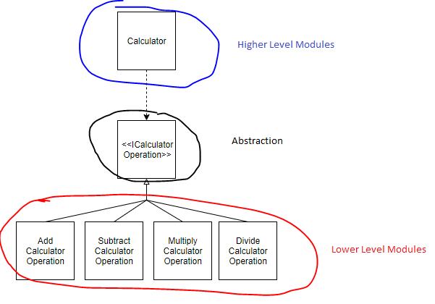

**Technical Example:**

EX 1:Using dependency injection to decouple classes, allowing for easier testing and swapping of dependencies.

EX 2:Consider a DatabaseManager class responsible for interacting with a database. Traditionally, it might directly use a MySQLDatabase class to connect, execute queries, and close connections. This creates tight coupling:

DatabaseManager is dependent on MySQLDatabase. Changing the database system would require modifying DatabaseManager.

Testing DatabaseManager becomes difficult as it directly interacts with the specific implementation.

Following DIP:

Introduce an interface: Define an interface Database with methods like connect(), execute(String query), and close(). This defines the abstraction for database interactions.

Concrete Implementations: Create classes like MySQLDatabase and OracleDatabase that implement the Database interface. These classes handle specific database interactions.

Dependency Injection: Modify DatabaseManager to accept a Database object as a constructor argument. This injects the dependency through the abstraction, allowing it to work with any database implementing the interface.

Now, DatabaseManager doesn't care about the specific database type. It relies on the Database interface to perform its task. This makes the code more flexible and easier to test.

**Layman Example:**

EX 1:When building a LEGO structure, you shouldn't glue the pieces together directly. Instead, use connectors so you can easily swap out pieces.

EX 2:Imagine a light switch and a light bulb. Traditionally, they might be wired directly together. This creates tight coupling:

Changing the bulb type requires rewiring the switch.

Testing the switch involves having a specific bulb connected.

Following DIP is like using a standard light socket (interface). Now, any bulb type with the matching socket can be used (concrete implementation).

The switch doesn't care about the specific bulb type, it just activates the socket.

**Benefits:**

Loose Coupling: By relying on abstractions (interfaces), high-level modules are not tightly coupled to specific low-level implementations. This makes the code more flexible and easier to maintain. You can change the underlying implementation without affecting the high-level logic.

Improved Testability: High-level modules can be easily tested in isolation by mocking or stubbing the abstractions. You don't need to rely on the actual low-level implementations during testing.

Open/Closed Principle Compliance: DIP promotes adherence to the Open/Closed Principle (OCP). You can introduce new low-level implementations (e.g., different database drivers) without modifying the high-level modules as long as they comply with the abstraction.

**Breach Situation:**

Imagine a legacy codebase where an OrderProcessor class handles processing customer orders. Traditionally, it might directly interact with a PaymentGateway class to process payments.