**IS Chapter 6**

**Technical controls:** refer to security measures implemented within an information technology (IT) system or infrastructure to manage and mitigate risks related to the confidentiality, integrity, and availability of data and resources. These controls are typically automated or implemented through technology and aim to enforce security policies, prevent unauthorized access, detect and respond to security incidents, and ensure compliance with regulatory requirements.

**Examples of technical controls include:**

* Access controls: This includes mechanisms such as passwords, biometric authentication, access permissions, and role-based access control (RBAC) to restrict and manage user access to systems and data.
* Encryption: Encrypting sensitive data both in transit and at rest helps protect it from unauthorized access or interception. This can include technologies like SSL/TLS for securing communications and disk encryption for securing stored data.
* Firewalls: Firewalls are network security devices that monitor and control incoming and outgoing network traffic based on predetermined security rules. They can be hardware or software-based and are often used to create a barrier between a trusted internal network and untrusted external networks, such as the internet.
* Intrusion Detection and Prevention Systems (IDPS): IDPS monitor network and system activities for signs of malicious behavior or policy violations. They can detect and alert administrators to potential security threats in real-time and may also take automated actions to block or mitigate attacks.
* Antivirus and Antimalware software: These programs scan for and remove malicious software (malware) such as viruses, worms, Trojans, and spyware from computers and networks.
* Patch management: Regularly applying security patches and updates to operating systems, applications, and firmware helps mitigate vulnerabilities and reduce the risk of exploitation by attackers.
* Data Loss Prevention (DLP): DLP technologies help prevent unauthorized disclosure of sensitive data by monitoring, detecting, and preventing the unauthorized transfer or access of sensitive information.
* Overall, technical controls play a crucial role in implementing a layered approach to cybersecurity, working alongside administrative and physical controls to safeguard organizational assets from a wide range of threats.

**Access controls:** This includes mechanisms such as passwords, biometric authentication, access permissions, and role-based access control (RBAC) to restrict and manage user access to systems and data.

**Types of Access Control**

**Mandatory Access Controls (MACs):**

* MACs are a type of access control mechanism that use data classification schemes to restrict access to resources based on the sensitivity or classification level of the data.
* In a MAC system, each resource (such as files, directories, or devices) and each user is assigned a classification level. These levels typically include labels like "top secret," "secret," "confidential," and "unclassified."
* Access to resources is then governed by a set of rules that dictate which users or processes are allowed to access data at different classification levels.
* MACs are often used in environments where security requirements are high, such as military or government settings, to ensure that sensitive information is only accessed by authorized personnel.

**Nondiscretionary Controls:**

* Nondiscretionary controls are a stricter version of MACs where access control decisions are not left to the discretion of individual users or resource owners.
* In a nondiscretionary control system, access control policies are centrally managed by a designated authority, typically a security administrator or an automated system.
* Unlike discretionary controls (which we'll discuss next), users do not have the ability to override or modify access permissions for resources.
* Nondiscretionary controls are often used in highly regulated environments or in organizations where there is a need for centralized control over access to sensitive information.

**Discretionary Access Controls (DACs):**

* DACs are another type of access control mechanism where access to resources is determined by the discretion or choice of the resource owner or data user.
* In a DAC system, resource owners have the flexibility to set access permissions for their own resources, including who can read, write, or execute them.
* Unlike MACs, where access decisions are based on data classification and nondiscretionary controls, where access decisions are centrally managed, DACs give individual users or resource owners the autonomy to manage access to their own resources.
* While DACs offer flexibility, they can also lead to security risks if resource owners are not diligent in managing access permissions, as users may grant overly permissive access to resources unintentionally.

**Identification:**

* Identification is a process or mechanism within a system whereby an entity, which could be a user, a device, or any other subject, proposes a label or identifier by which they are known to the system.
* When an entity seeks access to a resource, it provides an identifier that the system can use to recognize and distinguish it from other entities.
* The identifier proposed during the identification process may be a username, an employee ID, a device serial number, or any other unique label that the system can use to identify and authenticate the entity.
* Identification is typically the first step in the authentication process, where the system verifies the claimed identity of the entity seeking access before granting or denying access to the requested resource.

**Supplicant:**

* A supplicant is an entity, often a user or a device, that seeks access to a resource within a system.
* The supplicant initiates the process of authentication by presenting an identifier or credentials to the system, typically during the identification phase.
* The system then verifies the authenticity of the supplicant's identity and determines whether to grant or deny access to the requested resource based on the authentication outcome.

**Composite Identifiers:**

* Composite identifiers are identifiers that are composed of multiple elements concatenated together to form a unique label.
* Organizations may use composite identifiers to ensure uniqueness and avoid conflicts or duplication in identifier assignment.
* These elements could include department codes, employee IDs, random numbers, special characters, or any other components that, when combined, result in a unique identifier for each entity within the system.

**Authentication:**

Authentication is the process of verifying the claimed identity of a supplicant, which is an entity seeking access to a resource or system. It ensures that the entity requesting access is indeed who or what it claims to be. Authentication typically involves presenting one or more authentication factors to the system, which are then used to validate the supplicant's identity.

**Authentication Factors:**

Authentication factors are pieces of information or characteristics used to verify a supplicant's identity. They fall into three main categories:

**Something a Supplicant Knows:**

* This category includes knowledge-based authentication factors, such as passwords and passphrases.
* Password: A password is a private word or combination of characters known only to the user. It serves as a means for the user to prove their identity to the system.
* Passphrase: A passphrase is similar to a password but typically longer and composed of multiple words or characters. It provides increased security compared to passwords due to its length and complexity.

**Something a Supplicant Has:**

* This category includes possession-based authentication factors, such as smart cards and tokens.
* Smart Card: A smart card contains a computer chip that can verify and validate information. It is used as a physical token that the user possesses to authenticate their identity.
* Synchronous Tokens: Synchronous tokens generate one-time passwords (OTPs) that change at predetermined intervals and must be synchronized with the authentication server.
* Asynchronous Tokens: Asynchronous tokens generate OTPs independently of the authentication server and do not require synchronization.

**Something a Supplicant Is:**

* This category includes biometric authentication factors, which rely on unique biological characteristics or behavioral traits of the supplicant.
* Biometric authentication factors can include fingerprint scans, iris scans, facial recognition, voice recognition, or even behavioral biometrics like typing patterns or gait recognition.
* These factors rely on physical or behavioral characteristics that are unique to each individual, providing strong authentication.

**Strong Authentication:**

Strong authentication refers to the use of multiple authentication factors from different categories to enhance security and reduce the risk of unauthorized access. By requiring two or more authentication factors (e.g., something a supplicant knows and something a supplicant has), strong authentication provides greater assurance of the supplicant's identity compared to using a single factor alone.

**Authorization:**

Authorization is the process of determining what actions an authenticated entity (such as a user or a system) is permitted to perform on a particular resource or set of resources within a system. Once a supplicant's identity has been authenticated, authorization specifies the level of access they have to various information assets or functionalities.

**Methods of Authorization:**

Authorization can be handled in several ways, depending on the system architecture and requirements:

**Authorization for Each Authenticated User:**

* In this approach, authorization decisions are made individually for each authenticated user. The system evaluates the permissions associated with the specific user's identity and determines what actions they are allowed to take.
* This method offers fine-grained control over access permissions, allowing administrators to tailor access levels to the needs and roles of individual users.

**Authorization for Members of a Group:**

* Group-based authorization involves assigning permissions to groups of users rather than to individual users. Users are then granted access based on their membership in specific groups.
* This method simplifies the management of access control by allowing administrators to define permissions at the group level and then apply them to multiple users simultaneously.
* Group-based authorization is particularly useful in large organizations where users often have similar roles or access requirements.

**Authorization Across Multiple Systems:**

* Authorization may also need to be coordinated across multiple systems or applications within an organization's IT environment.
* In such cases, a centralized authorization mechanism or directory service may be used to manage access control policies consistently across all systems.
* This approach ensures uniformity and coherence in access control policies and simplifies administration by providing a single point of management for authorization rules.

**Authorization Tickets:**

* Authorization tickets, also known as access tokens or authorization tokens, are cryptographic tokens that represent the permissions granted to an authenticated entity.
* Once a user is authenticated, they are issued an authorization ticket that contains information about their access permissions.
* This ticket is presented to the system whenever the user attempts to access a protected resource.
* The system verifies the ticket and grants or denies access based on the permissions encoded within it.
* Authorization tickets are commonly used in distributed systems and web applications to enforce access control policies.

**Accountability (Auditability):**

Accountability, also known as auditability, is the principle that ensures that all actions taken within a system, whether they are authorized or unauthorized, can be traced back to an authenticated identity. In other words, it enables organizations to track who did what, when, and why within their systems.

**System Logs and Database Journals:**

System logs and database journals are essential tools for achieving accountability. These records capture detailed information about various events and actions occurring within a system, including user activities, system changes, security-related events, and more.

**System Logs:** System logs typically refer to files or databases where the operating system, applications, and network devices record events and activities. These logs contain a chronological record of system events, errors, warnings, and other relevant information. Examples of events logged include login attempts, file access, system startups and shutdowns, configuration changes, and security-related incidents.

**Database Journals:** Database journals, also known as transaction logs or audit trails, are records maintained by database management systems (DBMS) to track changes to the database. They capture details of database transactions, such as insertions, updates, deletions, and schema modifications. Database journals are crucial for maintaining data integrity, recovering from failures, and ensuring compliance with regulatory requirements.

**Purpose and Uses of Logs:**

System logs serve multiple purposes and have various uses within an organization:

* Troubleshooting and Diagnostics: Logs provide valuable information for troubleshooting system issues, diagnosing errors, and identifying performance bottlenecks. They enable system administrators and support personnel to pinpoint the root causes of problems and implement corrective measures.
* Security Monitoring and Incident Response: Logs play a crucial role in security monitoring and incident response efforts. By monitoring system logs for suspicious activities and security events, organizations can detect potential threats, unauthorized access attempts, malware infections, and other security incidents in real-time. Logs also serve as evidence during forensic investigations following security breaches or data breaches.
* Compliance and Auditing: Logs are essential for compliance with regulatory requirements and industry standards. Many regulations, such as the Payment Card Industry Data Security Standard (PCI DSS), Health Insurance Portability and Accountability Act (HIPAA), and General Data Protection Regulation (GDPR), mandate the logging and auditing of system activities. Organizations use logs to demonstrate compliance, track changes to sensitive data, and provide evidence during audits and regulatory inspections.
* Performance Monitoring and Optimization: Logs contain valuable insights into system performance, resource utilization, and application behavior. By analyzing logs, organizations can identify areas for optimization, fine-tune system configurations, and improve overall efficiency.

**Firewalls**

Think of a firewall as a security guard for your computer network. Its job is to keep the bad stuff out and let the good stuff in.

**Preventing Unwanted Information:** Imagine your computer network as a house, and the internet as the outside world. Sometimes, there are things on the internet that you don't want coming into your house, like viruses, hackers, or spam. These are the "unwanted information."

**Trusted vs. Untrusted:** Now, your house has two parts: the inside (where you and your family are) and the outside (where strangers and potential threats are). The inside is the "trusted network," and the outside is the "untrusted network."

**What Firewalls Do:** A firewall acts like a protective barrier between the inside (trusted) and outside (untrusted) parts of your network. It decides what information is safe to come in and go out. If the information meets certain rules and is safe, the firewall lets it pass through. But if it's suspicious or harmful, the firewall blocks it from entering your network.

**Different Types of Firewalls:**

* Sometimes, it's a separate computer system dedicated solely to this job.
* Other times, it's a software program running on your existing internet router or computer.
* And sometimes, it's like a team of devices working together to keep your network safe.

**Why They're Important:**

Firewalls are like the gatekeepers of your network, protecting it from unwanted visitors and keeping your information safe. They're an important part of keeping your computer and network secure from online threats.

**Five processing modes by which firewalls can be categorized:**

* Packet filtering
* Application gateways
* Circuit gateways
* MAC layer firewalls
* Hybrids

**1. Packet Filtering**

Packet filtering firewalls work at the network layer (Layer 3) of the OSI model. They examine each packet of data passing through the firewall and make decisions based on predefined rules, such as source and destination IP addresses, port numbers, and protocol types. Packet filtering firewalls examine the header information of data packets that come into a network. They make decisions about whether to allow or block these packets based on predefined rules. These rules are typically based on factors like IP addresses, port numbers, and the direction of traffic (inbound or outbound).

**Examples:**

iptables (Linux)

Windows Firewall (built-in to Windows OS)

**Subtypes**

Subset of Packet Filtering Firewalls:

**a. Static Filtering:**

* Static filtering involves the creation and installation of filtering rules that govern how the firewall decides which packets are allowed and which are denied. These rules are established by firewall administrators based on predefined criteria such as source and destination IP addresses, port numbers, and protocols.
* Static filtering firewalls enforce address restrictions, prohibiting packets with certain addresses or partial addresses from passing through the firewall.
* Access Control Lists (ACLs) are commonly used in static filtering firewalls to define these filtering rules.

**b. Dynamic Filtering:**

* Dynamic filtering allows the firewall to react to emergent events and update or create rules dynamically to deal with these events.
* Unlike static filtering, where rules are predefined and installed, dynamic filtering adapts to changing network conditions by adjusting filtering rules on-the-fly.
* Dynamic packet filtering firewalls only allow specific packets with particular source, destination, and port addresses to enter through the firewall, providing granular control over network traffic.

**c. Stateful Inspection:**

* Stateful inspection firewalls, also known as stateful firewalls, keep track of each network connection between internal and external systems using a state table.
* The state table records the state and context of each packet in the conversation, including which station sent what packet and when.
* Unlike simple packet filtering firewalls, stateful firewalls can block incoming packets that are not responses to internal requests, enhancing security by preventing unauthorized traffic from entering the network.

**Advantages and Disadvantages of Stateful Inspection:**

**Advantages:**

* Enhanced security: Stateful inspection firewalls provide a higher level of security by tracking the state of network connections and allowing only authorized traffic to pass through.
* Granular control: They can differentiate between legitimate traffic and malicious attempts to exploit vulnerabilities in the network.
* Improved performance: By selectively allowing only necessary traffic, stateful firewalls can help optimize network performance.

**Disadvantages:**

* Increased processing overhead: Stateful inspection requires additional processing to manage and verify packets against the state table, which can impact firewall performance.
* Vulnerability to DoS/DDoS attacks: The state table can become a target for denial-of-service (DoS) or distributed denial-of-service (DDoS) attacks, potentially overwhelming the firewall and causing service disruption.

In summary, packet filtering firewalls, including static filtering, dynamic filtering, and stateful inspection, play a crucial role in network security by examining and controlling network traffic based on predefined rules. Stateful inspection firewalls offer enhanced security by tracking the state of network connections, but they may incur additional processing overhead and be vulnerable to certain types of attacks.

**Advantages of Packet Filtering Firewalls:**

* Simplicity and Efficiency: Packet filtering firewalls are relatively simple in design and operation, making them easy to configure and deploy. They operate at the network layer (Layer 3) of the OSI model, allowing them to process packets quickly and efficiently without significant impact on network performance.
* Low Resource Consumption: Packet filtering firewalls typically require fewer system resources (such as CPU and memory) compared to more complex firewall types. Their lightweight nature makes them suitable for use in environments where resources are limited or where high-speed packet processing is required.
* Scalability: Packet filtering firewalls can scale to accommodate growing network traffic and expanding network infrastructure. They can be deployed in various network architectures, from small office/home office (SOHO) environments to large enterprise networks.
* Flexibility in Rule Definition: Administrators have flexibility in defining filtering rules based on a combination of factors such as source and destination IP addresses, port numbers, and protocol types. This allows organizations to customize firewall policies to meet their specific security requirements and network configurations.
* Compatibility with Network Address Translation (NAT): Packet filtering firewalls are compatible with Network Address Translation (NAT), which allows multiple devices within a private network to share a single public IP address. NAT functionality can be integrated with packet filtering firewalls to provide additional security and privacy for internal network resources.

**Disadvantages of Packet Filtering Firewalls:**

* Limited Application-Layer Visibility: Packet filtering firewalls operate at the network layer and lack visibility into the contents of packets beyond basic header information. They cannot inspect application-layer data or perform deep packet inspection (DPI) to detect advanced threats or protocol anomalies.
* Inability to Prevent Certain Attacks: Packet filtering firewalls are susceptible to certain types of attacks, such as IP spoofing and session hijacking, which exploit weaknesses in packet header information. They may not provide adequate protection against sophisticated attacks that manipulate packet attributes to bypass firewall rules.
* Lack of Granular Control: While packet filtering firewalls offer basic filtering based on source and destination IP addresses, port numbers, and protocol types, they may lack granular control over network traffic. Administrators may find it challenging to implement complex filtering policies or enforce detailed access controls using packet filtering alone.
* Difficulty in Handling Dynamic Protocols: Packet filtering firewalls may struggle to handle dynamic protocols or applications that use non-standard port numbers or encryption. They may require additional configuration or specialized rules to effectively filter traffic for such protocols, leading to increased complexity and potential security risks.
* Single-Layer Protection: Packet filtering firewalls primarily focus on filtering traffic at the network layer and may not provide comprehensive protection against threats originating from higher protocol layers. Organizations may need to complement packet filtering firewalls with additional security measures, such as intrusion detection systems (IDS) or application-layer firewalls, to achieve robust security posture.

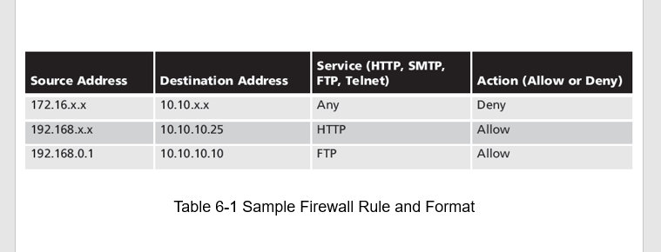

**2. Application Gateways**

Application Gateways are a type of firewall that operates at the application layer (Layer 7) of the OSI model. They act as intermediaries between client applications and servers, providing security by inspecting and filtering traffic at the application level.

**Key Points:**

**Proxy Server Functionality:**

* Application Gateways often function as proxy servers, meaning they run specialized software that acts as a proxy for service requests from client applications.
* When a client sends a request to access a service or resource, the application gateway intercepts the request, processes it on behalf of the client, and forwards it to the appropriate destination server.
* This proxying capability allows the application gateway to perform deep packet inspection and enforce security policies based on application-specific criteria.

**Placement and Network Architecture:**

* Application gateways are commonly installed on dedicated computers, separate from filtering routers. However, they are often used in conjunction with filtering routers to provide layered security.
* They are frequently placed in the demilitarized zone (DMZ) of a network, which is an isolated network segment between the internal network and the external (untrusted) network.
* By placing the application gateway in the DMZ, it is exposed to the higher levels of risk from less trusted networks, rather than the internal systems.

**Additional Filtering Routers:**

* Organizations may implement additional filtering routers behind the application gateway to further restrict access to the more secure internal systems.
* These filtering routers can provide an additional layer of defense by enforcing access control policies and filtering network traffic before it reaches the internal network.

**Advantages of Application Gateways:**

**Deep Packet Inspection:**

* Application gateways can perform deep packet inspection, allowing them to analyze the contents of application-layer traffic for signs of malicious activity.
* This capability enables them to detect and block sophisticated threats, such as application-layer attacks and malware hidden within application data.

**Granular Control:**

* Application gateways offer granular control over network traffic at the application level, allowing administrators to define security policies based on specific application characteristics.
* They can enforce access controls, restrict certain types of content or transactions, and provide detailed logging and auditing capabilities.

**Protocol Conversion:**

* Some application gateways support protocol conversion, allowing them to translate between different application protocols or versions.
* This feature can facilitate interoperability between heterogeneous network environments and enable secure communication between clients and servers using different protocols.

**Disadvantages of Application Gateways:**

**Performance Overhead:**

* Application gateways may introduce latency and performance overhead due to the additional processing required to inspect and proxy application-layer traffic.
* This can impact network throughput and response times, particularly in high-traffic environments or for latency-sensitive applications.

**Complexity and Configuration:**

* Configuring and maintaining application gateways can be complex, requiring expertise in application protocols and security policies.
* Administrators must carefully configure rules and policies to ensure effective security without disrupting legitimate application traffic.

**Single Point of Failure**:

* Since application gateways act as intermediaries for all application traffic, they represent a single point of failure in the network architecture.
* Any failure or downtime of the application gateway can disrupt access to critical services and applications for users.

**Subtypes of Application Gateways:**

**Web Application Firewalls (WAF):**

Specialized application gateways designed to protect web applications from common web-based attacks, such as SQL injection, cross-site scripting (XSS), and application-layer DDoS attacks.

**Email Gateways:**

Application gateways focused on filtering and securing email traffic, including spam filtering, malware detection, and content filtering for compliance purposes.

In summary, Application Gateways provide advanced security at the application layer by acting as intermediaries for client-server communication, performing deep packet inspection, and enforcing granular access controls. While they offer robust security features, they may introduce performance overhead and complexity in network configuration and maintenance. Organizations should carefully consider their security requirements and network architecture when deploying and managing Application Gateways.

**3. Circuit Gateways**

Circuit Gateways, also known as Circuit-Level Gateways, function at the transport layer (Layer 4) of the OSI model. Unlike application gateways that inspect and filter traffic at the application layer, circuit gateways focus on managing connections based on network addresses.

**Key Points:**

**Connection-Based Authorization:**

* Circuit gateways authorize connections based on network addresses, such as IP addresses and port numbers.
* Instead of inspecting application-layer traffic, they establish and manage connections between specific systems or processes on each side of the firewall.

**Prevention of Direct Connections:**

* Similar to filtering firewalls, circuit gateways prevent direct connections between networks by creating tunnels between authorized systems or processes.
* These tunnels serve as secure channels for authorized traffic to traverse the firewall while blocking unauthorized connection attempts.

**Tunneling for Authorized Traffic:**

* Circuit gateways create tunnels or virtual circuits connecting specific endpoints on each side of the firewall.
* Only authorized traffic, such as a specific type of TCP connection initiated by authorized users, is allowed to pass through these tunnels.

**Advantages of Circuit Gateways:**

**Enhanced Security for Network Connections:**

* Circuit gateways provide an additional layer of security by controlling network connections based on predefined authorization criteria.
* They prevent unauthorized access to network resources by allowing only authorized connections to traverse the firewall.

**Granular Control Over Network Traffic:**

* Administrators have granular control over which systems or processes can establish connections across the firewall.
* By specifying authorized endpoints and connection parameters, they can enforce strict access control policies tailored to the organization's security requirements.

**Simplicity in Configuration:**

* Circuit gateways are relatively simple to configure compared to application gateways, as they focus on managing connections rather than inspecting application-layer traffic.
* Administrators can define connection-based rules using straightforward criteria such as source and destination addresses and port numbers.

**Disadvantages of Circuit Gateways:**

**Limitations in Application-Layer Visibility:**

* Circuit gateways lack visibility into the contents of application-layer traffic, limiting their ability to detect and prevent certain types of attacks.
* They cannot inspect application payloads or enforce granular security policies based on application-layer characteristics.

**Inflexibility in Protocol Handling:**

* Circuit gateways may have limitations in handling non-standard or dynamic protocols, as they primarily focus on managing transport-layer connections.
* They may struggle to adapt to network environments with diverse application protocols or advanced encryption schemes.

**Potential Performance Impact:**

* Establishing and managing tunnels for authorized traffic can introduce latency and overhead, potentially impacting network performance.
* Organizations must carefully consider the trade-offs between security and performance when deploying circuit gateways in their network architecture.

In summary, Circuit Gateways provide secure connections between authorized endpoints by managing transport-layer connections based on network addresses. While they offer enhanced security and granular control over network traffic, they may have limitations in application-layer visibility, protocol handling, and performance impact. Organizations should evaluate their security requirements and network environment to determine if circuit gateways are suitable for their needs.

**4. MAC Layer Firewalls**

MAC Layer Firewalls operate at the Media Access Control (MAC) layer of the OSI network model, which is Layer 2(Data Link Layer). Unlike traditional firewalls that focus on IP addresses and port numbers, MAC Layer Firewalls consider the specific MAC addresses of host computers in their filtering decisions.

**Key Points:**

**Filtering Based on MAC Addresses:**

* MAC Layer Firewalls use Access Control Lists (ACLs) that are linked to specific MAC addresses of host computers.
* Each ACL entry defines the types of packets that are allowed or denied for a particular MAC address.
* The firewall inspects incoming packets and compares their source MAC addresses to the entries in the ACL to determine whether to allow or block the traffic.

**Host-Specific Filtering:**

* MAC Layer Firewalls provide host-specific filtering, allowing administrators to define different filtering rules for individual host computers based on their MAC addresses.
* This granular control enables tailored security policies to be applied to specific hosts, restricting their network communication to authorized types of traffic.

**Blocking Unwanted Traffic:**

* All traffic that does not match the ACL entries associated with a specific MAC address is blocked by the firewall.
* This effectively prevents unauthorized or unwanted traffic from reaching the protected host, enhancing network security.

**Advantages of MAC Layer Firewalls:**

**Enhanced Host-Level Security:**

* MAC Layer Firewalls provide an additional layer of security at the host level by filtering traffic based on MAC addresses.
* By controlling which types of packets are allowed to reach each host, they can mitigate the risk of unauthorized access or malicious activity.

**Prevention of MAC Address Spoofing:**

* MAC Layer Firewalls can help prevent MAC address spoofing attacks, where an attacker attempts to impersonate a legitimate host by using its MAC address.
* By associating MAC addresses with specific ACL entries, the firewall can detect and block spoofed packets that do not match the expected MAC addresses.

**Efficient Use of Network Resources:**

* MAC Layer Firewalls operate at a lower layer of the OSI model, providing efficient filtering capabilities without the overhead associated with inspecting higher-layer protocols.
* This can lead to improved network performance and reduced resource consumption compared to firewalls that operate at higher layers.

**Disadvantages of MAC Layer Firewalls:**

**Limited Visibility into Higher-Layer Protocols:**

* MAC Layer Firewalls lack visibility into the contents of higher-layer protocols, such as IP addresses and port numbers.
* They cannot inspect or filter traffic based on application-layer characteristics, potentially limiting their effectiveness against certain types of attacks.

**Complexity in Managing ACLs:**

* Managing ACLs for individual MAC addresses can be complex and time-consuming, especially in large networks with many hosts.
* Administrators must carefully configure and maintain ACL entries to ensure that they accurately reflect the security policies of the organization.

**Vulnerability to Layer 2 Attacks:**

* MAC Layer Firewalls are vulnerable to attacks targeting the MAC layer, such as MAC flooding or MAC address table overflow attacks.
* Attackers may attempt to overwhelm the firewall or manipulate its MAC address table to bypass filtering rules and gain unauthorized access to the network.

In summary, MAC Layer Firewalls provide host-specific filtering based on MAC addresses, enhancing network security at the host level. While they offer advantages such as preventing MAC address spoofing and efficient use of network resources, they may have limitations in visibility into higher-layer protocols and complexity in managing ACLs. Organizations should carefully evaluate the advantages and disadvantages of MAC Layer Firewalls to determine if they are suitable for their network security requirements.

**5. Hybrid Firewalls**

Hybrid Firewalls combine elements from different types of firewalls, such as packet filtering, proxy services, or circuit gateways. They leverage the strengths of each firewall type to provide comprehensive security solutions tailored to the organization's needs.

**Key Points:**

**Combination of Firewall Elements:**

* Hybrid Firewalls integrate features from multiple types of firewalls to create a unified security solution.
* For example, they may combine packet filtering for efficient traffic filtering with proxy services or circuit gateways for enhanced application-layer security or connection management.

**Customized Security Policies:**

* Hybrid Firewalls allow organizations to customize their security policies based on their specific requirements and network environments.
* Administrators can configure different firewall components to enforce policies at various layers of the OSI model, providing granular control over network traffic.

**Tandem Firewall Systems:**

* In some cases, a hybrid firewall system may consist of two separate firewall devices working in tandem.
* Each firewall device operates as a distinct firewall system, but they are connected and configured to complement each other's capabilities, providing layered defense against a wide range of threats.

**Advantages of Hybrid Firewalls:**

**Comprehensive Security Coverage:**

* Hybrid Firewalls offer comprehensive security coverage by combining the strengths of different firewall types.
* They can address multiple security concerns, including packet-level filtering, application-layer security, and connection management, in a single solution.

**Flexibility and Customization:**

* Hybrid Firewalls provide flexibility in designing and implementing security policies tailored to the organization's specific needs.
* Administrators can mix and match firewall components to create customized security configurations that align with their security objectives and network architecture.

**Scalability and Adaptability:**

* Hybrid Firewalls are scalable and adaptable to evolving security threats and network environments.
* Organizations can easily modify and expand their hybrid firewall configurations to accommodate changes in network infrastructure or emerging security challenges.

**Disadvantages of Hybrid Firewalls:**

**Complexity in Configuration and Management:**

* Configuring and managing hybrid firewalls can be complex, particularly when integrating multiple firewall components with different functionalities.
* Administrators may require specialized knowledge and skills to effectively deploy and maintain hybrid firewall configurations.

**Increased Resource Consumption:**

* Hybrid Firewalls may require additional resources, such as CPU, memory, and bandwidth, to support the simultaneous operation of multiple firewall components.
* This increased resource consumption could impact network performance and scalability, particularly in high-traffic environments.

**Potential Single Points of Failure:**

* Hybrid Firewalls, especially those consisting of multiple interconnected devices, may introduce single points of failure in the network architecture.
* Any failure or downtime of a firewall component could disrupt network connectivity or compromise security, highlighting the importance of redundancy and failover mechanisms.

In summary, Hybrid Firewalls offer comprehensive security solutions by combining elements from different types of firewalls. While they provide advantages such as comprehensive security coverage, flexibility, and scalability, they may also introduce complexity, resource overhead, and potential single points of failure. Organizations should carefully evaluate the advantages and disadvantages of Hybrid Firewalls to determine if they align with their security requirements and operational capabilities.

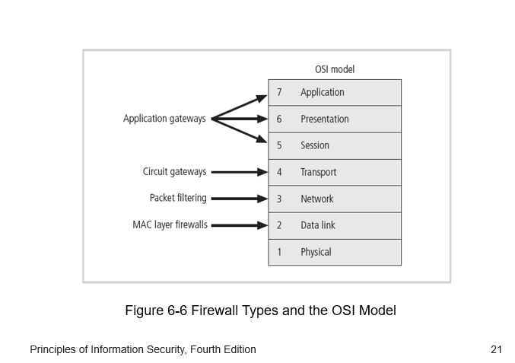

**Firewalls categorized by structure:**

* **Appliances:** Firewalls come in different forms, one of which is an appliance. An appliance is a hardware device that is designed to perform a specific function or set of functions. In the context of firewalls, an appliance is a standalone device that is dedicated solely to the task of firewalling. It typically includes its own operating system, hardware components, and software for managing network traffic.
* **Commercial-grade firewall system:** Commercial-grade firewalls are designed for use in business environments, ranging from small to large enterprises. These firewalls offer advanced features and capabilities tailored to the needs of organizations, such as robust security policies, centralized management, scalability, high-performance throughput, and support for complex network architectures. They are usually deployed at the perimeter of corporate networks to protect against external threats and enforce security policies.
* **Small office/home office (SOHO) firewall appliances:** SOHO firewall appliances are specifically designed for use in small office or home office environments. They are typically compact, easy to deploy, and offer essential security features suitable for smaller networks with fewer users and devices. SOHO firewalls often provide functionalities like basic packet filtering, NAT (Network Address Translation), VPN (Virtual Private Network) support, and simple management interfaces. They are cost-effective solutions for protecting small-scale networks from internet-based threats.
* **Residential-grade firewall software:** Residential-grade firewall software is intended for individual home users or small-scale residential networks. Unlike dedicated hardware appliances, these firewalls are software-based solutions that can be installed on personal computers or network devices within a home environment. They offer basic firewalling capabilities, such as packet filtering, port blocking, and intrusion detection, aimed at safeguarding personal devices and home networks from unauthorized access and malicious activities over the internet.

**Software vs. Hardware: the SOHO Firewall Debate**

The choice between software and hardware firewalls for residential users often depends on various factors such as budget, technical expertise, and specific security needs. Here's a breakdown of the considerations for each option:

**Software Firewall:**

**Advantages:**

* Cost-effective: Software firewalls are typically cheaper or even free compared to hardware solutions.
* Easy to install: They can be installed directly on individual computers or devices without requiring additional hardware.
* Flexible: Users can customize settings and policies based on their preferences and requirements.

**Disadvantages:**

* Relies on host system: Since software firewalls run on individual computers, they are only effective for protecting the device they are installed on and do not offer network-wide protection.
* Vulnerable to system compromises: If the host system is compromised or if the firewall software itself has vulnerabilities, attackers may bypass it and gain unauthorized access to the device.

**Hardware Firewall:**

**Advantages:**

* Network-wide protection: Hardware firewalls are deployed at the network perimeter, providing protection for all devices connected to the network.
* Dedicated security appliance: Hardware firewalls are designed specifically for firewalling tasks, offering robust security features and performance.
* Simplified management: Configuration and management of hardware firewalls are typically centralized, making it easier to enforce security policies across the entire network.

**Disadvantages:**

* Cost: Hardware firewalls can be more expensive upfront compared to software solutions, especially for residential users.
* Complexity: Setting up and configuring hardware firewalls may require technical expertise, which could be challenging for users with limited networking knowledge.

In the context of defending against hackers, both software and hardware firewalls have their strengths and weaknesses. While a hardware firewall provides an additional layer of protection at the network perimeter, a software firewall can still offer valuable defense mechanisms at the individual device level.

However, the statement in your question regarding the hardware firewall being more secure because it can "assign a non-routable IP address, making it virtually impossible to reach from the outside" needs clarification. Both hardware and software firewalls can utilize Network Address Translation (NAT) to hide internal IP addresses, making devices less visible from the internet. Additionally, both types of firewalls can implement security measures such as stateful packet inspection to block unauthorized access attempts.

Ultimately, for residential users, a combination of both software and hardware firewalls may provide the most comprehensive protection. A hardware firewall at the network perimeter can complement the security provided by individual software firewalls on devices, helping to mitigate the risks associated with both external and internal threats.

**Firewall Architectures**

Each of the firewall devices noted earlier can be configured in a number of network connection architectures. The firewall configuration that works best for a particular organization depends on three factors: the objectives of the network, the organization’s ability to develop and implement the architectures, and the budget available for the function. Although literally hundreds of variations exist, there are four common architectural implementations of firewalls:

* Packet filtering routers
* Screened host firewalls
* Dual-homed firewalls
* Screened subnet firewalls

**Packet Filtering Routers:**

**Description:**

Packet filtering routers are network devices that operate at the network layer (Layer 3) of the OSI model. They inspect individual packets of data as they pass through the router and make decisions about whether to allow or block the packets based on predefined rules or access control lists (ACLs). These rules specify criteria such as source and destination IP addresses, ports, and protocols. Packet filtering routers are commonly used at the perimeter of networks to control the flow of traffic between internal and external networks, such as the internet.

**Working:**

The operation of packet filtering routers involves examining each packet's header information against the configured rules. When a packet arrives at the router, it checks the packet's source and destination IP addresses, as well as other relevant information such as port numbers and protocol types. Based on these criteria, the router compares the packet against the ACLs to determine whether to permit or deny its passage through the network. If a packet matches an allow rule in the ACL, the router forwards the packet to its destination. Conversely, if the packet matches a deny rule or does not match any allow rules, the router discards the packet or sends an error message back to the sender, depending on the configuration.

**Advantages:**

* Simplicity: Packet filtering routers are relatively simple to configure and manage compared to more complex firewall solutions.
* Efficiency: They can process network traffic quickly, as they focus solely on inspecting packet headers rather than examining packet contents.
* Low overhead: Packet filtering routers have minimal impact on network performance, making them suitable for environments with high traffic volumes.
* Cost-effectiveness: Many routers include packet filtering capabilities as a standard feature, eliminating the need for additional hardware or software investments.

**Disadvantages:**

* Limited functionality: Packet filtering is based on basic criteria such as IP addresses and port numbers, lacking the ability to inspect packet contents for deeper analysis.
* Complexity of ACLs: Managing access control lists can become cumbersome and error-prone, especially as the number of rules grows, leading to potential security gaps or performance degradation.
* Lack of authentication: Packet filtering routers typically do not offer robust authentication mechanisms, making it challenging to enforce access control based on user identity.
* Minimal logging and auditing: Unlike more advanced firewall solutions, packet filtering routers may offer limited logging and auditing capabilities, making it difficult to track and analyze network traffic for security purposes.

In summary, packet filtering routers provide a basic level of network security by controlling the flow of traffic based on predefined rules. While they offer simplicity and efficiency, they may lack advanced features such as deep packet inspection and comprehensive logging, which are essential for addressing modern cybersecurity threats effectively. Organizations need to carefully consider their security requirements and weigh the advantages and disadvantages of packet filtering routers before implementing them as part of their network defense strategy.

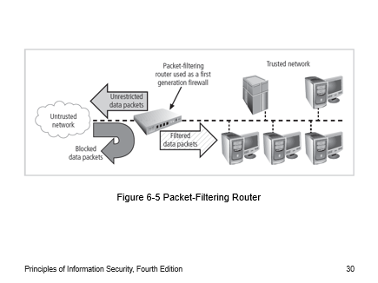

**Diagram Working:**

The diagram you sent depicts a packet-filtering router acting as a first-generation firewall [1]. Firewalls are network security devices that control incoming and outgoing traffic based on a set of security rules. Packet filtering routers, a type of firewall, examine individual data packets traveling across a network.

**Here’s a breakdown of the diagram:**

* Unrestricted data packets: These packets are attempting to enter the network from the untrusted network, which is likely the internet.
* Packet-filtering router: This device inspects each data packet according to a set of pre-configured rules.
* Filtered data packets: Packets that align with the router’s rules are allowed to pass through to the trusted network.
* Blocked data packets: Packets that violate the router’s rules are blocked.
* Trusted network: This is the protected network that the firewall is designed to safeguard. It typically includes servers and other critical devices.

**Packet filtering routers make decisions based on attributes of the data packet headers, such as:**

* Source IP address: The IP address of the device that sent the packet.
* Destination IP address: The IP address of the device intended to receive the packet.
* Port numbers: Ports are virtual doorways designated for specific types of traffic. For instance, port 80 is commonly used for web traffic.
* Transport layer protocol: This refers to the protocol governing how data is transmitted, such as TCP (Transmission Control Protocol) or UDP (User Datagram Protocol).

In essence, packet filtering routers function as a basic security barrier, but they have limitations. They only examine packet header information and don’t have the capability to inspect the contents of the data packets themselves. This means that sophisticated malware or other threats can potentially bypass packet-filtering routers if they are cleverly disguised.

**Screened Host Firewalls:**

**Description:**

A screened host firewall architecture combines a packet filtering router with a separate, dedicated firewall, typically implemented as an application proxy server. In this architecture, the packet filtering router serves as the first line of defense, prescreening packets based on basic criteria such as IP addresses and port numbers to minimize the network traffic and load on the internal proxy server. The application proxy, also known as a bastion host or sacrificial host, then examines the application layer protocols (Layer 7 of the OSI model) and performs proxy services on behalf of internal clients.

**Working:**

The operation of a screened host firewall involves two main components: the packet filtering router and the application proxy server (bastion host). When incoming packets arrive at the network perimeter, they are first inspected by the packet filtering router. The router filters the packets based on predefined rules or access control lists (ACLs), allowing only authorized traffic to pass through to the internal network. Once the packets pass through the packet filtering router, they are forwarded to the application proxy server (bastion host). The bastion host acts as a proxy for internal clients, intercepting and inspecting application layer protocols such as HTTP, FTP, or SMTP. It performs various security functions, including authentication, encryption/decryption, content filtering, and application-level access control. By acting as an intermediary between internal clients and external servers, the bastion host enhances security by shielding internal systems from direct exposure to external threats.

**Advantages:**

* Enhanced security: The combination of packet filtering and application proxying provides multiple layers of defense, improving overall network security posture.
* Granular control: Application proxies offer granular control over application layer protocols, allowing for more precise security policies and access controls.
* Reduced attack surface: By using a separate bastion host, organizations can reduce the attack surface exposed to external threats, as only authorized traffic is forwarded to internal systems.
* Logging and auditing: Application proxies typically offer robust logging and auditing capabilities, allowing organizations to monitor and analyze network traffic for security incidents and policy violations.

**Disadvantages:**

* Complexity: Implementing and managing a screened host firewall architecture can be complex, requiring expertise in both packet filtering and application proxying technologies.
* Performance overhead: The additional processing required for application proxying may introduce latency and overhead, impacting network performance, especially under heavy loads.
* Single point of failure: The bastion host serves as a critical component of the firewall architecture and may become a single point of failure if not properly configured or redundantly deployed.
* Resource requirements: Running an application proxy server requires dedicated hardware resources, such as CPU and memory, which may increase infrastructure costs.

In summary, a screened host firewall architecture offers a robust approach to network security by combining packet filtering with application proxying. While it provides enhanced security and control over network traffic, organizations need to consider the complexity, performance implications, and resource requirements associated with implementing and maintaining this architecture effectively.

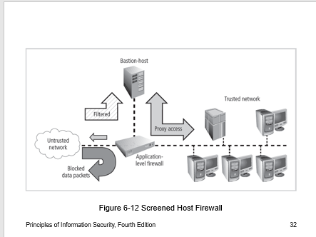

**Diagram Working:**

The diagram you sent depicts a screened host firewall, a type of firewall architecture that uses a combination of a packet-filtering router and a bastion host [1]. A bastion host is a highly secure server that sits between a trusted network and an untrusted network, such as the internet. It acts as a single point of access for users on the trusted network to access services on the untrusted network.

**Here’s a breakdown of the diagram’s components and how they work together:**

* Untrusted network: This is likely the internet, which is considered an unsecured network.
* Filtered: A packet-filtering router inspects all data packets traveling between the trusted and untrusted networks according to a set of pre-configured security rules.
* Blocked data packets: Packets that violate the router’s rules are blocked.
* Bastion host: This is a highly secured server on the trusted network that acts as a single point of access to internet services for trusted network devices. Only authorized traffic is allowed to flow between the bastion host and the internet.
* Proxy access: The bastion host may run proxy server software that filters and controls traffic between trusted network devices and the internet. For instance, a web proxy server would filter web traffic requests and responses.
* Trusted network: This is the protected network that the firewall is designed to safeguard. It typically includes devices such as servers and workstations.

**Dual-Homed Firewalls:**

**Description:**

A dual-homed host firewall architecture involves a bastion host (firewall) with two network interface cards (NICs), where one NIC is connected to the external network (e.g., the internet), and the other NIC is connected to the internal network. This configuration provides an additional layer of protection by forcing all traffic between the internal and external networks to pass through the firewall. The firewall examines and filters the traffic to enforce security policies and protect the internal network from unauthorized access or malicious activities originating from the external network.

**Working:**

In a dual-homed host firewall architecture, the firewall (bastion host) sits between the internal and external networks, acting as an intermediary for all traffic passing between them. When incoming packets arrive from the external network, they are first received by the external NIC of the bastion host. The firewall inspects the packets and applies security rules to determine whether to allow or block the traffic. If the traffic is allowed, the firewall forwards the packets to the internal NIC, where they are then transmitted to the internal network. Similarly, outgoing traffic from the internal network is directed to the internal NIC of the firewall, inspected, and filtered before being forwarded to the external network. Additionally, the implementation of Network Address Translation (NAT) mapping is often used in dual-homed host firewalls. NAT translates internal private IP addresses to a special range of non-routable internal IP addresses when communicating with external networks. This creates an additional barrier to intrusion by hiding internal network details from external attackers.

**Advantages:**

* Enhanced security: Dual-homed host firewalls provide an additional layer of security by enforcing traffic filtering and access control between internal and external networks.
* Centralized control: All network traffic must pass through the firewall, allowing for centralized monitoring, management, and enforcement of security policies.
* NAT mapping: NAT mapping obscures internal network details, making it more difficult for external attackers to target specific devices or services within the internal network.
* Scalability: The architecture can be scaled to accommodate growing network traffic and security requirements by upgrading hardware or adding additional firewall instances.

**Disadvantages:**

* Single point of failure: The bastion host serves as a critical component of the firewall architecture and may become a single point of failure if it experiences hardware failures or becomes compromised.
* Performance overhead: The additional processing required for packet inspection and filtering may introduce latency and overhead, impacting network performance, especially under heavy loads.
* Complexity: Configuring and managing a dual-homed host firewall architecture can be complex, requiring expertise in network security and firewall technologies.
* Cost: Implementing and maintaining dual-homed host firewalls may require investment in dedicated hardware, software, and ongoing maintenance, which can increase overall infrastructure costs.

In summary, dual-homed host firewalls offer robust network security by providing a dedicated barrier between internal and external networks, enforced through packet inspection, filtering, and NAT mapping. However, organizations need to carefully consider the trade-offs in terms of complexity, performance, and cost before implementing this architecture.

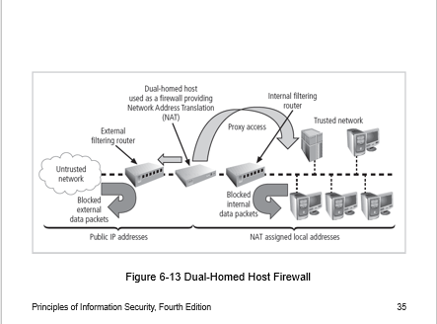

**Diagram Working:**

The image you sent depicts a dual-homed host firewall [1]. This type of firewall uses a single computer with two network interfaces (NICs) to separate a trusted network from an untrusted network, such as the internet. Traffic between the two networks must flow through the dual-homed host, which acts as a packet filter and enforces security policies.

**Here’s a breakdown of the way a dual-homed host firewall works:**

* Dual-homed host: This computer functions as the firewall. It has one NIC connected to the trusted network and another NIC connected to the untrusted network (the internet).
* Internal filtering router: This router filters traffic within the trusted network, further enhancing security.
* Network Address Translation (NAT): NAT is a method used to disguise the IP addresses of devices on the trusted network. When a device on the trusted network sends data to the internet, the dual-homed host rewrites the source IP address in the packet header with its own public IP address. This helps to hide the identity of devices on the trusted network from internet users.
* External filtering router: While not always shown in diagrams depicting dual-homed host firewalls, external filtering routers can be used to provide an additional layer of security at the perimeter of the network.

**Screened Subnet Firewalls:**

**Description:**

A screened subnet firewall architecture with a DMZ (Demilitarized Zone) is a widely used network security design. It involves the creation of a separate network segment, known as the DMZ, which sits between the internal trusted network and the external untrusted network, typically the internet. The DMZ acts as an intermediary zone that provides an additional layer of security by segregating internet-facing services from internal systems.

**Working:**

In this architecture, the firewall system typically consists of multiple components:

External filtering router: Incoming connections from the untrusted network are routed through an external filtering router, which performs basic packet filtering to block unauthorized traffic.

Routing firewall: The filtered connections are then routed into a routing firewall, which acts as the gateway to the DMZ. The routing firewall enforces more advanced security policies and access controls, allowing only authorized traffic to enter the DMZ.

DMZ: The DMZ is a separate network segment where internet-facing servers, such as web servers, email servers, or public-facing applications, are located. These servers are often referred to as bastion hosts and are hardened to resist attacks. The DMZ protects both the internal network by limiting external access and the DMZ systems from direct exposure to external threats.

Internal network: Connections from the DMZ to the internal network are carefully controlled, typically allowing only specific services or protocols necessary for business operations.

**Advantages:**

* Enhanced security: The DMZ provides an additional layer of defense by segregating internet-facing services from internal systems, reducing the attack surface and mitigating the impact of security breaches.
* Flexibility: Organizations can host internet-facing services in the DMZ while maintaining strict access controls to internal resources, enabling secure remote access and collaboration.
* Scalability: The architecture can be scaled to accommodate growing business needs by adding additional servers or services to the DMZ segment without compromising internal security.
* Compliance: Screened subnet firewalls with DMZ are often aligned with regulatory compliance requirements, such as PCI DSS (Payment Card Industry Data Security Standard) for handling sensitive data securely.

**Disadvantages:**

* Complexity: Implementing and managing a screened subnet firewall architecture with DMZ requires expertise in network security and firewall technologies, increasing operational complexity.
* Cost: Setting up and maintaining the DMZ infrastructure, including dedicated hardware, software licenses, and ongoing maintenance, can incur significant costs for organizations.
* Single point of failure: The DMZ serves as a critical component of the firewall architecture, and any failure or compromise in the DMZ infrastructure can impact both external-facing services and internal security.
* Performance overhead: The additional routing and inspection required for traffic passing through the DMZ may introduce latency and overhead, affecting network performance, especially under heavy loads.

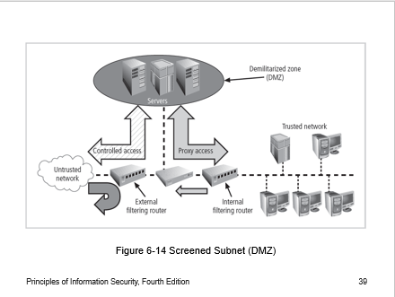

**Diagram Working:**

The diagram you sent depicts a screened subnet firewall, also referred to as a three-homed firewall or a DMZ (demilitarized zone) firewall [2]. It utilizes two packet-filtering routers and a firewall zone situated between them to create an extra layer of security for a trusted network [1]. The trusted network typically houses important servers and user workstations.

**Here's a breakdown of the screened subnet firewall and how it functions**:

* Untrusted network: This is likely the internet, which is considered an unsecured network.
* External filtering router: This router sits between the untrusted network and the DMZ. It filters traffic entering the DMZ according to a set of security rules. Only authorized traffic is permitted to enter the DMZ.
* Demilitarized zone (DMZ): This is a network segment that resides between the two routers. It can house servers, such as web servers or email servers, that need to be accessible from the internet but are still separated from the trusted network for an added layer of security.
* Internal filtering router: This router sits between the DMZ and the trusted network. It filters traffic leaving the DMZ and entering the trusted network according to a set of security rules. Only authorized traffic is allowed to flow from the DMZ to the trusted network.
* Trusted network: This is the protected network that the firewall is designed to safeguard. It typically includes devices such as servers and workstations.

**SOCKS Servers:**

**Description:**

SOCKS (Socket Secure) is a protocol for handling TCP traffic via a proxy server. It allows clients behind a firewall or NAT to access external resources securely by routing their traffic through a SOCKS proxy server.

**Working:**

A SOCKS client-side agent is installed on each workstation or client device behind the firewall.

When a client application requests a connection to an external resource, the SOCKS client forwards the request to the SOCKS proxy server.

The SOCKS proxy server establishes a connection with the external resource on behalf of the client, effectively acting as an intermediary.

All communication between the client and the external resource is routed through the SOCKS proxy server, ensuring security and anonymity.

**Advantages:**

* Enhanced security: SOCKS servers provide a layer of security by allowing clients behind a firewall to access external resources securely without exposing their IP addresses or network details.
* Anonymity: SOCKS proxy servers can mask the true identity and location of client devices by routing traffic through proxy servers located in different geographical locations.
* Flexibility: SOCKS proxies support various TCP-based applications and protocols, making them suitable for a wide range of use cases, including web browsing, email, and file sharing.
* Compatibility: SOCKS is supported by many operating systems and applications, making it easy to integrate into existing network environments.

**Disadvantages:**

* Resource requirements: Implementing and managing a SOCKS system can require additional support and management resources beyond those of traditional firewalls, including hardware, software, and administrative overhead.
* Complexity: Configuring and maintaining SOCKS proxy servers and client-side agents may require expertise in network security and proxy technologies, increasing complexity.
* Performance overhead: Routing traffic through SOCKS proxy servers may introduce latency and overhead, affecting network performance, especially for bandwidth-intensive applications.
* Single point of failure: SOCKS proxy servers represent a single point of failure in the network architecture, and any issues or outages with the proxy server can disrupt network connectivity for clients behind the firewall.

**Selecting the Right Firewall**

* **Budget Constraints:** Every organization operates within budget constraints. Investing in a firewall that exceeds the budget could lead to financial strain or compromise on other essential security measures. Therefore, it's crucial to find a firewall solution that provides the necessary protection without breaking the bank.
* **Total Cost of Ownership (TCO):** Cost considerations extend beyond the initial purchase price. The TCO includes not only the upfront costs but also ongoing expenses such as maintenance, updates, licensing fees, and support. A firewall might seem affordable at first glance, but the additional costs associated with maintaining it could make it more expensive in the long run.
* **Scalability:** As the organization grows, its network requirements evolve. The chosen firewall should be able to scale alongside the organization without requiring a significant investment in additional hardware or licenses. Scalability ensures that the firewall remains cost-effective over time by accommodating increasing network demands without the need for frequent upgrades or replacements.
* **Value for Money:** Cost-effectiveness isn't just about finding the cheapest option; it's about obtaining the best value for the investment. A firewall might have a higher upfront cost but offer advanced features, better performance, and lower maintenance expenses, making it a more cost-effective choice in the long term.
* **Comparative Analysis:** To make an informed decision about cost, organizations should conduct a comparative analysis of different firewall solutions. This involves evaluating not only the initial purchase price but also ongoing costs, feature sets, scalability, and vendor reputation. By comparing multiple options, organizations can identify the firewall that strikes the right balance between cost and value.

**Configuring and Managing Firewalls (Best Practices for Firewalls)**

* **All traffic from the trusted network is allowed out:** This practice ensures that internal users can freely access resources on the internet without restrictions. It maintains productivity while still enforcing security policies to control incoming traffic.
* **The firewall device is never directly accessible from the public network:** This principle prevents direct attacks on the firewall itself from external sources. By keeping the firewall hidden behind the perimeter, it adds an extra layer of defense against unauthorized access attempts.
* **SMTP data is allowed to pass through the firewall but should be routed to a well-configured SMTP gateway:** SMTP (Simple Mail Transfer Protocol) is commonly used for email communication. Allowing SMTP traffic through the firewall enables email services but routing it to an SMTP gateway ensures that incoming and outgoing email traffic is properly filtered, scanned for malware, and managed according to organizational policies, enhancing email security.
* **All ICMP data should be denied:** ICMP (Internet Control Message Protocol) is often used for network troubleshooting and diagnostics, but it can also be exploited for malicious purposes, such as ICMP flood attacks or ping sweeps. Denying all ICMP traffic by default helps mitigate these risks while still allowing specific ICMP types needed for legitimate network operations.
* **Telnet access to all internal servers from the public networks should be blocked:** Telnet is an unencrypted protocol, making it vulnerable to eavesdropping and interception. Blocking Telnet access from public networks prevents potential attackers from gaining unauthorized access to internal servers. Instead, organizations should use secure alternatives like SSH (Secure Shell) for remote server administration.

**Firewall Rules**

Firewall rules, also known as rule sets or firewall policies, form the core logic that dictates how a firewall processes network traffic. These rules are essentially a set of instructions or criteria that the firewall uses to make decisions about whether to allow or block packets based on their characteristics.

Here's how firewall rules typically operate:

* **Packet Examination:** When a packet enters the firewall, the firewall examines its header information. This information includes details such as source and destination IP addresses, port numbers, protocol type (e.g., TCP, UDP), and sometimes additional data like packet size or flags.
* **Comparison with Rules:** The firewall then compares the packet's characteristics against the predefined rules in its rule set. Each rule in the rule set specifies certain criteria that incoming packets must meet to either be allowed or denied.
* **Decision Making:** Based on the comparison with the rules, the firewall makes a decision on how to handle the packet. If the packet matches the criteria specified in a rule that permits traffic, it is allowed to pass through the firewall. Conversely, if the packet matches the criteria specified in a rule that blocks traffic, it is dropped or rejected by the firewall.
* **Rule Hierarchy and Order:** Firewall rules are often organized in a hierarchical manner or processed in a specific order. This means that the firewall evaluates packets against rules in a sequential fashion until a match is found. Once a match is found, the corresponding action defined by that rule is taken, and subsequent rules may not be evaluated.
* **Default Policies:** Firewalls may also have default policies that define how packets that do not match any specific rule should be handled. For example, a firewall might have a default policy to deny all traffic unless explicitly allowed by a rule.
* **Dynamic Updates:** In some cases, firewall rules may be dynamically updated based on changing network conditions, security threats, or administrative changes. This allows the firewall to adapt to evolving security requirements and mitigate emerging threats effectively.

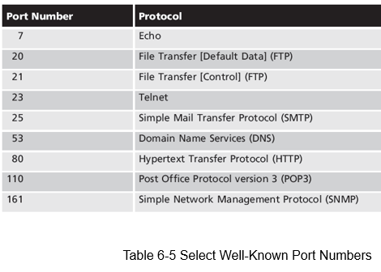

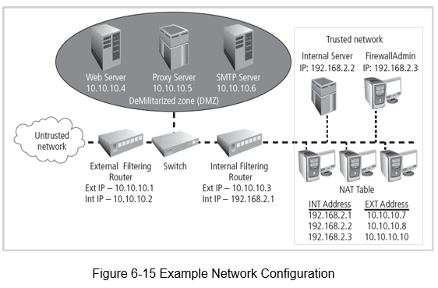

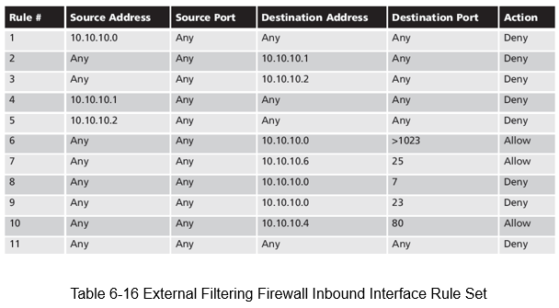

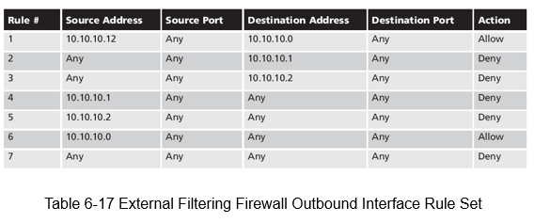

**Content Filters**

Content filters serve as an essential tool for organizations to manage and control internet access within their networks. Let's break down the key components and functionalities of content filters:

* **Restricting Access:** Content filters enable administrators to restrict access to specific internet resources, including websites, servers, or other online content. This restriction can be based on various criteria such as content categories, URLs, keywords, or file types.
* **Rating System:** The rating component of a content filter operates similarly to firewall rules but is focused on categorizing websites based on their content. Websites are typically categorized into different groups, such as adult content, gambling, violence, etc. This categorization allows administrators to define policies regarding which categories of websites users are allowed to access.
* **Filtering Mechanism:** Once websites are categorized, the filtering component of the content filter enforces the access policies set by the administrator. It examines user access requests and determines whether to allow or block access based on the predefined policies. Filtering can be done at the URL level, content category level, or using more advanced methods like content analysis or behavioral analysis.
* **Non-Business Related Material:** One of the primary objectives of content filters is to restrict access to non-business-related material, such as pornography, gambling sites, social media platforms, or online gaming websites. By blocking access to these types of sites, organizations can promote productivity, reduce security risks, and maintain a professional work environment.
* **Spam Email Filtering:** In addition to restricting access to websites, content filters often include features for filtering and blocking incoming spam email. These filters analyze email content, sender reputation, and other characteristics to identify and block spam messages before they reach users' inboxes, thereby reducing the risk of phishing attacks, malware distribution, and other email-based threats.

Overall, content filters play a crucial role in helping organizations enforce internet usage policies, protect against security threats, and ensure compliance with regulatory requirements. By implementing effective content filtering solutions, organizations can maintain a secure and productive network environment while minimizing the risks associated with inappropriate or malicious online content.

**Protecting Remote Connections**

Protecting remote connections is essential for ensuring the security and integrity of data transmitted between remote users and the organization's network. Here's an explanation of the various methods used to protect remote connections:

* **Leased Lines and Data Channels:** Leased lines and dedicated data channels provided by common carriers offer a secure and reliable method for establishing permanent connections between remote locations and the organization's network. These connections are typically secured under formal service agreements, ensuring reliability, availability, and often encryption to protect data in transit.
* **Dial-Up Services (e.g., Remote Authentication Service - RAS):** Historically, organizations provided remote connections exclusively through dial-up services like RAS. Users would dial into the organization's network using a modem and authenticate themselves to access resources. While dial-up connections offer basic security features like user authentication, they are less common today due to their slower speeds and limited scalability compared to modern alternatives.
* **Virtual Private Networks (VPNs):** With the widespread availability of the internet, virtual private networks (VPNs) have become the preferred method for securing remote connections. VPNs use encryption and tunneling protocols to create a secure, encrypted connection over the internet between remote users and the organization's network. This allows remote users to access internal resources securely as if they were physically connected to the organization's network. VPNs offer several advantages, including scalability, flexibility, and cost-effectiveness compared to traditional leased lines or dial-up services.
* **Security Protocols and Authentication Mechanisms:** Both traditional dial-up services and modern VPNs utilize security protocols and authentication mechanisms to ensure the identity of remote users and protect data in transit. These may include protocols like Point-to-Point Protocol (PPP), Internet Protocol Security (IPsec), Secure Socket Layer (SSL), or Transport Layer Security (TLS), as well as authentication methods such as username/password authentication, two-factor authentication (2FA), or digital certificates.
* **Firewalls and Intrusion Detection/Prevention Systems (IDS/IPS):** Organizations often deploy firewalls and intrusion detection/prevention systems at the network perimeter to monitor and control incoming and outgoing traffic, including remote connections. These security measures help detect and block unauthorized access attempts, malicious activities, and potential security threats targeting remote connections.

Overall, protecting remote connections involves implementing robust security measures, such as encryption, authentication, and access controls, to safeguard data transmitted between remote users and the organization's network, regardless of the method used to establish the connection.

**Remote Access**

Dial-up connections, while once common, are indeed considered less secure compared to modern alternatives like VPNs due to several vulnerabilities inherent in their technology. Here's an explanation of the security risks associated with dial-up connections and the technologies used to mitigate these risks:

* **Exposure to Attack:** Dial-up connection points are susceptible to attack because they represent potential entry points into an organization's network. Since dial-up lines use phone numbers to establish connections, attackers can use automated tools called war dialers to systematically dial a range of phone numbers and identify active dial-up connections.
* **War Dialers:** A war dialer is a type of automated phone-dialing program that scans phone numbers within a configured range to identify active dial-up connections. When a dial-up modem answers the call, the war dialer detects it, allowing the attacker to potentially gain unauthorized access to the network. This scanning process can be conducted rapidly and efficiently, making it easier for attackers to locate vulnerable dial-up connections.
* **Improved Authentication:** To enhance the security of dial-up connections, organizations can implement technologies like RADIUS (Remote Authentication Dial-In User Service), TACACS (Terminal Access Controller Access Control System), and CHAP (Challenge-Handshake Authentication Protocol) password systems. These technologies improve the authentication process by verifying the identity of remote users before granting them access to the network.
* **RADIUS and TACACS** are authentication protocols commonly used in dial-up networking to centralize user authentication and authorization. They provide a more robust and centralized method for managing user credentials and access privileges.
* **CHAP** is a protocol used to authenticate the identity of a remote user or network device. It involves a challenge-response mechanism where the server challenges the client to prove its identity by responding with a hashed value of the challenge.

**RADIUS:**

* **Functionality:** RADIUS is a client/server protocol that centralizes user authentication, authorization, and accounting (AAA) services. It places the responsibility for authenticating users on a central RADIUS server.
* **Operation:** When a user attempts to access the network via a dial-up connection, the remote access server (RAS) forwards the authentication request, including the user's credentials, to the RADIUS server.
* **Authentication:** The RADIUS server validates the user's credentials against its database or other authentication mechanisms (such as LDAP or Active Directory).
* **Decision Response:** Based on the authentication result, the RADIUS server sends a response (accept or deny) back to the RAS. If the authentication is successful, the user is granted access to the network; otherwise, access is denied.
* **Usage:** RADIUS is widely used in many types of networks, including enterprise networks, internet service provider (ISP) networks, and telecommunications networks.

**TACACS:**

* **Functionality:** TACACS (Terminal Access Controller Access Control System) is also a client/server protocol used for AAA services.
* **Operation:** Similar to RADIUS, TACACS centralizes user authentication and authorization on a dedicated TACACS server.
* **Authentication:** When a user attempts to access the network, the network device (such as a router or switch) sends the authentication request to the TACACS server.
* **Decision Response:** The TACACS server validates the user's credentials and sends an accept or deny response back to the network device.
* **Usage:** TACACS is commonly used in network devices like routers, switches, and firewalls, especially in Cisco networking environments.

**Diameter:**

* **Emerging Alternative:** Diameter is a newer protocol developed as an improvement and successor to RADIUS.
* **Enhancements:** Diameter offers several enhancements over RADIUS, including improved security, support for more complex authentication scenarios, and better scalability for larger networks.
* **Functionality:** Like RADIUS, Diameter provides AAA services, but it is designed to handle a broader range of network access technologies and services.
* **Usage:** While Diameter is not as widely deployed as RADIUS, it is gaining popularity, particularly in next-generation networks and services such as 4G and 5G mobile networks.

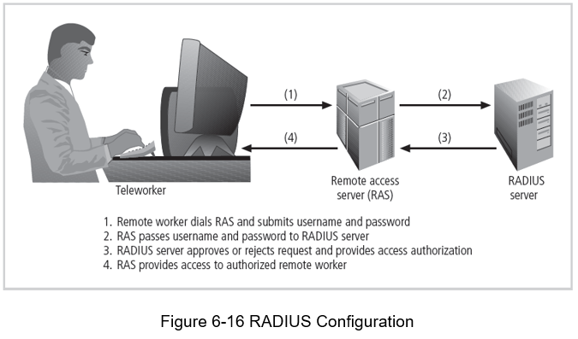

**Securing authentication with Kerberos**

Kerberos is a network authentication protocol designed to provide secure authentication for users and services in a distributed computing environment. It uses symmetric key encryption to validate the identities of users and services, thereby preventing unauthorized access to network resources. Let's break down how Kerberos works and its key components:

* Symmetric Key Encryption: Kerberos relies on symmetric key encryption, where the same secret key is used for both encryption and decryption. This means that both the client and the server share a secret key, which is used to encrypt and decrypt authentication messages exchanged during the authentication process.
* Key Distribution: Kerberos employs a central Key Distribution Center (KDC), which is responsible for generating and distributing session keys used for encryption between the client and server. The KDC consists of two main components: the Authentication Server (AS) and the Ticket Granting Server (TGS).
* Key Components: Authentication Server (AS): The AS is the initial point of contact for authentication requests. It verifies the identity of clients and servers based on their credentials (usually passwords) stored in a centralized database. Upon successful authentication, the AS generates a session key and a Ticket Granting Ticket (TGT) for the client.
* Ticket Granting Service (TGS): The TGS is responsible for granting service tickets to clients who request access to specific network services. When a client presents a TGT to the TGS along with a service request, the TGS verifies the client's identity and issues a service ticket containing the client's identity and a session key for accessing the requested service.
* Database Library: Kerberos uses a database library to store and manage user and service credentials, including private keys and authentication information.
* Ticket-based Authentication: Kerberos authentication relies on the use of tickets, which serve as identification cards for clients requesting access to network services.

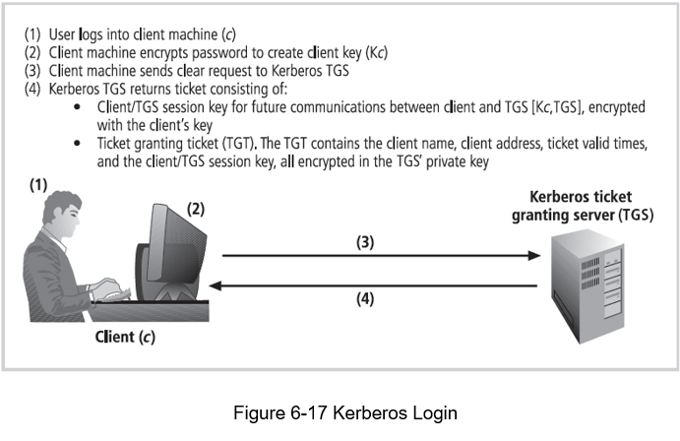

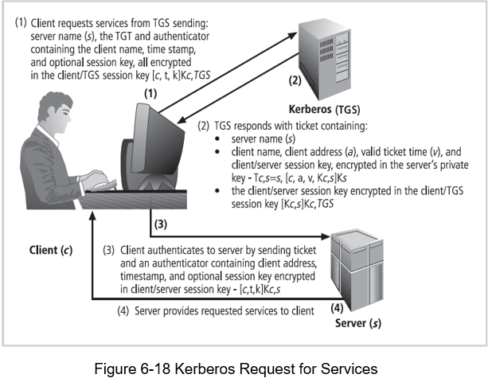

**SESAME**

SESAME (Secure European System for Applications in a Multivendor Environment) is an authentication and access control system that shares similarities with Kerberos but extends its functionality with additional features aimed at enhancing security, scalability, manageability, and access control in distributed computing environments. Let's explore the key components and features of SESAME:

* **Authentication Process:** Similar to Kerberos, SESAME involves an authentication process where a user is authenticated to an authentication server. Upon successful authentication, the user receives a token, which serves as proof of identity.
* **Privilege Attribute Server:** In SESAME, instead of a Ticket Granting Service (TGS) as in Kerberos, the token obtained from the authentication server is presented to a Privilege Attribute Server. The Privilege Attribute Server verifies the user's identity and grants a Privilege Attribute Certificate (PAC). This PAC contains information about the user's privileges and access rights within the system.
* **Access Control Features:** SESAME builds on the Kerberos model by incorporating additional and more sophisticated access control features. These features enable finer-grained control over user access to resources, allowing organizations to define and enforce access policies based on various criteria such as user roles, groups, and attributes.
* **Scalable Encryption Systems:** SESAME improves scalability by implementing more scalable encryption systems compared to Kerberos. This ensures that the system can accommodate a larger number of users and resources without compromising performance or security.
* **Improved Manageability:** SESAME enhances manageability by providing improved tools and mechanisms for administering user accounts, access policies, and security settings. This simplifies the management and configuration of the authentication and access control system, reducing administrative overhead.
* **Auditing Features:** SESAME includes auditing features that enable organizations to track and monitor user access and activities within the system. Auditing helps detect and investigate security incidents, compliance violations, and unauthorized access attempts, enhancing overall security and accountability.
* **Delegation of Responsibility:** SESAME allows for the delegation of responsibility for allowing access to resources. This means that administrators can assign specific individuals or groups the authority to grant or revoke access rights to particular resources, decentralizing access control management and improving operational efficiency.

**VPN**

Virtual Private Networks (VPNs) provide a secure and private network connection between systems over an unsecured and public network, such as the internet. They are commonly used by organizations to extend secure connectivity to remote locations or remote users beyond the boundaries of their trusted network. There are several VPN technologies, including trusted VPNs, secure VPNs, and hybrid VPNs, each offering different levels of security and connectivity options.

**VPN Technologies:**

**Trusted VPN (VPN):**

* Uses leased circuits from a service provider.
* Conducts packet switching over these leased circuits.
* Typically offers reliable and high-performance connectivity but may be more expensive than other options.

**Secure VPN:**

* Encrypts traffic transmitted across unsecured public networks like the internet.
* Utilizes security protocols to ensure confidentiality and integrity of data.
* Provides a secure and cost-effective solution for remote access and site-to-site connectivity.

**Hybrid VPN:**

* Combines features of trusted and secure VPNs.
* Provides encrypted transmissions over some or all of a trusted VPN network.
* Offers flexibility in balancing security and performance requirements.

**Requirements for Secure VPNs:**

**Encapsulation:**

* Embeds the native protocol of the client within the frames of a protocol that can be routed over the public network.
* Ensures compatibility with the server network environment.

**Encryption:**

* Encrypts incoming and outgoing data to maintain privacy while in transit over the public network.
* Allows data to be usable by client and server computers or local networks on both ends of the VPN connection.

**Authentication:**

* Validates the identity of the remote computer and potentially the remote user.
* Ensures accurate and reliable identification to authorize specific actions.

**Transport Mode vs. Tunnel Mode:**

**Transport Mode:**

* Encrypts only the data within an IP packet, leaving the header information unencrypted.
* Suitable for end-to-end transport of encrypted data between two end users or for remote access workers connecting to an office network.

**Tunnel Mode:**

* Encrypts the entire client packet and adds it as the data portion of a packet between two tunneling servers.
* Provides enhanced security by encrypting all traffic traversing the unsecured network.
* Conceals the true destination system from potential attackers intercepting packets.

**Advantages of VPNs:**

* **Enhanced Security:** Encrypts data to protect it from interception and tampering.
* **Remote Access:** Allows remote users to securely access internal resources from anywhere.
* **Cost-Effectiveness:** Can reduce the need for expensive dedicated leased lines.
* **Scalability:** Easily scales to accommodate growing network demands.
* **Flexibility:** Supports various connectivity options, including site-to-site, client-to-site, and clientless VPNs.

**Disadvantages of VPNs:**

* **Complexity:** Setting up and managing VPNs can be complex, especially for large-scale deployments.
* **Performance Overhead:** Encryption and tunneling can introduce latency and reduce network performance.
* **Security Concerns:** Vulnerabilities in VPN protocols or implementations can pose security risks.
* **Dependency on Public Networks:** Relies on the security and reliability of the underlying public network, such as the internet.