**Linear Regression on Famous Dataset**

import pandas as pd   
import numpy as np   
import matplotlib.pyplot as plt   
import seaborn as seabornInstance   
from sklearn.model\_selection import train\_test\_split   
from sklearn.linear\_model import LinearRegression  
from sklearn import metrics  
%matplotlib inline

The following command imports the CSV dataset using pandas:

dataset = pd.read\_csv('/Users/nageshsinghchauhan/Documents/projects/ML/ML\_BLOG\_LInearRegression/Weather.csv')

Let’s explore the data a little bit by checking the number of rows and columns in our datasets.

dataset.shape

You should receive output as (119040, 31), which means the data contains 119040 rows and 31 columns.

To see the statistical details of the dataset, we can use describe():

dataset.describe()

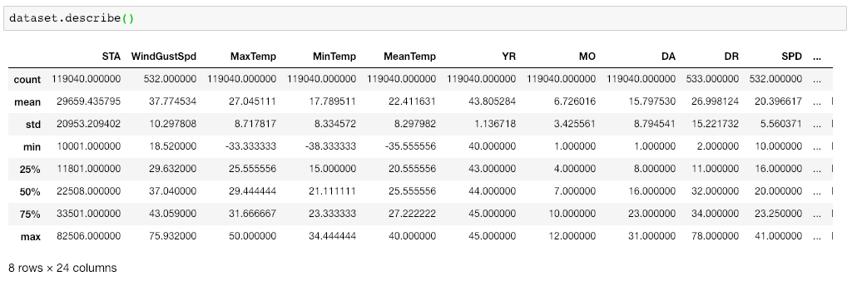

statistical view of the dataset

And finally, let’s plot our data points on a 2-D graph to eyeball our dataset and see if we can manually find any relationship between the data using the below script :

dataset.plot(x='MinTemp', y='MaxTemp', style='o')   
plt.title('MinTemp vs MaxTemp')   
plt.xlabel('MinTemp')   
plt.ylabel('MaxTemp')   
plt.show()

We have taken MinTemp and MaxTemp for doing our analysis. Below is a 2-D graph between MinTemp and MaxTemp.

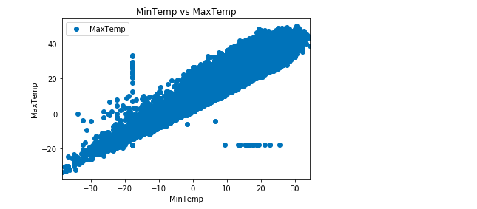

Let’s check the average max temperature and once we plot it we can observe that the Average Maximum Temperature is Between Nearly 25 and 35.

plt.figure(figsize=(15,10))  
plt.tight\_layout()  
seabornInstance.distplot(dataset['MaxTemp'])

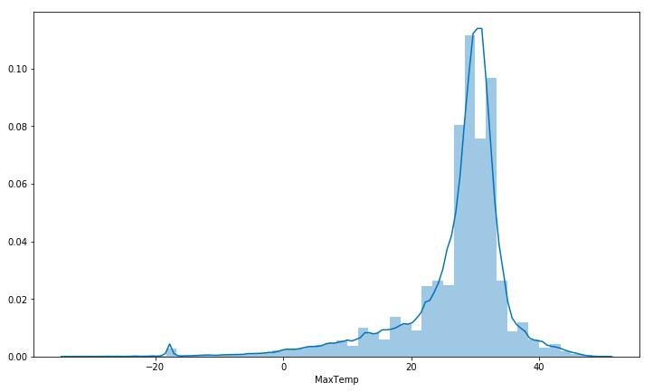

Average maximum temperature which is in between 25 and 35.

Our next step is to divide the data into “attributes” and “labels”.  
Attributes are the independent variables while labels are dependent variables whose values are to be predicted. In our dataset, we only have two columns. We want to predict the MaxTemp depending upon the MinTemp recorded. Therefore our attribute set will consist of the “MinTemp” column which is stored in the X variable, and the label will be the “MaxTemp” column which is stored in y variable.

X = dataset['MinTemp'].values.reshape(-1,1)  
y = dataset['MaxTemp'].values.reshape(-1,1)

Next, we split 80% of the data to the training set while 20% of the data to test set using below code.  
The test\_size variable is where we actually specify the proportion of the test set.

X\_train, X\_test, y\_train, y\_test = train\_test\_split(X, y, test\_size=0.2, random\_state=0)

After splitting the data into training and testing sets, finally, the time is to train our algorithm. For that, we need to import LinearRegression class, instantiate it, and call the fit() method along with our training data.

regressor = LinearRegression()   
regressor.fit(X\_train, y\_train) #training the algorithm

As we have discussed that the linear regression model basically finds the best value for the intercept and slope, which results in a line that best fits the data. To see the value of the intercept and slope calculated by the linear regression algorithm for our dataset, execute the following code.

#To retrieve the intercept:  
print(regressor.intercept\_)#For retrieving the slope:  
print(regressor.coef\_)

The result should be approximately 10.66185201 and  
0.92033997 respectively.

This means that for every one unit of change in Min temperature, the change in the Max temperature is about 0.92%.

Now that we have trained our algorithm, it’s time to make some predictions. To do so, we will use our test data and see how accurately our algorithm predicts the percentage score. To make predictions on the test data, execute the following script:

y\_pred = regressor.predict(X\_test)

Now compare the actual output values for X\_test with the predicted values, execute the following script:

df = pd.DataFrame({'Actual': y\_test.flatten(), 'Predicted': y\_pred.flatten()})  
df

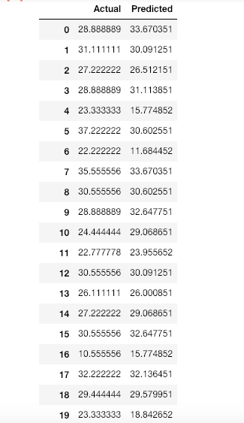

comparison of Actual and Predicted value

We can also visualize comparison result as a bar graph using the below script :

Note: As the number of records is huge, for representation purpose I’m taking just 25 records.

df1 = df.head(25)  
df1.plot(kind='bar',figsize=(16,10))  
plt.grid(which='major', linestyle='-', linewidth='0.5', color='green')  
plt.grid(which='minor', linestyle=':', linewidth='0.5', color='black')  
plt.show()

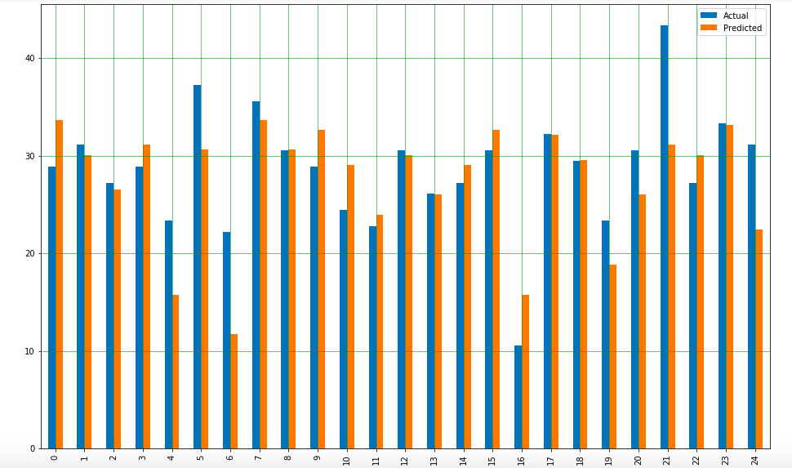

Bar graph showing the comparison of Actual and Predicted values.

Though our model is not very precise, the predicted percentages are close to the actual ones.

Let's plot our straight line with the test data :

plt.scatter(X\_test, y\_test, color='gray')  
plt.plot(X\_test, y\_pred, color='red', linewidth=2)  
plt.show()

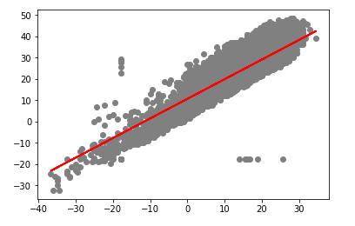

prediction vs test data

The straight line in the above graph shows our algorithm is correct.

The final step is to evaluate the performance of the algorithm. This step is particularly important to compare how well different algorithms perform on a particular dataset. For regression algorithms, three evaluation metrics are commonly used:

1. **Mean Absolute Error**(MAE) is the mean of the absolute value of the errors. It is calculated as:

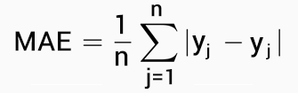

Mean Absolute Error

**2. Mean Squared Error** (MSE) is the mean of the squared errors and is calculated as:

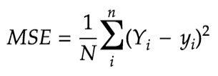

Mean Squared Error

**3. Root Mean Squared Error** (RMSE) is the square root of the mean of the squared errors:

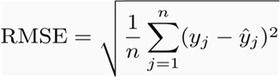

Root Mean Squared Error

Luckily, we don’t have to perform these calculations manually. The Scikit-Learn library comes with pre-built functions that can be used to find out these values for us.

Let’s find the values for these metrics using our test data.

print('Mean Absolute Error:', metrics.mean\_absolute\_error(y\_test, y\_pred))   
print('Mean Squared Error:', metrics.mean\_squared\_error(y\_test, y\_pred))   
print('Root Mean Squared Error:', np.sqrt(metrics.mean\_squared\_error(y\_test, y\_pred)))

You should receive output like this (but probably slightly different):

('Mean Absolute Error:', 3.19932917837853)  
('Mean Squared Error:', 17.631568097568447)  
('Root Mean Squared Error:', 4.198996082109204)

You can see that the value of root mean squared error is 4.19, which is more than 10% of the mean value of the percentages of all the temperature i.e. 22.41. This means that our algorithm was not very accurate but can still make reasonably good predictions.

**Multiple Linear Regression**

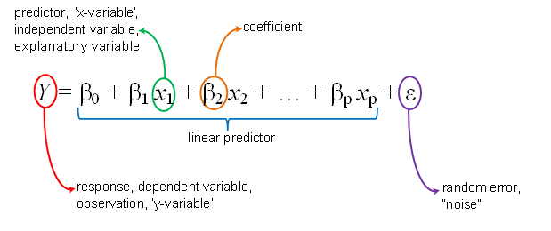

[source](https://hackernoon.com/an-intuitive-perspective-to-linear-regression-7dc566b2c14c)

We just performed linear regression in the above section involving two variables. Almost all the real-world problems that you are going to encounter will have more than two variables. Linear regression involving multiple variables is called “multiple linear regression” or multivariate linear regression. The steps to perform multiple linear regression are almost similar to that of simple linear regression. The difference lies in the evaluation. You can use it to find out which factor has the highest impact on the predicted output and how different variables relate to each other.

In this section, I have downloaded red wine quality dataset. The dataset related to red variants of the Portuguese “[Vinho Verde](https://en.wikipedia.org/wiki/Vinho_Verde" \t "_blank)” wine. Due to privacy and logistic issues, only physicochemical (inputs) and sensory (the output) variables are available (e.g. there is no data about grape types, wine brand, wine selling price, etc.).

You can download the dataset from [here](https://drive.google.com/open?id=195gkZ5cTZL11L308MHc7EyBbAoiB4xqf).

We will take into account various input features like fixed acidity, volatile acidity, citric acid, residual sugar, chlorides, free sulfur dioxide, total sulfur dioxide, density, pH, sulphates, alcohol. Based on these features we will predict the quality of the wine.

Now, let's start our coding :

import all the required libraries :

import pandas as pd   
import numpy as np   
import matplotlib.pyplot as plt   
import seaborn as seabornInstance   
from sklearn.model\_selection import train\_test\_split   
from sklearn.linear\_model import LinearRegression  
from sklearn import metrics  
%matplotlib inline

The following command imports the dataset from the file you downloaded via the link above:

dataset = pd.read\_csv('/Users/nageshsinghchauhan/Documents/projects/ML/ML\_BLOG\_LInearRegression/winequality.csv')

Let’s explore the data a little bit by checking the number of rows and columns in it.

dataset.shape

It will give (1599, 12) as output which means our dataset has 1599 rows and 12 columns.

To see the statistical details of the dataset, we can use describe():

dataset.describe()

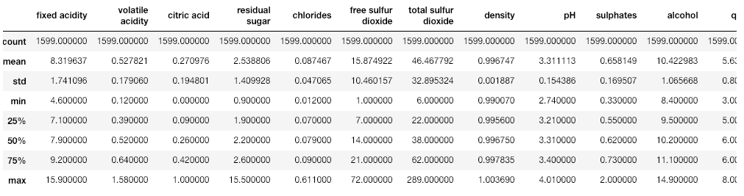

Let us clean our data little bit, So first check which are the columns the contains NaN values in it :

dataset.isnull().any()

Once the above code is executed, all the columns should give False, In case for any column you find True result, then remove all the null values from that column using below code.

dataset = dataset.fillna(method='ffill')

Our next step is to divide the data into “attributes” and “labels”. X variable contains all the attributes/features and y variable contains labels.

X = dataset[['fixed acidity', 'volatile acidity', 'citric acid', 'residual sugar', 'chlorides', 'free sulfur dioxide', 'total sulfur dioxide', 'density', 'pH', 'sulphates','alcohol']].valuesy = dataset['quality'].values

Let's check the average value of the “quality” column.

plt.figure(figsize=(15,10))  
plt.tight\_layout()  
seabornInstance.distplot(dataset['quality'])

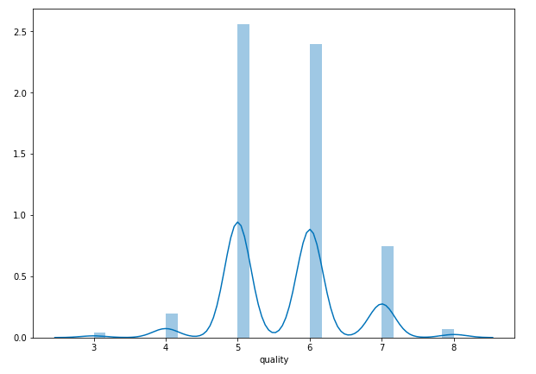

Average value of the quality of the wine.

As we can observe that most of the time the value is either 5 or 6.

Next, we split 80% of the data to the training set while 20% of the data to test set using below code.

X\_train, X\_test, y\_train, y\_test = train\_test\_split(X, y, test\_size=0.2, random\_state=0)

Now lets train our model.

regressor = LinearRegression()   
regressor.fit(X\_train, y\_train)

As said earlier, in the case of multivariable linear regression, the regression model has to find the most optimal coefficients for all the attributes. To see what coefficients our regression model has chosen, execute the following script:

coeff\_df = pd.DataFrame(regressor.coef\_, X.columns, columns=['Coefficient'])   
coeff\_df

it should give output something like :

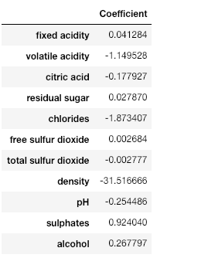

*This means that for a unit increase in “density”, there is a decrease of 31.51 units in the quality of the wine. Similarly, a unit decrease in “Chlorides“ results in an increase of 1.87 units in the quality of the wine. We can see that the rest of the features have very little effect on the quality of the wine.*

Now let's do prediction on test data.

y\_pred = regressor.predict(X\_test)

Check the difference between the actual value and predicted value.

df = pd.DataFrame({'Actual': y\_test, 'Predicted': y\_pred})df1 = df.head(25)

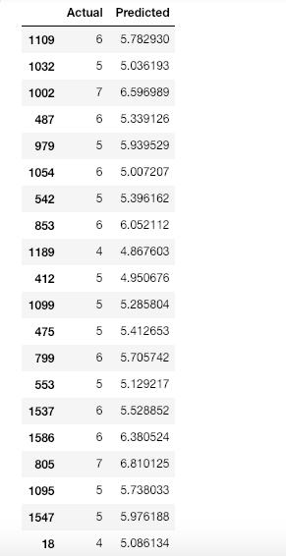

Comparison between Actual and Predicted value

Now let's plot the comparison of Actual and Predicted values

df1.plot(kind='bar',figsize=(10,8))  
plt.grid(which='major', linestyle='-', linewidth='0.5', color='green')  
plt.grid(which='minor', linestyle=':', linewidth='0.5', color='black')  
plt.show()

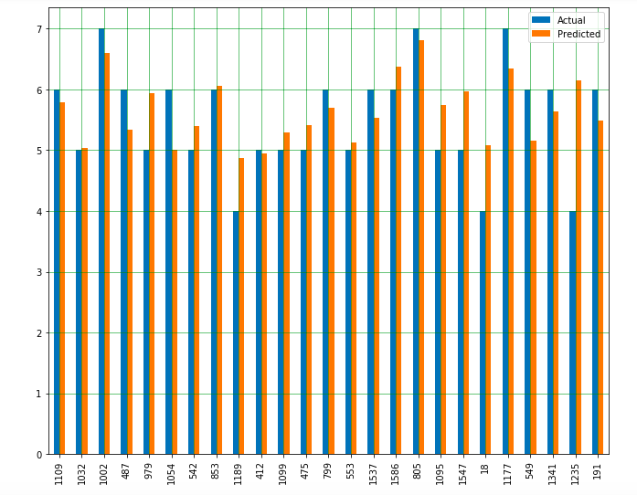

Bar graph showing the difference between Actual and predicted value

As we can observe here that our model has returned pretty good prediction results.

The final step is to evaluate the performance of the algorithm. We’ll do this by finding the values for [MAE](https://en.wikipedia.org/wiki/Mean_absolute_error), [MSE](https://en.wikipedia.org/wiki/Mean_squared_error), and [RMSE](https://en.wikipedia.org/wiki/Root-mean-square_deviation). Execute the following script:

print('Mean Absolute Error:', metrics.mean\_absolute\_error(y\_test, y\_pred))   
print('Mean Squared Error:', metrics.mean\_squared\_error(y\_test, y\_pred))   
print('Root Mean Squared Error:', np.sqrt(metrics.mean\_squared\_error(y\_test, y\_pred)))

The output looks like :

('Mean Absolute Error:', 0.46963309286611077)  
('Mean Squared Error:', 0.38447119782012446)  
('Root Mean Squared Error:', 0.6200574149384268)

You can see that the value of root mean squared error is 0.62, which is slightly greater than 10% of the mean value which is 5.63. This means that our algorithm was not very accurate but can still make reasonably good predictions.

There are many factors that may have contributed to this inaccuracy, for example :

**Need more data**: We need to have a huge amount of data to get the best possible prediction.  
**Bad assumptions**: We made the assumption that this data has a linear relationship, but that might not be the case. Visualizing the data may help you determine that.  
**Poor features**: The features we used may not have had a high enough correlation to the values we were trying to predict.