Requirements Specifications

P02: HerSafar

Student ID | Name
26100105 | Maryam Rizwan
26100405 | Kousar Pervaiz
26100352 | Emaan Waleed
26100365 | Muhammad
26100378 | Muhammad Zain Naseer

Table of Contents

1. Introduction 5
1.1. Background and Motivation 5
1.2. Project Goal 5
1.3. Objectives 5
1.4. Target Users 6
1.5. Potential Customers 6
1.6. Expected Impact 6
2. System Actors 7
3. Use Cases 8
3.1. Use Case Diagrams 8
3.2. Description of Use Cases 9
3.2.1. Book a Ride (Commuter) 9
3.2.2. Cancel Ride (Commuter) 10
3.2.3. Receive Trip Updates (Commuter) 11
3.2.4. Trigger SOS (Commuter) 13
3.2.5. Share Trip Details (Commuter) 14
3.2.6. Make Payment (Commuter/Driver) 15
3.2.7. Rate Ride (Commuter) 16
3.2.8. Send/Receive Voice Messages (Commuter) 17
3.2.9. Offer Ride (Driver) 18
3.2.10. Manage Earnings (Driver) 19
3.2.11. Monitor Trip (Trusted Contacts) 20
3.2.12. Receive SOS (Trusted Contacts) 21
3.2.13. Verify User Identity (Admin) 22
3.2.14. Manage User Accounts (Admin) 23
3.2.15. Monitor Transactions (Admin) 23
3.2.16. Track Rides in Real Time (Admin) 24
3.2.17. Update unsafe Areas (Admin) 25
3.2.18. Send safety alerts (Admin) 26
3.2.19. Analyze system data (Admin) 27
3.2.20. Update Fares and Policies (Admin) 28
4. Class Diagram 30
4.1 Diagram 30
4.2 Description 30
4.2.1. User (Abstract Class) 30
4.2.2. Commuter (Inherits from User) 31
4.2.3. Driver (Inherits from User) 31
4.2.4. Admin (Inherits from User) 31
4.2.5. TrustedContact (Inherits from User) 32
4.2.6. Ride 32
4.2.7. Payment 32
4.2.8. SOSAlert 33
4.2.9. VoiceCommandProcessor 33
5. Sequence Diagrams 34
5.1. Book a Ride (Commuter) 34
5.2. Cancel Ride (Commuter) 35
5.3. Receive Trip Updates (Commuter) 36
5.4. Trigger SOS (Commuter) 37
5.5. Share Trip Details (Commuter) 38
5.6. Make Payment (Commuter/Driver) 39
5.7. Rate Ride (Commuter) 40
5.8. Send/Receive Voice Messages (Commuter) 41
5.9. Offer Ride (Driver) 42
5.10. Manage Earnings (Driver) 43
5.11. Monitor Trip (Trusted Contacts) 44
5.12. Receive SOS 45
5.13. Verify User Identity 46
5.14. Manage User Accounts 47
5.15. Monitor Transactions: 48
5.16. Track Rides in Real-Time 49
5.17. Update Unsafe Areas 50
5.18. Send Safety Alerts: 51
5.19. Analyze System Data 52
5.20. Update Fares & Policies 53
6. State Diagrams 54
6.1 Diagram Details 54
6.1.1 Ride Object State Diagram 54
6.1.2 SOS Alert Object State Diagram 54
6.1.3 Payment Object State Diagram 55
6.2 Diagram 56
7. Data Requirements 57
8. Non-functional Requirements / Quality Attributes 57
9. Security Requirements 58
10. Security Engineer 58
11. Use of Generative AI 59
12. Who Did What? 59
13. Review checklist 59

1. Introduction

1.1. Background and Motivation
Female domestic workers in Pakistan face major commuting challenges. They often travel long distances, with public transport being overcrowded, unreliable, and time-consuming, while private options are too costly, consuming much of their low wages. Men share some of these issues, but women also face added safety risks, making daily travel especially stressful.
Existing digital transport apps fail to address these needs. Most are English-intensive, text-heavy, and complex, requiring reading, typing, and map navigation. For women with low literacy and limited English, these apps are inaccessible, leaving them excluded from technology that could otherwise make commuting safer and more affordable.

1.2. Project Goal
The goal of this project is to design a simple, voice-first commuting platform in Urdu and local languages that ensures both secure and affordable travel for female domestic workers. By removing the need for reading or typing, the platform will make commuting support accessible to women with low literacy and minimal digital skills. The system will enable them to plan safe routes, arrange affordable carpools, and receive real-time spoken updates, while prioritizing secure travel through features like a buddy system, SOS emergency alerts, and trusted contact sharing.

1.3. Objectives
- Accessibility – Design an inclusive, voice-based system in local languages that does not require reading, typing, or English proficiency.
- Safety – Provide secure travel features such as a buddy system, trusted contact sharing, real-time updates, and an SOS emergency function.
- Affordability – Offer cost-effective commuting options, including carpool coordination and optimized route planning.
- Ease of Use – Build a simple, intuitive interface for users with minimal digital skills.
- Reliability – Deliver real-time information and updates to ensure dependable commuting support.

1.4. Target Users
The primary users are female domestic workers in Pakistan, particularly those with low literacy and little to no English proficiency. Secondary stakeholders include their families, employers, and communities, who will benefit from the increased safety, reliability, and affordability of domestic workers’ commutes.

1.5. Potential Customers
- Non-Governmental Organizations (NGOs) and women’s rights groups working to improve safety and mobility for female workers.
- Government agencies and development organizations interested in supporting women’s workforce participation.
- Corporate CSR programs focused on gender equality, mobility, and community development.

1.6. Expected Impact
By introducing an easy-to-use, voice-based system, this project aims to empower female domestic workers by making their commutes safer, more affordable, and less stressful. It will reduce their vulnerability, improve their mobility, and support their participation in the workforce, ultimately contributing to their overall well-being.

2. System Actors

Actor Name | Description
Commuter | Commuters are the main users of the application, typically female domestic workers and other vulnerable groups. They use voice commands to find safe, affordable carpools, share their live location with trusted contacts, and access emergency safety features like SOS alerts.
Driver | Drivers are individuals offering rides along their daily routes. They interact with the system to register rides, receive optimized route suggestions, and collect secure payments through the app.
Trusted Contact | Trusted contacts are family members, friends, or guardians linked to a commuter’s account. They receive live trip updates, alerts, and SOS notifications to ensure the commuter’s safety during travel.
Admin | Admins manage the platform’s overall operations. They verify user profiles, monitor system activity, respond to SOS alerts, handle dispute resolution, and ensure the platform remains safe and trustworthy.

3. Use Cases

3.1. Use Case Diagrams

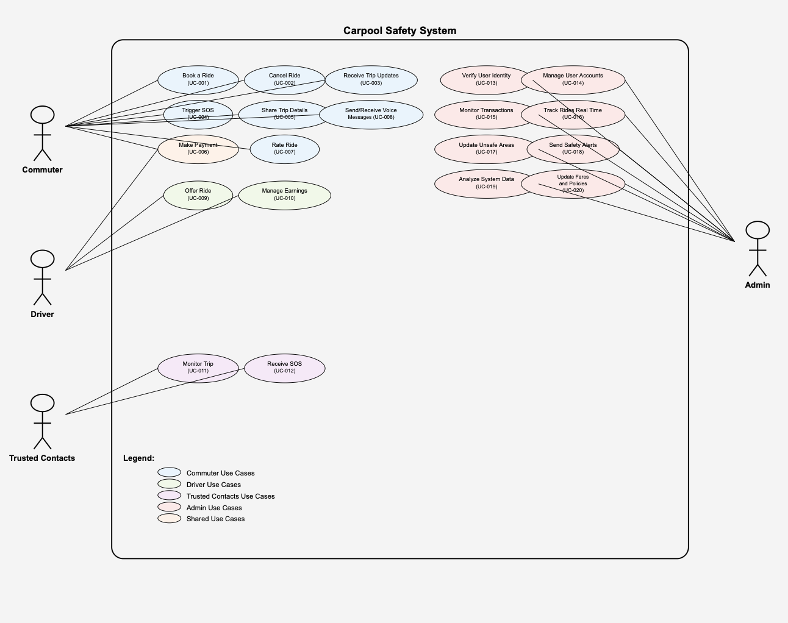

3.2. Description of Use Cases

3.2.1. Book a Ride (Commuter)

Identifier |  | UC-001
Purpose |  | The commuter uses voice commands to book a safe and affordable carpool.
Pre-conditions |  | User is registered and logged in. Location access enabled.
Post-conditions |  | Ride is confirmed, details are shared with trusted contact.
Step # | Typical Course of Action
 | Commuter opens app.
 | Commuter states the destination by voice in Urdu (e.g., “Model Town, Lahore”).
 | The system processes the spoken input using Urdu speech recognition, identifies the location, and searches for available drivers/carpools.
 | AI analyzes the options and suggests the most optimal, safe, and affordable match.
 | Commuter confirms the ride by voice.
 | Trip details (driver info, route, expected time) are displayed in audio and text form, and automatically shared with trusted contacts.
Step # | Alternate Courses of Action
4. | If the commuter says “Cancel” or declines the suggested ride, the system aborts the booking process and returns to the home screen.
2. | If no rides are available for the requested destination, the system informs the commuter and suggests safe alternate routes, such as nearby bus stops or shared rickshaw options. The commuter can either select one of these alternatives or exit.
4. | If internet connectivity is weak, the system delivers ride confirmation and trip updates via SMS to both the commuter and their trusted contacts.
Step # | Exception Paths
2. | If the system fails to recognize the commuter’s voice input after multiple attempts, it notifies the commuter of the issue and directs them to the help menu for manual assistance.
3. | If the commuter’s destination cannot be recognized after multiple attempts, the system notifies the commuter and cancels the ride booking.

3.2.2. Cancel Ride (Commuter)

Identifier |  | UC-002
Purpose |  | Cancel a booked ride.
Pre-conditions |  | Commuter has an active booking.  Location access and network connectivity are enabled.
Post-conditions |  | Ride canceled, driver notified, trusted contacts updated about the cancellation.
Step # | Typical Course of Action
1. | Commuter says “Cancel my ride” via voice command.
2. | System confirms the cancellation with the commuter (e.g., “Are you sure you want to cancel this ride?”).
3. | Commuter confirms cancellation.
4.. | System cancels the booking, notifies the driver, and updates trusted contacts about the cancellation.
5. | System informs the commuter that the ride has been successfully canceled.
Step # | Alternate Courses of Action
4. |  | If the cancellation is close to the ride start time, the system informs the commuter that a cancellation penalty may apply. The commuter can choose to proceed or abort the cancellation.
Step # | Exception Paths
1. | If the system cannot detect the voice command due to network issues, the commuter can cancel via SMS.
4. | If the system fails to notify the driver or contacts due to a technical error, the system retries and alerts the commuter if the update cannot be delivered.

3.2.3. Receive Trip Updates (Commuter)

Identifier |  | UC-003
Purpose |  | Provide spoken updates on trip progress to the commuter.
Pre-conditions |  | Trip is currently active.  Location access and network connectivity are enabled.
Post-conditions |  | Commuter is informed about driver arrival, delays, detours, or route changes.
Step # | Typical Course of Action
1. | System sends a spoken notification to the commuter in Urdu regarding trip status (e.g., driver arrival, delays, or route changes).
2. | Commuter acknowledges the update (optional).
3. | System logs the acknowledgment and continues monitoring the trip.
Step # | Alternate Courses of Action
1. | If the commuter is offline or has poor network connectivity, the system sends the update via SMS instead of voice.
Step # | Exception Paths
1. | If the commuter misses a spoken update (e.g., due to phone being muted), the system stores the update in a notification log for later access.
1. | If network or system failure prevents sending an update, the system retries automatically and logs any failures for review.

3.2.4. Trigger SOS (Commuter)

Identifier |  | UC-004
Purpose |  | Allow the commuter to alert trusted contacts and administrators in case of an emergency.
Pre-conditions |  | - Trip is currently active.  - Location access and network connectivity are enabled
Post-conditions |  | - SOS alert is sent to trusted contacts and admin with live GPS location.  - Authorities may be notified if escalated by admin.
Step # | Typical Course of Action
1. | Commuter presses the SOS button in the app.
2. | System immediately sends SOS alerts to trusted contacts and admin, including live GPS location of the commuter.
3. | Admin receives alert and may escalate the situation to local authorities if required.
4. | System continues to monitor the commuter’s location until the situation is resolved or canceled.
Step # | Alternate Courses of Action
2. | If the commuter is offline or has poor network connectivity, the system sends the SOS alert via SMS to trusted contacts and admin.
Step # | Exception Paths
1. | If the SOS is triggered accidentally, the commuter can cancel the alert within 10 seconds. The system then notifies contacts/admin that it was a false alarm and aborts escalation.
2. | If the system fails to send the SOS due to network or technical issues, it retries automatically and logs the failure.

3.2.5. Share Trip Details (Commuter)

Identifier |  | UC-005
Purpose |  | Keep trusted contacts informed about the commuter’s trip, including start, route, and live location.
Pre-conditions |  | - Commuter has linked trusted contacts.  - Trip has started.  - Location access and network connectivity are enabled.
Post-conditions |  | - Trusted contacts receive notifications about trip start, route, and live location.  - Contacts are kept updated throughout the trip unless they opt out.
Step # | Typical Course of Action
1. | Trip begins.
2. | System automatically notifies all linked trusted contacts with trip start, route, and live location updates.
3. | System continues to send periodic location updates and route progress to contacts until the trip ends or the commuter cancels sharing.
Step # | Alternate Courses of Action
2. | If a trusted contact chooses to stop receiving updates, the system stops sending notifications to that contact.
Step # | Exception Paths
1. | If location services are disabled on the commuter’s device, the system notifies the commuter and aborts sharing trip details until location is enabled.
2. | If network or system failure prevents sending updates, the system retries automatically and logs failures.

3.2.6. Make Payment (Commuter/Driver)

Identifier |  | UC-006
Purpose |  | Allow the commuter to pay for a completed ride, either digitally or via cash, and ensure the driver receives credit.
Pre-conditions |  | - Ride has been completed.  - Commuter has linked digital wallet/payment method if paying digitally.  - Network connectivity is enabled for digital payments.
Post-conditions |  | - Payment is successfully logged in the system.  - Driver is credited for the ride.  - Payment history is updated for both commuter and driver.
Step # | Typical Course of Action
1. | Commuter selects a payment option (digital or cash).
2. | If digital payment is selected, the system processes the transfer via linked wallet or card. If cash is selected, commuter confirms payment to the driver.
3. | System records the transaction, updates payment history, and notifies both commuter and driver of successful payment.
Step # | Alternate Courses of Action
2. | If digital payment fails (e.g., insufficient balance, network issue), the system prompts the commuter to fallback to cash payment.
Step # | Exception Paths
2. | If payment processing times out or fails repeatedly, the system retries automatically. If retries fail, the system notifies the commuter and driver, marks the payment as failed, and prompts the commuter to retry the payment manually or choose an alternate payment method.

3.2.7. Rate Ride (Commuter)

Identifier |  | UC-007
Purpose |  | Enable commuters to rate drivers, building a trust system and improving service quality.
Pre-conditions |  | Ride completed.
Post-conditions |  | - Rating is successfully stored in the driver’s profile.  - Driver’s overall rating is updated.
Step # | Typical Course of Action
1. | System prompts the commuter to rate the driver after ride completion.
2. | Commuter provides a rating via voice command (in Urdu/local language) or by tapping the interface.
3. | System records the rating and updates the driver’s profile.
Step # | Alternate Courses of Action
2. | Commuter chooses to skip rating. The system does not record a rating but allows future ratings for subsequent rides.
Step # | Exception Paths
2. | Invalid input (e.g., out-of-range rating or unclear voice input) is ignored. The system prompts the commuter to provide a valid rating.

3.2.8. Send/Receive Voice Messages (Commuter)

Identifier |  | UC-008
Purpose |  | Allow commuters to communicate via voice messages without typing, ensuring accessibility and convenience.
Pre-conditions |  | - User is logged in.  - App has permission to access microphone.
Post-conditions |  | - Voice message is delivered securely to the recipient.  - Recipient is notified of the incoming message.
Step # | Typical Course of Action
1. | Commuter records a voice note using the app.
2. | System encrypts the message and sends it to the recipient.
3. | Recipient receives a notification and can play the voice message.
Step # | Alternate Courses of Action
2. | If internet connection is weak, the system stores the message locally and forwards it automatically once the connection becomes stable.
Step # | Exception Paths
2. | If the message file is corrupted during recording or transmission, the system prompts a resend to ensure successful delivery.

3.2.9. Offer Ride (Driver)

Identifier |  | UC-009
Purpose |  | Allow verified drivers to post ride availability, enabling commuters to view and book rides.
Pre-conditions |  | - Driver is verified and logged in.  - Vehicle information and route details are available.
Post-conditions |  | - Ride is listed in the system for matching with commuters.  - System suggests the optimal, safe route for the driver.
Step # | Typical Course of Action
1. | Driver posts ride details including origin, destination, time, and vehicle info.
2. | System analyzes the route and suggests an optimized and safe path.
3. | Ride listing goes live and is available for commuters to book.
Step # | Alternate Courses of Action
2. | If the posted route is flagged as unsafe, the system suggests an alternative safe route for the driver.
Step # | Exception Paths
1. | If required ride details (e.g., origin, destination, time) are missing or invalid, the system rejects the posting and prompts the driver to provide complete information.

3.2.10. Manage Earnings (Driver)

Identifier |  | UC-010
Purpose |  | Allow drivers to track completed ride payments, view balances, and manage earnings efficiently.
Pre-conditions |  | - Driver has completed one or more rides.  - Driver is logged in.
Post-conditions |  | - Earnings log is updated with all completed transactions.  - Driver can view, export, and monitor earnings.
Step # | Typical Course of Action
1. | Driver opens the earnings section of the app.
2. | System displays a detailed log of completed transactions, including fare, payment method, and date.
Step # | Alternate Courses of Action
2. | Driver can export the earnings summary as a CSV or PDF file for personal record-keeping or accounting purposes.
Step # | Exception Paths
2. | If a payment dispute is detected (e.g., fare discrepancy or failed payment), the system flags the transaction for review and alerts the driver and admin.

3.2.11. Monitor Trip (Trusted Contacts)

Identifier |  | UC-011
Purpose |  | Allow trusted contacts to monitor the commuter’s trip progress and location for safety purposes.
Pre-conditions |  | - Commuter has linked trusted contacts in the system.  - Trip is active.  - Location access and network connectivity are enabled.
Post-conditions |  | - Trusted contacts are updated about the commuter’s trip status.  - Live tracking is available until trip completion.
Step # | Typical Course of Action
1. | Trip begins, and system sends notification to trusted contact.
2. | Trusted contact opens the app (or SMS link) to view commuter’s trip details and live location.
3. | System continues to update contact with trip progress in real-time.
Step # | Alternate Courses of Action
1. | If the trusted contact is offline, trip status and updates are sent via SMS.
Step # | Exception Paths
1. | If the commuter disables trip sharing, the trusted contact cannot view trip updates and is notified accordingly.

3.2.12. Receive SOS (Trusted Contacts)

Identifier |  | UC-012
Purpose |  | Ensure trusted contacts are immediately informed of commuter emergencies.
Pre-conditions |  | - Trusted contact is linked to the commuter.  - The commuter is on an active trip.
Post-conditions |  | Contact aware of commuter’s emergency.
Step # | Typical Course of Action
1. | Commuter triggers SOS.
2. | System generates SOS alert with commuter’s live GPS location.
3. | Trusted contact receives the SOS notification on the app.
Step # | Alternate Courses of Action
3. | If the trusted contact is offline, the system delivers the SOS alert via SMS.
Step # | Exception Paths
3. | If the alert delivery fails (due to network/server issues), the system retries automatically until confirmation of delivery is received.

3.2.13. Verify User Identity (Admin)

Identifier |  | UC-013
Purpose |  | Ensure only trusted users are approved for the platform.
Pre-conditions |  | User has applied for an account and submitted required documents (CNIC/license).
Post-conditions |  | User is either approved or rejected based on verification.
Step # | Typical Course of Action
1. | Admin reviews the submitted CNIC/license.
2. | Admin cross-checks the details with the database/official records.
3. | Admin approves or rejects the user’s account.
Step # | Alternate Courses of Action
1. | If the documents are unclear or incomplete, the admin requests resubmission from the user.
Step # | Exception Paths
3. | If documents are found to be forged, the system suspends the user’s account and flags it for investigation.

3.2.14. Manage User Accounts (Admin)

Identifier |  | UC-014
Purpose |  | Maintain a secure and updated user base.
Pre-conditions |  | Admin is logged into the system with valid credentials.
Post-conditions |  | User account(s) are added, updated, or removed as per admin action.
Step # | Typical Course of Action
1. | Admin searches for a user.
2. | Admin applies changes (add/update/remove).
3. | System confirms action.
Step # | Alternate Courses of Action
2. | Admin performs bulk updates (multiple accounts at once).
Step # | Exception Paths
1. | If admin is unauthorized, the system blocks the action and logs the attempt.

3.2.15. Monitor Transactions (Admin)

Identifier |  | UC-015
Purpose |  | Ensure payment transparency and maintain financial integrity.
Pre-conditions |  | All payments must be recorded in the system.
Post-conditions |  | Transactions are verified, flagged, or reported as necessary.
Step # | Typical Course of Action
1. | Admin reviews transaction logs.
2. | Admin flags any disputes or suspicious entries.
Step # | Alternate Courses of Action
1. | System auto-generates transaction reports for admin review.
Step # | Exception Paths
1. | If fraud detection is triggered, the system immediately alerts the admin and suspends the suspicious transaction(s).

3.2.16. Track Rides in Real Time (Admin)

Identifier |  | UC-016
Purpose |  | Monitor ongoing trips to ensure commuter and driver safety.
Pre-conditions |  | Active rides must be in progress.
Post-conditions |  | Admin dashboard is updated with live ride information, and anomalies (if any) are flagged.
Step # | Typical Course of Action
1. | Admin opens the real-time dashboard to view active rides.
2. | System fetches live GPS and ride status data.
3. | Any anomalies (delays, SOS alerts, unsafe routes) are highlighted on the dashboard.
Step # | Alternate Courses of Action
3. | Admin proactively sends a warning or message to the commuter/driver in case of detected anomalies.
Step # | Exception Paths
1. | If connection to the tracking service is lost, the system retries automatically until restored.

3.2.17. Update unsafe Areas (Admin)

Identifier |  | UC-017
Purpose |  | Keep database of unsafe/red zones updated for routing.
Pre-conditions |  | - Admin logged in.  - Reports of unsafe zones received.
Post-conditions |  | - Unsafe zones added or updated in system.  - Users warned if they plan routes through those zones.
Step # | Typical Course of Action
1. | Admin inputs new unsafe location into database.
2. | System updates map alerts.
3. | Commuters/drivers are warned when routes intersect unsafe zones.
Step # | Alternate Courses of Action
1. | Admin performs bulk upload of multiple unsafe areas.
Step # | Exception Paths
2. | Invalid entry flagged by system and rejected.

3.2.18. Send safety alerts (Admin)

Identifier |  | UC-018
Purpose |  | Alert commuters and drivers about urgent safety risks.
Pre-conditions |  | - Admin logged in.  - Threat identified (e.g., strike, road closure).
Post-conditions |  | - Users notified with alert.  - Trips adjusted if needed.
Step # | Typical Course of Action
1. | Admin drafts alert message.
2. | System sends push notification to all affected users.
Step # | Alternate Courses of Action
2. | For critical threats, system initiates automated voice call alerts.
Step # | Exception Paths
2. | If push delivery fails, system retries or sends SMS fallback.

3.2.19. Analyze system data (Admin)

Identifier |  | UC-019
Purpose |  | Allow admin to view analytics and improve platform services.
Pre-conditions |  | - Usage and transaction data logged.  - Admin logged in.
Post-conditions |  | - Reports generated and stored.  - Insights used for decision-making.
Step # | Typical Course of Action
1. | Admin opens analytics dashboard.
2. | System generates charts/reports of usage, rides, payments, and safety incidents.
3. | Admin reviews trends and patterns.
Step # | Alternate Courses of Action
3. | Admin exports data for external analysis.
Step # | Exception Paths
2. | If data corruption detected, system restores from backup.

3.2.20. Update Fares and Policies (Admin)

Identifier |  | UC-020
Purpose |  | Enable admin to adjust fare rules and platform policies.
Pre-conditions |  | - Admin logged in.  - Existing fare and policy structure available.
Post-conditions |  | - Updated fares/policies visible in the app.  - Future rides use new structure.
Step # | Typical Course of Action
1. | Admin opens fare/policy settings.
2. | Admin updates values or terms.
3. | System applies changes and logs update.
Step # | Alternate Courses of Action
3. | Instead of immediate application, system schedules changes to take effect at midnight to avoid confusion during active rides.
Step # | Exception Paths
3. | Invalid or incomplete entry rejected by system, with admin prompted to correct.

4. Class Diagram

4.1 Diagram

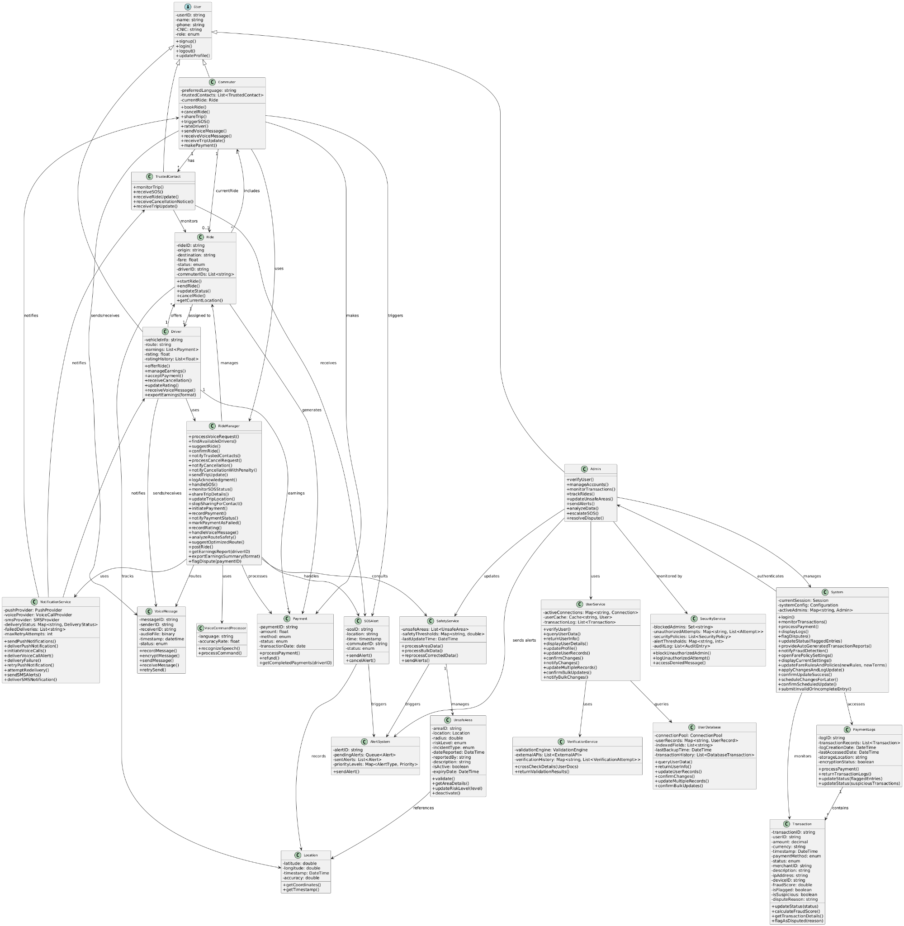

4.2 Description

4.2.1. User (Abstract Class)
Purpose:
Base class representing any type of user in the system (Commuter, Driver, TrustedContact, Admin).
Attributes:
- userID (string): Unique user identifier.
- name (string): User’s full name.
- phone (string): Registered phone number.
- CNIC (string): National ID for verification.
- role (enum: Commuter, Driver, TrustedContact, Admin): Defines user role type.
Methods:
- signup(): Registers new user.
- login(): Authenticates user.
- logout(): Ends current session.
- updateProfile(): Edits basic user info.

4.2.2. Commuter (Inherits from User)
Purpose:
Represents a passenger using the app to book, manage, and share rides.
Attributes:
- preferredLanguage (string): For voice command localization.
- trustedContacts[] (list of TrustedContact): Linked contacts for safety alerts.
- currentRide (Ride): Current or active ride info.

Methods:
- bookRide(): Start a new ride booking
- cancelRide(): Cancel an active booking
- shareTrip(): Share live trip info with trusted contacts
- triggerSOS(): Trigger an emergency alert
- rateDriver(): Submit feedback after ride
- sendVoiceMessage(): Record and send a voice message
- receiveVoiceMessage(): Play a received message
- receiveTripUpdate(): Receive trip progress updates
- makePayment(): Pay for completed rides

4.2.3. Driver (Inherits from User)
Purpose:
Represents the ride provider — manages rides, payments, and communication.
Attributes:
- vehicleInfo (string): Vehicle registration and details.
- route (string): Default or preferred driving route.
- earnings[] (list of Payment): Record of payments and completed rides.
- rating (float): Average feedback score.
- ratingHistory[] (list of float): Past ratings for transparency.
Methods:
- offerRide(): Post ride availability
- manageEarnings(): View and manage income
- acceptPayment(): Confirm received payment.
- receiveCancellation(): Handle commuter ride cancellations.
- updateRating(): Update driver rating post feedback.
- receiveVoiceMessage(): Get messages from commuters
- exportEarnings(format): Export earnings summary as CSV/PDF

4.2.4. Admin (Inherits from User)
Purpose:
Oversees operations, verifies users, manages disputes, and handles emergencies.
Methods:
- verifyUser(): Approve or reject user accounts.
- manageAccounts(): Edit, disable, or restore user profiles.
- monitorTransactions(): Review platform payment logs.
- trackRides(): View real-time ride data.
- updateUnsafeAreas(): Flag risky areas for route planning.
- sendAlerts(): Send platform-wide alerts.
- analyzeData(): Generate safety and performance insights.
- escalateSOS(): Contact authorities for emergencies
- resolveDispute(): Review and settle payment issues

4.2.5. TrustedContact (Inherits from User)
Purpose:
Monitors commuter safety during rides.
Methods:
- monitorTrip(): Track live trip location.
- receiveSOS(): Receive SOS notifications.
- receiveRideUpdate(): Get trip progress updates.
- receiveCancellationNotice(): Get alerts when a ride is canceled.
- receiveTripUpdate(): Get general trip notifications.

4.2.6. Ride
Purpose:
Represents a specific trip between a commuter and driver.
Attributes:
- rideID (string): Unique ride ID.
- origin (string): Starting point.
- destination (string): End location.
- fare (float): Cost of the ride.
- status (enum: Scheduled, Active, Completed, Cancelled): Ride state.
- driverID (string): Assigned driver.
- commuterIDs[] (list of strings): Participating commuters.
Methods:
- startRide(): Begin ride tracking.
- endRide(): Mark ride as complete.
- updateStatus(): Modify ride state.
- cancelRide(): Abort ride.
- getCurrentLocation(): Retrieve live GPS location.

4.2.7. Payment
Purpose:
Handles financial transactions between commuter and driver.
Attributes:
- paymentID (string): Unique transaction ID.
- amount (float): Total amount.
- method (enum: Cash, Digital): Payment type.
- status (enum: Pending, Completed, Failed): Payment state.
- transactionDate (date): Transaction timestamp.
Methods:
- processPayment(): Complete payment transaction
- refund(): Reverse payment if required.
- getCompletedPayments(driverID): Fetch driver’s completed payments

4.2.8. SOSAlert
Purpose:
Handles emergency alerts triggered by commuters.
Attributes:
- sosID (string): Unique SOS ID.
- location (string): GPS coordinates at trigger time.
- time (timestamp): Alert creation time.
- commuterID (string): Who triggered it.
- status (enum: Active, Resolved, Cancelled): Alert state.
Methods:
- sendAlert(): Notify admin and contacts
- cancelAlert(): Cancel false alarms

4.2.9. VoiceCommandProcessor
Purpose:
Processes Urdu/local-language speech into commands.
Attributes:
- language (string): Detected language.
- accuracyRate (float): Confidence level of speech recognition.
Methods:
- recognizeSpeech(): Convert speech to text.
- processCommand(): Map spoken words to system actions.

4.2.10. RideManager
Purpose:
Central controller that manages rides, payments, SOS, communications, and system coordination.
Methods:
- processVoiceRequest()
- findAvailableDrivers()
- suggestRide()
- confirmRide()
- notifyTrustedContacts()
- processCancelRequest()
- notifyCancellation()
- notifyCancellationWithPenalty()
- sendTripUpdate()
- logAcknowledgment()
- handleSOS()
- monitorSOSStatus()
- shareTripDetails()
- updateTripLocation()
- stopSharingForContact()
- initiatePayment()
- recordPayment()
- notifyPaymentStatus()
- markPaymentAsFailed()
- recordRating()
- handleVoiceMessage()
- analyzeRouteSafety()
- suggestOptimizedRoute()
- postRide()
- getEarningsReport(driverID)
- exportEarningsSummary(format)
- flagDispute(paymentID)

4.2.11. VoiceMessage
Purpose:
Manages recording, encryption, and delivery of voice messages between users.
Attributes:
- messageID (string)
- senderID (string)
- receiverID (string)
- audioFile (binary)
- timestamp (datetime)
- status (enum: Pending, Sent, Delivered, Failed)
Methods:
- recordMessage()
- encryptMessage()
- sendMessage()
- receiveMessage()
- retrySend()

4.2.12. NotificationService
Purpose:
Unified notification service that handles multiple delivery channels including push, voice, and SMS.
Attributes:
- pushProvider (PushProvider)
- voiceProvider (VoiceCallProvider)
- smsProvider (SMSProvider)
- deliveryStatus (Map<string, DeliveryStatus>)
- failedDeliveries (List)
- maxRetryAttempts (int)
Methods:
- sendPushNotifications()
- deliverPushNotification()
- initiateVoiceCalls()
- deliverVoiceCallAlert()
- deliveryFailure()
- retryPushNotification()
- attemptRedelivery()
- sendSMSAlerts()
- deliverSMSNotification()

4.2.13. Location
Purpose:
Represents geographical location data for tracking ride positions.
Attributes:
- latitude (double)
- longitude (double)
- timestamp (DateTime)
- accuracy (double)
Methods:
- getCoordinates()
- getTimestamp()

4.2.14. VerificationService
Purpose:
Service that validates user identity documents through official databases.
Attributes:
- validationEngine (ValidationEngine)
- externalAPIs (List)
- verificationHistory (Map<string, List>)
Methods:
- crossCheckDetails(UserDocs userDocs)
- returnValidationResults()

4.2.15. UserDatabase
Purpose:
Database layer that stores and manages all user account information.
Attributes:
- connectionPool (ConnectionPool)
- userRecords (Map<string, UserRecord>)
- indexedFields (List)
- lastBackupTime (DateTime)
- transactionHistory (List)
Methods:
- queryUserData()
- returnUserInfo()
- updateUserRecords()
- confirmChanges()
- updateMultipleRecords()
- confirmBulkUpdates()

4.2.16. UserService
Purpose:
Handles user operations such as verification, updates, and management.
Attributes:
- activeConnections (Map<string, Connection>)
- userCache (Cache<string, User>)
- transactionLog (List)
Methods:
- verifyUser()
- queryUserData()
- returnUserInfo()
- displayUserDetails()
- updateProfile()
- updateUserRecords()
- confirmChanges()
- notifyChanges()
- updateMultipleRecords()
- confirmBulkUpdates()
- notifyBulkChanges()

4.2.17. SecurityService
Purpose:
Handles access control, unauthorized access detection, and security logging.
Attributes:
- blockedAdmins (Set)
- unauthorizedAttempts (Map<string, List>)
- securityPolicies (List)
- alertThresholds (Map<string, int>)
- auditLog (List)
Methods:
- blockUnauthorizedAdmin()
- logUnauthorizedAttempt()
- accessDeniedMessage()

4.2.18. System
Purpose:
Main controller that coordinates authentication, transaction monitoring, and reporting.
Attributes:
- currentSession (Session)
- systemConfig (Configuration)
- activeAdmins (Map<string, Admin>)
Methods:
- login()
- monitorTransactions()
- processPayment()
- displayLogs()
- flagDisputes()
- updateStatus(List flaggedEntries)
- provideAutoGeneratedTransactionReports()
- notifyFraudDetection()
- openFarePolicySettings()
- displayCurrentSettings()
- updateFareRulesAndPolicies(FareRules newRules, Terms newTerms)
- applyChangesAndLogUpdate()
- confirmUpdateSuccess()
- scheduleChangesForLater()
- confirmScheduledUpdate()
- submitInvalidOrIncompleteEntry()

4.2.19. PaymentLogs
Purpose:
Stores and manages all payment transaction logs.
Attributes:
- logID (string)
- transactionRecords (List)
- logCreationDate (DateTime)
- lastAccessedDate (DateTime)
- storageLocation (string)
- encryptionStatus (boolean)
Methods:
- processPayment()
- returnTransactionLogs()
- updateStatus(List flaggedEntries)
- updateStatus(List suspiciousTransactions)

4.2.20. Transaction
Purpose:
Represents a single payment transaction with fraud detection.
Attributes:
- transactionID (string)
- userID (string)
- amount (decimal)
- currency (string)
- timestamp (DateTime)
- paymentMethod (enum: Card, Wallet, BankTransfer, Cash)
- status (enum: Completed, Pending, Failed, Flagged, Suspicious, Disputed)
- merchantID (string)
- description (string)
- ipAddress (string)
- deviceID (string)
- fraudScore (double)
- isFlagged (boolean)
- isSuspicious (boolean)
- disputeReason (string)

Methods:
- updateStatus(string status)
- calculateFraudScore()
- getTransactionDetails()
- flagAsDisputed(string reason)

4.2.21. AlertSystem
Purpose:
Manages and distributes proactive warnings and safety alerts.
Attributes:
- alertID (string)
- pendingAlerts (Queue)
- sentAlerts (List)
- priorityLevels (Map<AlertType, Priority>)
Methods:
- sendAlert()

4.2.22. SafetyService
Purpose:
Manages safety operations and unsafe area alerts.
Attributes:
- unsafeAreas (List)
- safetyThresholds (Map<string, double>)
- lastUpdateTime (DateTime)
Methods:
- processAreaData()
- processBulkData()
- reprocessCorrectedData()
- sendAlerts()

4.2.23. UnsafeArea
Purpose:
Represents a marked unsafe area with risk data.
Attributes:
- areaID (string)
- location (Location)
- radius (double)
- riskLevel (enum: Low, Medium, High, Critical)
- incidentType (enum: Crime, Accident, NaturalDisaster, Other)
- dateReported (DateTime)
- reportedBy (string)
- description (string)
- isActive (boolean)
- expiryDate (DateTime)
Methods:
- validate()
- getAreaDetails()
- updateRiskLevel(string level)
- deactivate()

5. Sequence Diagrams

5.1. Book a Ride (Commuter)

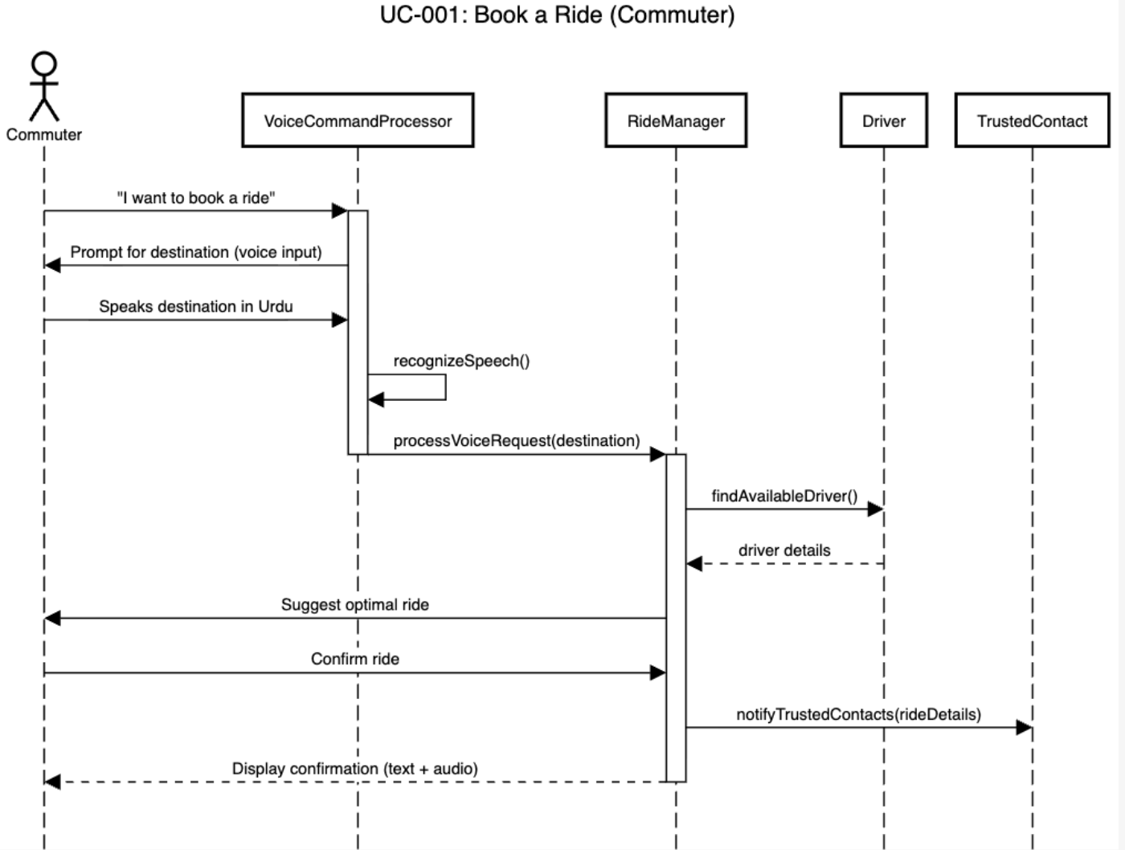

5.2. Cancel Ride (Commuter)

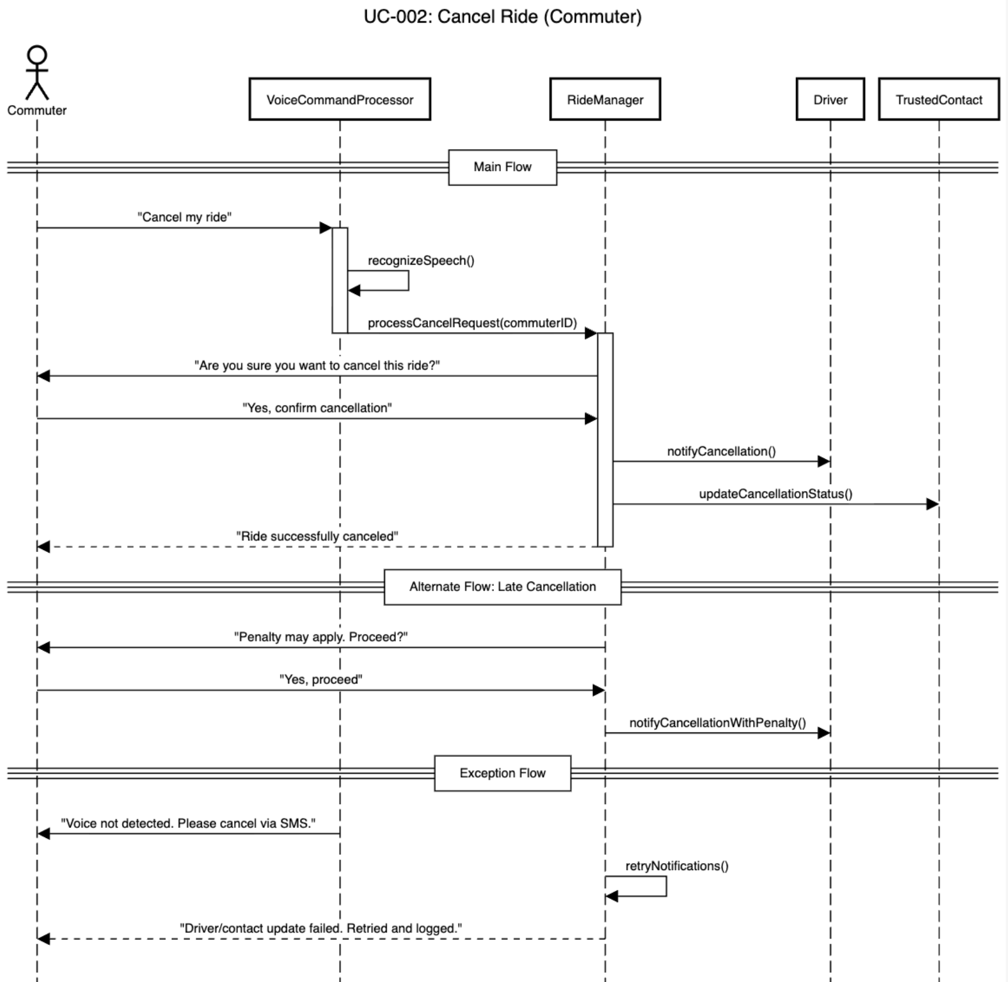

5.3. Receive Trip Updates (Commuter)

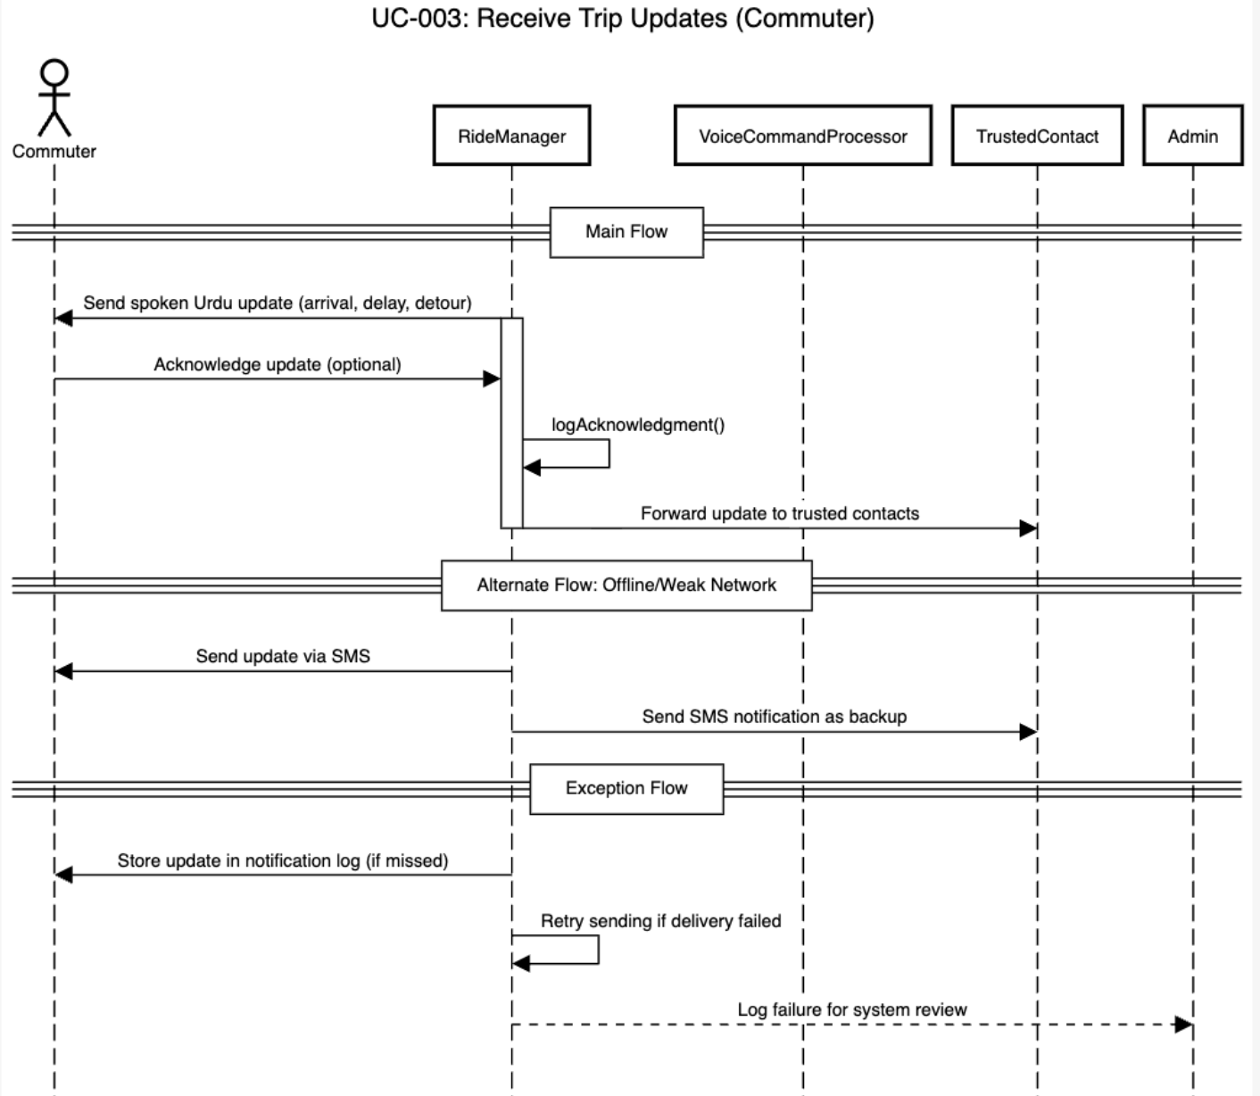

5.4. Trigger SOS (Commuter)

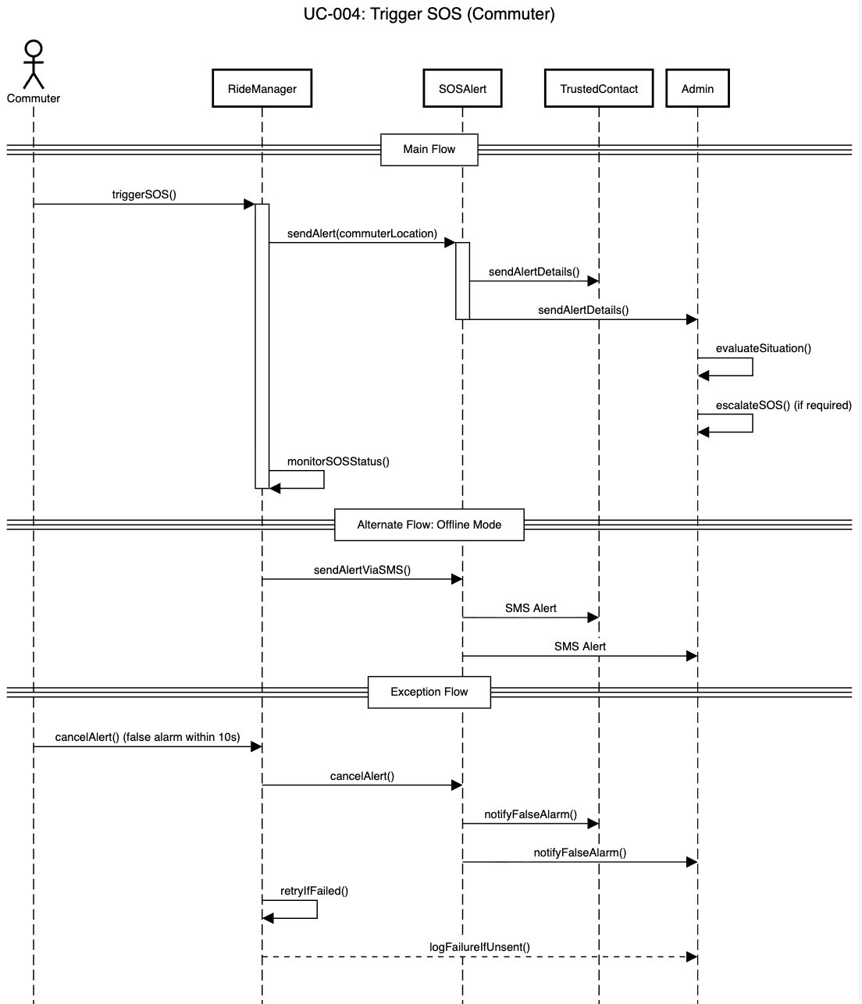

5.5. Share Trip Details (Commuter)

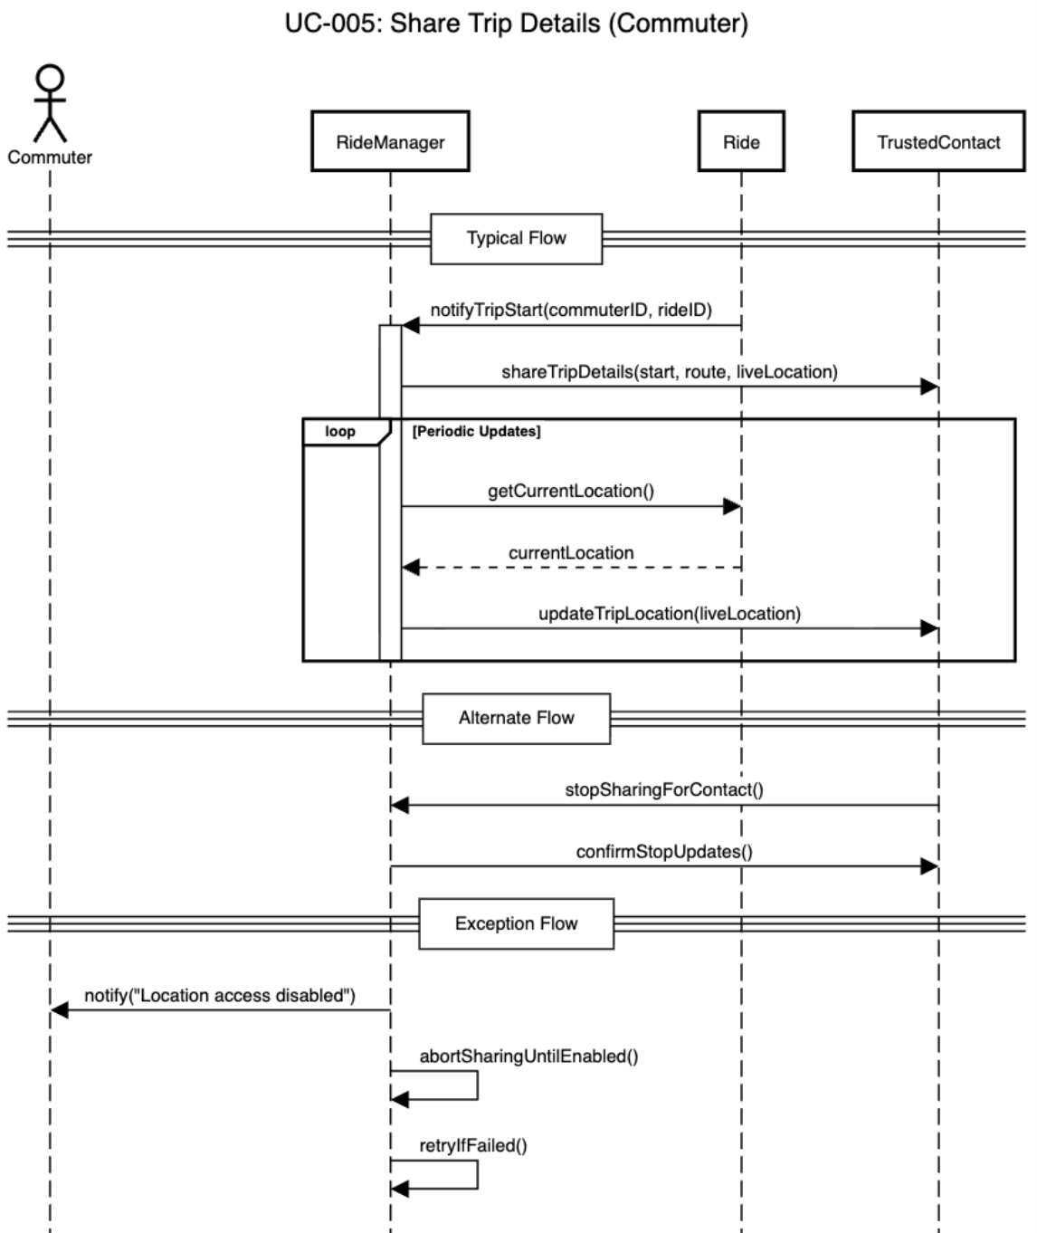

5.6. Make Payment (Commuter/Driver)
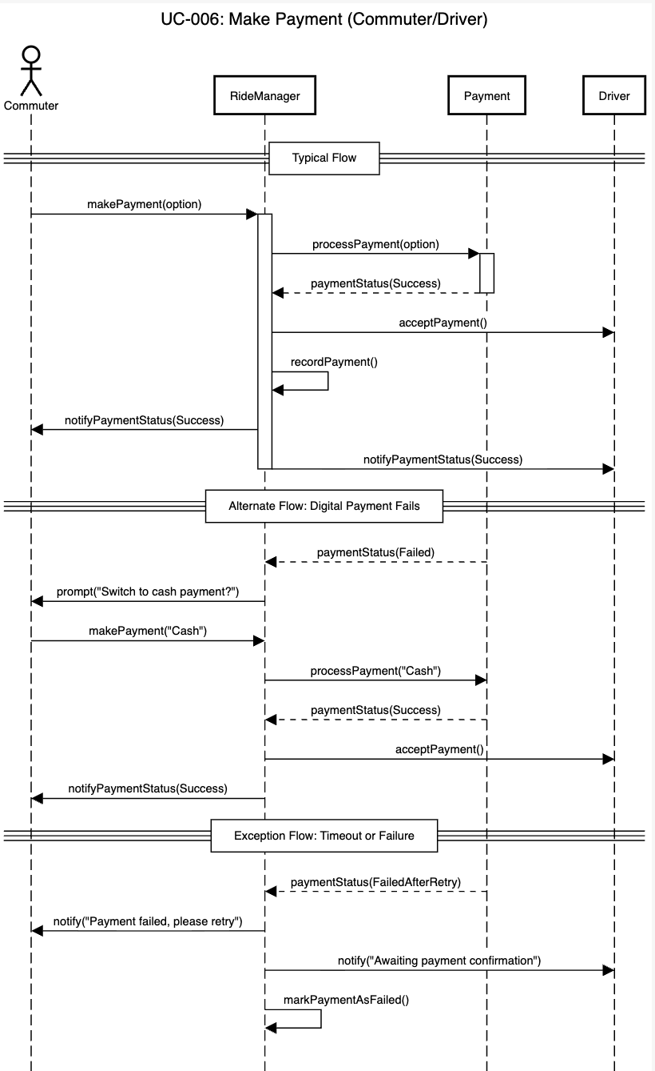

5.7. Rate Ride (Commuter)

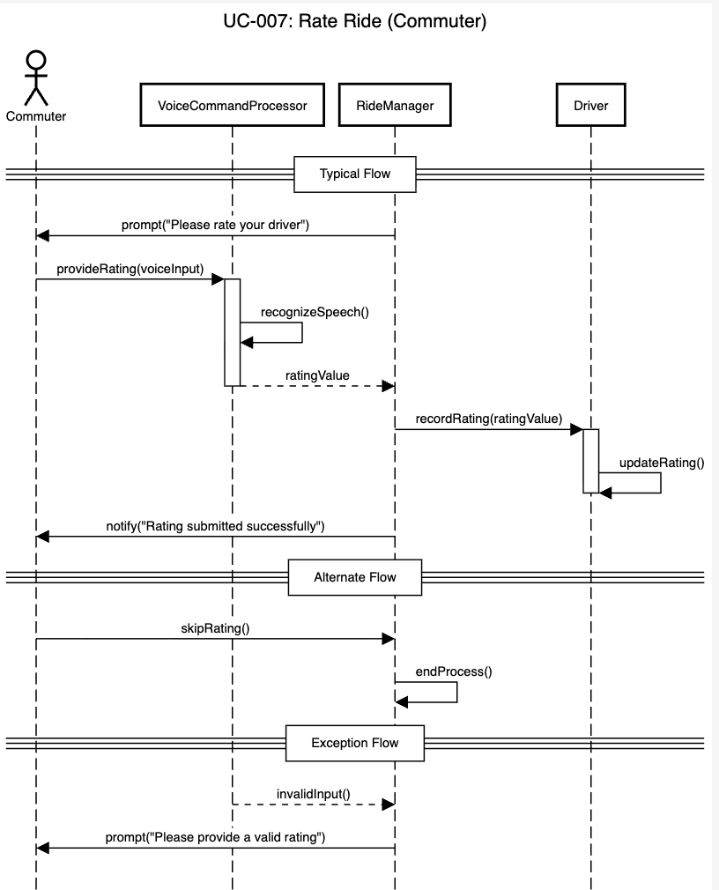

5.8. Send/Receive Voice Messages (Commuter)

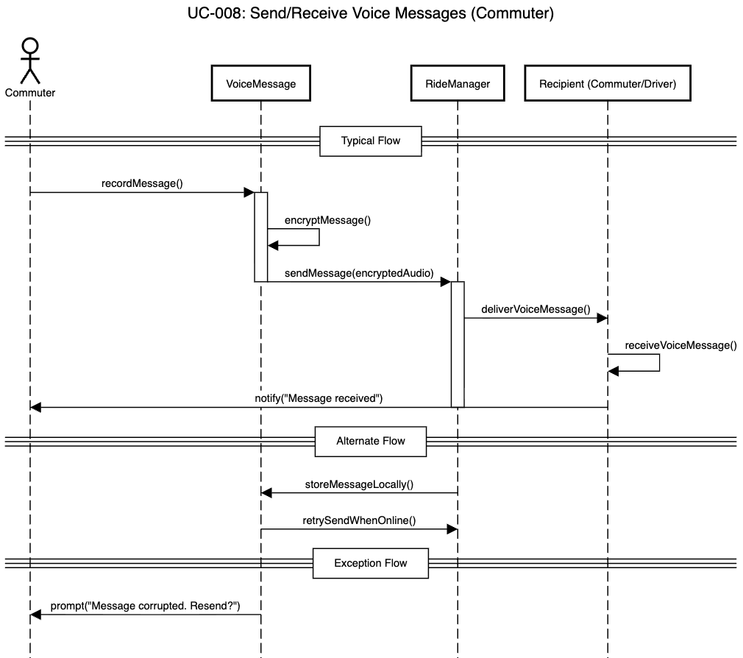

5.9. Offer Ride (Driver)

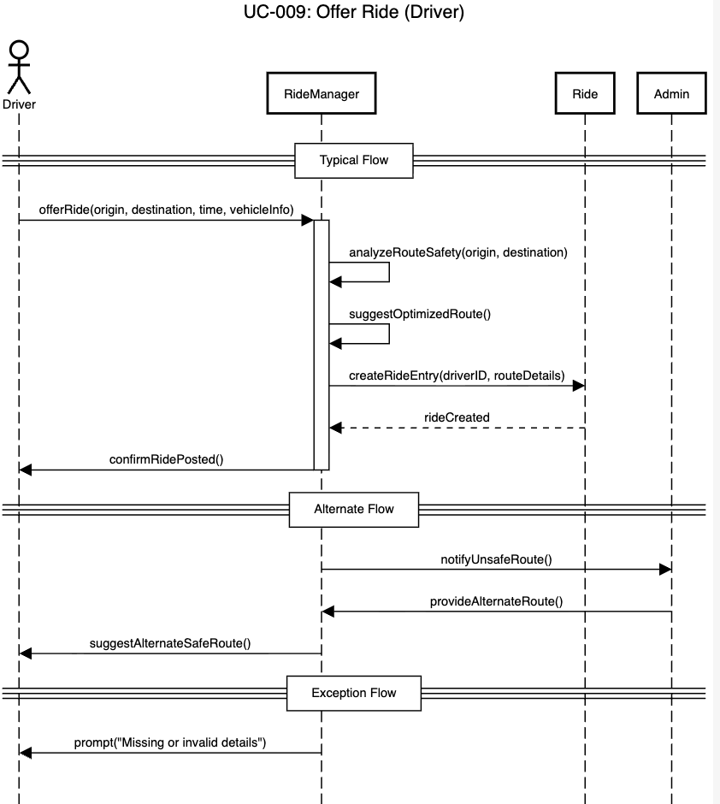

5.10. Manage Earnings (Driver)

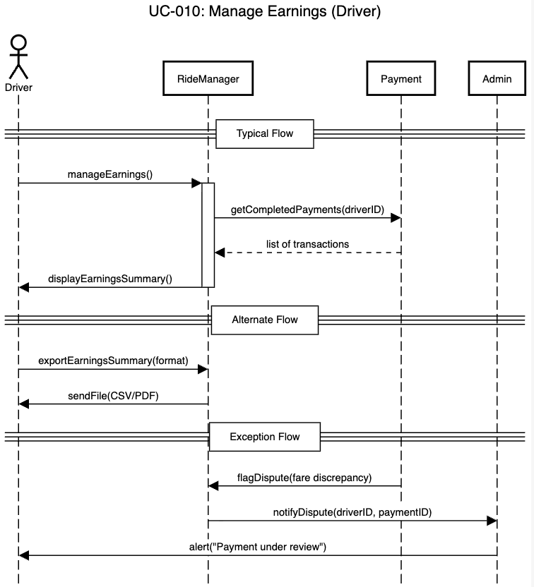

5.11. Monitor Trip (Trusted Contacts)

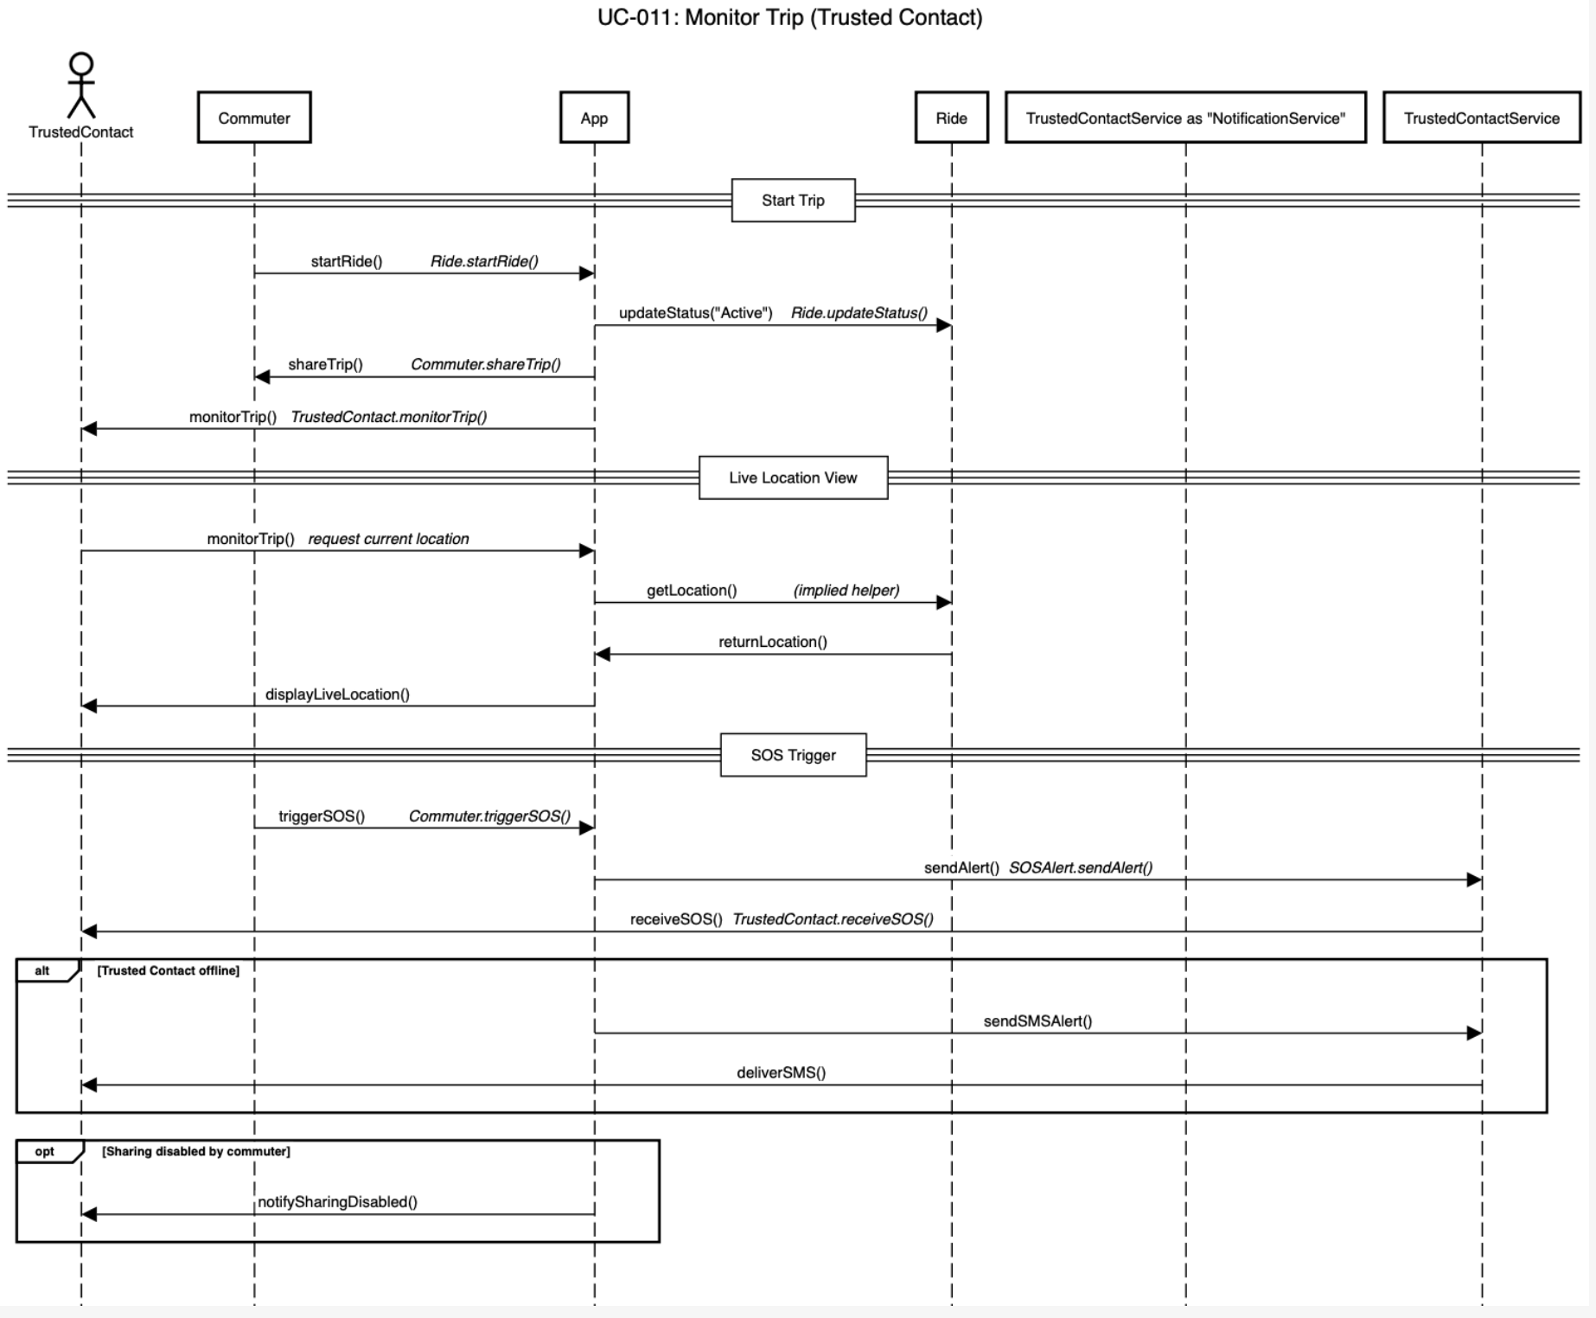

5.12. Receive SOS

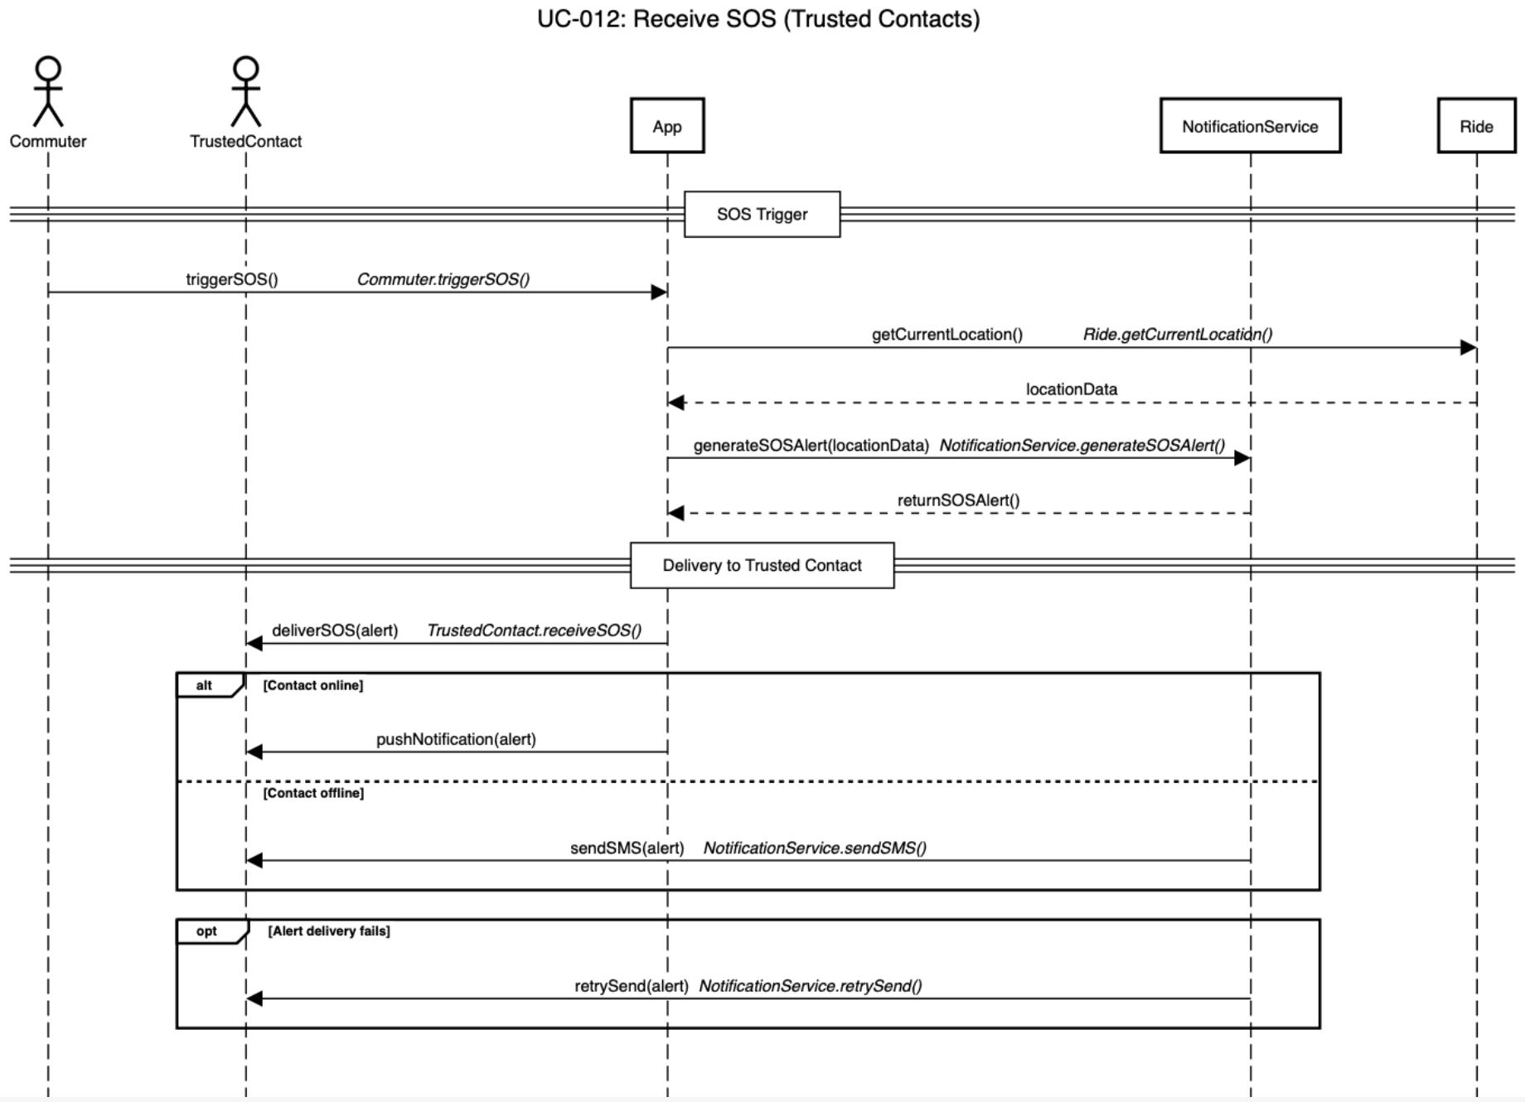

5.13. Verify User Identity

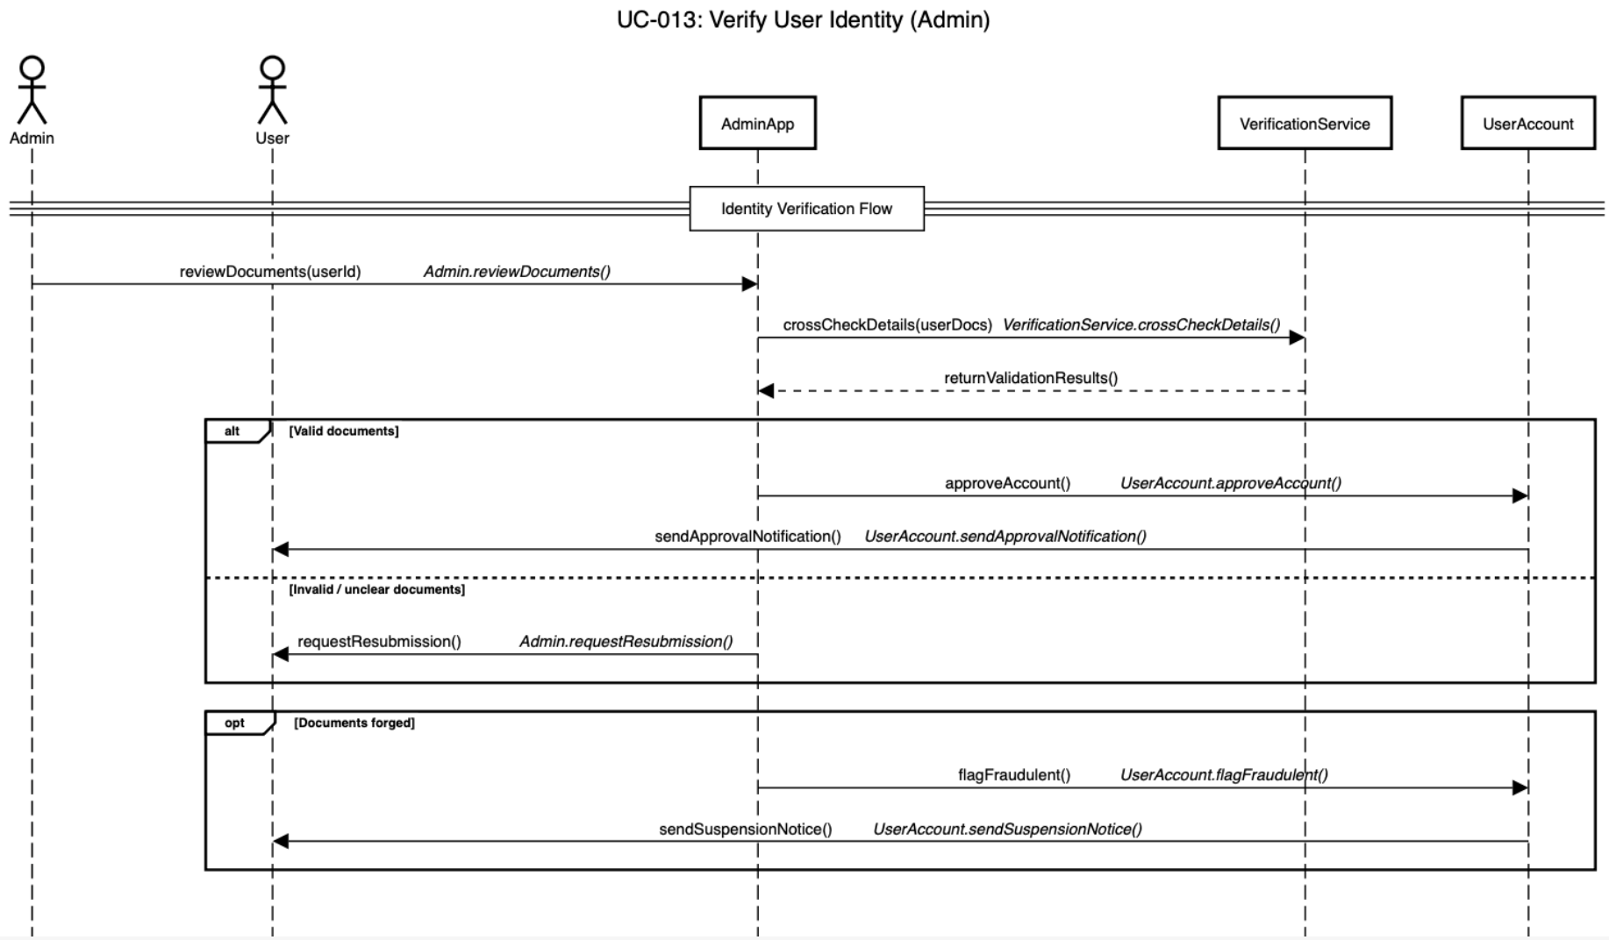

5.14. Manage User Accounts

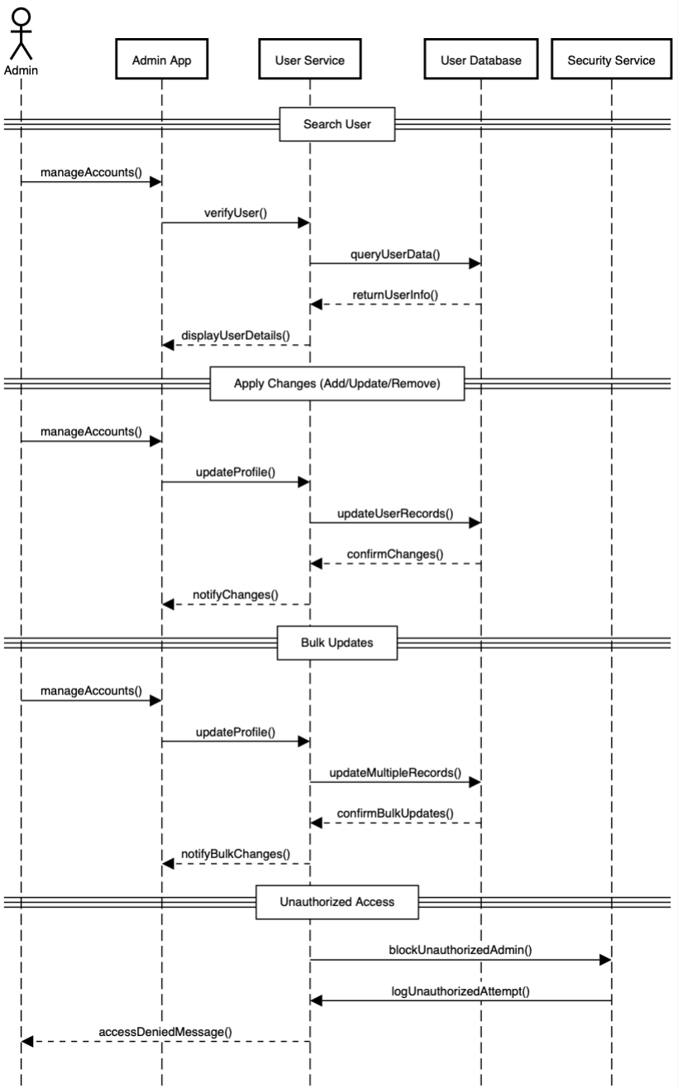

5.15. Monitor Transactions:

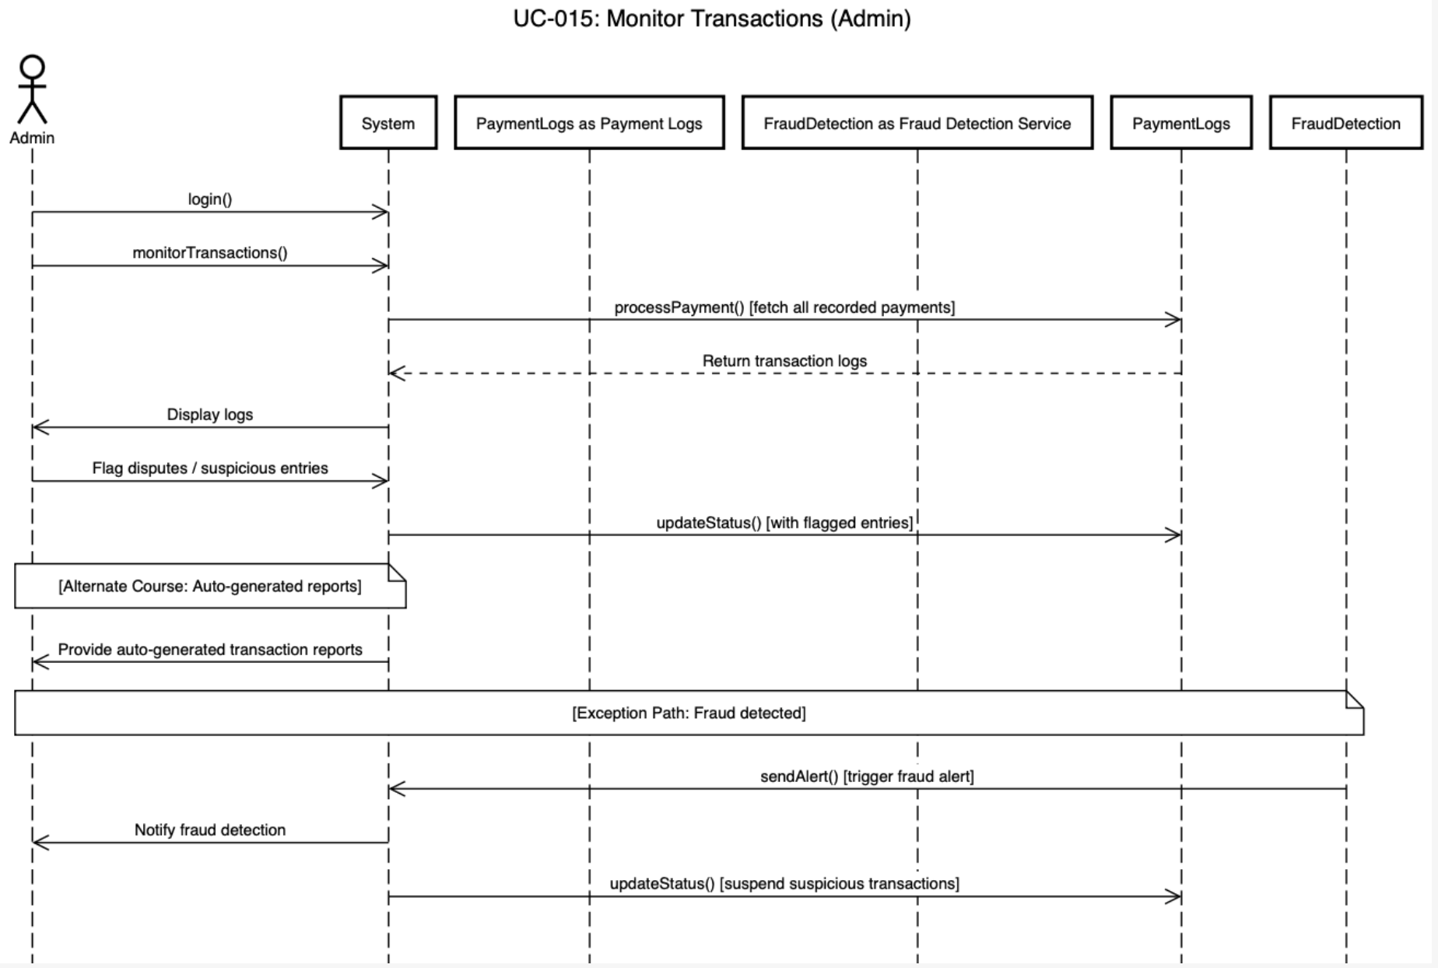

5.16. Track Rides in Real-Time

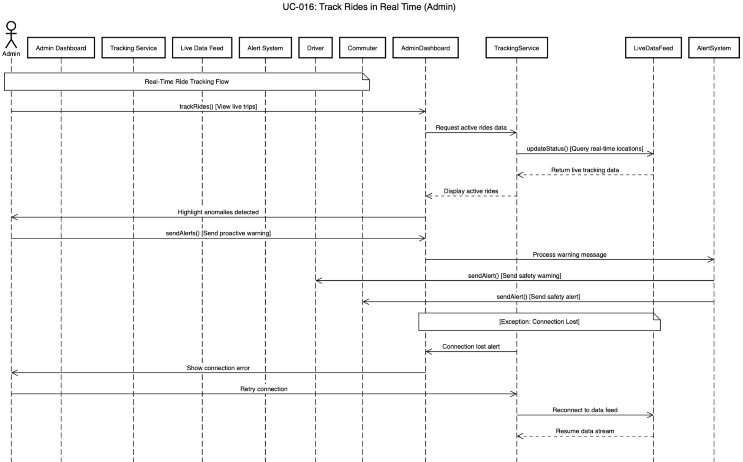

5.17. Update Unsafe Areas

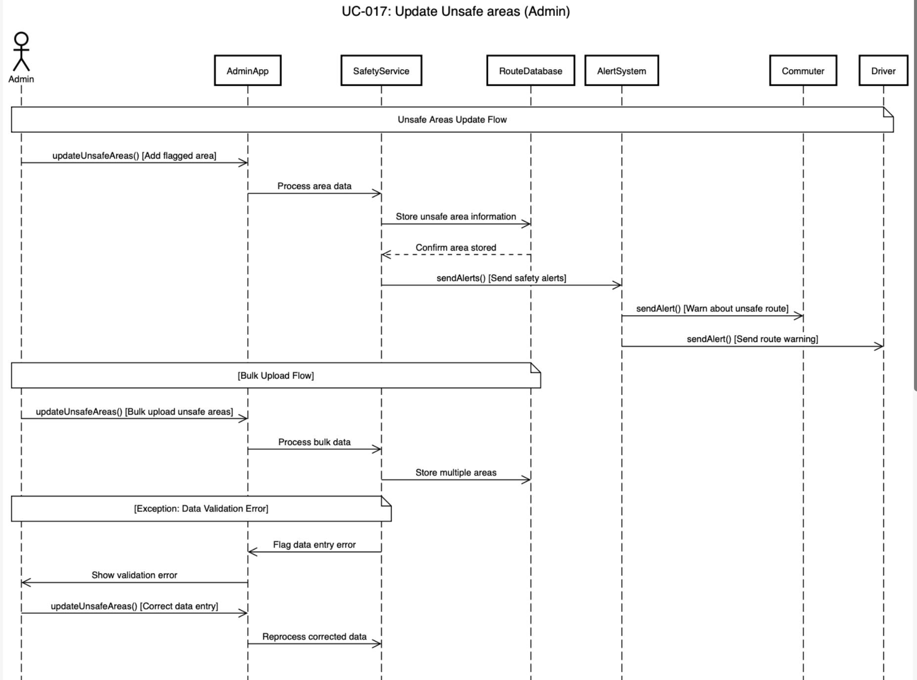

5.18. Send Safety Alerts:

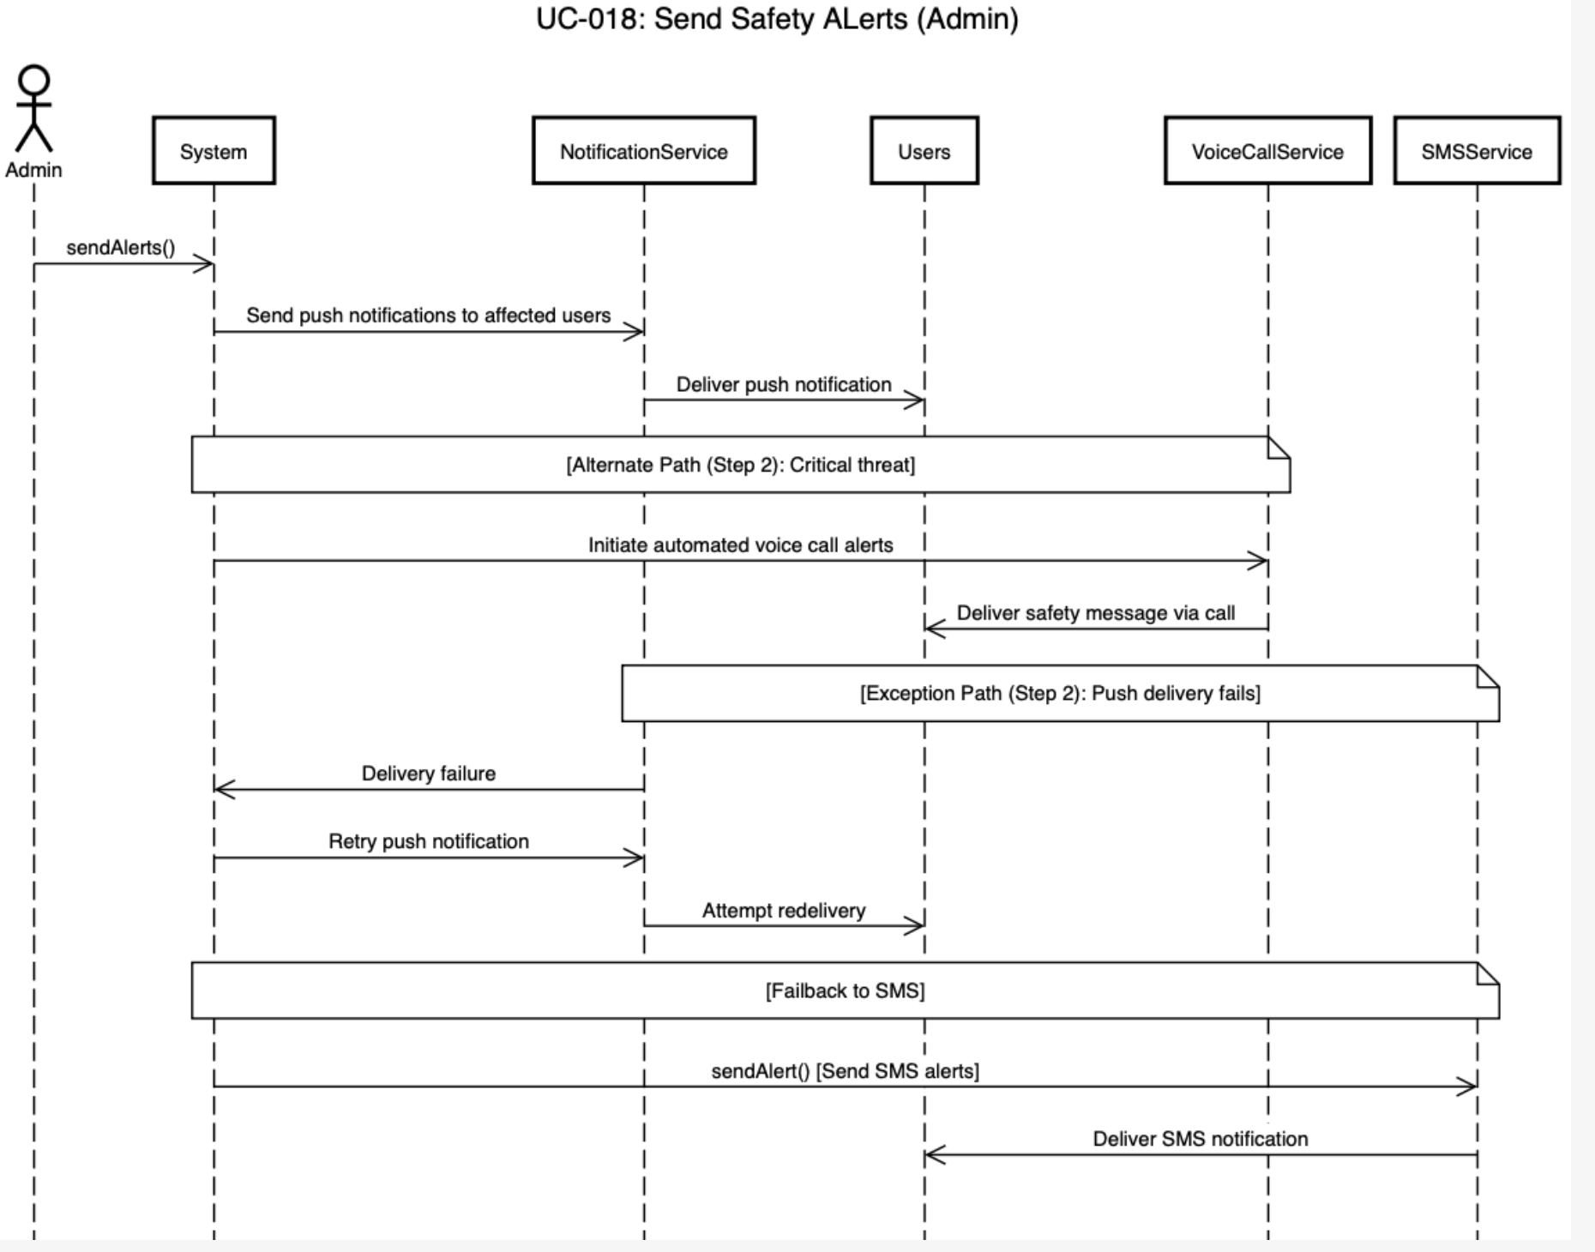

5.19. Analyze System Data

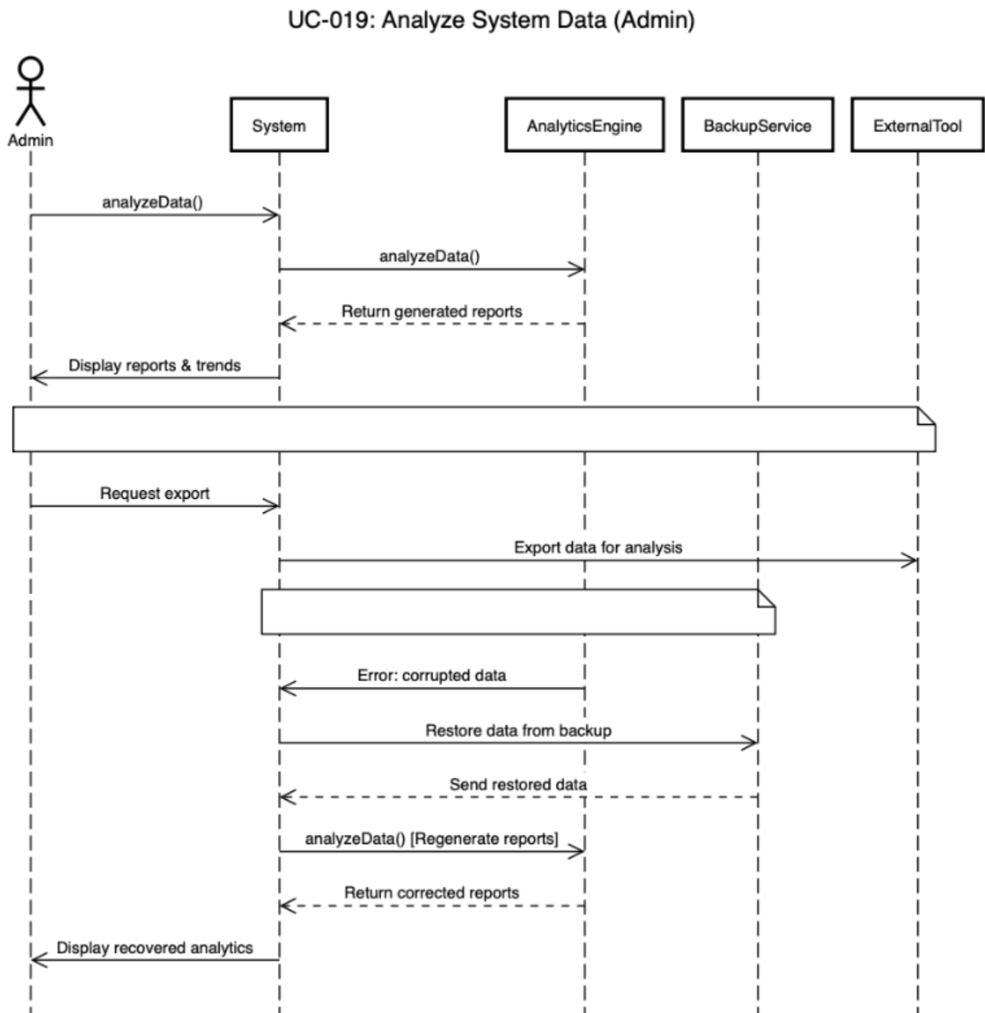

5.20. Update Fares & Policies

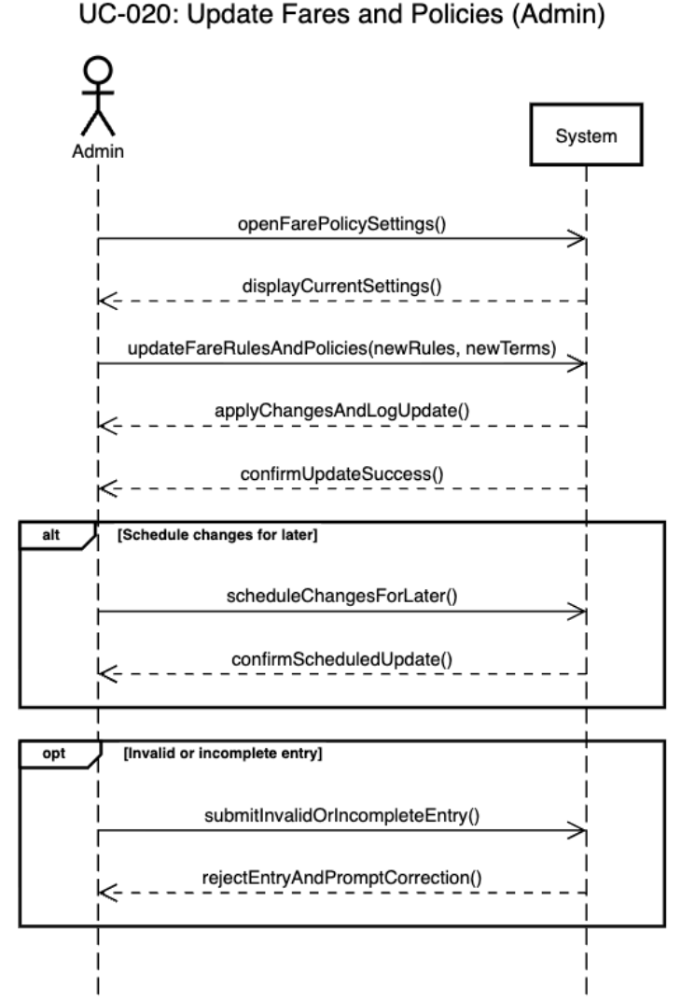

6. State Diagrams

6.1 Diagram Details

This section presents state diagrams for key objects in the HerSafar system. State diagrams model the behavior of objects by showing different states and transitions between them in response to events and conditions. The following objects have been selected for state modeling due to their complex lifecycles and critical role in system functionality.

6.1.1 Ride Object State Diagram

Object Name: Ride
Purpose: Models the complete lifecycle of a ride booking from initial request to final completion/cancellation

States:
- Requested: Commuter has requested a ride, system searching for drivers
- Matched: System found and matched driver with commuter
- Confirmed: Both driver and commuter have accepted the match
- InProgress: Ride is actively happening with live tracking enabled
- Emergency: SOS has been triggered during the ride
- Completed: Ride reached destination successfully
- PendingPayment: Ride completed, awaiting payment processing
- Paid: Payment successfully processed
- Cancelled: Ride was cancelled at any stage

Key Events/Messages:
- Driver Available, Both Parties Accept, Driver Arrives, Trip Starts
- SOS Triggered, Destination Reached, Payment Successful
- Commuter Cancels, Driver Declines, Emergency Resolved

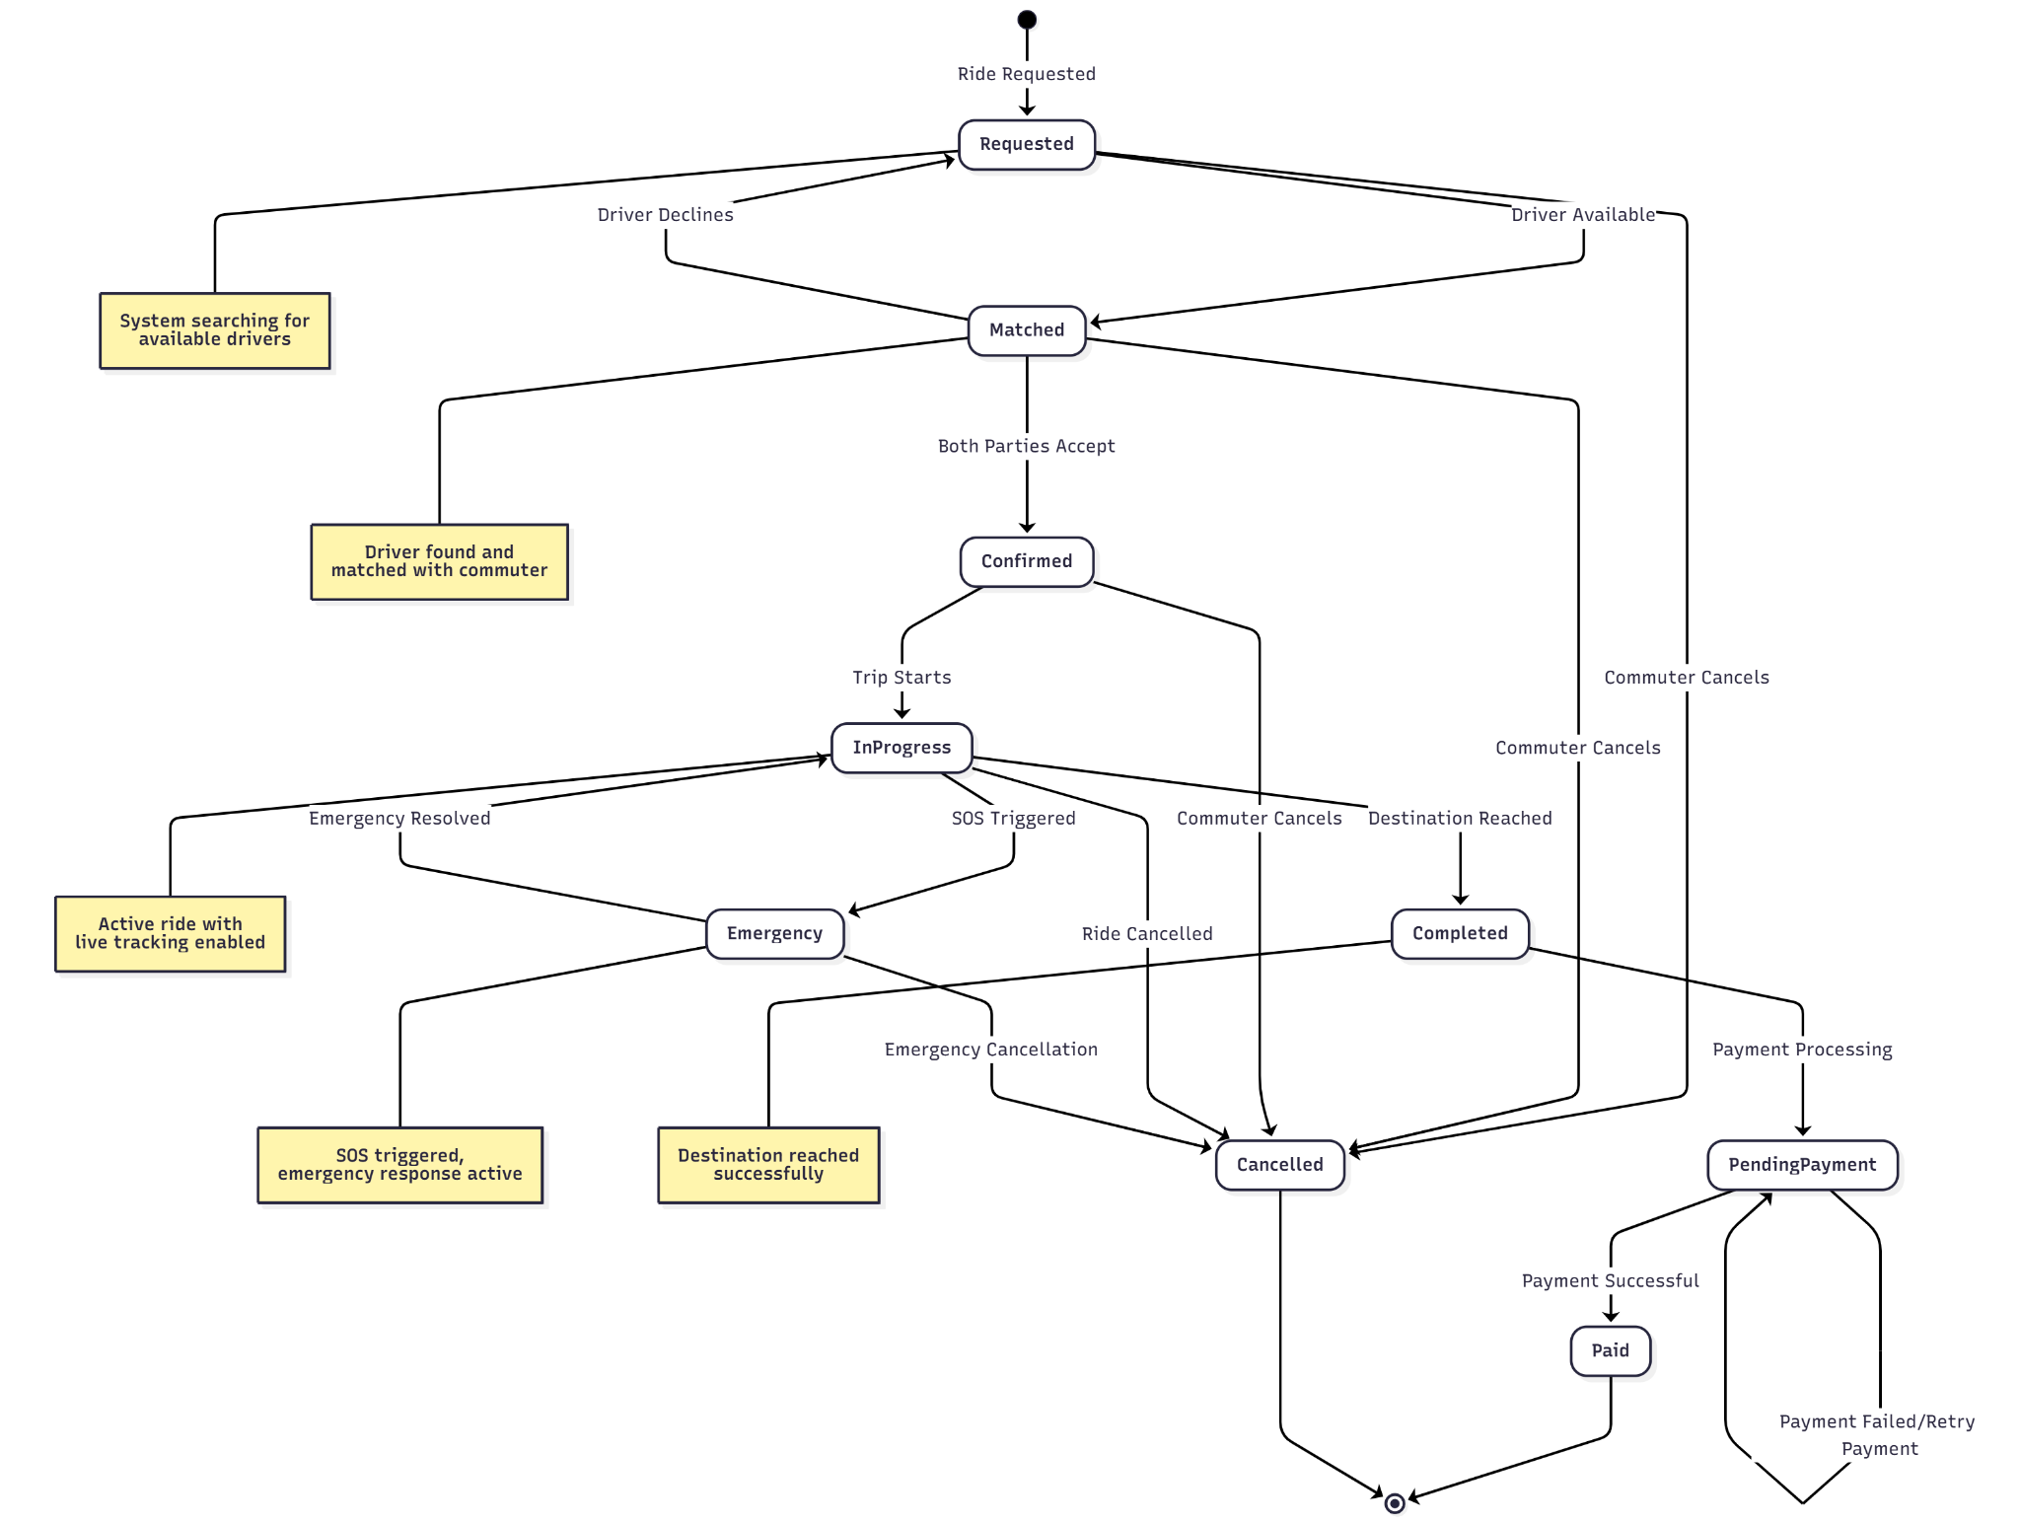

6.1.2 SOS Alert Object State Diagram

Object Name: SOSAlert
Purpose: Models the emergency alert system lifecycle from trigger to resolution

States:
- Inactive: No emergency, system monitoring normally
- Triggered: SOS button pressed, alert being sent
- Active: Emergency alert sent to contacts and admin
- Escalated: Admin has escalated to authorities
- Resolved: Emergency situation resolved safely
- Cancelled: False alarm, alert cancelled

Key Events/Messages:
- SOS Button Pressed, Alert Sent Successfully, Admin Notified
- Authorities Contacted, Emergency Resolved, False Alarm Detected

6.1.3 Payment Object State Diagram

Object Name: Payment
Purpose: Models payment processing from initiation to completion

States:
- Pending: Payment initiated, processing in progress
- Authorized: Payment method verified and authorized
- Completed: Payment successfully processed
- Failed: Payment processing failed
- Refunded: Payment has been refunded
- Disputed: Payment under dispute resolution

Key Events/Messages:
- Payment Initiated, Authorization Successful, Processing Complete
- Payment Failed, Refund Requested, Dispute Raised

6.2 Diagram

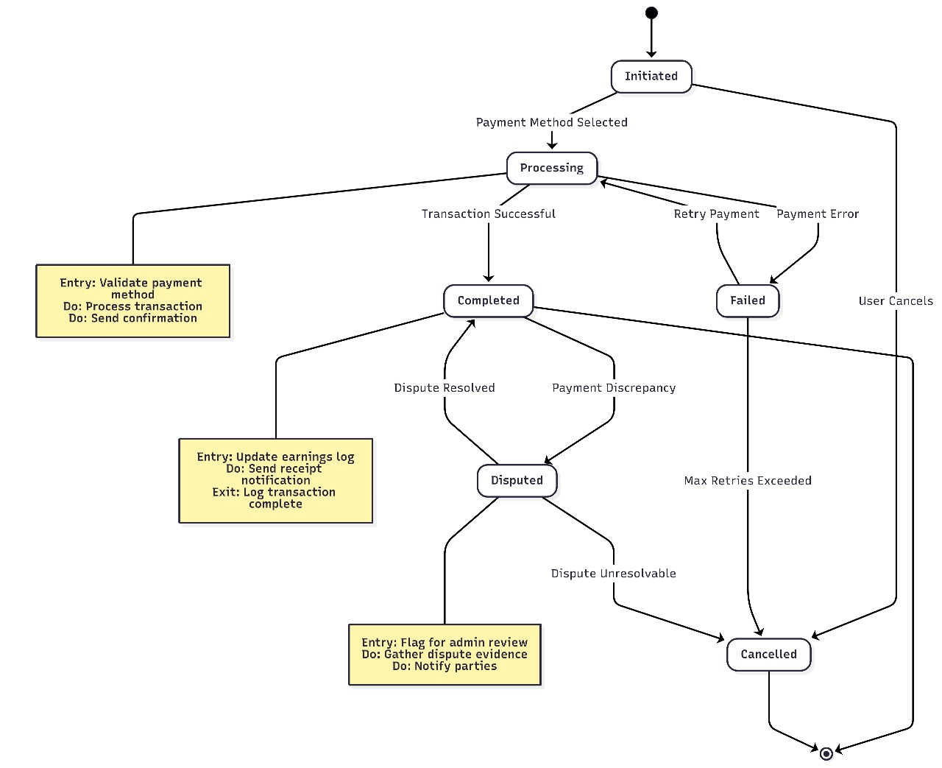

7. Data Requirements

Not Applicable

8. Non-functional Requirements / Quality Attributes

Sr# | Requirements
1 | The voice recognition system must achieve at least 85% accuracy for Urdu voice commands and 80% accuracy for regional dialects under normal noise conditions
2 | The system must respond to voice commands within 6 seconds of voice input completion, even on 3G network connections
3 | Battery consumption should not exceed 10% per hour of active usage on standard Android devices with a 3000mAh battery capacity.
4 | The application must maintain 99.5% uptime availability, measured monthly, excluding planned maintenance windows not exceeding 4 hours per month.
5 | The system should handle up to 100 active users simultaneously without any degradation in performance.
6 | The app interface should be intuitive and simple enough for users with minimal digital literacy to understand without requiring more than 2 onboarding sessions.

9. Security Requirements

Sr# | Security Risks | Potential Losses | Controls
1 | Insecure Authentication | Unauthorized access to user accounts, exposure of personal data | Use secure authentication, enforce strong passwords
2 | Insufficient Input Validation | System crash, data leaks | Validate & Sanitize all inputs, implement input filters
3 | Lack of Emergency Support | Physical harm | Implement an SOS feature: when triggered app will automatically sends live location + alert notification to the predefined emergency contacts
4 | Improper Access Control | Data Manipulation | Role-based access control (RBAC)
5 | Insecure Data Storage | Theft of sensitive information (e.g., location history, personal details), user privacy breaches, regulatory non-compliance | Encrypt sensitive data at rest and in transit, use secure databases, implement regular security audits and backups

10. Security Engineer

Name of the Security Engineer | Muhammad Zain Naseer

11. Use of Generative AI
Generative AI was employed to enhance language, organize content, and refine descriptions for clarity and professionalism. The project concepts and requirements were entirely defined by the team; AI was used solely as a drafting and editing tool. Additionally, AI assisted in creating diagrams.

12. Who Did What?

Name of the Team Member | Tasks done
Maryam Rizwan | 3. Use Cases + 4.1 Class Diagram
Kousar Pervaiz | 2. System Actors  4. Class Diagrams  11. Use of Generative AI
Emaan Waleed | 1. Introduction + 3.2. Use Cases (half) + 5. Sequence Diagrams (half)
Muhammad | 5. Sequence Diagrams (half )
Muhammad Zain Naseer | 6. State Diagram

13. Review checklist

Section Title | Reviewer Name(s)
4. Class Diagrams + 1. Introduction | Maryam Rizwan
2. System Actors + 7. Data Requirements + 3. Use Cases | Emaan Waleed
5. Sequence Diagrams + 9. Security Requirements | Kousar Pervaiz
8. Non-functional Requirements / Quality Attributes | Muhammad Zain Naseer
6. State Diagram | Muhammad

