1. What are the Boolean data type's two values? How do you go about writing them?

A) The two Boolean data type’s values are True and False.

The result of any logical operators results in the Boolean output that is either True or False.

2. What are the three different types of Boolean operators?

A) The three basic types of Boolean operators and AND, OR and NOT.

3. Make a list of each Boolean operator's truth tables (i.e. every possible combination of Boolean values for the operator and what it evaluate).

A) The truth-tables of the Boolean operators are as follows:

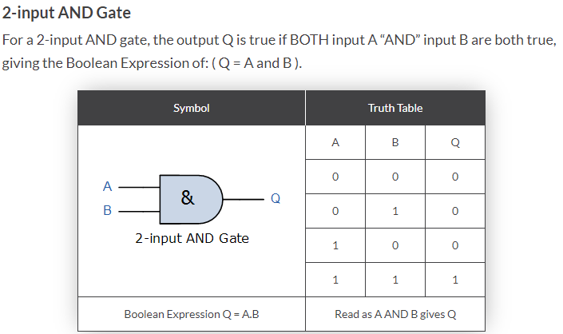

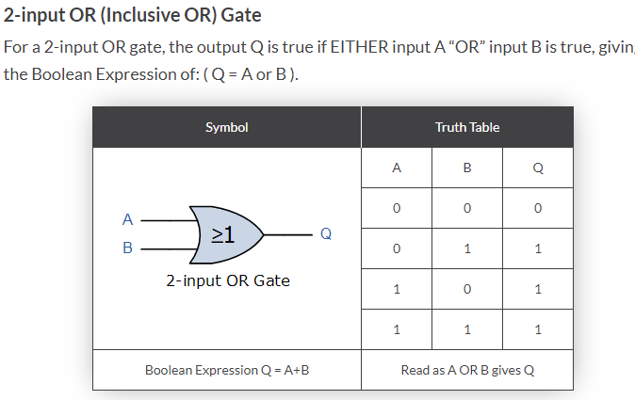

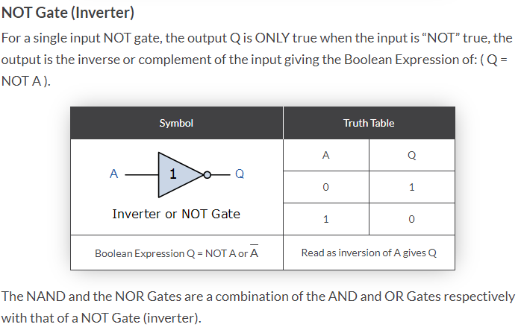

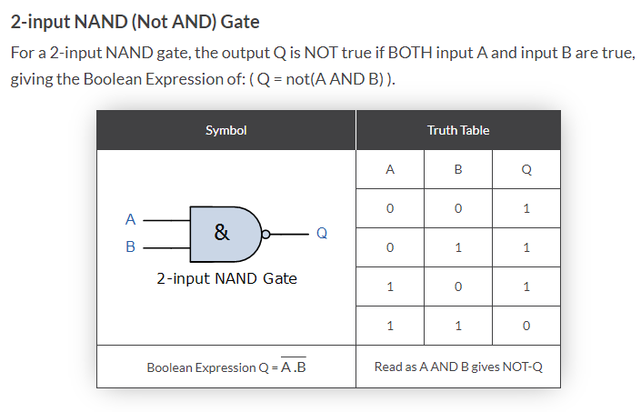

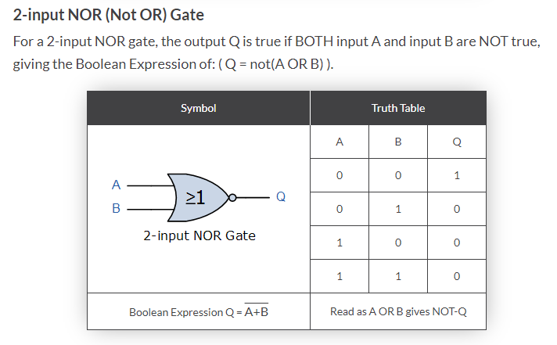

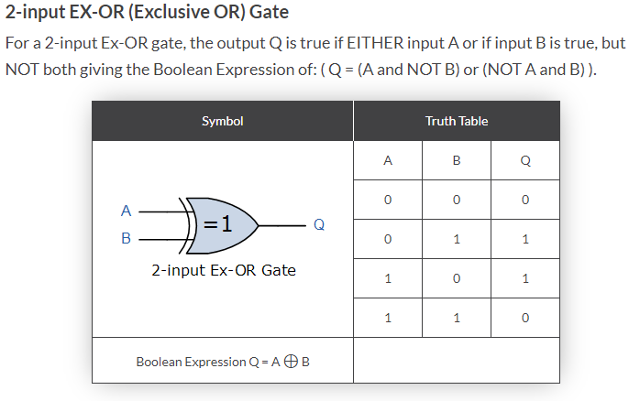

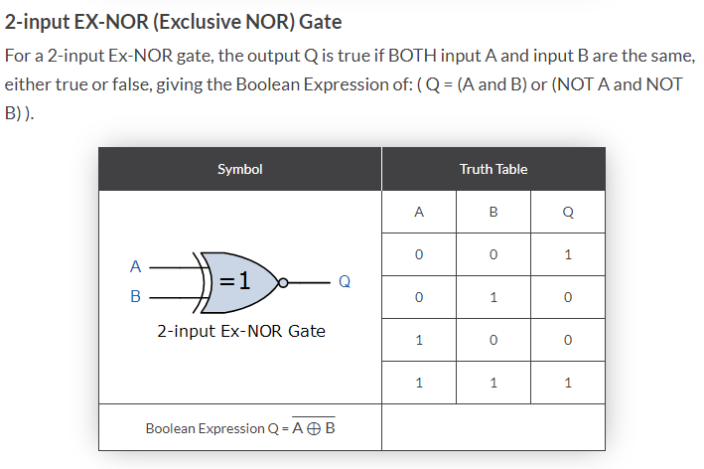

The table below portrays a great summary of the Boolean operators which is as follows:

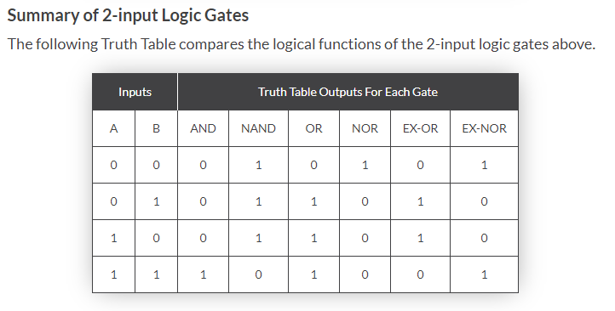

https://www.electronics-tutorials.ws/boolean/bool_7.html

4. What are the values of the following expressions?

(5 > 4) and (3 == 5) **False**

not (5 > 4) **False**

(5 > 4) or (3 == 5) **True**

not ((5 > 4) or (3 == 5)) **False**

(True and True) and (True == False**) False**

(not False) or (not True) **True**

5. What are the six different types of reference operators?

A) If talking about relational operators:

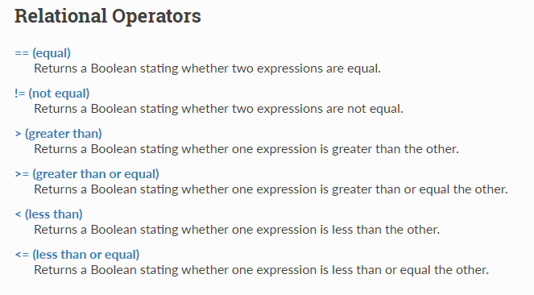

6. How do you tell the difference between the equal to and assignment operators?

A) The single equate sign ( “ = “) is used for the assignment of a value to a particular variable, whereas ,the double equal signs is used as the logical check whether the two quantities(entities) are equal or not , which eventually results in a True or a False.

7. Describe a condition and when you would use one.

A) For example, an AND condition is used where both the conditions have to met in-order for the result to have a True value. This goes to show that both the conditions are necessary to be held.

On the other hand, an OR operator is used where either one of the conditions is met. Even if one condition is met the resulting output would be True.

8. Recognize the following three blocks in this code:

1.spam = 0

2.if spam == 10:

3. print('eggs')

4. if spam > 5:

5. print('bacon')

6. else:

7. print('ham')

8. print('spam')

9.print('spam')

A)There exists a main if block starting at line 2 , then it has a nested if-else block.

9. Create a programme that prints. If 1 is stored in spam, prints Hello; if 2 is stored in spam, prints Howdy; and if 3 is stored in spam, prints Salutations! if there's something else in spam.

A)

spam=input(“Enter the value of spam from 1-3”)

if spam == 1:

print(“Hello”)

elif spam == 2:

print(“Howdy”)

elif spam==3:

print(“Saluations!”)

else:

print(“The spam contains unidentified content”)

10.If your programme is stuck in an endless loop, what keys can you press?

A) When working in a Jupyter notebook, one can interrupt the kernel.

11. How can you tell the difference between break and continue?

A) The main difference between break and continue is that for break keyword it breaks out of the loop without proceeding(considering) to next iterations, while the continue keyword tackles a particular iteration and continues the further processing and omitting(skipping) that iteration.

12. In a for loop, what is the difference between range(10), range(0, 10), and range(0, 10, 1)?

A) There is no difference among the three commands, as the initial point is ‘0’ unless specified and so is the step size is also by default ‘1’ unless specified otherwise.

All three would result in a series of numbers from 0 to 9.

13. Using a for loop, write a short programme that prints the numbers 1 to 10 Then, using a while loop, create an identical programme that prints the numbers 1 to 10.

A)

For i in range(1,11):

Print(i)

i=1

while(i<=10):

print(i)

i+=1

14. If you had a bacon() function within a spam module, how would you call it after importing spam?

A=bacon() #Simply calling the function

Or if the question is referred to calling a function from a spam module then

Spam.function()