Kyun pehle FastAPI?
Brain = FastAPI
Body = Flutter
Agar brain hi ready nahi, body useless hai.

- Tumhare paas already dot detection ka code chal raha hai (computer pe images se dots count aur validation) → Yeh code seedha FastAPI mein daal sakte ho aur test kar sakte ho bina mobile app ke tension ke.
- FastAPI seekhna bahut chhota aur simple hai compared to Flutter
  - 3–5 din mein basic server + image upload + response wala endpoint ban jaata hai
  - Flutter mein 10–15 din lagenge sirf camera + UI tak pahunchne mein
- Jab backend ready ho jaayega, toh tum browser se bhi test kar sakte ho → http://localhost:8000/docs kholo → image upload karo → turant result dekho Yeh confidence bohot badha deta hai
- Flutter baad mein seekhna asaan ho jaata hai jab backend ka endpoint already kaam kar raha ho → Tum bas ek button banaoge jo photo leke backend ko bhej de.
Flutter sirf: Photo capture karega, API ko bhejega, Result dikhaega / sunayega

🚀 Ideal Order For YOU
Phase 1 → FastAPI
- Local image upload
- API response JSON
- OpenCV integrate
- Return detection result
Phase 2 → Test via Postman
Phase 3 → Flutter basic UI
Phase 4 → Connect Flutter to FastAPI
Phase 5 → Camera + audio
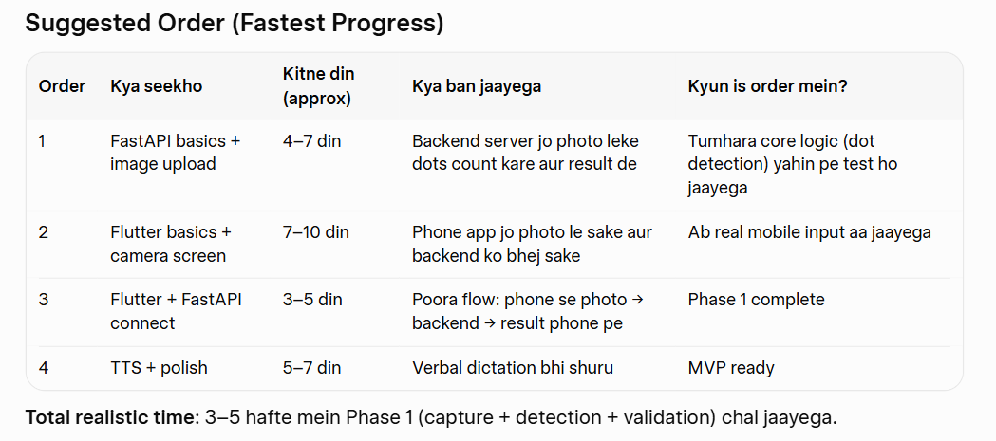

📌 Another Important Strategic Reason (Projects Can Make)
FastAPI seekhne ke baad tum:
- AI Mental Health bana sakte ho
- AI Teaching Assistant bana sakte ho
- Telemedicine bana sakte ho
- Flood prediction API bana sakte ho
Flutter sirf interface hai.
Backend knowledge = power.

🎯 FASTAPI COMPLETE TOPIC CHECKLIST (You MUST master these)

Phase 1 – Python Basics (If weak)
- Functions
- Classes
- Virtual environments
- Pip
- JSON
- File handling

Phase 2 – FastAPI Core
- What is API
- GET, POST
- Path parameters
- Query parameters
- Request body
- Pydantic models
- File uploads
- Returning JSON
- Exception handling
- CORS (very important for Flutter connection)

Phase 3 – Real App Features
- Upload image (UploadFile)
- Convert bytes to NumPy
- Integrate OpenCV
- Return structured JSON
- Async vs normal functions
- Running server with Uvicorn

Phase 4 – Advanced (Optional but Powerful)
- JWT Authentication
- Database (SQLite first)
- Dependency injection
- Background tasks

🎯 FLUTTER COMPLETE TOPIC CHECKLIST

Phase 1 – Dart Language
- Variables
- Functions
- Classes
- Async / await
- Futures
- Null safety

Phase 2 – Flutter Basics
- Widgets (VERY IMPORTANT)
- Stateless vs Stateful Widget
- Scaffold
- MaterialApp
- Navigation
- Layout (Row, Column, Container, Stack)
- Padding, Container

Build: Simple "Hello Braille" app with button

Phase 3 – Real Features You Need
For your Braille App:
- camera package (live preview, capture). Image preview after capture. State management (Provider or Riverpod — simple version)
- Camera plugin
- Image picker
- HTTP requests (http package)
- JSON decoding
- Loading indicator
- Error handling
- Text-to-Speech (flutter_tts)
- Permissions (camera, mic)

Build: Camera screen with "Capture Braille" button

Phase 4 – Advanced But Useful
- State management (Provider or Riverpod)
- Clean architecture
- Folder structure
- API services class
- Responsive UI

COMIBINING / INTEGRATION PHASE:
Week A: FastAPI Backend (Days 15–21)
- Create FastAPI app
- POST endpoint for image upload
- OpenCV integration (your dot detection code)
- Return JSON (dots count, valid combos)
- Build: Backend that receives image and returns your detection result
Week B: Connecting Flutter ↔ FastAPI (Days 22–28)
- http package to send image to backend
- Show loading + result on phone
- Error handling
- Build: Full flow: Capture → Send → Show "18 dots detected"
Week C: Advanced Features (Days 29–35)
- TTS (flutter_tts)
- Save scan history (SQLite/Hive)
- Preprocessing in backend (your improved dot code)
- Build: Verbal output ("Detected 6-dot cell: A")
Week D: Polish & Deploy (Days 36–42)
- Nice UI (Material 3)
- Deploy FastAPI to Render.com (free)
- Deploy Flutter app to Google Play (internal test)
- Build: Shareable APK + working backend link

🔥 COMPLETE LEARNING ORDER (VERY IMPORTANT)
Do NOT learn randomly.
Follow THIS exact order:
Step 1 → Python basics (if weak)
Step 2 → FastAPI basic API
Step 3 → Create simple API returning JSON
Step 4 → Flutter basics (UI only)
Step 5 → Connect Flutter to simple FastAPI endpoint
Step 6 → Add image upload
Step 7 → Integrate OpenCV detection
Step 8 → Add voice output

🚨 Common Beginner Mistakes
❌ Trying to learn everything at once
❌ Watching 20 tutorials but building nothing
❌ Skipping async/await
❌ Ignoring error handling
❌ Copy-pasting code blindly

FastApi python web framework, like many other Django & Flask

FastApi benefits:
- automatic documentation: {usually Postman used to check UI} but here we use SwaggerUI for API endpt or route etc, ReDoc)
- fast, synchronous, use Python, Pydantic (library for auto-typing),
- Based on Open Standards:
JSON schema(by default return JSON), OpenAPI (how u create API)
- VS code or Pycharm
- 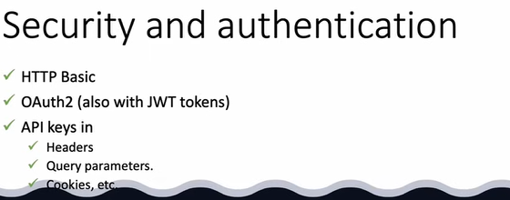
- 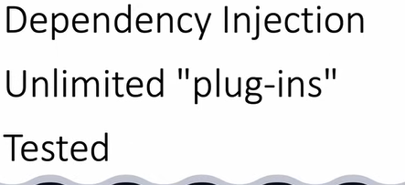
- 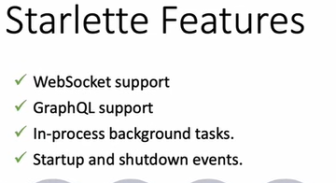 Framework of Python
- 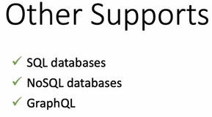

cd D or cd “D” wrong D: correct
cd Foldername
dir
python -m venv venv maybe setup venv
venv\Scripts\activate activating that venv
Uvicorn only install in virtual environment so it will run here

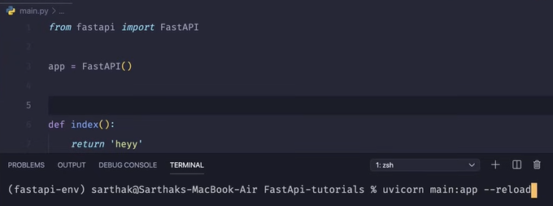
fastapi package, FastAPI is class

uvicorn main:app -reload
server_starter_name than_filename: then_instance to_reload_automatically(whenever we do any chg in file)
When we run we Will get Error as no path available.

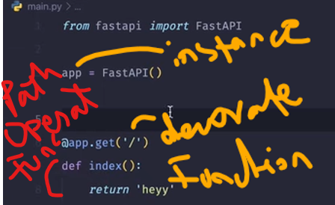
get() . Doing the GET REQUEST, but post get etc are the Operations.
Do this operation on the path which is described in below Path Operation Function
@app is Path Operation Decorator
/ means Base URL (local host value)
JSON return (dictionary), detail: Not Found is the default Error of FastAPI

Route/End Points/Path means facebook.com/about or facebook.com/feed etc
If different route have same method name, no issue they will run. Decorator matters alot
In other framework called route or end pt which is written in () of get. But in FastAPI called Path
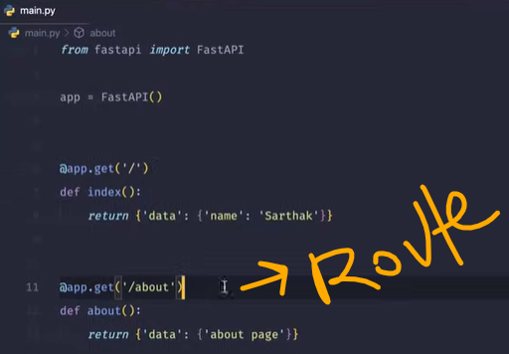
Base url kea age about ka izafa kr ROUTE bna dia localhost:8000/about

For Dynamic Routing use {val}
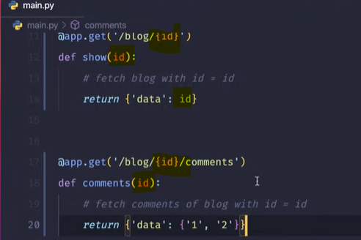
From Browser, we get String (means in the route/path)
But in function we want to use it as int, not as int. So:
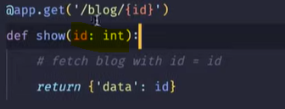
So whatever Data Type we want, we will define here

When we write this: localhost:8000/blog/unpublished_blog, the below code give ERROR. But why? Unpublish func does not taking any parameter so what’s the issue?
REASON: Code execute in Linear & Top to Bottom way. Dynamic routing code is written above, so this route matches to that one, b/c it said anything after blog that’s why it executes.
REMEMBER: Make sure that if dynamic and static route are matching so always put Static route above Dynamic route
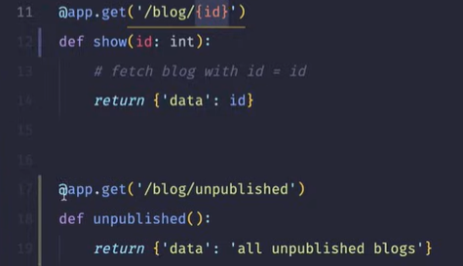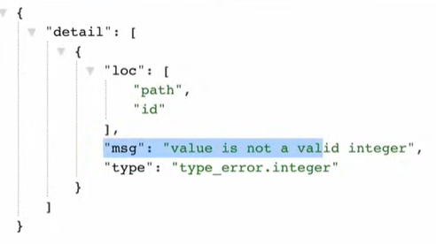

When we want that the route/path which we are writing in the browser, means the parameter written there will not automatically do any changes in the query (as the above code written). We have to handle it (as the below code written).
Query syntax: ? name = value
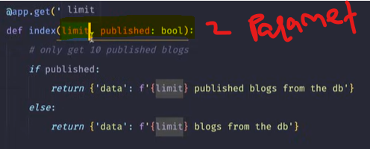
http://127.0.0.1:8000/blog?limit=10&published=true
ab yaha jo published true h isko bhi wo as a String pass kr raha h browser, isi wajah se hm ne Function m parameter m explicitly DT batai

Now if we just write this:
http://127.0.0.1:8000/blog
Means not providing any parameter, so it will show error like that which says that both parameter are required
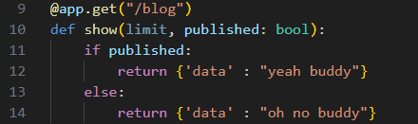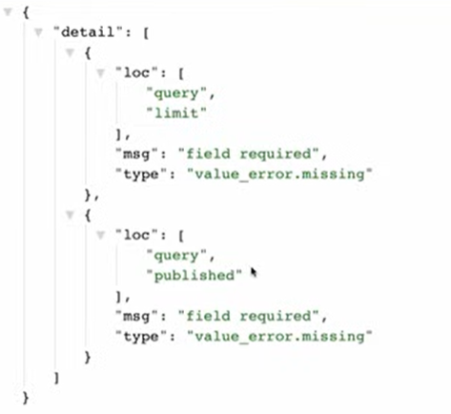

Accepting Query Parameter, defining its DT, setting it Default or Optional:
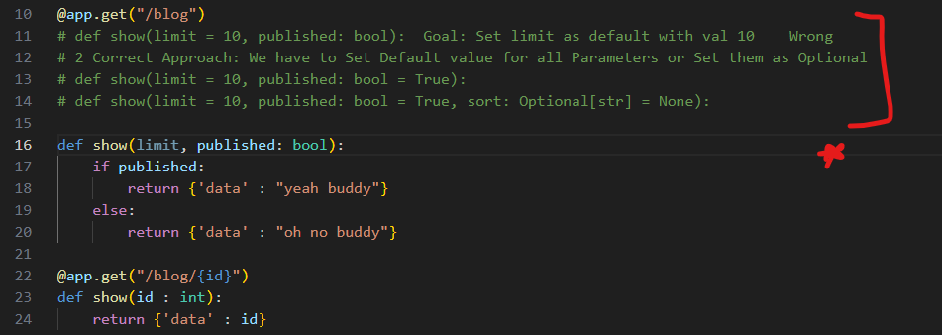
how FastAPI detecting query parameter vs path parameter vs function parameter
Rule:
- Anything written in {} in the path = Path Parameter.
- If parameter is in the function but NOT in {} → Query Parameter. If you give a default value, it becomes optional query param.
- If you pass a Pydantic model or complex object, FastAPI treats it as request body (JSON).
  - Classes / models = Body
  - Simple types (int, str) = Path or Query
Example:
@app.get("/users/{user_id}")
def get_user(user_id: int):
return {"id": user_id}

@app.get("/items")
def get_items(limit: int = 10):
return {"limit": limit}

from pydantic import BaseModel

class Item(BaseModel):
name: str
price: float

@app.post("/items")
def create_item(item: Item):
return item
👉 item comes from request body (JSON). This parameter type is called Function Parameters (Body Parameters)
Where it appears | Treated as
{id} in URL | Path
?name=value | Query
JSON payload | Body

