**Online Doctor Appointment System**

**Synopsis**

**Bachelor of Technology**

**Computer Science and Engineering**

Submitted By

Sritiman Adak (13000118035)

Srinjoy Ghosh (13000118036)

Sayan Mukherjee (13000118054)

Sayak Khan (13000118055)

Under the guidance of:

Arpita Biswas

September 2021



Techno Main Salt Lake

EM 4/1, Salt Lake, Sector V, Kolkata-700091

# Problem Definition

The main idea is to create a platform which will help any person to have an appointment with a doctor based on his or her necessity. This platform will serve basically two types of users: the patients and the doctors. This platform may also have features like video conferencing to enhance the interaction between patients and the doctors. Both patients and the doctors will be needed to sign up with the application to avail the services.

# Problem Domain

We will be building the full application as a website so that it can be accessible through multiple devices. So, our domain will be ‘Web-app’ where we will be working with technologies like JavaScript, HTML, CSS and Django. Since the project is about a medical website we will also be gathering some basic knowledge about the different fields of medical science which will be used to implement various functionalities in the application. The database management system we will use for this project will be an RDBMS using SQL.

# Background

In today’s world if someone wants to book a doctor’s appointment, we need to call in doctor’s clinic or personally visit hospital for doctor’s checkup. Also if the doctor cancels appointment suddenly then the patient will not know that until he/she visits the hospital or the doctor’s chamber. All these waste the valuable time of the patient. Also, in this pandemic situation going physically to hospital or doctor’s chamber in risky [1]. Thus the objective of this project is to get rid of all these problems that the patient has to face. This project ensures to ease the whole process of doctor’s appointment in a totally online mode [2]. This ensures a smooth booking of a doctor’s appointment. Also the cancellation of booking is notified to all the patients if their booking is cancelled by the doctor. This saves the valuable time of the patient. The patient can book an appointment through his/her phone/laptop/desktop from anywhere in the world. Once the booking is confirmed the patient will receive the slot for the face to face video conferencing with the doctor [3]. On the doctors’ side, all the doctors will come to know about the number of patients that he has to attend through this website [4].

# Probable Solutions

We will create to different types of users for this system:

a. Patient

b. Doctor

Execution of the process:

1) Patient registers and logs into his profile page. Doctor does the same thing.

2) Patient selects a specialist according to his/her needs.

3) Patient sends an appointment request to a certain Doctor. Doctor receives the request and schedules a date and time of consultancy which is sent to the patient.

4) A one-to-one consultancy (preferably through video conference) is done at the scheduled time.

5) After conference, doctor sends patient a prescription and patient make the payment to the doctor.

The following diagrams will make the process more clear.

**Diagram 1**

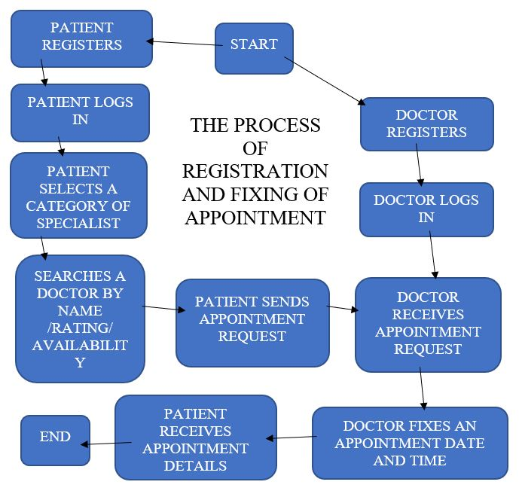

**Diagram 2**

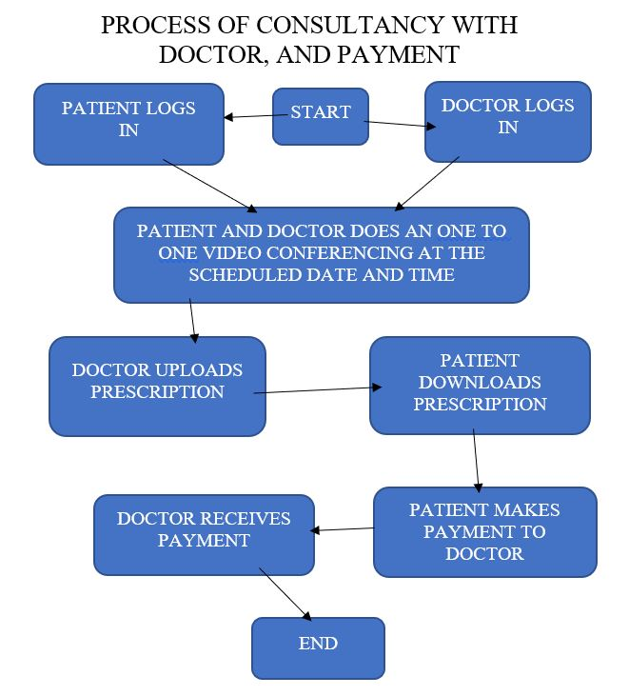

# Project Benefits

[State usefulness, new ideas / innovations for this project, potential market demand for the project outcome in quantitative / qualitative terms (as applicable). “Re-inventing the wheel” should be avoided; doing something old should be done differently and in a better way.

*You may refer the pool of popular project sites for inspiration only, and not for copying. If you are opting cliché projects like Library Management System etc, you will have to study* [*published projects*](https://drive.google.com/drive/folders/0B4-4_9ecSKNrNE1nLXFtZm9rU0U) *for proposed improvements and value-additions. Your ability to apply systematic thought, reasoning and concepts will surely make your project strand out in the crowd.*]

# Conclusion

[Specify the expected outcome of the proposed project with summarized benefits]

# References

[1] Yeo Symey, Suresh Sankaran arayanan, Siti Nurafifah binti Sait “Application of Smart Technologies for Mobile Patient Appointment System”, International Journal of Advanced Trends in Computer Science and Engineering, august 2013.

[2] A. Luschi, A. Belardinelli, L. Marzi, F. Frosini, R. Miniati and E. Iadanza “Careggi Smart Hospital: a mobile app for patients, citizens and healthcare staff”, IEEE-EMBS International Conference on Biomedical and Health informatics (BHI), 2014, pp.125-128.

[3] Prof. S. B. Choudhari, ChaitanyaKusurkar, RuchaSonje, ParagMahajan, Joanna Vaz “Application for Doctor‟s Appointment with Live Conferencing ”, International Journal of Innovative Research in Computer and Communication Engineering, January 2014

[4] S.Gavaskar, A. Sumithra, A.Saranya “Health Portal-An Android Smarter Healthcare Application”, International Journal of Research in Engineering and Technology, Sep-2013.

***Instructions:***

1. *Save your document as* ***SYN-ProjectShortCode-GRnn.doc****, where nn is your group number.*
2. *Synopsis content should be within 2-3 pages.*
3. *Double-click under page header, ensure to replace [ Project Title ] with the title of your project.*
4. *Replace names and project title with actual names on the cover page*
5. ***Remove this section after completing this document.***