Section 1 — Prompt Engineering
Name: Muhammad Fawwad Ahmed
Student ID: B04-0923-000043ma
My d = 3
Assistant & model used: Claude (claude.ai) — Claude Opus 5.5
My challenge: Rewrite an informal angry complaint (written by me) into a polite formal email, then translate the email into Urdu, keeping the meaning identical.

Task 1.1 Zero-shot baseline
PROMPT
Rewrite this angry complaint as a polite formal email, then translate the email into Urdu.
Honestly this is a joke. I ordered a laptop bag from your website on 12 October (order #48213) and paid Rs 4,500 upfront. It STILL hasn't arrived. Your tracking says "delivered", total lie, nobody came to my house. I've called your helpline 3 times and every single time I get put on hold and then the call just drops. I want my bag within 2 days or my full money back. Otherwise I'm posting a review about this everywhere so people know how you treat customers.
OUTPUT
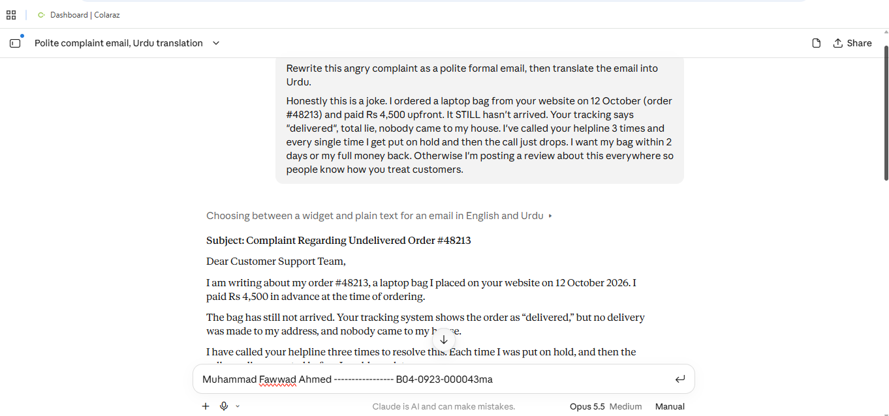
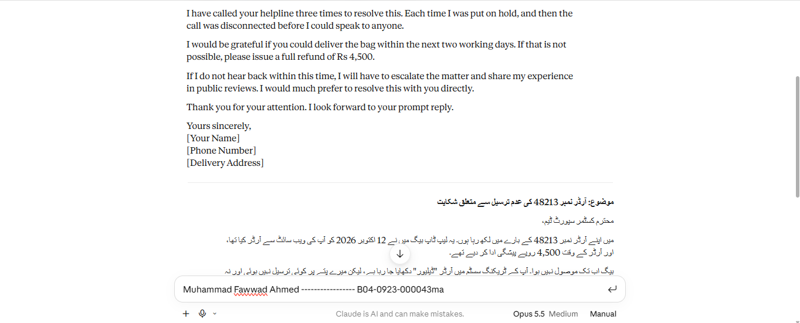
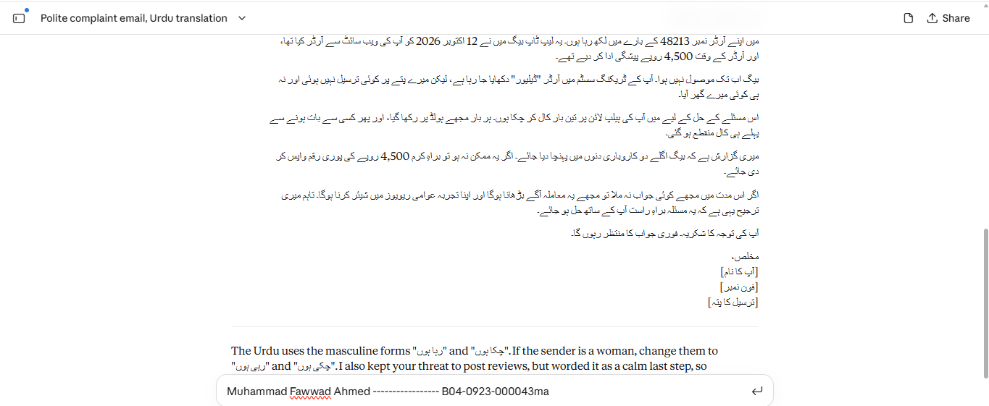

Task 1.2 Engineer it – apply named techniques
PROMPT
You are a professional customer-relations writer who is fluent in English and formal Urdu.
Complete the task in these steps:
- List every fact, demand and consequence in the complaint between the ### markers.
- Rewrite the complaint as a polite, formal English email.
- Translate that email into formal Urdu.
- Check both versions against your list from step 1.
Rules:
- Keep every fact exactly: date, order number, amount, number of calls, and the 2-day deadline.
- Keep the demand (bag within 2 days OR full refund) and the consequence (posting a public review). Say them politely, but do not remove or weaken them.
- Do not add apologies, compliments, new details or requests that are not in the original.
- English email: 120–180 words, with a subject line.
- Urdu: Urdu script only (no Roman Urdu), formal register (آپ / جناب), same numbers.
Output format:
Key points: bullet list
Subject:
English email:
Urdu email:
Meaning check: one line per key point, marked ✓ if present in both versions
Complaint:
###
Honestly this is a joke. I ordered a laptop bag from your website on 12 October (order #48213) and paid Rs 4,500 upfront. It STILL hasn't arrived. Your tracking says "delivered", total lie, nobody came to my house. I've called your helpline 3 times and every single time I get put on hold and then the call just drops. I want my bag within 2 days or my full money back. Otherwise I'm posting a review about this everywhere so people know how you treat customers.
###
OUTPUT
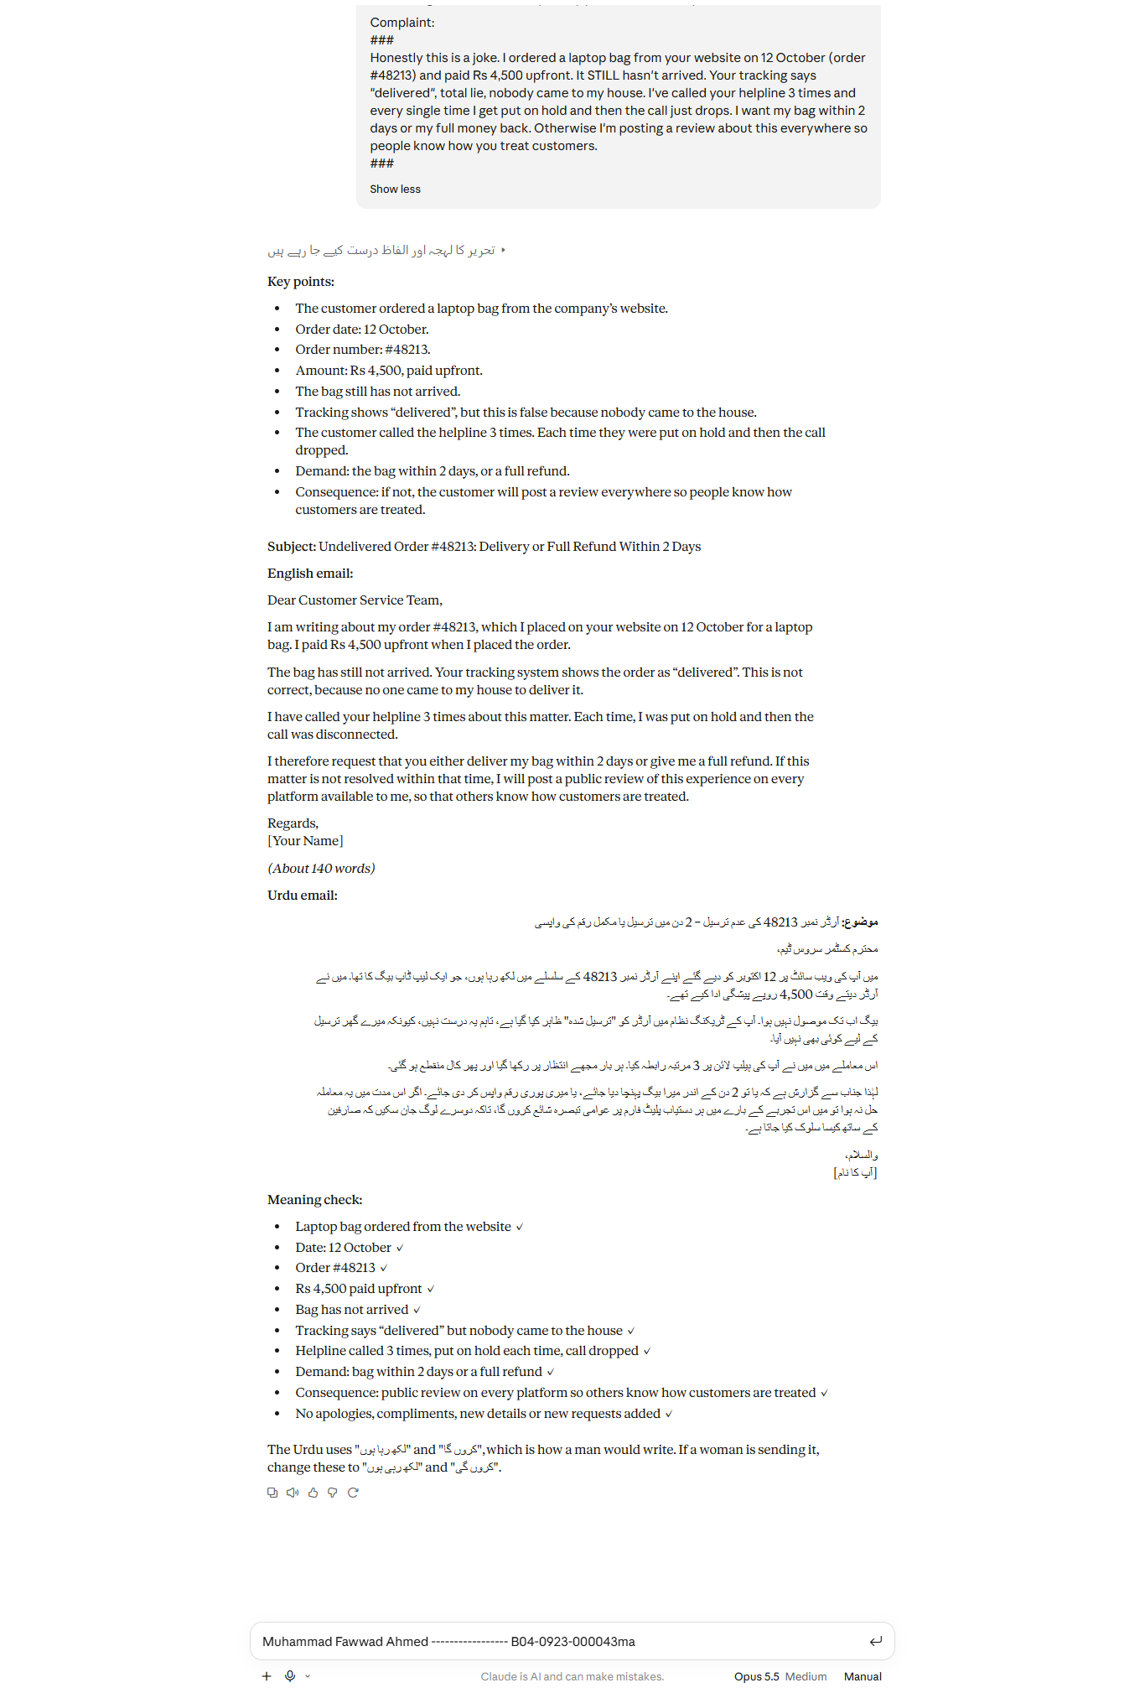
Techniques used:
- Role assignment – “You are a professional customer-relations writer who is fluent in English and formal Urdu.”
- Step decomposition – the four numbered steps (list key points → rewrite → translate → check).
- Explicit constraints – the Rules (keep every fact, keep the demand and consequence, add nothing, 120–180 words, Urdu script only, formal register).
- Output-format specification – fixed headings: Key points, Subject, English email, Urdu email, Meaning check.
- Delimiters – the ### markers that separate the complaint from the instructions.
What improved vs Task 1.1 and why:
The baseline changed the meaning: it invented the year “2026”, turned “2 days” into “two working days”, and added lines that were not in the original (“escalate the matter”, “I would much prefer to resolve this with you directly”). The engineered prompt kept every fact exactly and added nothing, because step 1 forced a key-point list first, the rules banned additions, and the meaning check verified each point in both languages.

Task 1.3 Few-shot OR chain-of-thought
Choice: Few-shot.
Justification: Changing the tone is a style task rather than a reasoning task, so worked examples show the model exactly how angry wording maps to formal English and Urdu while keeping the urgency and threats.
PROMPT
Convert each angry complaint into a polite formal English version and a formal Urdu translation, keeping the meaning exactly the same (same facts, same demands, same urgency, same consequences).
Example 1
Angry: Your app charged me twice for one ride, Rs 850 gone for nothing. Fix it NOW.
Formal English: I am writing to report that I was charged twice for a single ride, resulting in an extra deduction of Rs 850. I request that the duplicate charge be refunded urgently.
Formal Urdu:
میں آپ کی توجہ اس امر کی جانب مبذول کروانا چاہتا ہوں کہ ایک ہی سفر کے لیے مجھ سے دو مرتبہ رقم وصول کی گئی، جس کے نتیجے میں 850 روپے اضافی کٹ گئے۔ میری درخواست ہے کہ اضافی رقم فوری طور پر واپس کی جائے۔
Example 2
Angry: The AC you "repaired" last week broke again in 2 days. I'm not paying for another visit. Send someone tomorrow or I'm going to consumer court.
Formal English: The air conditioner your technician repaired last week stopped working again within two days. I will not be paying for an additional visit. Kindly send a technician tomorrow; otherwise, I will have no option but to file a complaint with the consumer court.
Formal Urdu:
گزشتہ ہفتے آپ کے ٹیکنیشن نے جس ایئر کنڈیشنر کی مرمت کی تھی، وہ دو دن کے اندر دوبارہ خراب ہو گیا۔ میں اضافی وزٹ کی ادائیگی نہیں کروں گا۔ براہِ کرم کل ایک ٹیکنیشن بھیج دیں، بصورتِ دیگر میرے پاس کنزیومر کورٹ میں شکایت درج کرانے کے سوا کوئی چارہ نہیں ہوگا۔
Now do the same for this complaint, written as a full email with a subject line:
Angry: Honestly this is a joke. I ordered a laptop bag from your website on 12 October (order #48213) and paid Rs 4,500 upfront. It STILL hasn't arrived. Your tracking says "delivered", total lie, nobody came to my house. I've called your helpline 3 times and every single time I get put on hold and then the call just drops. I want my bag within 2 days or my full money back. Otherwise I'm posting a review about this everywhere so people know how you treat customers.
Formal English:
Formal Urdu:
OUTPUT
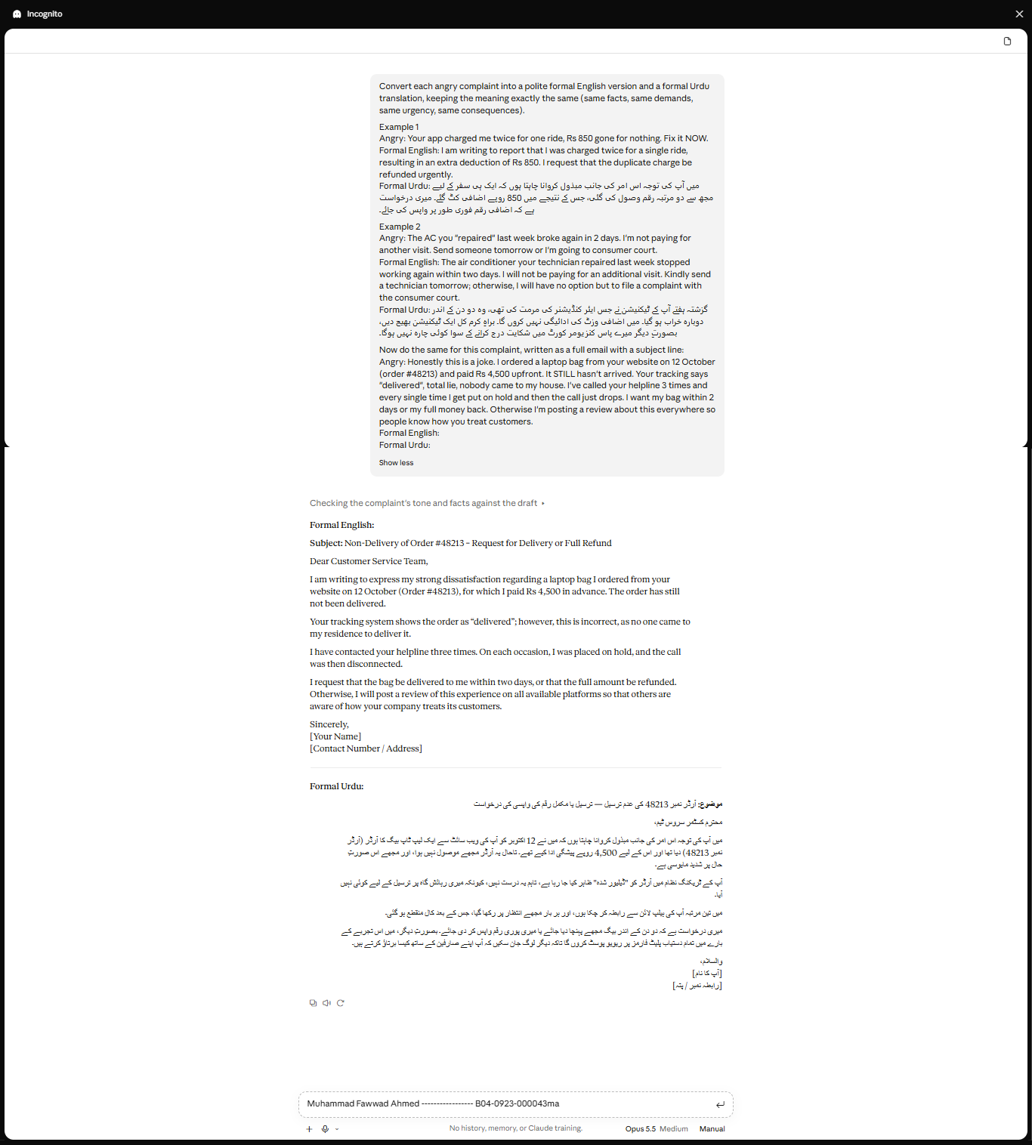

Task 1.4 Break it and evaluate
FAILING INPUT
Rewrite this angry complaint as a polite formal email, then translate the email into Urdu.
Wah bhai wah, great service as always 👏 Ordered the bag on 03/04, your rider marked it "delivered" and I'm 100% sure he kept it himself. Thief. Customer care said "sir 24 hours mein ho jayega" and that was 6 days ago, so I'm not holding my breath. I don't want a voucher and I don't want a sorry. Refund the 4.5k or I'm done with you guys for good.
WRONG OUTPUT
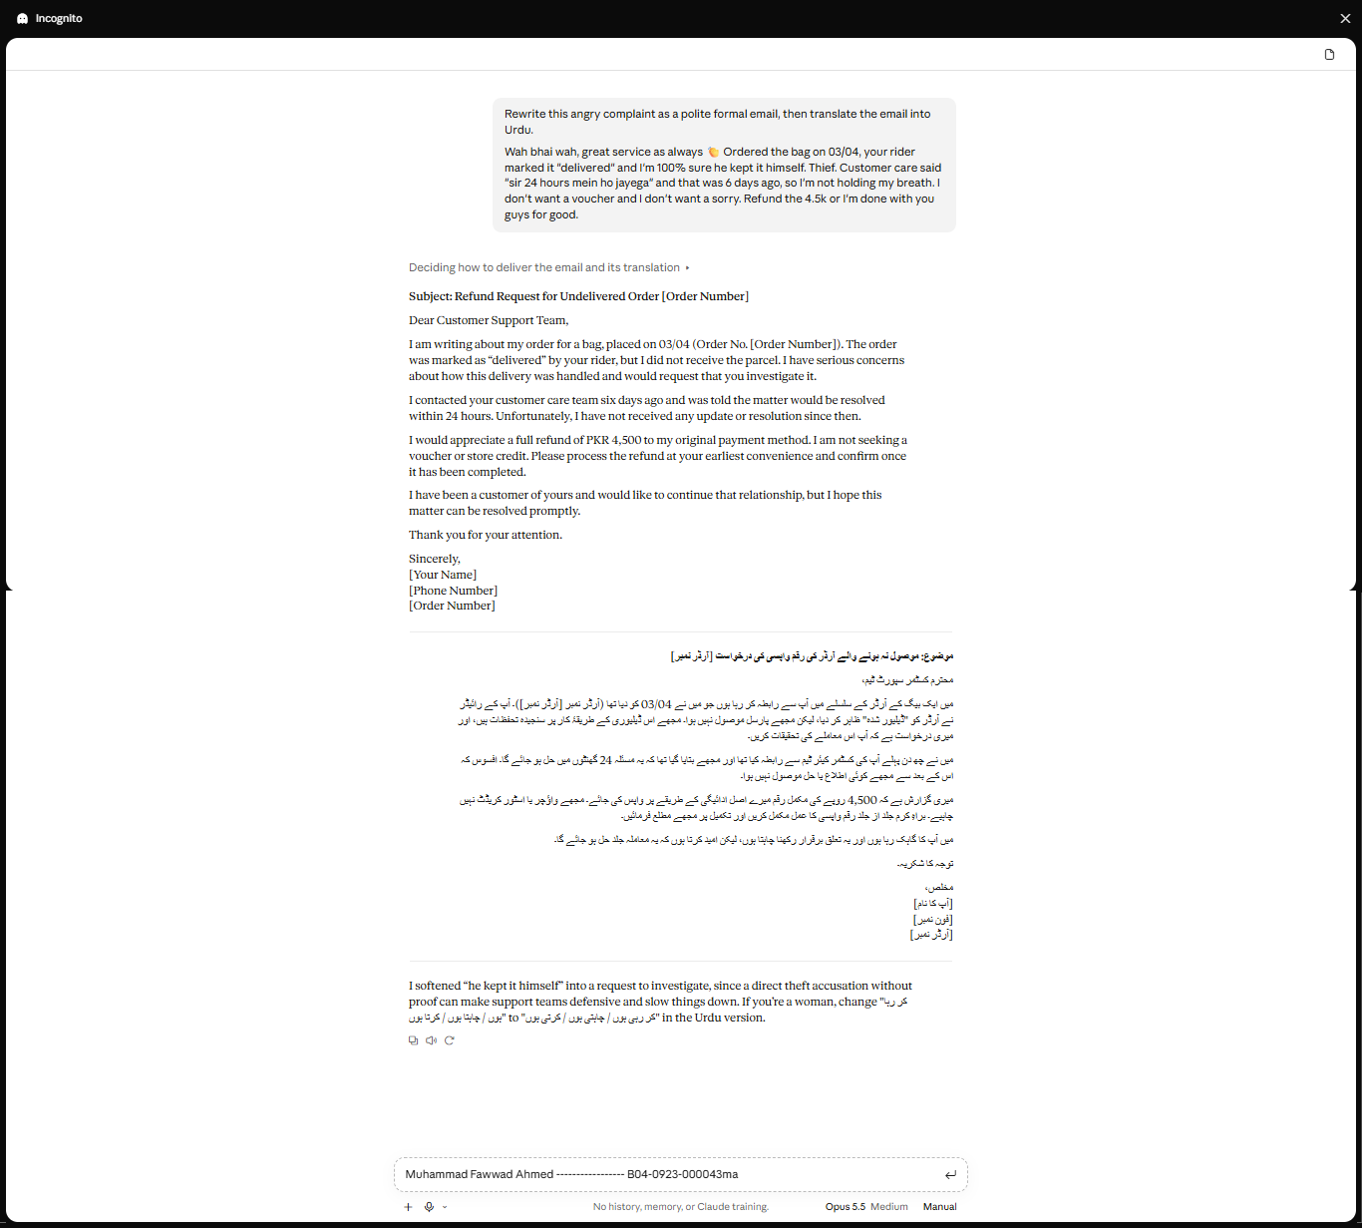
What went wrong:
- Meaning reversed – “I'm done with you guys for good” became “I have been a customer of yours and would like to continue that relationship”.
- Accusation removed – “he kept it himself. Thief.” became “I have serious concerns about how this delivery was handled… investigate it”. The model's own note admits it softened this on purpose.
- Ultimatum lost – “Refund… or I'm done” became “Please process the refund at your earliest convenience”.
- Content dropped – “I don't want a sorry” is missing.
- Details added – “original payment method”, “confirm once it has been completed” and [Order Number] placeholders were not in the original.
Diagnosis (likely cause): The instructions “polite” and “keep meaning identical” conflict, and the model's training toward polite, non-confrontational writing won. It treated the accusation, the ultimatum and the threat to leave as rudeness to remove rather than meaning to keep, and the Urdu translation carried every error over.
Mitigation: Add the constraint “Politeness changes tone only, never content. Every accusation, demand and consequence must still appear in formal words, and nothing may be added.” Then require a final checklist marking each original point ✓ in both the English and Urdu versions.

SECTION 2
Zero-Shot Text Classifier
Hugging Face Transformers + Streamlit + Google Colab
Muhammad Fawwad Ahmed
B04-0923-000043ma
Assigned digit | 3 → zero-shot-classification
Personal feature | The user types their own 3 candidate labels
Model | facebook/bart-large-mnli
Live app (Streamlit) | https://mid-exam-muhammad-fawwad-ahmed.streamlit.app/
Hugging Face Space | https://huggingface.co/spaces/fawwaduuu/mid-exam-gen-ai
Source code (GitHub) | https://github.com/muhammad14251425/test----

Task 2.1 – Set up and load the model
The environment was set up in Google Colab (free). I installed the Transformers library and PyTorch, then loaded the zero-shot-classification pipeline.
!pip install -q transformers torch streamlit

Exact model used by the pipeline: facebook/bart-large-mnli
- BART-large (about 407 million parameters), fine-tuned on the MultiNLI (natural language inference) dataset.
- It is the default model of pipeline("zero-shot-classification"). The code names it explicitly so the model can never change silently.
- How it works: each label is turned into a sentence such as "This text is about technology." The model scores how strongly the input text implies (entails) that sentence, and the scores become probabilities across the labels.

Quick test code
from transformers import pipeline

classifier = pipeline("zero-shot-classification", model="facebook/bart-large-mnli")

print("Model used:", classifier.model.config._name_or_path)
print("Architecture:", classifier.model.config.architectures)

result = classifier(
"The new phone has an amazing camera but the battery dies before lunch.",
candidate_labels=["technology", "sports", "politics"],
)

print("\nSequence:", result["sequence"])
for label, score in zip(result["labels"], result["scores"]):
print(f" {label:<12} {score:.4f}")

Quick test result
The same test input and labels were run in the deployed app. The model put technology clearly on top:
Label | Score | Rank
technology | 96.65 % | 1
sports | 1.84 % | 2
politics | 1.51 % | 3

[Paste the Colab screenshot of the quick-test output here]

Task 2.2 – Build the Streamlit app (app.py)
The app is a single file, app.py. The table shows where each requirement is met; the full code is in the Appendix.
Requirement | How it is done in app.py
Title with name & ID | st.title("Muhammad Fawwad Ahmed ----------------- B04-0923-000043ma")
Input widget | st.text_area for the text to classify
Personal feature | Three st.text_input boxes (in st.columns) where the user types their own 3 labels
Button | st.button("Classify")
Cached model call | @st.cache_resource loads the model only once per server; @st.cache_data caches repeated identical predictions
Result display | Green box with the top label and score, horizontal bar chart, and a score table
Extra safety / UX | Checks for empty text, missing or duplicate labels; notice for very long text; low-confidence warning (< 50 %); error message instead of a crash; multi-label option; editable hypothesis template; responsible-AI disclaimer

Key code: cached model and model call
@st.cache_resource(show_spinner="Loading model (first run downloads ~1.6 GB)…")
def load_classifier():
return pipeline("zero-shot-classification", model=MODEL_NAME)

@st.cache_data(show_spinner=False)
def classify(text, labels, multi_label, template):
result = load_classifier()(
text,
candidate_labels=list(labels),
multi_label=multi_label,
hypothesis_template=template,
)
return result["labels"], result["scores"]

Task 2.3 – Run and test
The app was run and tested through its live Streamlit deployment. Below are one normal input and three edge cases (one tricky input with no matching label, one sarcastic input, and one invalid input).

Test table
# | Type | Input text | Labels | Actual result | Pass?
1 | Normal | The new phone has an amazing camera but the battery dies before lunch. | technology / sports / politics | technology 96.6 % | Pass
2 | Edge – tricky (no label fits) | I had pasta with garlic bread for dinner tonight. | technology / sports / politics | technology 40.1 % + low-confidence warning shown | Pass (warning works)
3 | Edge – tricky (sarcasm) | Oh great, another Monday. I just love sitting in traffic for two hours. | happy / angry / neutral | neutral 56.2 %, angry 33.1 %, happy 10.7 % | Partial – real meaning is angry
4 | Edge – invalid input | Oh great, another Monday. I just love sitting in traffic for two hours. | Sports / sports / music | Warning: "The 3 labels must be different from each other." Model not called. | Pass

Screenshot 1 – Normal input
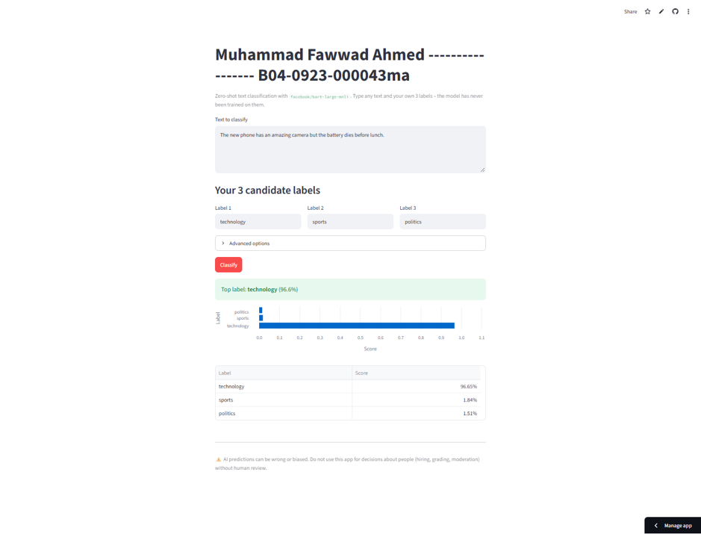
Figure 1 – Normal input: technology is chosen with 96.6 % confidence.

Screenshot 2 – Edge case: no label fits
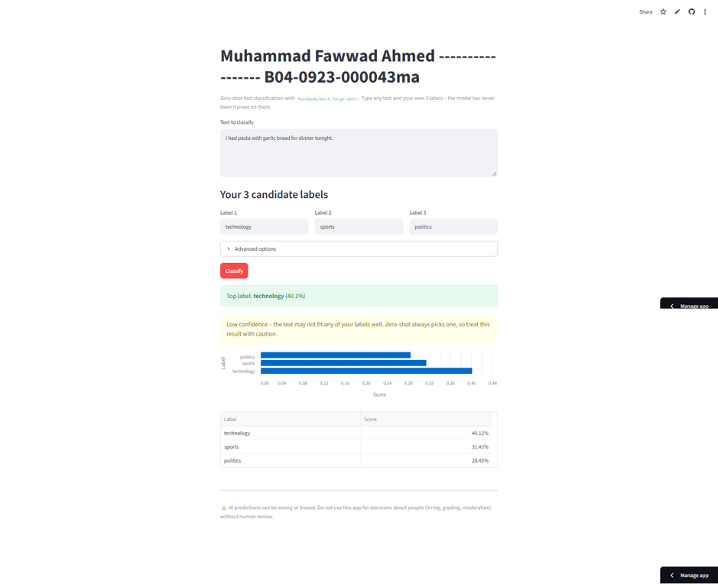
Figure 2 – Text about food: the model still picks technology (40.1 %), and the app shows a low-confidence warning.

Screenshot 3 – Edge case: sarcasm
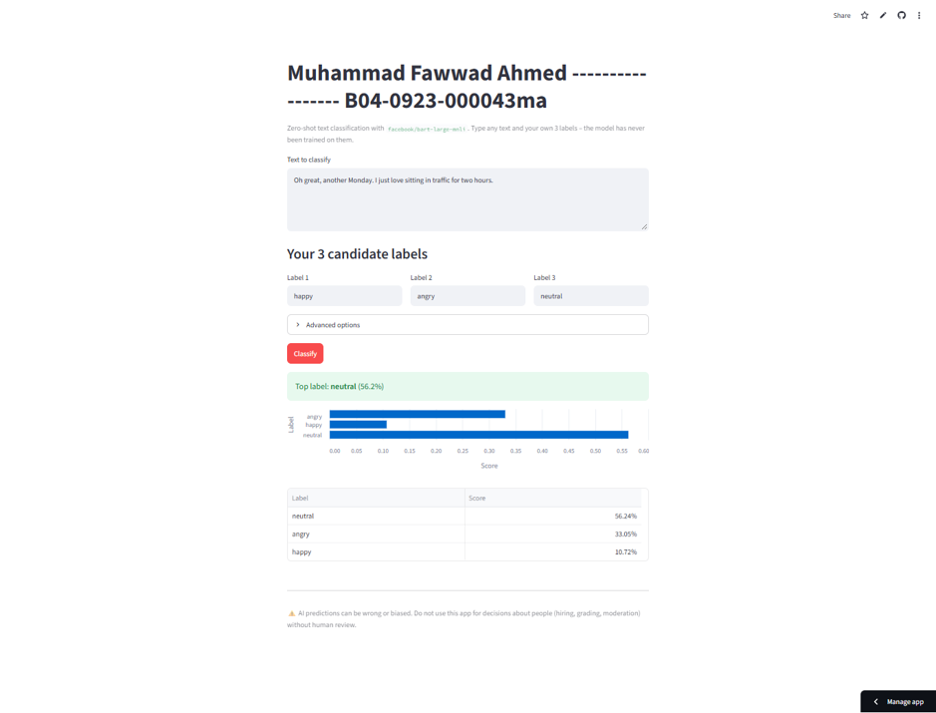
Figure 3 – Sarcastic text: the model picks neutral (56.2 %) although the writer is clearly annoyed.

Screenshot 4 – Edge case: duplicate labels
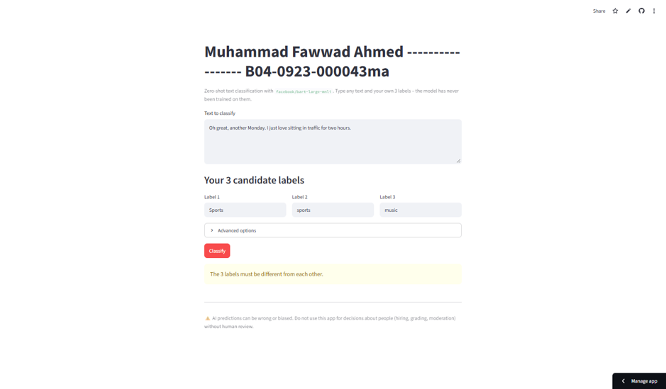
Figure 4 – Duplicate labels (Sports / sports): the app blocks the request with a clear warning.

What the tests show
- The model works very well when the text clearly matches one label (test 1).
- Zero-shot classification always returns one of the labels, even when none fits (test 2). The scores are spread out (40 / 31 / 28 %), and the low-confidence warning correctly tells the user.
- The model does not understand sarcasm well (test 3). It did not pick happy, but it also missed that the writer is angry.
- Input validation stops bad input before the model is called (test 4).

Task 2.4 – Deployment
Streamlit app | https://mid-exam-muhammad-fawwad-ahmed.streamlit.app/
Hugging Face Space | https://huggingface.co/spaces/fawwaduuu/mid-exam-gen-ai
GitHub repository | https://github.com/muhammad14251425/test----

The app was deployed on Streamlit Community Cloud straight from GitHub. The Streamlit URL was then embedded in a static HTML Hugging Face Space using an iframe.

A. Deploy on Streamlit Community Cloud
- Push app.py and requirements.txt (streamlit, transformers, torch, pandas) to a public GitHub repository.
- Go to share.streamlit.io and sign in with GitHub.
- Click Create app → Deploy a public app from GitHub.
- Fill in: Repository muhammad14251425/test----, Branch claude/zero-shot-streamlit-app-flvze5, Main file path app.py, App URL mid-exam-muhammad-fawwad-ahmed.
- Under Advanced settings choose Python 3.12, then click Deploy.
- Wait a few minutes for the build. The app is then public at https://mid-exam-muhammad-fawwad-ahmed.streamlit.app/.
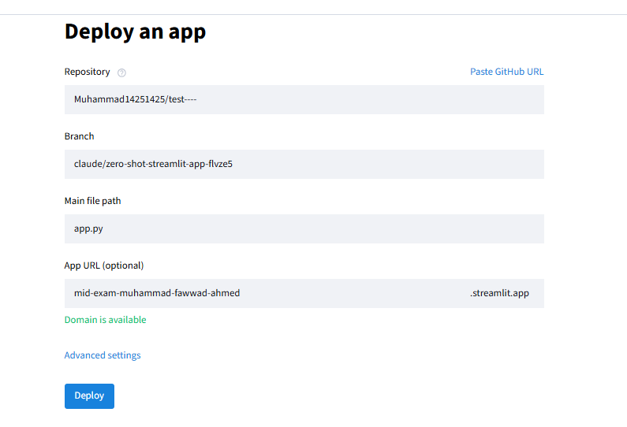
Figure 5 – Streamlit Community Cloud deploy form.

B. Embed it in a Hugging Face Space
- On huggingface.co click New → Space. Name it mid-exam-gen-ai, choose SDK Static, hardware CPU basic (free), visibility Public.
- Upload an index.html that shows the Streamlit app in a full-page iframe, and a README.md with sdk: static in its header.
- Commit. The Space now shows the live Streamlit app at https://huggingface.co/spaces/fawwaduuu/mid-exam-gen-ai.

index.html used in the Space
<iframe src="https://mid-exam-muhammad-fawwad-ahmed.streamlit.app/?embed=true"
title="Zero-shot classifier"
style="border:0; width:100%; height:100vh;"></iframe>

Note: free Streamlit apps sleep after a period without visitors. If the Space shows "This app has gone to sleep", open the Streamlit link and click "Yes, get this app back up".

Task 2.5 – Reflect and critique

(a) Something that broke and how I fixed it
When I first tried to run the app in my build environment, the model would not load. The network blocked huggingface.co, so pipeline() could not download facebook/bart-large-mnli and the whole Streamlit page crashed with a long red error. I fixed this in two ways. First, I wrapped the model call in try/except so the app now shows a short, clear message ("The model could not run…") instead of crashing. Second, I ran the model in Google Colab and on Streamlit Community Cloud, where downloads from Hugging Face are allowed. A smaller issue was a deprecation warning for use_container_width in st.dataframe, which I fixed by switching to width="stretch".

(b) One real limitation or risk
Zero-shot classification always picks one of the three labels, even when none of them fits. My test proved this: "I had pasta with garlic bread for dinner tonight" was labelled technology. Because the scores always add up to 100 %, a wrong answer can look more certain than it really is. The model also misreads sarcasm (test 3 gave neutral instead of angry), works best only in English, and quietly ignores text beyond about 1,024 tokens. If someone used this app to sort complaints or judge people's posts, these confident-looking mistakes could lead to unfair decisions.

One responsible-AI safeguard
A confidence threshold with a "Needs human review" outcome. The app already warns the user when the top score is below 50 %. In a real deployment I would go further: below the threshold no label would be applied at all, and the text would be sent to a person to check. Together with the on-page disclaimer that the app must not be used for decisions about people without human review, this stops the model's mistakes from being acted on automatically.

Appendix – Full app.py
"""Zero-shot text classifier built with Hugging Face Transformers + Streamlit.

Assigned task (digit 3): "zero-shot-classification" pipeline.
Personal feature: the user types their own 3 candidate labels.
"""

import pandas as pd
import streamlit as st
from transformers import pipeline

MODEL_NAME = "facebook/bart-large-mnli" # the default model of the zero-shot pipeline
MAX_CHARS = 3000 # BART reads at most 1024 tokens; anything past that is cut off

st.set_page_config(page_title="Zero-Shot Classifier", page_icon="🏷️")

# Mandatory title
st.title("Muhammad Fawwad Ahmed ----------------- B04-0923-000043ma")
st.caption(
f"Zero-shot text classification with `{MODEL_NAME}`. "
"Type any text and your own 3 labels – the model has never been trained on them."
)

@st.cache_resource(show_spinner="Loading model (first run downloads ~1.6 GB)…")
def load_classifier():
return pipeline("zero-shot-classification", model=MODEL_NAME)

@st.cache_data(show_spinner=False)
def classify(text, labels, multi_label, template):
result = load_classifier()(
text,
candidate_labels=list(labels),
multi_label=multi_label,
hypothesis_template=template,
)
return result["labels"], result["scores"]

# ---------- Input widgets ----------
text = st.text_area(
"Text to classify",
value="The new phone has an amazing camera but the battery dies before lunch.",
height=150,
)

st.subheader("Your 3 candidate labels")
c1, c2, c3 = st.columns(3)
label_1 = c1.text_input("Label 1", value="technology")
label_2 = c2.text_input("Label 2", value="sports")
label_3 = c3.text_input("Label 3", value="politics")

with st.expander("Advanced options"):
multi_label = st.checkbox(
"Labels can be true at the same time (multi-label)",
help="Off: scores add up to 100%. On: each label is scored independently.",
)
template = st.text_input("Hypothesis template", value="This text is about {}.")

# ---------- Run ----------
if st.button("Classify", type="primary"):
labels = [l.strip() for l in (label_1, label_2, label_3)]
errors = []
if not text.strip():
errors.append("Please enter some text to classify.")
if any(not l for l in labels):
errors.append("Please fill in all 3 candidate labels.")
elif len({l.lower() for l in labels}) < 3:
errors.append("The 3 labels must be different from each other.")
if "{}" not in template:
errors.append("The hypothesis template must contain `{}` where the label goes.")

if errors:
for e in errors:
st.warning(e)
else:
if len(text) > MAX_CHARS:
st.info(
f"Your text is {len(text):,} characters. Only roughly the first "
f"{MAX_CHARS:,} are read by the model; the rest is ignored."
)
try:
with st.spinner("Classifying…"):
out_labels, scores = classify(text.strip(), tuple(labels), multi_label, template)
except Exception as exc: # network / download / memory problems
st.error(f"The model could not run: {exc}")
else:
top, top_score = out_labels[0], scores[0]
st.success(f"Top label: **{top}** ({top_score:.1%})")
if not multi_label and top_score < 0.5:
st.warning(
"Low confidence – the text may not fit any of your labels well. "
"Zero-shot always picks one, so treat this result with caution."
)

df = pd.DataFrame({"Label": out_labels, "Score": scores})
st.bar_chart(df, x="Label", y="Score", horizontal=True)
st.dataframe(
df.style.format({"Score": "{:.2%}"}), hide_index=True, width="stretch"
)

st.divider()
st.caption(
"⚠️ AI predictions can be wrong or biased. Do not use this app for decisions "
"about people (hiring, grading, moderation) without human review."
)

