Mid Exam – Generative AI
Zero-Shot Text Classifier
Hugging Face Transformers + Streamlit + Google Colab
Muhammad Fawwad Ahmed
B04-0923-000043ma
Assigned digit | 3 → zero-shot-classification
Personal feature | The user types their own 3 candidate labels
Model | facebook/bart-large-mnli
Live app (Streamlit) | https://mid-exam-muhammad-fawwad-ahmed.streamlit.app/
Hugging Face Space | https://huggingface.co/spaces/fawwaduuu/mid-exam-gen-ai
Source code (GitHub) | https://github.com/muhammad14251425/test----

Task 2.1 – Set up and load the model
The environment was set up in Google Colab (free). I installed the Transformers library and PyTorch, then loaded the zero-shot-classification pipeline.
!pip install -q transformers torch streamlit

Exact model used by the pipeline: facebook/bart-large-mnli
- BART-large (about 407 million parameters), fine-tuned on the MultiNLI (natural language inference) dataset.
- It is the default model of pipeline("zero-shot-classification"). The code names it explicitly so the model can never change silently.
- How it works: each label is turned into a sentence such as "This text is about technology." The model scores how strongly the input text implies (entails) that sentence, and the scores become probabilities across the labels.

Quick test code
"""Task 2.1 – load the zero-shot pipeline and run one quick test.

Run in Google Colab:
!pip install -q transformers torch
!python task_2_1_test_model.py
"""

from transformers import pipeline

classifier = pipeline("zero-shot-classification", model="facebook/bart-large-mnli")

print("Model used:", classifier.model.config._name_or_path)
print("Architecture:", classifier.model.config.architectures)

result = classifier(
"The new phone has an amazing camera but the battery dies before lunch.",
candidate_labels=["technology", "sports", "politics"],
)

print("\nSequence:", result["sequence"])
for label, score in zip(result["labels"], result["scores"]):
print(f" {label:<12} {score:.4f}")

Quick test result
The same test input and labels were run in the deployed app. The model put technology clearly on top:
Label | Score | Rank
technology | 96.65 % | 1
sports | 1.84 % | 2
politics | 1.51 % | 3

[Paste the Colab screenshot of the quick-test output here]

Task 2.2 – Build the Streamlit app (app.py)
The app is a single file, app.py. The table shows where each requirement is met; the full code is in the Appendix.
Requirement | How it is done in app.py
Title with name & ID | st.title("Muhammad Fawwad Ahmed ----------------- B04-0923-000043ma")
Input widget | st.text_area for the text to classify
Personal feature | Three st.text_input boxes (in st.columns) where the user types their own 3 labels
Button | st.button("Classify")
Cached model call | @st.cache_resource loads the model only once per server; @st.cache_data caches repeated identical predictions
Result display | Green box with the top label and score, horizontal bar chart, and a score table
Extra safety / UX | Checks for empty text, missing or duplicate labels; notice for very long text; low-confidence warning (< 50 %); error message instead of a crash; multi-label option; editable hypothesis template; responsible-AI disclaimer

Key code: cached model and model call
@st.cache_resource(show_spinner="Loading model (first run downloads ~1.6 GB)…")
def load_classifier():
return pipeline("zero-shot-classification", model=MODEL_NAME)

@st.cache_data(show_spinner=False)
def classify(text, labels, multi_label, template):
result = load_classifier()(
text,
candidate_labels=list(labels),
multi_label=multi_label,
hypothesis_template=template,
)
return result["labels"], result["scores"]

Task 2.3 – Run and test
The app was run and tested through its live Streamlit deployment. Below are one normal input and three edge cases (one tricky input with no matching label, one sarcastic input, and one invalid input).

Test table
# | Type | Input text | Labels | Actual result | Pass?
1 | Normal | The new phone has an amazing camera but the battery dies before lunch. | technology / sports / politics | technology 96.6 % | Pass
2 | Edge – tricky (no label fits) | I had pasta with garlic bread for dinner tonight. | technology / sports / politics | technology 40.1 % + low-confidence warning shown | Pass (warning works)
3 | Edge – tricky (sarcasm) | Oh great, another Monday. I just love sitting in traffic for two hours. | happy / angry / neutral | neutral 56.2 %, angry 33.1 %, happy 10.7 % | Partial – real meaning is angry
4 | Edge – invalid input | Oh great, another Monday. I just love sitting in traffic for two hours. | Sports / sports / music | Warning: "The 3 labels must be different from each other." Model not called. | Pass

Screenshot 1 – Normal input
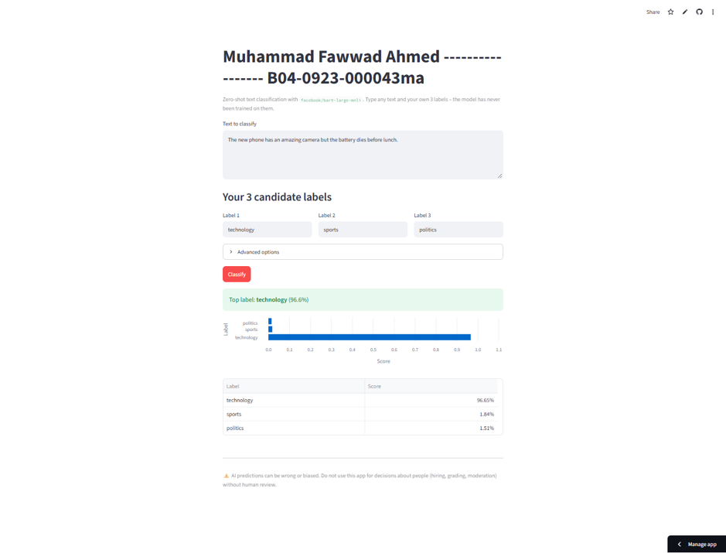
Figure 1 – Normal input: technology is chosen with 96.6 % confidence.

Screenshot 2 – Edge case: no label fits
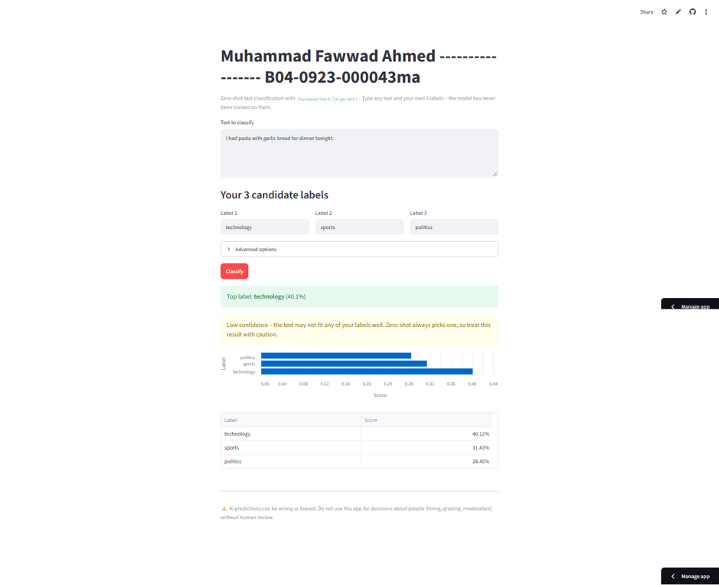
Figure 2 – Text about food: the model still picks technology (40.1 %), and the app shows a low-confidence warning.

Screenshot 3 – Edge case: sarcasm
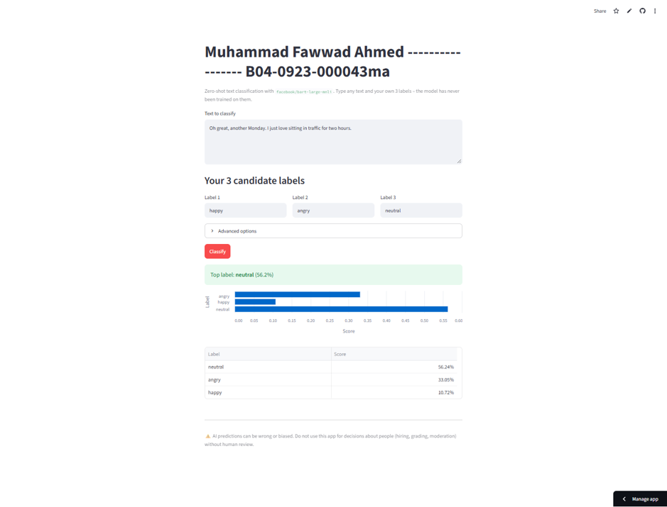
Figure 3 – Sarcastic text: the model picks neutral (56.2 %) although the writer is clearly annoyed.

Screenshot 4 – Edge case: duplicate labels
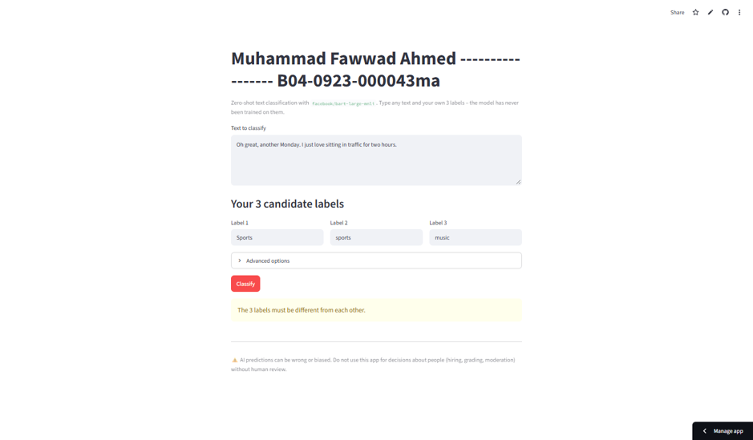
Figure 4 – Duplicate labels (Sports / sports): the app blocks the request with a clear warning.

What the tests show
- The model works very well when the text clearly matches one label (test 1).
- Zero-shot classification always returns one of the labels, even when none fits (test 2). The scores are spread out (40 / 31 / 28 %), and the low-confidence warning correctly tells the user.
- The model does not understand sarcasm well (test 3). It did not pick happy, but it also missed that the writer is angry.
- Input validation stops bad input before the model is called (test 4).

Task 2.4 – Deployment
Streamlit app | https://mid-exam-muhammad-fawwad-ahmed.streamlit.app/
Hugging Face Space | https://huggingface.co/spaces/fawwaduuu/mid-exam-gen-ai
GitHub repository | https://github.com/muhammad14251425/test----

The app was deployed on Streamlit Community Cloud straight from GitHub. The Streamlit URL was then embedded in a static HTML Hugging Face Space using an iframe.

A. Deploy on Streamlit Community Cloud
- Push app.py and requirements.txt (streamlit, transformers, torch, pandas) to a public GitHub repository.
- Go to share.streamlit.io and sign in with GitHub.
- Click Create app → Deploy a public app from GitHub.
- Fill in: Repository muhammad14251425/test----, Branch claude/zero-shot-streamlit-app-flvze5, Main file path app.py, App URL mid-exam-muhammad-fawwad-ahmed.
- Under Advanced settings choose Python 3.12, then click Deploy.
- Wait a few minutes for the build. The app is then public at https://mid-exam-muhammad-fawwad-ahmed.streamlit.app/.
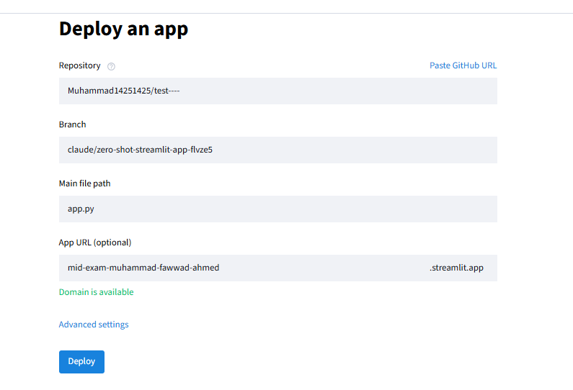
Figure 5 – Streamlit Community Cloud deploy form.

B. Embed it in a Hugging Face Space
- On huggingface.co click New → Space. Name it mid-exam-gen-ai, choose SDK Static, hardware CPU basic (free), visibility Public.
- Upload an index.html that shows the Streamlit app in a full-page iframe, and a README.md with sdk: static in its header.
- Commit. The Space now shows the live Streamlit app at https://huggingface.co/spaces/fawwaduuu/mid-exam-gen-ai.

index.html used in the Space
<iframe src="https://mid-exam-muhammad-fawwad-ahmed.streamlit.app/?embed=true"
title="Zero-shot classifier"
style="border:0; width:100%; height:100vh;"></iframe>

Note: free Streamlit apps sleep after a period without visitors. If the Space shows "This app has gone to sleep", open the Streamlit link and click "Yes, get this app back up".

Task 2.5 – Reflect and critique

(a) Something that broke and how I fixed it
When I first tried to run the app in my build environment, the model would not load. The network blocked huggingface.co, so pipeline() could not download facebook/bart-large-mnli and the whole Streamlit page crashed with a long red error. I fixed this in two ways. First, I wrapped the model call in try/except so the app now shows a short, clear message ("The model could not run…") instead of crashing. Second, I ran the model in Google Colab and on Streamlit Community Cloud, where downloads from Hugging Face are allowed. A smaller issue was a deprecation warning for use_container_width in st.dataframe, which I fixed by switching to width="stretch".

(b) One real limitation or risk
Zero-shot classification always picks one of the three labels, even when none of them fits. My test proved this: "I had pasta with garlic bread for dinner tonight" was labelled technology. Because the scores always add up to 100 %, a wrong answer can look more certain than it really is. The model also misreads sarcasm (test 3 gave neutral instead of angry), works best only in English, and quietly ignores text beyond about 1,024 tokens. If someone used this app to sort complaints or judge people's posts, these confident-looking mistakes could lead to unfair decisions.

One responsible-AI safeguard
A confidence threshold with a "Needs human review" outcome. The app already warns the user when the top score is below 50 %. In a real deployment I would go further: below the threshold no label would be applied at all, and the text would be sent to a person to check. Together with the on-page disclaimer that the app must not be used for decisions about people without human review, this stops the model's mistakes from being acted on automatically.

Appendix – Full app.py
"""Zero-shot text classifier built with Hugging Face Transformers + Streamlit.

Assigned task (digit 3): "zero-shot-classification" pipeline.
Personal feature: the user types their own 3 candidate labels.
"""

import pandas as pd
import streamlit as st
from transformers import pipeline

MODEL_NAME = "facebook/bart-large-mnli" # the default model of the zero-shot pipeline
MAX_CHARS = 3000 # BART reads at most 1024 tokens; anything past that is cut off

st.set_page_config(page_title="Zero-Shot Classifier", page_icon="🏷️")

# Mandatory title
st.title("Muhammad Fawwad Ahmed ----------------- B04-0923-000043ma")
st.caption(
f"Zero-shot text classification with `{MODEL_NAME}`. "
"Type any text and your own 3 labels – the model has never been trained on them."
)

@st.cache_resource(show_spinner="Loading model (first run downloads ~1.6 GB)…")
def load_classifier():
return pipeline("zero-shot-classification", model=MODEL_NAME)

@st.cache_data(show_spinner=False)
def classify(text, labels, multi_label, template):
result = load_classifier()(
text,
candidate_labels=list(labels),
multi_label=multi_label,
hypothesis_template=template,
)
return result["labels"], result["scores"]

# ---------- Input widgets ----------
text = st.text_area(
"Text to classify",
value="The new phone has an amazing camera but the battery dies before lunch.",
height=150,
)

st.subheader("Your 3 candidate labels")
c1, c2, c3 = st.columns(3)
label_1 = c1.text_input("Label 1", value="technology")
label_2 = c2.text_input("Label 2", value="sports")
label_3 = c3.text_input("Label 3", value="politics")

with st.expander("Advanced options"):
multi_label = st.checkbox(
"Labels can be true at the same time (multi-label)",
help="Off: scores add up to 100%. On: each label is scored independently.",
)
template = st.text_input("Hypothesis template", value="This text is about {}.")

# ---------- Run ----------
if st.button("Classify", type="primary"):
labels = [l.strip() for l in (label_1, label_2, label_3)]
errors = []
if not text.strip():
errors.append("Please enter some text to classify.")
if any(not l for l in labels):
errors.append("Please fill in all 3 candidate labels.")
elif len({l.lower() for l in labels}) < 3:
errors.append("The 3 labels must be different from each other.")
if "{}" not in template:
errors.append("The hypothesis template must contain `{}` where the label goes.")

if errors:
for e in errors:
st.warning(e)
else:
if len(text) > MAX_CHARS:
st.info(
f"Your text is {len(text):,} characters. Only roughly the first "
f"{MAX_CHARS:,} are read by the model; the rest is ignored."
)
try:
with st.spinner("Classifying…"):
out_labels, scores = classify(text.strip(), tuple(labels), multi_label, template)
except Exception as exc: # network / download / memory problems
st.error(f"The model could not run: {exc}")
else:
top, top_score = out_labels[0], scores[0]
st.success(f"Top label: **{top}** ({top_score:.1%})")
if not multi_label and top_score < 0.5:
st.warning(
"Low confidence – the text may not fit any of your labels well. "
"Zero-shot always picks one, so treat this result with caution."
)

df = pd.DataFrame({"Label": out_labels, "Score": scores})
st.bar_chart(df, x="Label", y="Score", horizontal=True)
st.dataframe(
df.style.format({"Score": "{:.2%}"}), hide_index=True, width="stretch"
)

st.divider()
st.caption(
"⚠️ AI predictions can be wrong or biased. Do not use this app for decisions "
"about people (hiring, grading, moderation) without human review."
)

