

**Ministry of Higher Education**

Higher Technological Institute

10th of Ramadan City

6th of October Branch

**Electrical and Computer Engineering Department**

**Communication Systems**

EET 139 (G 92)

**MATLAB Task**

**Under Supervision: Prof. Dr. Ali Elmoghazy**

Eng. Mahmoud hamed/ Eng. Kareem Badawi

Name / Muhammad Magdy Srour

**ID/ 32015251**

Table of Contents

1 - AM (Amplitude modulation) 5

1.1 – introduction 5

1.2 – time domain modulation equation 6

1.3 – modulation method 6

1.4 – de-modulation method 6

1.5 – MATLAB code 7

Set the code parameters 7

Generate massage and carrier 7

Plotting the massage and carrier 7

massage and carrier 8

Modulation 8

Demodulation 8

Plotting modulated and demodulated signals 9

modulated and demodulated signals 9

2 - DSB-SC (Double-sideband suppressed-carrier transmission) 10

2.1 – introduction 10

2.2 – time domain modulation equation 10

2.3 – modulation method 11

2.4 – de-modulation method 11

2.5 – MATLAB code 11

Set the code parameters 11

Generate massage and carrier 12

Plotting the massage and carrier 12

massage and carrier 12

Modulation 13

Demodulation 13

Plotting modulated and demodulated signals 13

modulated and demodulated signals 14

3 – SSB (Single-sideband modulation) 15

3.1 – introduction 15

3.2 – time domain modulation equation 16

3.3 – modulation method 16

3.4 – de-modulation method 17

3.5 – MATLAB code 17

Set the code parameters 17

Generate massage and carrier 17

Plotting the massage and carrier 18

massage and carrier 18

Modulation 19

Demodulation 19

Plotting modulated and demodulated signals 19

modulated and demodulated signals 20

4 – MATLAB used functions 21

4.1 amdemod 21

4.2 butter 21

Figure 1 AM signal 6

Figure 2 AM modulation method 7

Figure 3 AM de-modulation method 7

Figure 4 AM Set the code parameters 8

Figure 5 AM Generate massage and carrier 8

Figure 6 AM Plotting the massage and carrier 8

Figure 7 AM massage and carrier 9

Figure 8 AM Modulation equation 9

Figure 9 AM Demodulation equation 9

Figure 10 AM Plotting modulated and demodulated signals 10

Figure 11 AM modulated and demodulated signals 10

Figure 12 DSB-SC modulation method 12

Figure 13 DSB-SC demodulation method 12

Figure 14 DCB-SC Set the code parameters 12

Figure 15 DCB-SC Generate massage and carrier 13

Figure 16 DSB-SC Plotting the massage and carrier 13

Figure 17 DCB-SC massage and carrier 13

Figure 18 DSB-SC Modulation equation 14

Figure 19 DSB-SC Demodulation equation 14

Figure 20 DSB-SC Plotting modulated and demodulated signals 14

Figure 21 DSB-SC modulated and demodulated signals 15

Figure 22 SSB signal 16

Figure 23 SSB modulation method 1 17

Figure 24 SSB modulation method 2 17

Figure 25 SSB de-modulation method 18

Figure 26 SSB Set the code parameters 18

Figure 27 SSB Generate massage and carrier 18

Figure 28 SSB Plotting the massage and carrier 19

Figure 29 SSB massage and carrier 19

Figure 30 SSB(LSB) Modulation equation 20

Figure 31 SSB(LSB) Demodulation equation 20

Figure 32 SSB(LSB) Plotting modulated and demodulated signals 20

Figure 33 SSB(LSB) modulated and demodulated signals 21

Figure 34 amdemod function 22

Figure 35 butter function 22

# 1 - AM (Amplitude modulation)

## – introduction

amplitude modulation (AM) is a [modulation](https://en.wikipedia.org/wiki/Modulation) technique used in electronic communication, most commonly for transmitting information via a [radio](https://en.wikipedia.org/wiki/Radio) [carrier wave](https://en.wikipedia.org/wiki/Carrier_wave). In amplitude modulation, the [amplitude](https://en.wikipedia.org/wiki/Amplitude) (signal strength) of the carrier wave is varied in proportion to that of the message signal being transmitted. The message signal is, for example, a function of the sound to be reproduced by a [loudspeaker](https://en.wikipedia.org/wiki/Loudspeaker), or the light intensity of pixels of a television screen. This technique contrasts with [frequency modulation](https://en.wikipedia.org/wiki/Frequency_modulation), in which the [frequency](https://en.wikipedia.org/wiki/Frequency) of the [carrier signal](https://en.wikipedia.org/wiki/Carrier_signal) is varied, and [phase modulation](https://en.wikipedia.org/wiki/Phase_modulation), in which its [phase](https://en.wikipedia.org/wiki/Phase_(waves)) is varied.

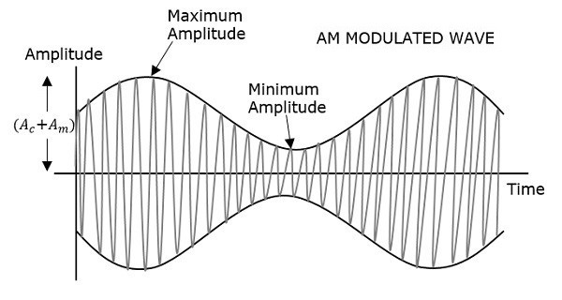

Figure 1 AM signal

## 

## 1.2 – time domain modulation equation

S(t) = (Ac+m(t)) * cos(Wc*t)

**Where**

S(t) = AM modulated signal .

AC = carrier amplitude.

M(t) = massage signal .

## 1.3 – modulation method

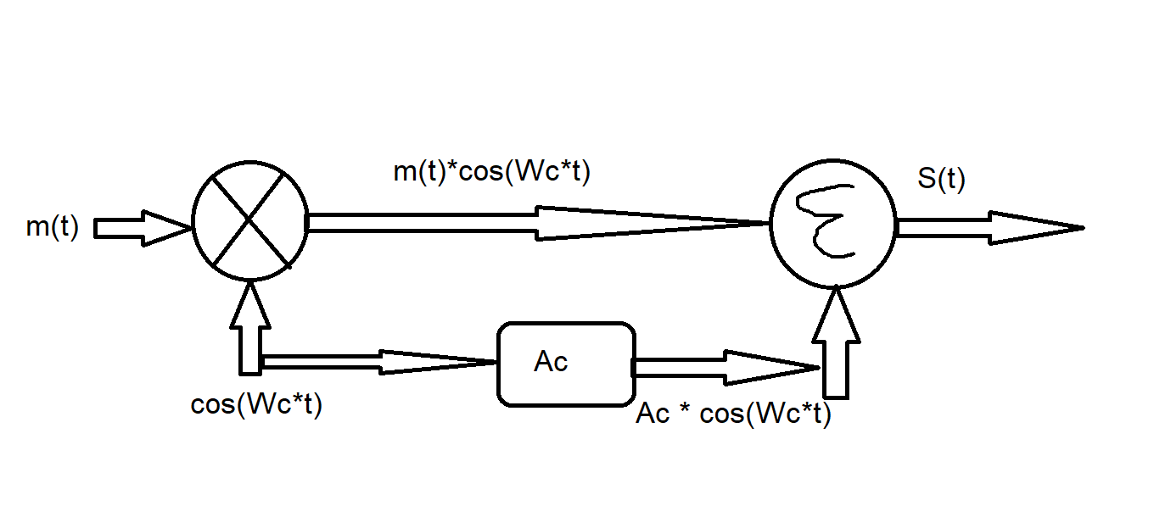

Figure 2 AM modulation method

## 1.4 – de-modulation method

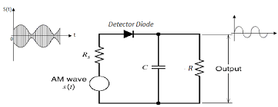

Figure 3 AM de-modulation method

## 1.5 – MATLAB code

### Set the code parameters

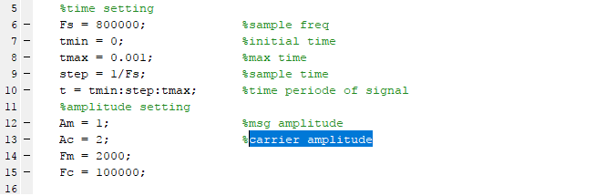

Figure 4 AM Set the code parameters

### Generate massage and carrier



Figure 5 AM Generate massage and carrier

### Plotting the massage and carrier

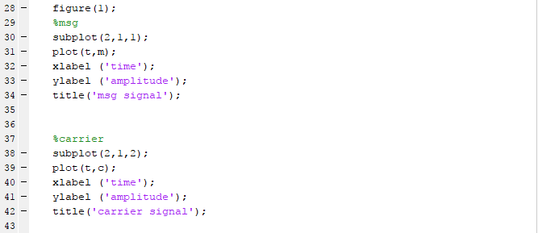

Figure 6 AM Plotting the massage and carrier

### massage and carrier

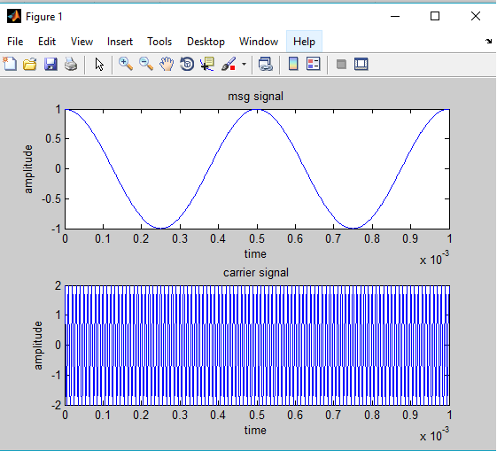

Figure 7 AM massage and carrier

### Modulation



Figure 8 AM Modulation equation

### Demodulation



Figure 9 AM Demodulation equation

### Plotting modulated and demodulated signals

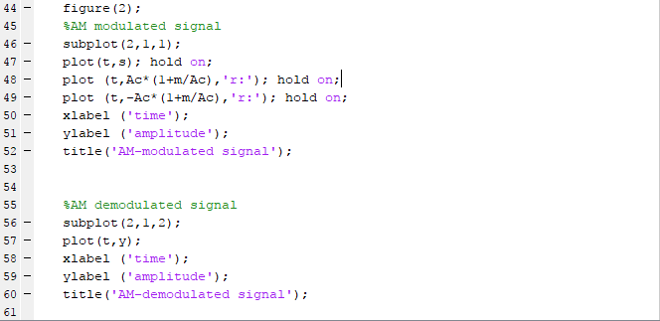

Figure 10 AM Plotting modulated and demodulated signals

### modulated and demodulated signals

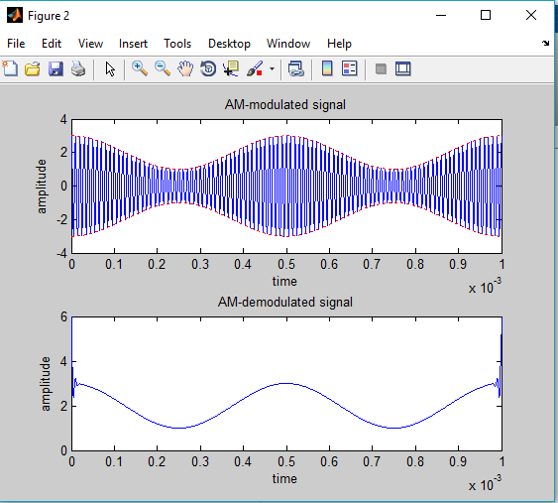

Figure 11 AM modulated and demodulated signals

# 2 - DSB-SC (Double-sideband suppressed-carrier transmission)

## 2.1 – introduction

 is [transmission](https://en.wikipedia.org/wiki/Transmission_(telecommunications)) in which frequencies produced by [amplitude modulation](https://en.wikipedia.org/wiki/Amplitude_modulation) (AM) are symmetrically spaced above and below the [carrier frequency](https://en.wikipedia.org/wiki/Carrier_frequency) and the carrier level is reduced to the lowest practical level, ideally being completely suppressed.

In the DSB-SC modulation, unlike in AM, the wave carrier is not transmitted; thus, much of the power is distributed between the side bands, which implies an increase of the cover in DSB-SC, compared to AM, for the same power used.

DSB-SC transmission is a special case of [double-sideband reduced carrier transmission](https://en.wikipedia.org/wiki/Double-sideband_reduced_carrier_transmission). It is used for [radio data systems](https://en.wikipedia.org/wiki/Radio_Data_System).

## 2.2 – time domain modulation equation

S(t) = m(t) * Ac * cos(Wc*t)

**Where**

S(t) = DSB-SC modulated signal .

AC = carrier amplitude.

M(t) = massage signal .

## 2.3 – modulation method

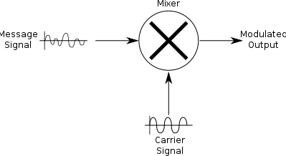

Figure 12 DSB-SC modulation method

## 2.4 – de-modulation method

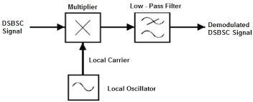

Figure 13 DSB-SC demodulation method

## 2.5 – MATLAB code

### Set the code parameters



Figure 14 DCB-SC Set the code parameters

### Generate massage and carrier



Figure 15 DCB-SC Generate massage and carrier

### Plotting the massage and carrier



Figure 16 DSB-SC Plotting the massage and carrier

### massage and carrier



Figure 17 DCB-SC massage and carrier

### Modulation



Figure 18 DSB-SC Modulation equation

### Demodulation

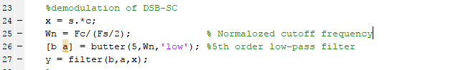

Figure 19 DSB-SC Demodulation equation

### Plotting modulated and demodulated signals

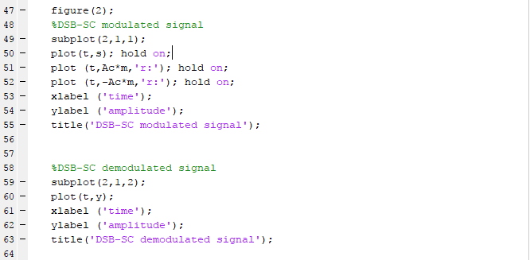

Figure 20 DSB-SC Plotting modulated and demodulated signals

### modulated and demodulated signals

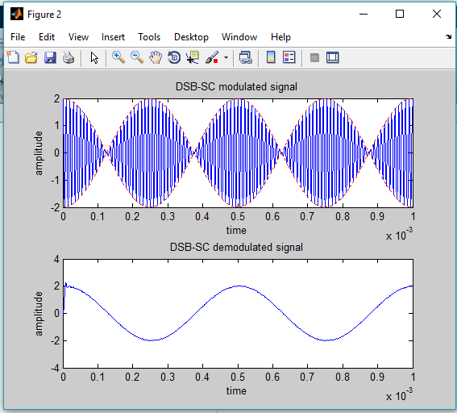

Figure 21 DSB-SC modulated and demodulated signals

# 3 – SSB (Single-sideband modulation)

## 3.1 – introduction

is a type of [modulation](https://en.wikipedia.org/wiki/Modulation), used to transmit information, such as an [audio signal](https://en.wikipedia.org/wiki/Audio_signal), by [radio waves](https://en.wikipedia.org/wiki/Radio_wave). A refinement of [amplitude modulation](https://en.wikipedia.org/wiki/Amplitude_modulation), it uses transmitter power and [bandwidth](https://en.wikipedia.org/wiki/Bandwidth_(signal_processing)) more efficiently. Amplitude modulation produces an output signal that has twice the bandwidth of the original baseband signal. Single-sideband modulation avoids this bandwidth doubling, and the power wasted on a carrier, at the cost of increased device complexity and more difficult tuning at the receiver.

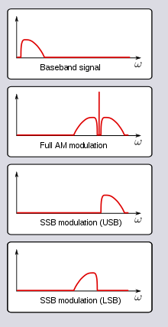

Figure 22 SSB signal

## 3.2 – time domain modulation equation

S(t) = m(t)*cos(Wc*t) – Mh(t)*sin(Wc*t) for USB (upper side band)

S(t) = m(t)*cos(Wc*t) + Mh(t)*sin(Wc*t) for LSB (lower side band)

**Where**

S(t) = DSB-SC modulated signal .

M(t) = massage signal .

Mh(t) = hilbert transform of m(t).

## 3.3 – modulation method

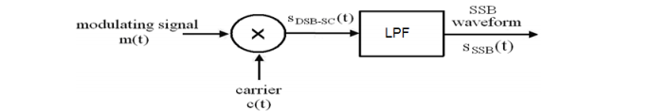

Figure 23 SSB modulation method 1

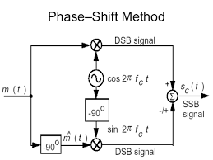

Figure 24 SSB modulation method 2

## 3.4 – de-modulation method

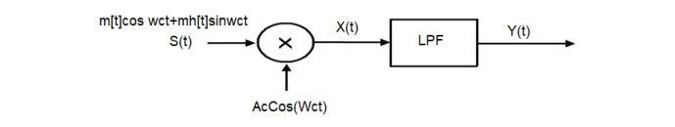

Figure 25 SSB de-modulation method

## 3.5 – MATLAB code

### Set the code parameters



Figure 26 SSB Set the code parameters

### Generate massage and carrier

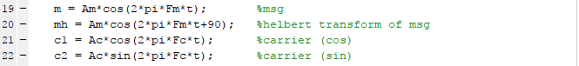

Figure 27 SSB Generate massage and carrier

### Plotting the massage and carrier

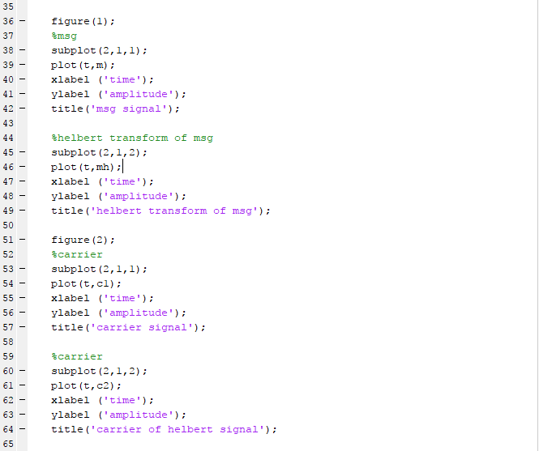

Figure 28 SSB Plotting the massage and carrier

### massage and carrier

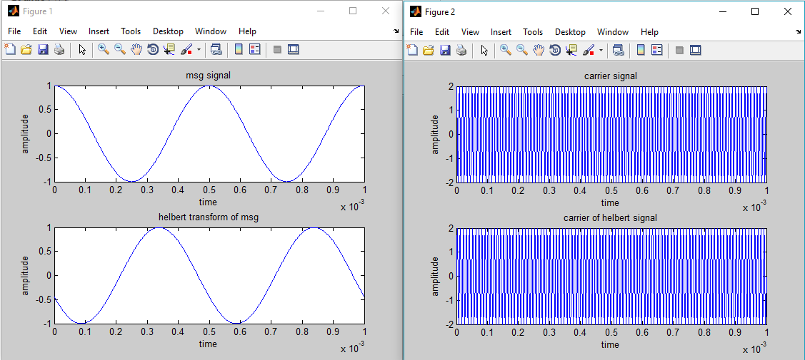

Figure 29 SSB massage and carrier

### Modulation

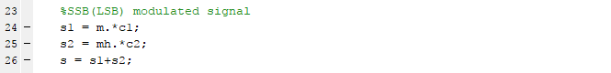

Figure 30 SSB(LSB) Modulation equation

### Demodulation

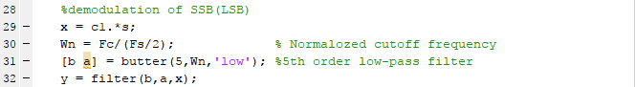

Figure 31 SSB(LSB) Demodulation equation

### Plotting modulated and demodulated signals

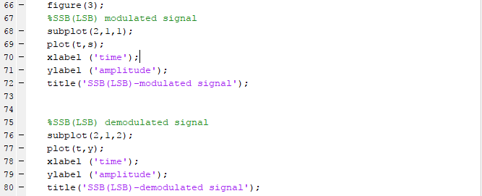

Figure 32 SSB(LSB) Plotting modulated and demodulated signals

### modulated and demodulated signals

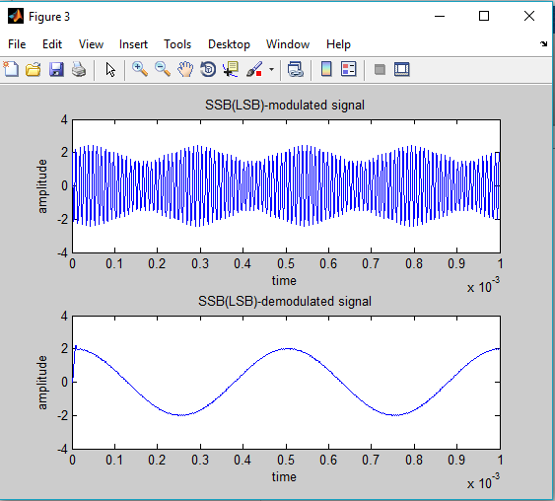

Figure 33 SSB(LSB) modulated and demodulated signals

# 4 – MATLAB used functions

## 4.1 amdemod

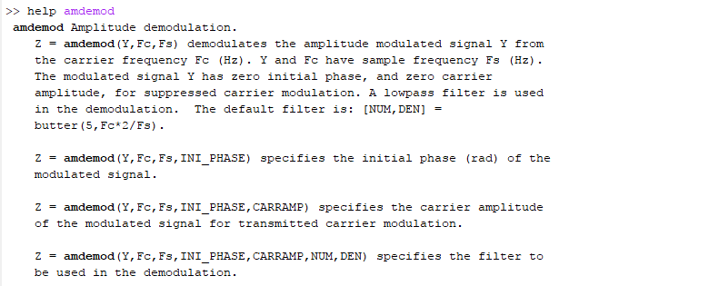

Figure 34 amdemod function

## 4.2 butter

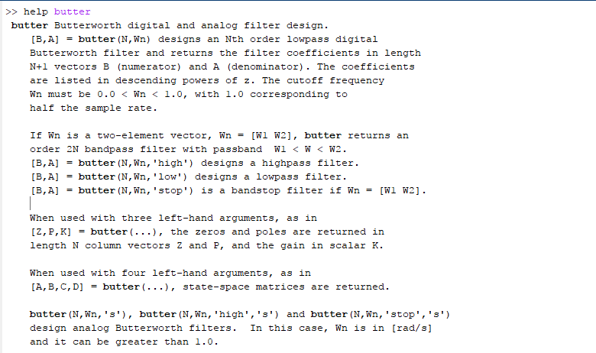

Figure 35 butter function