
Muhammad_23F-0577
Muhammad Usman_23F-0570
Artificial Intelligence
Assignment 1 Part 2
BSCS-6D
Sir Dr. Hashem Yassin

Depth first Search
Code
import tkinter as tk
import time

total_rows, total_columns = 9, 9
cell_size = 40

moves = [(-1, 0), (0, 1), (1, 0), (1, 1), (0, -1), (-1, -1)]

hurdles = { (0, 3), (1, 3), (2, 3), (3, 3), (4, 5),(5, 5),
(6, 5),(7, 1), (7, 2), (7, 3), (5, 7), (6, 7)
}

# Visualization
root = tk.Tk()
root.title("DFS Grid Animation")
canvas = tk.Canvas(root, width=total_columns * cell_size, height=total_rows * cell_size)
canvas.pack()

def draw_grid(visited_positions, current_position, start_position, goal_position, final_path=None):
canvas.delete("all")

for row in range(total_rows):
for col in range(total_columns):
x1 = col * cell_size
y1 = row * cell_size
x2 = x1 + cell_size
y2 = y1 + cell_size

color = "white"

if (row, col) in hurdles:
color = "black"
elif (row, col) in visited_positions:
color = "lightblue"

if final_path and (row, col) in final_path:
color = "yellow"

if (row, col) == current_position:
color = "orange"
if (row, col) == start_position:
color = "green"
if (row, col) == goal_position:
color = "red"

canvas.create_rectangle(x1, y1, x2, y2, fill=color, outline="gray")

def get_neighbors(Currentrow, Currentcolumn):
neighbors = []
for rowChange, colChange in moves:
nRow = Currentrow + rowChange
nColumn = Currentcolumn + colChange
if (0 <= nRow < total_rows and 0 <= nColumn < total_columns and (nRow, nColumn) not in hurdles):
neighbors.append((nRow, nColumn))
return neighbors

# DFS
def DFS(start_position, goal_position):
visited_positions = set()
stack = [(start_position, [start_position])]
while stack:
current_position, path = stack.pop()
if current_position in visited_positions:
continue
visited_positions.add(current_position)

draw_grid(visited_positions, current_position, start_position, goal_position)
root.update()
time.sleep(0.1)

if current_position == goal_position:
print("Goal reached!")
print("Total steps:", len(path) - 1)

draw_grid(visited_positions, current_position, start_position, goal_position, final_path=path)
root.update()
return

for neighbor in get_neighbors(current_position[0], current_position[1]):
if neighbor not in visited_positions:
stack.append((neighbor, path + [neighbor]))
print("Goal not reachable.")

start_position = (0, 0)
goal_position = (8, 8)

DFS(start_position, goal_position)
root.mainloop()

Output
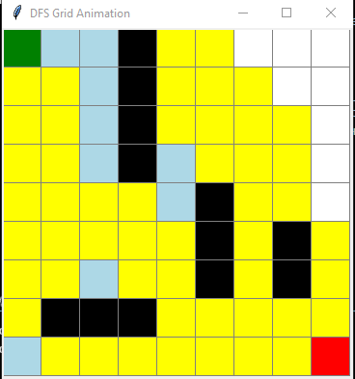

Note That: Yellow is Shortest Path. White + Yellow is overall cost.
Green is Start
Red is Goal
Black are hurdles

Breadth first Search
Code
import tkinter as tk
from collections import deque
import time

total_rows, total_columns = 9, 9
cell_size = 40

moves = [(-1, 0), (0, 1), (1, 0), (1, 1), (0, -1), (-1, -1)]

hurdles = { (0, 3), (1, 3), (2, 3), (3, 3), (4, 5),(5, 5),
(6, 5),(7, 1), (7, 2), (7, 3), (5, 7), (6, 7)
}

# ---------- Visualization ----------
root = tk.Tk()
root.title("BFS Grid")
canvas = tk.Canvas(root,width=total_columns * cell_size, height=total_rows * cell_size)
canvas.pack()

def draw_grid(visited_positions, current_position, start_position, goal_position, final_path=None):
canvas.delete("all")
for row in range(total_rows):
for col in range(total_columns):
x1 = col * cell_size
y1 = row * cell_size
x2 = x1 + cell_size
y2 = y1 + cell_size
color = "white"
if (row, col) in hurdles:
color = "black"
elif (row, col) in visited_positions:
color = "lightblue"
if final_path and (row, col) in final_path:
color = "yellow"
if (row, col) == current_position:
color = "orange"
if (row, col) == start_position:
color = "green"
if (row, col) == goal_position:
color = "red"
canvas.create_rectangle(x1, y1, x2, y2, fill=color, outline="gray")

def get_neighbors(Currentrow, Currentcolumn):
neighbors = []
for rowChange, colChange in moves:
nRow = Currentrow + rowChange
nColumn = Currentcolumn + colChange
if (0 <= nRow < total_rows and 0 <= nColumn < total_columns and (nRow, nColumn) not in hurdles):
neighbors.append((nRow, nColumn))
return neighbors

# Breadth First Search
def BFS(start_position, goal_position):
visited_positions = set()
queue = deque([(start_position, [start_position])])
while queue:
current_position, path = queue.popleft()
if current_position in visited_positions:
continue
visited_positions.add(current_position)

draw_grid(visited_positions, current_position, start_position, goal_position)
root.update()
time.sleep(0.1)

if current_position == goal_position:
print("Goal reached!")
print("Total steps:", len(path) - 1)

draw_grid(visited_positions, current_position, start_position, goal_position, final_path=path)
root.update()
return

for neighbor in get_neighbors(current_position[0], current_position[1]):
if neighbor not in visited_positions:
queue.append((neighbor, path + [neighbor]))

print("Goal not reachable.")

start_position = (0, 0)
goal_position = (8, 8)

BFS(start_position, goal_position)
root.mainloop()

Output
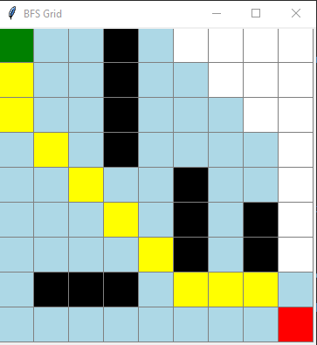
Note That: Yellow is Shortest Path. White + Yellow is overall cost.
Green is Start
Red is Goal
Black are hurdles

Depth limited Search
Code
import tkinter as tk

total_rows, total_columns = 9, 9
cell_size = 40

moves = [(-1, 0), (0, 1), (1, 0), (1, 1), (0, -1), (-1, -1)]

hurdles = { (0, 3), (1, 3), (2, 3), (3, 3), (4, 5),(5, 5),
(6, 5),(7, 1), (7, 2), (7, 3), (5, 7), (6, 7)
}

root = tk.Tk()
root.title("Depth-Limited Search (DLS) Grid Animation")
canvas = tk.Canvas(root,width=total_columns * cell_size, height=total_rows * cell_size)
canvas.pack()

def draw_grid(visited_positions, current_position, start_position, goal_position, final_path=None):
canvas.delete("all")
for row in range(total_rows):
for col in range(total_columns):
x1 = col * cell_size
y1 = row * cell_size
x2 = x1 + cell_size
y2 = y1 + cell_size
color = "white"
if (row, col) in hurdles:
color = "black"
elif (row, col) in visited_positions:
color = "lightblue"
if final_path and (row, col) in final_path:
color = "yellow"
if (row, col) == current_position:
color = "orange"
if (row, col) == start_position:
color = "green"
if (row, col) == goal_position:
color = "red"
canvas.create_rectangle(x1, y1, x2, y2,fill=color,outline="gray")
root.update()

def get_neighbors(Currentrow, Currentcolumn):
neighbors = []
for rowChange, colChange in moves:
nRow = Currentrow + rowChange
nColumn = Currentcolumn + colChange
if (0 <= nRow < total_rows and 0 <= nColumn < total_columns and (nRow, nColumn) not in hurdles):
neighbors.append((nRow, nColumn))
return neighbors

def dls(start_position, goal_position, depth_limit=20):
visited_positions = set()
stack = [(start_position, 0, [start_position])]
goal_found = False
while stack:
current_position, depth, path = stack.pop()

if current_position not in visited_positions:
visited_positions.add(current_position)

draw_grid(visited_positions, current_position,start_position, goal_position)
root.after(100)

if current_position == goal_position:
print("Goal reached at depth ",depth)
print("Total steps:", len(path) - 1)
draw_grid(visited_positions, current_position,start_position, goal_position, final_path=path)
goal_found = True
break

if depth < depth_limit:
for neighbor in get_neighbors(current_position[0], current_position[1]):
if neighbor not in visited_positions:
stack.append((neighbor, depth + 1, path + [neighbor]))
else:
print("Depth limit", depth_limit," reached at" ,current_position)

if not goal_found:
print("Goal not reachable within depth limit due to cutoof.")

start_position = (0, 0)
goal_position = (8, 8)

dls(start_position, goal_position, depth_limit=40)

root.mainloop()

Output
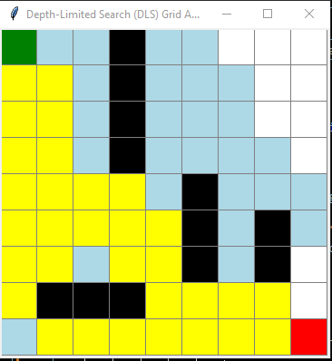
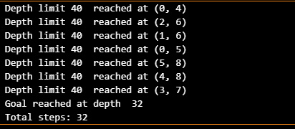
Note That: Yellow is Shortest Path. White + Yellow is overall cost.
Green is Start
Red is Goal
Black are hurdles

Iterative Deepening Search
Code
import tkinter as tk
import time

total_rows, total_columns = 9, 9
cell_size = 40

moves = [(-1, 0), (0, 1), (1, 0), (1, 1), (0, -1), (-1, -1)]

hurdles = { (0, 3), (1, 3), (2, 3), (3, 3), (4, 5),(5, 5),
(6, 5),(7, 1), (7, 2), (7, 3), (5, 7), (6, 7)
}

root = tk.Tk()
root.title("Iterative Deepening Search (IDS) Grid Animation")
canvas = tk.Canvas(root, width=total_columns * cell_size, height=total_rows * cell_size)
canvas.pack()

def draw_grid(visited_positions, current_position, start_position, goal_position, final_path=None):
canvas.delete("all")
for row in range(total_rows):
for col in range(total_columns):
x1 = col * cell_size
y1 = row * cell_size
x2 = x1 + cell_size
y2 = y1 + cell_size
color = "white"
if (row, col) in hurdles:
color = "black"
elif (row, col) in visited_positions:
color = "lightblue"
if final_path and (row, col) in final_path:
color = "yellow"
if (row, col) == current_position:
color = "orange"
if (row, col) == start_position:
color = "green"
if (row, col) == goal_position:
color = "red"
canvas.create_rectangle(x1, y1, x2, y2,fill=color,outline="gray")
root.update()

def get_neighbors(Currentrow, Currentcolumn):
neighbors = []
for rowChange, colChange in moves:
nRow = Currentrow + rowChange
nColumn = Currentcolumn + colChange
if (0 <= nRow < total_rows and 0 <= nColumn < total_columns and (nRow, nColumn) not in hurdles):
neighbors.append((nRow, nColumn))
return neighbors

# Depth Limited Search using for IDS
def dls(start_position, goal_position, depth_limit):
visited_positions = set()
stack = [(start_position, 0, [start_position])]

while stack:
current_position, depth, path = stack.pop()

if current_position not in visited_positions:
visited_positions.add(current_position)

draw_grid(visited_positions, current_position, start_position, goal_position)
time.sleep(0.1)

if current_position == goal_position:
print("Goal found at depth", depth, "limit = ",depth_limit)
print("Total steps:", len(path) - 1)

draw_grid(visited_positions, current_position, start_position, goal_position, final_path=path)
return True

if depth < depth_limit:
for neighbor in get_neighbors(current_position[0], current_position[1]):
if neighbor not in visited_positions:
stack.append((neighbor, depth + 1, path + [neighbor]))

return False

# Iterative Deepening Search
def IDS(start_position, goal_position, max_depth=20):
for depth_limit in range(max_depth + 1):
print("Searching with depth limit = " ,depth_limit)
found = dls(start_position, goal_position, depth_limit)
if found:
print("Goal reached Successfully")
return
else:
print("Depth: ", depth_limit,"complete and goal not found so increasing limit...")
print("Goal not found within maximum depth.")

start_position = (0, 0)
goal_position = (8, 8)

IDS(start_position, goal_position, max_depth=20)

root.mainloop()

Output
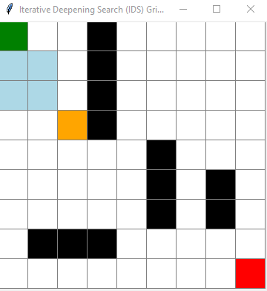
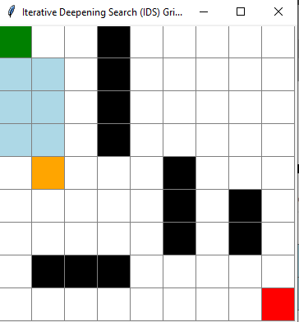
These are different iteration I can’t show all due to fast speed so it is two of screen shot

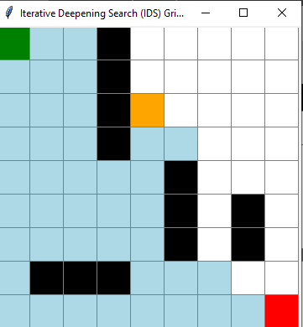
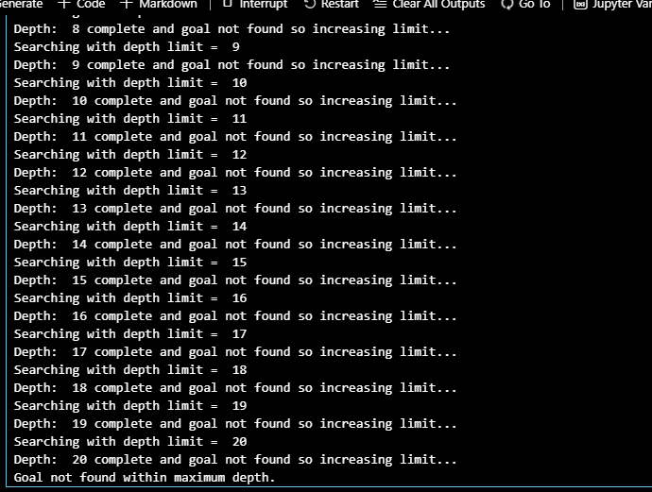
Never Reached to Goal due to Low Limit
Note That: Yellow is Shortest Path. White + Yellow is overall cost.
Green is Start
Red is Goal
Black are hurdles

Uniform Cost Search
Code
import tkinter as tk
import heapq
import time
import random

total_rows, total_columns = 9, 9
cell_size = 40

moves = [(-1, 0), (0, 1), (1, 0), (1, 1), (0, -1), (-1, -1)]

hurdles = { (0, 3), (1, 3), (2, 3), (3, 3), (4, 5),(5, 5),
(6, 5),(7, 1), (7, 2), (7, 3), (5, 7), (6, 7)
}

#For Drawing Output
root = tk.Tk()
root.title("Uniform Cost Search Grid Animation with Per-Cell Costs")
canvas = tk.Canvas(root, width=total_columns * cell_size, height=total_rows * cell_size)
canvas.pack()
def draw_grid(visited_positions, current_position, start_position, goal_position):
canvas.delete("all")
for row in range(total_rows):
for col in range(total_columns):
x1 = col * cell_size
y1 = row * cell_size
x2 = x1 + cell_size
y2 = y1 + cell_size
color = "white"
if (row, col) in hurdles:
color = "black"
elif (row, col) in visited_positions:
color = "lightblue"
if (row, col) == current_position:
color = "orange"
if (row, col) == start_position:
color = "green"
if (row, col) == goal_position:
color = "red"
canvas.create_rectangle(x1, y1, x2, y2,fill=color, outline="gray")
if (row, col) not in hurdles:
canvas.create_text(x1 + cell_size/2, y1 + cell_size/2, text=str(cell_costs[(row, col)]), fill="black", font=("Arial", 12, "bold"))

# Assign a random cost to each cell (between 1 and 9)
cell_costs = {}
for row in range(total_rows):
for col in range(total_columns):
if (row, col) in hurdles:
cell_costs[(row, col)] = float('inf')
else:
cell_costs[(row, col)] = random.randint(1, 9)

def get_neighbors(Currentrow, Currentcolumn):
neighbors = []
for rowChange, colChange in moves:
nRow = Currentrow + rowChange
nColumn = Currentcolumn + colChange
if (0 <= nRow < total_rows and 0 <= nColumn < total_columns and (nRow, nColumn) not in hurdles):
neighbors.append((nRow, nColumn))
return neighbors

def UCS(start_position, goal_position):
visited_positions = set()
pq = []
heapq.heappush(pq, (cell_costs[start_position], start_position))
costs = {start_position: cell_costs[start_position]}
while pq:

current_cost, current_position = heapq.heappop(pq)
if current_position in visited_positions:
continue
visited_positions.add(current_position)

draw_grid(visited_positions, current_position, start_position, goal_position)
root.update()
time.sleep(0.1)

if current_position == goal_position:
print("Goal reached with total cost:", current_cost)
return
for neighbor in get_neighbors(current_position[0], current_position[1]):
step_cost = cell_costs[neighbor]
new_cost = current_cost + step_cost

if neighbor not in costs or new_cost < costs[neighbor]:
costs[neighbor] = new_cost
heapq.heappush(pq, (new_cost, neighbor))
print("Goal not reachable.")

start_position = (0, 0)
goal_position = (8, 8)

UCS(start_position, goal_position)
root.mainloop()

Output
Always give random cost
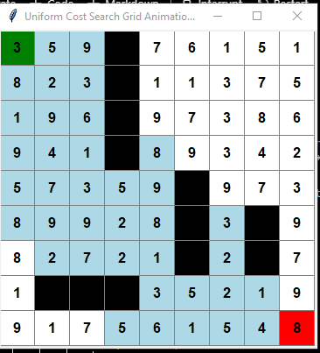

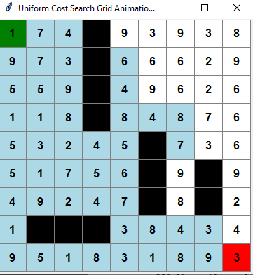
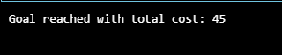
Bidirectional Search
Code
import tkinter as tk
from collections import deque
import time

total_rows, total_columns = 9, 9
cell_size = 40

moves = [(-1, 0), (0, 1), (1, 0), (1, 1), (0, -1), (-1, -1)]

hurdles = { (0, 3), (1, 3), (2, 3), (3, 3), (4, 5),(5, 5),
(6, 5),(7, 1), (7, 2), (7, 3), (5, 7), (6, 7)
}

root = tk.Tk()
root.title("Bidirectional BFS with Meeting Point")
canvas = tk.Canvas(root, width=total_columns * cell_size, height=total_rows * cell_size)
canvas.pack()
def draw_grid(front_start, front_goal, current_start, current_goal, start_position, goal_position, meeting_points):
canvas.delete("all")
for row in range(total_rows):
for col in range(total_columns):
x1 = col * cell_size
y1 = row * cell_size
x2 = x1 + cell_size
y2 = y1 + cell_size

pos = (row, col)
color = "white"

if pos in hurdles:
color = "black"
elif pos in meeting_points:
color = "purple"
elif pos in front_start:
color = "lightblue"
elif pos in front_goal:
color = "lightgreen"

if pos == current_start or pos == current_goal:
color = "orange"
if pos == start_position:
color = "green"
if pos == goal_position:
color = "red"

canvas.create_rectangle(x1, y1, x2, y2,fill=color,outline="gray")
root.update()

def getNeighbor(Currentrow, Currentcolumn):
neighbors = []
for rowChange, colChange in moves:
nRow = Currentrow + rowChange
nColumn = Currentcolumn + colChange
if (0 <= nRow < total_rows and 0 <= nColumn < total_columns and (nRow, nColumn) not in hurdles):
neighbors.append((nRow, nColumn))
return neighbors

def Bidirectional(start_position, goal_position):
visited_start = set([start_position])
visited_goal = set([goal_position])
queue_start = deque([start_position])
queue_goal = deque([goal_position])

meeting_points = set()

while queue_start and queue_goal:
# CHeking from start side
current_start = queue_start.popleft()
for neighbor in getNeighbor(*current_start):
if neighbor not in visited_start:
visited_start.add(neighbor)
queue_start.append(neighbor)

# CHeking from Goal side
current_goal = queue_goal.popleft()
for neighbor in getNeighbor(*current_goal):
if neighbor not in visited_goal:
visited_goal.add(neighbor)
queue_goal.append(neighbor)

# Check for meeting points
meeting_points = visited_start & visited_goal

draw_grid(visited_start, visited_goal, current_start, current_goal, start_position, goal_position, meeting_points)
time.sleep(0.1)

if meeting_points:
print("Goal reached met at:",meeting_points)
break
else:
print("Goal not reachable.")

start_position = (0, 0)
goal_position = (8, 8)

Bidirectional(start_position, goal_position)
root.mainloop()

Output

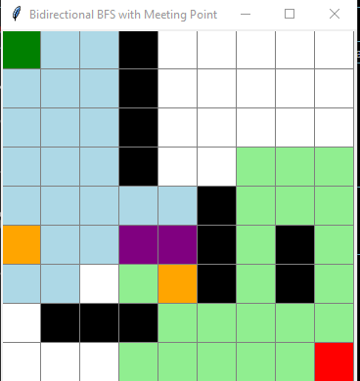
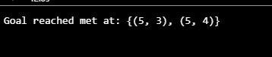
Purple is the meeting point common from source to goal

Little Description

BFS (Breadth-First Search)
BFS checks all nearby cells first before moving further. It always finds the shortest path if each step costs the same. It’s easy to understand but uses a lot of memory and can be slow on big grids. Its time complexity is O(V + E), or about O(rows × columns).

DFS (Depth-First Search)
DFS goes straight down one path before checking others. It uses less memory and is simple to write, but it can go the wrong way and miss shorter paths. It doesn’t always give the best route. Its time complexity is O(V + E), or about O(rows × columns).

UCS (Uniform Cost Search)
UCS looks for the cheapest overall path instead of just the shortest. It works well when moves have different costs but is slower than BFS and needs a priority queue to manage steps. Its time complexity is O(E log V), which makes it slower on large grids.

DLS (Depth-Limited Search)
DLS is like DFS but only goes a set number of steps deep. It saves memory and avoids endless paths. If the limit is too low, it can miss the goal, and if too high, it acts like DFS. Its time complexity is O(b^l), where b is possible moves and l is limit depth.

