SLOT 1

CN FINAL LAB

Maarij Bukhari - 221803

**Configuration Details:**

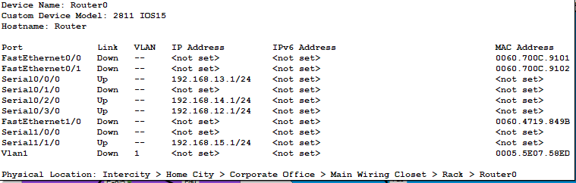

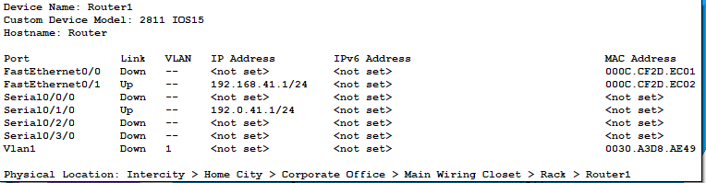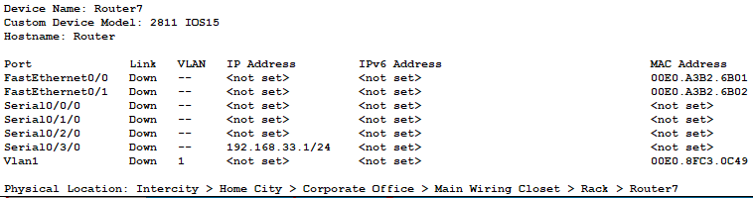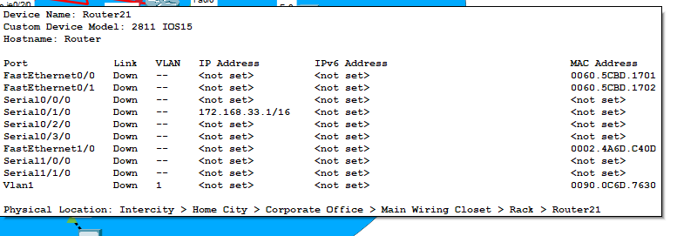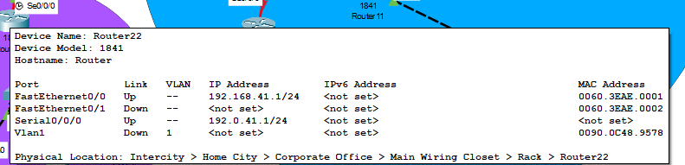

**Commands Used:**

router ospf 1

network 255.255.255.0 1 10 10 10 10

redistribute rip 1

router ospf 10

network 255.255.255.255.0 1 10 10 10 10

redistribute eigrp 1

**Justification For Design choices:**Need to add the area for Id (My id is 221803 ), but Area <03> is already initialized o I used Area <33>   
Already discussed with Sir Nasir AYUB.

**Screenshots:**

