

|  |  |
| --- | --- |
| **Vehicles:**  **Car Model Recognizer**  FINAL YEAR PROJECT-1  ASSIGNMENT NO. | **gROUP MEMBERS:**    **NAME**: M. KHURRAM SHAHZAD  **ARID NO:** 2018-ARID-1253  **NAME:** ALI ASGHAR  **ARID NO:** 2018-ARID-1159  **SUBMITTED TO:**  Ms. Jannat Khatoon  **DATE:**  /11/2021 |
|  |  |

BARANI INSTITUTE OF INFORMATION TECHNOLOGY

**Contents**

**Chapter 1: Introduction** 2

**1.1 Purpose** 2

**1.2 Scope** 2

**1.3 Acronyms, Abbreviation** 2

**Chapter 2: System Analysis** 3

**2.1 Functional Requirements Specification** 3

**2.2 Use Case Diagram** 4

**2.3 Written Use cases** 5

**2.4 Software Model Selection** 6

**Chapter 3:** 6

**3.1 Entity Relationship Diagram** 6

# **Chapter 1: Introduction**

## **1.1 Purpose**

As we know that stealing of vehicles i.e. cars, truck or van is a major crime. The police or investigating team finds it very difficult to trace and find these stolen cars. That’s why there is need to develop a system which can be deployed in any area/place which will be able to recognize the car from its look and identify such stolen cars on the basis of car maker, type, model, color and number plate.

So we are proposing a system(**Vehicle: Car Model Recognizer)** that will make it easier for the police to find reported vehicles present in their area and helps them to control vehicle stolen crime rate by catch the car thieves involves in car robberies.

## **1.2 Scope**

The scope of project is wide. As it is the car model recognizer, so it will help in all the scenarios which involves detecting cars or matching car details etc.

There are two major side of project, first is user side. Such that police will input the detail of stolen car/vehicle including (car maker, type, model, color, number plate etc). Another side is the implementation side, such as when the system will be deployed on the camera point almost ½ km from respective police barrier, it will recognize the passing cars from their look and match their details with the reported car details i.e. find their

* Car maker (Honda/Suzuki etc.)
* Type (Civic/Accord etc.)
* Model (2020/2021 etc.)
* Color and
* Number plate.

Then the system will issue the alert to its respective police barrier and notify that Vehicle X is spotted at camera point with id=xyz at this date and time. In this way the police can catch the stolen vehicle very easily.

* Internet connection is mandatory, as system will issue alert to nearest check post.
* Android Studio will be used to create front-end as well as to manage back-end.
* SSMS will be used where we will create database.
* The duration of the project is almost 8 week.

## **1.3 Acronyms, Abbreviation**

CMR: Car Model Recognizer

SSMS: Sql. Server Management Studio

# **Chapter 2: System Analysis**

## **2.1 Functional Requirements Specification**

* Admin will create account for all police stations.
* Police station can input stolen car details.
* System will recognize car model and other details from car’s look and match it with the stolen car details in the database.
* If the details are matched, it will issue alert to its registered check point including car detail, camera id, date and time.
* Admin will make sure the proper functionality of system i.e. internet connection, database connectivity etc.

## **2.2 Use Case Diagram**

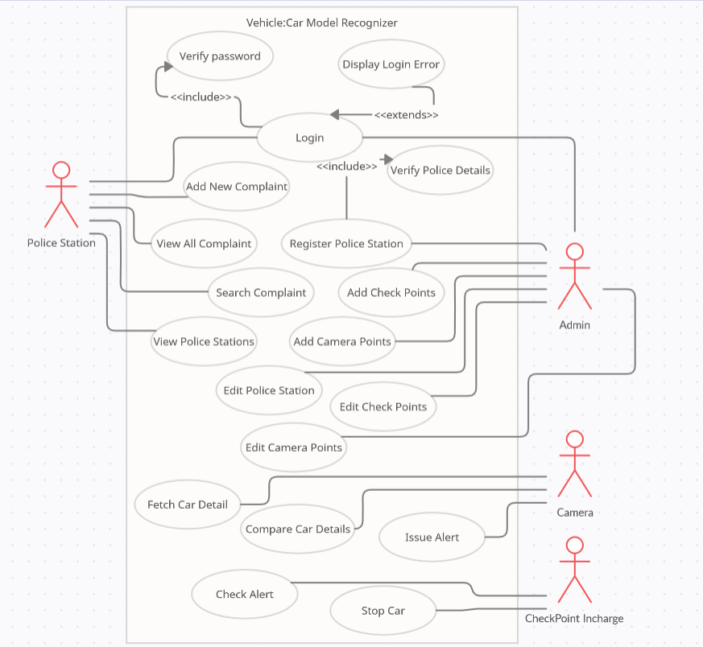

## 

## **2.3 Written Use cases**

**For Admin:**

|  |  |
| --- | --- |
| **Name** | **Create Account** |
| Participating Actors | Admin |
| Event flow | 1. Login into the system. 2. Create account for police station. 3. Send login details to respective police station. |
| Entry Conditions | Verified police station details are required. |
| Exit Conditions | Police station will get their login info. |
| Special requirements |  |

|  |  |
| --- | --- |
| **Name** | **Manage System** |
| Participating Actors | Admin |
| Event flow | 1. Check the system is properly working or not. 2. Check the working of internet connection. 3. Check the connection of database. |
| Entry Conditions | System must be deployed at the place. |
| Exit Conditions | System is fully functioning. |
| Special requirements |  |

**For Police:**

|  |  |
| --- | --- |
| **Name** | **Input Details** |
| Participating Actors | Police |
| Event flow | 1. Login into the system. 2. Input car details. 3. Click on ADD button to add the details to database. |
| Entry Conditions | Police should have their login info. |
| Exit Conditions | Details added successfully. |
| Special requirements |  |

**For Constable:**

|  |  |
| --- | --- |
| **Name** | **Stopping Car** |
| Participating Actors | Barrier Constable |
| Event flow | 1. See the car details from the receiving alert. 2. Match with the coming car. 3. Stop the car and interrogate. |
| Entry Conditions | He should receive the alert from the camera. |
| Exit Conditions | Car has been interrogated. |
| Special requirements |  |

## **2.4 Software Model Selection**

There are several types of software models.

The proposed model for Vehicle: Car Model Recognizer is “**The incremental Model**”.

The reason is that our project consist of three main modules (Front-end, back-end, database design). So we treat each of them separately and incremental model is best suited for such scenario. Here for each module we will perform analysis, design, coding and testing. Thus here after completion of one module add function to the previous module until our system is not completed.

# **Chapter 3:**

## **3.1 Entity Relationship Diagram**

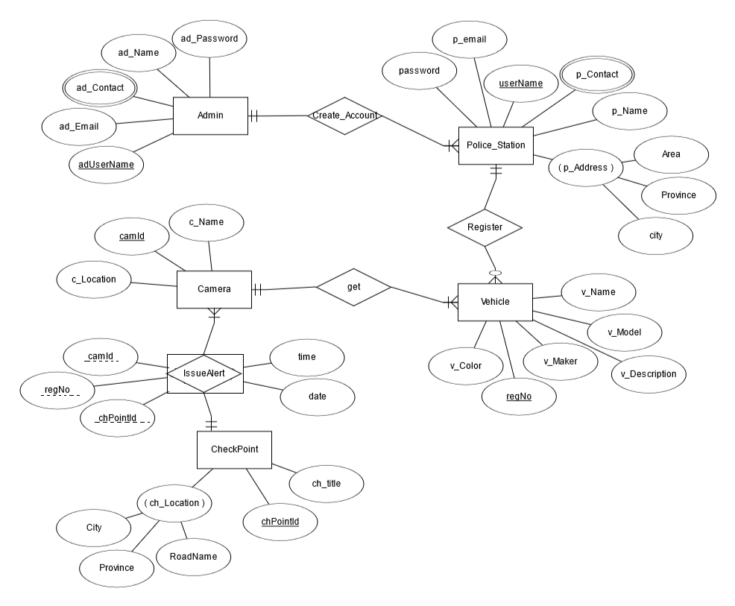

# Conceptual diagram:

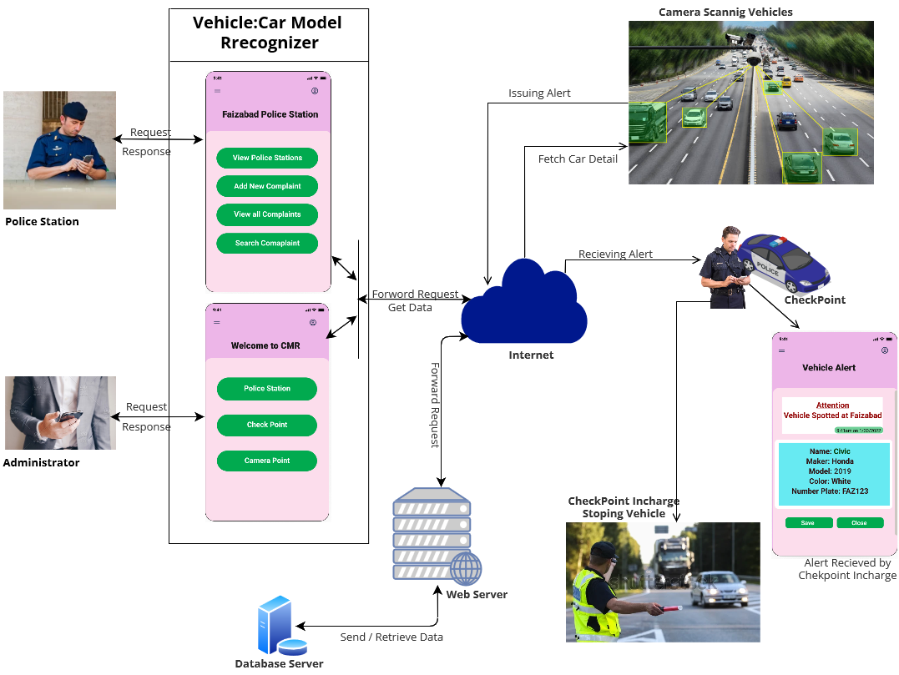

# MockUps:

First of all admin will login into the system.

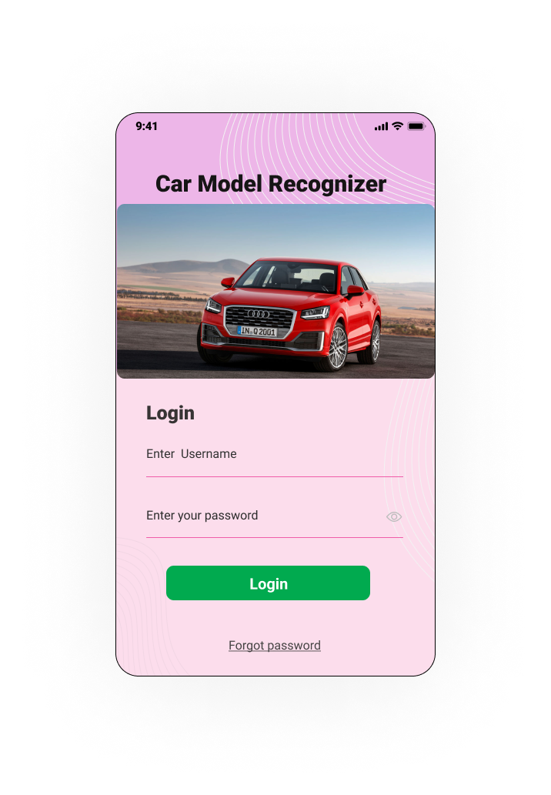

The main menu will appear from which admin can perform further functionalities. He can create accounts for Police stations,

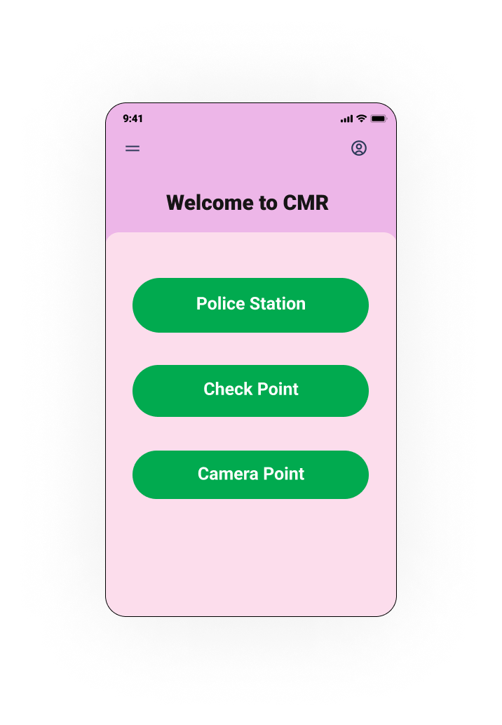

On Clicking Police Station button, all police station details will be opened.

