Results — Corrected Decision Thresholds
External-validation results recomputed with the corrected operating point. Every value is read from corrected_ev_paip.csv, corrected_ev_surgen.csv and corrected_ev_summary.csv. These tables replace the operating-point results of the PAIP-EV and SurGen-EV sections; the frozen-threshold column is retained alongside so the two are directly comparable. Best row in each table (by corrected balanced accuracy) is bold.

1 What the correction changes
The frozen configuration selected k = 3 for KNN and applied a decision threshold τ fitted on TCGA out-of-fold predictions to the target cohort unchanged. Two independent failures followed. First, k = 3 admits only four distinct score values, so the ranking collapses and AUROC degenerates — in the worst case every slide receives the same score and AUROC is exactly 0.5000. Second, several classifiers rank well but produce compressed scores that fall entirely on one side of the frozen τ, so nothing is predicted positive and balanced accuracy pins at 0.5 regardless of how good the ranking is.
The corrected configuration makes two changes, both selected on TCGA only. KNN uses k = 35 with uniform weights and τ refit at k = 35 on TCGA out-of-fold predictions. LR, ANN, ProtoNet and RF keep their scores unchanged and take a quantile (rate-matched) threshold, which places τ so that the predicted positive rate matches the TCGA training prevalence. Distance weighting was tested and rejected (+0.006). k = 35 is justified two ways, both TCGA-only: it gives the highest TCGA out-of-fold balanced accuracy (0.6971), and the prevalence rule 35 × 0.145 ≈ 5 gives roughly five expected positive neighbours. The original grid was capped at k = 15, which is why k = 3 kept being selected.
Two consequences are worth stating explicitly, because they bound what these tables can and cannot show. AUROC is threshold-free, so for LR, ANN, ProtoNet and RF it is identical in both columns — 0 of the 160 non-KNN configurations show any change at all. Every AUROC gain in these tables comes from KNN, and from the change in k alone. And thresholds_TCGA.json (dated 08-04) was deliberately not regenerated, so the frozen baseline remains reproducible and the comparison stays clean.
The correction clears every degenerate configuration. Under the frozen threshold 38 of 200 configurations were flagged as non-viable (23 dead, 13 near-dead, 1 saturated, 1 near-saturated). Under the corrected threshold 200 of 200 are viable and none remains flagged. No configuration sits at AUROC or balanced accuracy of exactly 0.5, and no configuration predicts a single class across the whole cohort.
PAIP-IV and SurGen-CV are internal experiments — the threshold is fitted on their own data or fixed at 0.5 — so the corrected mode does not apply to them and their numbers are unchanged.

1.1 Correction summary by cohort and classifier
Aggregate over all four aggregation strategies × five foundation models. BalAcc oracle is the best balanced accuracy achievable on the target cohort by sweeping τ post hoc; it is not attainable without target labels and is shown only to bound the remaining headroom.
Cohort | Classifier | N | AUROC frozen | AUROC corr. | BalAcc frozen | BalAcc corr. | BalAcc oracle | Δ BalAcc
PAIP-EV | ANN | 20 | 0.8643 | 0.8643 | 0.7553 | 0.8139 | 0.8536 | +0.0586
PAIP-EV | KNN | 20 | 0.6110 | 0.8114 | 0.5959 | 0.7029 | 0.7697 | +0.1070
PAIP-EV | LR | 20 | 0.8717 | 0.8717 | 0.7431 | 0.7890 | 0.8428 | +0.0459
PAIP-EV | ProtoNet | 20 | 0.8502 | 0.8502 | 0.7273 | 0.7940 | 0.8274 | +0.0667
PAIP-EV | RF | 20 | 0.8359 | 0.8359 | 0.6609 | 0.7724 | 0.8190 | +0.1115
SurGen-EV | ANN | 20 | 0.7363 | 0.7363 | 0.5886 | 0.6720 | 0.6994 | +0.0834
SurGen-EV | KNN | 20 | 0.5893 | 0.6533 | 0.5653 | 0.5708 | 0.6211 | +0.0055
SurGen-EV | LR | 20 | 0.7089 | 0.7089 | 0.5944 | 0.6493 | 0.6837 | +0.0549
SurGen-EV | ProtoNet | 20 | 0.7094 | 0.7094 | 0.5227 | 0.6525 | 0.6779 | +0.1298
SurGen-EV | RF | 20 | 0.7026 | 0.7026 | 0.5618 | 0.6418 | 0.6694 | +0.0800

Balanced accuracy improves for every cohort × classifier pair. The largest gains are exactly where the diagnosis predicted them: RF on PAIP-EV (+0.1115, from 0.6609 to 0.7724) and ProtoNet on SurGen-EV (+0.1298, from 0.5227 to 0.6525) were the two classifiers whose compressed scores fell outside the frozen τ most often. KNN gains AUROC on both cohorts — +0.2004 on PAIP-EV (0.6110 to 0.8114) and +0.0640 on SurGen-EV (0.5893 to 0.6533) — which is the k = 3 ranking collapse being repaired.
The exception is KNN on SurGen-EV, where mean balanced accuracy moves by only +0.0055 while every other cohort × classifier pair gains between +0.046 and +0.130. k = 35 was selected on TCGA and transfers to PAIP but not to SurGen; Section 4 lists the individual configurations affected. The remaining gap to the oracle threshold is 0.025 to 0.067 on average, so most of the recoverable headroom has been taken.

2 PAIP-EV — External Validation, TCGA → PAIP
Models trained entirely on TCGA and applied to all 78 PAIP slides that have features. No PAIP data enters training and no preprocessing is refit on the target cohort. Both the frozen and the corrected operating point are fitted on TCGA out-of-fold predictions, so neither is tuned on PAIP. N = 78, 19 positive.

2.1 Averaging Aggregation (1× feature dim)
PAIP-EV: Averaging Aggregation (1× feature dim). N = 78.
Model | Clf | AUROC frozen | AUROC corr. | BalAcc frozen | BalAcc corr. | Δ BalAcc | BalAcc oracle | Frozen status
Conch1_5 | LR | 0.7939 | 0.7939 | 0.7168 | 0.6945 | −0.0223 | 0.7386 | ok
Conch1_5 | ANN | 0.7627 | 0.7627 | 0.6690 | 0.7489 | +0.0799 | 0.7574 | ok
Conch1_5 | KNN | 0.6311 | 0.7128 | 0.5526 | 0.6062 | +0.0536 | 0.7047 | ok
Conch1_5 | ProtoNet | 0.8412 | 0.8412 | 0.7132 | 0.7395 | +0.0263 | 0.7640 | ok
Conch1_5 | RF | 0.7529 | 0.7529 | 0.5789 | 0.7217 | +0.1428 | 0.7217 | ok
UNI2 | LR | 0.9153 | 0.9153 | 0.7547 | 0.7471 | −0.0076 | 0.8617 | ok
UNI2 | ANN | 0.8573 | 0.8573 | 0.5923 | 0.7913 | +0.1990 | 0.8287 | ok
UNI2 | KNN | 0.5000 | 0.8127 | 0.5000 | 0.6146 | +0.1146 | 0.7676 | dead
UNI2 | ProtoNet | 0.8448 | 0.8448 | 0.6053 | 0.7600 | +0.1547 | 0.8082 | ok
UNI2 | RF | 0.7413 | 0.7413 | 0.5000 | 0.6155 | +0.1155 | 0.7328 | dead
H-Optimus-1 | LR | 0.8751 | 0.8751 | 0.5789 | 0.8430 | +0.2641 | 0.8608 | ok
H-Optimus-1 | ANN | 0.8662 | 0.8662 | 0.7904 | 0.8608 | +0.0704 | 0.8702 | ok
H-Optimus-1 | KNN | 0.5535 | 0.7966 | 0.5535 | 0.6766 | +0.1231 | 0.7761 | ok
H-Optimus-1 | ProtoNet | 0.8742 | 0.8742 | 0.8702 | 0.8617 | −0.0085 | 0.8787 | ok
H-Optimus-1 | RF | 0.8430 | 0.8430 | 0.6494 | 0.8363 | +0.1869 | 0.8448 | ok
ConchV1 | LR | 0.8644 | 0.8644 | 0.7770 | 0.7649 | −0.0121 | 0.8176 | ok
ConchV1 | ANN | 0.7939 | 0.7939 | 0.7752 | 0.7132 | −0.0620 | 0.7921 | ok
ConchV1 | KNN | 0.6160 | 0.7774 | 0.6079 | 0.7516 | +0.1437 | 0.7516 | ok
ConchV1 | ProtoNet | 0.8216 | 0.8216 | 0.7565 | 0.7029 | −0.0536 | 0.7658 | ok
ConchV1 | RF | 0.7957 | 0.7957 | 0.7132 | 0.7150 | +0.0018 | 0.7386 | ok
Virchow2 | LR | 0.8912 | 0.8912 | 0.7021 | 0.8439 | +0.1418 | 0.8439 | ok
Virchow2 | ANN | 0.8457 | 0.8457 | 0.5660 | 0.8269 | +0.2609 | 0.8439 | ok
Virchow2 | KNN | 0.5656 | 0.7248 | 0.5589 | 0.6717 | +0.1128 | 0.6954 | ok
Virchow2 | ProtoNet | 0.8412 | 0.8412 | 0.7819 | 0.7658 | −0.0161 | 0.8024 | ok
Virchow2 | RF | 0.8368 | 0.8368 | 0.6757 | 0.7302 | +0.0545 | 0.8202 | ok

2.2 Caption-Based Aggregation (14× feature dim)
PAIP-EV: Caption-Based Aggregation (14× feature dim). N = 78.
Model | Clf | AUROC frozen | AUROC corr. | BalAcc frozen | BalAcc corr. | Δ BalAcc | BalAcc oracle | Frozen status
Conch1_5 | LR | 0.8626 | 0.8626 | 0.7319 | 0.7480 | +0.0161 | 0.7855 | ok
Conch1_5 | ANN | 0.8760 | 0.8760 | 0.8354 | 0.7930 | −0.0424 | 0.8524 | ok
Conch1_5 | KNN | 0.6329 | 0.7939 | 0.5620 | 0.6869 | +0.1249 | 0.7600 | ok
Conch1_5 | ProtoNet | 0.8448 | 0.8448 | 0.7159 | 0.7997 | +0.0838 | 0.8336 | ok
Conch1_5 | RF | 0.8492 | 0.8492 | 0.5526 | 0.7208 | +0.1682 | 0.8091 | ok
UNI2 | LR | 0.9063 | 0.9063 | 0.7810 | 0.8430 | +0.0620 | 0.8872 | ok
UNI2 | ANN | 0.9117 | 0.9117 | 0.8363 | 0.8956 | +0.0593 | 0.8956 | ok
UNI2 | KNN | 0.5705 | 0.9037 | 0.5705 | 0.6936 | +0.1231 | 0.8372 | ok
UNI2 | ProtoNet | 0.8626 | 0.8626 | 0.5000 | 0.7988 | +0.2988 | 0.8787 | dead
UNI2 | RF | 0.8528 | 0.8528 | 0.5442 | 0.8524 | +0.3082 | 0.8787 | ok
H-Optimus-1 | LR | 0.8769 | 0.8769 | 0.6579 | 0.7462 | +0.0883 | 0.8872 | ok
H-Optimus-1 | ANN | 0.8965 | 0.8965 | 0.8533 | 0.8702 | +0.0169 | 0.8956 | ok
H-Optimus-1 | KNN | 0.5883 | 0.8617 | 0.5883 | 0.7556 | +0.1673 | 0.7930 | ok
H-Optimus-1 | ProtoNet | 0.8796 | 0.8796 | 0.8109 | 0.8617 | +0.0508 | 0.8956 | ok
H-Optimus-1 | RF | 0.8626 | 0.8626 | 0.7462 | 0.8524 | +0.1062 | 0.8617 | ok
ConchV1 | LR | 0.8483 | 0.8483 | 0.8185 | 0.8269 | +0.0084 | 0.8448 | ok
ConchV1 | ANN | 0.8421 | 0.8421 | 0.7346 | 0.7685 | +0.0339 | 0.8448 | ok
ConchV1 | KNN | 0.6628 | 0.7525 | 0.6922 | 0.6753 | −0.0169 | 0.7252 | ok
ConchV1 | ProtoNet | 0.8510 | 0.8510 | 0.7355 | 0.7752 | +0.0397 | 0.8015 | ok
ConchV1 | RF | 0.8475 | 0.8475 | 0.6945 | 0.6945 | +0.0000 | 0.8194 | ok
Virchow2 | LR | 0.8876 | 0.8876 | 0.8278 | 0.8702 | +0.0424 | 0.8787 | ok
Virchow2 | ANN | 0.8965 | 0.8965 | 0.7770 | 0.8702 | +0.0932 | 0.8863 | ok
Virchow2 | KNN | 0.7792 | 0.8252 | 0.7431 | 0.7083 | −0.0348 | 0.7658 | ok
Virchow2 | ProtoNet | 0.8599 | 0.8599 | 0.7837 | 0.7743 | −0.0094 | 0.8252 | ok
Virchow2 | RF | 0.8617 | 0.8617 | 0.7921 | 0.7837 | −0.0084 | 0.8260 | ok

2.3 Caption-Based Aggregation, 15 classes (15× feature dim)
PAIP-EV: Caption-Based Aggregation, 15 classes (15× feature dim). N = 78.
Model | Clf | AUROC frozen | AUROC corr. | BalAcc frozen | BalAcc corr. | Δ BalAcc | BalAcc oracle | Frozen status
Conch1_5 | LR | 0.8831 | 0.8831 | 0.8024 | 0.7658 | −0.0366 | 0.8211 | ok
Conch1_5 | ANN | 0.8760 | 0.8760 | 0.7770 | 0.7855 | +0.0085 | 0.8439 | ok
Conch1_5 | KNN | 0.6664 | 0.8354 | 0.6454 | 0.8024 | +0.1570 | 0.8024 | ok
Conch1_5 | ProtoNet | 0.8537 | 0.8537 | 0.7913 | 0.8082 | +0.0169 | 0.8082 | ok
Conch1_5 | RF | 0.8564 | 0.8564 | 0.5000 | 0.7462 | +0.2462 | 0.8176 | dead
UNI2 | LR | 0.9037 | 0.9037 | 0.7632 | 0.8252 | +0.0620 | 0.8787 | ok
UNI2 | ANN | 0.8974 | 0.8974 | 0.8533 | 0.8524 | −0.0009 | 0.8693 | ok
UNI2 | KNN | 0.5789 | 0.8872 | 0.5789 | 0.6146 | +0.0357 | 0.8363 | ok
UNI2 | ProtoNet | 0.8626 | 0.8626 | 0.5000 | 0.8345 | +0.3345 | 0.8872 | dead
UNI2 | RF | 0.8537 | 0.8537 | 0.7021 | 0.8448 | +0.1427 | 0.8617 | ok
H-Optimus-1 | LR | 0.8787 | 0.8787 | 0.6053 | 0.7988 | +0.1935 | 0.8956 | ok
H-Optimus-1 | ANN | 0.9019 | 0.9019 | 0.8448 | 0.8617 | +0.0169 | 0.8956 | ok
H-Optimus-1 | KNN | 0.5285 | 0.8591 | 0.5272 | 0.7293 | +0.2021 | 0.8109 | ok
H-Optimus-1 | ProtoNet | 0.8778 | 0.8778 | 0.8448 | 0.8533 | +0.0085 | 0.8778 | ok
H-Optimus-1 | RF | 0.8475 | 0.8475 | 0.7462 | 0.8439 | +0.0977 | 0.8702 | ok
ConchV1 | LR | 0.8644 | 0.8644 | 0.8363 | 0.7734 | −0.0629 | 0.8448 | ok
ConchV1 | ANN | 0.8715 | 0.8715 | 0.7431 | 0.8448 | +0.1017 | 0.8787 | ok
ConchV1 | KNN | 0.6789 | 0.7930 | 0.6302 | 0.7083 | +0.0781 | 0.7083 | ok
ConchV1 | ProtoNet | 0.8608 | 0.8608 | 0.8024 | 0.8006 | −0.0018 | 0.8194 | ok
ConchV1 | RF | 0.8537 | 0.8537 | 0.7021 | 0.7462 | +0.0441 | 0.8354 | ok
Virchow2 | LR | 0.9099 | 0.9099 | 0.8457 | 0.8872 | +0.0415 | 0.8947 | ok
Virchow2 | ANN | 0.9045 | 0.9045 | 0.7440 | 0.8024 | +0.0584 | 0.8947 | ok
Virchow2 | KNN | 0.6838 | 0.8657 | 0.6378 | 0.7846 | +0.1468 | 0.8006 | ok
Virchow2 | ProtoNet | 0.8724 | 0.8724 | 0.8260 | 0.8354 | +0.0094 | 0.8515 | ok
Virchow2 | RF | 0.8608 | 0.8608 | 0.7895 | 0.8167 | +0.0272 | 0.8448 | ok

2.4 Tissue-Type Clustering Aggregation (9× feature dim)
PAIP-EV: Tissue-Type Clustering Aggregation (9× feature dim). N = 78.
Model | Clf | AUROC frozen | AUROC corr. | BalAcc frozen | BalAcc corr. | Δ BalAcc | BalAcc oracle | Frozen status
Conch1_5 | LR | 0.8394 | 0.8394 | 0.7752 | 0.7574 | −0.0178 | 0.7930 | ok
Conch1_5 | ANN | 0.8296 | 0.8296 | 0.8194 | 0.7770 | −0.0424 | 0.8363 | ok
Conch1_5 | KNN | 0.6111 | 0.7797 | 0.6209 | 0.7217 | +0.1008 | 0.7667 | ok
Conch1_5 | ProtoNet | 0.8171 | 0.8171 | 0.7226 | 0.7047 | −0.0179 | 0.7761 | ok
Conch1_5 | RF | 0.8475 | 0.8475 | 0.6860 | 0.7694 | +0.0834 | 0.7948 | ok
UNI2 | LR | 0.8858 | 0.8858 | 0.7640 | 0.7997 | +0.0357 | 0.8533 | ok
UNI2 | ANN | 0.8733 | 0.8733 | 0.6338 | 0.7837 | +0.1499 | 0.8457 | ok
UNI2 | KNN | 0.5263 | 0.8265 | 0.5263 | 0.6673 | +0.1410 | 0.7609 | near-dead
UNI2 | ProtoNet | 0.8555 | 0.8555 | 0.5000 | 0.8515 | +0.3515 | 0.8515 | dead
UNI2 | RF | 0.8207 | 0.8207 | 0.5263 | 0.7649 | +0.2386 | 0.8109 | near-dead
H-Optimus-1 | LR | 0.8724 | 0.8724 | 0.6053 | 0.8260 | +0.2207 | 0.8702 | ok
H-Optimus-1 | ANN | 0.8894 | 0.8894 | 0.8363 | 0.8278 | −0.0085 | 0.8787 | ok
H-Optimus-1 | KNN | 0.5455 | 0.8524 | 0.5450 | 0.7114 | +0.1664 | 0.7855 | ok
H-Optimus-1 | ProtoNet | 0.8689 | 0.8689 | 0.8194 | 0.8439 | +0.0245 | 0.8608 | ok
H-Optimus-1 | RF | 0.8680 | 0.8680 | 0.6579 | 0.8524 | +0.1945 | 0.8787 | ok
ConchV1 | LR | 0.8260 | 0.8260 | 0.7480 | 0.6851 | −0.0629 | 0.7734 | ok
ConchV1 | ANN | 0.8287 | 0.8287 | 0.7913 | 0.7913 | +0.0000 | 0.8185 | ok
ConchV1 | KNN | 0.7034 | 0.7823 | 0.6829 | 0.7516 | +0.0687 | 0.7516 | ok
ConchV1 | ProtoNet | 0.8216 | 0.8216 | 0.7440 | 0.7591 | +0.0151 | 0.7855 | ok
ConchV1 | RF | 0.8341 | 0.8341 | 0.7021 | 0.7565 | +0.0544 | 0.8118 | ok
Virchow2 | LR | 0.8492 | 0.8492 | 0.7694 | 0.7328 | −0.0366 | 0.8252 | ok
Virchow2 | ANN | 0.8653 | 0.8653 | 0.6338 | 0.8118 | +0.1780 | 0.8439 | ok
Virchow2 | KNN | 0.5977 | 0.7864 | 0.5946 | 0.7261 | +0.1315 | 0.7939 | ok
Virchow2 | ProtoNet | 0.7921 | 0.7921 | 0.7226 | 0.7489 | +0.0263 | 0.7761 | ok
Virchow2 | RF | 0.8323 | 0.8323 | 0.7591 | 0.7846 | +0.0255 | 0.8015 | ok

2.5 Radar Plots
Each axis is one classifier × aggregation combination and the four shaded quadrants group the aggregation strategies (CBA, CBA15, AVG, TTC), so a trace that bulges into one quadrant is a foundation model that favours that aggregation. Both plots use the corrected thresholds; the concave notches that marked dead configurations in the frozen plots are gone.
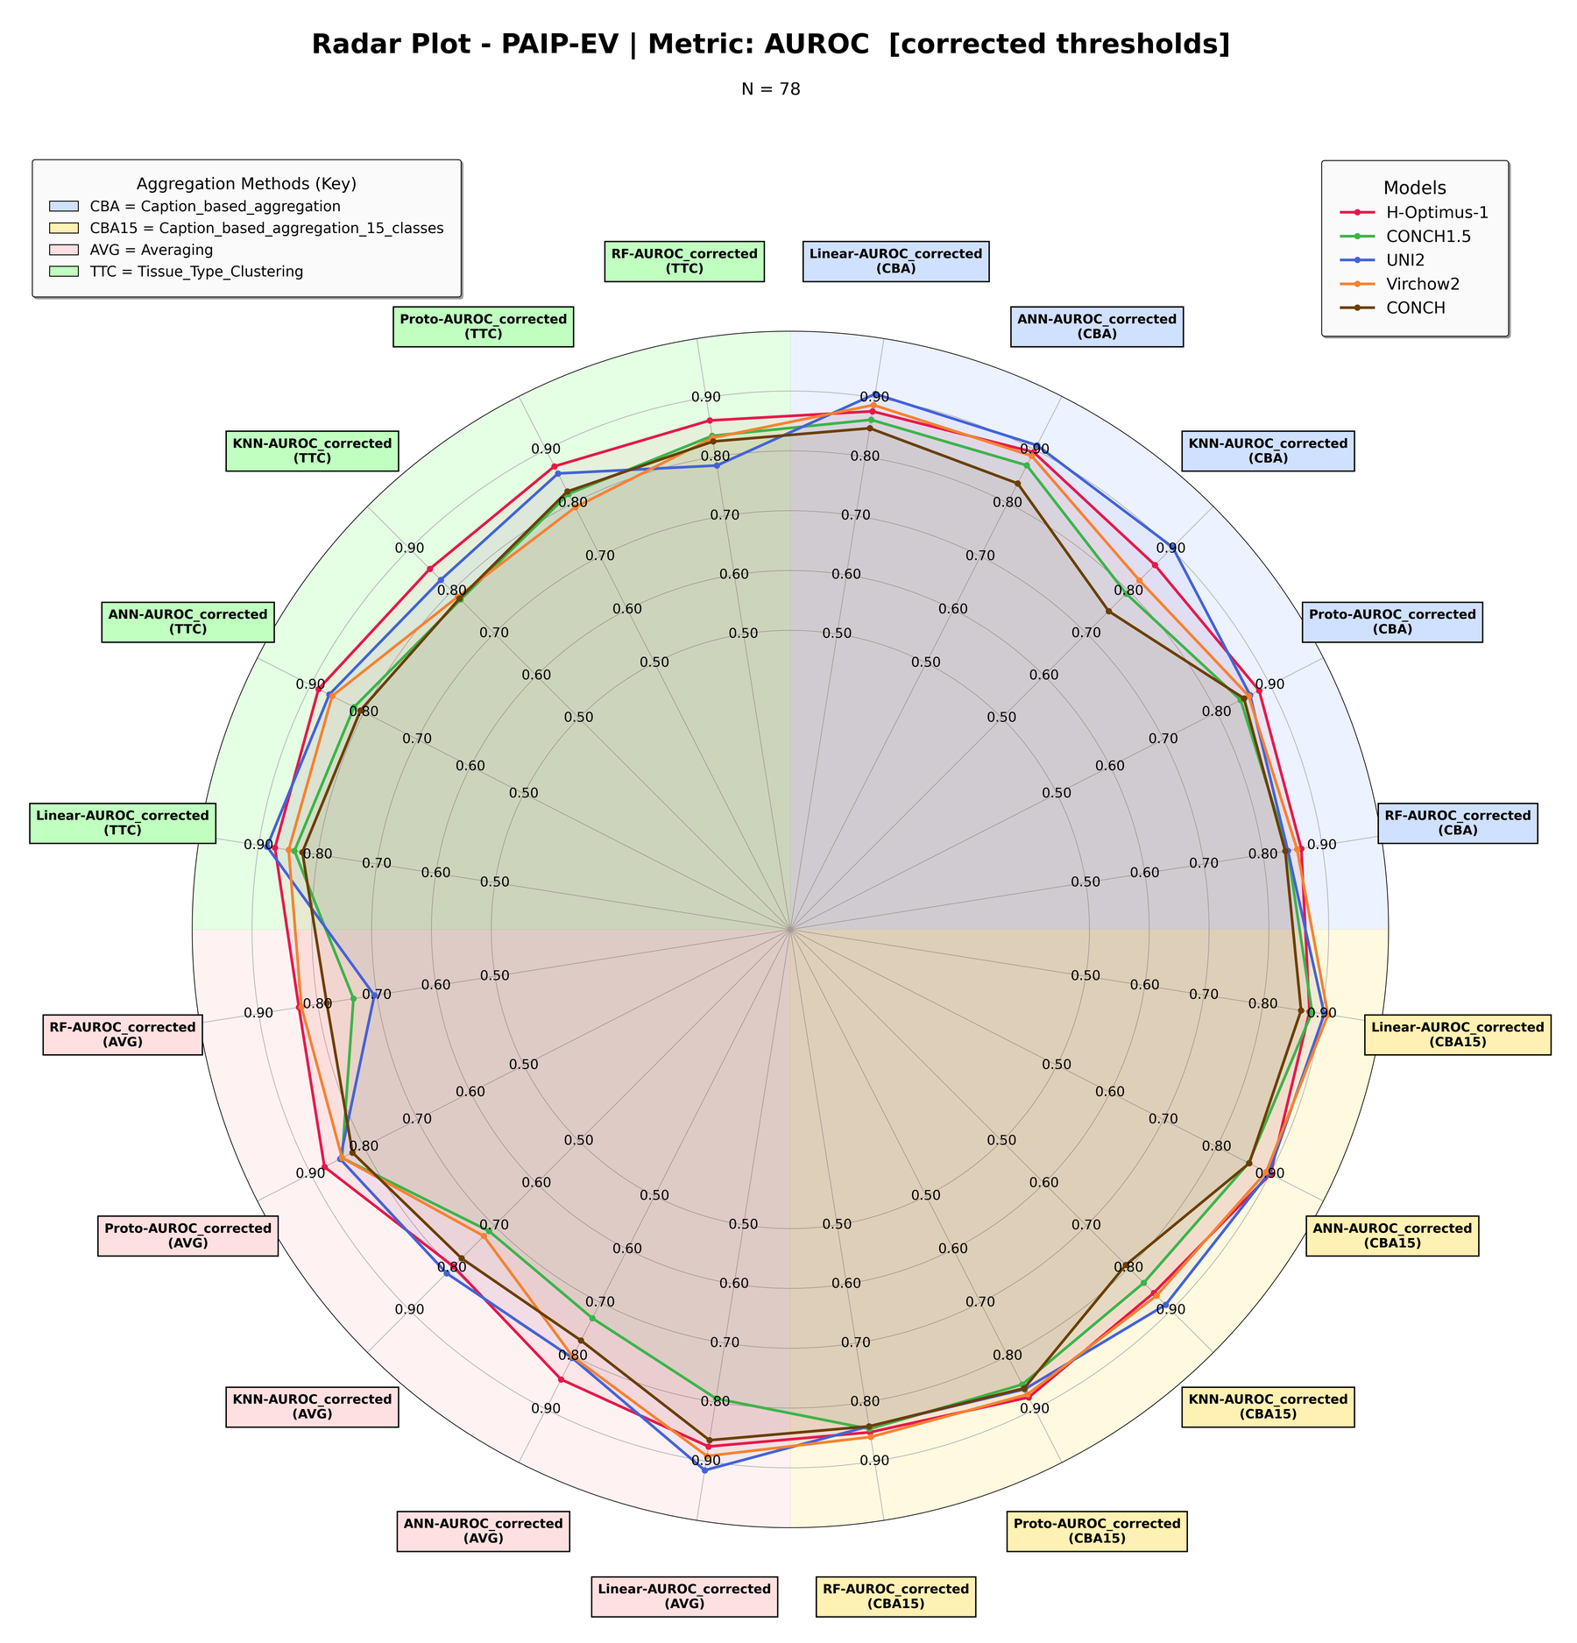
Figure 1. PAIP-EV — AUROC across every classifier × aggregation axis, corrected thresholds. N = 78.
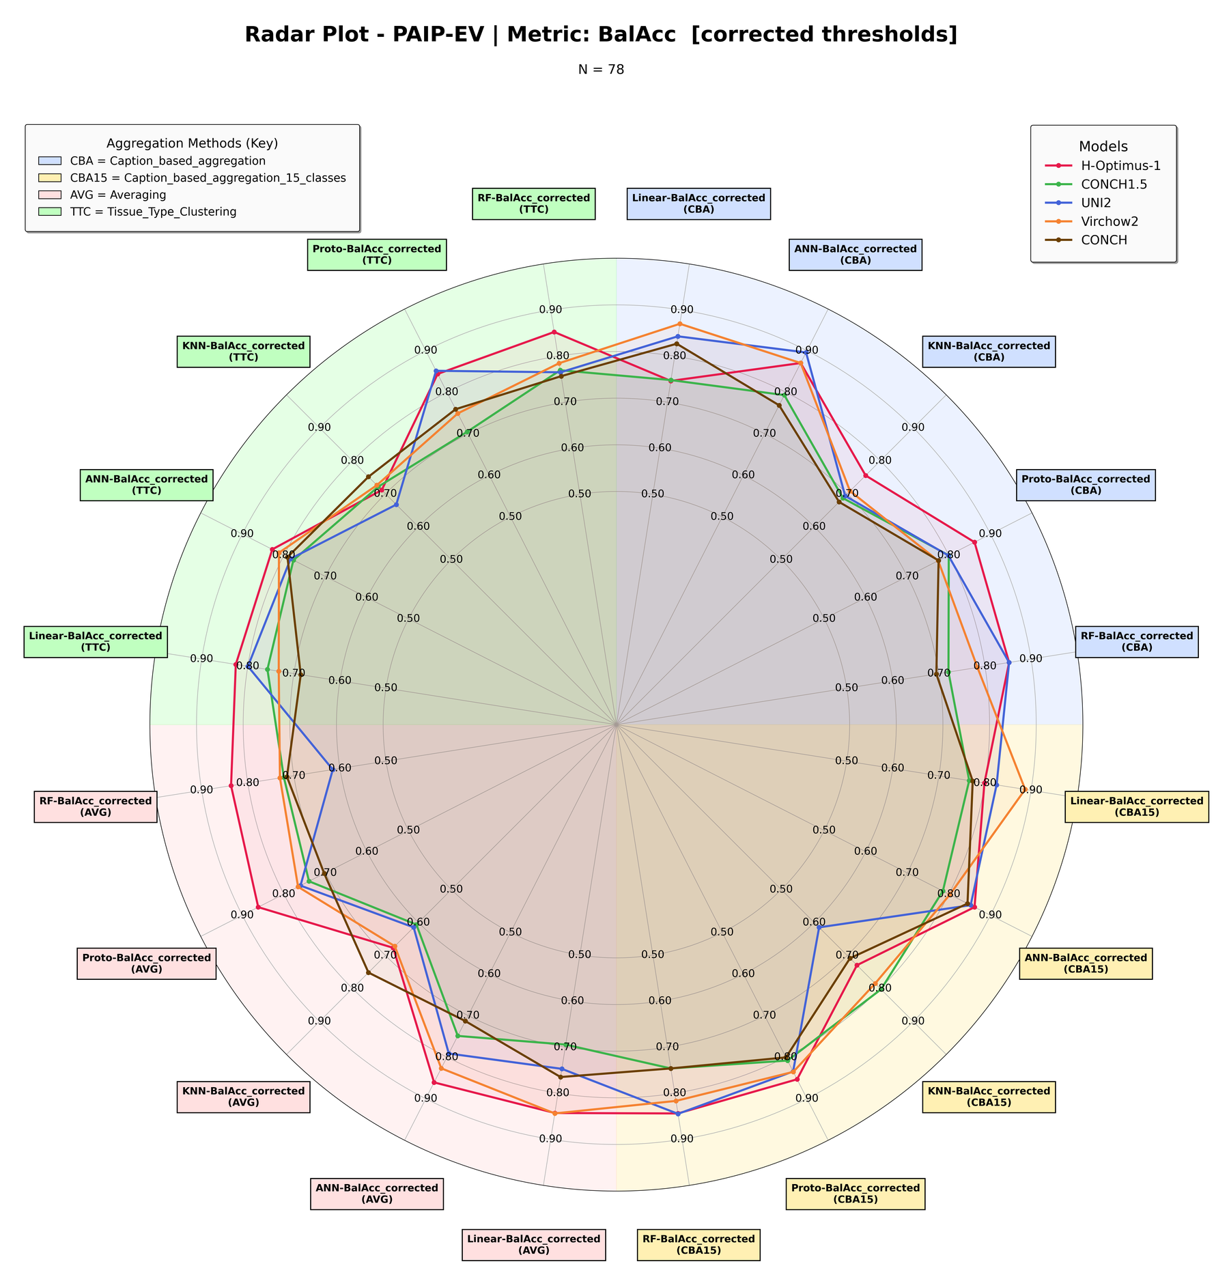
Figure 2. PAIP-EV — balanced accuracy across every classifier × aggregation axis, corrected thresholds. N = 78.

3 SurGen-EV — External Validation, TCGA → SurGen
TCGA-trained models applied to the SurGen cohort under the same protocol as Section 2. N = 622, except the Averaging and Tissue-Type Clustering configurations of H-Optimus-1, where N = 613.

3.1 Averaging Aggregation (1× feature dim)
SurGen-EV: Averaging Aggregation (1× feature dim). N = 622 (H-Optimus-1 under Averaging and Tissue-Type Clustering: N = 613).
Model | Clf | AUROC frozen | AUROC corr. | BalAcc frozen | BalAcc corr. | Δ BalAcc | BalAcc oracle | Frozen status
Conch1_5 | LR | 0.5969 | 0.5969 | 0.5137 | 0.5203 | +0.0066 | 0.6192 | ok
Conch1_5 | ANN | 0.6644 | 0.6644 | 0.5973 | 0.6437 | +0.0464 | 0.6661 | ok
Conch1_5 | KNN | 0.5807 | 0.6372 | 0.5314 | 0.6128 | +0.0814 | 0.6128 | ok
Conch1_5 | ProtoNet | 0.6397 | 0.6397 | 0.5000 | 0.6263 | +0.1263 | 0.6350 | dead
Conch1_5 | RF | 0.6525 | 0.6525 | 0.5528 | 0.5989 | +0.0461 | 0.6375 | ok
UNI2 | LR | 0.7492 | 0.7492 | 0.6875 | 0.6453 | −0.0422 | 0.7155 | ok
UNI2 | ANN | 0.7735 | 0.7735 | 0.5133 | 0.6929 | +0.1796 | 0.7155 | ok
UNI2 | KNN | 0.6439 | 0.7294 | 0.6412 | 0.6326 | −0.0086 | 0.6796 | ok
UNI2 | ProtoNet | 0.7598 | 0.7598 | 0.5000 | 0.6945 | +0.1945 | 0.7184 | dead
UNI2 | RF | 0.7722 | 0.7722 | 0.5206 | 0.6198 | +0.0992 | 0.7181 | ok
H-Optimus-1 | LR | 0.5692 | 0.5692 | 0.5615 | 0.5728 | +0.0113 | 0.5900 | ok
H-Optimus-1 | ANN | 0.7238 | 0.7238 | 0.5899 | 0.6701 | +0.0802 | 0.7039 | ok
H-Optimus-1 | KNN | 0.5470 | 0.5942 | 0.5240 | 0.5607 | +0.0367 | 0.5863 | ok
H-Optimus-1 | ProtoNet | 0.6508 | 0.6508 | 0.5805 | 0.6051 | +0.0246 | 0.6186 | ok
H-Optimus-1 | RF | 0.5974 | 0.5974 | 0.5426 | 0.5447 | +0.0021 | 0.5852 | ok
ConchV1 | LR | 0.6142 | 0.6142 | 0.5757 | 0.6126 | +0.0369 | 0.6190 | ok
ConchV1 | ANN | 0.6108 | 0.6108 | 0.5430 | 0.5716 | +0.0286 | 0.6055 | ok
ConchV1 | KNN | 0.4842 | 0.6075 | 0.4954 | 0.5574 | +0.0620 | 0.5845 | ok
ConchV1 | ProtoNet | 0.6904 | 0.6904 | 0.5000 | 0.6315 | +0.1315 | 0.6544 | dead
ConchV1 | RF | 0.5441 | 0.5441 | 0.5211 | 0.5357 | +0.0146 | 0.5600 | ok
Virchow2 | LR | 0.6515 | 0.6515 | 0.6062 | 0.5636 | −0.0426 | 0.6284 | ok
Virchow2 | ANN | 0.6709 | 0.6709 | 0.5044 | 0.6121 | +0.1077 | 0.6340 | near-sat.
Virchow2 | KNN | 0.5291 | 0.6792 | 0.5096 | 0.6080 | +0.0984 | 0.6366 | ok
Virchow2 | ProtoNet | 0.7053 | 0.7053 | 0.5363 | 0.6478 | +0.1115 | 0.6766 | ok
Virchow2 | RF | 0.6535 | 0.6535 | 0.5131 | 0.5941 | +0.0810 | 0.6237 | near-dead

3.2 Caption-Based Aggregation (14× feature dim)
SurGen-EV: Caption-Based Aggregation (14× feature dim). N = 622 (H-Optimus-1 under Averaging and Tissue-Type Clustering: N = 613).
Model | Clf | AUROC frozen | AUROC corr. | BalAcc frozen | BalAcc corr. | Δ BalAcc | BalAcc oracle | Frozen status
Conch1_5 | LR | 0.6240 | 0.6240 | 0.5595 | 0.5650 | +0.0055 | 0.6306 | ok
Conch1_5 | ANN | 0.6728 | 0.6728 | 0.6193 | 0.6140 | −0.0053 | 0.6391 | ok
Conch1_5 | KNN | 0.6448 | 0.7005 | 0.5853 | 0.6472 | +0.0619 | 0.6472 | ok
Conch1_5 | ProtoNet | 0.6556 | 0.6556 | 0.5000 | 0.5784 | +0.0784 | 0.6107 | dead
Conch1_5 | RF | 0.6515 | 0.6515 | 0.5000 | 0.6045 | +0.1045 | 0.6127 | dead
UNI2 | LR | 0.8543 | 0.8543 | 0.7690 | 0.7809 | +0.0119 | 0.7851 | ok
UNI2 | ANN | 0.8519 | 0.8519 | 0.5552 | 0.7622 | +0.2070 | 0.7833 | ok
UNI2 | KNN | 0.7148 | 0.7331 | 0.6808 | 0.5741 | −0.1067 | 0.6741 | ok
UNI2 | ProtoNet | 0.8005 | 0.8005 | 0.5000 | 0.6863 | +0.1863 | 0.7412 | dead
UNI2 | RF | 0.8464 | 0.8464 | 0.6922 | 0.7504 | +0.0582 | 0.7901 | ok
H-Optimus-1 | LR | 0.7362 | 0.7362 | 0.5551 | 0.6535 | +0.0984 | 0.6974 | ok
H-Optimus-1 | ANN | 0.7842 | 0.7842 | 0.6744 | 0.7269 | +0.0525 | 0.7433 | ok
H-Optimus-1 | KNN | 0.6129 | 0.6840 | 0.6064 | 0.6204 | +0.0140 | 0.6414 | ok
H-Optimus-1 | ProtoNet | 0.7617 | 0.7617 | 0.6168 | 0.7106 | +0.0938 | 0.7189 | ok
H-Optimus-1 | RF | 0.7411 | 0.7411 | 0.5932 | 0.6915 | +0.0983 | 0.7130 | ok
ConchV1 | LR | 0.6662 | 0.6662 | 0.5167 | 0.6451 | +0.1284 | 0.6517 | near-dead
ConchV1 | ANN | 0.6831 | 0.6831 | 0.6058 | 0.5984 | −0.0074 | 0.6660 | ok
ConchV1 | KNN | 0.5652 | 0.6193 | 0.4928 | 0.5332 | +0.0404 | 0.5797 | ok
ConchV1 | ProtoNet | 0.6738 | 0.6738 | 0.5000 | 0.6291 | +0.1291 | 0.6546 | dead
ConchV1 | RF | 0.6727 | 0.6727 | 0.5000 | 0.6446 | +0.1446 | 0.6557 | dead
Virchow2 | LR | 0.7613 | 0.7613 | 0.6494 | 0.6716 | +0.0222 | 0.7165 | ok
Virchow2 | ANN | 0.7809 | 0.7809 | 0.6984 | 0.6623 | −0.0361 | 0.7343 | ok
Virchow2 | KNN | 0.5658 | 0.6183 | 0.5367 | 0.5148 | −0.0219 | 0.5778 | ok
Virchow2 | ProtoNet | 0.6915 | 0.6915 | 0.5149 | 0.6317 | +0.1168 | 0.6784 | near-dead
Virchow2 | RF | 0.7237 | 0.7237 | 0.5524 | 0.6252 | +0.0728 | 0.6642 | ok

3.3 Caption-Based Aggregation, 15 classes (15× feature dim)
SurGen-EV: Caption-Based Aggregation, 15 classes (15× feature dim). N = 622 (H-Optimus-1 under Averaging and Tissue-Type Clustering: N = 613).
Model | Clf | AUROC frozen | AUROC corr. | BalAcc frozen | BalAcc corr. | Δ BalAcc | BalAcc oracle | Frozen status
Conch1_5 | LR | 0.6866 | 0.6866 | 0.5590 | 0.6513 | +0.0923 | 0.6922 | ok
Conch1_5 | ANN | 0.7213 | 0.7213 | 0.6685 | 0.6623 | −0.0062 | 0.6910 | ok
Conch1_5 | KNN | 0.6819 | 0.5972 | 0.6309 | 0.5130 | −0.1179 | 0.5776 | ok
Conch1_5 | ProtoNet | 0.6737 | 0.6737 | 0.5083 | 0.6334 | +0.1251 | 0.6558 | near-dead
Conch1_5 | RF | 0.6767 | 0.6767 | 0.5000 | 0.6404 | +0.1404 | 0.6568 | dead
UNI2 | LR | 0.8563 | 0.8563 | 0.7750 | 0.7666 | −0.0084 | 0.7819 | ok
UNI2 | ANN | 0.8444 | 0.8444 | 0.5819 | 0.7587 | +0.1768 | 0.7731 | ok
UNI2 | KNN | 0.6984 | 0.7402 | 0.6862 | 0.5906 | −0.0956 | 0.6895 | ok
UNI2 | ProtoNet | 0.7951 | 0.7951 | 0.5000 | 0.7075 | +0.2075 | 0.7257 | dead
UNI2 | RF | 0.8354 | 0.8354 | 0.7327 | 0.7332 | +0.0005 | 0.7685 | ok
H-Optimus-1 | LR | 0.7402 | 0.7402 | 0.5298 | 0.6880 | +0.1582 | 0.6969 | ok
H-Optimus-1 | ANN | 0.8137 | 0.8137 | 0.5919 | 0.7466 | +0.1547 | 0.7593 | ok
H-Optimus-1 | KNN | 0.6413 | 0.7458 | 0.6331 | 0.6395 | +0.0064 | 0.6971 | ok
H-Optimus-1 | ProtoNet | 0.7403 | 0.7403 | 0.6746 | 0.6907 | +0.0161 | 0.7020 | ok
H-Optimus-1 | RF | 0.7652 | 0.7652 | 0.6736 | 0.7212 | +0.0476 | 0.7275 | ok
ConchV1 | LR | 0.7387 | 0.7387 | 0.4964 | 0.6548 | +0.1584 | 0.6976 | near-dead
ConchV1 | ANN | 0.7113 | 0.7113 | 0.6343 | 0.6725 | +0.0382 | 0.6776 | ok
ConchV1 | KNN | 0.5539 | 0.6228 | 0.5106 | 0.5056 | −0.0050 | 0.5926 | ok
ConchV1 | ProtoNet | 0.6963 | 0.6963 | 0.5074 | 0.6412 | +0.1338 | 0.6812 | near-dead
ConchV1 | RF | 0.6641 | 0.6641 | 0.5000 | 0.6276 | +0.1276 | 0.6385 | dead
Virchow2 | LR | 0.7836 | 0.7836 | 0.6940 | 0.7108 | +0.0168 | 0.7287 | ok
Virchow2 | ANN | 0.7742 | 0.7742 | 0.5311 | 0.6875 | +0.1564 | 0.7209 | ok
Virchow2 | KNN | 0.5500 | 0.6295 | 0.5421 | 0.5788 | +0.0367 | 0.5889 | ok
Virchow2 | ProtoNet | 0.6882 | 0.6882 | 0.5074 | 0.6754 | +0.1680 | 0.6881 | near-dead
Virchow2 | RF | 0.7136 | 0.7136 | 0.5131 | 0.6479 | +0.1348 | 0.6677 | near-dead

3.4 Tissue-Type Clustering Aggregation (9× feature dim)
SurGen-EV: Tissue-Type Clustering Aggregation (9× feature dim). N = 622 (H-Optimus-1 under Averaging and Tissue-Type Clustering: N = 613).
Model | Clf | AUROC frozen | AUROC corr. | BalAcc frozen | BalAcc corr. | Δ BalAcc | BalAcc oracle | Frozen status
Conch1_5 | LR | 0.5633 | 0.5633 | 0.5078 | 0.5419 | +0.0341 | 0.5723 | ok
Conch1_5 | ANN | 0.6375 | 0.6375 | 0.5526 | 0.5998 | +0.0472 | 0.6356 | ok
Conch1_5 | KNN | 0.5658 | 0.5973 | 0.5453 | 0.5593 | +0.0140 | 0.5738 | ok
Conch1_5 | ProtoNet | 0.6137 | 0.6137 | 0.5000 | 0.5802 | +0.0802 | 0.6259 | dead
Conch1_5 | RF | 0.6509 | 0.6509 | 0.6247 | 0.6086 | −0.0161 | 0.6364 | ok
UNI2 | LR | 0.8335 | 0.8335 | 0.6944 | 0.7694 | +0.0750 | 0.7876 | ok
UNI2 | ANN | 0.8177 | 0.8177 | 0.5000 | 0.7487 | +0.2487 | 0.7635 | saturated
UNI2 | KNN | 0.6534 | 0.6489 | 0.6427 | 0.5125 | −0.1302 | 0.6581 | ok
UNI2 | ProtoNet | 0.7905 | 0.7905 | 0.5000 | 0.6914 | +0.1914 | 0.7243 | dead
UNI2 | RF | 0.8317 | 0.8317 | 0.6198 | 0.7786 | +0.1588 | 0.7830 | ok
H-Optimus-1 | LR | 0.7503 | 0.7503 | 0.5065 | 0.7154 | +0.2089 | 0.7275 | near-dead
H-Optimus-1 | ANN | 0.7571 | 0.7571 | 0.6766 | 0.6999 | +0.0233 | 0.7297 | ok
H-Optimus-1 | KNN | 0.5018 | 0.6568 | 0.5020 | 0.6019 | +0.0999 | 0.6161 | ok
H-Optimus-1 | ProtoNet | 0.7804 | 0.7804 | 0.5083 | 0.6658 | +0.1575 | 0.7182 | near-dead
H-Optimus-1 | RF | 0.6761 | 0.6761 | 0.5000 | 0.6334 | +0.1334 | 0.6442 | dead
ConchV1 | LR | 0.6838 | 0.6838 | 0.5074 | 0.5996 | +0.0922 | 0.6567 | near-dead
ConchV1 | ANN | 0.6901 | 0.6901 | 0.5691 | 0.6376 | +0.0685 | 0.6492 | ok
ConchV1 | KNN | 0.5069 | 0.6065 | 0.4832 | 0.5384 | +0.0552 | 0.5918 | ok
ConchV1 | ProtoNet | 0.6428 | 0.6428 | 0.5000 | 0.6399 | +0.1399 | 0.6426 | dead
ConchV1 | RF | 0.6445 | 0.6445 | 0.5000 | 0.5712 | +0.0712 | 0.6263 | dead
Virchow2 | LR | 0.7195 | 0.7195 | 0.6241 | 0.6572 | +0.0331 | 0.6799 | ok
Virchow2 | ANN | 0.7432 | 0.7432 | 0.5655 | 0.6727 | +0.1072 | 0.6966 | ok
Virchow2 | KNN | 0.5442 | 0.6185 | 0.5271 | 0.5148 | −0.0123 | 0.6169 | ok
Virchow2 | ProtoNet | 0.7389 | 0.7389 | 0.5000 | 0.6832 | +0.1832 | 0.6874 | dead
Virchow2 | RF | 0.7389 | 0.7389 | 0.5845 | 0.6649 | +0.0804 | 0.6789 | ok

3.5 Radar Plots
Same construction as Figures 1 and 2. SurGen is the harder cohort and the traces sit closer to the centre throughout; UNI2 is the clearest outer trace on both metrics.
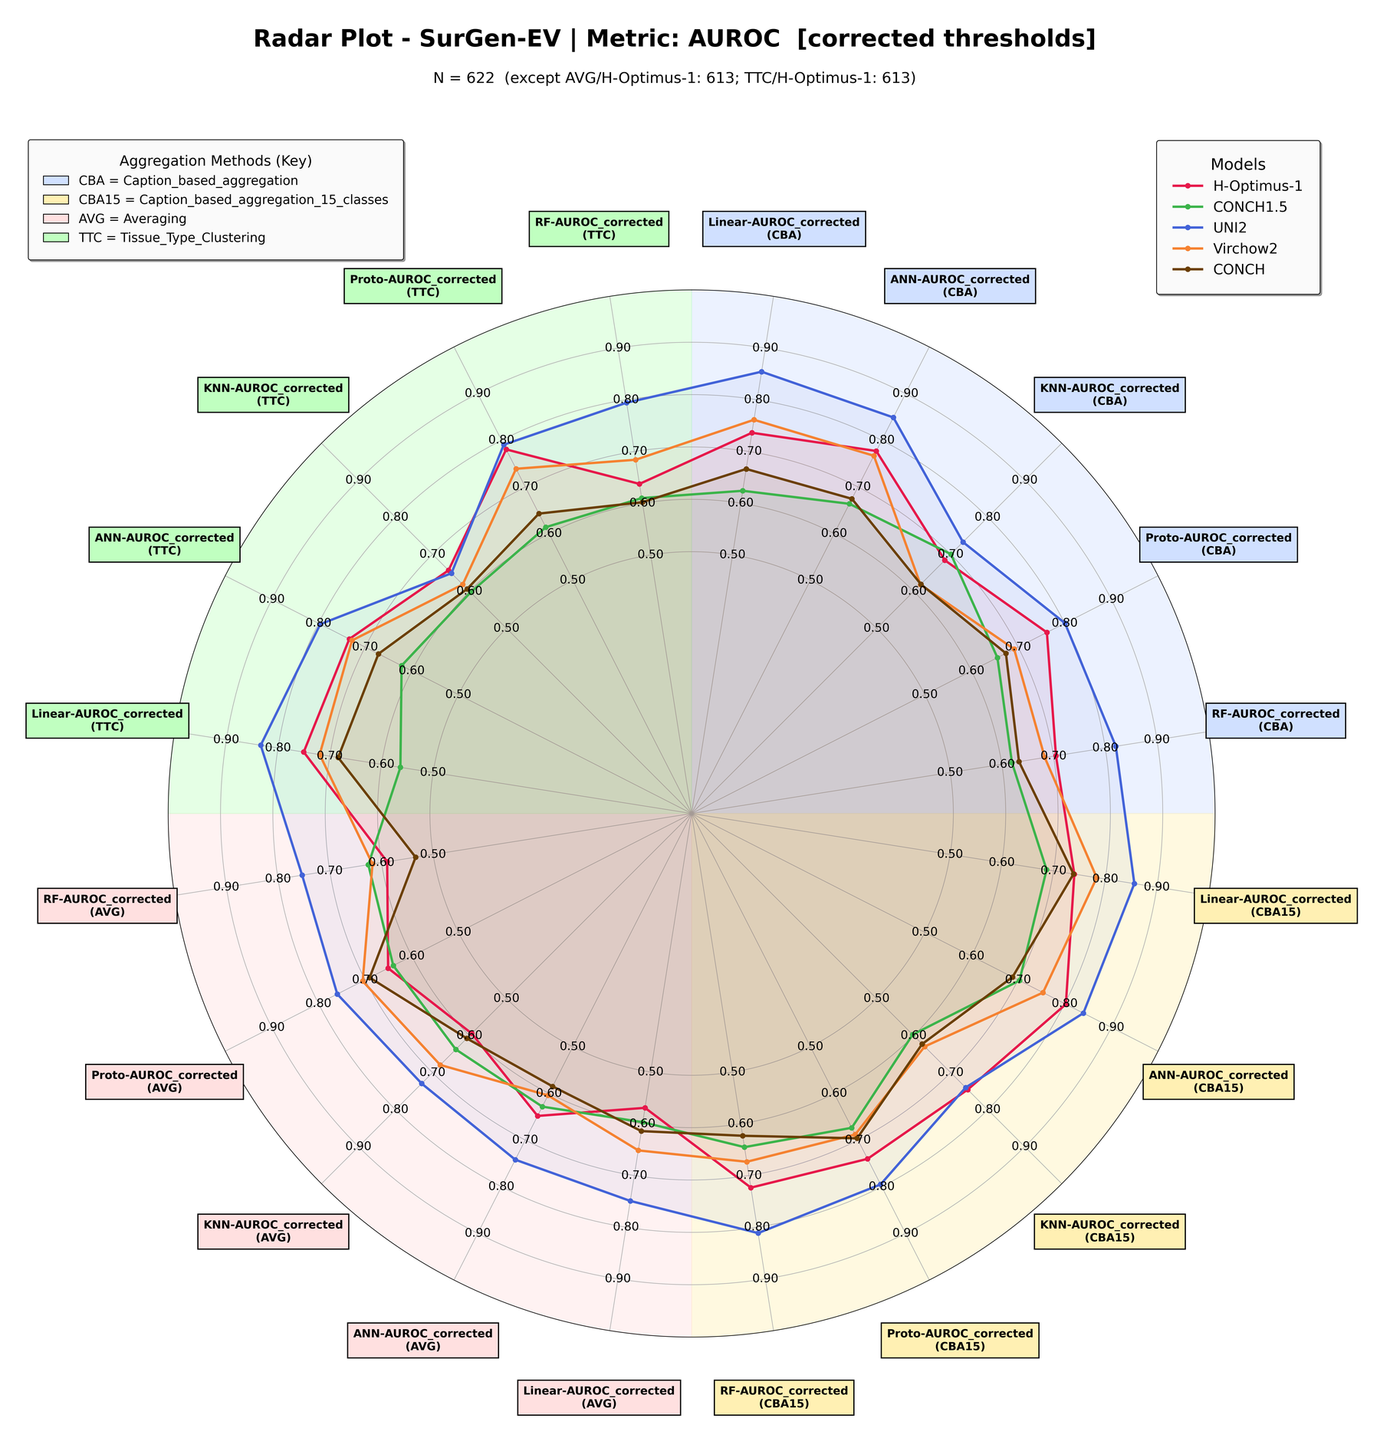
Figure 3. SurGen-EV — AUROC across every classifier × aggregation axis, corrected thresholds. N = 622.
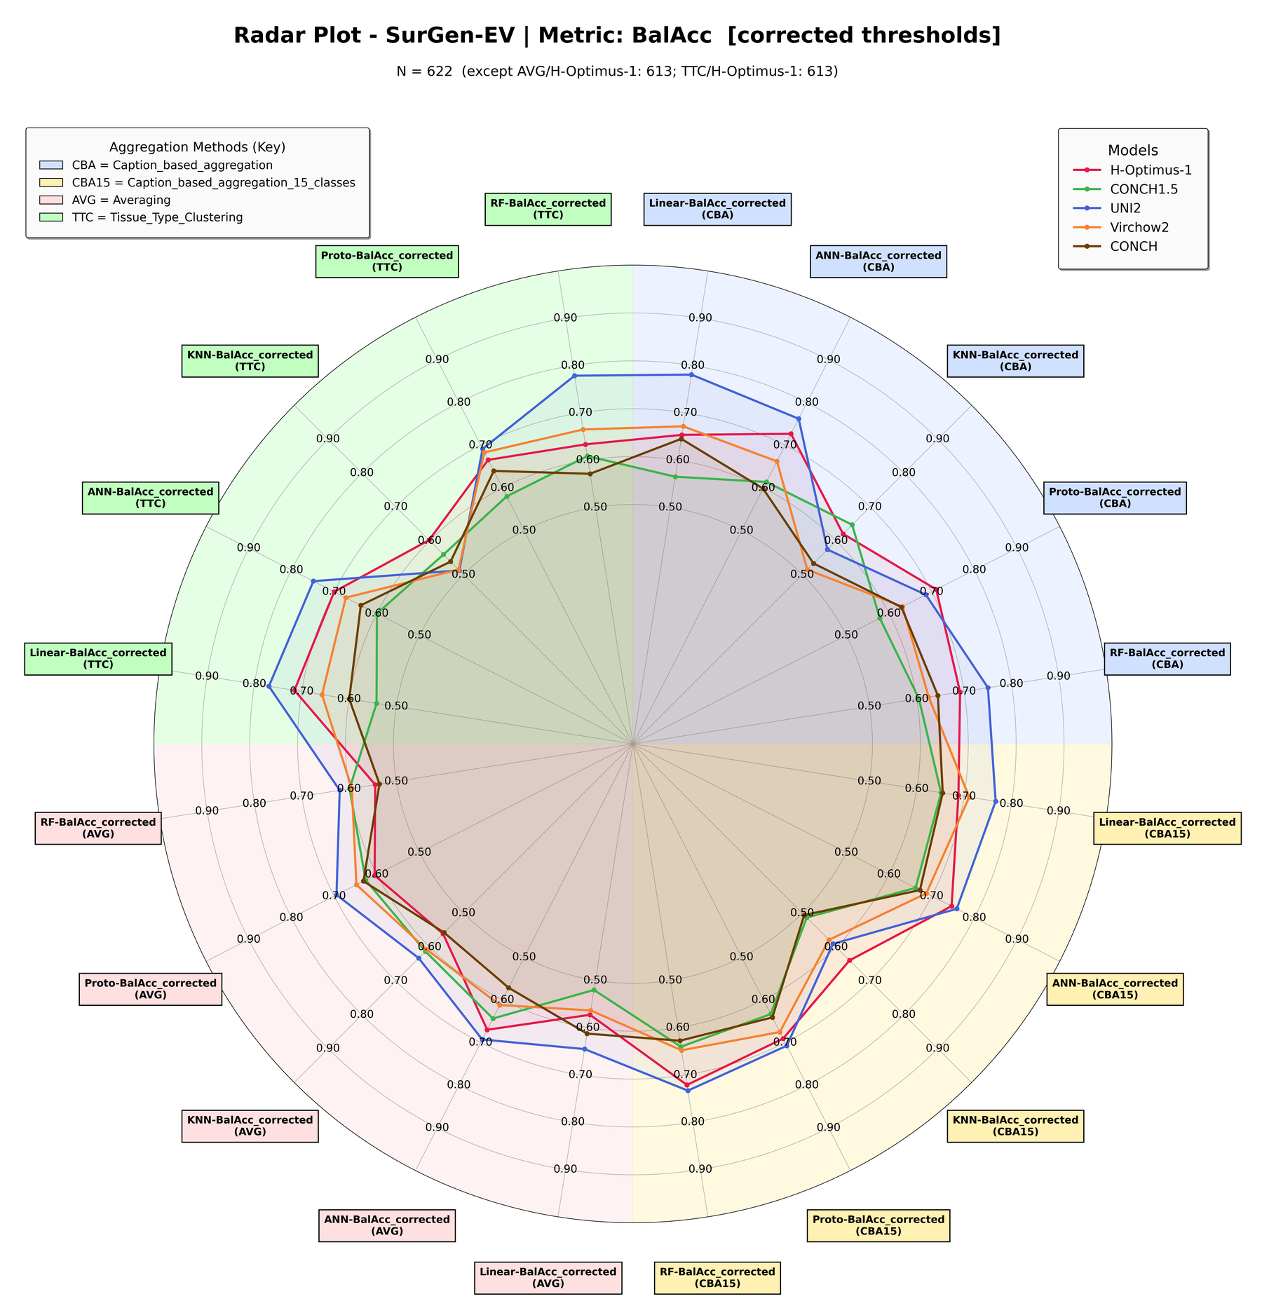
Figure 4. SurGen-EV — balanced accuracy across every classifier × aggregation axis, corrected thresholds. N = 622.

4 Configurations that regressed
Rate-matching trades a small loss on well-calibrated configurations for the recovery of the 38 broken ones, and that trade is not free. 38 of 200 configurations lose balanced accuracy under the corrected threshold. They are listed in full below rather than left for a reviewer to find.
The four largest regressions are all KNN on SurGen-EV: tissue-type clustering with UNI2 (−0.1302), caption-based 15-class with Conch1_5 (−0.1179), caption-based with UNI2 (−0.1067) and caption-based 15-class with UNI2 (−0.0956). This is the same k = 35 transfer problem visible in the summary table, and it is the one result in this document that a reviewer is likely to press on. The defence is that k was selected on TCGA alone, which is the correct protocol for external validation, and that selecting it on SurGen would invalidate the experiment. Outside the SurGen KNN group the losses are small — mostly −0.01 to −0.06 — and concentrated on ConchV1 and Conch1_5 with the linear head on PAIP-EV.
All configurations with a negative change in balanced accuracy, sorted worst first. Rows at −0.05 or worse are bold.
Cohort | Aggregation | Model | Clf | BalAcc frozen | BalAcc corr. | Δ BalAcc
SurGen-EV | Tissue-type clustering | UNI2 | KNN | 0.6427 | 0.5125 | −0.1302
SurGen-EV | Caption-based (15 classes) | Conch1_5 | KNN | 0.6309 | 0.5130 | −0.1179
SurGen-EV | Caption-based | UNI2 | KNN | 0.6808 | 0.5741 | −0.1067
SurGen-EV | Caption-based (15 classes) | UNI2 | KNN | 0.6862 | 0.5906 | −0.0956
PAIP-EV | Caption-based (15 classes) | ConchV1 | LR | 0.8363 | 0.7734 | −0.0629
PAIP-EV | Tissue-type clustering | ConchV1 | LR | 0.7480 | 0.6851 | −0.0629
PAIP-EV | Averaging | ConchV1 | ANN | 0.7752 | 0.7132 | −0.0620
PAIP-EV | Averaging | ConchV1 | ProtoNet | 0.7565 | 0.7029 | −0.0536
SurGen-EV | Averaging | Virchow2 | LR | 0.6062 | 0.5636 | −0.0426
PAIP-EV | Caption-based | Conch1_5 | ANN | 0.8354 | 0.7930 | −0.0424
PAIP-EV | Tissue-type clustering | Conch1_5 | ANN | 0.8194 | 0.7770 | −0.0424
SurGen-EV | Averaging | UNI2 | LR | 0.6875 | 0.6453 | −0.0422
PAIP-EV | Caption-based (15 classes) | Conch1_5 | LR | 0.8024 | 0.7658 | −0.0366
PAIP-EV | Tissue-type clustering | Virchow2 | LR | 0.7694 | 0.7328 | −0.0366
SurGen-EV | Caption-based | Virchow2 | ANN | 0.6984 | 0.6623 | −0.0361
PAIP-EV | Caption-based | Virchow2 | KNN | 0.7431 | 0.7083 | −0.0348
PAIP-EV | Averaging | Conch1_5 | LR | 0.7168 | 0.6945 | −0.0223
SurGen-EV | Caption-based | Virchow2 | KNN | 0.5367 | 0.5148 | −0.0219
PAIP-EV | Tissue-type clustering | Conch1_5 | ProtoNet | 0.7226 | 0.7047 | −0.0179
PAIP-EV | Tissue-type clustering | Conch1_5 | LR | 0.7752 | 0.7574 | −0.0178
PAIP-EV | Caption-based | ConchV1 | KNN | 0.6922 | 0.6753 | −0.0169
PAIP-EV | Averaging | Virchow2 | ProtoNet | 0.7819 | 0.7658 | −0.0161
SurGen-EV | Tissue-type clustering | Conch1_5 | RF | 0.6247 | 0.6086 | −0.0161
SurGen-EV | Tissue-type clustering | Virchow2 | KNN | 0.5271 | 0.5148 | −0.0123
PAIP-EV | Averaging | ConchV1 | LR | 0.7770 | 0.7649 | −0.0121
PAIP-EV | Caption-based | Virchow2 | ProtoNet | 0.7837 | 0.7743 | −0.0094
SurGen-EV | Averaging | UNI2 | KNN | 0.6412 | 0.6326 | −0.0086
PAIP-EV | Averaging | H-Optimus-1 | ProtoNet | 0.8702 | 0.8617 | −0.0085
PAIP-EV | Tissue-type clustering | H-Optimus-1 | ANN | 0.8363 | 0.8278 | −0.0085
PAIP-EV | Caption-based | Virchow2 | RF | 0.7921 | 0.7837 | −0.0084
SurGen-EV | Caption-based (15 classes) | UNI2 | LR | 0.7750 | 0.7666 | −0.0084
PAIP-EV | Averaging | UNI2 | LR | 0.7547 | 0.7471 | −0.0076
SurGen-EV | Caption-based | ConchV1 | ANN | 0.6058 | 0.5984 | −0.0074
SurGen-EV | Caption-based (15 classes) | Conch1_5 | ANN | 0.6685 | 0.6623 | −0.0062
SurGen-EV | Caption-based | Conch1_5 | ANN | 0.6193 | 0.6140 | −0.0053
SurGen-EV | Caption-based (15 classes) | ConchV1 | KNN | 0.5106 | 0.5056 | −0.0050
PAIP-EV | Caption-based (15 classes) | ConchV1 | ProtoNet | 0.8024 | 0.8006 | −0.0018
PAIP-EV | Caption-based (15 classes) | UNI2 | ANN | 0.8533 | 0.8524 | −0.0009

5 Reference: PAIP-IV radar plots
PAIP-IV is the PAIP provider’s own train/test split evaluated as a single fixed split (N = 31, 7 positive). It is an internal experiment: the threshold is fitted on its own data, so the correction does not apply and these plots are unchanged from the previous draft. They are reproduced here so the external-validation figures can be read against an internal baseline on the same cohort. Note that the axis labels carry no "_corrected" suffix, unlike Figures 1 to 4.
The earlier empty PAIP-IV AUROC plot was caused by a partially rebuilt results tree, with missing cells filled as 0.0, rather than by a computation fault; these figures are from the complete tree.
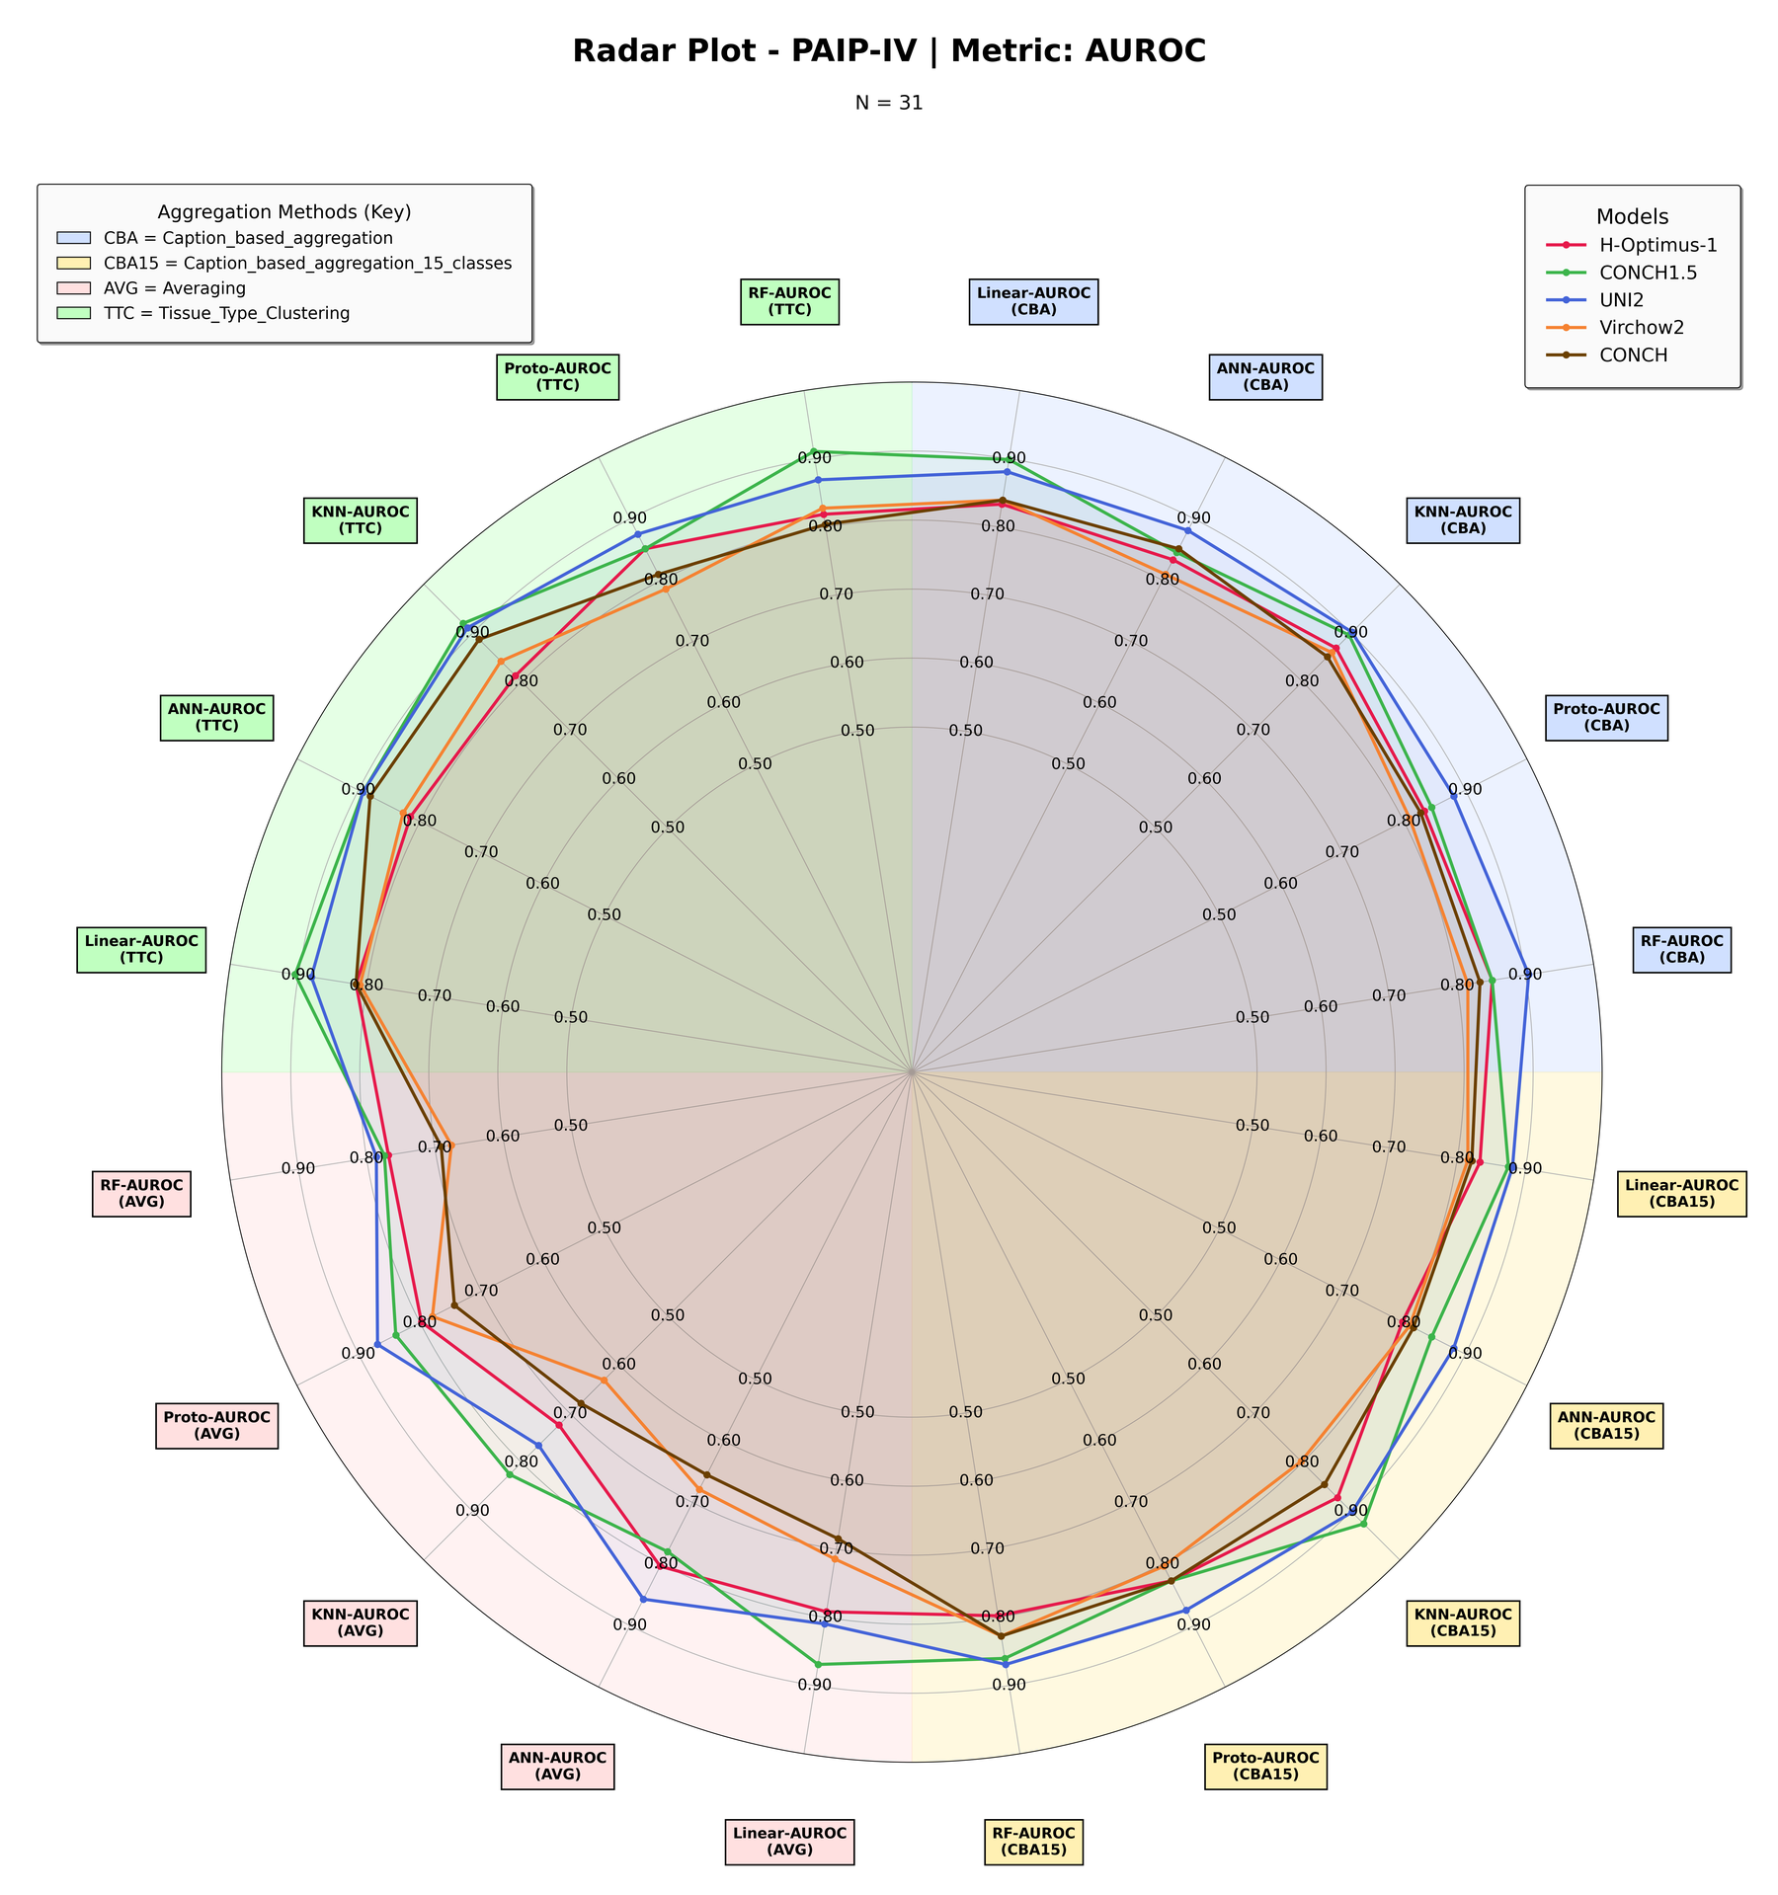
Figure 5. PAIP-IV — AUROC across every classifier × aggregation axis. Internal validation, thresholds not corrected. N = 31.
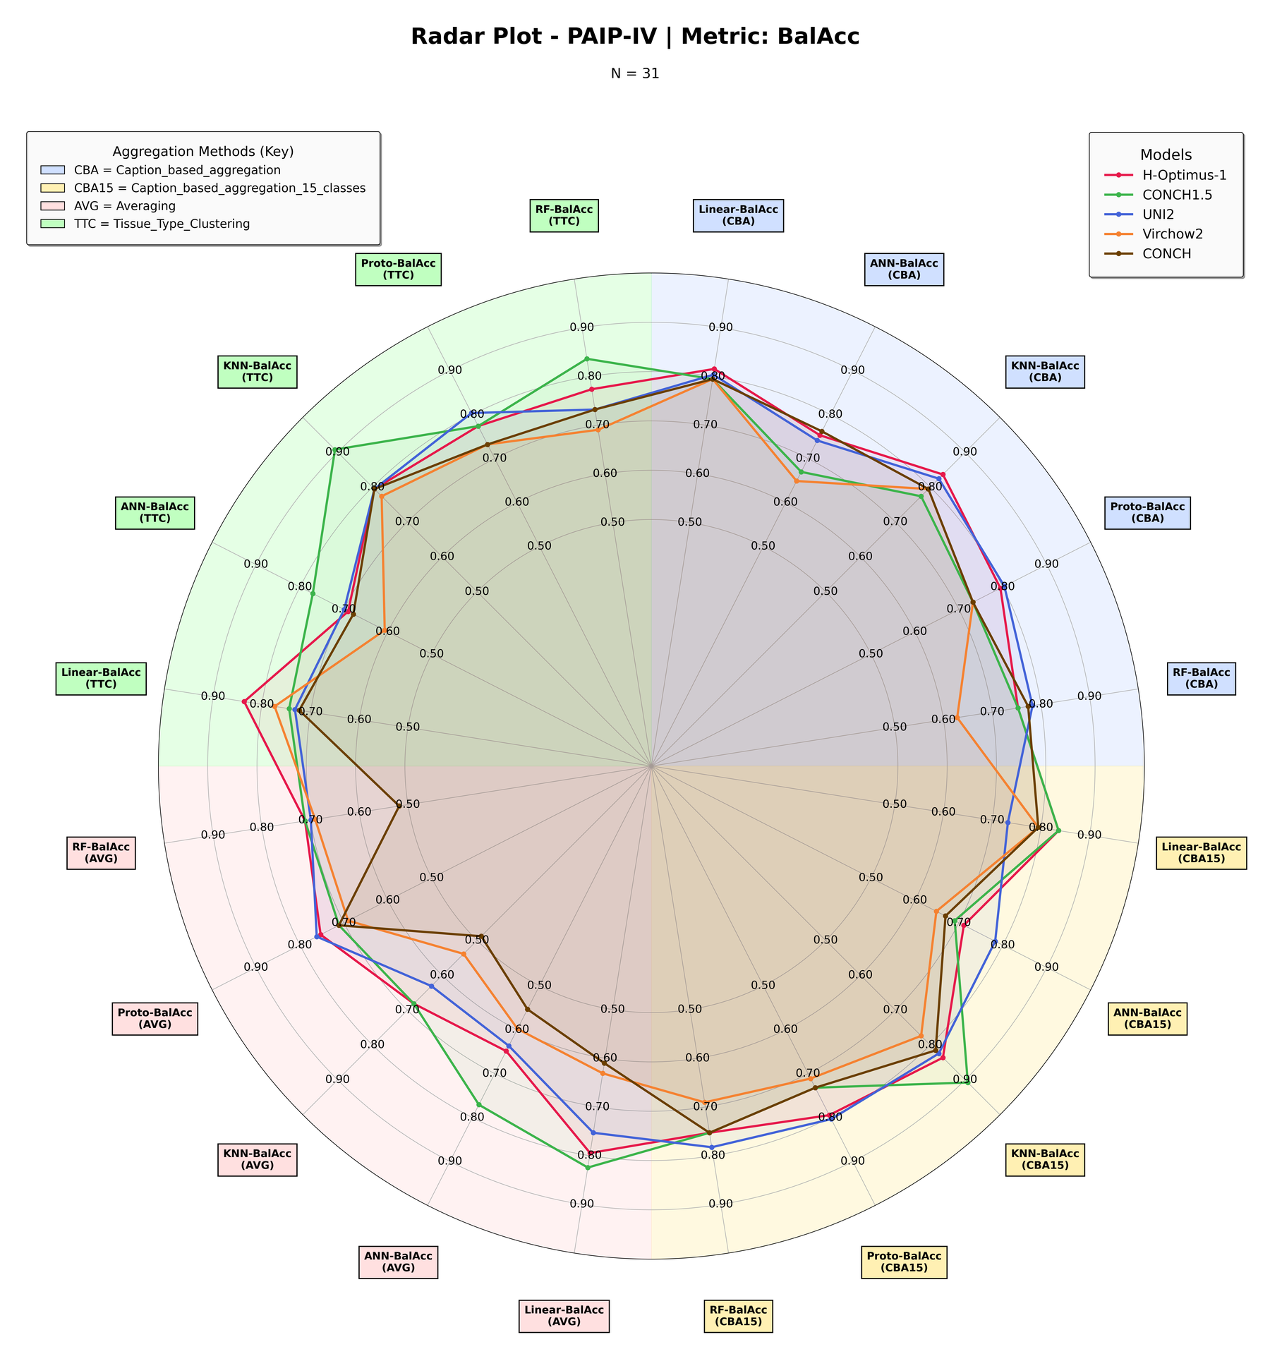
Figure 6. PAIP-IV — balanced accuracy across every classifier × aggregation axis. Internal validation, thresholds not corrected. N = 31.

