Results
Every value is read from the provenance-stamped result_*.json files. Latest run: 2026-08-27T09:11:35+00:00. Git commit(s): 48179b3, bbe4c0e, e8cbb89. Best row in each table (by BalAcc) is bold.

4.1 TCGA Validation Results
Internal 4-fold cross-validation on TCGA (N = 413). For each foundation model the table reports its best aggregation, selected by BalAcc. Confusion matrices are [[TN, FP], [FN, TP]].

1. Conch1_5
TCGA (4-fold CV): Conch1_5 — best aggregation: tissue-type clustering. N = 413.
Classifier | Acc | Bal Acc | Macro-F1 | AUROC | CM
Linear | 86.01% | 65.64% | 66.95% | 81.73% | [[83,5],[9,6]]
ANN | 78.73% | 72.84% | 66.48% | 83.94% | [[71,17],[5,10]]
KNN | 86.04% | 56.11% | 56.73% | 67.88% | [[86,2],[13,2]]
ProtoNet | 60.85% | 58.37% | 51.04% | 68.32% | [[55,33],[7,8]]
r_forest | 87.68% | 62.87% | 65.87% | 82.11% | [[86,2],[11,4]]

2. UNI-2h
TCGA (4-fold CV): UNI-2h — best aggregation: averaging. N = 413.
Classifier | Acc | Bal Acc | Macro-F1 | AUROC | CM
Linear | 90.04% | 74.09% | 76.20% | 86.08% | [[85,4],[7,8]]
ANN | 83.38% | 78.89% | 72.57% | 86.40% | [[75,14],[4,11]]
KNN | 86.34% | 58.80% | 61.13% | 70.34% | [[86,2],[12,3]]
ProtoNet | 64.15% | 65.77% | 55.82% | 72.09% | [[56,32],[4,10]]
r_forest | 89.14% | 65.47% | 68.92% | 83.94% | [[87,1],[10,5]]

3. H-Optimus-1
TCGA (4-fold CV): H-Optimus-1 — best aggregation: caption-based clustering (15). N = 413.
Classifier | Acc | Bal Acc | Macro-F1 | AUROC | CM
Linear | 92.30% | 80.04% | 82.85% | 92.79% | [[86,2],[6,10]]
ANN | 87.51% | 82.83% | 78.24% | 91.90% | [[79,10],[4,12]]
KNN | 86.79% | 60.05% | 62.69% | 72.51% | [[86,2],[12,4]]
ProtoNet | 81.45% | 75.07% | 69.73% | 83.67% | [[74,14],[5,10]]
r_forest | 89.48% | 67.73% | 72.33% | 91.59% | [[87,2],[10,6]]

4. Conch_V1
TCGA (4-fold CV): Conch_V1 — best aggregation: tissue-type clustering. N = 413.
Classifier | Acc | Bal Acc | Macro-F1 | AUROC | CM
Linear | 88.04% | 69.81% | 72.27% | 77.58% | [[84,4],[8,7]]
ANN | 79.14% | 76.05% | 68.31% | 81.06% | [[70,18],[4,11]]
KNN | 85.77% | 59.24% | 60.74% | 70.14% | [[85,3],[12,4]]
ProtoNet | 67.01% | 60.58% | 54.50% | 67.96% | [[62,27],[7,8]]
r_forest | 89.20% | 65.93% | 69.14% | 80.89% | [[87,2],[10,5]]

5. Virchow2
TCGA (4-fold CV): Virchow2 — best aggregation: caption-based clustering (15). N = 413.
Classifier | Acc | Bal Acc | Macro-F1 | AUROC | CM
Linear | 89.53% | 73.20% | 76.36% | 88.08% | [[85,4],[8,8]]
ANN | 80.10% | 78.95% | 70.08% | 86.96% | [[71,17],[4,12]]
KNN | 85.30% | 58.30% | 59.34% | 68.58% | [[85,3],[12,3]]
ProtoNet | 69.19% | 64.25% | 57.45% | 69.69% | [[63,25],[6,8]]
r_forest | 89.43% | 65.38% | 69.67% | 87.47% | [[88,1],[10,5]]

Summary of Best Results
TCGA: summary of best results — one row per foundation model × aggregation; the adaptation shown is the classifier with the highest BalAcc for that pair.
Models | Aggregation | Best Adaptation | Balanced Acc | AUROC
Conch 1.5 | Averaging | LR | 70.98 | 74.36
UNI-2h | Averaging | ANN | 78.89 | 86.40
H-Optimus-1 | Averaging | ANN | 80.04 | 88.37
Conch V1 | Averaging | ANN | 71.74 | 76.72
Virchow2 | Averaging | ANN | 76.26 | 82.85
Conch 1.5 | Caption | LR | 72.28 | 83.89
UNI-2h | Caption | ANN | 78.18 | 88.64
H-Optimus-1 | Caption | ANN | 81.73 | 91.31
Conch V1 | Caption | ANN | 69.74 | 81.23
Virchow2 | Caption | ANN | 76.70 | 85.50
Conch 1.5 | Caption-15 | ANN | 71.90 | 80.72
UNI-2h | Caption-15 | ANN | 78.61 | 87.86
H-Optimus-1 | Caption-15 | ANN | 82.83 | 91.90
Conch V1 | Caption-15 | LR | 69.89 | 79.93
Virchow2 | Caption-15 | ANN | 78.95 | 86.96
Conch 1.5 | Tissue-type | ANN | 72.84 | 83.94
UNI-2h | Tissue-type | ANN | 78.37 | 88.07
H-Optimus-1 | Tissue-type | ANN | 79.16 | 90.45
Conch V1 | Tissue-type | ANN | 76.05 | 81.06
Virchow2 | Tissue-type | ANN | 72.36 | 83.39
PRISM | PRISM | ANN | 79.33 | 86.85
Conch with TITAN | TITAN | ANN | 80.29 | 86.45

Radar Plots
Each axis is one classifier × aggregation combination. The four shaded quadrants group the aggregation strategies (CBA, CBA15, AVG, TTC) and each coloured trace is one foundation model, so a trace that bulges into one quadrant is a model that favours that aggregation.
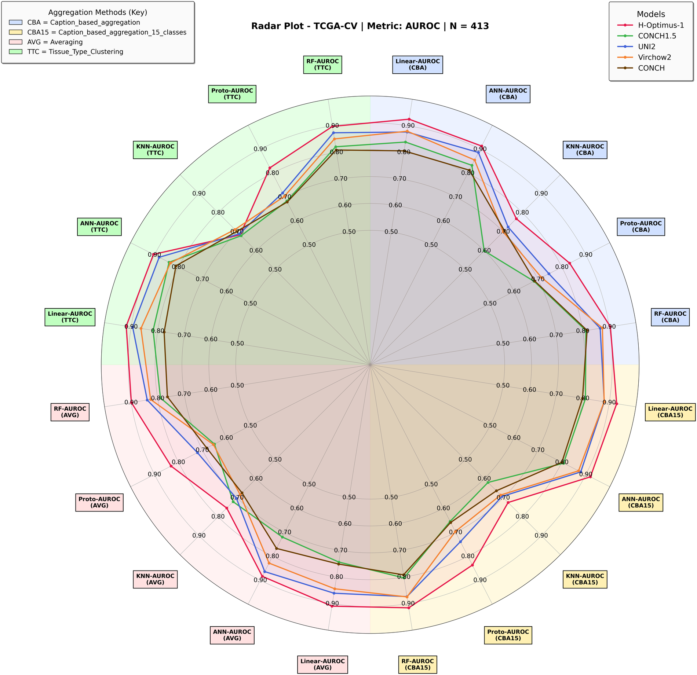
Figure 1. TCGA-CV — AUROC across every classifier × aggregation axis. N = 413.
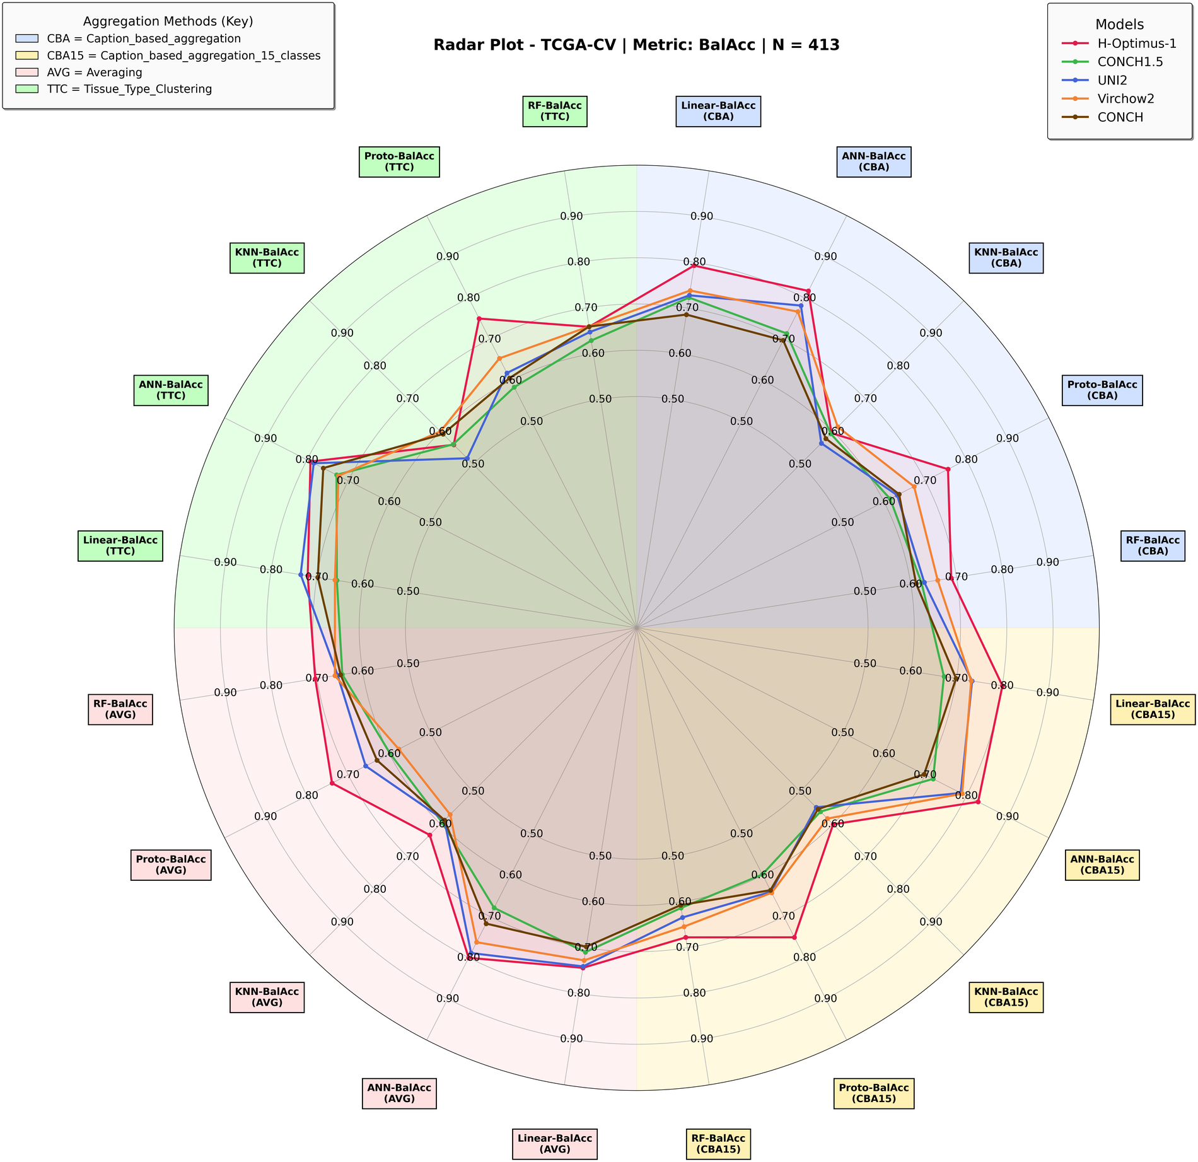
Figure 2. TCGA-CV — balanced accuracy across every classifier × aggregation axis. N = 413.

4.2 PAIP Validation Results
After training on TCGA, models were validated on the PAIP cohort across all aggregation strategies. No PAIP data enters training and the decision threshold is fixed on TCGA (Youden's J on pooled out-of-fold TCGA-CV probabilities), so the operating point is never tuned on the target cohort. Confusion matrices are [[TN, FP], [FN, TP]].

4.2.1 Averaging Aggregation (1× feature dim)
PAIP: Averaging Aggregation (1× feature dim). N = 78.
Model | Clf | Acc | Bal-Acc | Mac-F1 | AUROC | Avg CM
Conch1_5 | LR | 0.6795 | 0.7168 | 0.6490 | 0.7939 | [[38,21],[4,15]]
Conch1_5 | ANN | 0.7385 | 0.7094 | 0.6822 | 0.7293 | [[45,14],[7,12]]
Conch1_5 | KNN | 0.7821 | 0.5526 | 0.5323 | 0.6311 | [[59,0],[17,2]]
Conch1_5 | ProtoNet | 0.7821 | 0.7132 | 0.7094 | 0.8412 | [[50,9],[8,11]]
Conch1_5 | RF | 0.7974 | 0.5878 | 0.5889 | 0.7395 | [[59,0],[16,3]]
UNI2 | LR | 0.8718 | 0.7547 | 0.7937 | 0.9153 | [[58,1],[9,10]]
UNI2 | ANN | 0.4000 | 0.5820 | 0.3833 | 0.8037 | [[13,46],[1,18]]
UNI2 | KNN | 0.7564 | 0.5000 | 0.4307 | 0.5000 | [[59,0],[19,0]]
UNI2 | ProtoNet | 0.8077 | 0.6053 | 0.6175 | 0.8448 | [[59,0],[15,4]]
UNI2 | RF | 0.7564 | 0.5000 | 0.4307 | 0.7042 | [[59,0],[19,0]]
H-Optimus-1 | LR | 0.7949 | 0.5789 | 0.5767 | 0.8751 | [[59,0],[16,3]]
H-Optimus-1 | ANN | 0.8205 | 0.7779 | 0.7701 | 0.8442 | [[51,8],[6,13]]
H-Optimus-1 | KNN | 0.7564 | 0.5535 | 0.5475 | 0.5535 | [[56,3],[16,3]]
H-Optimus-1 | ProtoNet | 0.8846 | 0.8702 | 0.8511 | 0.8742 | [[53,6],[3,16]]
H-Optimus-1 | RF | 0.8205 | 0.6601 | 0.6849 | 0.8319 | [[57,2],[12,7]]
ConchV1 | LR | 0.7436 | 0.7770 | 0.7115 | 0.8644 | [[42,17],[3,16]]
ConchV1 | ANN | 0.6897 | 0.6879 | 0.6425 | 0.7711 | [[41,18],[6,13]]
ConchV1 | KNN | 0.7308 | 0.6079 | 0.6132 | 0.6160 | [[50,9],[12,7]]
ConchV1 | ProtoNet | 0.8205 | 0.7565 | 0.7565 | 0.8216 | [[52,7],[7,12]]
ConchV1 | RF | 0.7692 | 0.6940 | 0.6914 | 0.7848 | [[50,9],[9,10]]
Virchow2 | LR | 0.8462 | 0.7021 | 0.7388 | 0.8912 | [[58,1],[11,8]]
Virchow2 | ANN | 0.4667 | 0.6225 | 0.4479 | 0.8014 | [[19,40],[1,18]]
Virchow2 | KNN | 0.6026 | 0.5589 | 0.5388 | 0.5656 | [[38,21],[10,9]]
Virchow2 | ProtoNet | 0.8590 | 0.7819 | 0.7974 | 0.8412 | [[55,4],[7,12]]
Virchow2 | RF | 0.8385 | 0.6827 | 0.7173 | 0.8275 | [[58,1],[12,7]]

4.2.2 Caption-Based Aggregation (14× feature dim)
PAIP: Caption-Based Aggregation (14× feature dim). N = 78.
Model | Clf | Acc | Bal-Acc | Mac-F1 | AUROC | Avg CM
Conch1_5 | LR | 0.7564 | 0.7319 | 0.7033 | 0.8626 | [[46,13],[6,13]]
Conch1_5 | ANN | 0.8308 | 0.8132 | 0.7880 | 0.8707 | [[50,9],[4,15]]
Conch1_5 | KNN | 0.7692 | 0.5620 | 0.5568 | 0.6329 | [[57,2],[16,3]]
Conch1_5 | ProtoNet | 0.7051 | 0.7159 | 0.6650 | 0.8448 | [[41,18],[5,14]]
Conch1_5 | RF | 0.7846 | 0.5650 | 0.5527 | 0.8417 | [[59,0],[16,3]]
UNI2 | LR | 0.8846 | 0.7810 | 0.8188 | 0.9063 | [[58,1],[8,11]]
UNI2 | ANN | 0.8282 | 0.8365 | 0.7949 | 0.9083 | [[48,11],[3,16]]
UNI2 | KNN | 0.7821 | 0.5705 | 0.5665 | 0.5705 | [[58,1],[16,3]]
UNI2 | ProtoNet | 0.7564 | 0.5000 | 0.4307 | 0.8626 | [[59,0],[19,0]]
UNI2 | RF | 0.7872 | 0.5881 | 0.5917 | 0.8421 | [[58,1],[15,4]]
H-Optimus-1 | LR | 0.8333 | 0.6579 | 0.6904 | 0.8769 | [[59,0],[13,6]]
H-Optimus-1 | ANN | 0.8538 | 0.8463 | 0.8182 | 0.8955 | [[51,8],[3,16]]
H-Optimus-1 | KNN | 0.7821 | 0.5883 | 0.5951 | 0.5883 | [[57,2],[15,4]]
H-Optimus-1 | ProtoNet | 0.7949 | 0.8109 | 0.7593 | 0.8796 | [[46,13],[3,16]]
H-Optimus-1 | RF | 0.8487 | 0.7359 | 0.7645 | 0.8648 | [[56,3],[9,10]]
ConchV1 | LR | 0.8333 | 0.8185 | 0.7913 | 0.8483 | [[50,9],[4,15]]
ConchV1 | ANN | 0.6308 | 0.7024 | 0.6103 | 0.8368 | [[33,26],[3,16]]
ConchV1 | KNN | 0.6154 | 0.6922 | 0.5985 | 0.6628 | [[32,27],[3,16]]
ConchV1 | ProtoNet | 0.6538 | 0.7355 | 0.6366 | 0.8510 | [[34,25],[2,17]]
ConchV1 | RF | 0.8179 | 0.7048 | 0.7246 | 0.8376 | [[55,4],[10,9]]
Virchow2 | LR | 0.8205 | 0.8278 | 0.7842 | 0.8876 | [[48,11],[3,16]]
Virchow2 | ANN | 0.7436 | 0.7877 | 0.7149 | 0.8885 | [[41,18],[2,17]]
Virchow2 | KNN | 0.6923 | 0.7431 | 0.6657 | 0.7792 | [[38,21],[3,16]]
Virchow2 | ProtoNet | 0.8077 | 0.7837 | 0.7592 | 0.8599 | [[49,10],[5,14]]
Virchow2 | RF | 0.8205 | 0.7993 | 0.7749 | 0.8576 | [[50,9],[5,14]]

4.2.3 Caption-Based Aggregation, 15 classes (15× feature dim)
PAIP: Caption-Based Aggregation, 15 classes (15× feature dim). N = 78.
Model | Clf | Acc | Bal-Acc | Mac-F1 | AUROC | Avg CM
Conch1_5 | LR | 0.7821 | 0.8024 | 0.7471 | 0.8831 | [[45,14],[3,16]]
Conch1_5 | ANN | 0.7564 | 0.7783 | 0.7220 | 0.8599 | [[43,16],[3,16]]
Conch1_5 | KNN | 0.6795 | 0.6454 | 0.6194 | 0.6664 | [[42,17],[8,11]]
Conch1_5 | ProtoNet | 0.8462 | 0.7913 | 0.7913 | 0.8537 | [[53,6],[6,13]]
Conch1_5 | RF | 0.7615 | 0.5105 | 0.4519 | 0.8453 | [[59,0],[19,0]]
UNI2 | LR | 0.8846 | 0.7632 | 0.8094 | 0.9037 | [[59,0],[9,10]]
UNI2 | ANN | 0.8359 | 0.8309 | 0.8003 | 0.8976 | [[50,9],[3,16]]
UNI2 | KNN | 0.7949 | 0.5789 | 0.5767 | 0.5789 | [[59,0],[16,3]]
UNI2 | ProtoNet | 0.7564 | 0.5000 | 0.4307 | 0.8626 | [[59,0],[19,0]]
UNI2 | RF | 0.8308 | 0.6812 | 0.7087 | 0.8409 | [[57,2],[12,7]]
H-Optimus-1 | LR | 0.8077 | 0.6053 | 0.6175 | 0.8787 | [[59,0],[15,4]]
H-Optimus-1 | ANN | 0.8359 | 0.8380 | 0.8009 | 0.9008 | [[49,10],[3,16]]
H-Optimus-1 | KNN | 0.7436 | 0.5272 | 0.5076 | 0.5285 | [[56,3],[17,2]]
H-Optimus-1 | ProtoNet | 0.8462 | 0.8448 | 0.8101 | 0.8778 | [[50,9],[3,16]]
H-Optimus-1 | RF | 0.8487 | 0.7323 | 0.7603 | 0.8510 | [[57,2],[9,10]]
ConchV1 | LR | 0.8333 | 0.8363 | 0.7970 | 0.8644 | [[49,10],[3,16]]
ConchV1 | ANN | 0.6641 | 0.7351 | 0.6411 | 0.8610 | [[35,24],[2,17]]
ConchV1 | KNN | 0.6026 | 0.6302 | 0.5715 | 0.6789 | [[34,25],[6,13]]
ConchV1 | ProtoNet | 0.7821 | 0.8024 | 0.7471 | 0.8608 | [[45,14],[3,16]]
ConchV1 | RF | 0.8282 | 0.6652 | 0.6940 | 0.8409 | [[58,1],[12,7]]
Virchow2 | LR | 0.8205 | 0.8457 | 0.7894 | 0.9099 | [[47,12],[2,17]]
Virchow2 | ANN | 0.6692 | 0.7528 | 0.6512 | 0.8928 | [[35,24],[2,17]]
Virchow2 | KNN | 0.6410 | 0.6378 | 0.5962 | 0.6838 | [[38,21],[7,12]]
Virchow2 | ProtoNet | 0.8718 | 0.8260 | 0.8260 | 0.8724 | [[54,5],[5,14]]
Virchow2 | RF | 0.8821 | 0.7793 | 0.8151 | 0.8589 | [[58,1],[8,11]]

4.2.4 Tissue-Type Clustering Aggregation (9× feature dim)
PAIP: Tissue-Type Clustering Aggregation (9× feature dim). N = 78.
Model | Clf | Acc | Bal-Acc | Mac-F1 | AUROC | Avg CM
Conch1_5 | LR | 0.7949 | 0.7752 | 0.7468 | 0.8394 | [[48,11],[5,14]]
Conch1_5 | ANN | 0.7564 | 0.7712 | 0.7208 | 0.8187 | [[44,15],[4,15]]
Conch1_5 | KNN | 0.6154 | 0.6209 | 0.5752 | 0.6111 | [[36,23],[7,12]]
Conch1_5 | ProtoNet | 0.7692 | 0.7226 | 0.7068 | 0.8171 | [[48,11],[7,12]]
Conch1_5 | RF | 0.7949 | 0.6860 | 0.6973 | 0.8354 | [[53,6],[10,9]]
UNI2 | LR | 0.8590 | 0.7640 | 0.7886 | 0.8858 | [[56,3],[8,11]]
UNI2 | ANN | 0.5000 | 0.6445 | 0.4822 | 0.8651 | [[21,38],[1,18]]
UNI2 | KNN | 0.7692 | 0.5263 | 0.4838 | 0.5263 | [[59,0],[18,1]]
UNI2 | ProtoNet | 0.7564 | 0.5000 | 0.4307 | 0.8555 | [[59,0],[19,0]]
UNI2 | RF | 0.7795 | 0.5474 | 0.5218 | 0.7852 | [[59,0],[17,2]]
H-Optimus-1 | LR | 0.8077 | 0.6053 | 0.6175 | 0.8724 | [[59,0],[15,4]]
H-Optimus-1 | ANN | 0.8538 | 0.8463 | 0.8171 | 0.8853 | [[51,8],[3,16]]
H-Optimus-1 | KNN | 0.7436 | 0.5450 | 0.5385 | 0.5455 | [[55,4],[16,3]]
H-Optimus-1 | ProtoNet | 0.8077 | 0.8194 | 0.7716 | 0.8689 | [[47,12],[3,16]]
H-Optimus-1 | RF | 0.8359 | 0.6632 | 0.6964 | 0.8614 | [[59,0],[13,6]]
ConchV1 | LR | 0.8077 | 0.7480 | 0.7436 | 0.8260 | [[51,8],[7,12]]
ConchV1 | ANN | 0.8282 | 0.7794 | 0.7704 | 0.8066 | [[52,7],[6,13]]
ConchV1 | KNN | 0.6282 | 0.6829 | 0.6048 | 0.7034 | [[34,25],[4,15]]
ConchV1 | ProtoNet | 0.6667 | 0.7440 | 0.6479 | 0.8216 | [[35,24],[2,17]]
ConchV1 | RF | 0.8308 | 0.6812 | 0.7105 | 0.8259 | [[57,2],[12,7]]
Virchow2 | LR | 0.7051 | 0.7694 | 0.6821 | 0.8492 | [[38,21],[2,17]]
Virchow2 | ANN | 0.5256 | 0.6508 | 0.5210 | 0.8596 | [[24,35],[2,17]]
Virchow2 | KNN | 0.6026 | 0.5946 | 0.5571 | 0.5977 | [[36,23],[8,11]]
Virchow2 | ProtoNet | 0.7692 | 0.7226 | 0.7068 | 0.7921 | [[48,11],[7,12]]
Virchow2 | RF | 0.7564 | 0.7712 | 0.7186 | 0.8319 | [[44,15],[4,15]]

4.2.5 TITAN Aggregation (Conch1_5 only)
PAIP: TITAN Aggregation (Conch1_5 only). N = 78.
Classifier | Acc | Bal-Acc | Mac-F1 | AUROC | Avg CM
LR | 0.6795 | 0.7525 | 0.6593 | 0.8171 | [[36,23],[2,17]]
ANN | 0.7103 | 0.7550 | 0.6820 | 0.8623 | [[39,20],[3,16]]
KNN | 0.7821 | 0.7489 | 0.7271 | 0.7560 | [[48,11],[6,13]]
ProtoNet | 0.7436 | 0.7770 | 0.7115 | 0.8457 | [[42,17],[3,16]]
RF | 0.8231 | 0.7903 | 0.7732 | 0.8426 | [[50,9],[5,14]]

4.2.6 PRISM Aggregation (slide-level embedding)
PAIP: PRISM Aggregation (slide-level embedding). N = 78.
Classifier | Acc | Bal-Acc | Mac-F1 | AUROC | Avg CM
LR | 0.7564 | 0.7855 | 0.7232 | 0.8439 | [[43,16],[3,16]]
ANN | 0.7821 | 0.7953 | 0.7487 | 0.8535 | [[45,14],[3,16]]
KNN | 0.7692 | 0.6869 | 0.6869 | 0.7029 | [[50,9],[9,10]]
ProtoNet | 0.8077 | 0.7837 | 0.7592 | 0.8216 | [[49,10],[5,14]]
RF | 0.8333 | 0.7756 | 0.7743 | 0.8111 | [[52,7],[6,13]]

4.2.7 Radar Plots
Axes, quadrants and colours follow the convention introduced in 4.1.
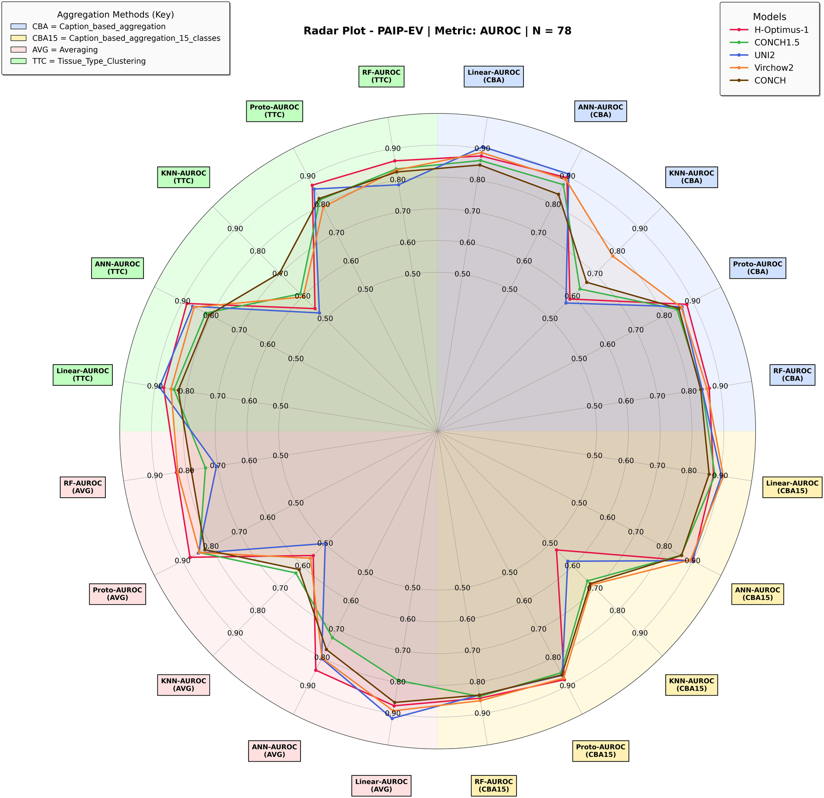
Figure 3. PAIP-EV — AUROC. N = 78.
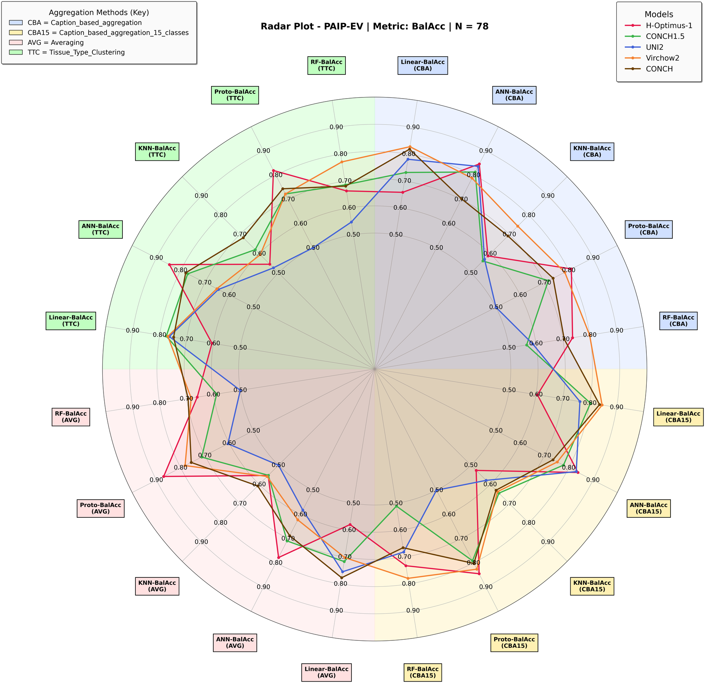
Figure 4. PAIP-EV — balanced accuracy. N = 78.
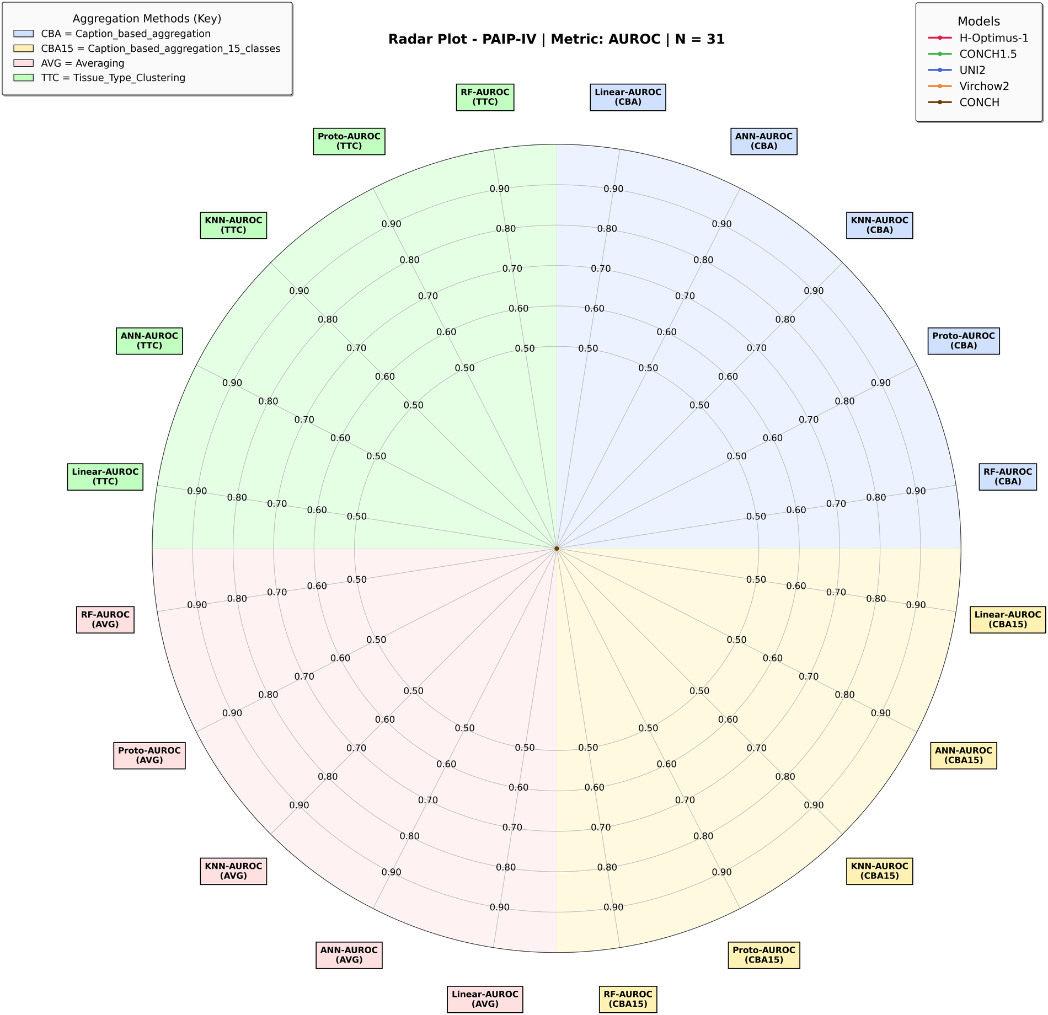
Figure 5. PAIP-IV — AUROC. N = 31. No model traces are drawn in this plot: every AUROC value collapsed to the axis origin when the figure was generated.
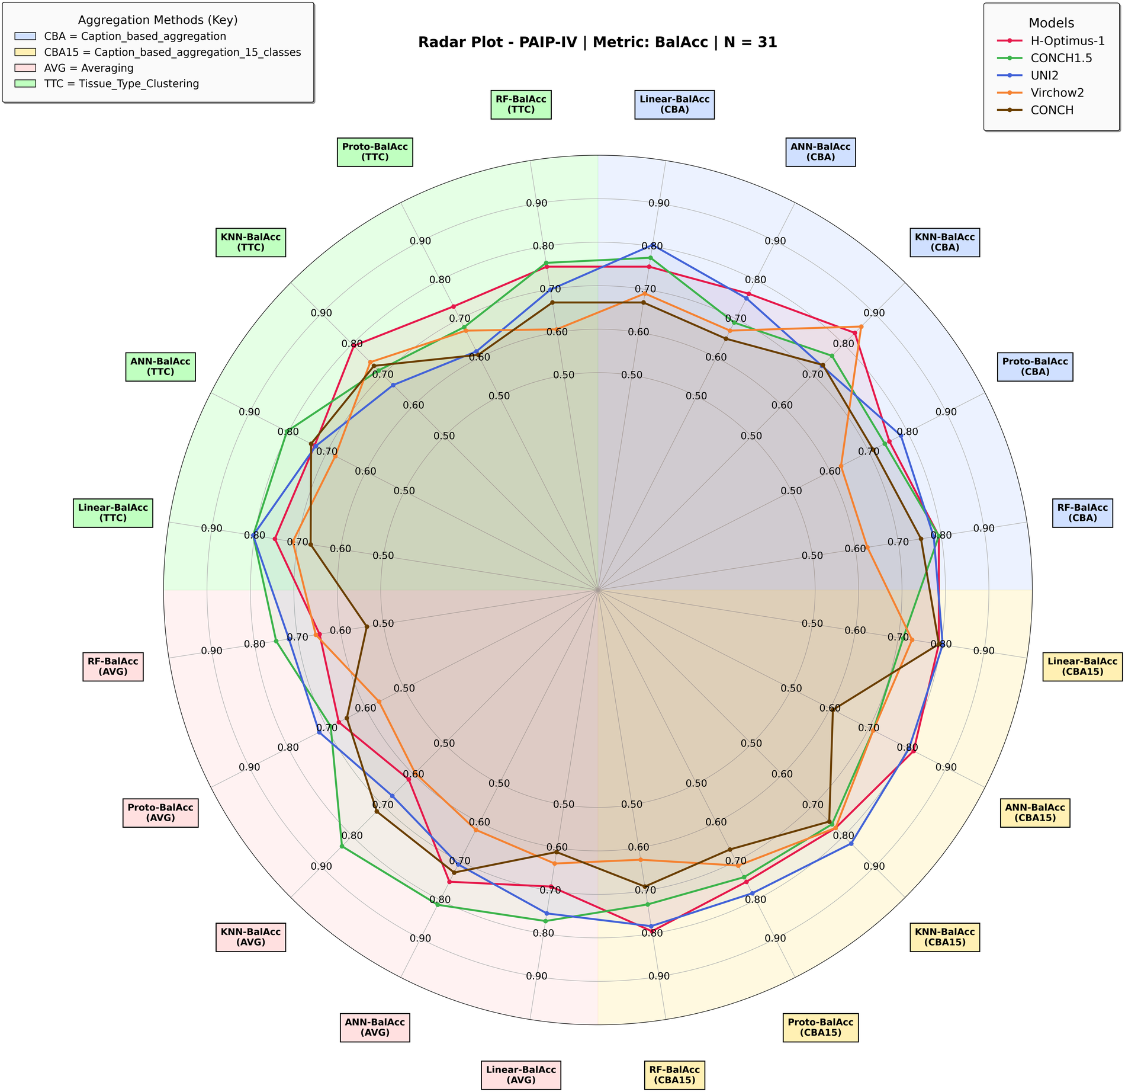
Figure 6. PAIP-IV — balanced accuracy. N = 31.

4.3 SurGen External Test Results
The SurGen cohort (two surgical sets, SR1482 and SR386, CZI format at 40x; EBI accession S-BIAD1285) serves as a fully external test. All five foundation models are now available. SurGen is markedly imbalanced - 60 MSI-H among 622 slides (9.6%) - which strongly shapes threshold-dependent metrics. Models are TCGA-trained and scored at the TCGA-fixed threshold. Confusion matrices are [[TN, FP], [FN, TP]].

4.3.1 Averaging Aggregation (1× feature dim)
SurGen (external test): Averaging Aggregation (1× feature dim). N = 613/622.
Model | Clf | Acc | Bal-Acc | Mac-F1 | AUROC | Avg CM
Conch1_5 | LR | 0.2154 | 0.5137 | 0.2138 | 0.5969 | [[81,481],[7,53]]
Conch1_5 | ANN | 0.4608 | 0.5587 | 0.3675 | 0.6284 | [[246,316],[19,41]]
Conch1_5 | KNN | 0.8392 | 0.5314 | 0.5319 | 0.5807 | [[513,49],[51,9]]
Conch1_5 | ProtoNet | 0.9035 | 0.5000 | 0.4747 | 0.6397 | [[562,0],[60,0]]
Conch1_5 | RF | 0.8161 | 0.5558 | 0.5450 | 0.6254 | [[494,68],[46,14]]
UNI2 | LR | 0.5563 | 0.6875 | 0.4756 | 0.7492 | [[295,267],[9,51]]
UNI2 | ANN | 0.1280 | 0.5174 | 0.1233 | 0.7421 | [[20,542],[0,60]]
UNI2 | KNN | 0.4727 | 0.6412 | 0.4171 | 0.6439 | [[243,319],[9,51]]
UNI2 | ProtoNet | 0.9035 | 0.5000 | 0.4747 | 0.7598 | [[562,0],[60,0]]
UNI2 | RF | 0.9010 | 0.5284 | 0.5301 | 0.7534 | [[556,6],[56,4]]
H-Optimus-1 | LR | 0.7047 | 0.5615 | 0.5107 | 0.5692 | [[409,144],[37,23]]
H-Optimus-1 | ANN | 0.3520 | 0.5636 | 0.3051 | 0.6483 | [[166,387],[10,50]]
H-Optimus-1 | KNN | 0.4763 | 0.5240 | 0.3973 | 0.5470 | [[257,296],[25,35]]
H-Optimus-1 | ProtoNet | 0.5514 | 0.5805 | 0.4492 | 0.6508 | [[301,252],[23,37]]
H-Optimus-1 | RF | 0.4437 | 0.5550 | 0.3830 | 0.5889 | [[230,323],[18,42]]
ConchV1 | LR | 0.8521 | 0.5757 | 0.5757 | 0.6142 | [[516,46],[46,14]]
ConchV1 | ANN | 0.3453 | 0.5410 | 0.2954 | 0.5850 | [[168,394],[13,47]]
ConchV1 | KNN | 0.1688 | 0.4954 | 0.1688 | 0.4842 | [[51,511],[6,54]]
ConchV1 | ProtoNet | 0.9035 | 0.5000 | 0.4747 | 0.6904 | [[562,0],[60,0]]
ConchV1 | RF | 0.4569 | 0.5149 | 0.3659 | 0.5339 | [[249,313],[25,35]]
Virchow2 | LR | 0.6785 | 0.6062 | 0.5165 | 0.6515 | [[391,171],[29,31]]
Virchow2 | ANN | 0.1974 | 0.5306 | 0.1850 | 0.6043 | [[66,496],[3,57]]
Virchow2 | KNN | 0.4502 | 0.5096 | 0.3794 | 0.5291 | [[245,317],[25,35]]
Virchow2 | ProtoNet | 0.9019 | 0.5363 | 0.5444 | 0.7053 | [[556,6],[55,5]]
Virchow2 | RF | 0.8942 | 0.5276 | 0.5251 | 0.6173 | [[552,10],[56,4]]

4.3.2 Caption-Based Aggregation (14× feature dim)
SurGen (external test): Caption-Based Aggregation (14× feature dim). N = 622.
Model | Clf | Acc | Bal-Acc | Mac-F1 | AUROC | Avg CM
Conch1_5 | LR | 0.9035 | 0.5595 | 0.5796 | 0.6240 | [[554,8],[52,8]]
Conch1_5 | ANN | 0.4990 | 0.5977 | 0.4128 | 0.6638 | [[267,295],[17,43]]
Conch1_5 | KNN | 0.8424 | 0.5853 | 0.5791 | 0.6448 | [[508,54],[44,16]]
Conch1_5 | ProtoNet | 0.9035 | 0.5000 | 0.4747 | 0.6556 | [[562,0],[60,0]]
Conch1_5 | RF | 0.9042 | 0.5033 | 0.4814 | 0.6196 | [[562,0],[60,0]]
UNI2 | LR | 0.7170 | 0.7690 | 0.5903 | 0.8543 | [[396,166],[10,50]]
UNI2 | ANN | 0.3013 | 0.6029 | 0.2767 | 0.8489 | [[129,433],[1,59]]
UNI2 | KNN | 0.5981 | 0.6808 | 0.4977 | 0.7148 | [[325,237],[13,47]]
UNI2 | ProtoNet | 0.9035 | 0.5000 | 0.4747 | 0.8005 | [[562,0],[60,0]]
UNI2 | RF | 0.8363 | 0.6831 | 0.6355 | 0.8205 | [[491,71],[30,30]]
H-Optimus-1 | LR | 0.8955 | 0.5551 | 0.5708 | 0.7362 | [[549,13],[52,8]]
H-Optimus-1 | ANN | 0.5331 | 0.6464 | 0.4407 | 0.7770 | [[284,278],[13,47]]
H-Optimus-1 | KNN | 0.5981 | 0.6064 | 0.4783 | 0.6129 | [[335,227],[23,37]]
H-Optimus-1 | ProtoNet | 0.8859 | 0.6168 | 0.6307 | 0.7617 | [[534,28],[43,17]]
H-Optimus-1 | RF | 0.8601 | 0.5847 | 0.5824 | 0.7047 | [[520,42],[45,15]]
ConchV1 | LR | 0.9068 | 0.5167 | 0.5077 | 0.6662 | [[562,0],[58,2]]
ConchV1 | ANN | 0.6891 | 0.5719 | 0.4820 | 0.6745 | [[403,159],[34,26]]
ConchV1 | KNN | 0.1238 | 0.4928 | 0.1207 | 0.5652 | [[20,542],[3,57]]
ConchV1 | ProtoNet | 0.9035 | 0.5000 | 0.4747 | 0.6738 | [[562,0],[60,0]]
ConchV1 | RF | 0.9035 | 0.5000 | 0.4747 | 0.6332 | [[562,0],[60,0]]
Virchow2 | LR | 0.8103 | 0.6494 | 0.6019 | 0.7613 | [[477,85],[33,27]]
Virchow2 | ANN | 0.7068 | 0.6993 | 0.5627 | 0.7668 | [[398,164],[19,41]]
Virchow2 | KNN | 0.3376 | 0.5367 | 0.3138 | 0.5658 | [[163,399],[13,47]]
Virchow2 | ProtoNet | 0.9035 | 0.5149 | 0.5058 | 0.6915 | [[560,2],[58,2]]
Virchow2 | RF | 0.8765 | 0.5640 | 0.5678 | 0.6831 | [[535,27],[49,11]]

4.3.3 Caption-Based Aggregation, 15 classes (15× feature dim)
SurGen (external test): Caption-Based Aggregation, 15 classes (15× feature dim). N = 622.
Model | Clf | Acc | Bal-Acc | Mac-F1 | AUROC | Avg CM
Conch1_5 | LR | 0.8891 | 0.5590 | 0.5736 | 0.6866 | [[544,18],[51,9]]
Conch1_5 | ANN | 0.5277 | 0.5734 | 0.3973 | 0.7029 | [[290,272],[22,38]]
Conch1_5 | KNN | 0.5482 | 0.6309 | 0.4587 | 0.6819 | [[297,265],[16,44]]
Conch1_5 | ProtoNet | 0.9051 | 0.5083 | 0.4915 | 0.6737 | [[562,0],[59,1]]
Conch1_5 | RF | 0.9035 | 0.5000 | 0.4747 | 0.6452 | [[562,0],[60,0]]
UNI2 | LR | 0.8087 | 0.7750 | 0.6552 | 0.8563 | [[459,103],[16,44]]
UNI2 | ANN | 0.2968 | 0.6019 | 0.2782 | 0.8399 | [[126,436],[1,59]]
UNI2 | KNN | 0.7154 | 0.6862 | 0.5635 | 0.6984 | [[406,156],[21,39]]
UNI2 | ProtoNet | 0.9035 | 0.5000 | 0.4747 | 0.7951 | [[562,0],[60,0]]
UNI2 | RF | 0.6904 | 0.7185 | 0.5605 | 0.8114 | [[384,178],[15,45]]
H-Optimus-1 | LR | 0.9035 | 0.5298 | 0.5333 | 0.7402 | [[558,4],[56,4]]
H-Optimus-1 | ANN | 0.3714 | 0.6060 | 0.3279 | 0.8024 | [[177,385],[6,54]]
H-Optimus-1 | KNN | 0.6463 | 0.6331 | 0.5101 | 0.6413 | [[365,197],[23,37]]
H-Optimus-1 | ProtoNet | 0.8424 | 0.6746 | 0.6369 | 0.7403 | [[496,66],[32,28]]
H-Optimus-1 | RF | 0.8248 | 0.6202 | 0.5948 | 0.7235 | [[491,71],[38,22]]
ConchV1 | LR | 0.8971 | 0.4964 | 0.4729 | 0.7387 | [[558,4],[60,0]]
ConchV1 | ANN | 0.5646 | 0.6162 | 0.4453 | 0.6880 | [[310,252],[19,41]]
ConchV1 | KNN | 0.1559 | 0.5106 | 0.1553 | 0.5539 | [[40,522],[3,57]]
ConchV1 | ProtoNet | 0.9035 | 0.5074 | 0.4907 | 0.6963 | [[561,1],[59,1]]
ConchV1 | RF | 0.9035 | 0.5000 | 0.4747 | 0.6232 | [[562,0],[60,0]]
Virchow2 | LR | 0.8103 | 0.6940 | 0.6237 | 0.7836 | [[471,91],[27,33]]
Virchow2 | ANN | 0.1945 | 0.5453 | 0.1908 | 0.7534 | [[62,500],[1,59]]
Virchow2 | KNN | 0.5627 | 0.5421 | 0.4434 | 0.5500 | [[319,243],[29,31]]
Virchow2 | ProtoNet | 0.9035 | 0.5074 | 0.4907 | 0.6882 | [[561,1],[59,1]]
Virchow2 | RF | 0.9013 | 0.5136 | 0.5034 | 0.6735 | [[559,3],[58,2]]

4.3.4 Tissue-Type Clustering Aggregation (9× feature dim)
SurGen (external test): Tissue-Type Clustering Aggregation (9× feature dim). N = 613/622.
Model | Clf | Acc | Bal-Acc | Mac-F1 | AUROC | Avg CM
Conch1_5 | LR | 0.4871 | 0.5078 | 0.3983 | 0.5633 | [[271,291],[28,32]]
Conch1_5 | ANN | 0.3820 | 0.5627 | 0.3189 | 0.6219 | [[190,372],[13,47]]
Conch1_5 | KNN | 0.2186 | 0.5453 | 0.2177 | 0.5658 | [[79,483],[3,57]]
Conch1_5 | ProtoNet | 0.9035 | 0.5000 | 0.4747 | 0.6137 | [[562,0],[60,0]]
Conch1_5 | RF | 0.6090 | 0.5782 | 0.4733 | 0.6099 | [[346,216],[28,32]]
UNI2 | LR | 0.5016 | 0.6944 | 0.4441 | 0.8335 | [[256,306],[4,56]]
UNI2 | ANN | 0.1029 | 0.5036 | 0.0954 | 0.7963 | [[4,558],[0,60]]
UNI2 | KNN | 0.4486 | 0.6427 | 0.4023 | 0.6534 | [[226,336],[7,53]]
UNI2 | ProtoNet | 0.9035 | 0.5000 | 0.4747 | 0.7905 | [[562,0],[60,0]]
UNI2 | RF | 0.8752 | 0.6392 | 0.6384 | 0.7943 | [[524,38],[39,21]]
H-Optimus-1 | LR | 0.9005 | 0.5065 | 0.4896 | 0.7503 | [[551,2],[59,1]]
H-Optimus-1 | ANN | 0.6421 | 0.6218 | 0.5014 | 0.7340 | [[358,195],[24,36]]
H-Optimus-1 | KNN | 0.7716 | 0.5020 | 0.4968 | 0.5018 | [[463,90],[50,10]]
H-Optimus-1 | ProtoNet | 0.9038 | 0.5083 | 0.4911 | 0.7804 | [[553,0],[59,1]]
H-Optimus-1 | RF | 0.9018 | 0.5013 | 0.4773 | 0.6373 | [[553,0],[60,0]]
ConchV1 | LR | 0.9035 | 0.5074 | 0.4907 | 0.6838 | [[561,1],[59,1]]
ConchV1 | ANN | 0.8540 | 0.5768 | 0.5647 | 0.6715 | [[517,45],[46,14]]
ConchV1 | KNN | 0.1334 | 0.4832 | 0.1318 | 0.5069 | [[28,534],[5,55]]
ConchV1 | ProtoNet | 0.9035 | 0.5000 | 0.4747 | 0.6428 | [[562,0],[60,0]]
ConchV1 | RF | 0.9039 | 0.5076 | 0.4901 | 0.6019 | [[561,1],[59,1]]
Virchow2 | LR | 0.8183 | 0.6241 | 0.5926 | 0.7195 | [[486,76],[37,23]]
Virchow2 | ANN | 0.3190 | 0.5844 | 0.2867 | 0.7281 | [[144,418],[5,55]]
Virchow2 | KNN | 0.4952 | 0.5271 | 0.4069 | 0.5442 | [[274,288],[26,34]]
Virchow2 | ProtoNet | 0.9035 | 0.5000 | 0.4747 | 0.7389 | [[562,0],[60,0]]
Virchow2 | RF | 0.8868 | 0.5741 | 0.5900 | 0.6840 | [[540,22],[49,11]]

4.3.5 TITAN Aggregation (Conch1_5 only)
SurGen (external test): TITAN Aggregation (Conch1_5 only). N = 622.
Classifier | Acc | Bal-Acc | Mac-F1 | AUROC | Avg CM
LR | 0.0981 | 0.4934 | 0.0904 | 0.6843 | [[2,560],[1,59]]
ANN | 0.1203 | 0.5102 | 0.1152 | 0.6674 | [[15,547],[0,60]]
KNN | 0.7781 | 0.6614 | 0.5889 | 0.6648 | [[453,109],[29,31]]
ProtoNet | 0.1720 | 0.5418 | 0.1717 | 0.7643 | [[47,515],[0,60]]
RF | 0.1331 | 0.5173 | 0.1299 | 0.7017 | [[23,539],[0,60]]

4.3.6 Radar Plots
Axes, quadrants and colours follow the convention introduced in 4.1.
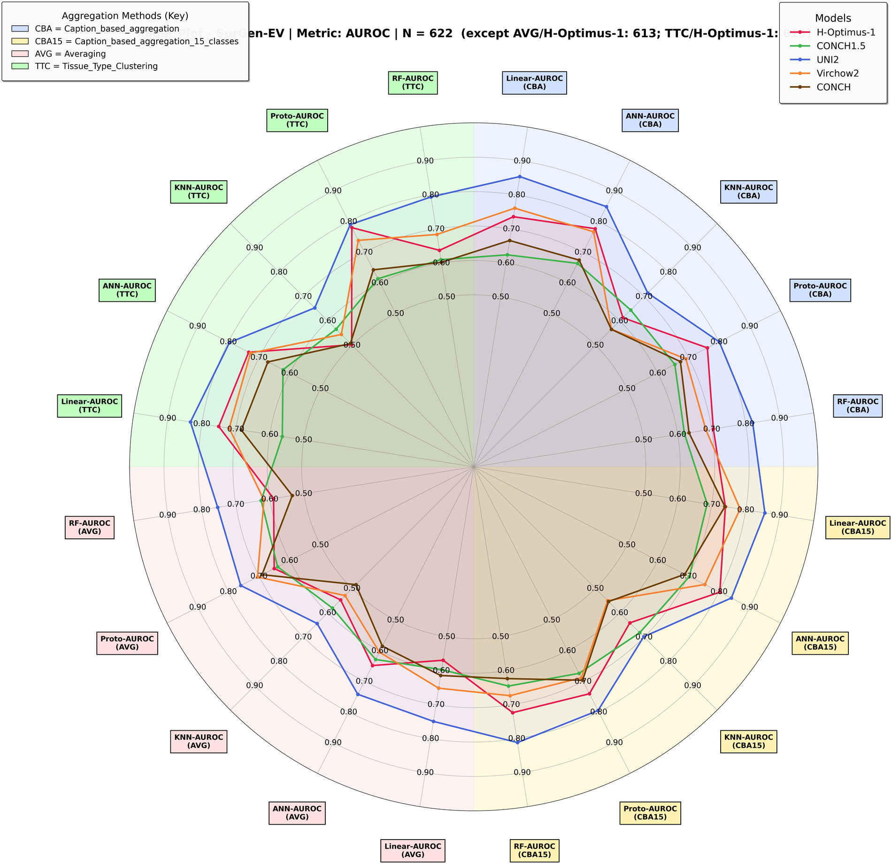
Figure 7. SurGen-EV — AUROC. N = 622 (AVG and TTC with H-Optimus-1: 613).
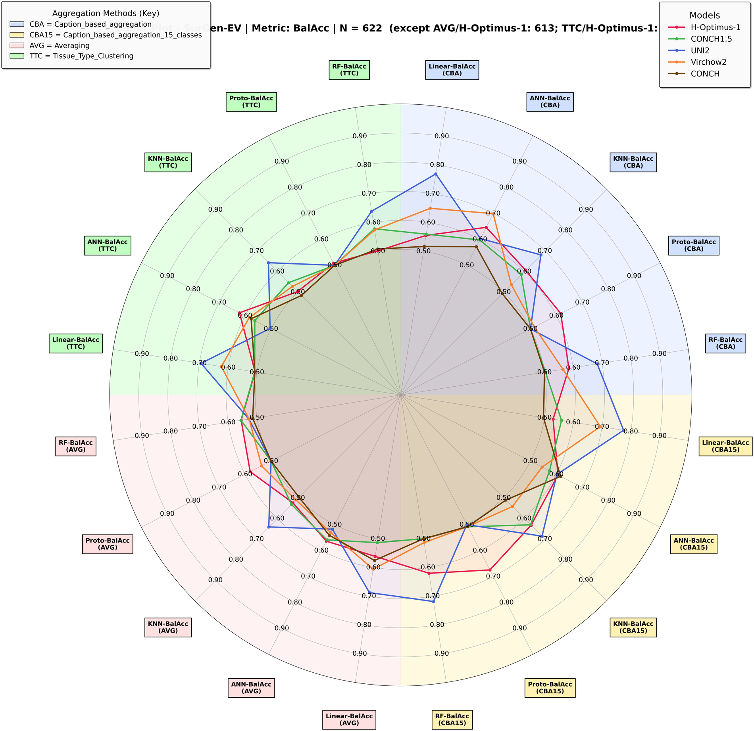
Figure 8. SurGen-EV — balanced accuracy. N = 622 (AVG and TTC with H-Optimus-1: 613).

4.4 SurGen Internal Cross-Validation Results
Internal 4-fold cross-validation within SurGen, with folds built at case level so no case is split across folds. Each fold serves as test once, the next fold as validation, and the remaining two as training. Reported at a fixed 0.5 threshold. Because prevalence is 9.6%, the majority-class accuracy baseline is 0.9035 - accuracy should not be read as evidence of performance here.

4.4.1 Averaging Aggregation (1× feature dim)
SurGen (internal CV): Averaging Aggregation (1× feature dim). N = 613/622.
Model | Clf | Acc | Bal-Acc | Mac-F1 | AUROC | Avg CM
Conch1_5 | LR | 0.8829 | 0.5694 | 0.5760 | 0.6850 | [[134,6],[12,3]]
Conch1_5 | ANN | 0.7340 | 0.5721 | 0.5238 | 0.6468 | [[108,32],[10,6]]
Conch1_5 | KNN | 0.8919 | 0.5293 | 0.5347 | 0.5892 | [[138,3],[14,1]]
Conch1_5 | ProtoNet | 0.6262 | 0.5763 | 0.4828 | 0.6574 | [[90,51],[7,8]]
Conch1_5 | RF | 0.8840 | 0.4961 | 0.4823 | 0.7005 | [[137,3],[15,0]]
UNI2 | LR | 0.8843 | 0.6129 | 0.6160 | 0.7910 | [[133,7],[11,4]]
UNI2 | ANN | 0.7895 | 0.6666 | 0.5984 | 0.7385 | [[115,26],[7,8]]
UNI2 | KNN | 0.8860 | 0.5057 | 0.4952 | 0.6046 | [[137,3],[14,0]]
UNI2 | ProtoNet | 0.6824 | 0.6154 | 0.5222 | 0.7037 | [[98,42],[7,8]]
UNI2 | RF | 0.8953 | 0.5237 | 0.5182 | 0.7892 | [[138,2],[14,1]]
H-Optimus-1 | LR | 0.8730 | 0.6140 | 0.6086 | 0.7495 | [[129,9],[10,4]]
H-Optimus-1 | ANN | 0.7650 | 0.5878 | 0.5475 | 0.6597 | [[112,26],[10,6]]
H-Optimus-1 | KNN | 0.8891 | 0.5076 | 0.4923 | 0.5448 | [[136,2],[14,0]]
H-Optimus-1 | ProtoNet | 0.6233 | 0.5822 | 0.4847 | 0.6624 | [[88,51],[7,8]]
H-Optimus-1 | RF | 0.8891 | 0.5071 | 0.4969 | 0.7223 | [[136,2],[14,0]]
ConchV1 | LR | 0.8666 | 0.5524 | 0.5517 | 0.6669 | [[132,8],[12,2]]
ConchV1 | ANN | 0.7479 | 0.5028 | 0.4932 | 0.5790 | [[113,27],[12,3]]
ConchV1 | KNN | 0.8858 | 0.4902 | 0.4697 | 0.5472 | [[138,3],[15,0]]
ConchV1 | ProtoNet | 0.6437 | 0.5849 | 0.4947 | 0.6804 | [[92,48],[7,8]]
ConchV1 | RF | 0.8844 | 0.5112 | 0.5061 | 0.6612 | [[137,4],[14,1]]
Virchow2 | LR | 0.8700 | 0.6123 | 0.6011 | 0.7876 | [[131,10],[10,4]]
Virchow2 | ANN | 0.7700 | 0.5914 | 0.5497 | 0.6356 | [[114,26],[10,6]]
Virchow2 | KNN | 0.8921 | 0.5012 | 0.4853 | 0.5459 | [[138,2],[15,0]]
Virchow2 | ProtoNet | 0.6585 | 0.6027 | 0.5069 | 0.6321 | [[94,46],[7,8]]
Virchow2 | RF | 0.8792 | 0.4939 | 0.4797 | 0.6925 | [[136,4],[15,0]]

4.4.2 Caption-Based Aggregation (14× feature dim)
SurGen (internal CV): Caption-Based Aggregation (14× feature dim). N = 622.
Model | Clf | Acc | Bal-Acc | Mac-F1 | AUROC | Avg CM
Conch1_5 | LR | 0.8859 | 0.5940 | 0.6041 | 0.7258 | [[134,6],[12,4]]
Conch1_5 | ANN | 0.7439 | 0.6722 | 0.5740 | 0.6959 | [[107,34],[6,9]]
Conch1_5 | KNN | 0.8881 | 0.5144 | 0.5121 | 0.5817 | [[137,3],[14,1]]
Conch1_5 | ProtoNet | 0.6535 | 0.5994 | 0.5029 | 0.6712 | [[94,47],[7,8]]
Conch1_5 | RF | 0.8924 | 0.5008 | 0.4847 | 0.7583 | [[138,2],[15,0]]
UNI2 | LR | 0.8990 | 0.6573 | 0.6643 | 0.8180 | [[134,6],[10,6]]
UNI2 | ANN | 0.8163 | 0.7182 | 0.6389 | 0.7741 | [[118,22],[6,9]]
UNI2 | KNN | 0.8940 | 0.5308 | 0.5292 | 0.6425 | [[138,3],[14,1]]
UNI2 | ProtoNet | 0.6935 | 0.6210 | 0.5291 | 0.7276 | [[100,41],[7,8]]
UNI2 | RF | 0.8972 | 0.5178 | 0.5130 | 0.8402 | [[139,2],[14,1]]
H-Optimus-1 | LR | 0.8875 | 0.6366 | 0.6408 | 0.7957 | [[133,8],[10,5]]
H-Optimus-1 | ANN | 0.7714 | 0.6634 | 0.5851 | 0.7256 | [[112,28],[7,8]]
H-Optimus-1 | KNN | 0.8844 | 0.5033 | 0.4900 | 0.5734 | [[137,4],[14,0]]
H-Optimus-1 | ProtoNet | 0.6369 | 0.5896 | 0.4923 | 0.6977 | [[91,50],[7,8]]
H-Optimus-1 | RF | 0.8954 | 0.5025 | 0.4863 | 0.7969 | [[139,2],[15,0]]
ConchV1 | LR | 0.8648 | 0.5750 | 0.5815 | 0.7349 | [[131,9],[12,3]]
ConchV1 | ANN | 0.7471 | 0.5915 | 0.5408 | 0.6294 | [[110,30],[9,6]]
ConchV1 | KNN | 0.8942 | 0.4949 | 0.4720 | 0.6082 | [[139,2],[15,0]]
ConchV1 | ProtoNet | 0.6781 | 0.6135 | 0.5205 | 0.6903 | [[97,43],[7,8]]
ConchV1 | RF | 0.8890 | 0.4920 | 0.4706 | 0.7507 | [[138,2],[15,0]]
Virchow2 | LR | 0.8874 | 0.6072 | 0.6149 | 0.7737 | [[134,6],[11,4]]
Virchow2 | ANN | 0.7763 | 0.6523 | 0.5835 | 0.7017 | [[113,27],[8,8]]
Virchow2 | KNN | 0.8941 | 0.4948 | 0.4720 | 0.6271 | [[139,2],[15,0]]
Virchow2 | ProtoNet | 0.6791 | 0.6215 | 0.5229 | 0.6644 | [[97,43],[7,8]]
Virchow2 | RF | 0.8922 | 0.5006 | 0.4846 | 0.7670 | [[138,2],[15,0]]

4.4.3 Caption-Based Aggregation, 15 classes (15× feature dim)
SurGen (internal CV): Caption-Based Aggregation, 15 classes (15× feature dim). N = 622.
Model | Clf | Acc | Bal-Acc | Mac-F1 | AUROC | Avg CM
Conch1_5 | LR | 0.8780 | 0.5817 | 0.5956 | 0.7236 | [[133,7],[12,3]]
Conch1_5 | ANN | 0.7298 | 0.6354 | 0.5487 | 0.6923 | [[106,35],[7,8]]
Conch1_5 | KNN | 0.8846 | 0.4970 | 0.4802 | 0.5937 | [[137,3],[15,0]]
Conch1_5 | ProtoNet | 0.6760 | 0.6514 | 0.5297 | 0.6914 | [[96,45],[6,9]]
Conch1_5 | RF | 0.8954 | 0.5024 | 0.4842 | 0.7354 | [[139,2],[15,0]]
UNI2 | LR | 0.9132 | 0.6583 | 0.6813 | 0.8261 | [[137,4],[10,5]]
UNI2 | ANN | 0.8054 | 0.7333 | 0.6358 | 0.7772 | [[116,25],[5,10]]
UNI2 | KNN | 0.8891 | 0.5069 | 0.4905 | 0.6855 | [[138,3],[14,0]]
UNI2 | ProtoNet | 0.6967 | 0.6383 | 0.5368 | 0.7206 | [[100,41],[6,8]]
UNI2 | RF | 0.9017 | 0.5278 | 0.5285 | 0.8533 | [[139,1],[14,1]]
H-Optimus-1 | LR | 0.9038 | 0.6317 | 0.6558 | 0.8066 | [[136,4],[10,4]]
H-Optimus-1 | ANN | 0.7755 | 0.6764 | 0.5939 | 0.7330 | [[112,28],[7,8]]
H-Optimus-1 | KNN | 0.8860 | 0.4978 | 0.4801 | 0.6123 | [[138,3],[15,0]]
H-Optimus-1 | ProtoNet | 0.6338 | 0.5879 | 0.4902 | 0.6923 | [[90,50],[7,8]]
H-Optimus-1 | RF | 0.8954 | 0.5098 | 0.4979 | 0.8182 | [[139,2],[14,0]]
ConchV1 | LR | 0.8799 | 0.6126 | 0.6239 | 0.7386 | [[132,8],[11,4]]
ConchV1 | ANN | 0.7362 | 0.6377 | 0.5579 | 0.6366 | [[107,34],[7,8]]
ConchV1 | KNN | 0.8862 | 0.5123 | 0.5028 | 0.5464 | [[137,4],[14,1]]
ConchV1 | ProtoNet | 0.6992 | 0.6418 | 0.5400 | 0.7193 | [[100,40],[6,8]]
ConchV1 | RF | 0.8890 | 0.4989 | 0.4831 | 0.7282 | [[138,2],[15,0]]
Virchow2 | LR | 0.8953 | 0.5972 | 0.6134 | 0.8020 | [[136,5],[12,4]]
Virchow2 | ANN | 0.8183 | 0.6601 | 0.6122 | 0.7497 | [[120,20],[8,7]]
Virchow2 | KNN | 0.8988 | 0.5273 | 0.5220 | 0.6176 | [[139,2],[14,1]]
Virchow2 | ProtoNet | 0.6805 | 0.6224 | 0.5237 | 0.6646 | [[98,43],[7,8]]
Virchow2 | RF | 0.8954 | 0.5093 | 0.4961 | 0.7760 | [[139,2],[14,0]]

4.4.4 Tissue-Type Clustering Aggregation (9× feature dim)
SurGen (internal CV): Tissue-Type Clustering Aggregation (9× feature dim). N = 613/622.
Model | Clf | Acc | Bal-Acc | Mac-F1 | AUROC | Avg CM
Conch1_5 | LR | 0.8720 | 0.5950 | 0.5997 | 0.7216 | [[132,9],[11,4]]
Conch1_5 | ANN | 0.7237 | 0.6238 | 0.5442 | 0.6484 | [[105,36],[8,8]]
Conch1_5 | KNN | 0.8958 | 0.5186 | 0.5153 | 0.5757 | [[138,2],[14,1]]
Conch1_5 | ProtoNet | 0.6408 | 0.5849 | 0.4922 | 0.6569 | [[92,49],[7,8]]
Conch1_5 | RF | 0.8909 | 0.4930 | 0.4711 | 0.7233 | [[138,2],[15,0]]
UNI2 | LR | 0.9005 | 0.6374 | 0.6551 | 0.7784 | [[135,5],[10,5]]
UNI2 | ANN | 0.7988 | 0.7090 | 0.6223 | 0.7484 | [[115,25],[6,9]]
UNI2 | KNN | 0.8941 | 0.5470 | 0.5567 | 0.6043 | [[137,3],[13,2]]
UNI2 | ProtoNet | 0.6581 | 0.5939 | 0.5033 | 0.7059 | [[94,46],[7,8]]
UNI2 | RF | 0.8972 | 0.5040 | 0.4867 | 0.7983 | [[139,1],[15,0]]
H-Optimus-1 | LR | 0.8824 | 0.5620 | 0.5726 | 0.7165 | [[133,6],[12,2]]
H-Optimus-1 | ANN | 0.7858 | 0.5840 | 0.5564 | 0.6694 | [[116,23],[10,5]]
H-Optimus-1 | KNN | 0.8955 | 0.4964 | 0.4724 | 0.5503 | [[137,1],[15,0]]
H-Optimus-1 | ProtoNet | 0.6381 | 0.5830 | 0.4920 | 0.6633 | [[90,48],[7,8]]
H-Optimus-1 | RF | 0.8972 | 0.4973 | 0.4729 | 0.7647 | [[138,1],[15,0]]
ConchV1 | LR | 0.8605 | 0.5949 | 0.5974 | 0.7251 | [[130,11],[11,4]]
ConchV1 | ANN | 0.7341 | 0.5547 | 0.5164 | 0.6133 | [[109,31],[10,5]]
ConchV1 | KNN | 0.8815 | 0.4947 | 0.4798 | 0.6396 | [[137,4],[15,0]]
ConchV1 | ProtoNet | 0.6613 | 0.6026 | 0.5081 | 0.6692 | [[95,46],[7,8]]
ConchV1 | RF | 0.8909 | 0.4999 | 0.4836 | 0.7347 | [[138,2],[15,0]]
Virchow2 | LR | 0.8968 | 0.6262 | 0.6382 | 0.7532 | [[135,6],[10,4]]
Virchow2 | ANN | 0.7481 | 0.6277 | 0.5580 | 0.6959 | [[109,32],[8,7]]
Virchow2 | KNN | 0.8972 | 0.5264 | 0.5287 | 0.6079 | [[138,2],[14,1]]
Virchow2 | ProtoNet | 0.6889 | 0.6036 | 0.5213 | 0.6420 | [[100,41],[8,8]]
Virchow2 | RF | 0.8938 | 0.5016 | 0.4844 | 0.7301 | [[139,2],[15,0]]

4.4.5 TITAN Aggregation (Conch1_5 only)
SurGen (internal CV): TITAN Aggregation (Conch1_5 only). N = 622.
Classifier | Acc | Bal-Acc | Mac-F1 | AUROC | Avg CM
LR | 0.8697 | 0.6128 | 0.6129 | 0.7555 | [[131,10],[10,4]]
ANN | 0.8052 | 0.6694 | 0.6087 | 0.7220 | [[118,23],[8,8]]
KNN | 0.8859 | 0.5425 | 0.5516 | 0.6074 | [[136,4],[13,2]]
ProtoNet | 0.7440 | 0.6735 | 0.5792 | 0.7554 | [[107,34],[6,9]]
RF | 0.8799 | 0.5316 | 0.5382 | 0.8009 | [[135,5],[14,2]]

4.4.6 Radar Plots
Axes, quadrants and colours follow the convention introduced in 4.1.
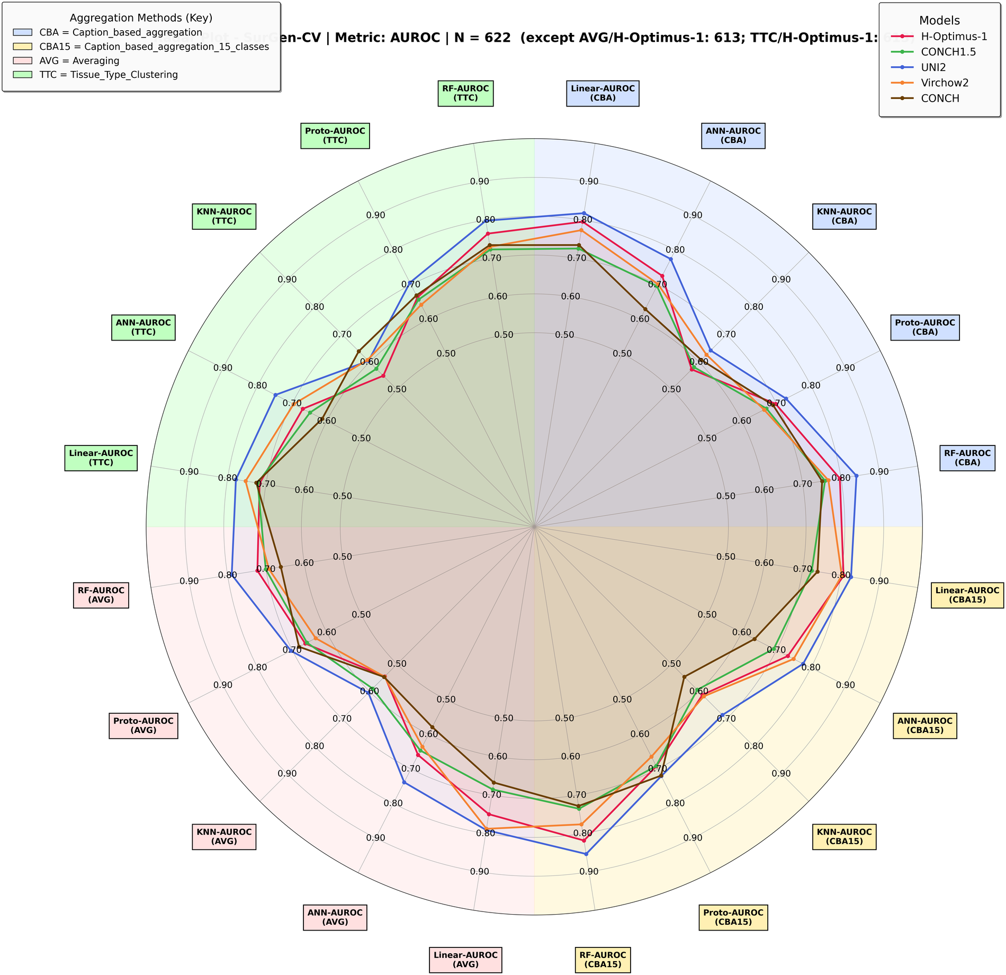
Figure 9. SurGen-CV — AUROC. N = 622 (AVG and TTC with H-Optimus-1: 613).
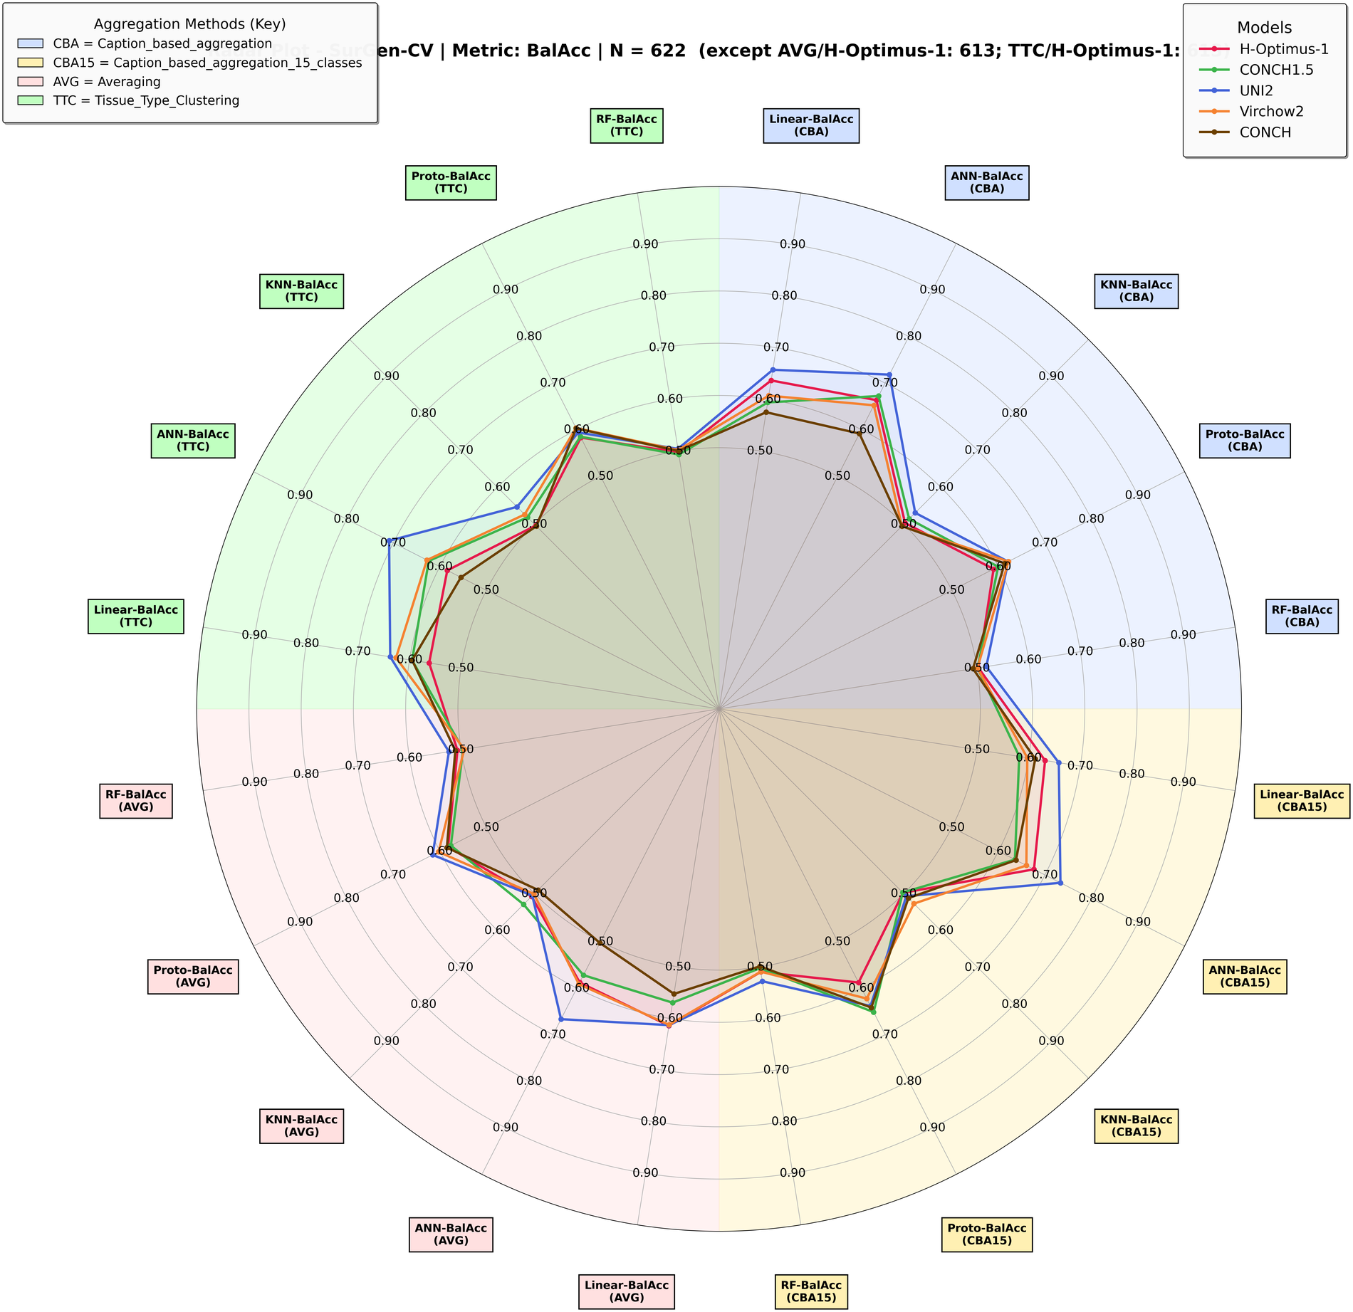
Figure 10. SurGen-CV — balanced accuracy. N = 622 (AVG and TTC with H-Optimus-1: 613).

