What a routine H&E slide can tell us about pancreatic cancer spread
Fourteen questions, answered in the order they arose. 21 tissue sections, 12 patients, 63,919 measured spots.
Companion document to the slide deck of the same name. Same questions, same order, same figures; this adds how each test was run and what would have overturned it.

Summary
A stained slide can see cancer, and can read the fibroblast environment well enough to be useful. It cannot read metastasis, and the reason is not that our models were weak: metastasis is not a single thing to read. Liver and lymph node deposits share only about half a programme, and the half that differs is immune. That pattern replicates in an independent cohort and extends across seven organs.
What we asked | Answer | Number
Can a slide tell cancer from normal tissue? | Yes, clearly | 0.96
Can it tell metastasis from primary? | Only in the liver | 0.80 vs 0.60
Is that metastasis, or the organ? | The organ | transfer 0.53, chance 0.50
Do the two metastatic sites share one programme? | About half | cosine 0.55
What is the differing half? | Immune, B cells | d = 2.03, q = 0.042
Does it replicate? | Yes, more strongly | mean cosine -0.15
Does the organ effect go beyond pancreas? | Yes, 7 organs | 0.23 to 0.13
What can a slide read instead? | Fibroblast content | 0.77, and 0.74 adjusted
Does that hold in other laboratories? | Yes, and fails where it should | median 0.30, brain 0.05
Is it usable per section? | Yes | 0.91
Does it depend on the image encoder? | Mostly no | 3 encoders agree; one gap halves
Table 1. The headline questions in brief. Each is developed below in the order it arose, because every question here exists because of the answer to the one before.

The data, and the two rules applied throughout
21 sections from 12 patients: 6 primary pancreatic tumours, 7 liver deposits, 5 lymph node deposits and 3 normal pancreas, giving 63,919 spots. Each spot is 55 microns and carries a stained image tile, a gene expression profile and an estimate of its cell composition, all describing the same physical location.
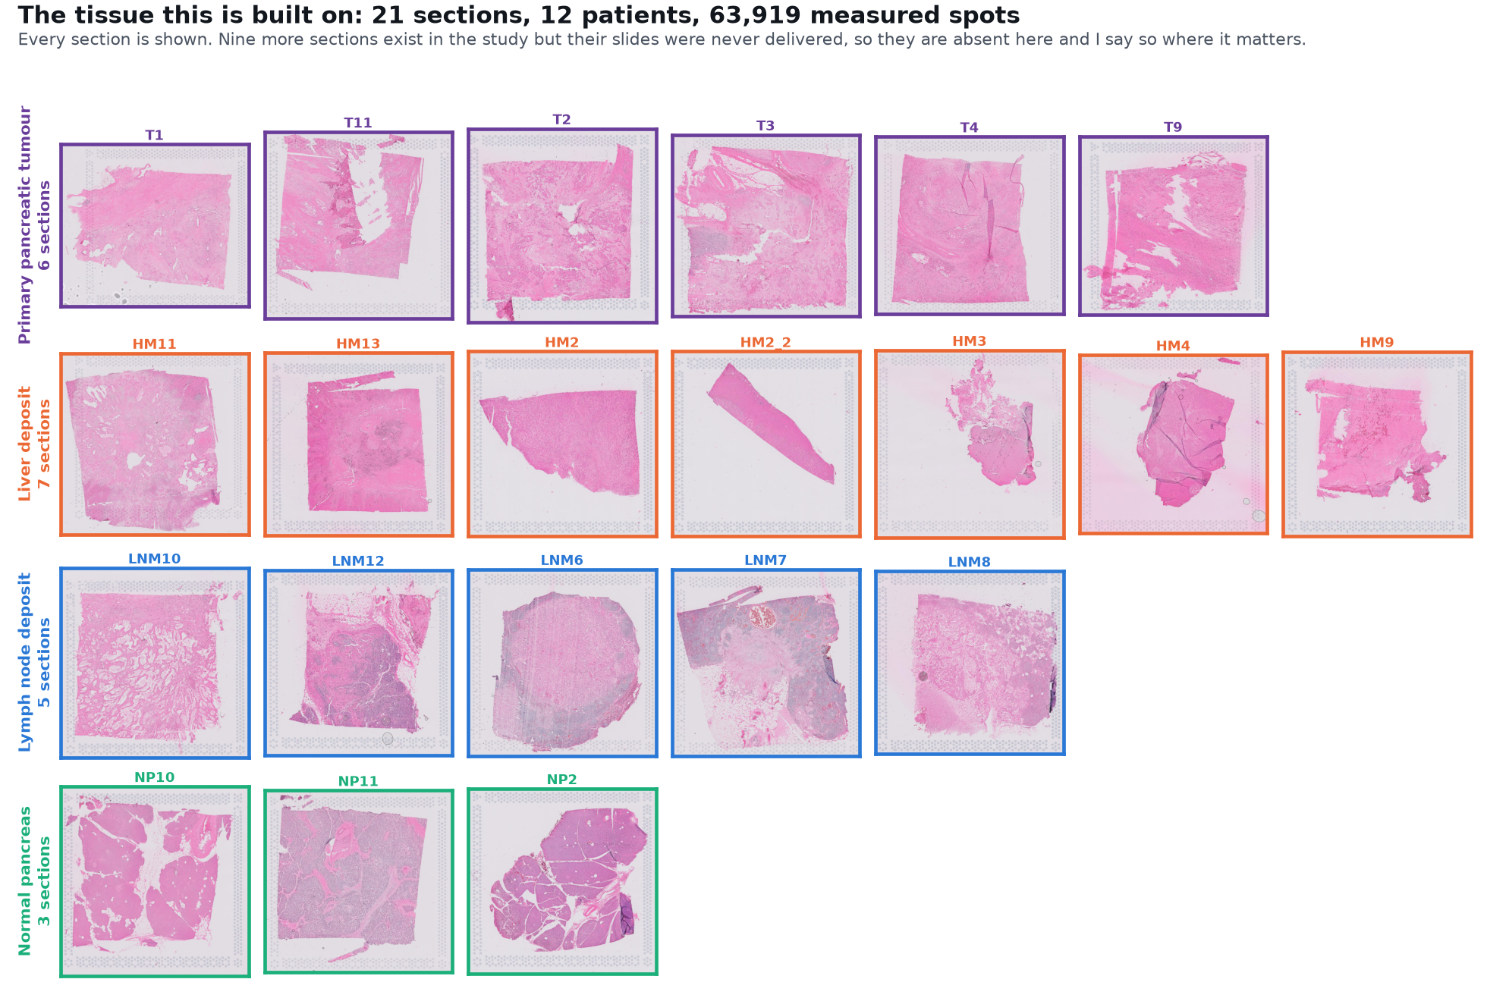
Figure 1. Every section used. Nine further sections belong to this study but their slides were never delivered; where that changes what can be concluded, it is stated.

Nine sections of the original 30 are absent because the slides were never delivered. This is not uniform loss. All four patients who provided both a liver and a lymph node deposit lost their liver slide, which makes one specific analysis impossible rather than merely underpowered. That is stated again at Question 11 where it bites.

Two rules
- Leave one patient out, never one spot. Spots inside a section are one tumour measured thousands of times. Splitting them at random lets a model memorise the patient and returns correlations near 0.9 that mean nothing. This is the easiest way to produce a beautiful and false result on this data.
- Sweep tumour purity rather than fixing it. A liver deposit sits in liver. Restricting to tumour-rich spots and then repeating at rising thresholds separates a result about cancer from a result about the surrounding organ.
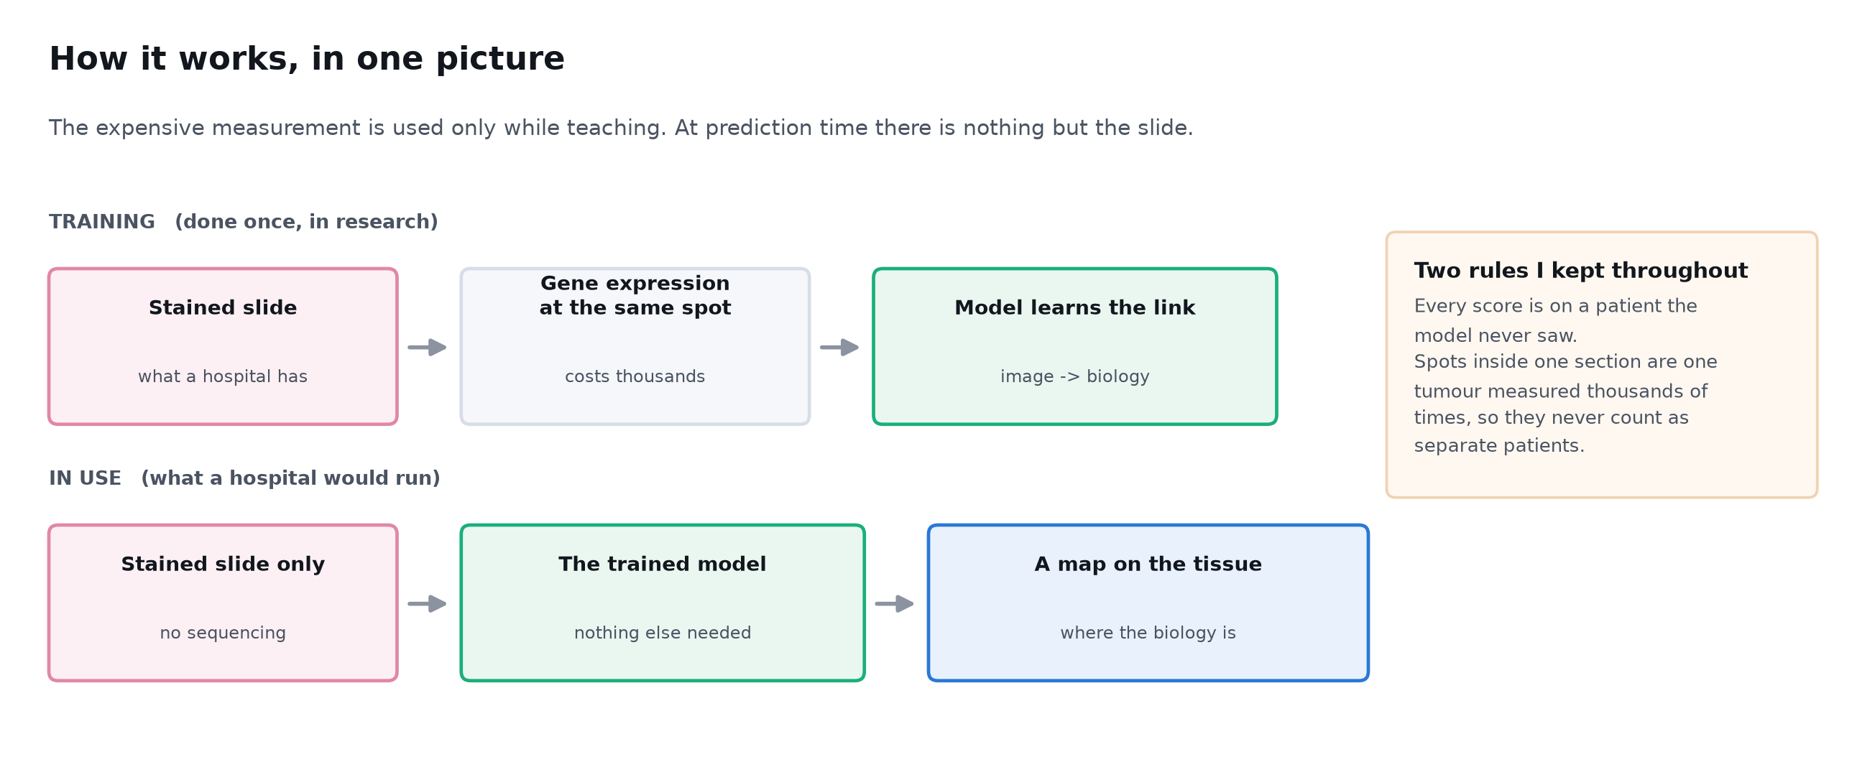
Figure 2. Expression is used only while training. At prediction time there is nothing but the slide, which is what a hospital has.

Part one: can a slide see cancer at all?

Question 1. Can a stained slide tell cancer from normal tissue?
Answer: Yes, and clearly. 0.96, slightly ahead of gene expression.

How it was tested
Primary tumour against normal pancreas: same organ, same tissue type, the only difference being cancer. Leave one patient out, logistic regression on UNI2-h image features.

What came out
The image reaches 0.956 balanced accuracy against 0.904 for gene expression on the same spots. This is the floor test, and it establishes that anything that fails later fails for reasons other than the image being blind.
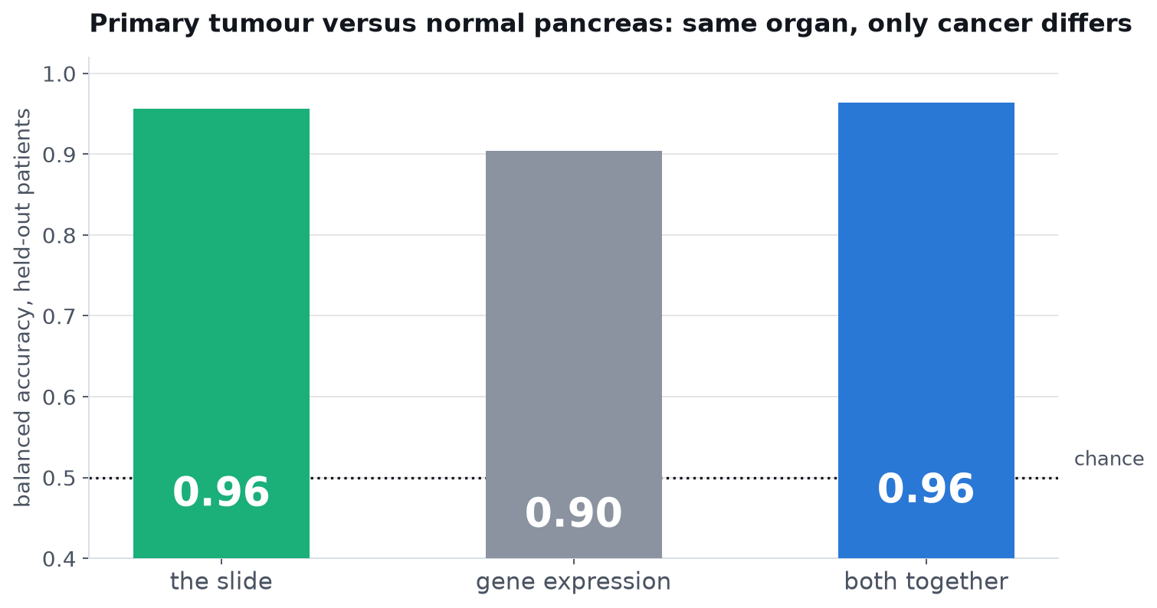
Figure 3. Organ held constant, only cancer varying.

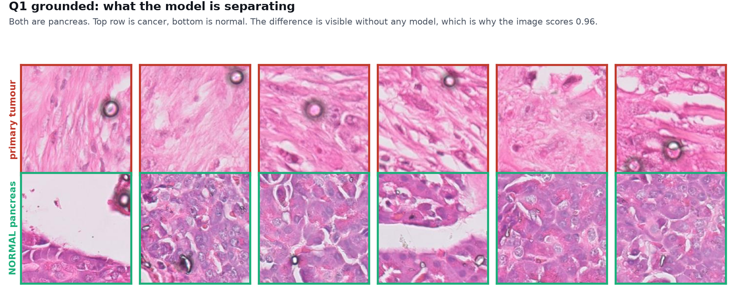
Figure 4. The same claim on the tissue. Top row cancer, bottom row normal pancreas. The difference needs no model.

Part two: can it see spread?

Question 2. Can a slide tell a metastatic deposit from a primary tumour?
Answer: Only in the liver. 0.80 there, 0.60 in lymph node, falling to 0.44 in tumour-rich tissue.

How it was tested
The two metastatic sites were tested separately rather than pooled, at four tumour purity thresholds, with a matched gene expression arm on identical spots and folds.

What came out
Liver deposits hold up as non-tumour tissue is stripped away; lymph node deposits collapse. These figures are UNI2-h; two other encoders narrow the gap by about half, which Question 14 quantifies. Gene expression behaves differently, performing about equally at both sites (0.58 and 0.62), which is what a signal about the cancer looks like.
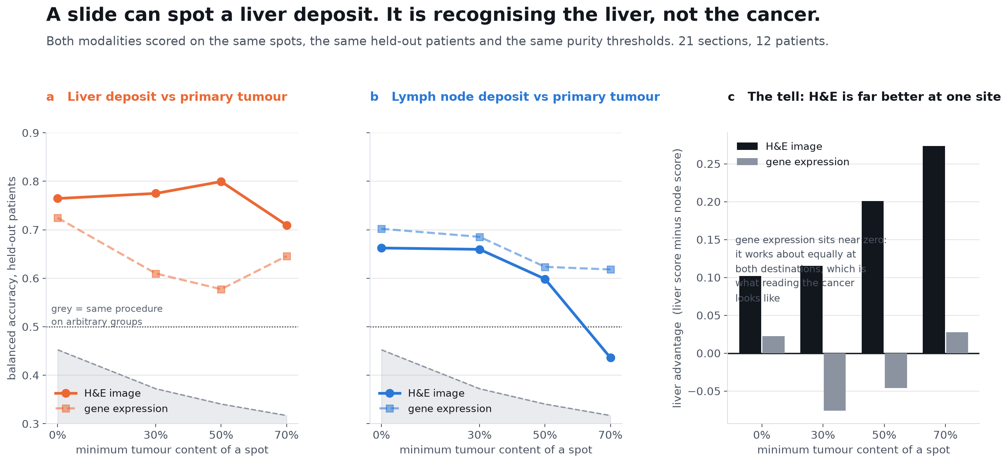
Figure 5. Purity sweep at both sites, and the liver advantage that grows as tissue is removed.

What would change this answer
Pooling the two metastatic sites would have produced a single respectable number and hidden this entirely. The split is what makes the result interpretable.

Question 3. Is it seeing metastasis, or is it seeing liver?
Answer: It is seeing the liver. Cross-site transfer sits at chance.

How it was tested
Train a metastasis detector on one site and test it on the other, with no patient overlap. A model that learned metastasis transfers; a model that learned liver cannot, because a lymph node is not a liver.

What came out
Trained on liver and tested on lymph node: 0.53. The other direction: 0.53. Chance is 0.50. Nothing learned at one site carries to the other. The 0.80 from Question 2 contains nothing that generalises: the image combines two things it genuinely can see, this is cancer and this is liver, into something that resembles a metastasis detector and is not one.
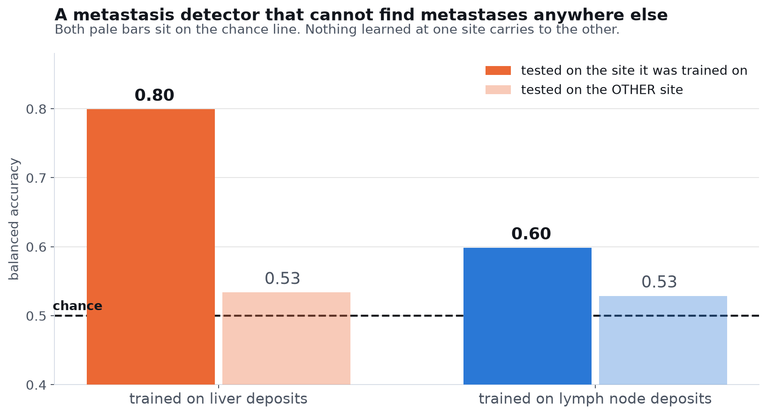
Figure 6. Solid bars tested on the training site, pale bars on the other site.

What would change this answer
A transfer score meaningfully above 0.5 in either direction would have shown a shared metastatic appearance. Neither direction gets there.
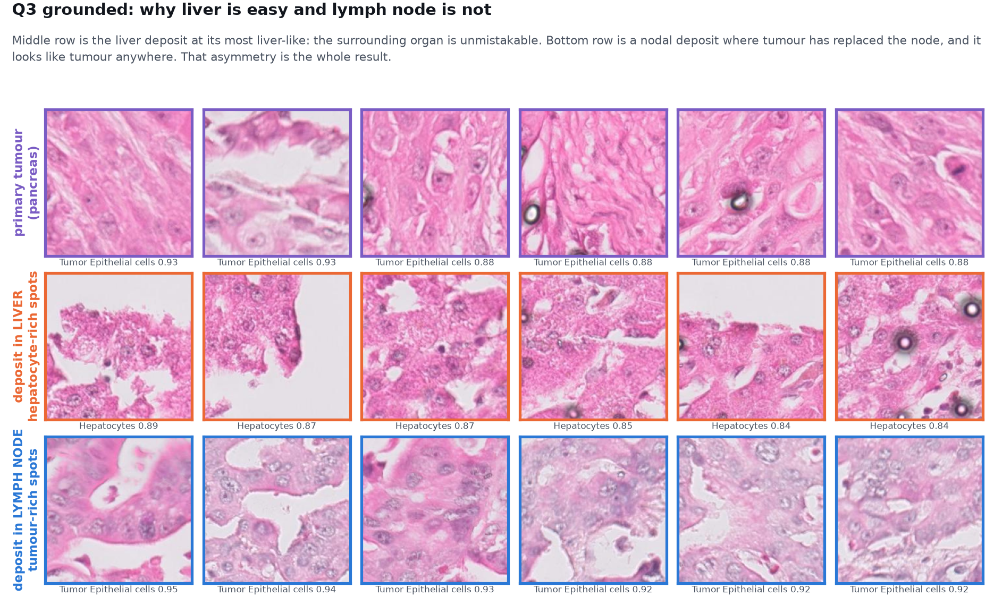
Figure 7. Why, in tissue. The liver row is unmistakable; primary and nodal tumour look like one another.

Part three: so why can nothing detect metastasis?

Question 4. Do metastases in different organs share one programme?
Answer: Only about half. Cosine 0.55.

How it was tested
For each site, the shift away from the matched primary was computed across 42 features at section level, then the two shift vectors compared by cosine. Four patients gave tumour from both sites, so the comparison happens inside one person.

What came out
About 55 percent of what changes is shared between destinations and the rest depends on where the tumour landed. This reframes everything before it: the earlier models were not failing to detect metastasis, they were trying to detect something that is only half a thing.
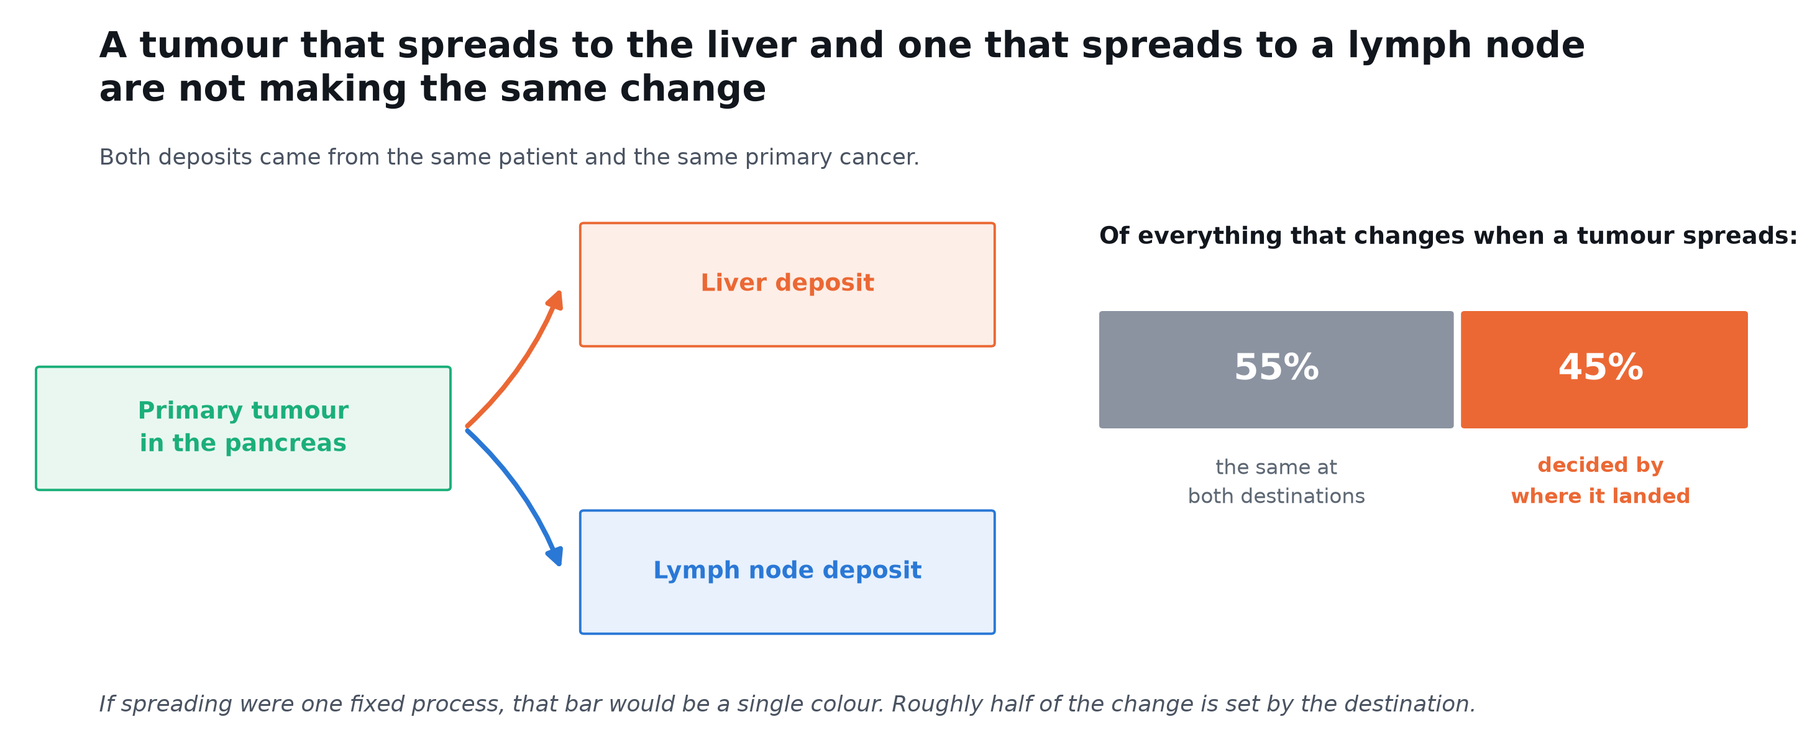
Figure 8. Same patient, same cancer, two destinations.

Question 5. What is the part that differs?
Answer: Immune content, and B cells specifically.

How it was tested
42 features tested individually at section level with Benjamini and Hochberg correction across all 42, then repeated within the four patients measured at both sites, then the whole analysis repeated at rising tumour purity.

What came out
B cell content is the one feature that separates the two sites and survives correction (d = 2.03, q = 0.042), rising in all four paired patients. Across the purity sweep, liver contamination falls roughly eightfold while the immune difference holds at about twice, which is not how a contamination artefact behaves.
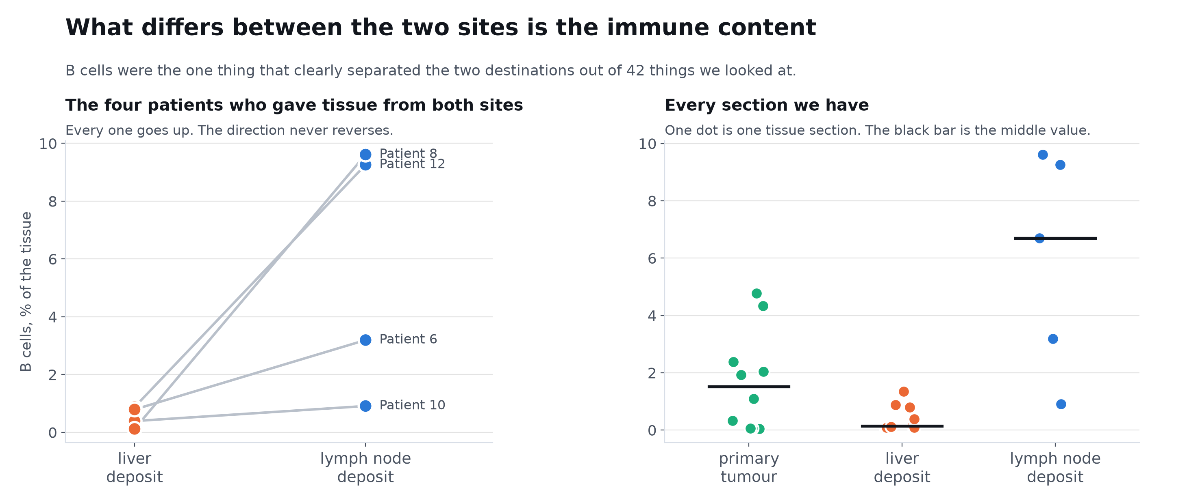
Figure 9. Four patients measured at both of their own sites; the direction never reverses.

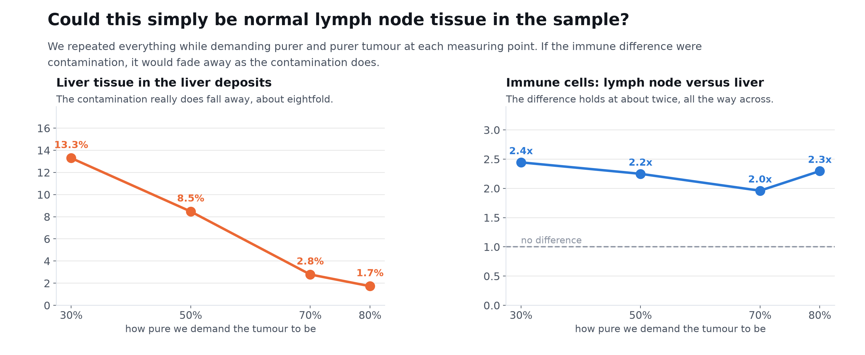
Figure 10. The contamination control that makes the previous figure usable.

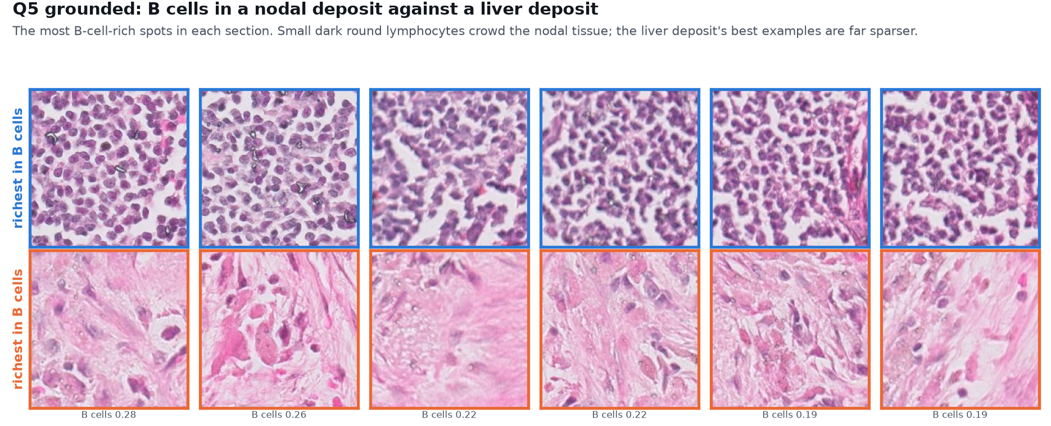
Figure 11. The most B-cell-rich tissue in each deposit, side by side.

Question 6. Does this hold in patients we did not study?
Answer: Yes, and more strongly.

How it was tested
The same analysis applied to a published cohort from another centre, in which no patient had chemotherapy before sampling and three metastatic sites are represented rather than two.

What came out
Every immune cell type falls in liver deposits and rises in lung deposits. The shifts at different sites are unrelated or opposed (mean cosine -0.15) rather than shared. Organ positive controls behave correctly. One control failed and is reported as such: mesothelin cannot mark peritoneal lining here because pancreatic tumour cells express it themselves.
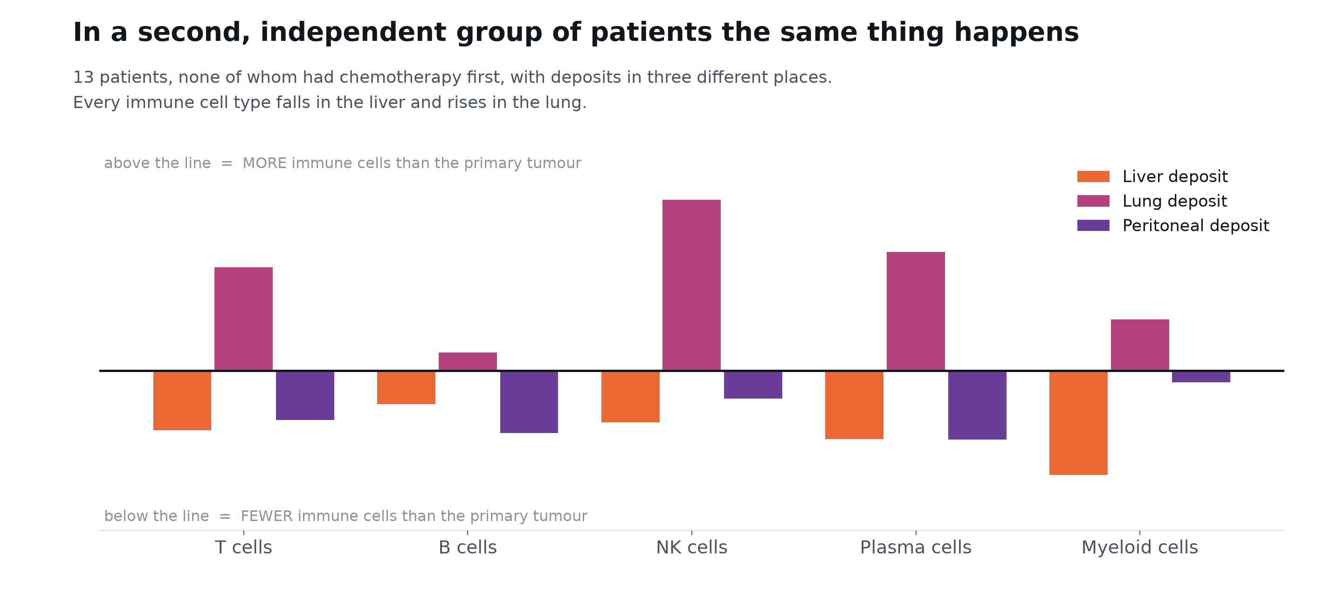
Figure 12. Independent cohort, treatment naive, three destinations.

What would change this answer
This cohort contains no lymph nodes, so the B cell result specifically is untested here rather than confirmed.

Question 7. Is this about pancreas, or about tissue in general?
Answer: General. It holds across seven organs.

How it was tested
A prediction derived from the previous answers and then tested: if tissue context governs what a slide implies about expression, an image model should fail to cross organs. Tested on 156 sections across seven organs, with a batch control that holds the organ fixed and changes only the laboratory.

What came out
Changing laboratory costs about 15 percent (0.235 to 0.199). Changing organ costs a further 37 percent (to 0.125). The loss is tissue biology, not a technical artefact.
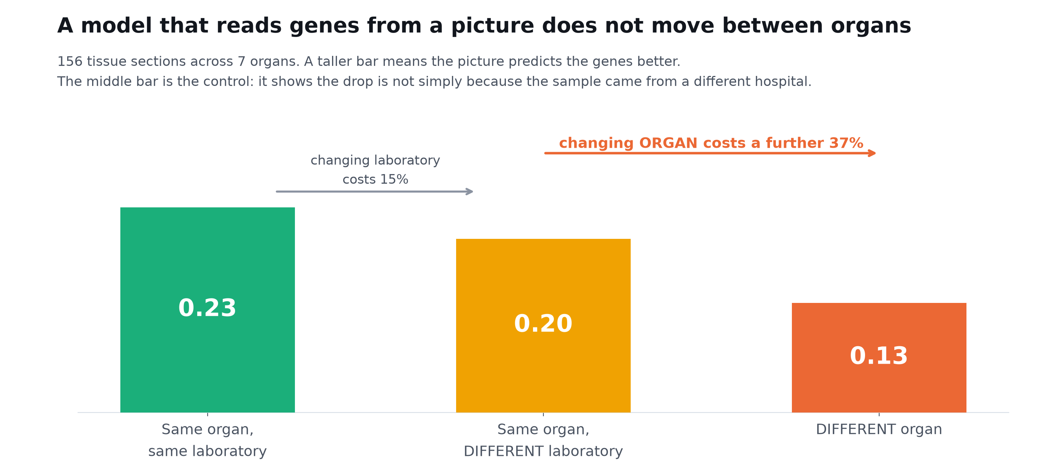
Figure 13. The middle bar is the control that makes this interpretable.

What would change this answer
This analysis first gave the opposite answer. Three sections labelled whole transcriptome were in fact a targeted panel of about a thousand genes; filtering them on a minimum gene count reversed the conclusion. The control decided the result, not the headline number.

Part four: so what is a slide good for?

Question 8. What can a slide read, if not metastasis?
Answer: Fibroblast content, very well.

How it was tested
42 measured quantities predicted from image features by ridge regression under leave one patient out, each also scored after removing the part explained by predicted tumour fraction, because earlier work on six sections concluded the slide reads tumour abundance and little else.

What came out
Myofibroblastic CAF content reaches 0.774 pooled and retains 0.736 after the tumour-amount adjustment, so it is not merely a restatement of how much tumour is present. B cell content reaches 0.472 with 0.459 surviving. The earlier conclusion was a sample size artefact.
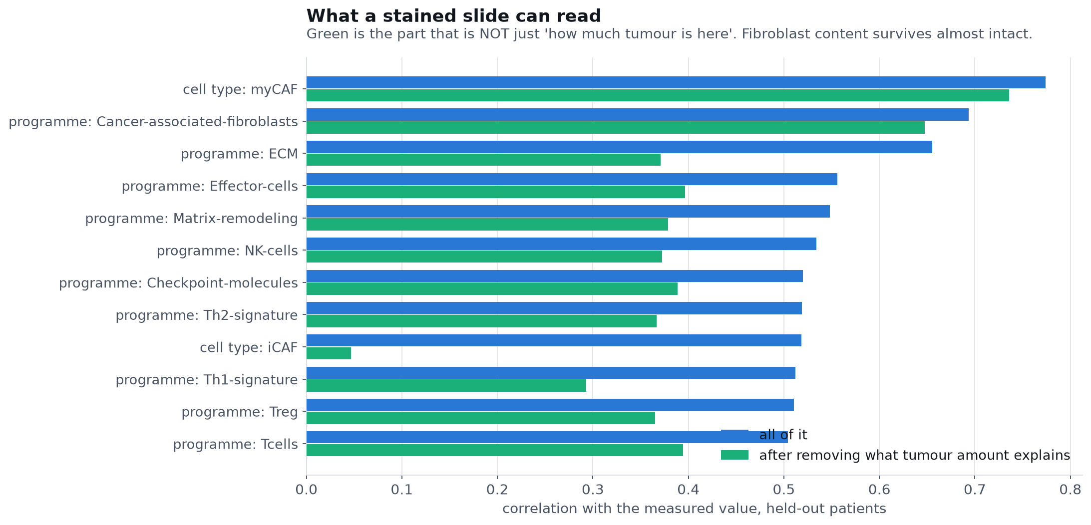
Figure 14. Blue is the raw agreement, green the part not explained by tumour amount.

Target | Pooled | Median patient | Worst patient | After tumour control
cell type: myCAF | 0.774 | 0.640 | -0.144 | 0.736
cell type: Tumor Epithelial cells | 0.712 | 0.664 | -0.110 | control
programme: Cancer-associated-fibroblasts | 0.693 | 0.604 | +0.156 | 0.648
programme: ECM | 0.656 | 0.562 | +0.051 | 0.371
programme: Effector-cells | 0.556 | 0.480 | +0.167 | 0.397
programme: Matrix-remodeling | 0.548 | 0.491 | +0.050 | 0.379
Table 2. The worst-patient column is kept deliberately. For several targets it is negative, meaning at least one held-out patient is predicted in the wrong direction.

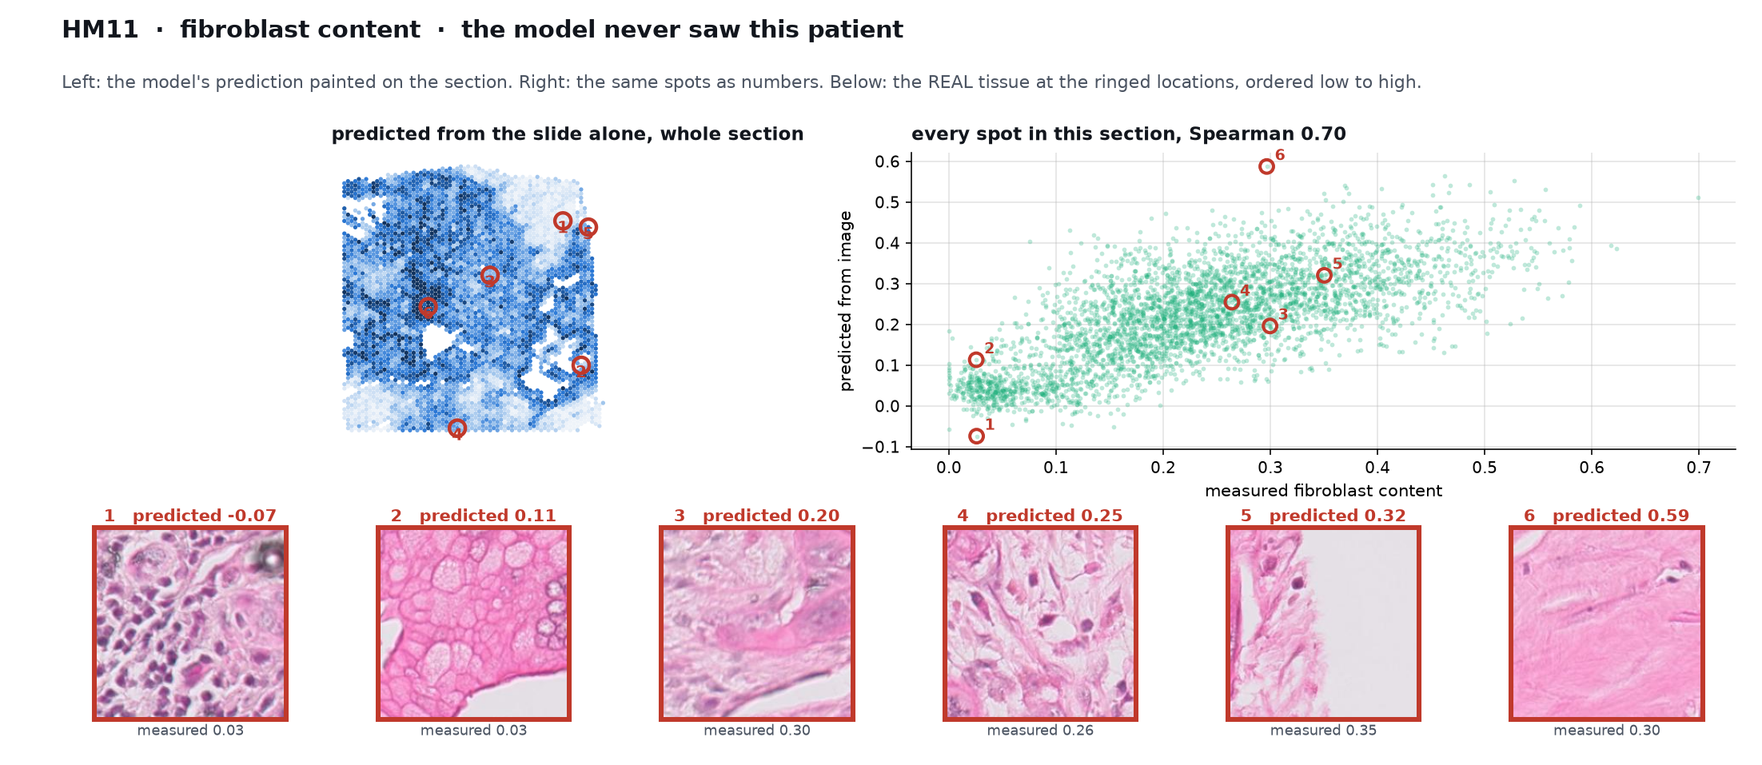
Figure 15. The prediction on a section, and the real tissue at six ringed locations ordered low to high.

Question 9. Can expression teach the slide, so a hospital only needs the slide?
Answer: Yes, and the answer can be drawn on the tissue.

How it was tested
Predictions from the held-out folds are painted back onto the section, so the output is a map a pathologist can inspect rather than a number.

What came out
In the clearest case, B cell content predicted from the image alone reaches Spearman 0.73 on a section from an unseen patient, and places the B cells around the rim of the lymph node, which is where B cell follicles sit.
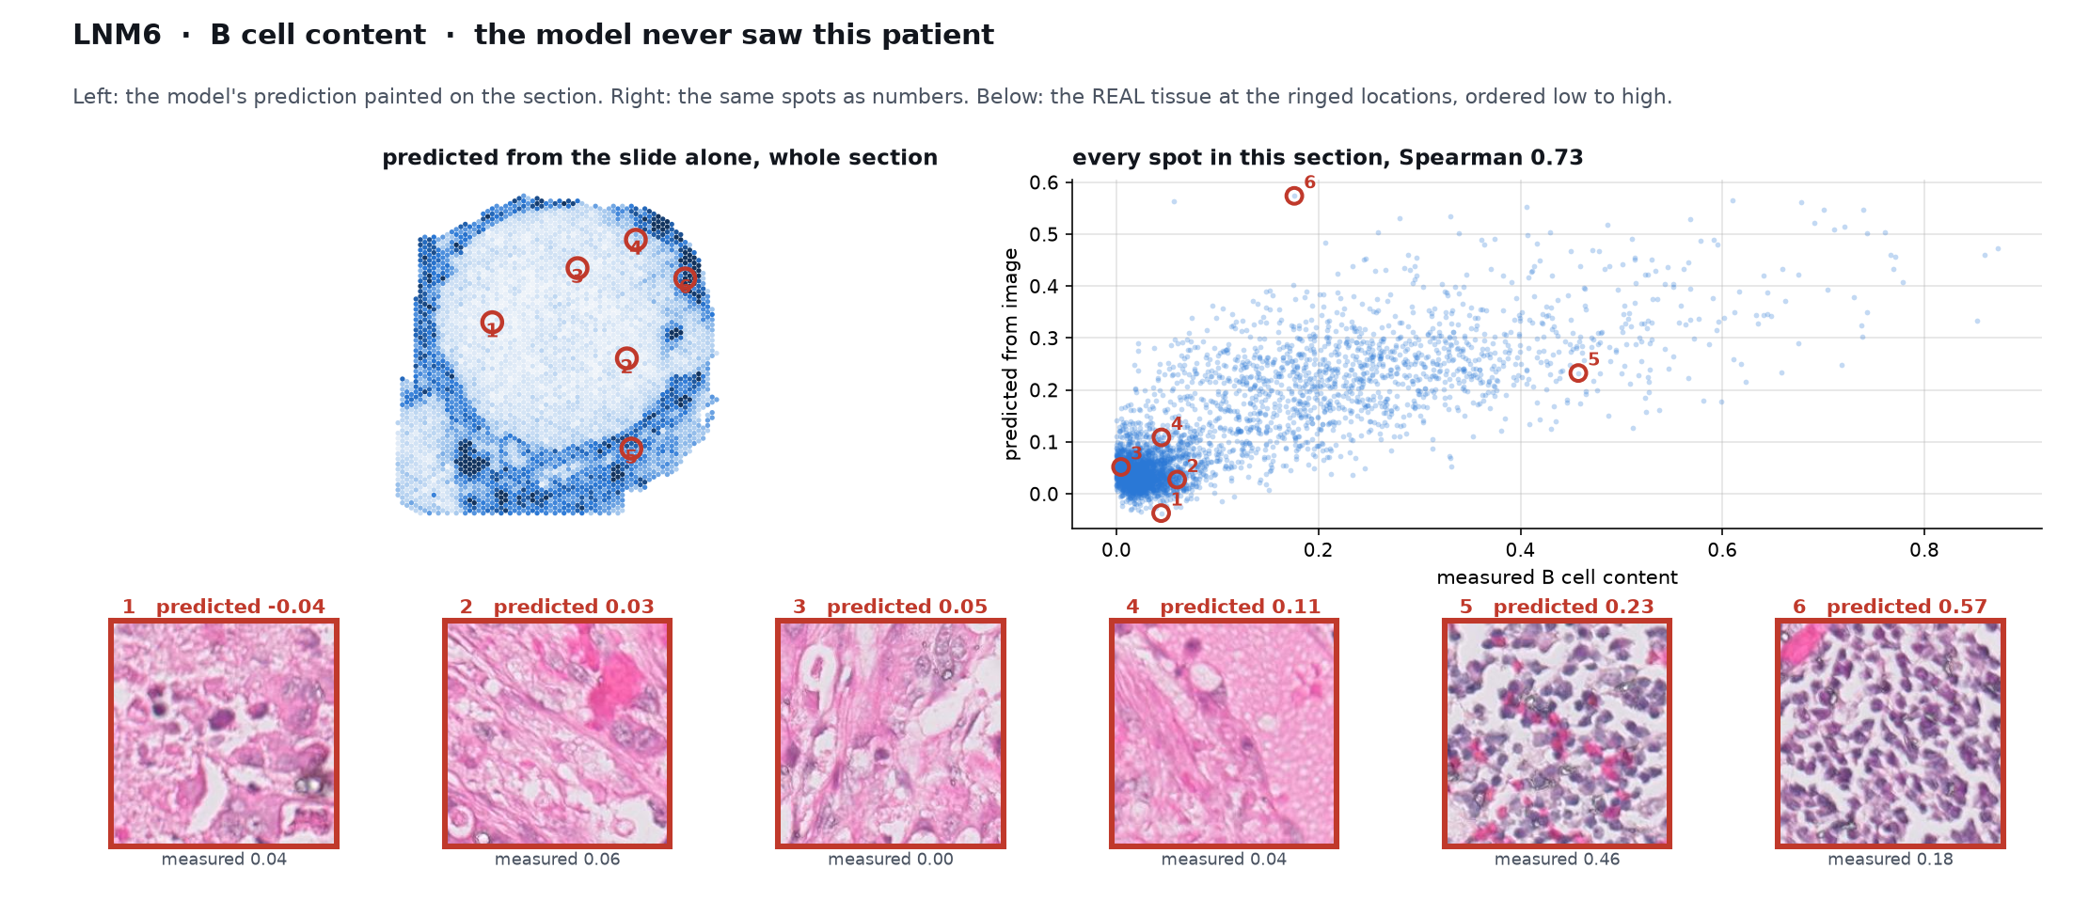
Figure 16. Ordered by prediction, the tissue runs from pink stroma to sheets of lymphocytes.

Question 10. Is it reliable enough to use?
Answer: Not yet, and the spread is the reason.

How it was tested
Per-section scores rather than a pooled figure, because a median hides exactly what matters clinically.

What came out
Fibroblast prediction ranges from 0.79 on the best section to below zero on the worst, with a median of 0.49. It works on most sections and fails on some, and with 12 patients we cannot yet say which in advance.
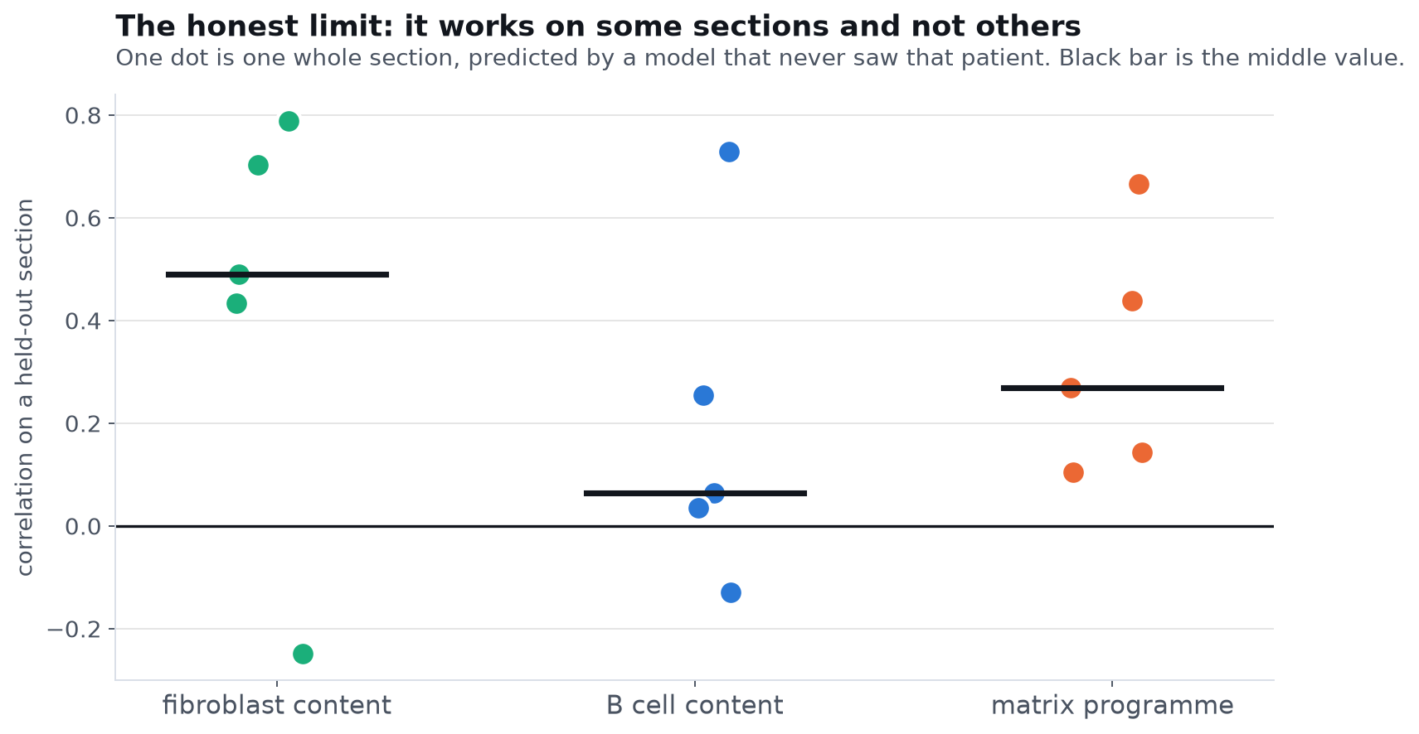
Figure 17. One dot per whole section, each from a model that never saw that patient.

Question 11. Could this be reached without sequencing at all?
Answer: Partly, and we can say which part fails.

How it was tested
The entire site-specificity analysis rebuilt using predicted values in place of measured ones, with two controls against the obvious circularity: a within-section versus between-section split, and a model retrained having never seen a lymph node.

What came out
The B cell difference survives in direction but loses significance, effect size falling from 1.86 to 0.69. Within tumour-rich tissue the B cell signal is weak and most of what the slide reads is between whole sections. But it is not merely organ recognition: a model trained without a single lymph node still predicts B cell content in nodal sections at 0.59.
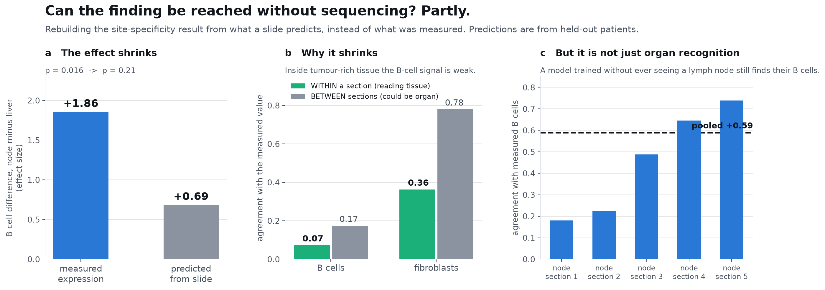
Figure 18. What shrinks, why it shrinks, and the control that stops it being circular.

What would change this answer
The paired within-patient test that carried the original result cannot be run here at all: all four patients with both deposits lost their liver slide among the nine never delivered. Recovering those slides would settle this question rather than leaving it open.

Question 12. Does the fibroblast read-out hold in other people's data?
Answer: Yes, and it fails exactly where it should.

How it was tested
Trained on our 21 sections only and applied unchanged to 158 HEST-1k sections from other laboratories. Deliberately conservative: nothing refitted, and the target there is a marker gene score rather than a deconvolution, so agreement across two different definitions is harder to obtain than across one.

What came out
Median agreement 0.30 across all sections and 0.27 on the four pancreas sections. Brain comes out at 0.05, which is the result that makes the rest credible: brain has almost no collagen stroma, so a fibroblast reader should find nothing there.
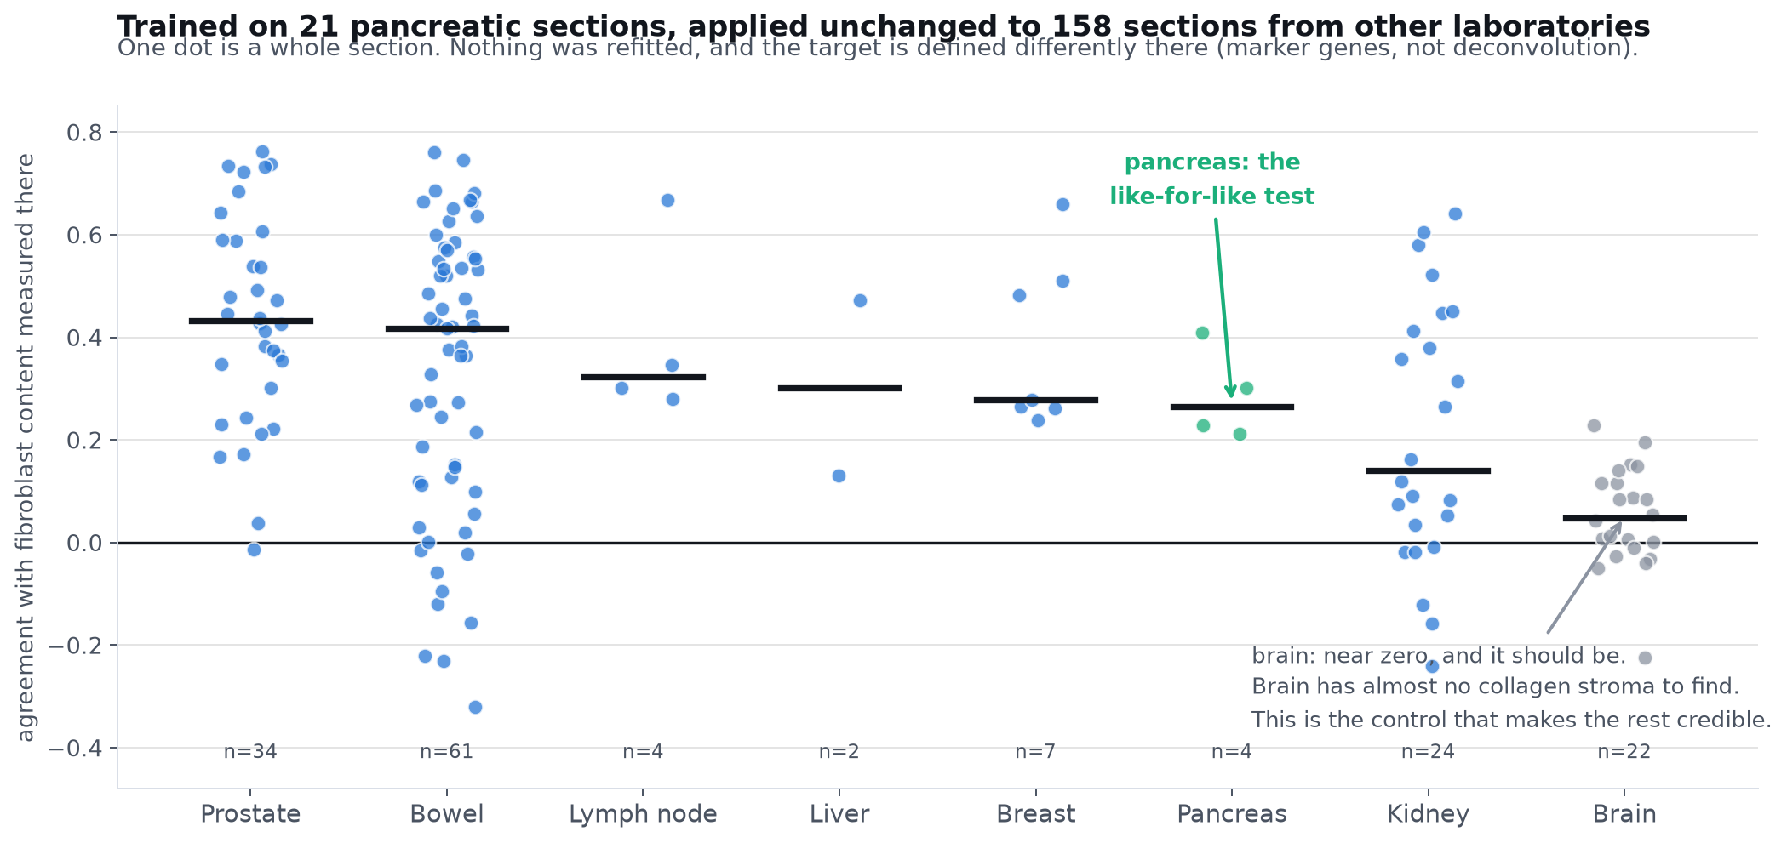
Figure 19. One dot per section, 158 sections, none of them used in training.

What would change this answer
A model that scored well in every organ including brain would indicate it was keying on something generic rather than on fibroblasts.

Question 13. Is it usable per section, and do we know what it looks at?
Answer: Yes on both.

How it was tested
The output averaged over a whole section, which is the shape a clinical report takes, then the prediction regressed on image statistics anyone can name across 18,900 patches.

What came out
One number per section tracks measured fibroblast content at 0.91 across 21 sections, and the ordering recovered from images alone is primary tumour 0.35, liver deposit 0.18, node deposit 0.16, normal pancreas 0.02. That reproduces from pictures what the sequencing showed separately: pancreatic primaries are densely desmoplastic and deposits shed much of that stroma. The model keys on tissue that is pale, smooth and short of nuclei, which is what collagenous stroma looks like.
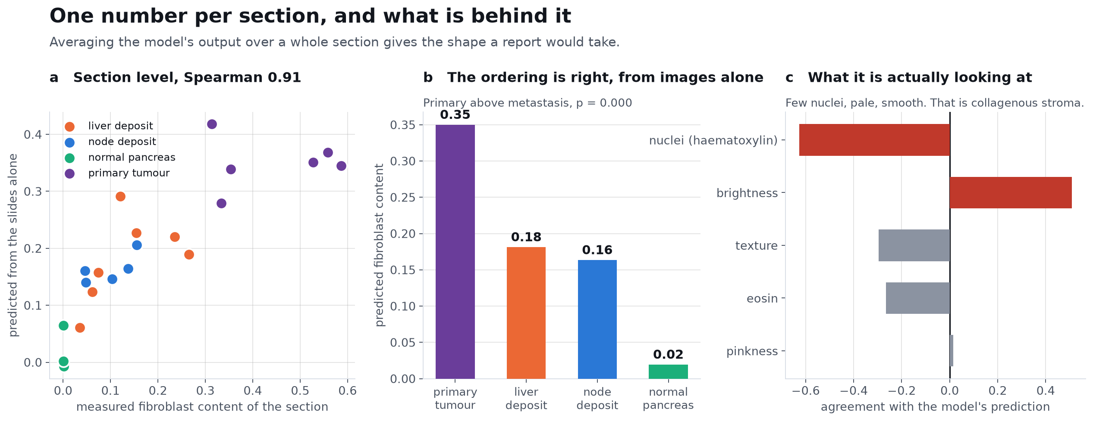
Figure 20. Section level agreement, the recovered ordering, and what drives the prediction.

What would change this answer
Brightness carries part of the signal and brightness drifts with staining batch, so stain normalisation is required before any prospective use.

Question 14. Does any of this depend on which image encoder was used?
Answer: Mostly no. One result was overstated by the original encoder.

How it was tested
Every question above that uses image features re-run under three encoders, UNI2-h, H-optimus-1 and Virchow2, on identical spots, identical held-out patients and identical code. Only the features change.

What came out
The fibroblast read-out is effectively identical under all three (0.775, 0.775, 0.764, and 0.738, 0.733, 0.729 after the tumour-amount control), as is cancer versus normal (0.955, 0.956, 0.962) and the section-level score (0.912, 0.906, 0.918). Cross-site transfer stays near chance under every encoder, so the central negative of Question 3 is a property of the tissue rather than of one model.
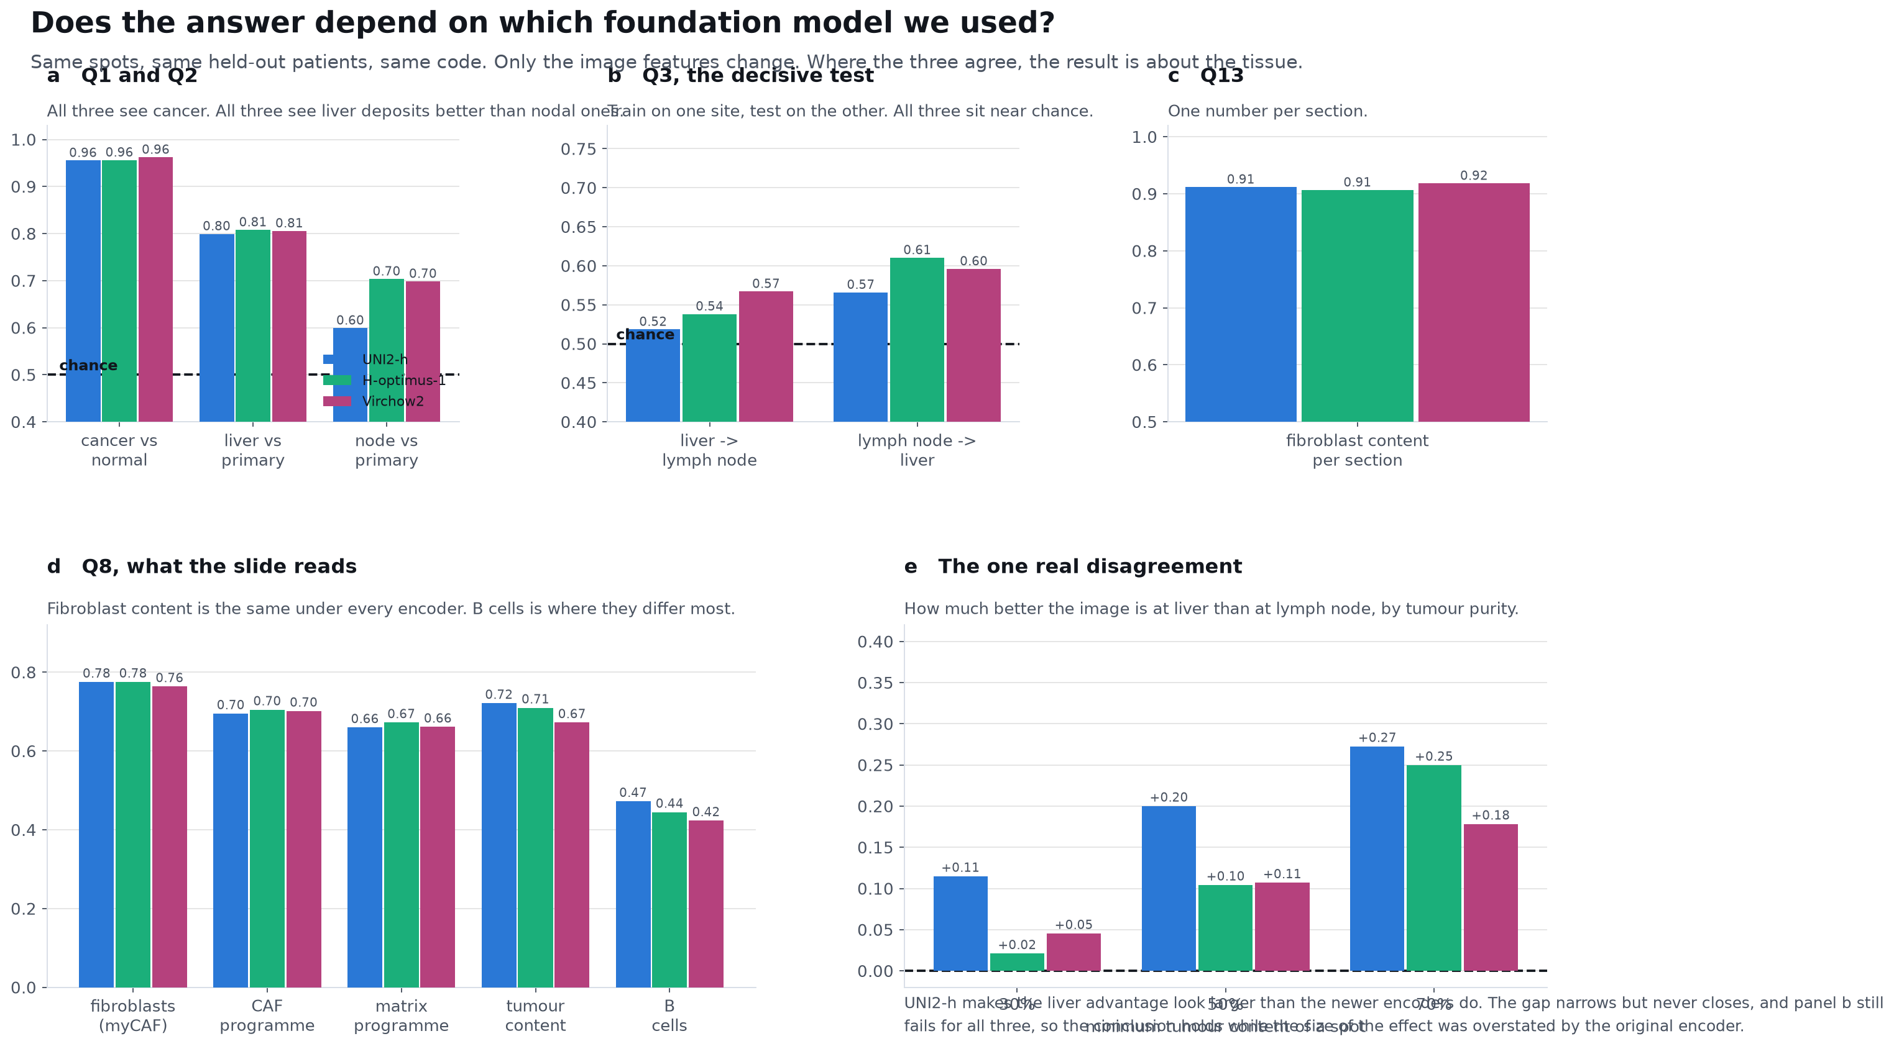
Figure 21. Agreement is visible at a glance; the single disagreement is panel e.

What would change this answer
The liver advantage reported at Question 2 is real under all three encoders but about half as large under the newer two. At 50 percent purity the gap is 0.20 under UNI2-h against 0.11 under H-optimus-1 and Virchow2, because those encoders read nodal deposits better (0.599 rising to 0.703 and 0.698). The conclusion is unchanged, since the transfer test still fails for all three, but the magnitude quoted at Question 2 comes from the encoder that makes it look largest, and that is stated there. Had only one encoder been run, the claim would have been stronger than the data supports.

What could not be done
- Nine sections were never delivered, and the loss was not uniform. All four patients who provided both a liver and a lymph node deposit lost their liver slide, so the paired comparison behind the B cell result cannot be run on images. This is a missing-data problem, not a method problem.
- Twelve patients. Per section the fibroblast read-out ranges from 0.79 to below zero, and which sections fail cannot yet be predicted.
- No outcome data. Clinical fields were available for a minority of patients, all at the same stage, with no survival endpoint. Nothing here is connected to how patients did.
- A 55 micron spot holds up to ten cells. The purity sweep argues against contamination driving the results but cannot separate a tumour cell from its neighbour.
- The B cell finding rests on one cohort. The replication cohort had no lymph nodes, so that specific result is untested elsewhere rather than confirmed.

What would move this furthest
- Confirm the B cell difference on a stain. It needs a pathologist's eye rather than more computation, and it would confirm or kill the weakest link quickly.
- Recover the nine missing slides. It restores the paired design, takes the cohort from 21 sections to 30, and closes Question 11.
- Test the fibroblast read-out against treatment response, which needs a cohort with outcomes attached. It already survives in other laboratories and other organs, so the next question is whether it matters clinically.
- Stain normalisation, before the read-out is used prospectively anywhere.

Data and code
Question | Script | Outputs
1, 3 | 06_WSI/stage11_organ_or_cancer.py | Outputs/stage11_organ_or_cancer
2 | 06_WSI/stage10_primary_vs_met_HE.py | Outputs/stage10_primary_vs_met
4, 5 | 04_Models/stage6_site_specific_program.py | Outputs/stage6_site_program
6 | 04_Models/stage7_external_replication.py | Outputs/stage7_external_replication
7 | 05_HEST/hest_cross_organ.py | Outputs/stage8_hest_cross_organ
8 | 06_WSI/stage9_histology_readout.py | Outputs/stage9_histology
9, 10 | 06_WSI/stage12_spatial_readout.py | Outputs/stage12_spatial
11 | 06_WSI/stage13_site_specificity_from_HE.py | Outputs/stage13_site_from_HE
12 | 06_WSI/stage14_external_caf.py | Outputs/stage14_external_caf
13 | 06_WSI/stage15_usable_and_why.py | Outputs/stage15_usable
tissue grounding | 06_WSI/tissue_grounding.py | Outputs/grounding
slide alignment | 06_WSI/register_spots_to_crops.py | Outputs/wsi_mapping
Table 3. Every number in this report regenerates from these.

Cohorts: GSE272362 (discovery, Khaliq et al. 2024), GSE274557 (replication, Maitra laboratory 2025), HEST-1k (Jaume et al. 2024). Image features: UNI2-h, MahmoodLab.

