### Q1) Apply Greedy Best-First Search on the following Scenario:

**International Spy Network Mission**

A **top-secret international spy organization** needs to **deliver classified intelligence** from their base in **City A** to an undercover agent hiding in **City J**. The spies operate in a highly monitored environment where they must **avoid detection** while ensuring the fastest possible delivery.

1. City A (Start) is the intelligence base.
2. City J (Goal) is where the undercover agent awaits the secret message.
3. Each node represents a different safe house, checkpoint, or transit hub.
4. The edges represent various transportation routes, each with an associated heuristic value representing the estimated "risk level" (lower is better).
5. Spies use Greedy Best-First Search to always pick the "safest-looking" route (i.e., the one with the lowest heuristic).

### ****Tasks:**** 1)**Apply Greedy Best-First Search to determine the route taken by the spies.** 2)**Analyze whether the chosen route was truly the safest and fastest or if another, less obvious route might have been better.**

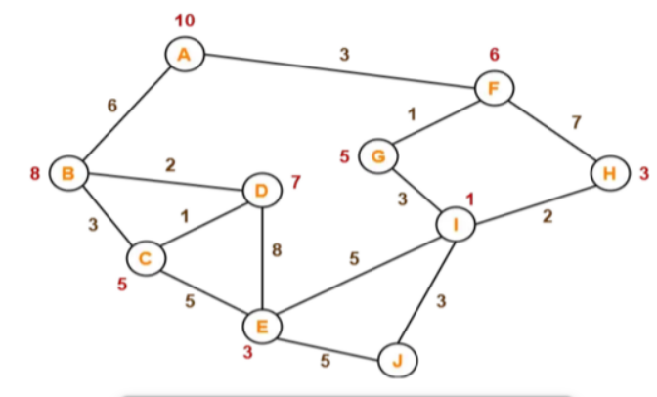

**Question 2)**

**Apply Min-Max Algorithm on the following Scenario:**

**AI vs. Human Chess Endgame**

An **AI chess engine (Max - Player A)** is competing against a **human player (Min - Player B)** in a crucial **endgame situation**. The AI wants to maximize its chances of **winning**, while the human player is trying to **minimize the AI's advantage** by making defensive moves.

1️ The AI (Max) has two main strategies to continue the game:

* **Strategy X:** Leads to a position where the AI can either checkmate in 3 moves or go into an endgame with a slight material advantage.
* **Strategy Y:** Leads to a position where the AI can either force a draw or gain a significant positional advantage.

2️ The Human (Min) then picks the move that minimizes the AI’s winning chances.  
3️ The AI finally executes its best move based on the minimax decision tree.

**Endgame Scenarios (Leaf Nodes - Final Outcomes):**

* **Strategy X** can lead to either **Checkmate in 3 moves (Score = 9)** or **a minor material advantage (Score = 5).**
* **Strategy Y** can lead to either **a Forced Draw (Score = 3)** or **a strong positional advantage (Score = 7).**

**Tasks:**

1️) Construct a game tree showing the AI’s and human player’s decision-making process.  
2️) Apply the Minimax algorithm to determine which strategy the AI should follow for the best outcome.

**Question 3)**

**Apply A-Star Algorithm: Start: A , Goal: Z**

Heuristic values of respective nodes are written in **Orange**.

