Week 9 Individual Progress Report
  - Penetration Testing of Sensor Network for Compliance Reporting

Student: Muhammad Abdullah Athar
Report Theme: Packet and Routing Security Evidence
Focus: Wireshark Analysis, IPv6/RPL Inspection, Routing Attacks, and NIST Mapping

Scope: Week 9 practical penetration testing only

1. Week 9 Packet Security Overview
The objective of this week 9 submission is a packet-level security analysis, specifically detecting routing attacks witnessed across a Contiki-NG RPL-UDP sensor network. In particular, discussions around loss of confidentiality, risk of replaying, and routing instability and relevance with regard to compliance.
2. Assigned Contribution: Packet and Routing Analysis
- The analyzed packet captures exports from Cooja with the tools Wireshark, tshark, and tcpdump.
- Reviewed: IPv6 address, ICMPv6 / RPL packets, Packet layout, Packet Hex representation.
- Documented: Replay-risk, selective-forwarding, packet-sniffing, routing instability, Sinkhole, HELLO flood proof, and.
- Mapping the findings with NIST CSF function for the reporting:
3. Wireshark, tshark, and tcpdump Setup
The packet-level analysis presented is performed on the provided rpludpweek9_raw.pcap file. This file, provided through the Cooja Radio Messages tool, was imported to analyze packet-content, to analyze via the packet contents in Wireshark and in packet hierarchy/ICMPv6/RPL analysis via tcpdump and tshark.
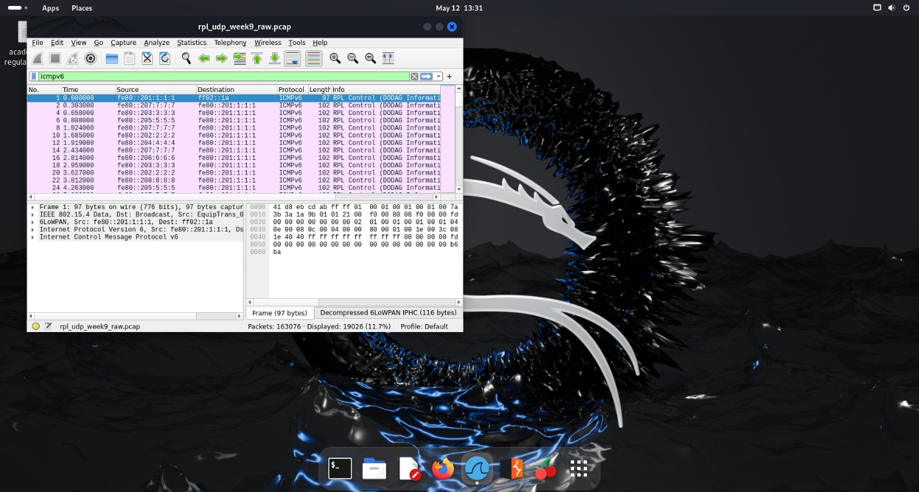
Figure 1: Wireshark interface showing RPL/ICMPv6 packet inspection.
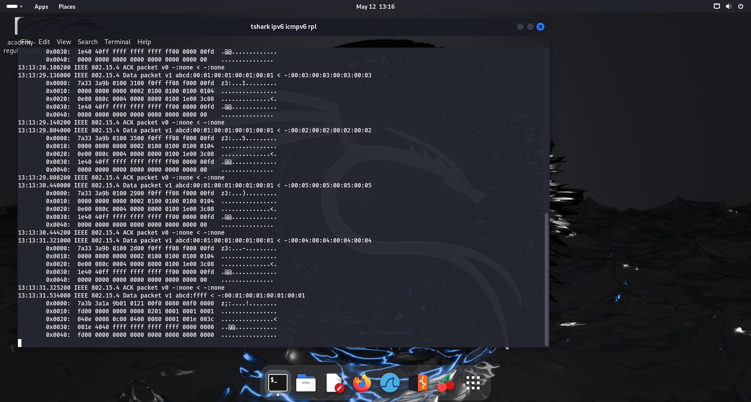
Figure 2: tshark/tcpdump output showing IPv6 and ICMPv6/RPL traffic.

4. Routing and Inspection Attack Evidence
4.1 Selective Forwarding Analysis
The selective forwarding was observed by a pattern of traffic and control packets. This is a fairly invisible attack because it is easy for there to be a fairly continuous stream of traffic.
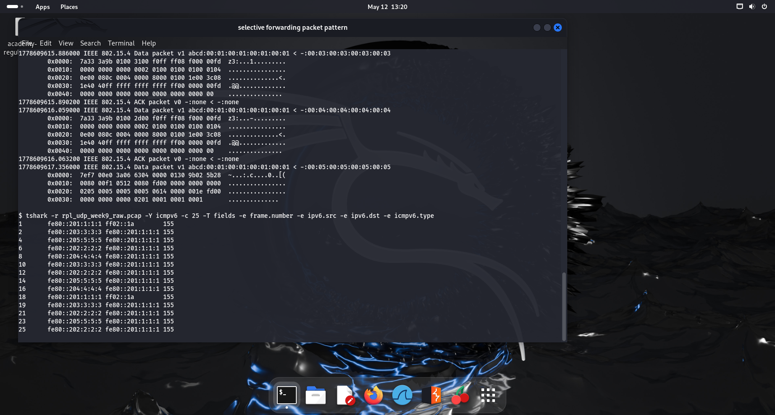
Figure 3: Selective forwarding packet-pattern evidence.

4.2 Replay Attack Evidence
The replay-risk analysis focused on identifying repeated sequences of packets in the capture. When a system provides poor freshness check, a sender could potentially inject old message and has them considered genuine by the restricted node.
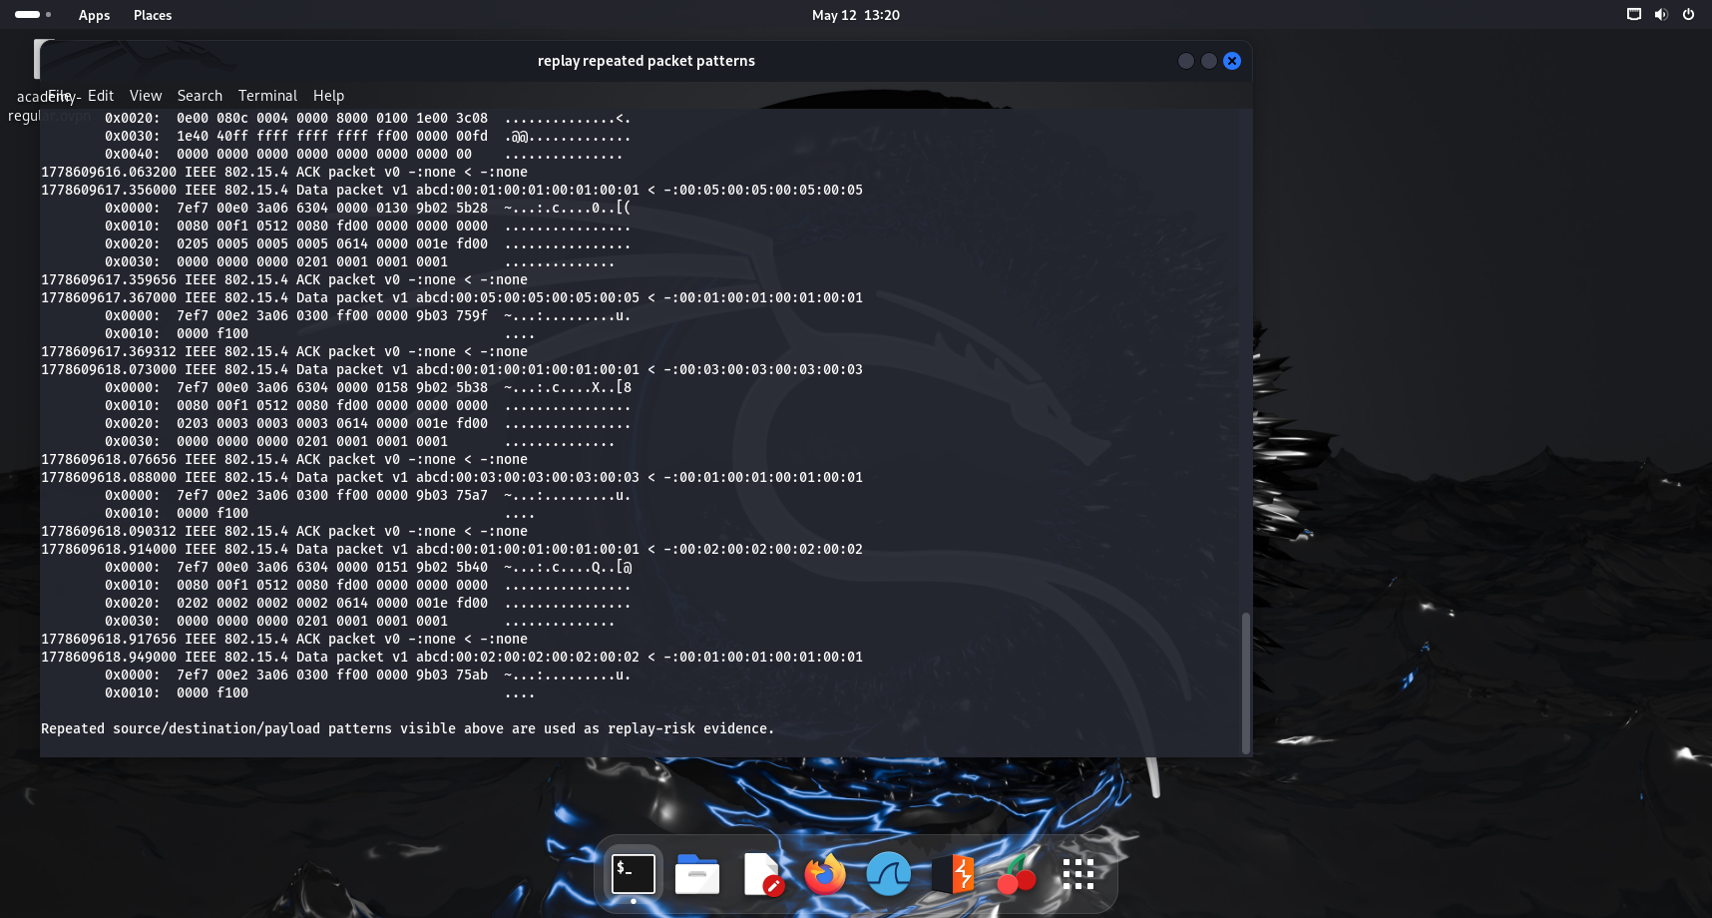
Figure 4: Repeated packet patterns used as replay-risk evidence.
4.3 Packet Sniffing and Confidentiality Exposure
To examine the packet sniffing, we employ the Wireshark tool. Within a capture we can inspect: control message of RPL, source and destination fields, and bytes of packets, and how many packets received in a period of time.

Figure 5: Wireshark packet-sniffing evidence with ICMPv6/RPL filter.
4.4 RPL Routing Instability
An analysis of the stability of routing has been conducted over the topologies at hand, and reducing the number of accessible nodes, to force RPL into the route control behavior and trigger the route repair.
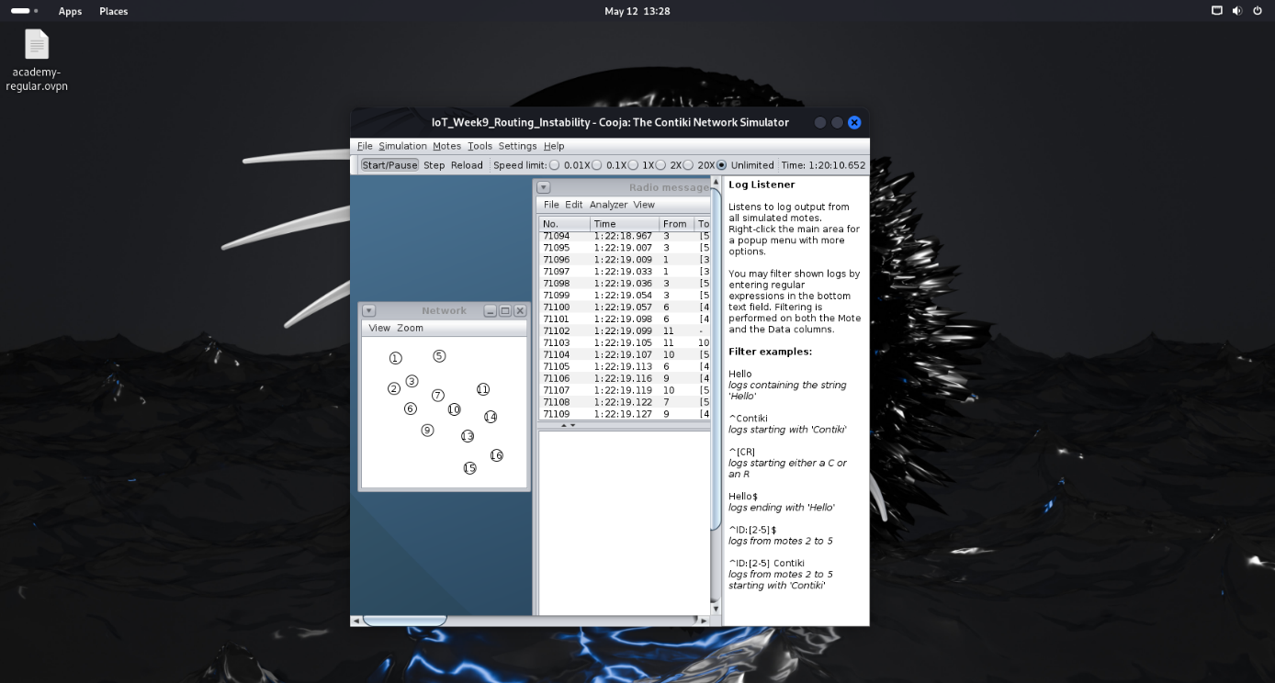
Figure 6: Cooja topology evidence for routing instability.
4.5 Sinkhole-Style Route Dependency
For the sinkhole-style scenario, we apply topology manipulation technique to show the impact of the traffic dependency located at the location of an attractive path and demonstrate an vulnerability of routing-trust in RPL-like networks.
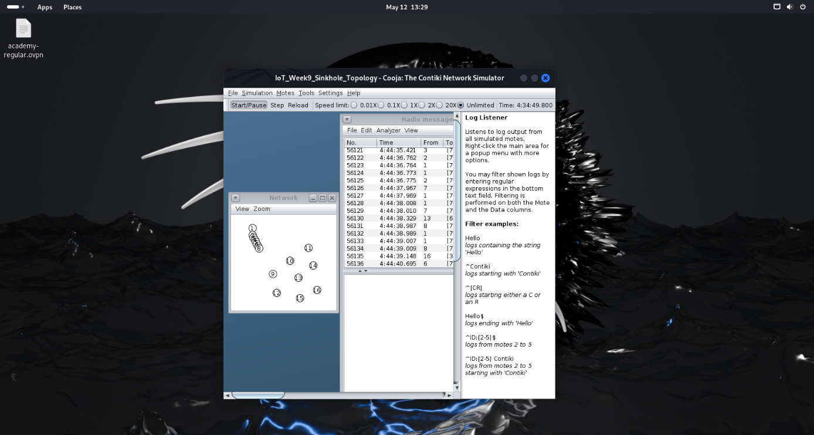
Figure 7: Sinkhole-style topology dependency evidence.
4.6 HELLO/RPL Flood Evidence
For analyzing HELLO/RPL flood, both the ICMPv6/RPL counters and DODAG information have been used. Intensive routing advertisement can lead to overload and unstable route.
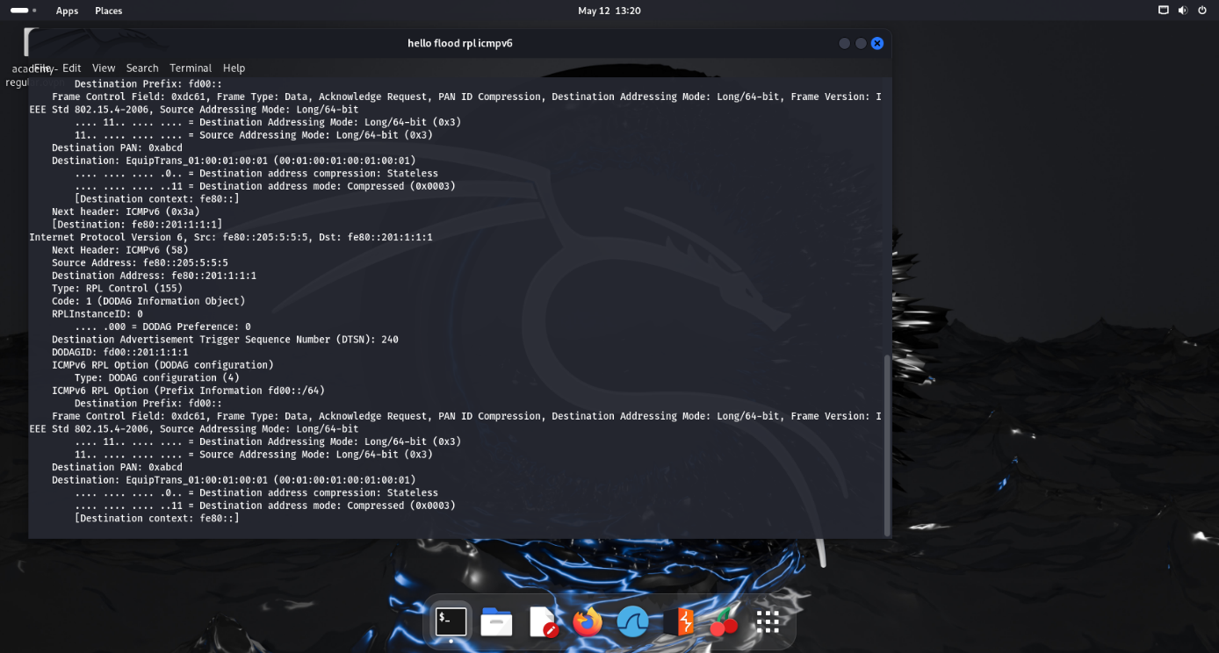
Figure 8: HELLO/RPL flood evidence from tshark output.
5. IPv6, ICMPv6/RPL, and UDP Packet Analysis
In the Packet capture the IEEE 802.15.4 frame, 6LoWPAN, IPv6, ICMPv6/RPL and UDP/data packets are captured and presented. Trace illustrates not only the visibility of the metadata, but also the inspection capability on the low-power network traffic.
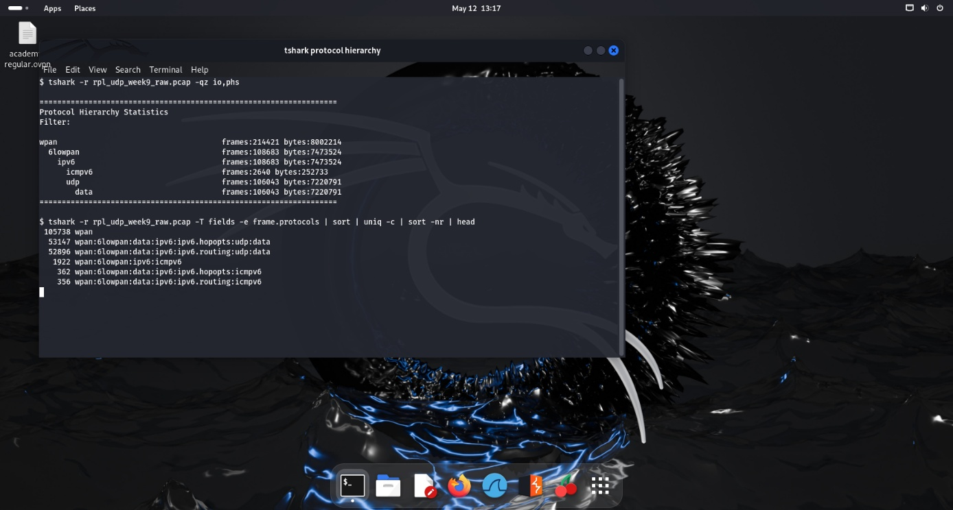
Figure 9: Protocol hierarchy showing UDP, ICMPv6/RPL, and data frames.

6. Vulnerability Findings
- Confidentiality risk: Wireshark, tcpdump could show open fields within packets and the corresponding hexadecimal bytes.
- Replay risk: repetitive patterns of packets would require a way of providing freshness, anti-replay mechanism.
- Trust on the routing weakness: change in topology may result in the concentration of routes, and the choice of parent.
- Selective forwarding risk: if there is a partial drop it might not be detected if not all the messages were delivered.
- HELLO/RPL control plane risk: Excessive routing traffic may consume processing capabilities and bandwidth.
7. Confidentiality and Routing Integrity Impact
The most important results from my analysis based on week 9 are loss of confidentiality and routing integrity. By analyzing the packets one is able to determine what is being communicated by whom and by replay, sinkhole, selective forwarding, or HELLO flood routing integrity is at risk.
8. NIST CSF Compliance Mapping  NIST CSF Function | Week 9 Evidence | Control / Reporting Relevance
Identify | Packet capture revealed active nodes, traffic relationships, and RPL control dependencies. | Document data flows, node roles, and routing dependencies.
Protect | Sniffing and replay risks were visible in practical evidence. | Use encryption, authentication, secure joining, and freshness controls.
Detect | RPL/ICMPv6 volume and repeated traffic patterns can indicate attack behavior. | Create alerts for RPL spikes, duplicate packets, parent churn, and abnormal packet timing.
Respond | Selective forwarding, sinkhole, and HELLO flood require containment. | Isolate suspicious nodes, preserve PCAP evidence, and rebuild trusted routes.
Recover | Routing instability can affect report availability. | Validate route restoration and confirm post-incident sensor reporting integrity.

9. Reflection Week
Packet-analysis was the most tangible approach with router screens and PCAP-analysis; to illustrate the routing behavior in a real packet-level view with such tools as Wireshark and tshark.
10. Conclusion
This Week 9 showed packet inspection and routing security vulnerabilities within the RPL-UDP sensor network, and illustrates recommendations with regard to use of encryption and anti-replay controls with route monitoring, response should focus on compliance.
11. References
Wireshark packet inspection and protocol analysis performed using the Week 9 RPL-UDP packet capture generated from the Cooja simulation environment.
tshark traffic analysis and packet statistics generated from the Week 9 Cooja PCAP capture files.
tcpdump command-line packet inspection and traffic verification conducted during the practical penetration testing activities.
Contiki-NG RPL-UDP example source files and network simulation environment used for practical IoT sensor network testing.
Cooja simulation environment used for topology creation, routing analysis, attack simulation, and traffic monitoring.
National Institute of Standards and Technology (NIST) Cybersecurity Framework functions:
Identify
Protect
Detect
Respond
Recover
Winter, T. et al. (2012) RPL: IPv6 Routing Protocol for Low-Power and Lossy Networks. IETF RFC 6550.
Dunkels, A., Gronvall, B. and Voigt, T. (2004) ‘Contiki: A lightweight and flexible operating system for tiny networked sensors’, Proceedings of the 29th Annual IEEE International Conference on Local Computer Networks (LCN). IEEE.
Sicari, S., Rizzardi, A., Grieco, L.A. and Coen-Porisini, A. (2015) ‘Security, privacy and trust in Internet of Things: The road ahead’, Computer Networks, 76, pp. 146-164.
Alaba, F.A., Othman, M., Hashem, I.A.T. and Alotaibi, F. (2017) ‘Internet of Things security: A survey’, Journal of Network and Computer Applications, 88, pp. 10-28.

