OPERATION & MAINTENANCE MANUAL
Automatic Weight-Based Liquid Filling Machine
PID-Controlled, Load-Cell Feedback, Single-Nozzle DC Pump System
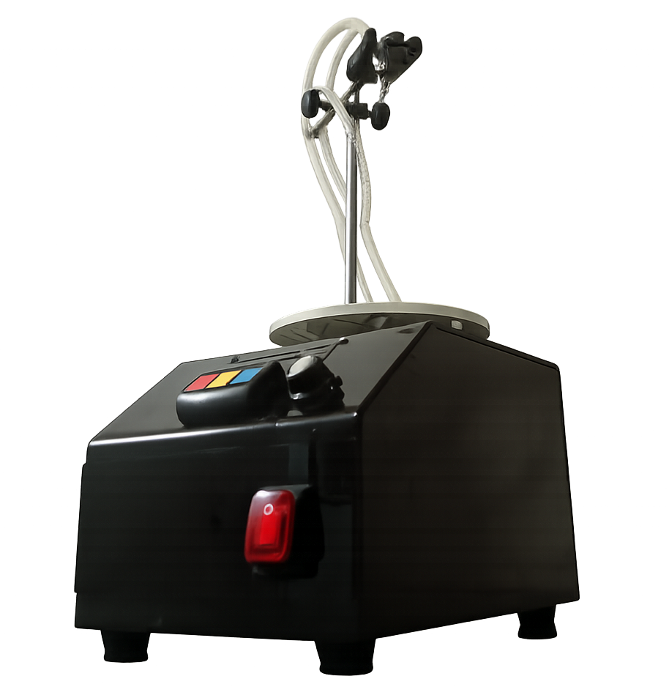

Parameter | Value
Model / Reference No.
Serial Number
Date of Manufacture / Build
Owner / Facility
Document Revision

CONTENTS
CONTENTS 4
1. INTRODUCTION 5
2. TECHNICAL PARAMETERS 5
3. PERFORMANCE CHARACTERISTICS 6
4. INSTALLATION 7
5. CONTROL PANEL 7
6. ADDITIONAL PUMP CONTROL PANEL 8
7. OPERATION 9
8. FAQ 10
9. MAINTENANCE 11
10. TROUBLE SHOOT 11
11. APPANDIX 12

NOTE: Right-click the table above and choose “Update Field” in Microsoft Word to populate page numbers after editing.

1. INTRODUCTION
This machine is a compact, bench-top automatic liquid filling system designed for small-batch dispensing of low-viscosity, particle-free liquids. Unlike conventional timer-based filling machines, this unit uses direct weight feedback from a load cell, combined with closed-loop PID (Proportional-Integral-Derivative) control, to dispense liquid by mass rather than by elapsed time. This allows the machine to automatically compensate for changes in liquid density, tube condition, supply-container head height, and pump wear, resulting in consistently accurate fill weights without manual recalibration of a fill time.
The system is built around an Arduino-class microcontroller, an HX711 precision load-cell amplifier, a 16×2 I²C liquid crystal display (LCD), a rotary encoder, three tactile pushbuttons, and a DC pump driven through an L298-type motor driver. The user places an empty container on the integrated weighing stage, sets the desired target fill weight, and starts the cycle. The controller runs the pump at a controlled PWM (pulse-width-modulated) speed, slowing the pump automatically as the reading approaches the target weight, and stopping the pump once the target is reached within tolerance.
Typical applications include filling of water, juices, oils, cosmetic liquids, light syrups, and similar free-flowing, non-corrosive liquids in laboratory, pilot-line, or small-batch production settings.

Key Features
- Gravimetric (weight-based) filling — accuracy is independent of liquid density and viscosity variation.
- Closed-loop PID control of pump speed for smooth approach to target weight and minimized overshoot.
- Automatic slow-down zone near the target weight to reduce splashing and over-fill.
- Digital tare function to zero out the weight of the empty container before each cycle.
- Target weight adjustable in the field via pushbuttons or rotary encoder, without reprogramming.
- Real-time LCD display of set weight, live weight, and machine status (STOP / RUN / DONE).
- Configurable overshoot compensation to correct for pump/tube dribble after cut-off.

2. TECHNICAL PARAMETERS
Fill in the fields below to record the specific configuration and ratings of your unit.
Parameter | Value
Supply Voltage | 100-240V AC
Rated Power Consumption
Pump Type | Self-Priming Pump
Maximum Flow Rate | >1000mLPM
Maximum Suction / Lift Height | >1m
Load Cell Capacity | 5000 Grams
Weighing Resolution | 0.1 gram
Fill Weight Range | 10 g – 1000 g (firmware-limited; adjustable in 10 g steps)
Fill Weight Increment (Buttons / Encoder) | 10 g per press / per detent
Stop Tolerance (accuracy band) | ± 0.5 g (firmware default — adjust per calibration)
Slow-Down Zone | Begins 40 g before target weight (firmware default)
Display | 16 × 2 character LCD, I²C interface
Controller / Motor Driver | Microcontroller with HX711 load-cell amplifier and L298-type DC motor driver
Overall Dimensions (L × W × H) | 235 x 170 x 180 (mm)
Net Weight
Ambient Operating Temperature | -10°C to +40°C
Compatible Liquid Viscosity Range
Compatible Liquid pH Range | 4.5-8.0

3. PERFORMANCE CHARACTERISTICS
- Weight-based (gravimetric) dosing: fill accuracy is determined by direct measurement of dispensed mass on the load-cell stage, not by elapsed pump run time.
- PID closed-loop control automatically adjusts pump PWM speed in real time to approach the target weight smoothly and repeatably.
- Automatic slow-approach near target: pump speed is progressively limited within the last ~40 g (default) of travel to minimize overshoot caused by pump and liquid inertia.
- Configurable overshoot compensation subtracts a small fixed offset from the target weight internally, so that residual dribble after pump cut-off lands the final reading on target.
- Digital display, precise and free from parallax, updating approximately every 0.3 seconds.
- Tactile push-button and rotary-encoder interface for fast, tool-free adjustment of the target weight.
- Tare function removes the weight of the empty container from the reading so that “Wt” always reflects dispensed liquid only.
- Status indication on-screen at all times: STOP (idle), RUN (filling in progress), DONE (last cycle completed and stopped at target).
NOTE: The exact accuracy achieved in practice depends on load-cell calibration, liquid viscosity, tube condition, and mechanical stability of the stand — see MAINTENANCE and TROUBLE SHOOT for guidance.

4. INSTALLATION
Reference the labeled photograph of the machine (Inlet, Outlet, Stage, Display, Tare/Up/Down buttons, Rotary Encoder, Power Button) supplied with this manual while completing the following steps.
- Place the machine on a flat, level, stable, and dry surface, close enough to a mains socket to reach without straining the power cord.
- Assemble the support stand: mount the vertical stainless-steel rod into the base clamp and tighten securely, then attach the horizontal boom/clamp carrying the outlet nozzle holder at a height that positions the nozzle centrally above the weighing stage.
- Fit the outlet nozzle/tube into the nozzle holder on the boom so it discharges directly and vertically above the center of the weighing stage.
- Connect the clear silicone inlet tube from the pump inlet fitting to the bottom of the supply container (e.g., bottle or reservoir), ensuring the tube end (with mesh strainer/check valve, if fitted) remains fully submerged in the liquid at all times during operation.
- Connect the outlet tube from the pump outlet fitting to the outlet nozzle mounted on the boom.
- Ensure all tube connections are pushed on fully and are free of kinks, sharp bends, or pinch points along their length.
- Place an empty container on the weighing stage, centered under the outlet nozzle, to confirm clearance and alignment before first use.
- Plug in the power cord and switch on the machine using the illuminated rocker Power Button on the front-lower panel.
- Allow the display to initialize; the LCD will briefly show a startup message before switching to the normal operating screen (Set / Wt / status).
CAUTION: Do not run the pump dry for extended periods and never allow the inlet tube to lift out of the liquid while filling is in progress, as this may draw air into the pump and cause inaccurate readings or pump damage.

5. CONTROL PANEL
The front control panel consists of a 16×2 LCD display, three colored push-buttons (Tare / Up / Down), and a rotary encoder. Their functions are summarized below.
Control | Type | Function
Display | 16×2 LCD (I²C) | Top line shows the current target weight ("Set:_ _g"). Bottom line shows the live measured weight ("Wt:_ _g") and machine status: STOP (idle), RUN (filling), or DONE (cycle complete).
Tare (red) | Pushbutton | Zeroes the load-cell reading with the empty container on the stage. Only active while the machine is stopped (not filling). Display briefly shows "Taring...".
Up (yellow) | Pushbutton | Increases the target fill weight by 10 g per press, up to the maximum of 1000 g. Only active while stopped.
Down (blue) | Pushbutton | Decreases the target fill weight by 10 g per press, down to the minimum of 10 g. Only active while stopped.
Rotary Encoder | Rotary encoder (rotate + press) | Rotate clockwise/counter-clockwise to raise/lower the target weight in 10 g steps, in the same way as the Up/Down buttons — useful for fast, one-handed adjustment. Press the encoder knob to Start a filling cycle; press again to Stop the cycle at any time. Encoder rotation is ignored while a fill cycle is in progress.
Power Button | Illuminated rocker switch | Switches mains power to the machine on and off. Located on the lower front panel.

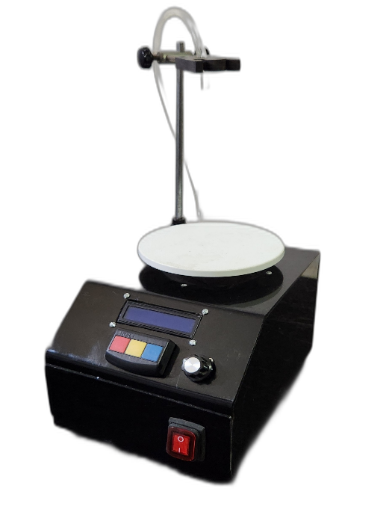
6. ADDITIONAL PUMP CONTROL PANEL
This machine uses a single DC pump whose speed is automatically and continuously modulated by the internal PID controller — there is no separate manual pump-speed knob or ON/OFF panel for the operator to set, unlike multi-nozzle diaphragm/peristaltic pump machines. Pump behavior is instead governed by a small set of firmware parameters, which are set once at commissioning/calibration and are not intended for routine adjustment by the operator.
These firmware (service-level) parameters are listed below for reference by qualified maintenance personnel:
Parameter | Firmware Default | Purpose
calibration_factor | 198.40 | Converts raw load-cell counts to grams. Must be re-derived whenever the load cell, stage, or amplifier is replaced or serviced.
overshootComp | 1.0 g | Amount subtracted from the target weight internally to compensate for liquid that continues to drip after the pump is commanded to stop.
minPWM / maxPWM | 10 / 255 | Minimum PWM value needed to start liquid flow, and the maximum allowable pump drive signal.
stopTolerance | 0.5 g | Acceptable error band, in grams, at which the fill cycle is considered complete and the pump is stopped.
slowZone | 40 g | Distance from target weight at which the controller begins limiting pump speed to reduce overshoot.
Kp / Ki / Kd | 8.0 / 0.4 / 1.2 | PID tuning constants controlling how aggressively the pump responds to the weight error.
minTarget / maxTarget | 10 g / 1000 g | Lower and upper bounds allowed when setting the target fill weight from the panel.
CAUTION: Firmware parameters should only be changed by a technician familiar with the control program, using the manufacturer's programming tools. Incorrect PID or PWM values can cause overshoot, spillage, or pump damage.

7. OPERATION

7.1 Preparation
- Ensure the inlet tube is fully submerged in the liquid to be dispensed and the outlet nozzle is positioned above the weighing stage.
- Switch on the machine at the Power Button and wait for the LCD to show the normal operating screen.
- Place the empty container to be filled on the weighing stage.
- Press Tare to zero the display so that "Wt" reads 0.0 g with the empty container in place.

7.2 Setting the Target Fill Weight
- With the machine stopped, use the Up and Down buttons, or rotate the Rotary Encoder, to set the desired fill weight shown on the top line of the display ("Set:__g").
- The target weight adjusts in 10 g increments and is limited to the range 10 g – 1000 g.
- The set weight is retained until changed again; it is not necessary to re-enter it before every cycle unless a different fill weight is required.

7.3 Running a Fill Cycle
- With the tared, empty container on the stage and the target weight set, press the Rotary Encoder (or dedicated Start/Stop button) to begin filling. The display status will change to RUN.
- The pump will run at full speed initially, then automatically slow down as the live weight approaches the target, minimizing overshoot.
- The pump stops automatically once the measured weight reaches the target within the stop tolerance. The display status will change to DONE.
- To stop a cycle manually at any time before completion, press the Rotary Encoder (or Start/Stop button) again.
- Remove the filled container from the stage.
- For the next cycle, place a new empty container, press Tare, and press Start again. Repeat as required.
NOTE: The target weight cannot be changed while a fill cycle is running (RUN status). Stop the cycle first if a different target weight is needed.

7.4 Shutting Down
- Ensure the machine is stopped (STOP or DONE status) before switching off.
- Switch off at the Power Button.
- If the machine will be idle for an extended period, remove the inlet tube from the liquid and run a brief empty/clean cycle (see MAINTENANCE) to avoid liquid drying inside the pump and tubing.

8. FAQ

Q: The display shows a weight reading even with nothing on the stage — is this normal?
A: A small non-zero reading can occur due to drift or a change in ambient temperature. Press Tare with the stage empty (or with only the empty container you intend to fill) to zero the reading before each cycle.

Q: The machine stops filling far short of, or well past, the set target weight.
A: This is usually a calibration or overshoot issue. Confirm the load cell is properly calibrated (see calibration_factor in ADDITIONAL PUMP CONTROL PANEL) and that the overshootComp value reflects your liquid's typical dribble volume. Also check that the container is not touching the boom, stand, or tubing, which can add friction and produce false weight readings.

Q: Pressing Up/Down or turning the encoder has no effect.
A: These controls are only active while the machine is stopped. If the display shows RUN, stop the current cycle first (press the Start/Stop control), then adjust the target weight.

Q: The pump motor runs but no liquid comes out.
A: This typically means air is trapped in the pump or tubing, or the inlet tube is not fully submerged. Confirm the inlet tube end remains under the liquid surface at all times, check for kinks in the tubing, and prime the line by allowing the pump to run briefly with the tube submerged.

Q: The weight reading is unstable or jumps around.
A: Check that the machine is on a stable, level, vibration-free surface, that no tubing is resting on or pulling against the container on the stage, and that the load cell mounting screws are tight. Electrical interference from nearby motors can also affect readings — ensure the machine's own wiring is properly shielded and connectors are seated.

Q: Can I fill by volume (mL) instead of by weight?
A: The machine doses by mass (grams) directly. For a liquid of known density, convert your desired volume to a target mass (mass = volume × density) and enter that value as the target weight.

9. MAINTENANCE
- After each production run, flush the inlet tube, pump, and outlet tube with clean water (or a mild detergent solution appropriate to the liquid used) to prevent residue build-up.
- Keep the weighing stage clean and dry. Wipe up any spills immediately — liquid ingress into the load cell or electronics can cause permanent damage and inaccurate readings.
- Periodically inspect all tubing for kinks, cracking, or wear, and replace as needed to maintain consistent flow and accuracy.
- Check that the stand, boom clamp, and nozzle holder remain securely tightened; a loose nozzle position can cause dripping outside the container or onto the stage.
- Periodically re-verify calibration by dispensing a known mass of liquid onto a certified reference scale and comparing it with the machine's display; adjust calibration_factor if a qualified technician determines it is required.
- Keep electrical connections, the display, and the control panel free of dust and moisture.
- Store the machine in a dry location when not in use, with the inlet tube removed from any liquid.

10. TROUBLE SHOOT
Issue | Likely Cause | Solution
Display stays blank after power-on | No mains power reaching unit, or loose display connector | Confirm the power cord and Power Button; check the I²C connector to the LCD is fully seated
Weight display reads negative or does not return to 0.0 g after Tare | Load cell drift, stage overloaded, or liquid residue on stage | Remove all items from stage, clean any spilled liquid, and press Tare again. If the issue persists, the load cell may require recalibration
Pump does not start when a cycle is begun | Target weight already met/below stop tolerance, motor driver wiring loose, or Start control not registering | Confirm the target weight is higher than the current tared reading; check motor driver (L298) wiring; try pressing the Start/Stop control firmly
Pump runs continuously and does not stop at target | Load cell reading not increasing (dry pump / disconnected load cell) or target weight set below current reading | Manually stop the machine; check load-cell wiring and calibration; confirm liquid is actually reaching the container
Significant overshoot past the set target weight | overshootComp too low for the liquid's dribble volume, or slowZone/PID values too aggressive for this liquid viscosity | Increase overshootComp slightly and re-test; for persistent overshoot, have a technician re-tune the Kp/Ki/Kd values
Fill weight varies noticeably between consecutive cycles | Kinked or partially blocked tube, unstable stand, or inlet tube not staying submerged | Straighten/replace tubing, ensure the stand is level and rigid, keep the inlet tube fully submerged throughout each run
Up/Down buttons or encoder do not change the target weight | Machine is currently in RUN (filling) status | Stop the current cycle first, then adjust the target weight
No liquid drawn even though pump sound is heard | Air trapped in pump/tubing, or inlet not submerged | Prime the line by keeping the inlet submerged and running the pump briefly; check for tube kinks or loose fittings

11. APPANDIX

A. Control System Overview
The controller reads the load cell via the HX711 amplifier, compares the live weight (Input) to the target weight (Setpoint) to compute an error, and uses a PID algorithm to calculate the pump drive signal (Output), which is written to the pump driver as a PWM value. As the error falls below the configured slow-down zone, the maximum permitted PWM is progressively reduced, so the pump decelerates smoothly on approach to the target rather than stopping abruptly. Filling stops automatically once the error falls within the stop tolerance.

B. Firmware Parameter Reference
See Section 6 (ADDITIONAL PUMP CONTROL PANEL) for the full list of firmware parameters, default values, and their function.

C. Recommended Spare Parts
- Silicone inlet/outlet tubing (appropriate bore size for the fitted pump)
- Mesh strainer / inlet check valve, if fitted
- Spare pump (matched to the DC motor driver rating)
- Fuses (if fitted) matching the machine's rated current

D. Revision History
Revision | Date | Description
A |  | Initial issue

E. Safety Notes
- Disconnect mains power before opening the enclosure or performing any internal maintenance.
- Do not immerse the electronic enclosure, display, or load-cell wiring in water or cleaning solution.
- Use only with liquids compatible with the pump and tubing materials fitted to this unit.
- Keep hands and loose clothing clear of moving pump components during operation.

