**Machine Learning Operations**

**Course Instructor**

**Sir Samiullah Shah**

**Lab Instructor**

-

**Submitted By:**

22i-2504 (Muhammad Abdullah Iqbal),

**Fall 2025**



**Department of Computer Science**

FAST – National University of Computer & Emerging Science

Building Dockers image:

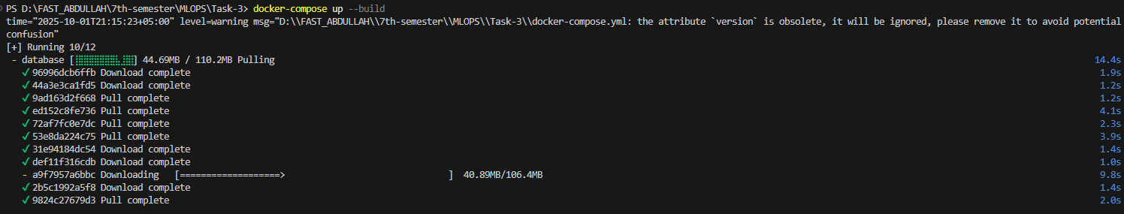

Docker Containers Running form:

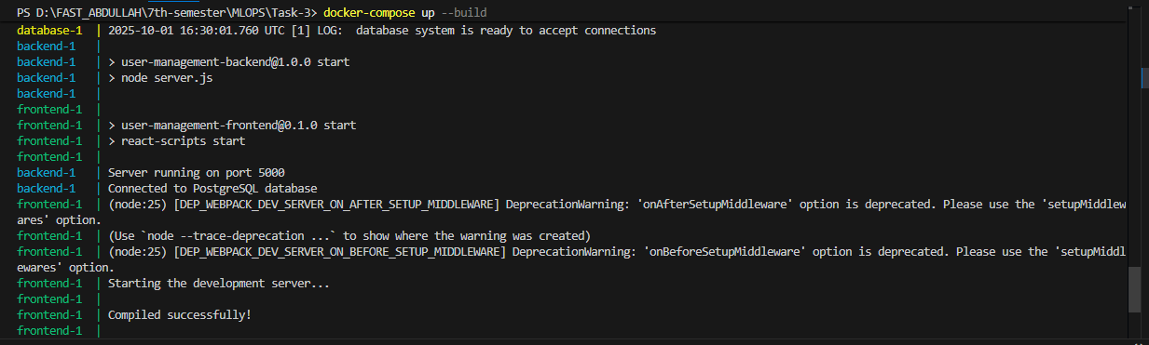

Before enabling watch:

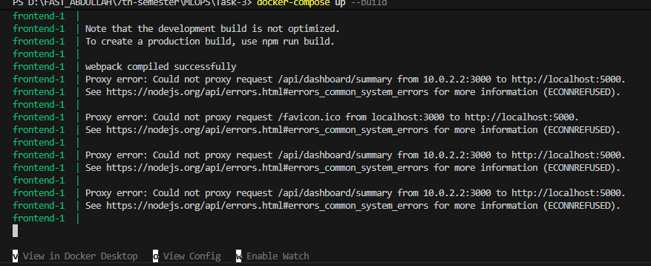

After enabling watch :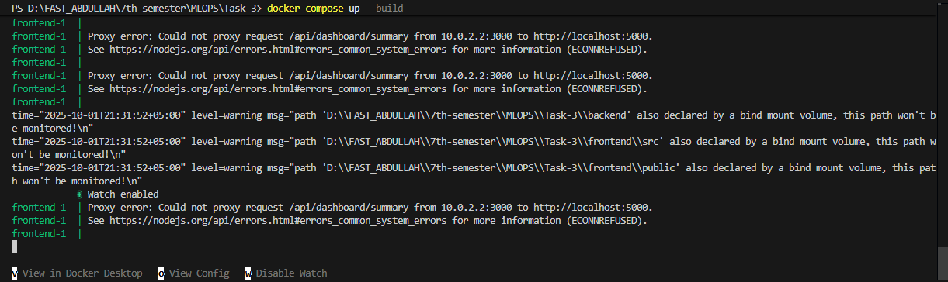

No user added for now:

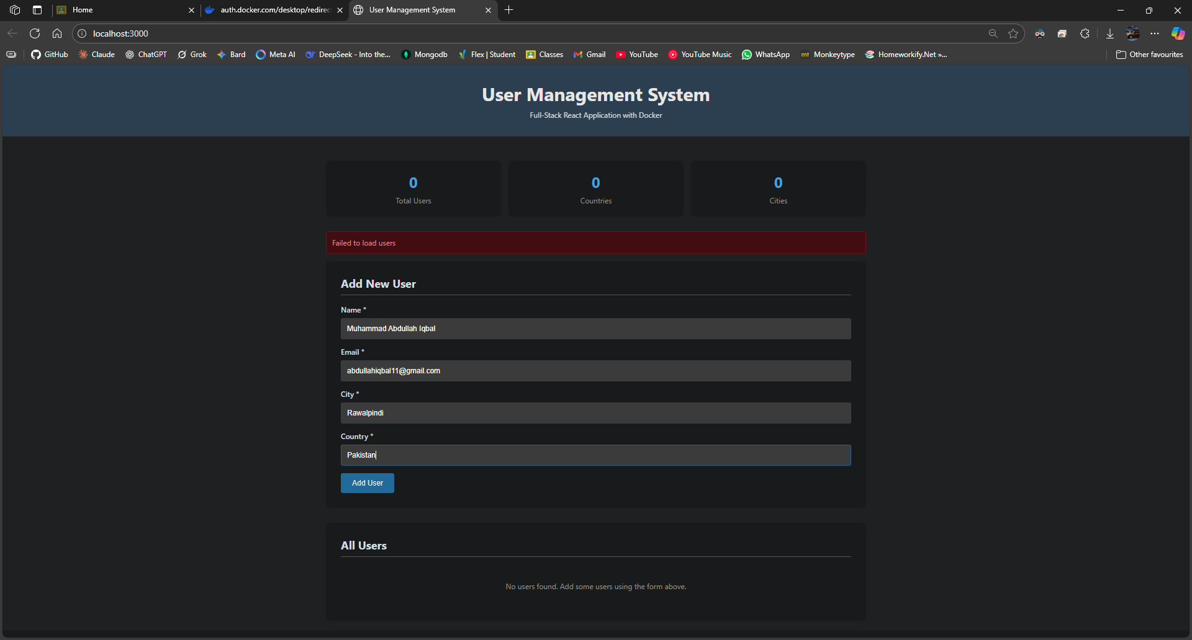

Failure to add a new user:

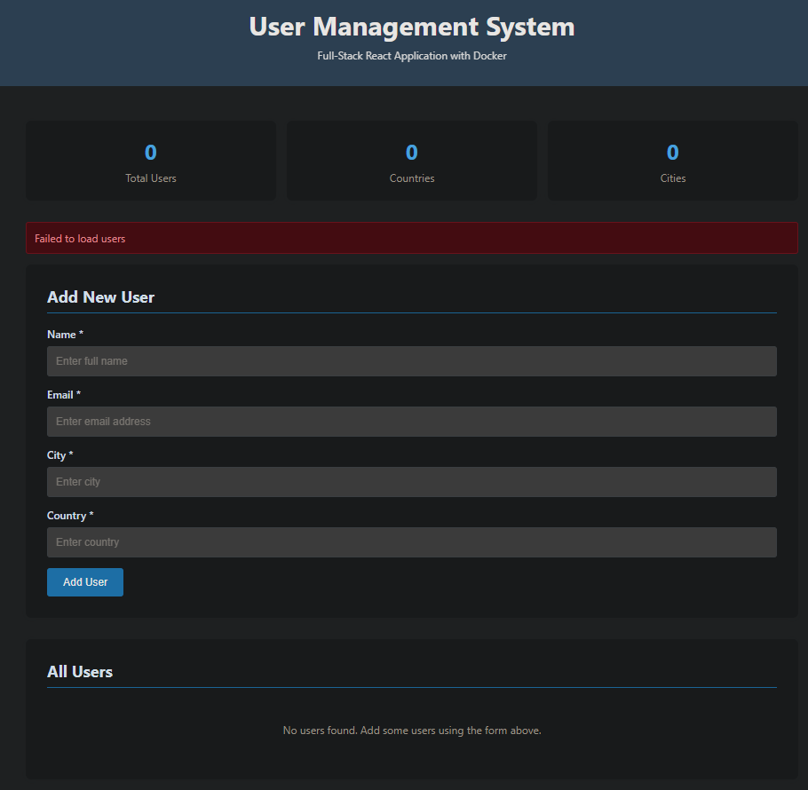

**After adding a user (fix) using watch:**

Table is shown:

Adding:

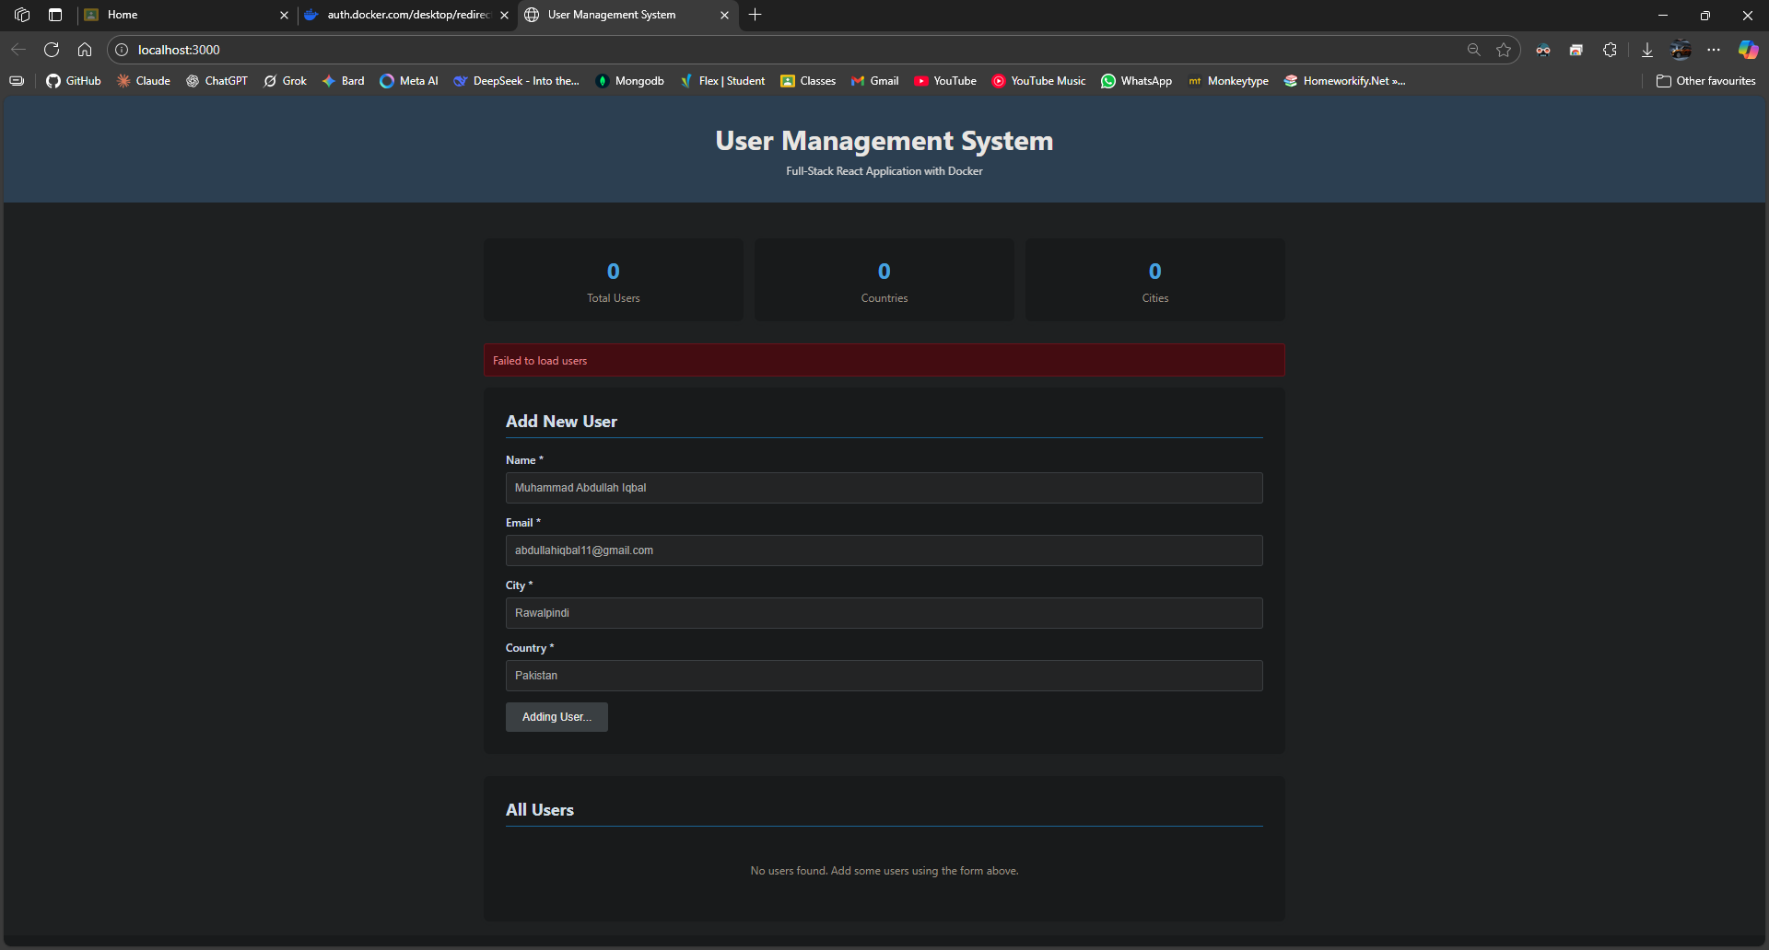

New user added:

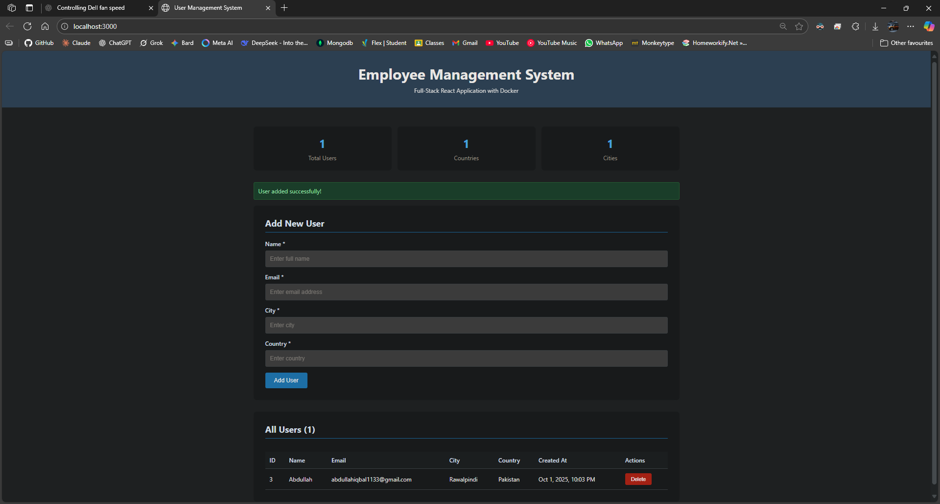

**Changing UI to ensure watch is working:**

Before: header:

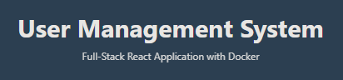

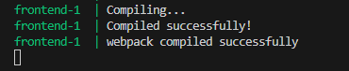



Works!!!