Software Design Document
AI Resume Screening System



Submitted by:
Muhammad Abdullah Khan
Roll No: F24BINCE1M0403>
Submitted to:
Muzammil ur Rehman

Department of Information Technology
Faculty of Computing
The Islamia University of Bahawalpur

Summery
This Software Design Document (SDD) presents the design and architectural details of the AI-Powered Resume Screening System. The project focuses on automating the resume evaluation process by analyzing and ranking candidate resumes based on their relevance to a given job description using Artificial Intelligence (AI) and Natural Language Processing (NLP) techniques. The system leverages NLP models to extract skills, experience, and keywords from resumes and compare them with job requirements to generate accurate matching scores.
This document provides a comprehensive overview of the system architecture, design decisions, data flow, algorithmic approach, and user interface components. It explains how different software modules—such as resume parsing, job description analysis, similarity scoring, and result visualization—interact to deliver efficient and unbiased resume screening. The purpose of this SDD is to clearly define the internal structure and behavior of the system, serving as a technical reference for system development, implementation, and academic evaluation.

Table of Content
Contents
Table of Content 2
1. Application Architecture 2
2. Data Model Schema 7
3. User Interface 8

Application Architecture
The AI-Powered Resume Screening System is designed using a modular layered architecture to ensure separation of concerns, scalability, and ease of maintenance. This architectural approach divides the system into independent and well-defined components, where each module is responsible for a specific functionality within the resume screening workflow. Such a design enhances system flexibility and allows future improvements such as model upgrades or integration with external HR platforms. The application follows a web-based client–server architecture. The backend is implemented using Python Flask, which handles business logic, AI processing, and data management, while the frontend is developed using HTML, CSS, and JavaScript to provide an interactive user interface. Internally, the system follows a controller-driven approach, where a central application controller manages communication between user requests, NLP processing modules, and data storage components.

Architectural Components
The major components of the system are described below:

User Interface Controller
Handles user interactions through the web interface, including uploading resumes, entering job descriptions, and displaying ranked resume results along with matching scores.

Resume Upload & Parsing Controller
Responsible for receiving resume files (PDF/DOCX), extracting textual content, and preprocessing the data for NLP analysis.

Job Description Processing Controller
Processes the job description input by the recruiter, extracting required skills, qualifications, and keywords using NLP techniques.

Resume Matching & Ranking Controller
Applies NLP models to compare resume content with the job description and calculates similarity scores to rank candidates based on relevance.

AI/NLP Engine
Utilizes spaCy and/or HuggingFace Transformers to perform text vectorization, keyword extraction, semantic similarity analysis, and contextual understanding.

Database Controller
Manages storage of uploaded resumes, job descriptions, candidate metadata, and screening results in the database.

Logging & Audit Controller
Maintains logs of screening activities, including timestamps, scoring results, and system events for transparency and evaluation purposes.

Controllers and Their Functions
Controller Name | Major Functions
UIController | uploadResume(), submitJobDescription(), displayResults()
ResumeParserController | readFile(), extractText(), preprocessText()
JobDescriptionController | analyzeJobText(), extractKeywords()
MatchingController | computeSimilarity(), rankResumes()
NLPEngineController | loadModel(), generateEmbeddings()
DatabaseController | saveData(), retrieveResults()
LoggingController | logScreeningActivity()

APIs and Libraries Used
The system utilizes the following libraries and technologies:
- Flask: Backend web framework for request handling and routing
- spaCy: NLP library for text preprocessing and entity extraction
- HuggingFace Transformers: Used for advanced language models and semantic similarity computation
- NLTK: Optional support for tokenization and stop-word removal
- HTML, CSS, JavaScript: Frontend user interface development
- SQLite / MySQL: Database for storing resumes, job descriptions, and screening results
The system primarily operates as a local or private web application. External APIs are not mandatory, ensuring data privacy and secure handling of candidate information.

UML Diagrams
The following UML diagrams are used to illustrate the system design:

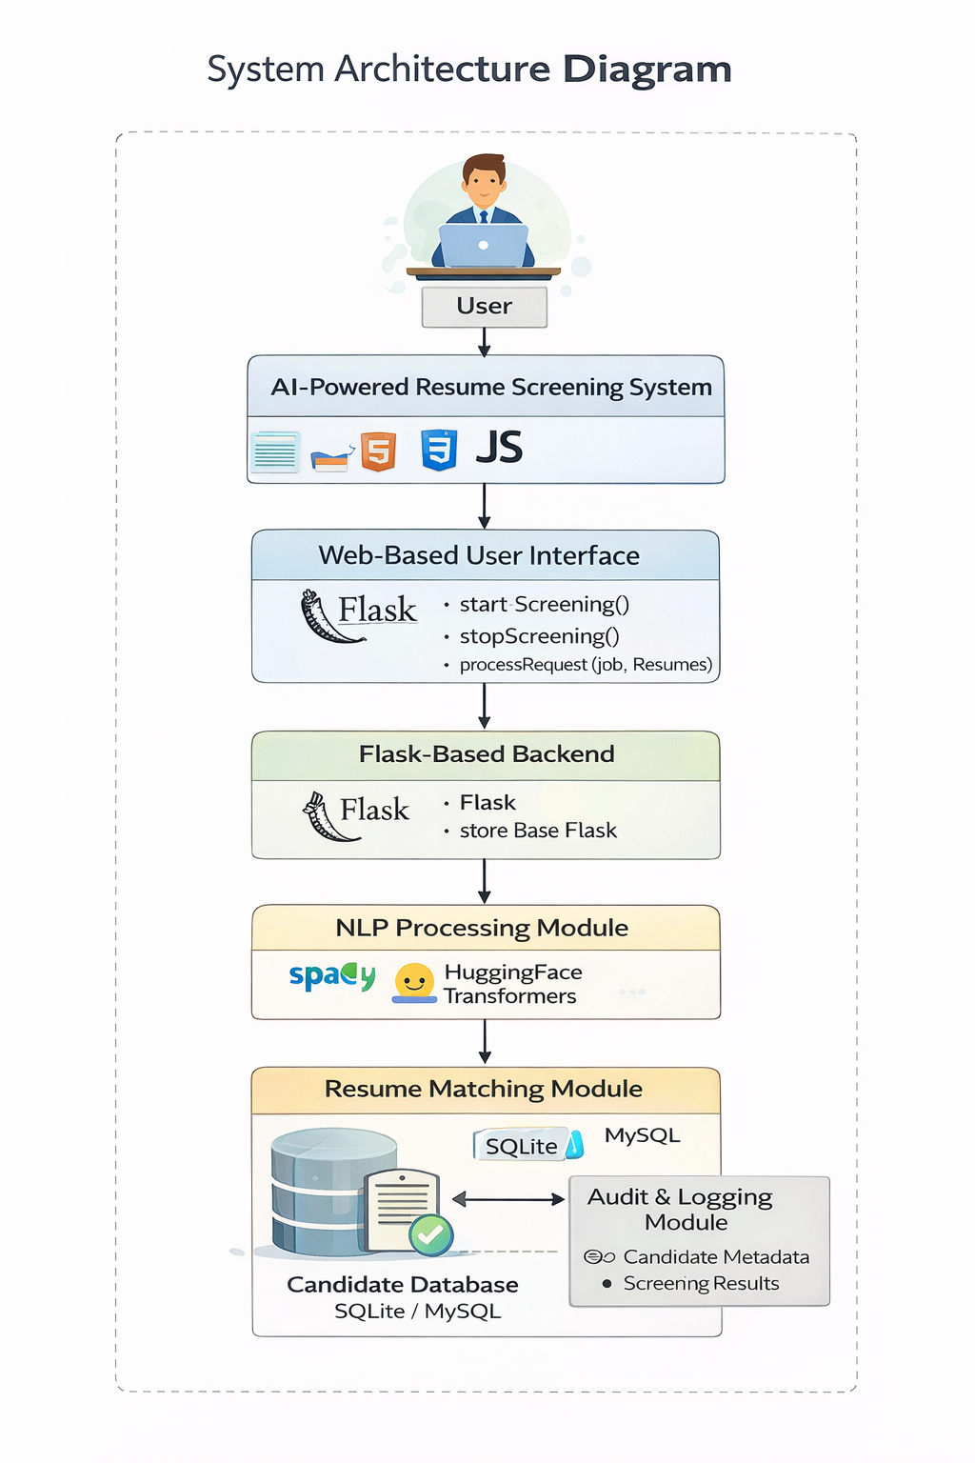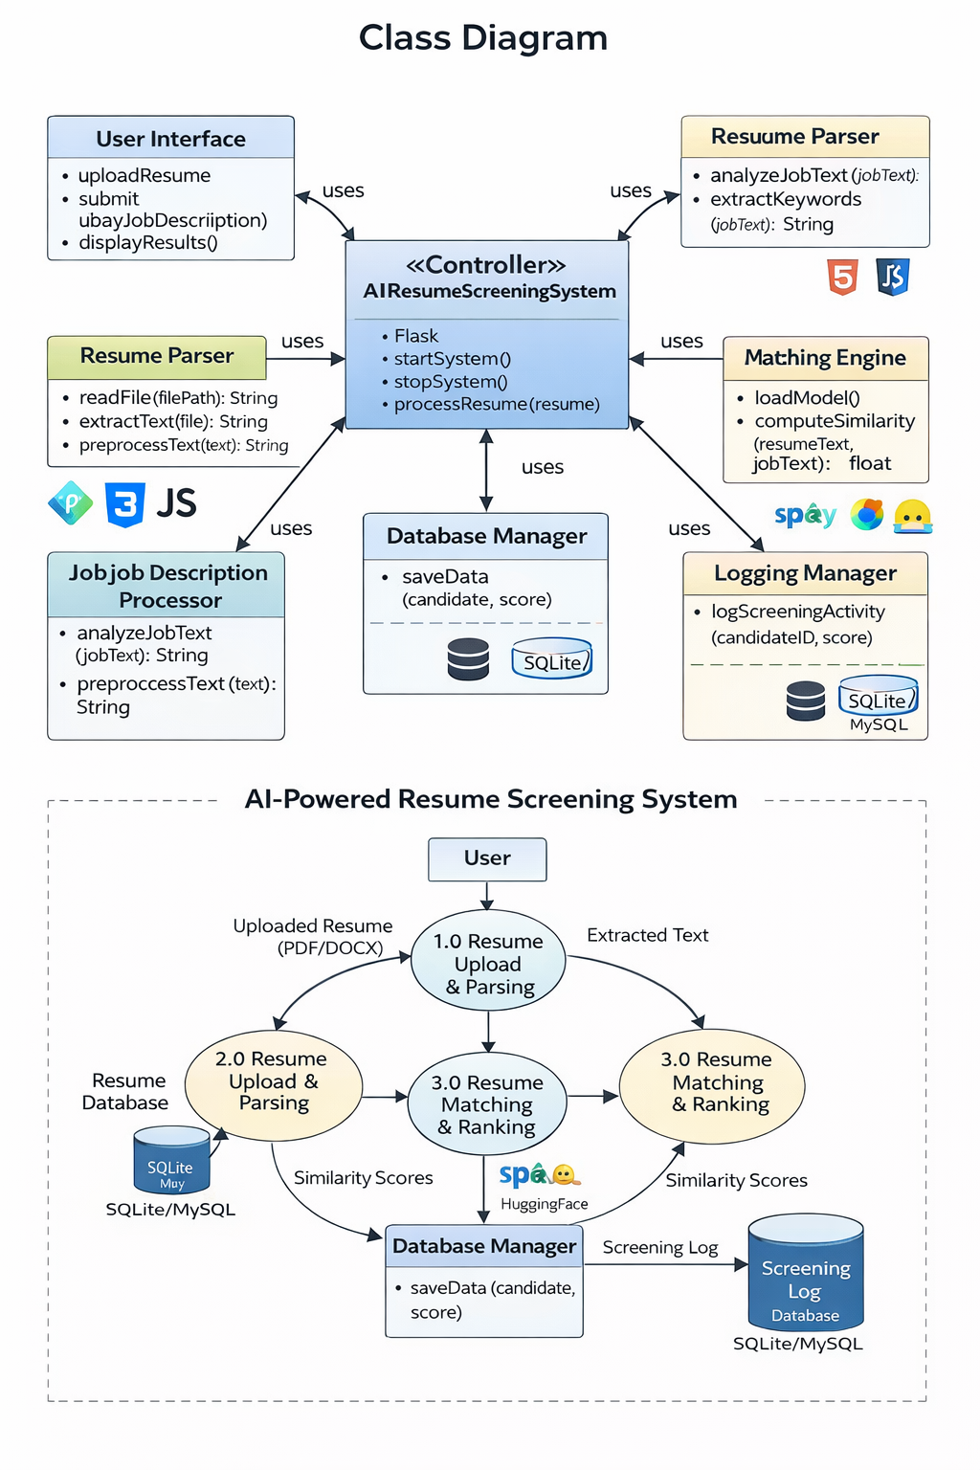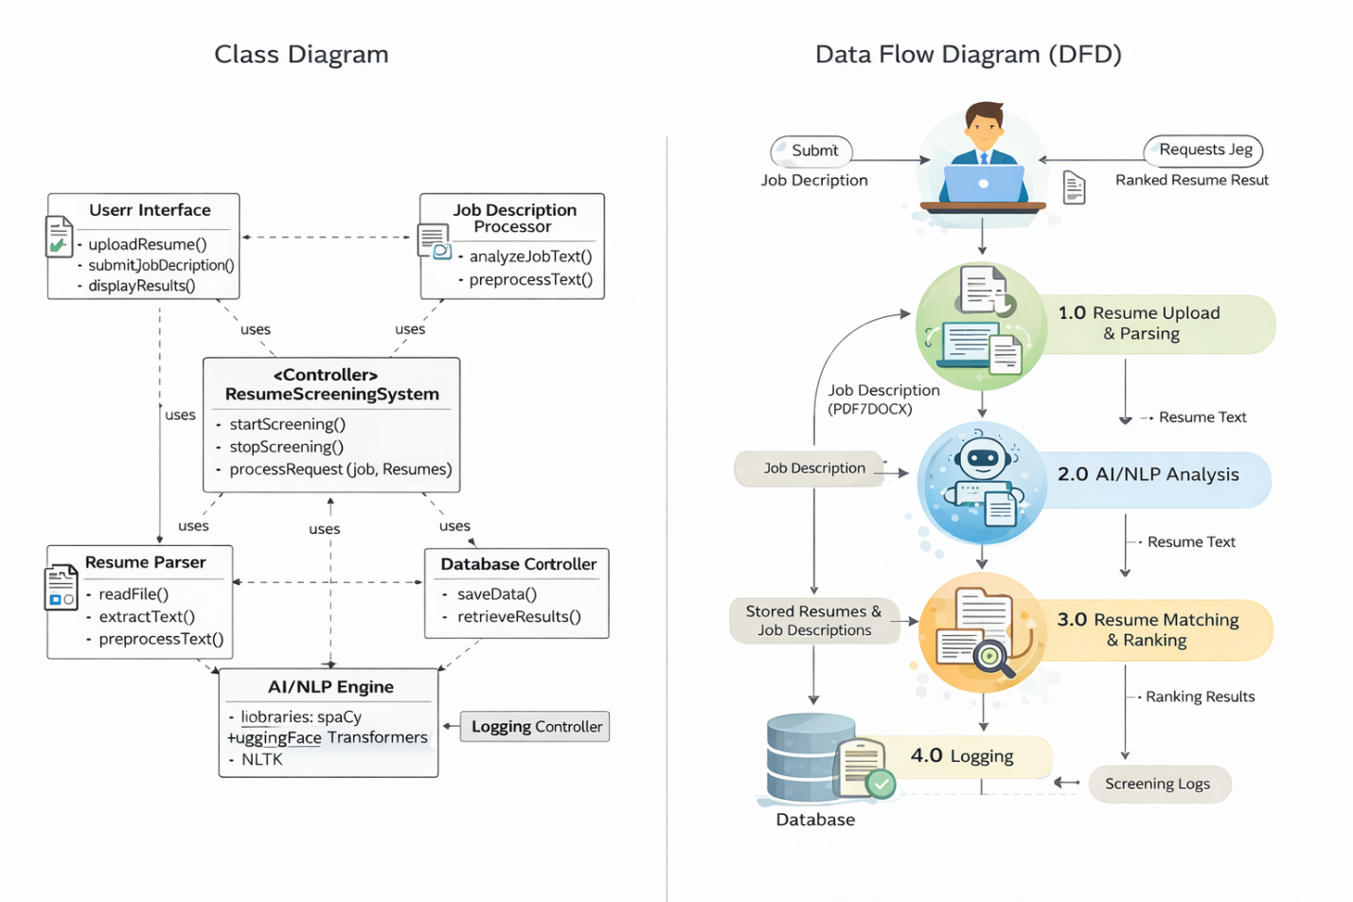

Coding Conventions
The development of the AI-Powered Resume Screening System follows standard Python and web development coding conventions to ensure code readability, maintainability, and scalability.
- Python naming conventions are strictly followed
- Classes are named using PascalCase
- Functions and variables use snake_case
- Each major system component is implemented in a separate modular file
- Meaningful comments and documentation strings (docstrings) are added where necessary
- Frontend code follows standard HTML, CSS, and JavaScript best practices

1. Data Model Schema
The AI-Powered Resume Screening System uses a relational database to store resume data, job descriptions, screening results, and system logs. The database is designed to be lightweight yet extensible to support future enhancements such as recruiter analytics and historical candidate tracking.

Entity: Candidate
This entity stores basic information about each candidate.
Attribute | Description
Candidate_ID | Unique identifier (Primary Key)
Name | Candidate full name
Email | Candidate email address
Resume_Text | Extracted resume content
Upload_Timestamp | Date and time of resume upload

Entity: Job_Description
This entity stores job description details provided by the recruiter.
Attribute | Description
Job_ID | Unique identifier (Primary Key)
Job_Title | Title of the job role
Job_Text | Job description content
Created_Timestamp | Date and time of job creation

Entity: Screening_Result
This entity stores resume screening and ranking results.
Attribute | Description
Result_ID | Unique identifier (Primary Key)
Candidate_ID | Candidate identifier (Foreign Key)
Job_ID | Job identifier (Foreign Key)
Match_Score | Resume-to-job similarity score
Rank | Assigned ranking position
Screening_Timestamp | Date and time of screening
Each screening result represents a single resume evaluation event. Foreign key relationships are used to maintain logical associations between candidates, job descriptions, and screening outcomes.

ER Diagram
An Entity Relationship (ER) diagram is used to visually represent the database structure, including entities, attributes, and relationships between candidate data, job descriptions, and screening results.

2. User Interface
The user interface of the AI-Powered Resume Screening System is designed with a strong focus on usability, clarity, and efficiency. The web-based interface allows recruiters to easily upload resumes, enter job descriptions, and view ranked screening results.

Design Philosophy
- Clean and professional layout
- Simple color scheme suitable for HR applications
- Readable fonts and structured content sections
- Minimal but effective controls
- Responsive web-based design compatible with desktop browsers

Screens and Description

Main Dashboard
- Allows uploading of multiple resumes (PDF/DOCX)
- Provides input field for job description
- Displays ranked list of candidates
- Shows match scores and screening status

Controls Used
Control | Purpose
File Upload Button | Upload candidate resumes
Text Area | Enter job description
Submit Button | Start resume screening process
Table/Grid View | Display ranked resumes and scores

Input Constraints
- Resume files must be in PDF or DOCX format
- Maximum file size restrictions may apply
- Job description must be provided before screening
- Internet or local server must be running for backend processing

