Name: Muhammad Abu Bakar

Roll Number: 24k-0826

Section: BCS–1D

Week3 – PF Lab

Teacher: Sir Muhammad Aashir

Screenshots

Question-1

Answer-1) The reason is that the value assigned to the variable "testInteger" is "3000000000" which exceedes the maximum limit of data that can be stored by a variable of Integer datatype. Hence, when the program is executed the value displayed in the command prompt/terminal window that is out of the blue, an error value.

Question-2

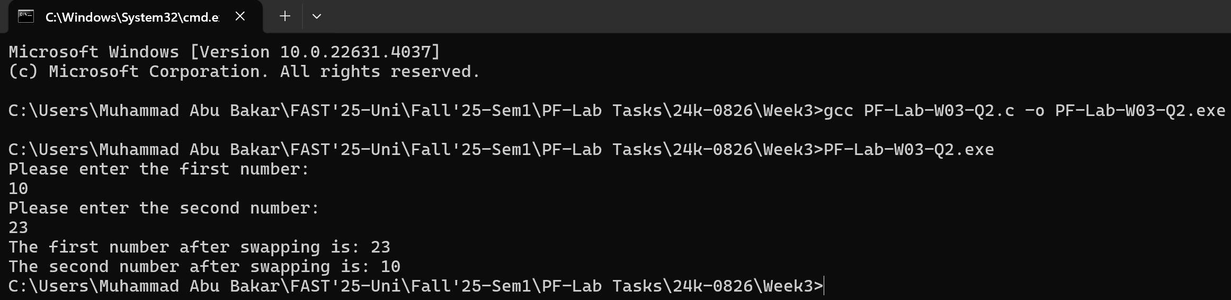

Question-3

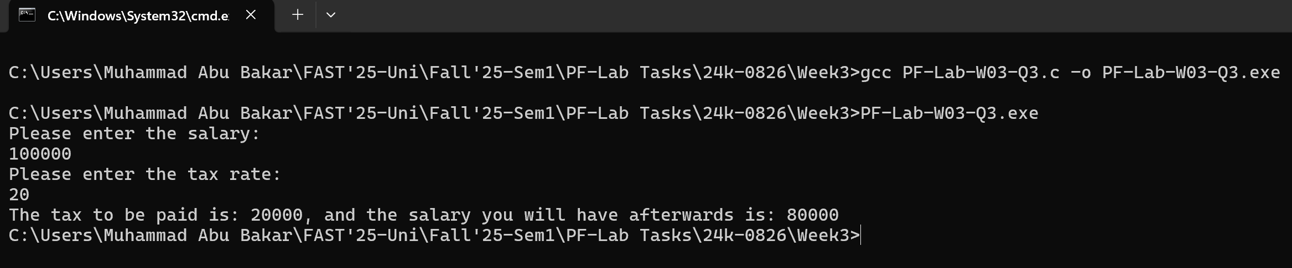

Question-4

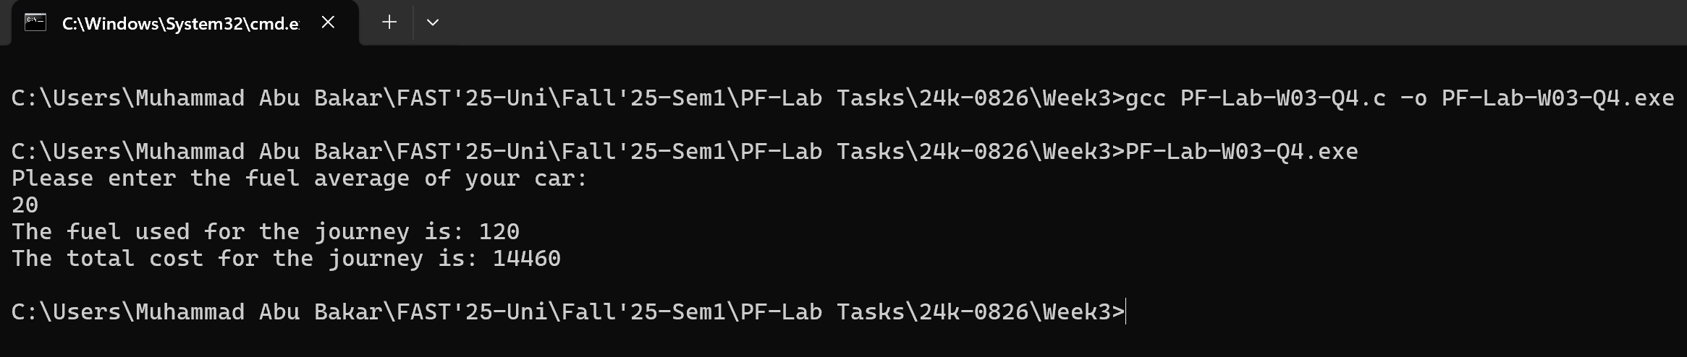

Question-5

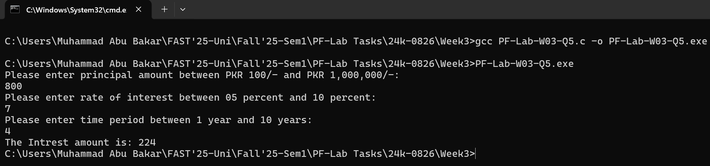

Question-6

