Name: Muhammad Abu Bakar

Roll Number: 24k-0826

Section: BCS–1D

Week5 – PF Lab

Teacher: Sir Muhammad Aashir

Screenshots

**Section-1**

Question-1

Question-2

**Section-2**

Question-1

Question-2

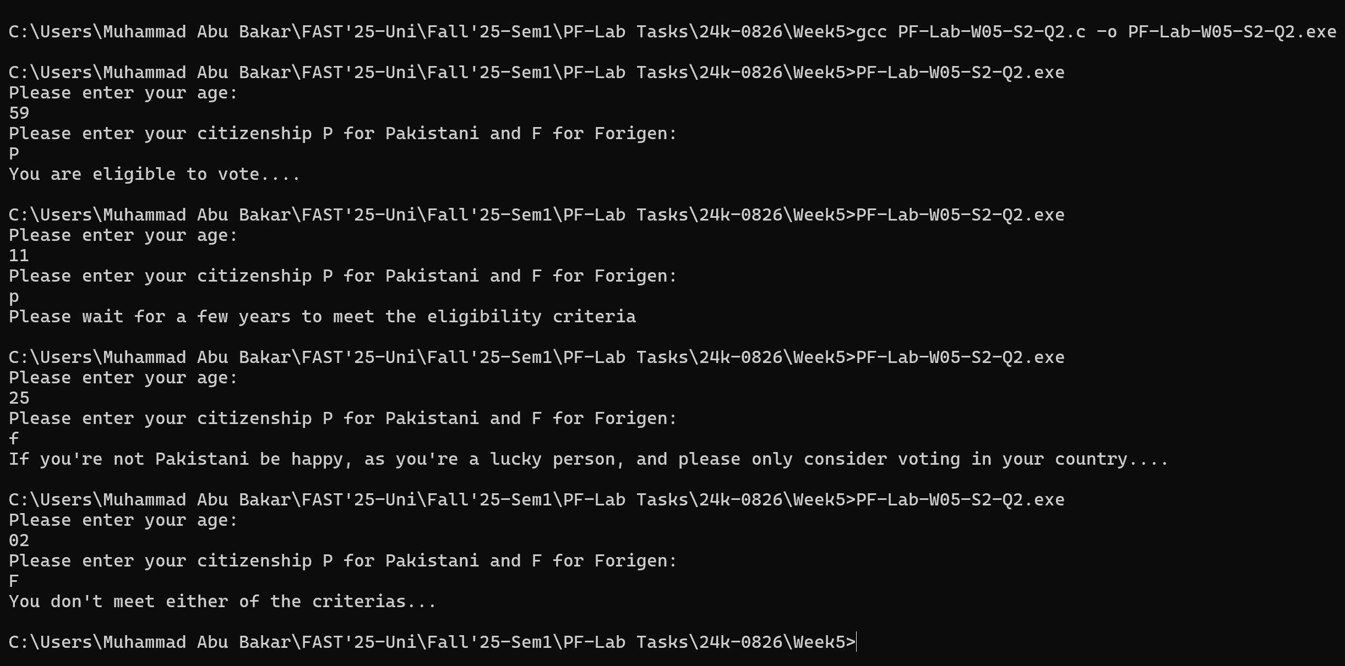

**Section-3**

Question-1

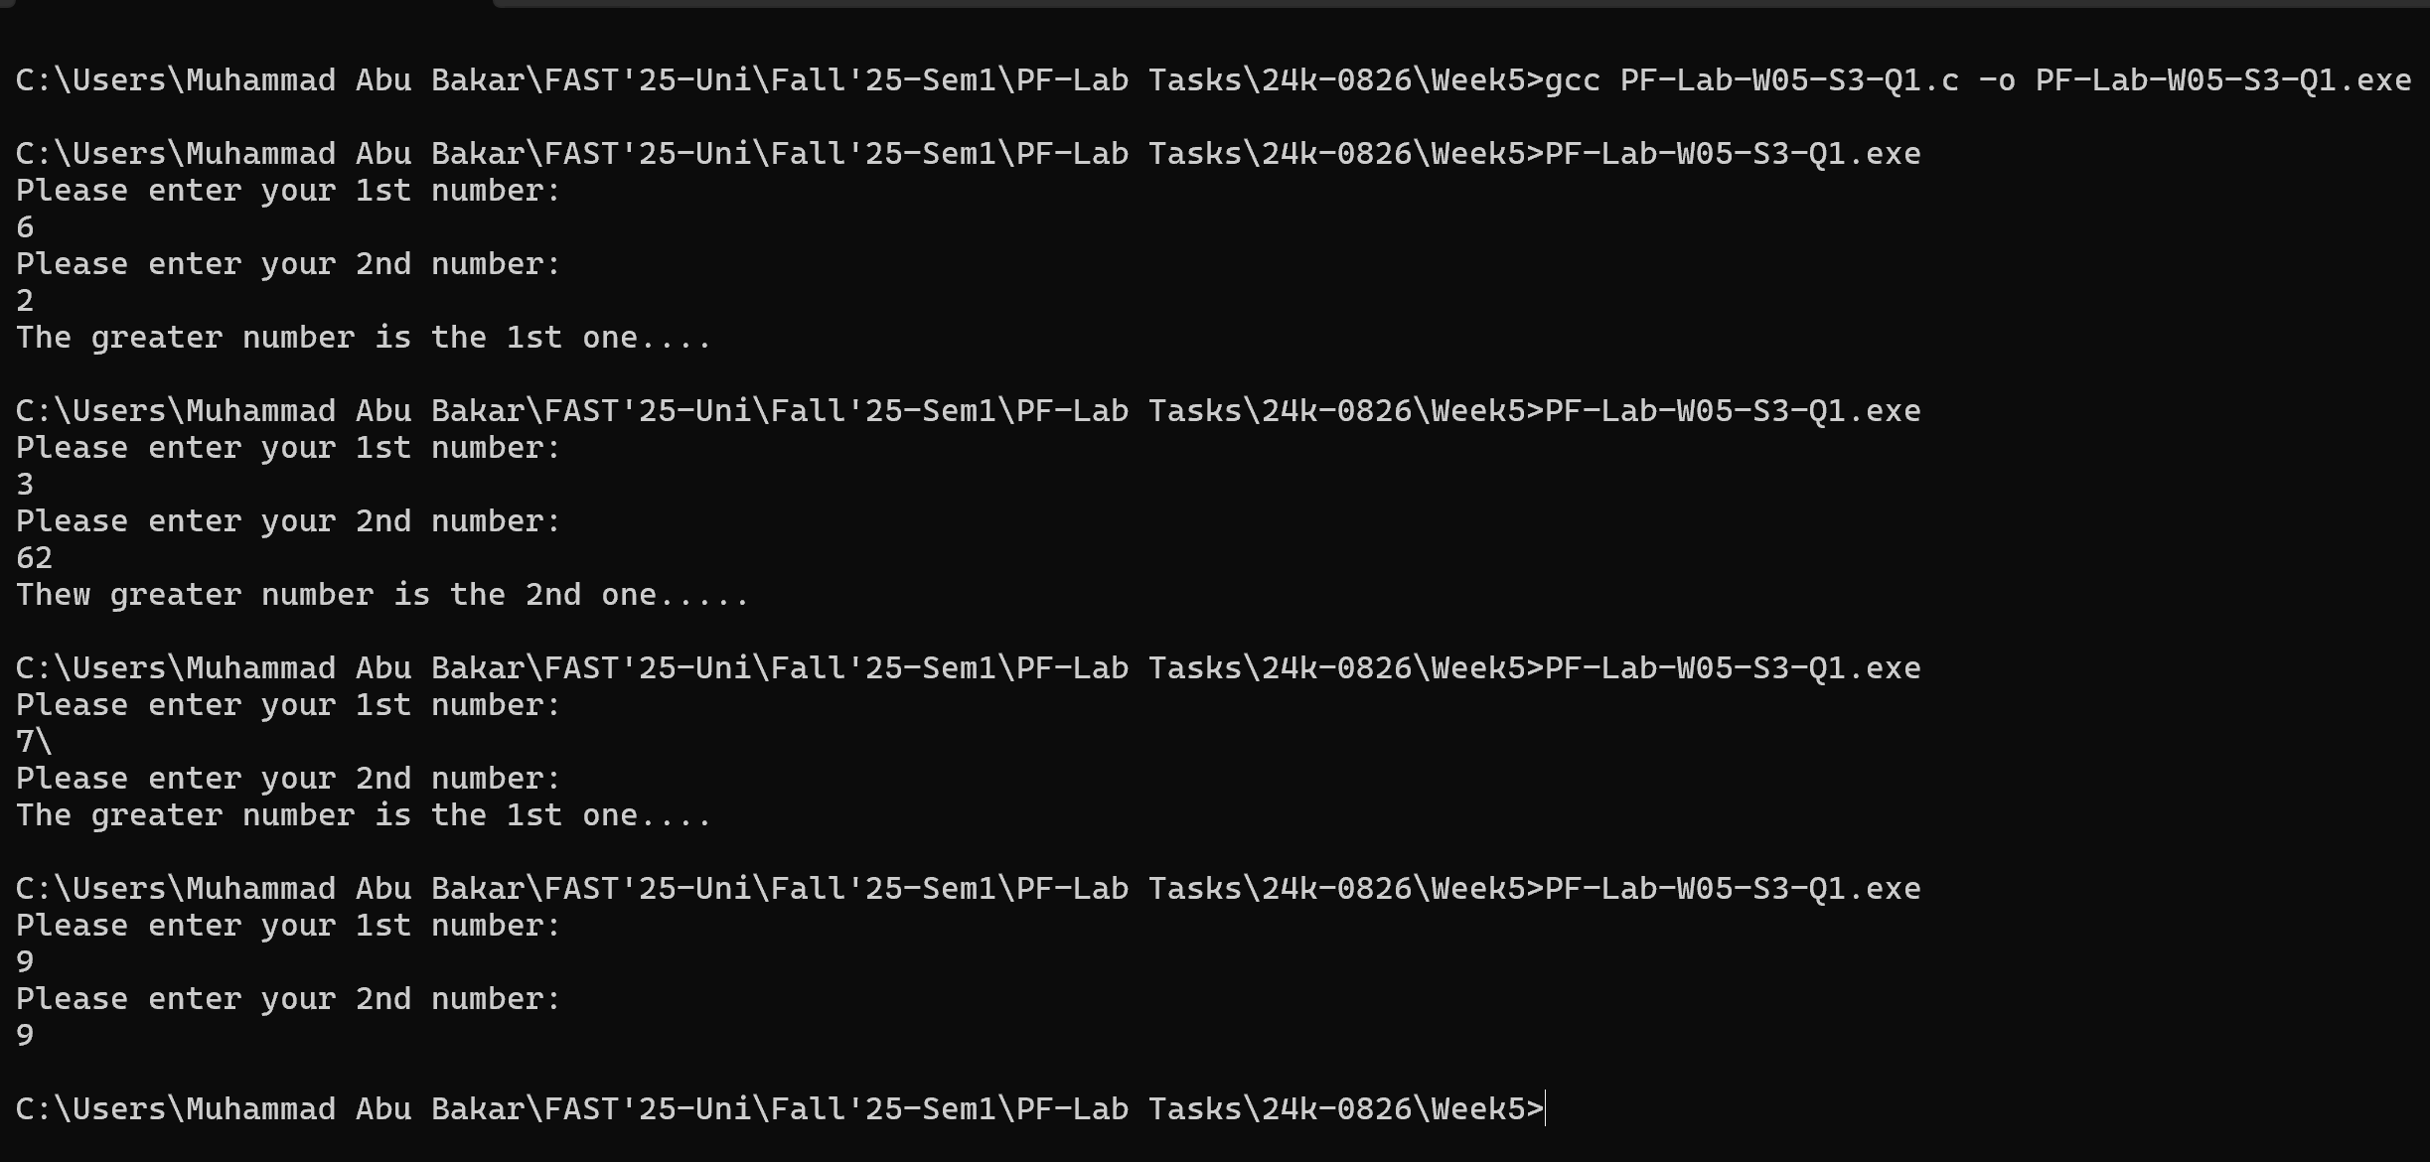

Question-2

**Section-4**

Question-1

Question-2

(This was not part of the assignment, However I had an idea on how to solve this that’s why I went ahead to attempt this)

**Section-5**

Question-1

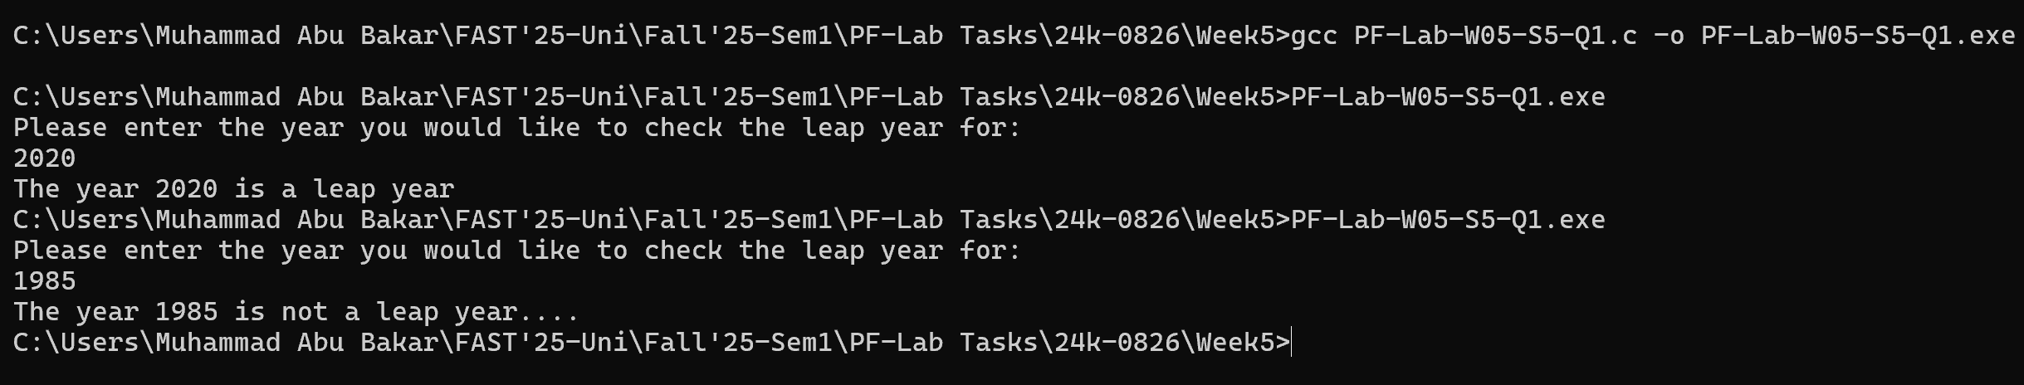

Question-2

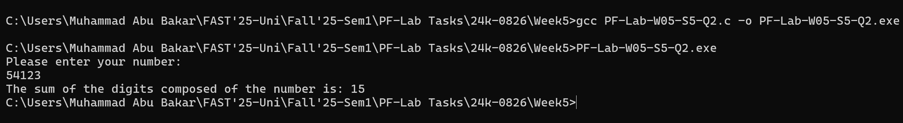

**More Problems**

Question-1

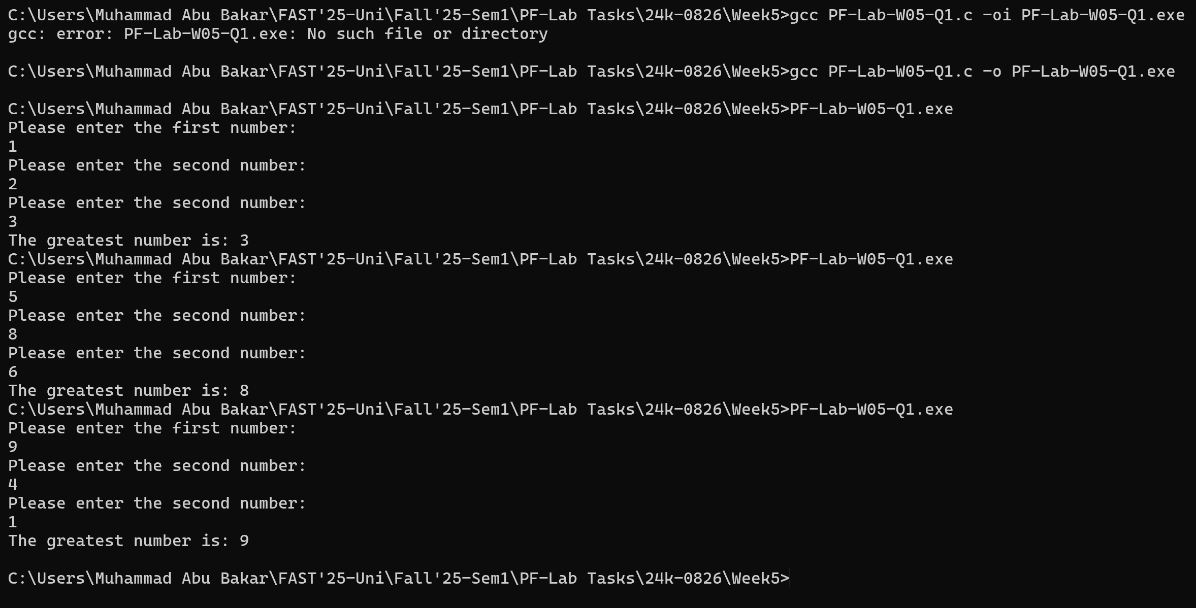

Question-2

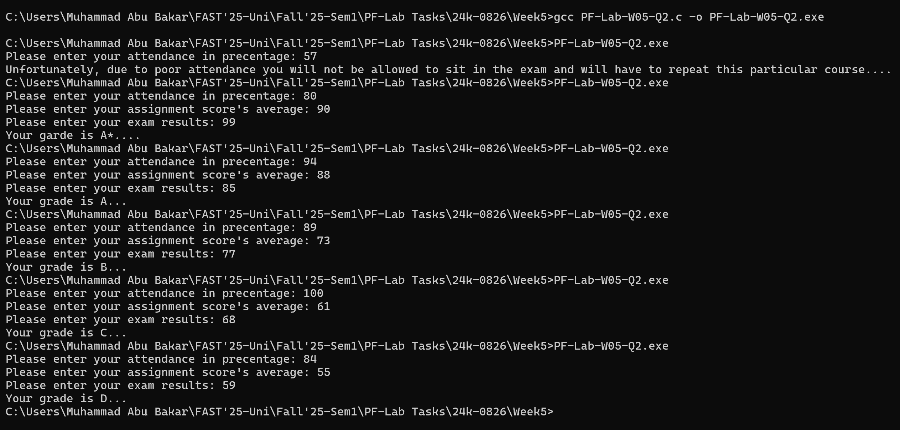

Question-3

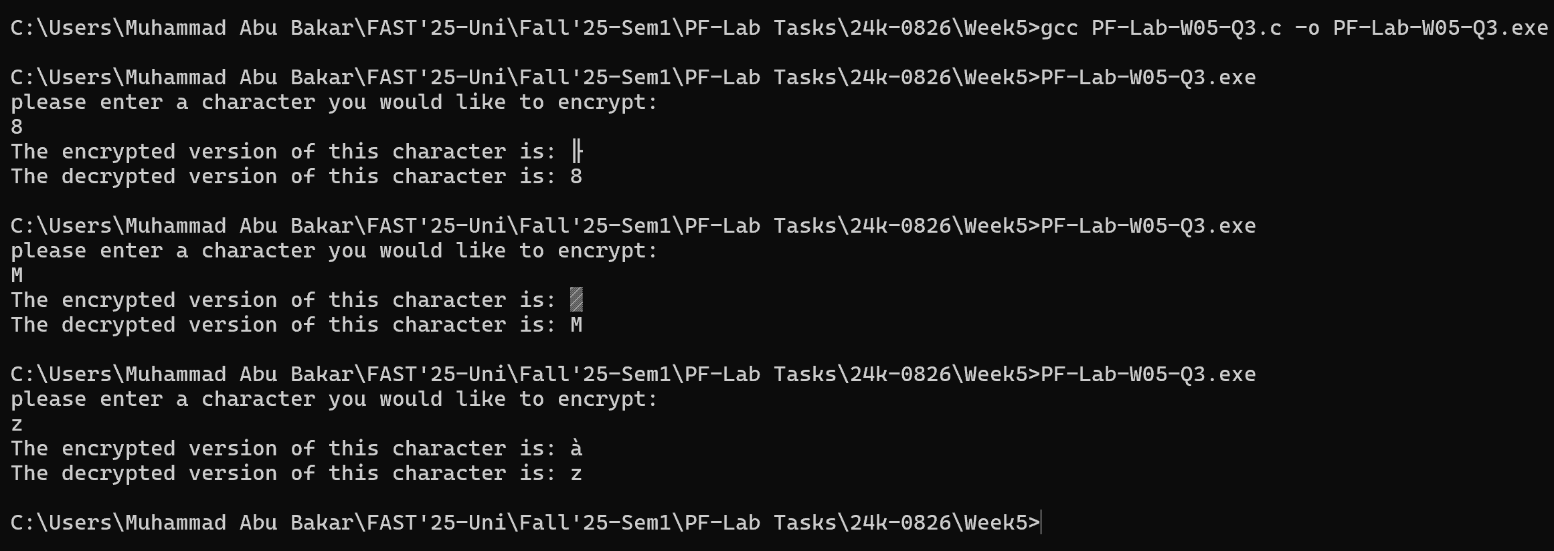

Question-4

