Name: Muhammad Abu Bakar

Roll Number: 24k-0826

Section: BCS–1D

Week6 – PF Lab

Teacher: Sir Muhammad Aashir

Screenshots

Question-1

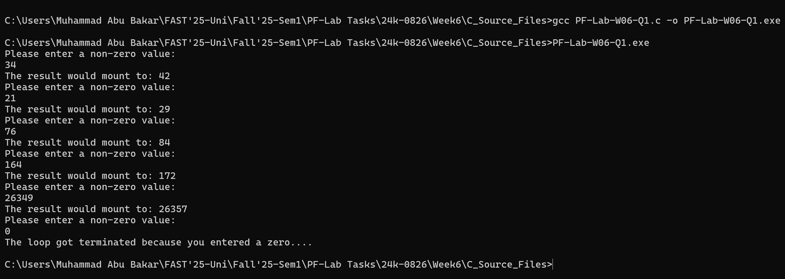

Question-2

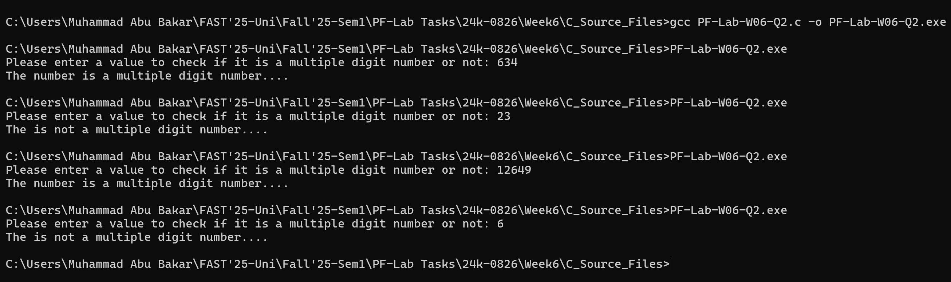

Question-3

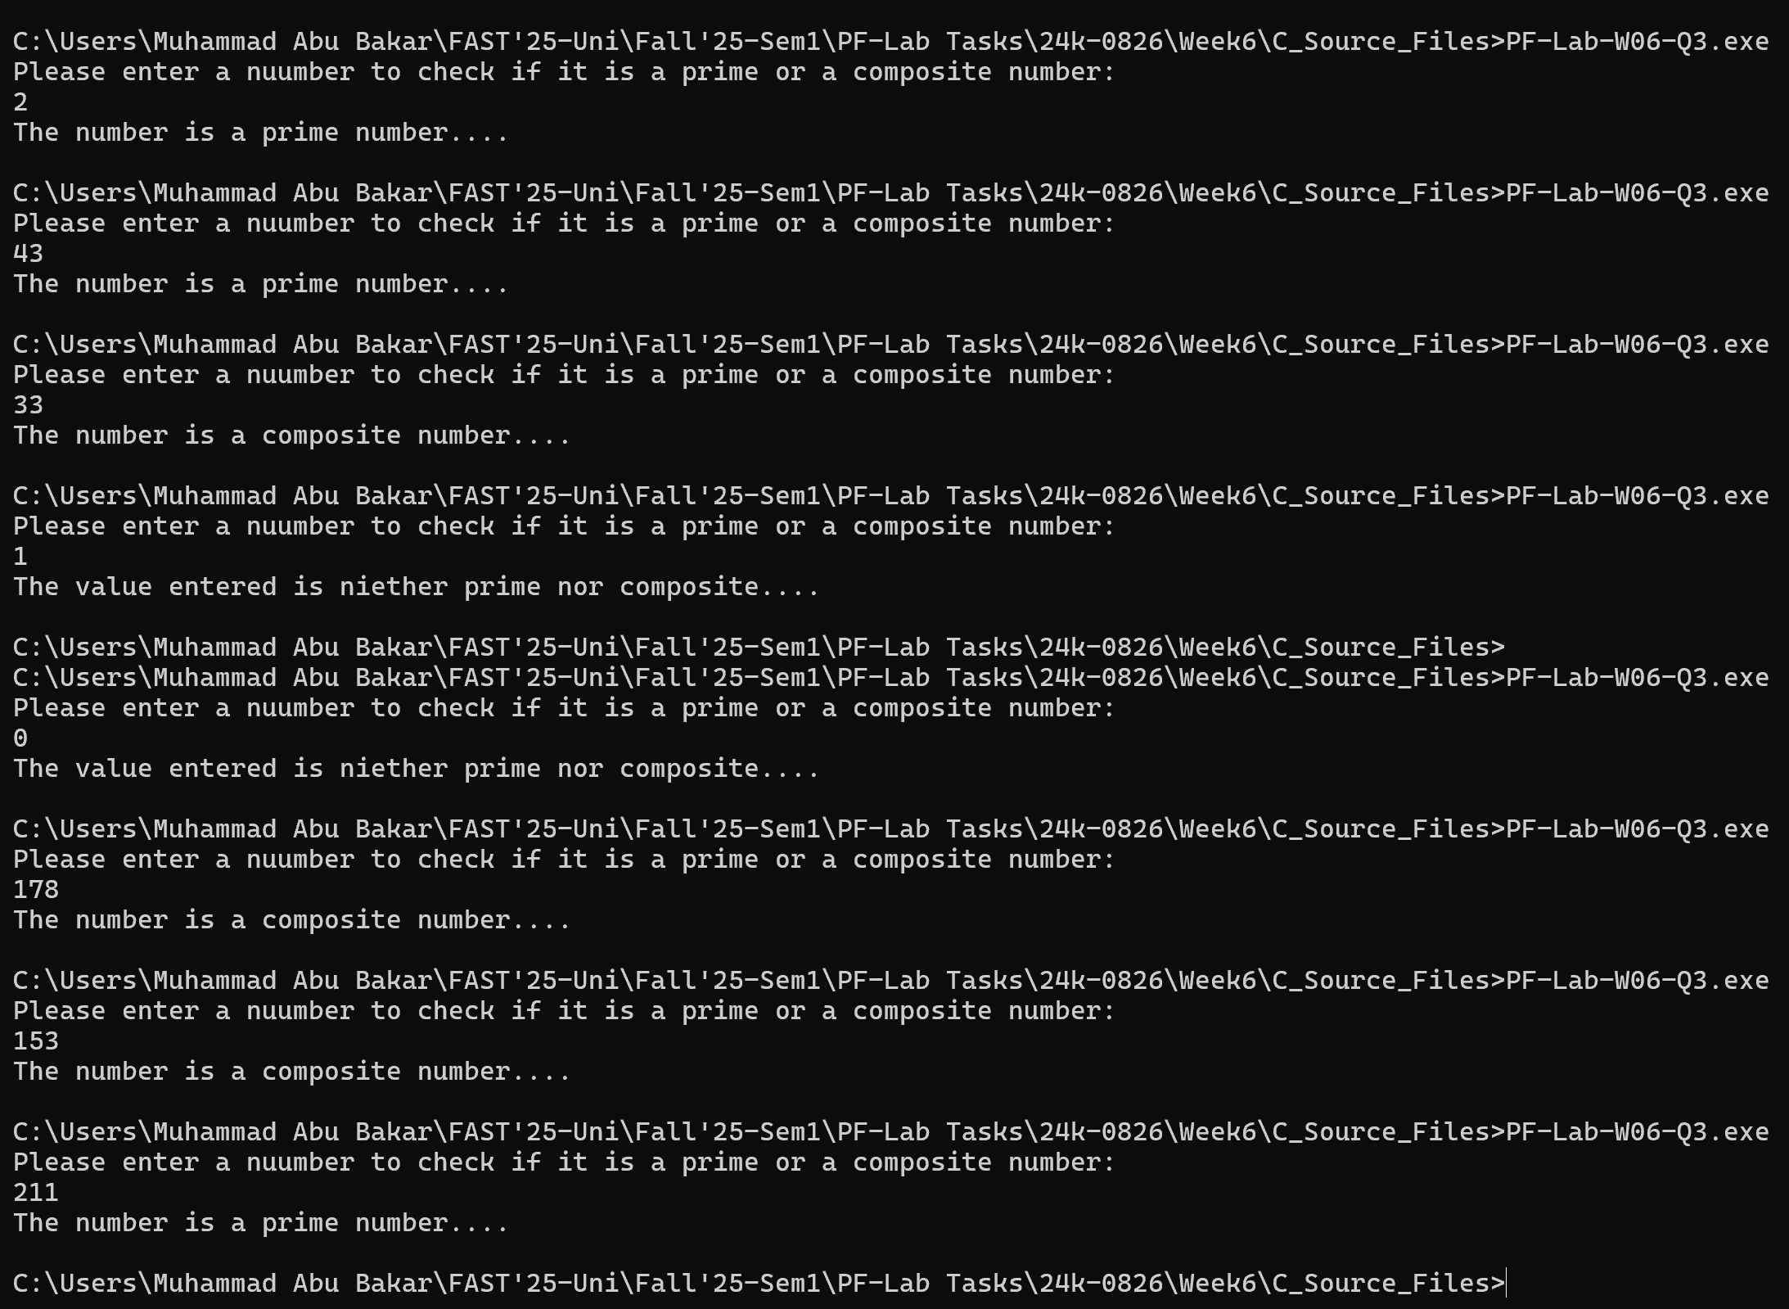

Question-4



Question-5



Question-6

