Name: Muhammad Abu Bakar
NUID: 24K-0826
Section: BCS-243D
Syllabus: Database Systems Lab
Syllabus Code: CL2005
Instructor: Sir Osama Tahir

Q1)
Query:
SELECT e.first_name, d.department_name
FROM HR.employees e
INNER JOIN HR.departments d ON e.department_id = d.department_id;

Snapshot:
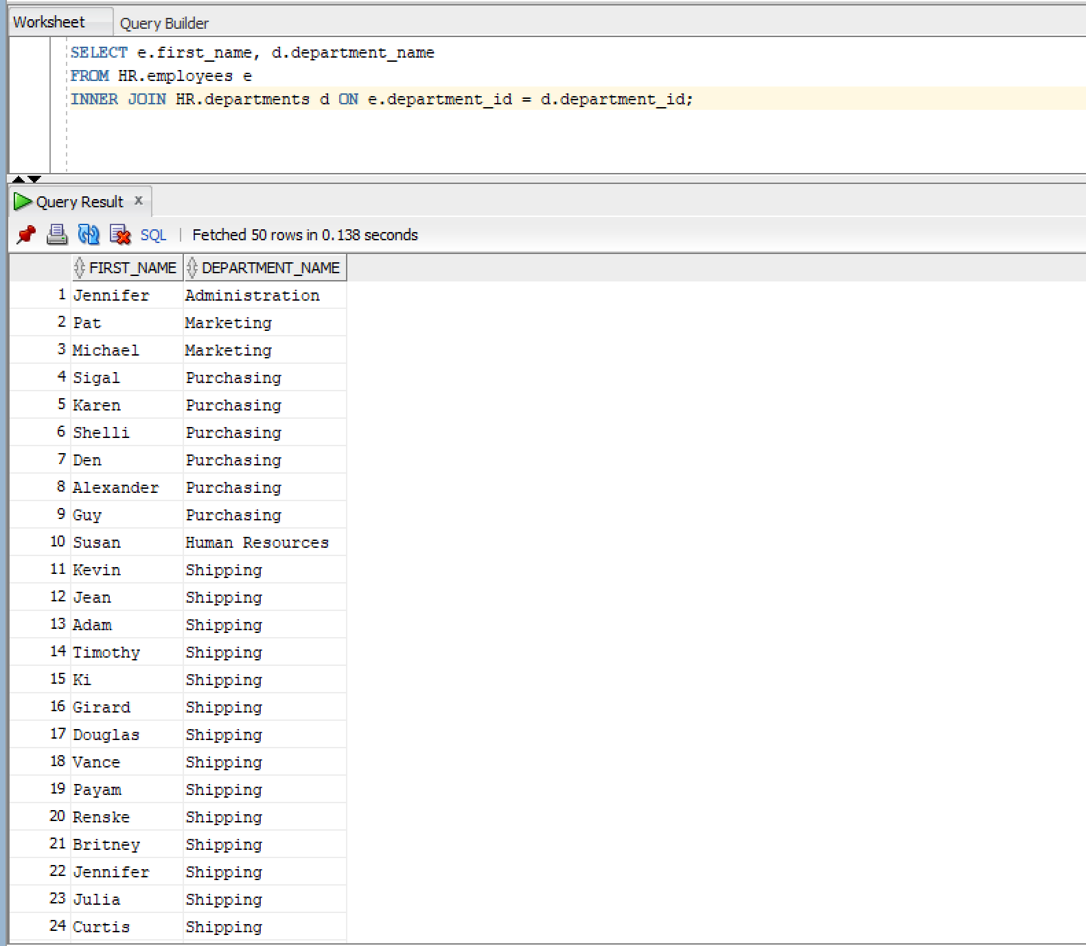

Q2)
Query:
SELECT e.first_name, e.last_name, d.department_name
FROM HR.employees e
LEFT OUTER JOIN HR.departments d ON e.department_id = d.department_id;

Snapshot:
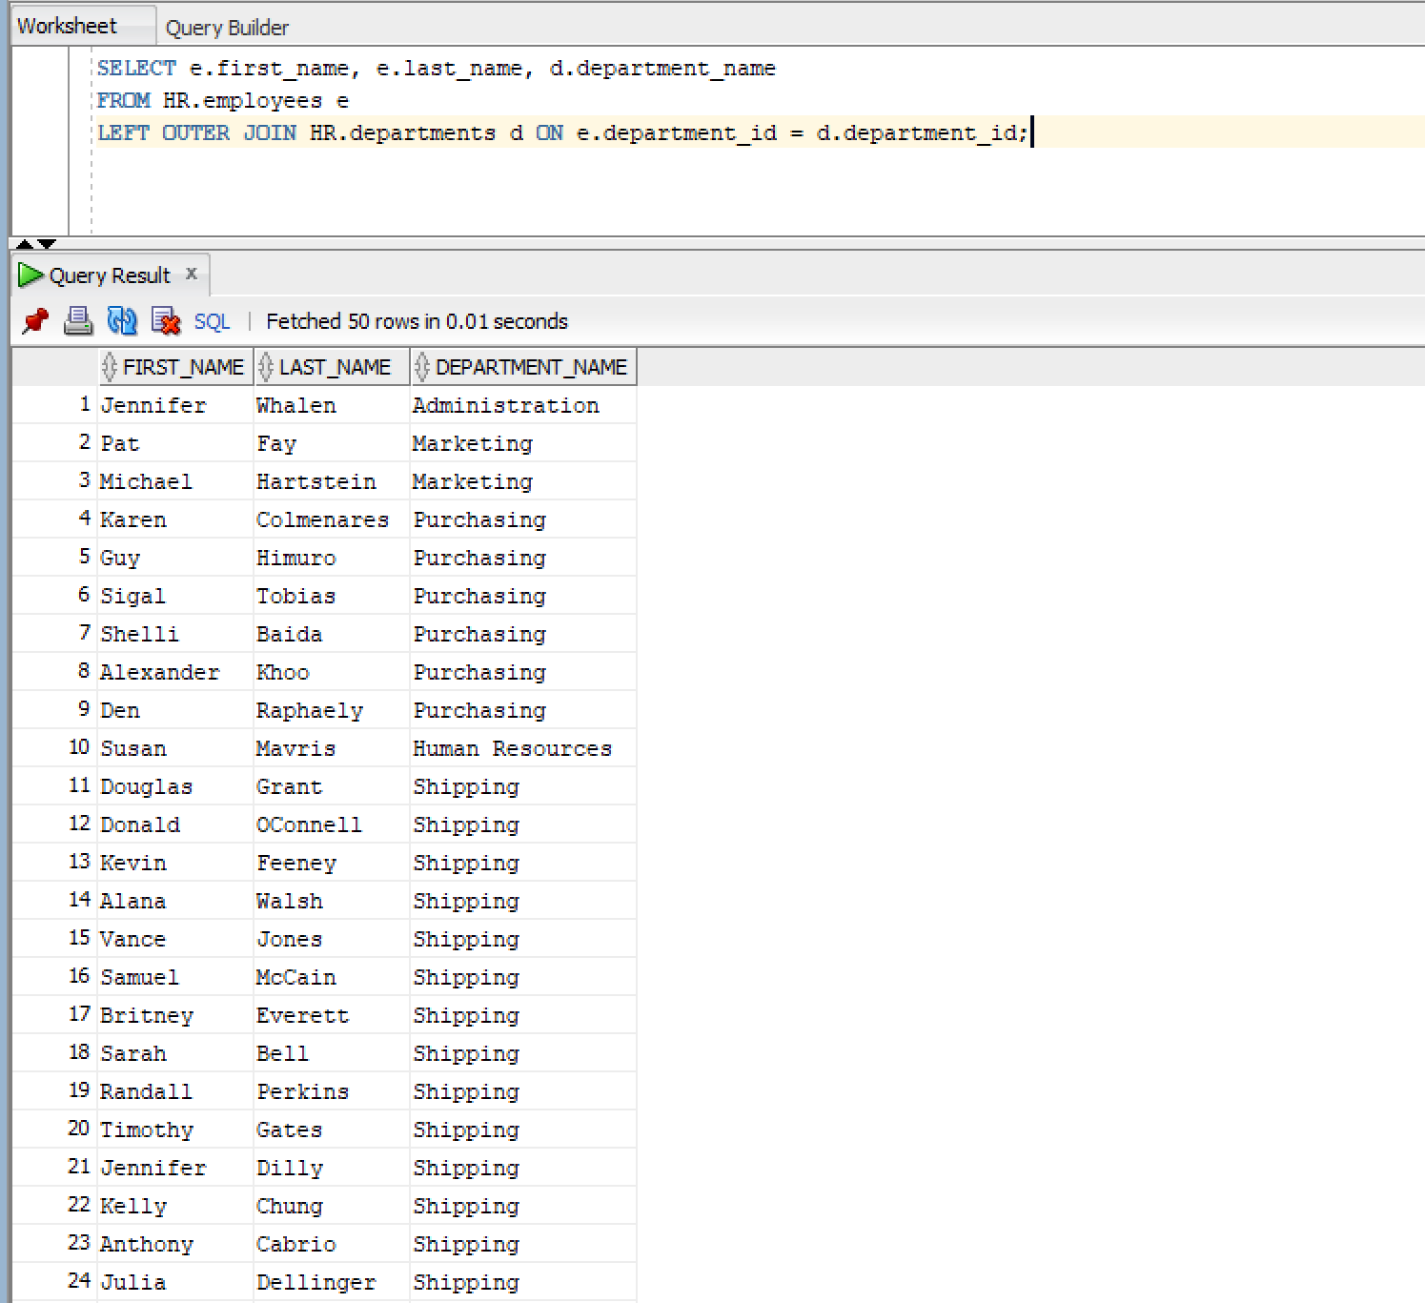

Q3)
Query:
SELECT d.department_name, e.first_name, e.last_name
FROM HR.departments d
LEFT OUTER JOIN HR.employees e ON d.department_id = e.department_id;

Snapshot:
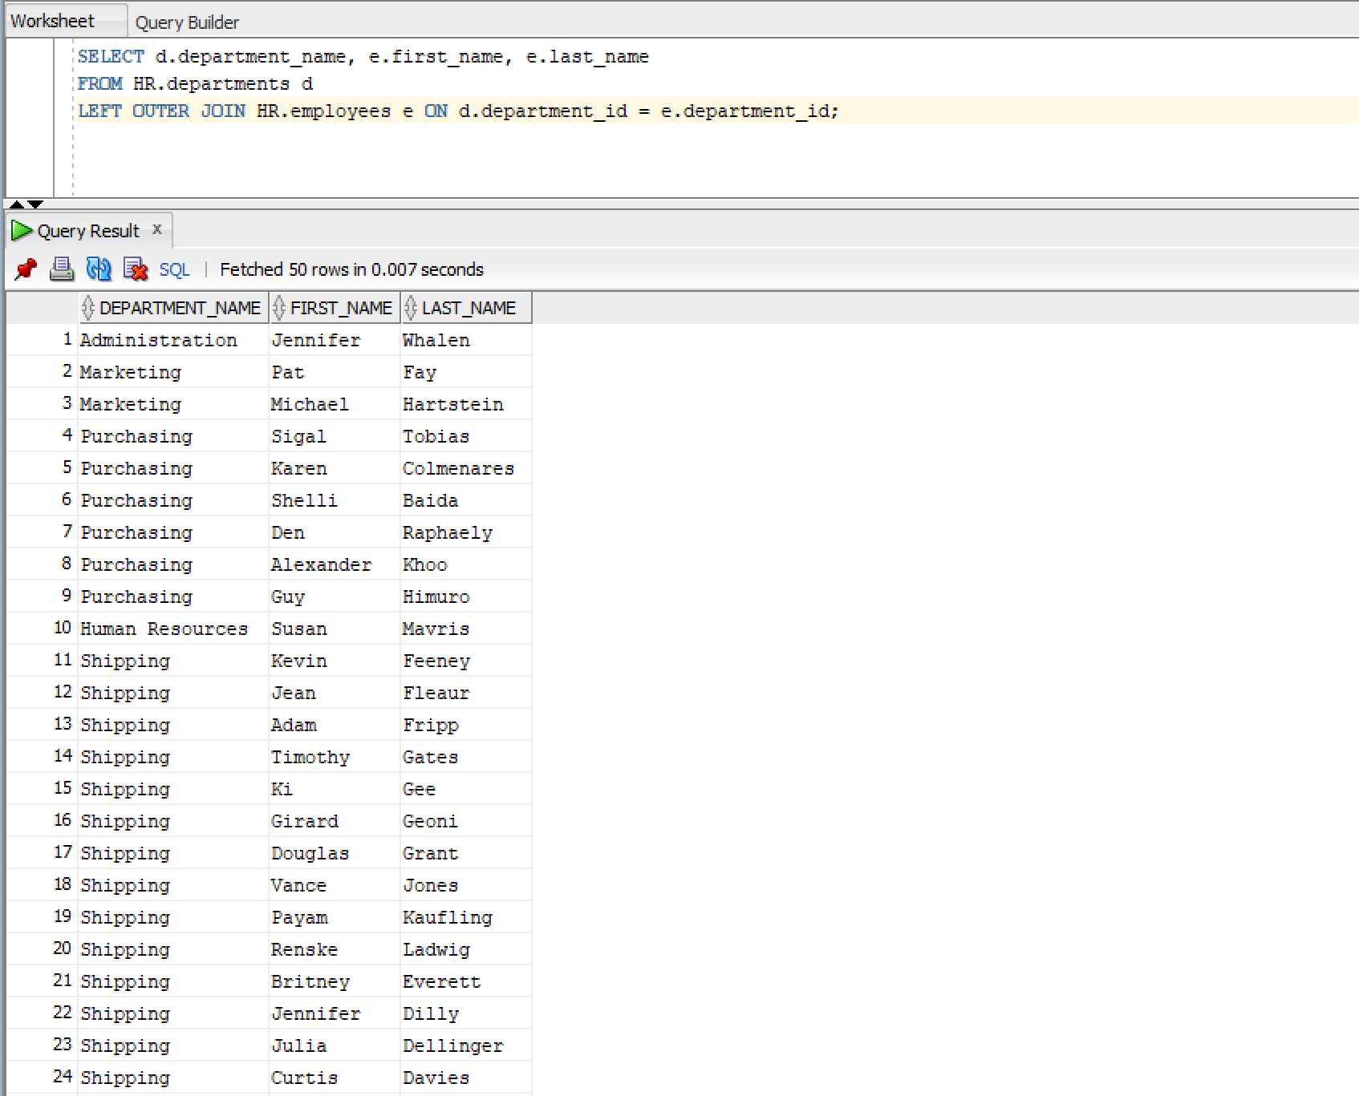

Q4)
Query:
SELECT e.first_name, j.job_title
FROM HR.employees e
JOIN HR.jobs j ON e.job_id = j.job_id;

Snapshot:
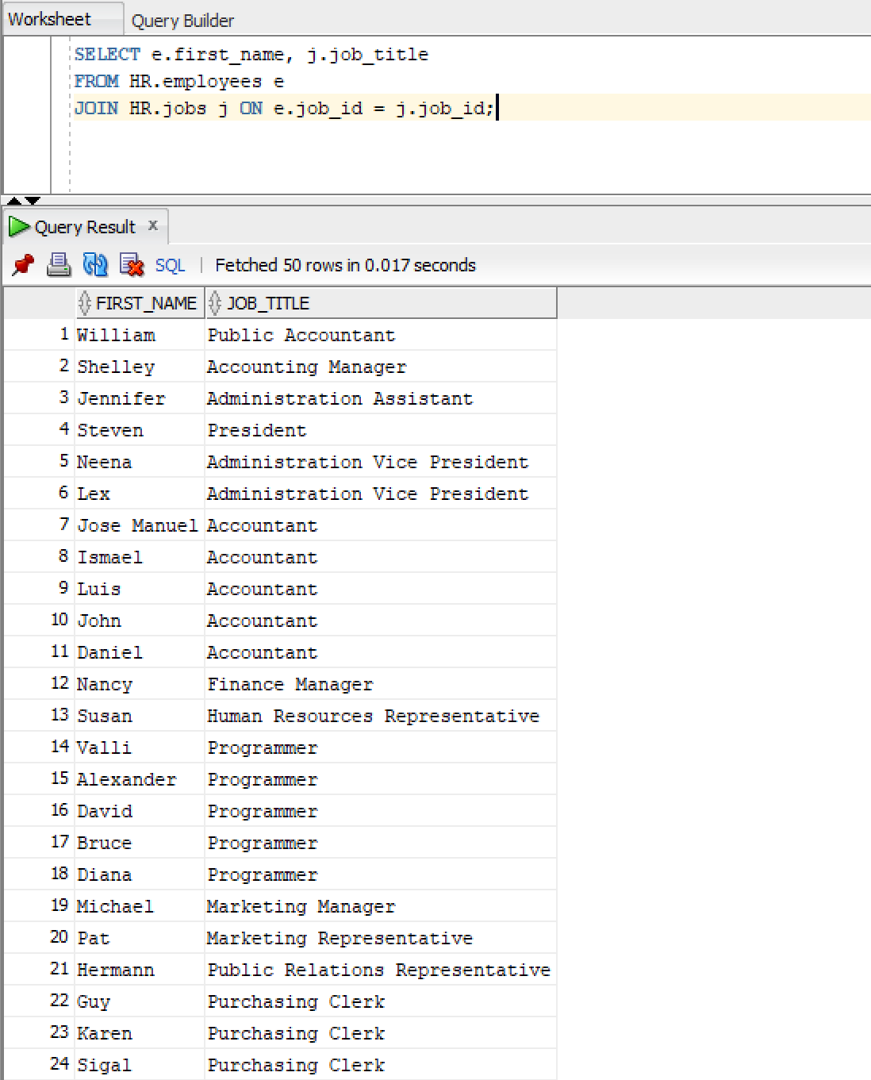
Q5)
Query:
SELECT e.first_name || ' ' || e.last_name AS full_name, department_id, d.location_id
FROM HR.employees e
JOIN HR.departments d USING (department_id);

Snapshot:
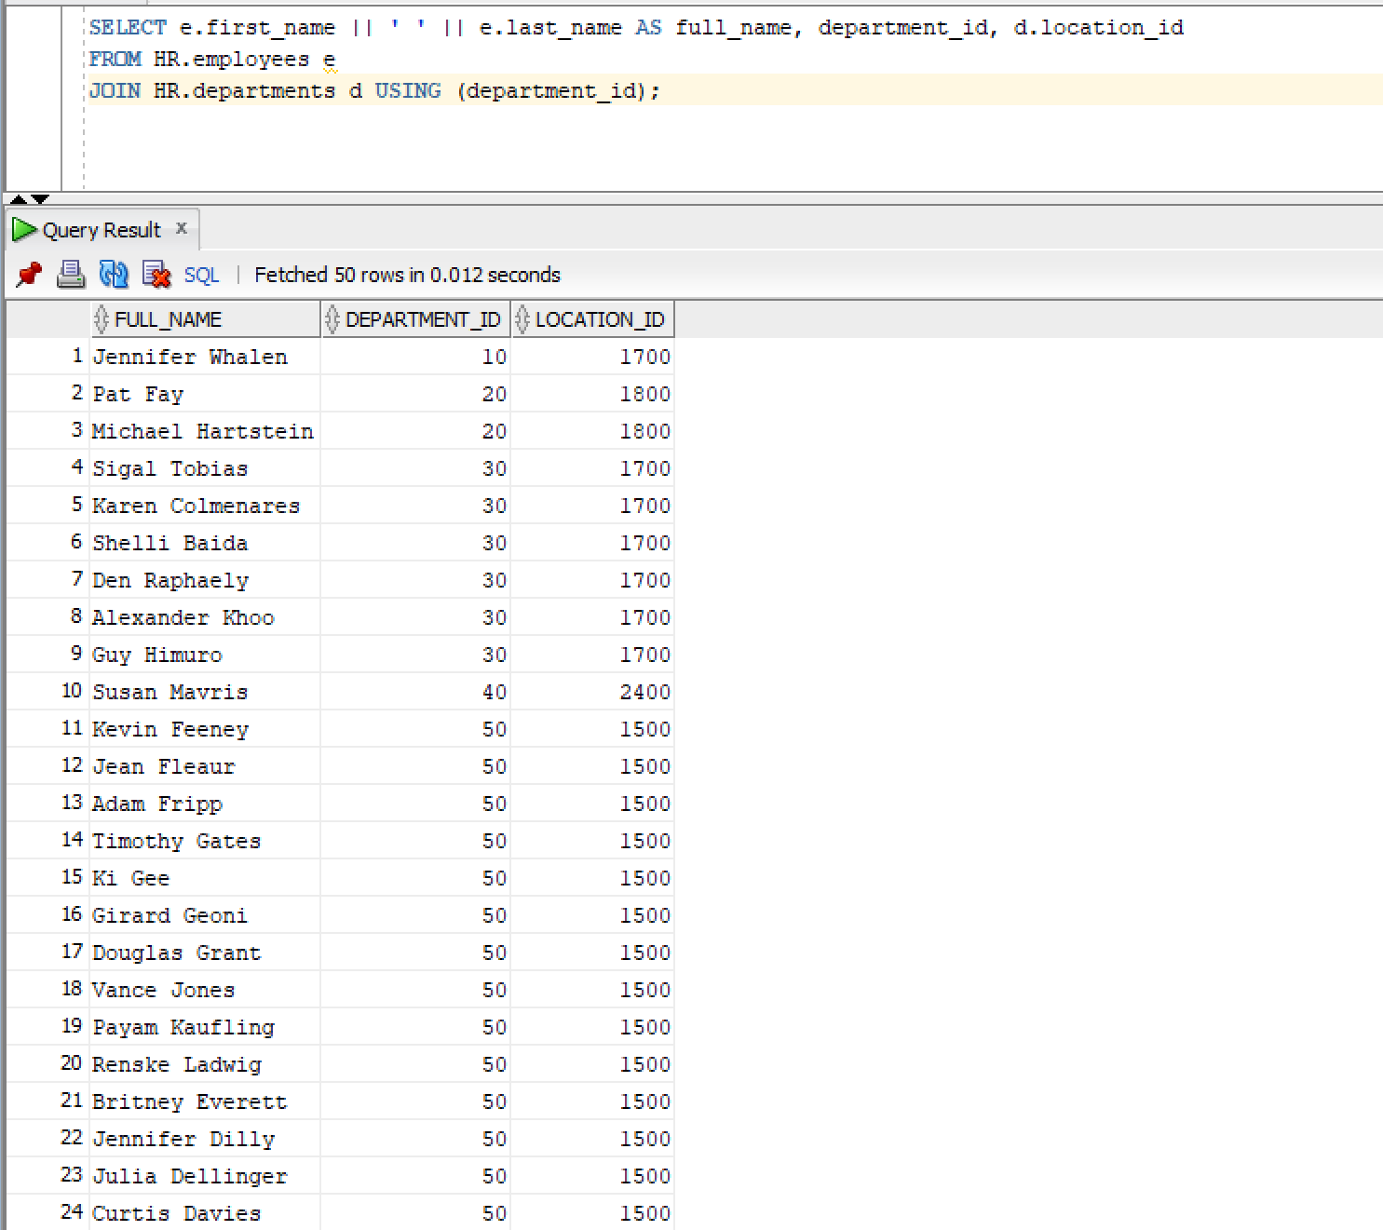

Q6)
Query:
SELECT first_name, last_name, department_name
FROM HR.employees
NATURAL JOIN HR.departments;

Snapshot:
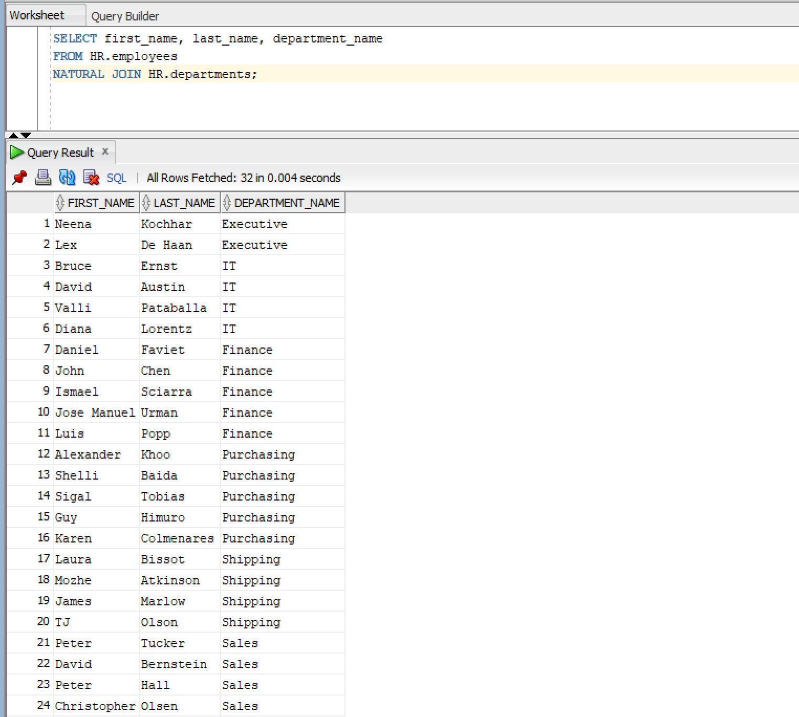

Q7)
Query:
SELECT e.first_name AS employee_name, m.first_name AS manager_name
FROM HR.employees e
JOIN HR.employees m ON e.manager_id = m.employee_id;

Snapshot:
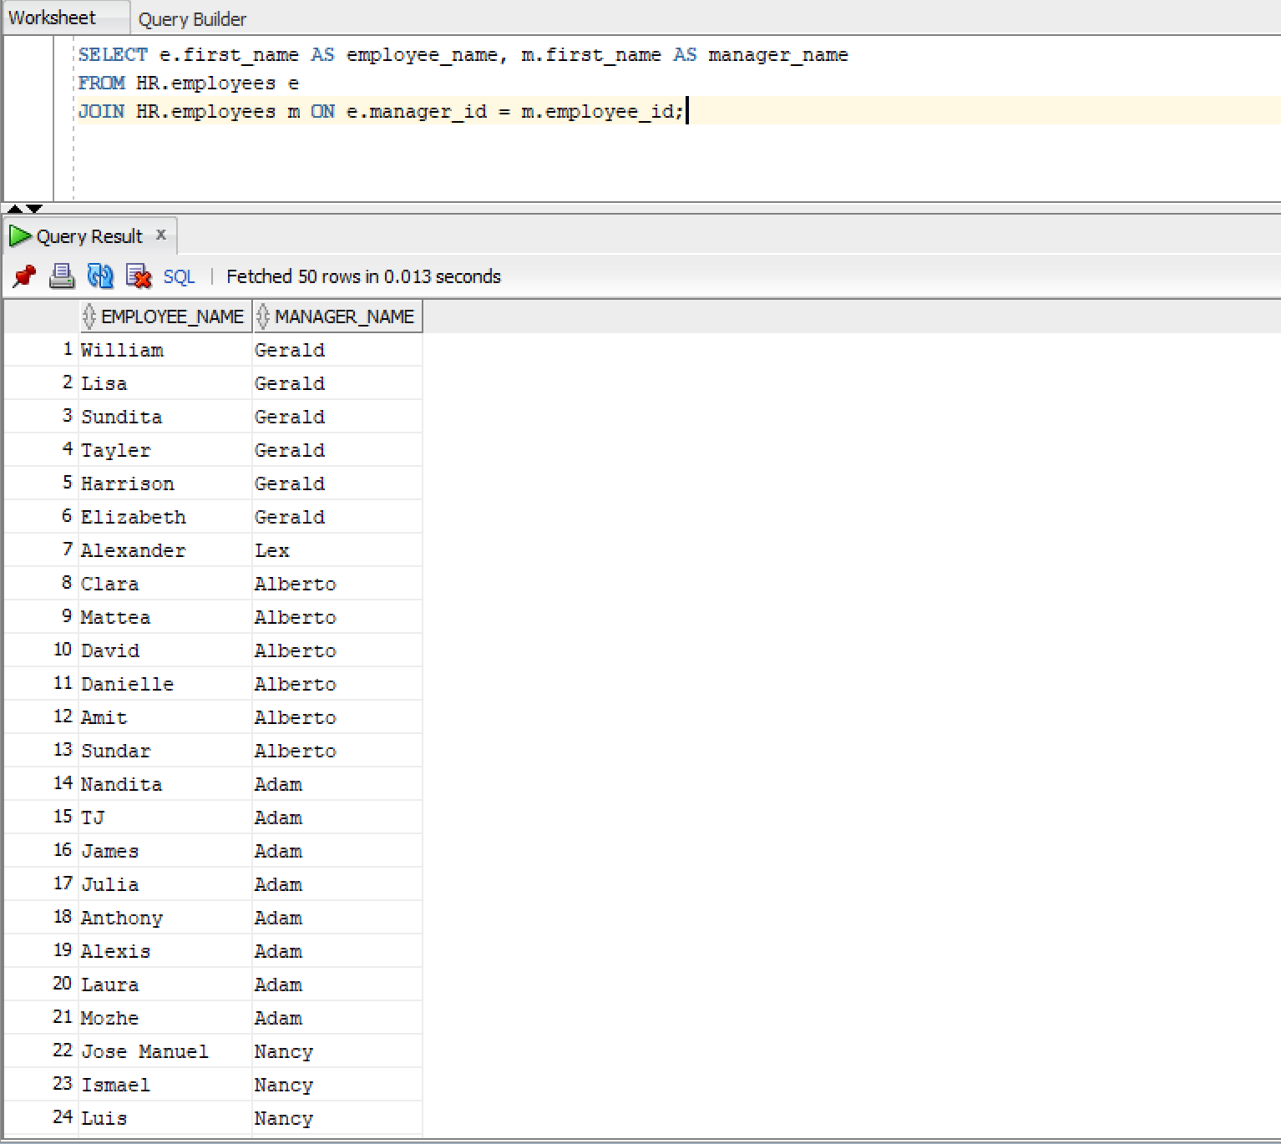

Q8)
Query:
SELECT e.first_name, d.department_name
FROM HR.employees e
CROSS JOIN HR.departments d;
Snapshot:
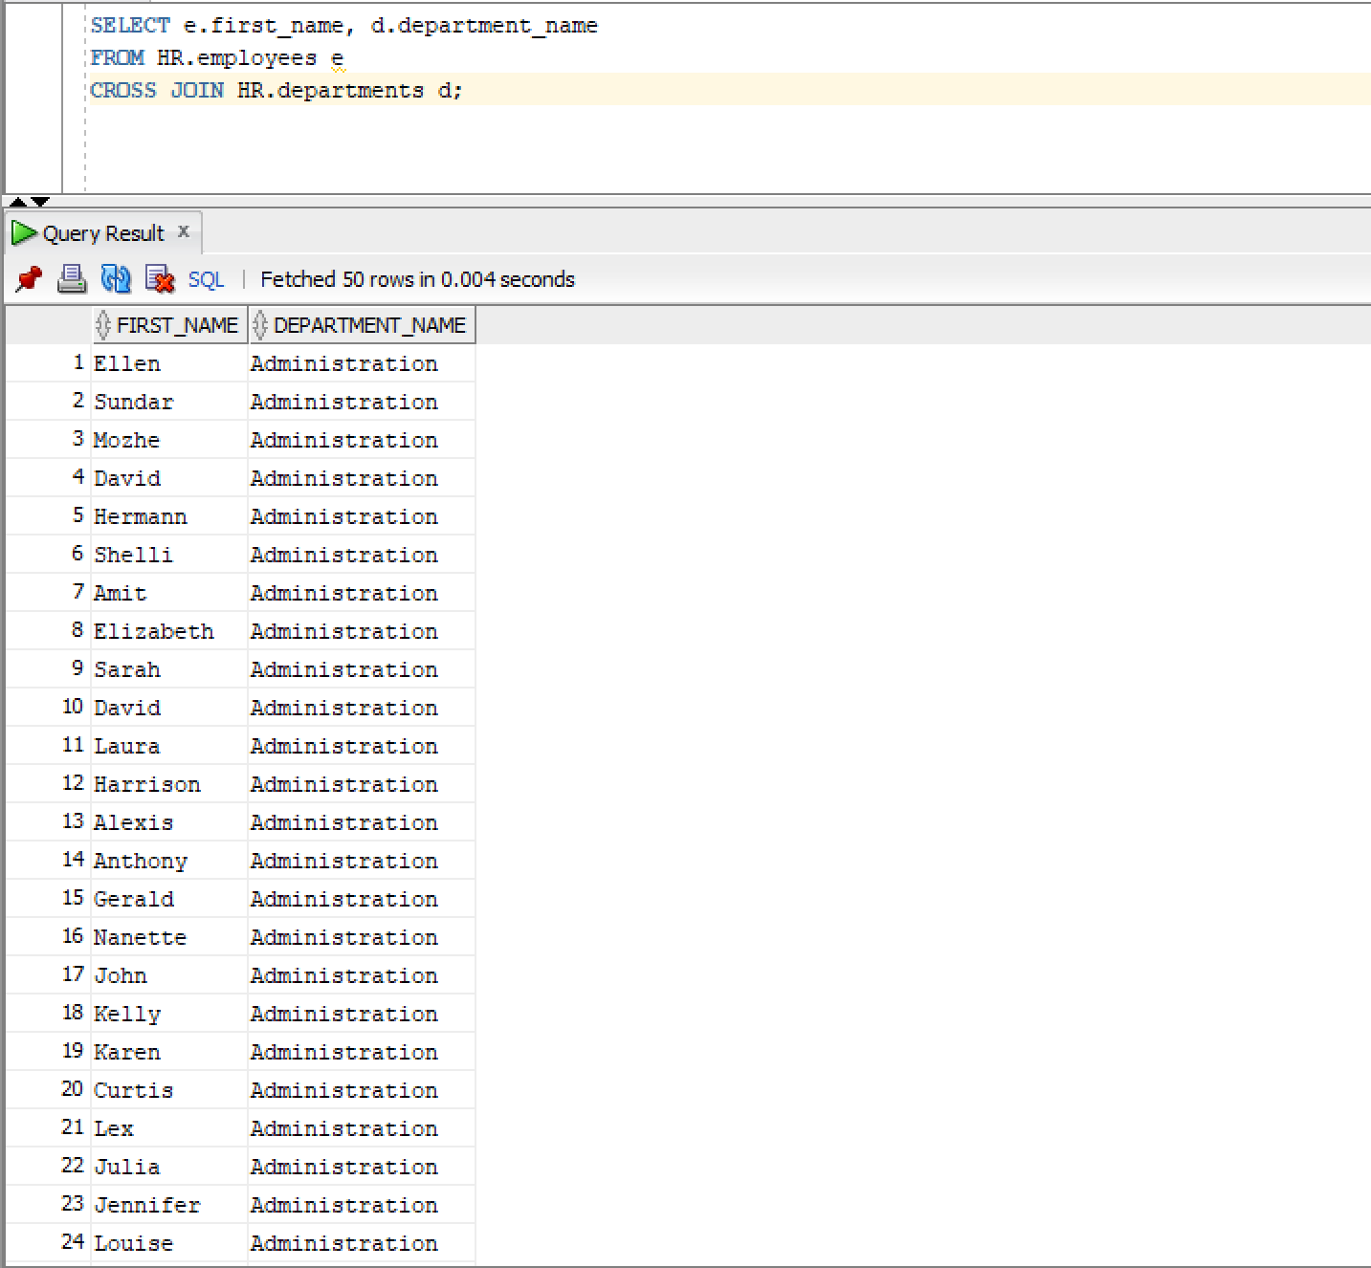

Q9)
Query:
SELECT e.first_name, d.department_name
FROM HR.employees e
FULL OUTER JOIN HR.departments d ON e.department_id = d.department_id;

Snapshot:
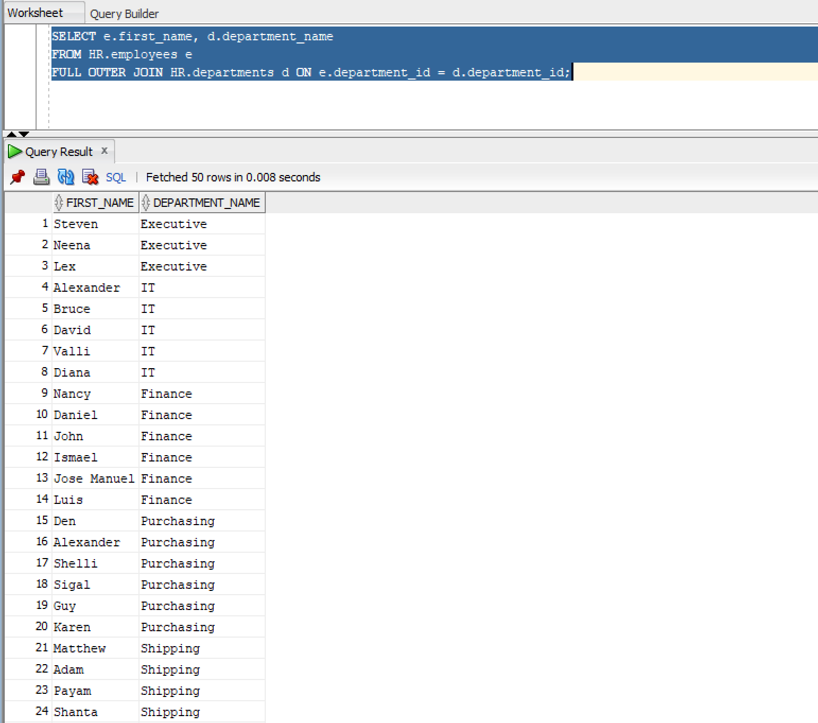

Q10)
Query:
SELECT e.first_name, d.department_name, j.job_title
FROM HR.employees e
JOIN HR.departments d ON e.department_id = d.department_id
JOIN HR.jobs j ON e.job_id = j.job_id;

Snapshot:
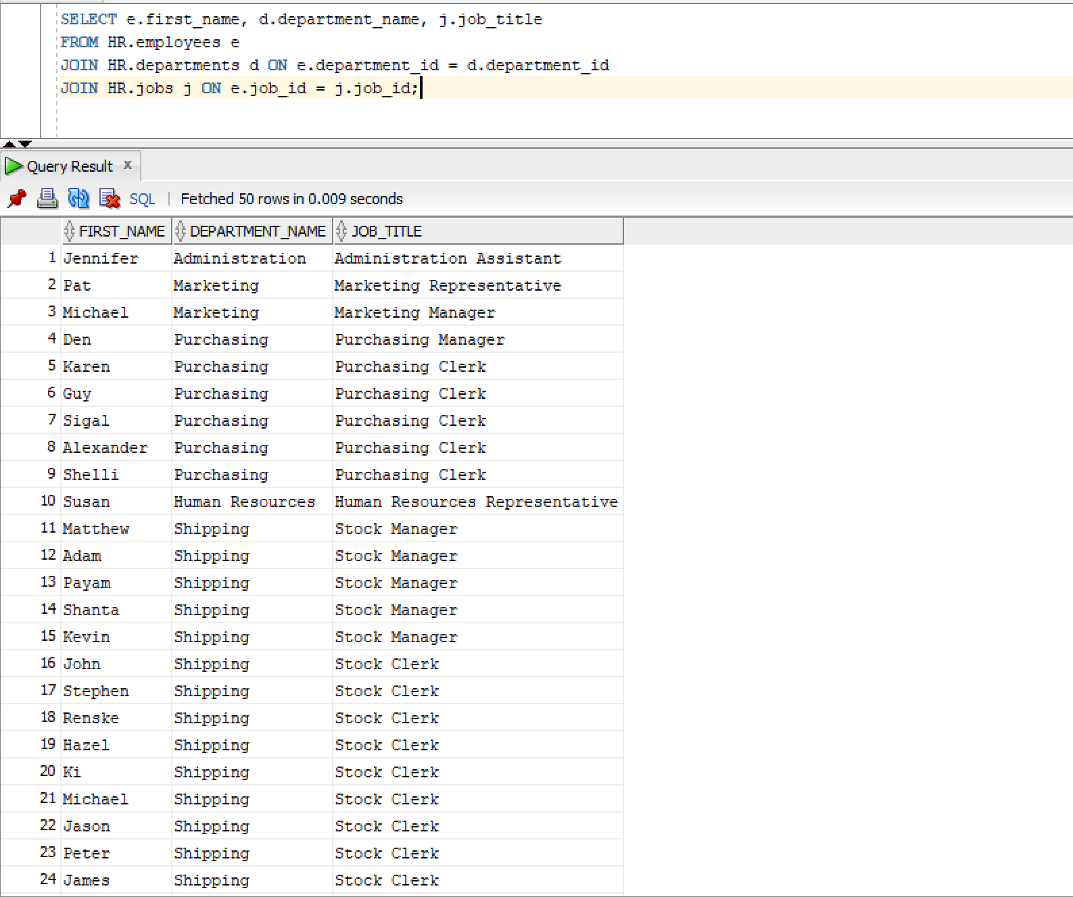

Q11)
Query:
SELECT e.first_name, e.last_name
FROM HR.employees e
LEFT JOIN HR.employees m ON e.manager_id = m.employee_id
WHERE m.employee_id IS NULL;

Snapshot:
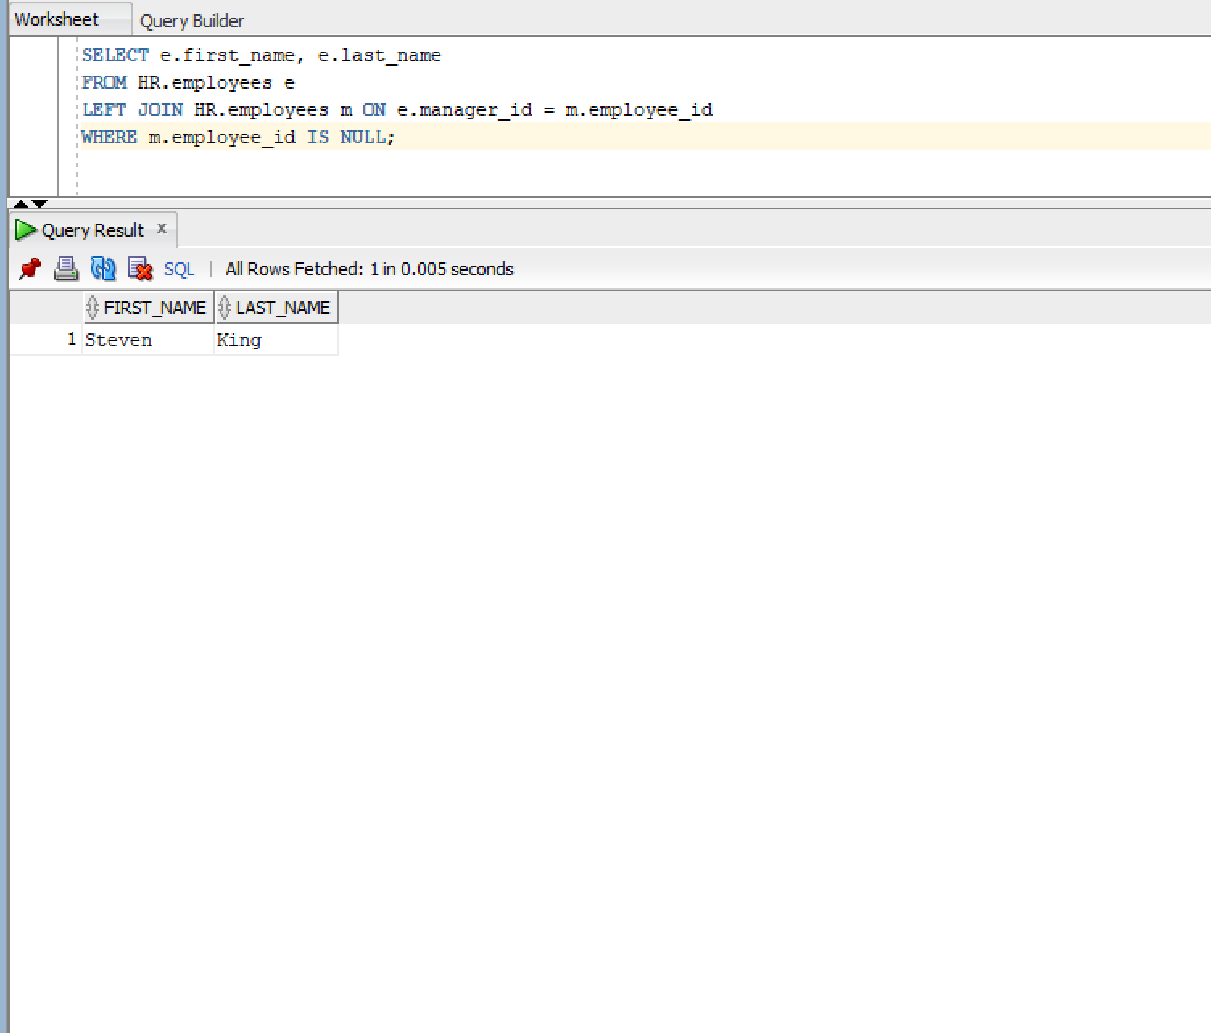

Q12)
Query:
SELECT d.department_name
FROM HR.departments d
LEFT JOIN HR.employees e ON d.department_id = e.department_id
WHERE e.employee_id IS NULL;

Snapshot:
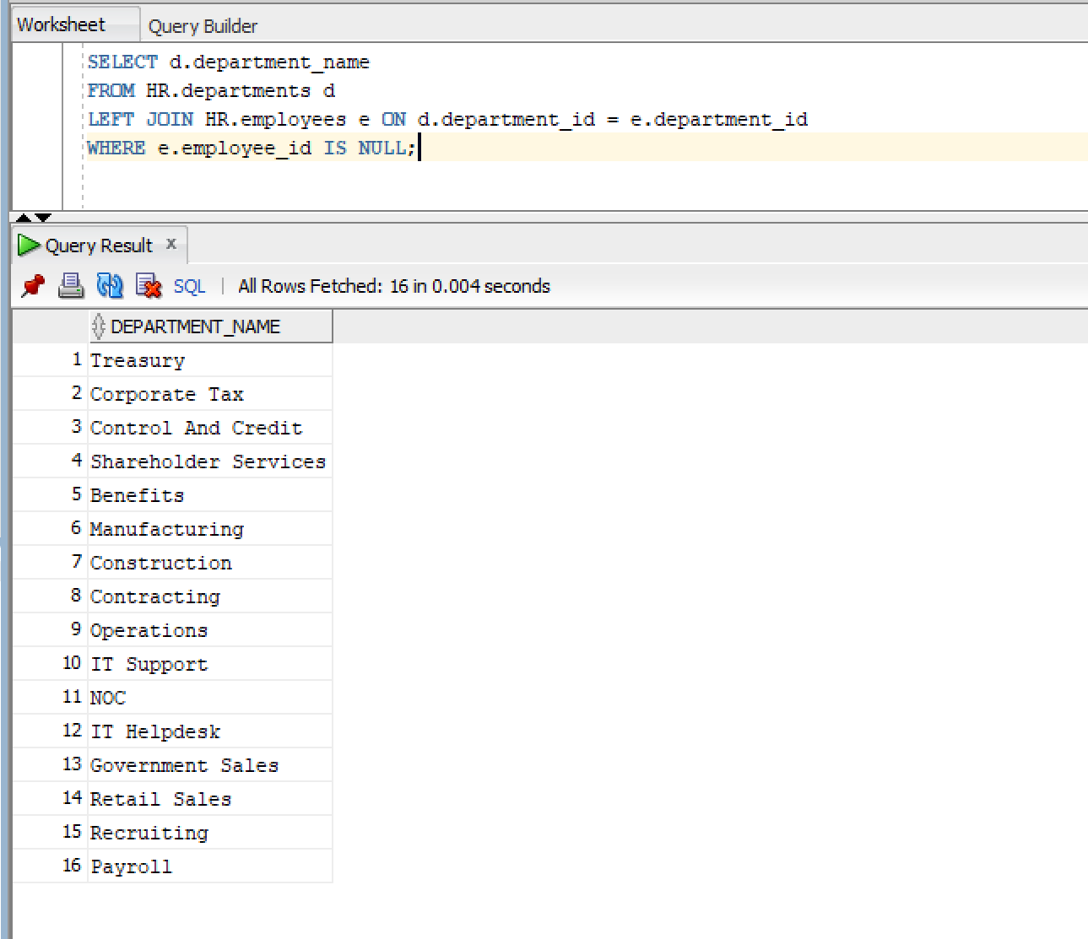

Q13)
Query:
SELECT employee_id FROM HR.employees
UNION
SELECT employee_id FROM HR.job_history;

Snapshot:
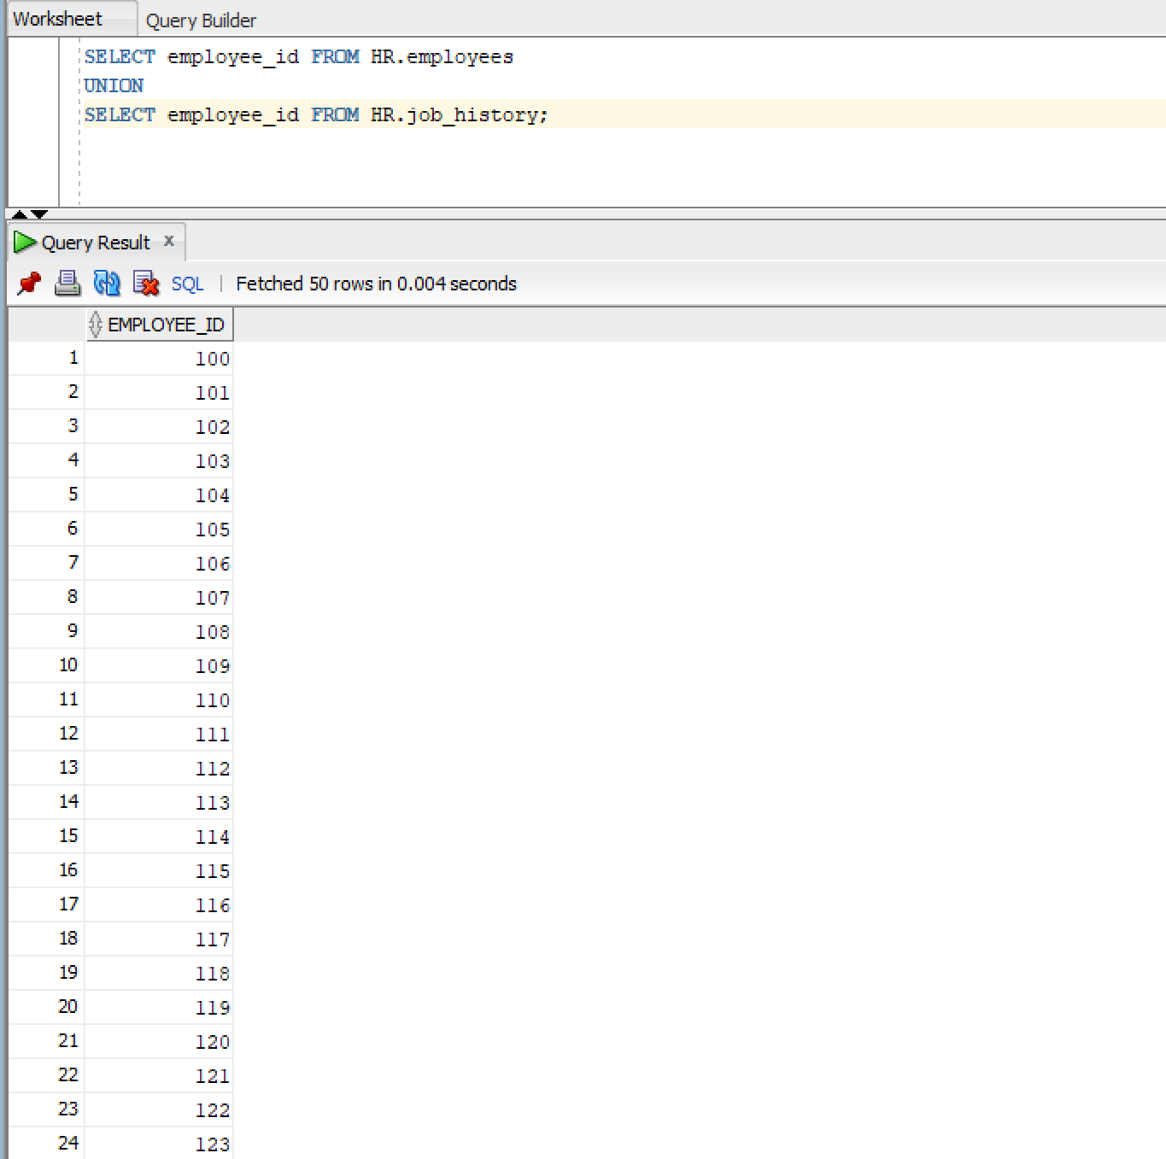

Q14)
Query:
SELECT employee_id FROM HR.employees
UNION ALL
SELECT employee_id FROM HR.job_history;

Snapshot:
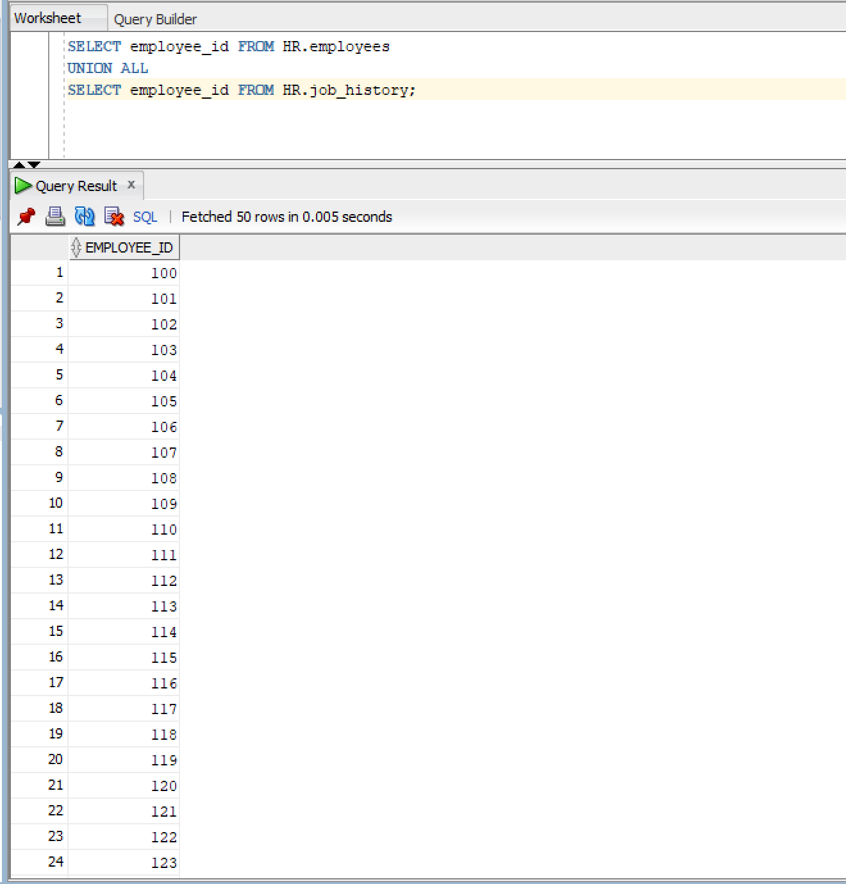
Q15)
Query:
SELECT employee_id FROM HR.employees
UNION
SELECT employee_id FROM HR.job_history
ORDER BY employee_id;

Snapshot:
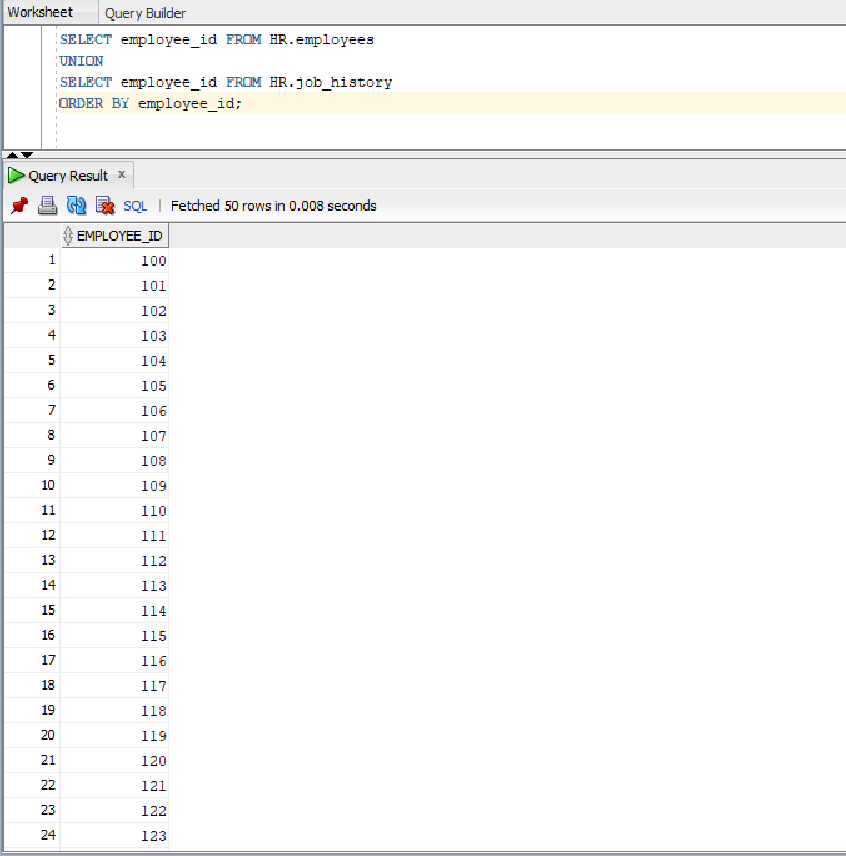

Q16)
Query:
SELECT employee_id FROM HR.employees
INTERSECT
SELECT employee_id FROM HR.job_history;

Snapshot:
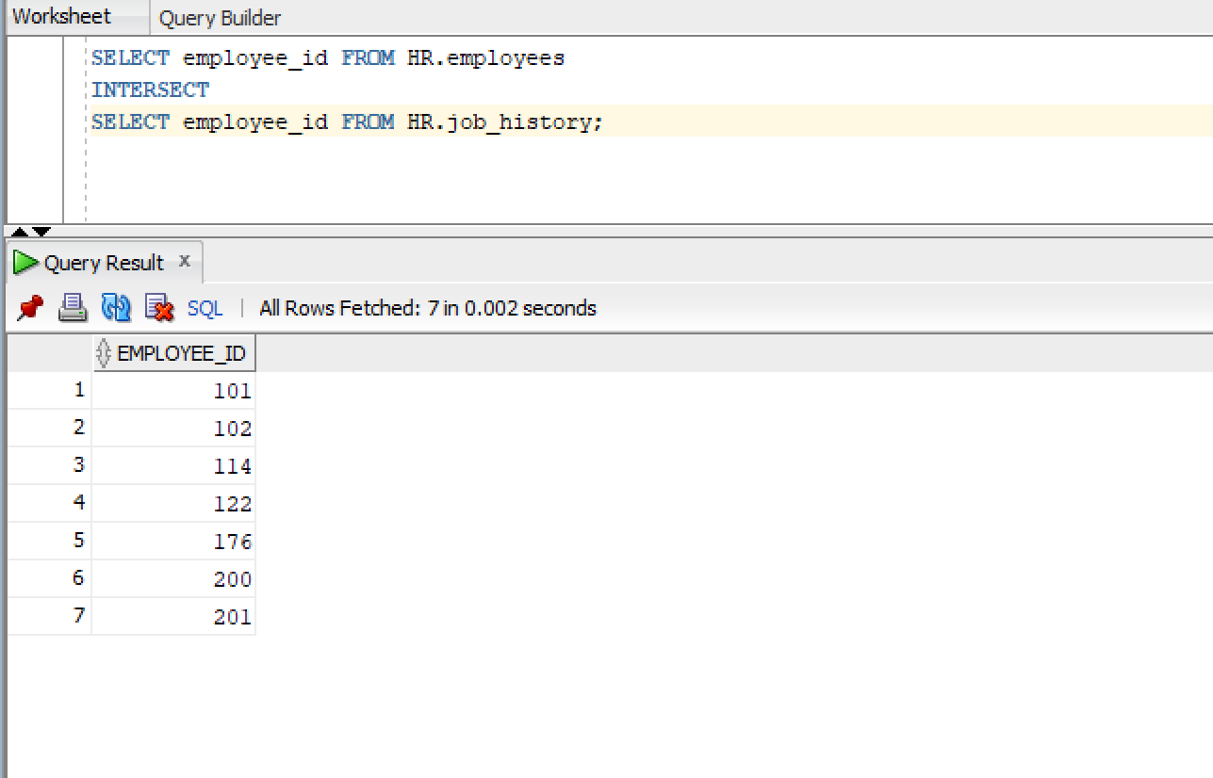

Q17)
Query:
SELECT employee_id FROM HR.employees
MINUS
SELECT employee_id FROM HR.job_history;

Snapshot:
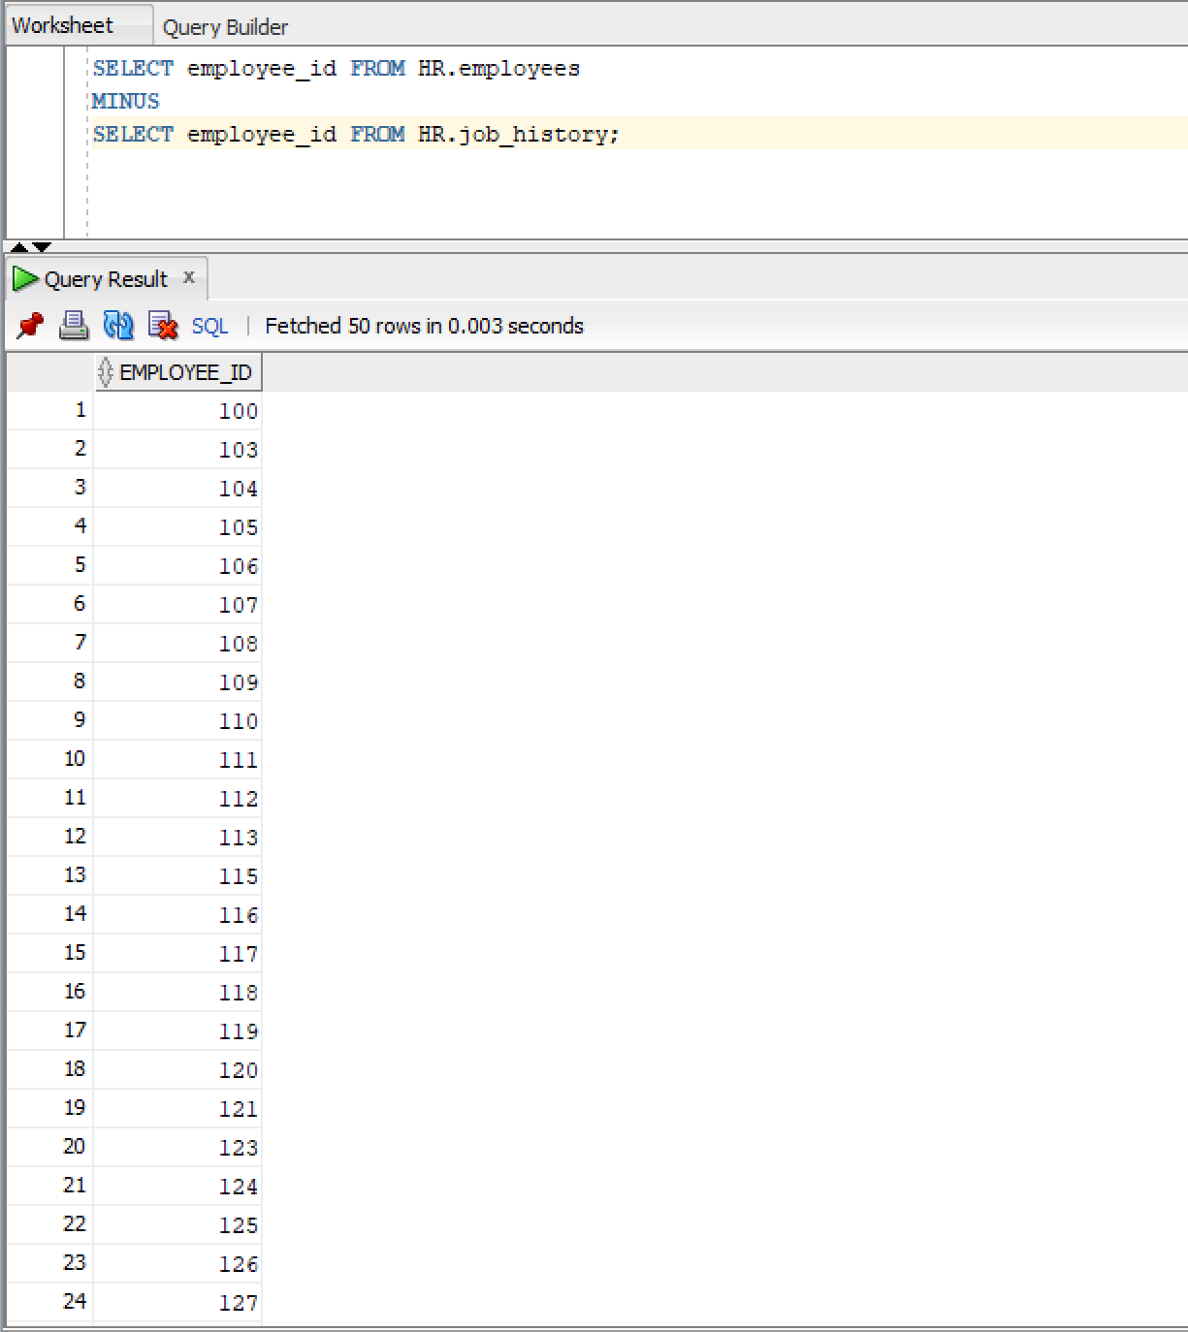

Q18)
Query:
SELECT employee_id FROM HR.employees
UNION
SELECT employee_id FROM HR.job_history;

Snapshot:
