

Lab Task(s) Report – Lab 00

Name:

Muhammad Abu Bakar

NU ID:

24K-0826

January 31st, 2026

—

Syllabus:

Database Systems Lab

Syllabus Code: CL-2005

—

Instructor:

Sir Osama Tahir

Q1)

SQL Query Text:
SELECT * FROM HR.EMPLOYEES;

Screenshot:
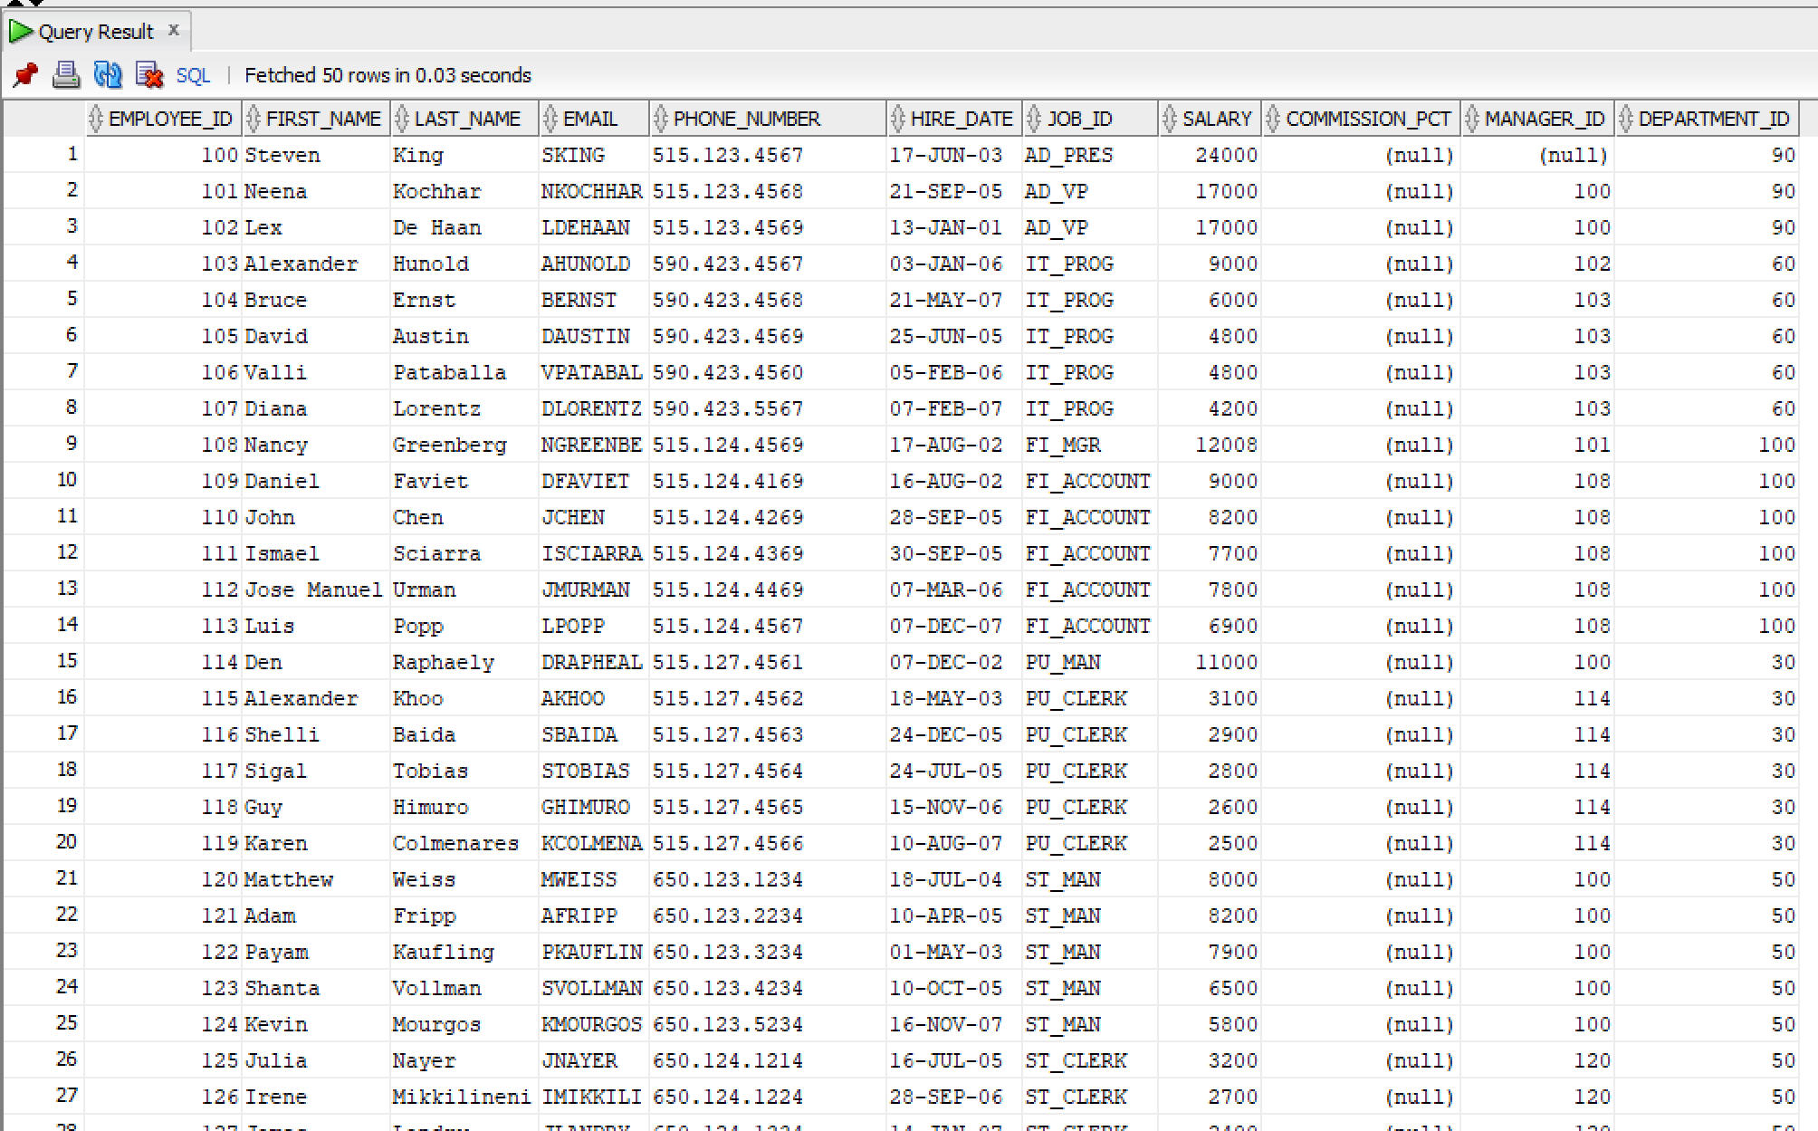

Q2)

SQL Query Text:
SELECT FIRST_NAME, LAST_NAME, SALARY
FROM HR.EMPLOYEES;

Screenshot:

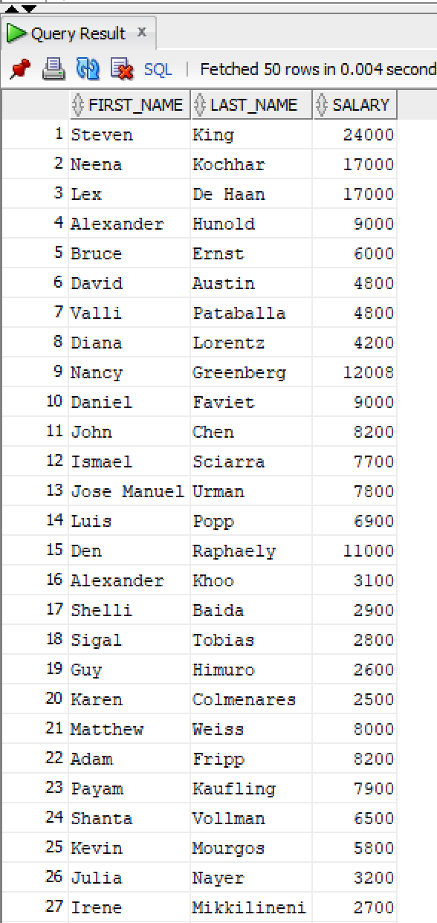

Q3)

1st Method

SQL Query Text:
SELECT EMPLOYEE_ID, FIRST_NAME, LAST_NAME
FROM HR.EMPLOYEES
WHERE DEPARTMENT_ID = 60;

Screenshot:
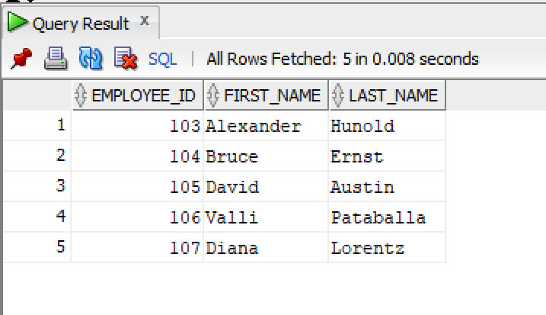

2nd Method

SQL Query Text:
SELECT EMPLOYEES.EMPLOYEE_ID, EMPLOYEES.FIRST_NAME, EMPLOYEES.LAST_NAME, DEPARTMENTS.DEPARTMENT_NAME
FROM HR.EMPLOYEES
JOIN HR.DEPARTMENTS ON EMPLOYEES.DEPARTMENT_ID = DEPARTMENTS.DEPARTMENT_ID
WHERE DEPARTMENTS.DEPARTMENT_NAME = 'IT';

Screenshot:
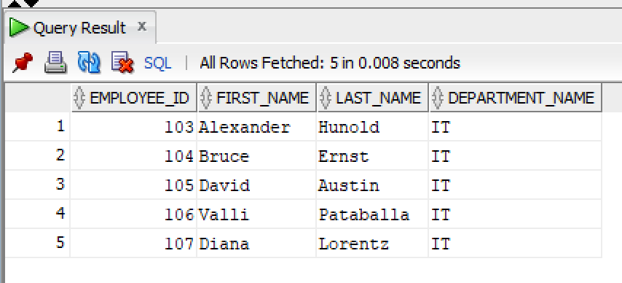

Q4)

SQL Query Text:
SELECT FIRST_NAME, LAST_NAME, SALARY
FROM HR.EMPLOYEES
WHERE SALARY > 60000;

Screenshot:
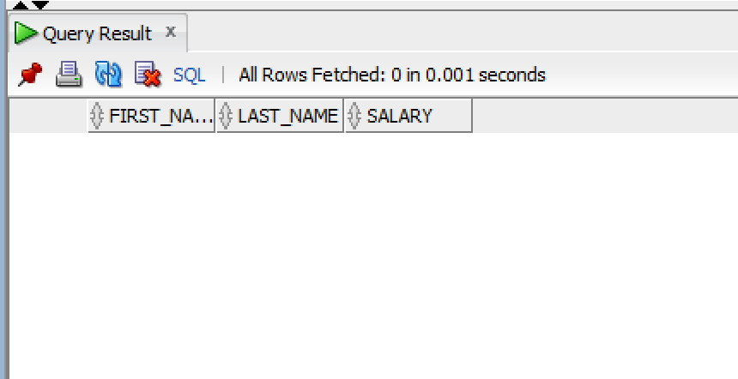

Q5)

1st Method

SQL Query Text:
SELECT FIRST_NAME, LAST_NAME, JOB_ID
FROM HR.EMPLOYEES
WHERE JOB_ID LIKE '%MAN%';

Screenshot:
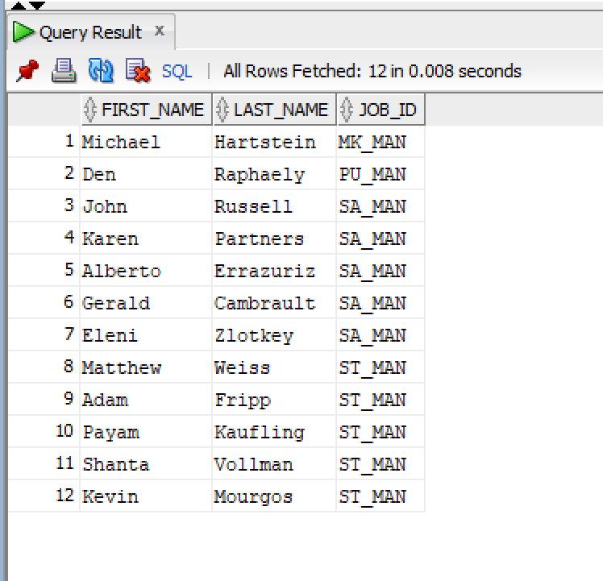

2nd Method

SQL Query Text:
SELECT FIRST_NAME, LAST_NAME, EMPLOYEES.JOB_ID
FROM HR.EMPLOYEES
JOIN HR.JOBS ON JOBS.JOB_ID = EMPLOYEES.JOB_ID
WHERE UPPER(JOB_TITLE) LIKE '%MANAGER%';

Screenshot:
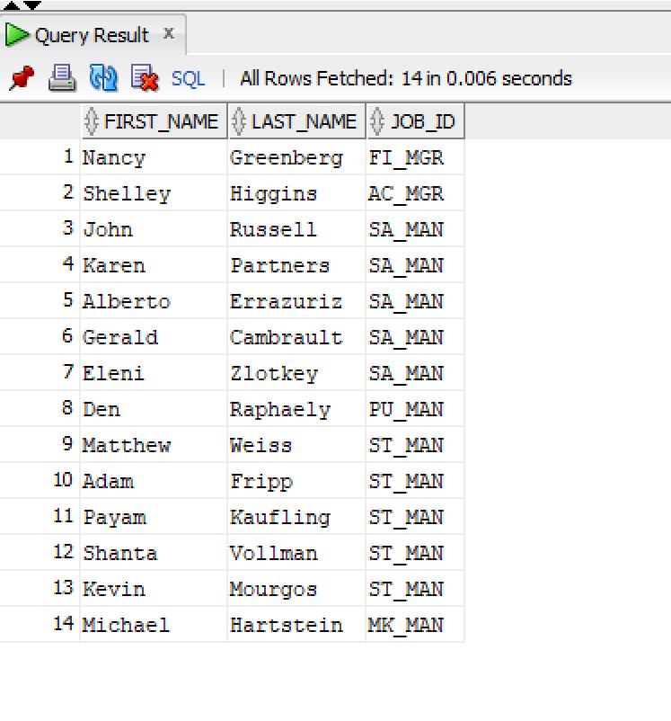

Q6)

SQL Query Text:
SELECT EMPLOYEE_ID, FIRST_NAME, LAST_NAME, SALARY
FROM HR.EMPLOYEES
WHERE SALARY < 30000;

Screenshot:
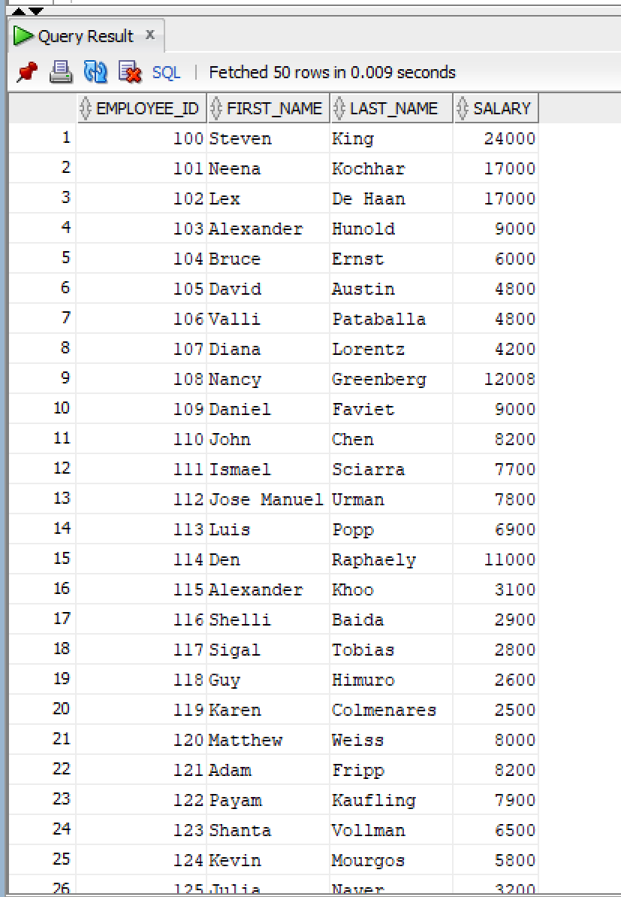

Q7)

SQL Query Text:
SELECT FIRST_NAME, LAST_NAME
FROM HR.EMPLOYEES
WHERE UPPER(LAST_NAME) = 'JOHN';

Screenshot:
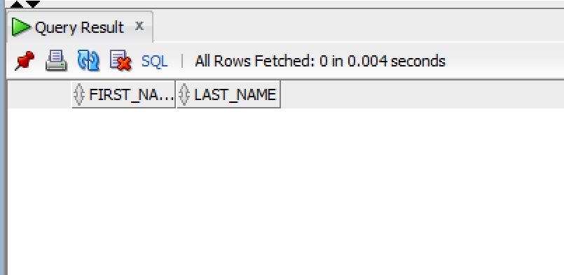

Q8)

SQL Query Text:
SELECT EMPLOYEE_ID, FIRST_NAME, LAST_NAME, SALARY
FROM HR.EMPLOYEES
WHERE SALARY = 50000;

Screenshot:
