

Lab Task(s) Report – Lab 02

Name:

Muhammad Abu Bakar

NU ID:

24K-0826

February 5th, 2026

—

Syllabus:

Database Systems Lab

Syllabus Code: CL-2005

—

Instructor:

Sir Osama Tahir

Q1)

SQL Query Text:
SELECT * FROM Patients;

Screenshot:
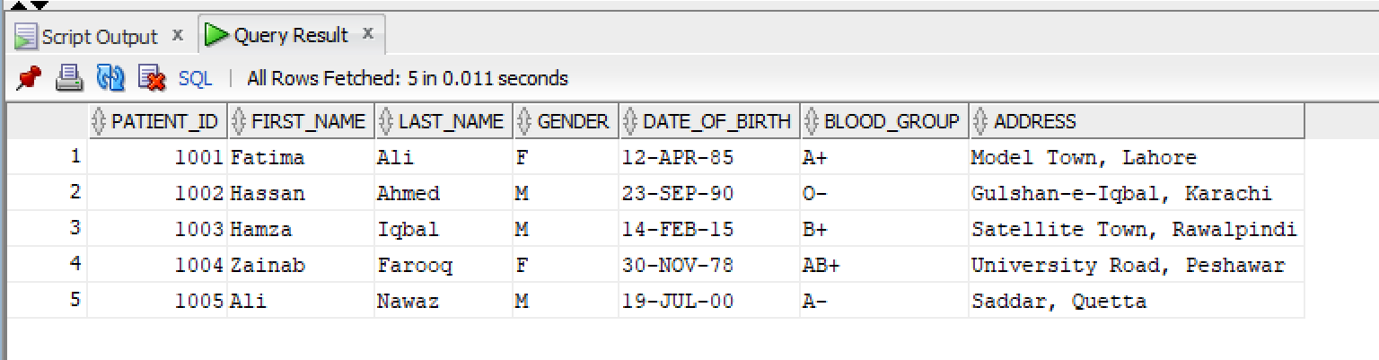

Q2)

SQL Query Text:
SELECT * FROM Doctors;

Screenshot:

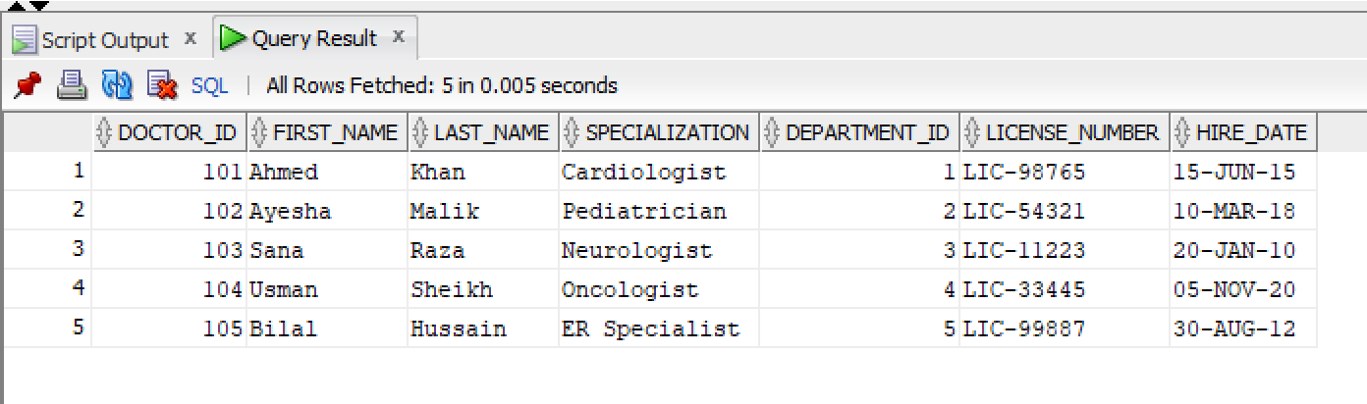

Q3)

SQL Query Text:
SELECT first_name, last_name, address
FROM Patients;

Screenshot:
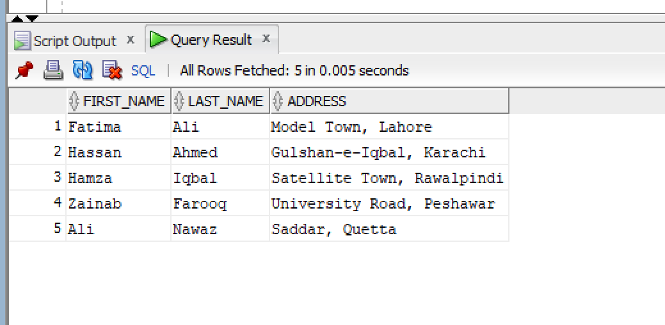

Q4)

SQL Query Text:
SELECT * FROM Departments;

Screenshot:
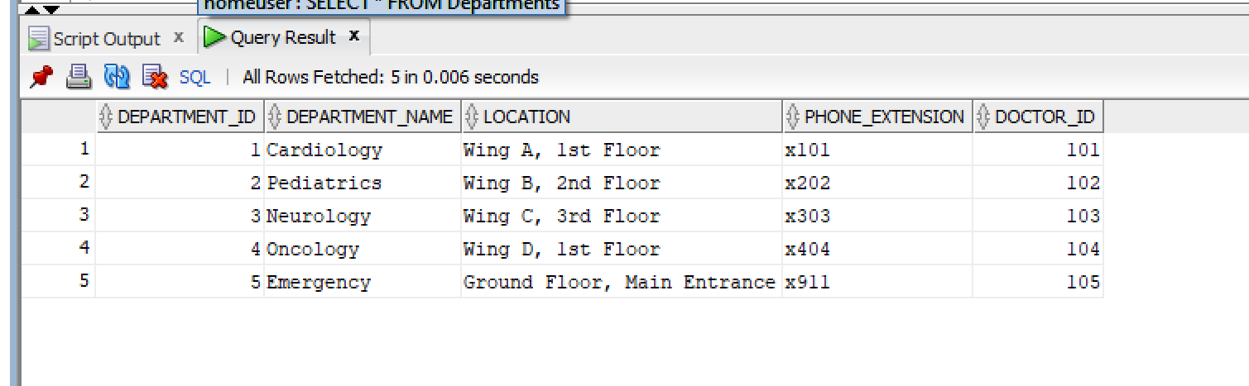

Q5)

1st Method

SQL Query Text:
SELECT * FROM Patients
WHERE blood_group = 'O+';

Screenshot:
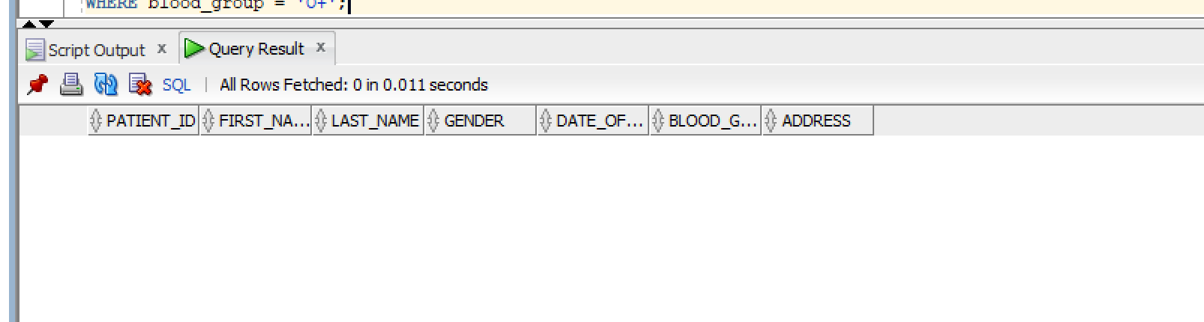

Q6)

SQL Query Text:
SELECT * FROM Doctors WHERE specialization LIKE '%Lung%' OR specialization LIKE '%Pulmonology%';

Screenshot:
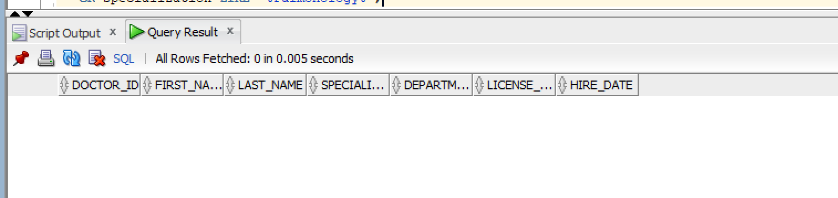

Q7)

SQL Query Text:
SELECT * FROM Doctors WHERE hire_date > TO_DATE('2024-01-01', 'YYYY-MM-DD');

Screenshot:
