Name: Muhammad Abu Bakar
NUID: 24K-0826
Section: BCS-243D
Syllabus: Database Systems Lab
Syllabus Code: CL2005
Instructor: Sir Osama Tahir

Q1)

1)
SQL Query:
SELECT SUM(Salary) AS TOTAL_SALARY FROM HR.EMPLOYEES;
Snapshot of Query:
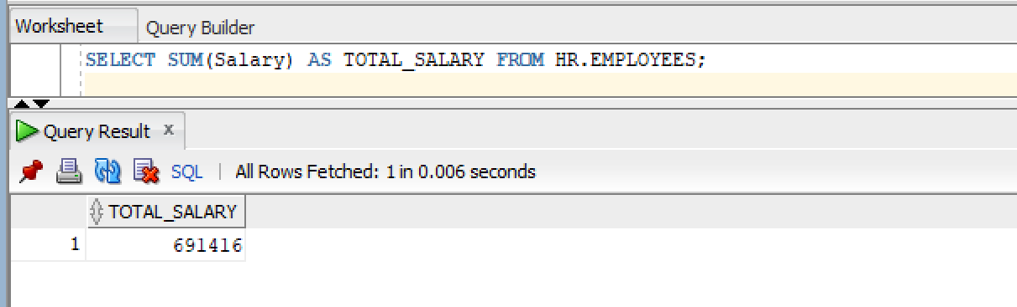

2)
SQL Query:
SELECT ROUND(AVG(Salary), 2) AS AVERAGE_SALARY FROM HR.EMPLOYEES;
Snapshot of Query:
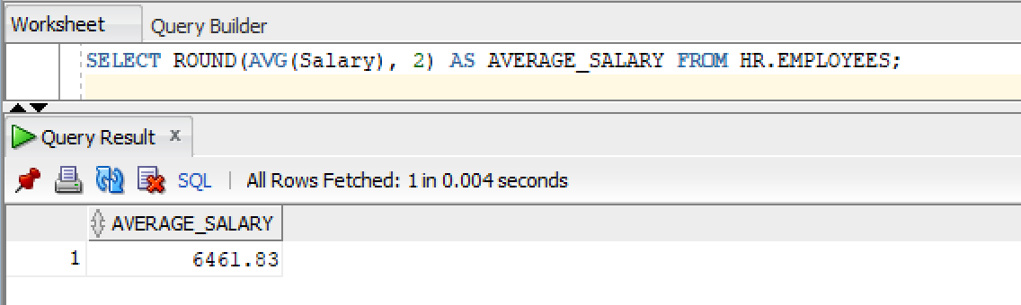

3)
MAX
SQL Query:
SELECT MAX(Salary) AS AVERAGE_SALARY FROM HR.EMPLOYEES;
Snapshot of Query:
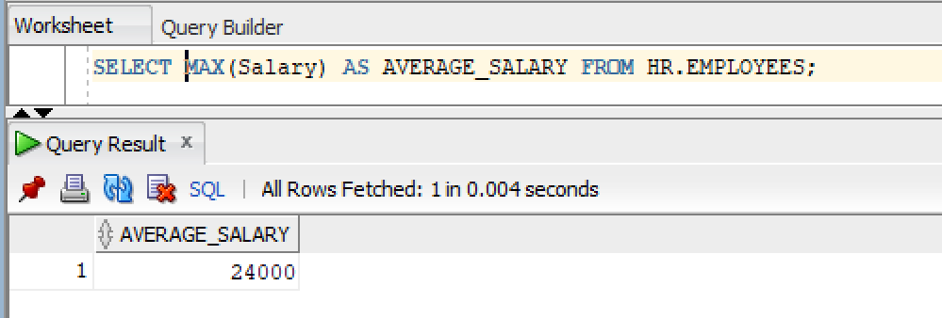

MIN
SQL Query:
SELECT MIN(Salary) AS AVERAGE_SALARY FROM HR.EMPLOYEES;
Snapshot of Query:
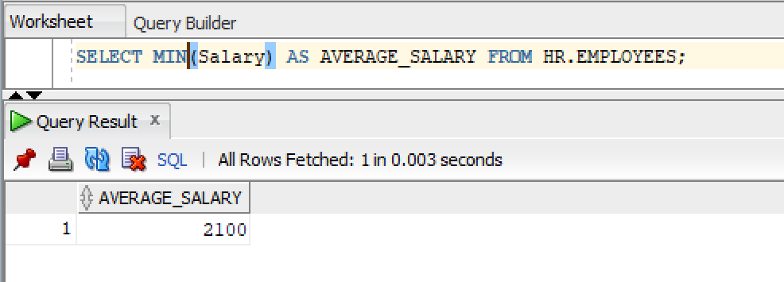

4)
SQL Query:
SELECT COUNT(*) AS Total_Employees, COUNT(Salary) AS Total_Salaries FROM HR.EMPLOYEES;
Snapshot of Query:
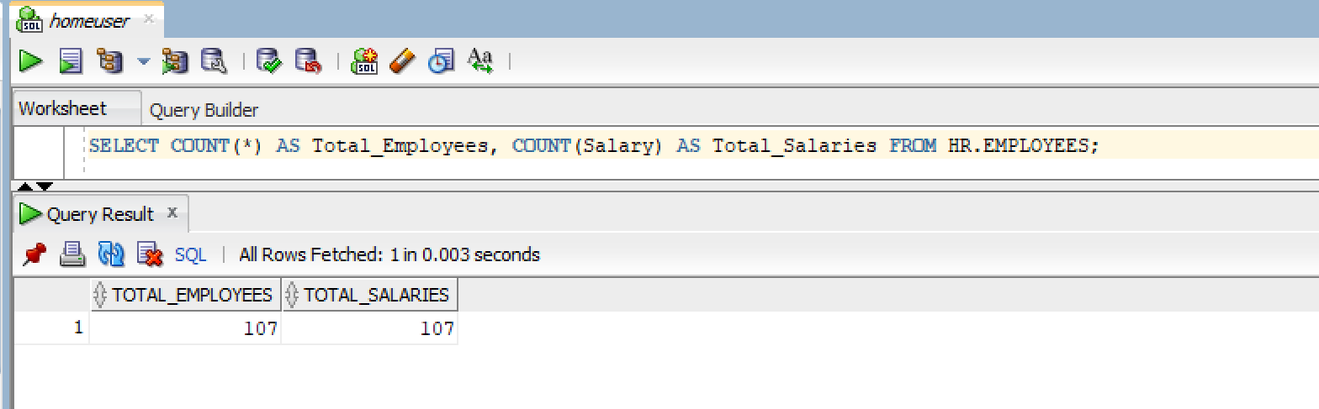

5)
SQL Query:
SELECT COUNT(DISTINCT DEPARTMENT_ID) AS Unique_Departments FROM HR.EMPLOYEES;
Snapshot of Query:
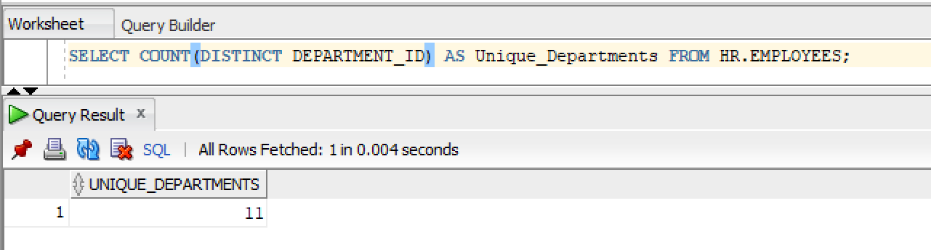

Q2)

1)
SQL Query:
SELECT DEPARTMENT_ID, SUM(SALARY) AS Dept_Total_Sal
FROM HR.EMPLOYEES
GROUP BY DEPARTMENT_ID;
Snapshot of Query:
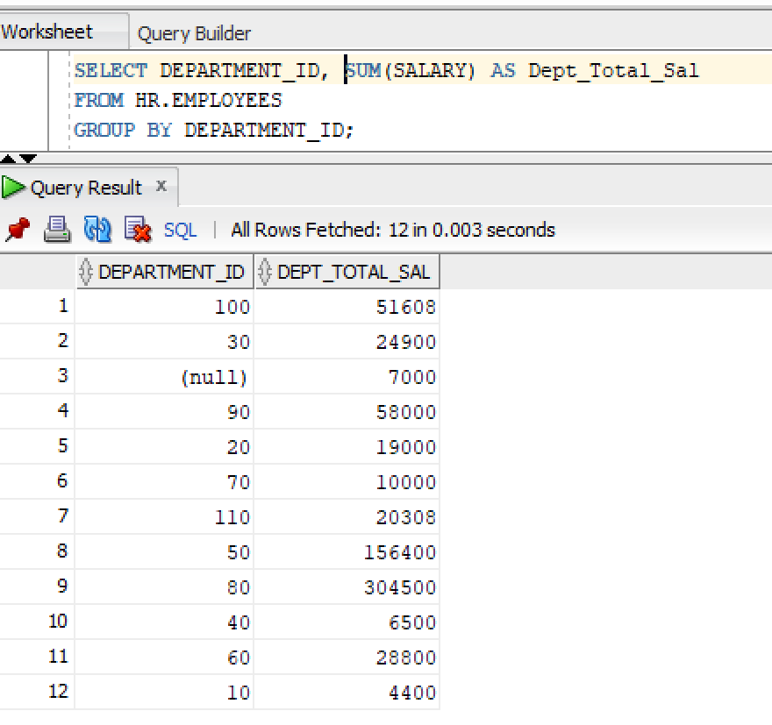

2)
SQL Query:
SELECT JOB_ID, ROUND(AVG(SALARY), 2) AS Job_Avg_Sal
FROM HR.EMPLOYEES
GROUP BY JOB_ID;
Snapshot of Query:
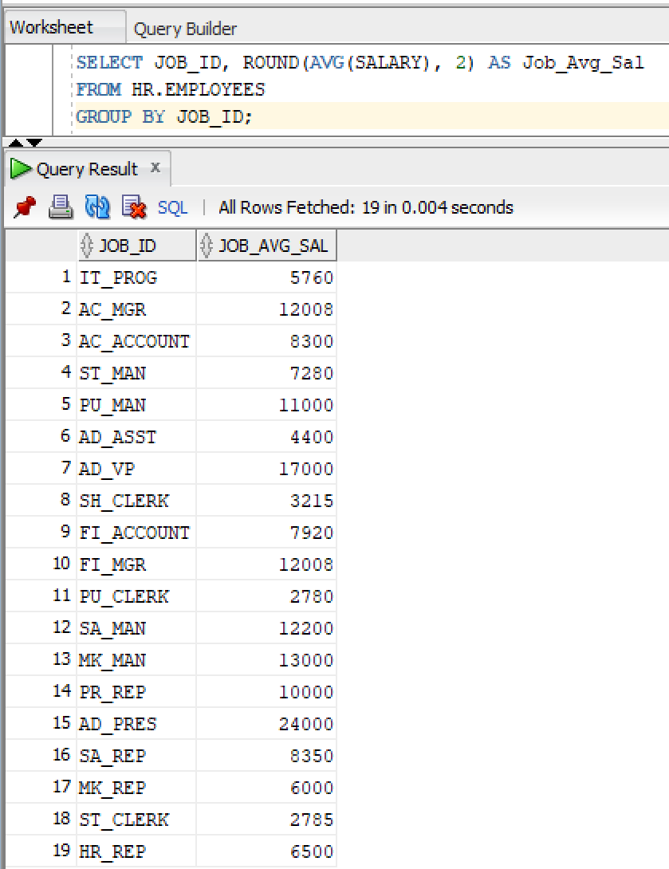
3)
SQL Query:
SELECT DEPARTMENT_ID, MAX(SALARY) AS Dept_Max_Sal
FROM HR.EMPLOYEES
GROUP BY DEPARTMENT_ID;
Snapshot of Query:
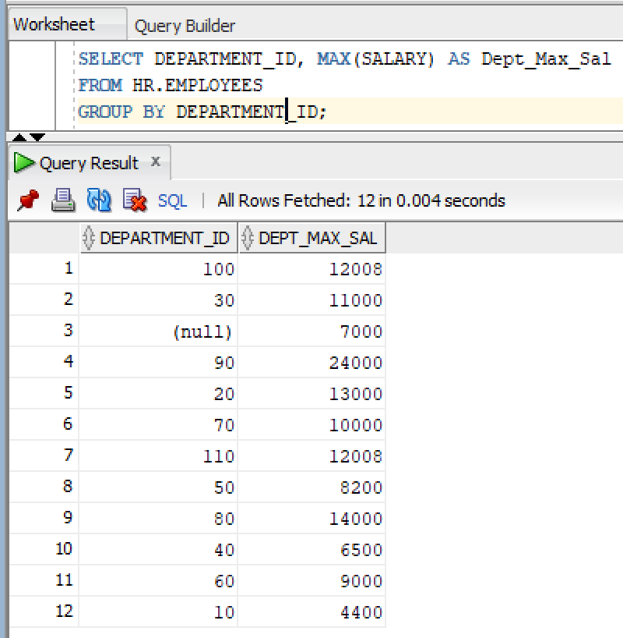

4)
SQL Query:
SELECT DEPARTMENT_ID, JOB_ID, COUNT(*) AS EMPLOYEE_COUNT
FROM HR.EMPLOYEES
GROUP BY DEPARTMENT_ID, JOB_ID
ORDER BY DEPARTMENT_ID;
Snapshot of Query:
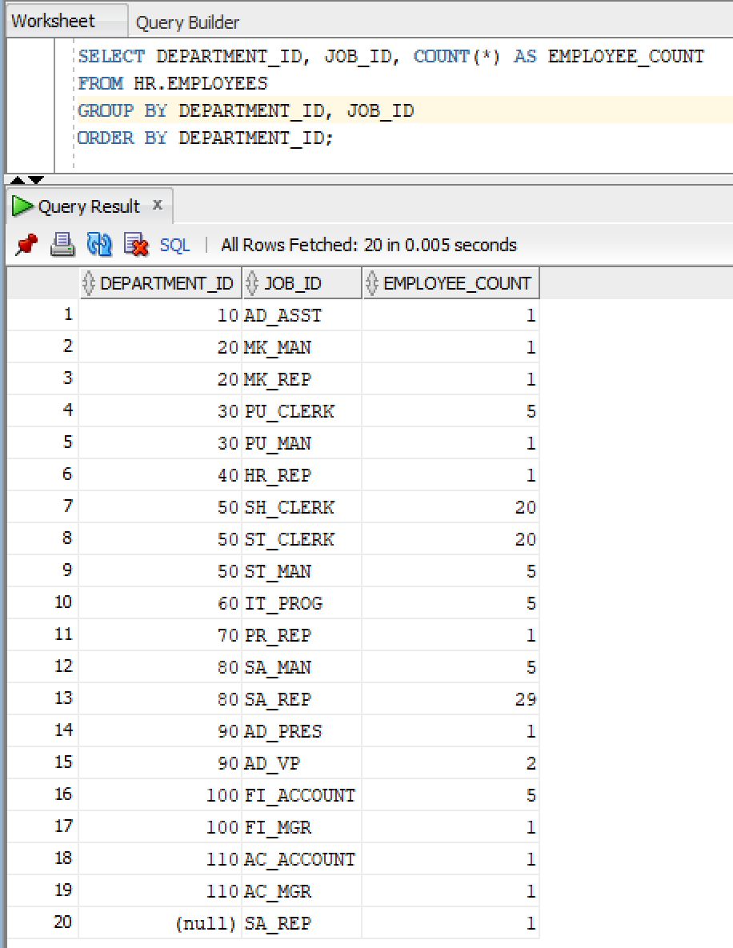
Q3)

1)
SQL Query:
SELECT DEPARTMENT_ID, COUNT(EMPLOYEE_ID) AS NUM_OF_EMP
FROM HR.EMPLOYEES
GROUP BY DEPARTMENT_ID
HAVING COUNT(EMPLOYEE_ID) > 3;
Snapshot of Query:
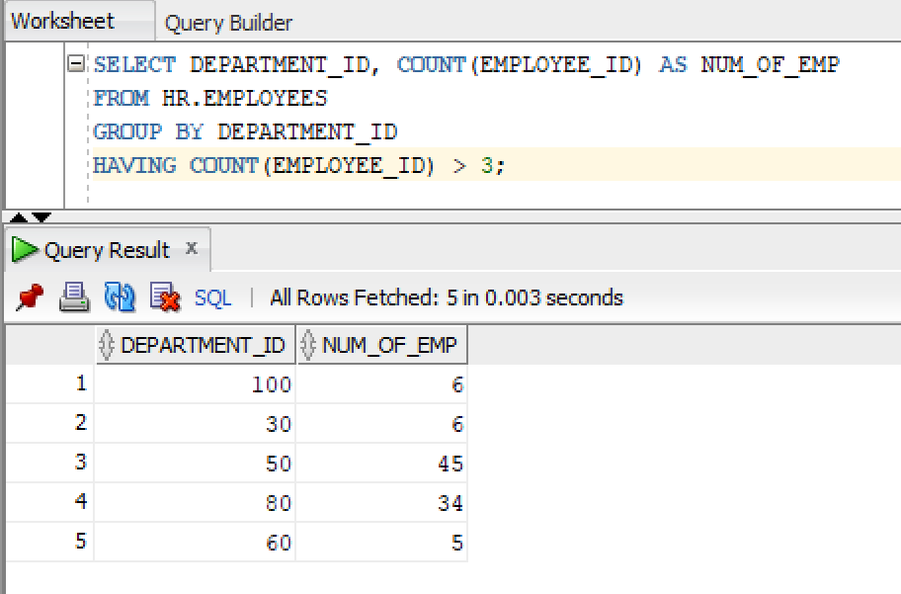

2)
SQL Query:
SELECT DEPARTMENT_ID, AVG(SALARY) AS AVG_SAL
FROM HR.EMPLOYEES
GROUP BY DEPARTMENT_ID
HAVING AVG(SALARY) > 50000;
Snapshot of Query:
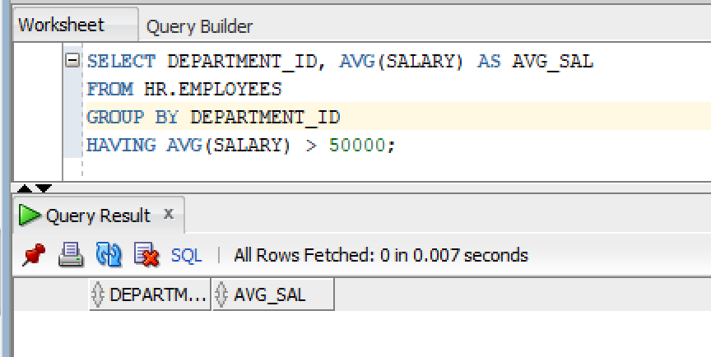

3)
SQL Query:
SELECT DEPARTMENT_ID, MIN(SALARY) AS MIN_SAL
FROM HR.EMPLOYEES
GROUP BY DEPARTMENT_ID
HAVING MIN(SALARY) < 25000;
Snapshot of Query:
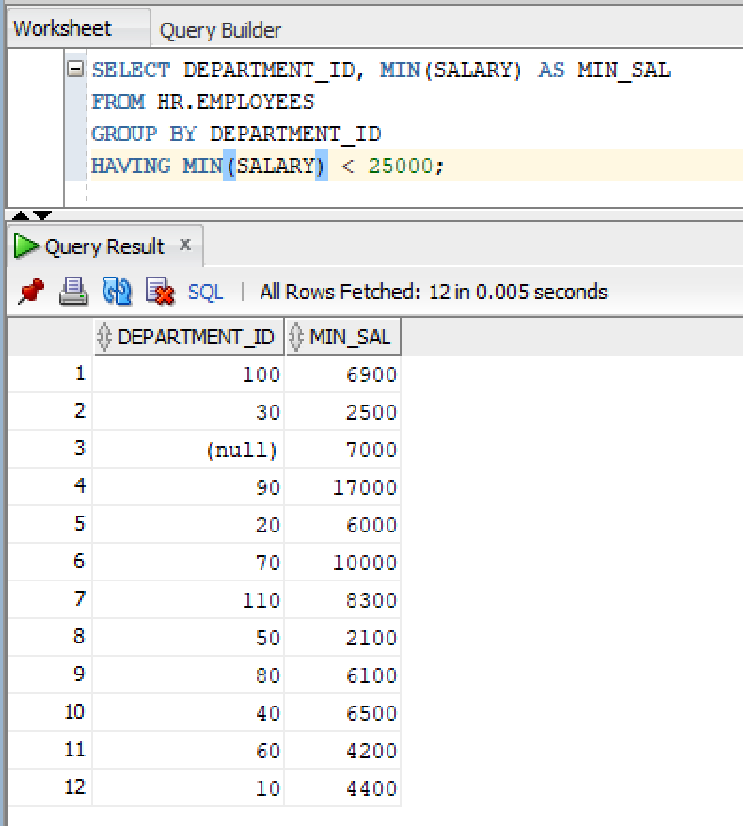

Q4)

1)
SQL Query:
SELECT DEPARTMENT_ID, COUNT(*) AS NUM_OF_EMP
FROM HR.EMPLOYEES
WHERE SALARY > 30000
GROUP BY DEPARTMENT_ID;
Snapshot of Query:
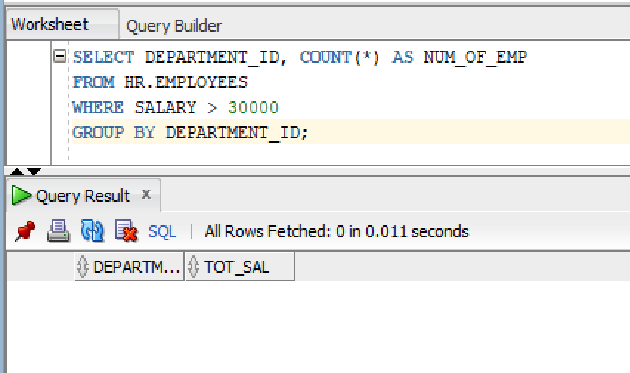

2)
SQL Query:
SELECT DEPARTMENT_ID, SUM(SALARY) AS TOT_SAL
FROM HR.EMPLOYEES
WHERE SALARY > 30000
GROUP BY DEPARTMENT_ID
HAVING SUM(SALARY) > 200000;
Snapshot of Query:
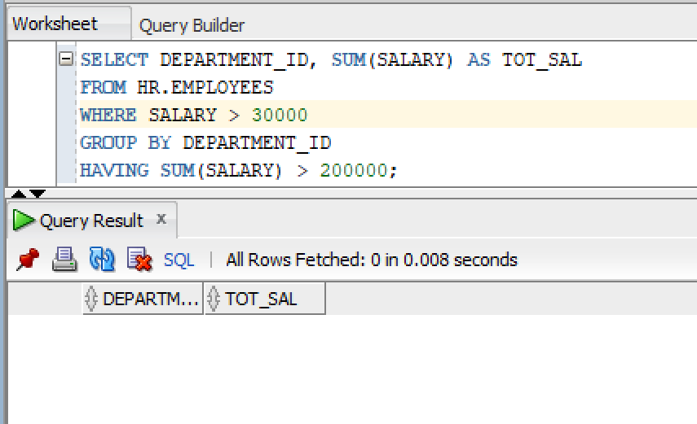

PART B – DML OPERATIONS
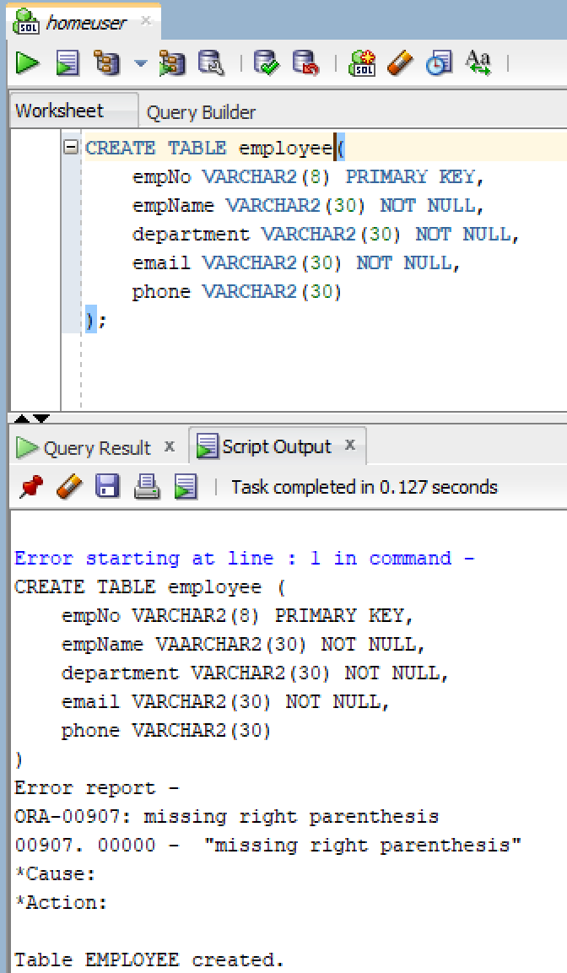

Q5)

SQL Query:
INSERT INTO employee (empNo, empName, department, email, phone)
VALUES ('E001', 'Muhammad Abu Bakar', 'IT', 'bakar@gmail.com', '0300-1234567');

INSERT INTO employee (empNo, empName, department, email, phone)
VALUES ('E002', 'Fatima Tariq', 'HR', 'fatima.tariq@gmail.com', '0333-9876543');

INSERT INTO employee (empNo, empName, department, email, phone)
VALUES ('E003', 'Bilal Ahmed', 'Marketing', 'bilal.ahmed@gmail.com', '0345-1122334');
Snapshot of Query:
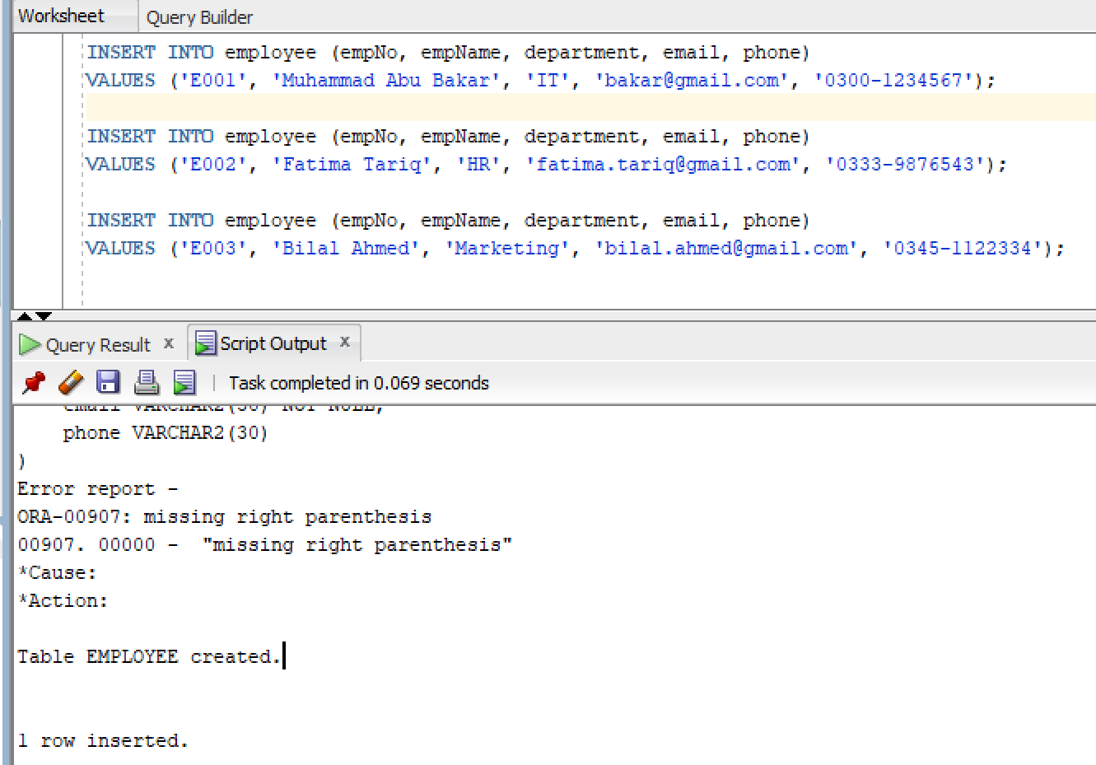

Q6)

1)
SQL Query:
UPDATE employee
SET phone = '0300-9998877'
WHERE empNo = 'E001';
Snapshot of Query:
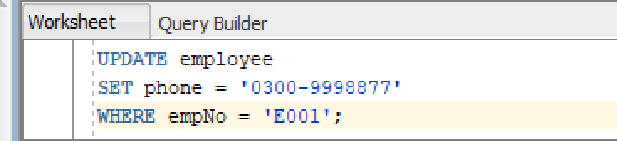


2)
SQL Query:
UPDATE employee
SET department = 'Human Resources'
WHERE department = 'HR';
Snapshot of Query:
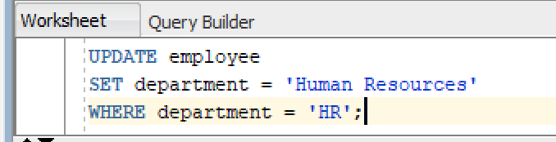


3)
SQL Query:
UPDATE employee
SET department = 'Sales', phone = '0345-0000000'
WHERE empNo = 'E003';
Snapshot of Query:
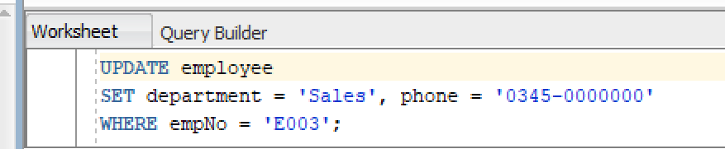


4)
SQL Query:
UPDATE employee
SET email = REPLACE(email, 'gmail.com', 'fast.edu.pk');
Snapshot of Query:
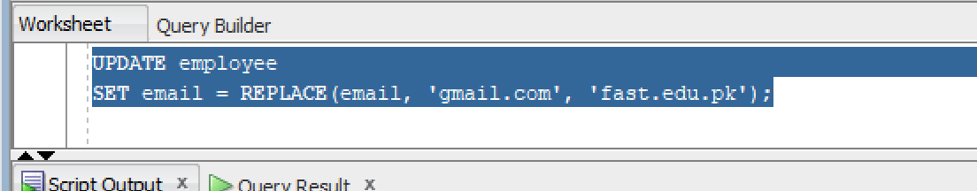


Q7)

1)
SQL Query:
DELETE FROM employee
WHERE empNo = 'E001';
Snapshot of Query:
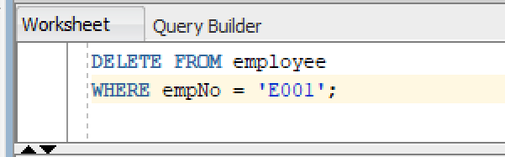


2)
SQL Query:
DELETE FROM employee
WHERE department = 'Sales';
Snapshot of Query:
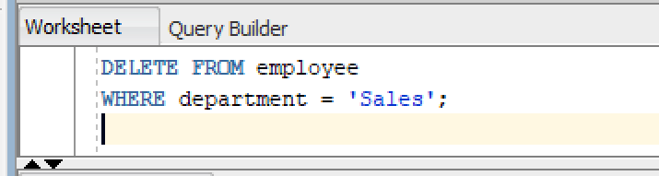

3)
SQL Query:
DELETE FROM employee;
Snapshot of Query:
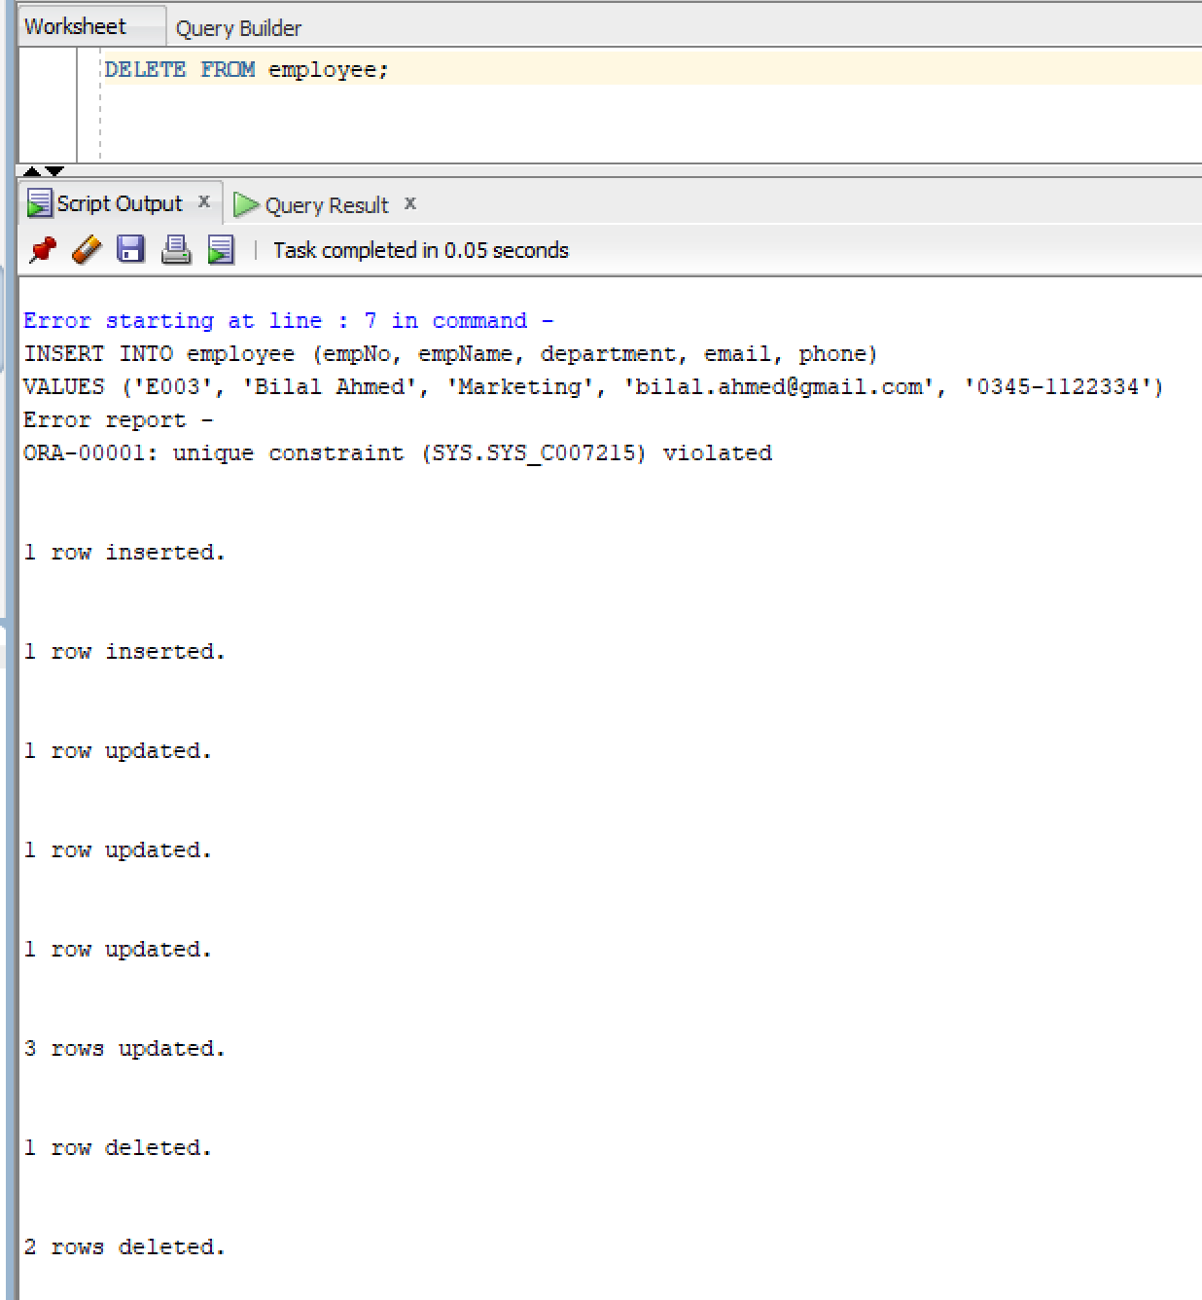

4)
SQL Query:
TRUNCATE TABLE tasks;
Snapshot of Query:
