Name: Muhammad Abu Bakar
NUID: 24K-0826
Section: BCS-243D
Syllabus: Database Systems Lab
Syllabus Code: CL2005
Instructor: Sir Osama Tahir

Q1)
SQL Query:
SELECT first_name, last_name, hire_date
FROM HR.employees
WHERE hire_date > (
SELECT hire_date
FROM HR.employees
WHERE first_name = 'Nancy' AND last_name = 'Greenberg'
);

Snapshot of Query:
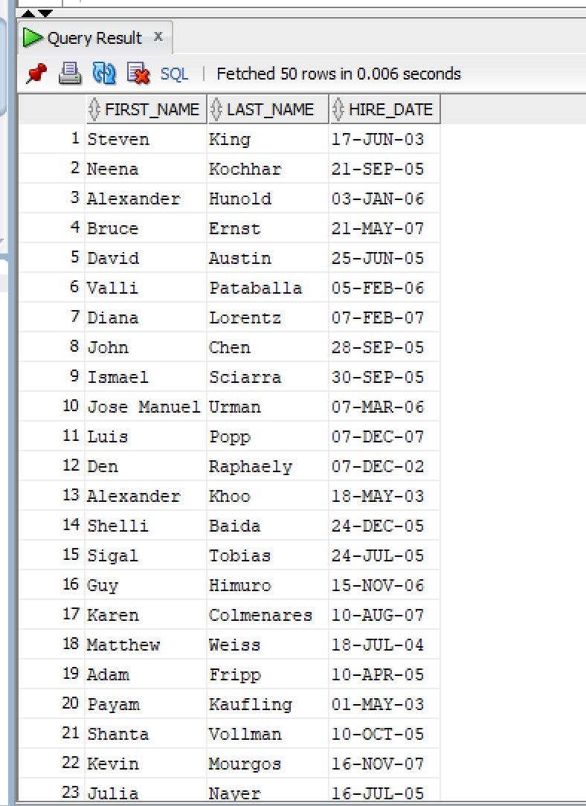

Q2)
SQL Query:
SELECT first_name, last_name, salary
FROM HR.employees
WHERE salary = (
SELECT MIN(salary)
FROM HR.employees
);
Snapshot of Query:
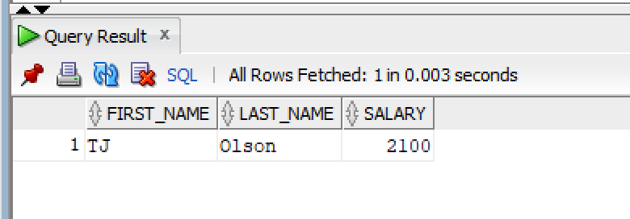

Q3)
SQL Query:
SELECT first_name, last_name, salary
FROM HR.employees
WHERE salary > (
SELECT salary
FROM HR.employees
WHERE first_name = 'Karen' AND last_name = 'Colmenares'
);

Snapshot of Query:
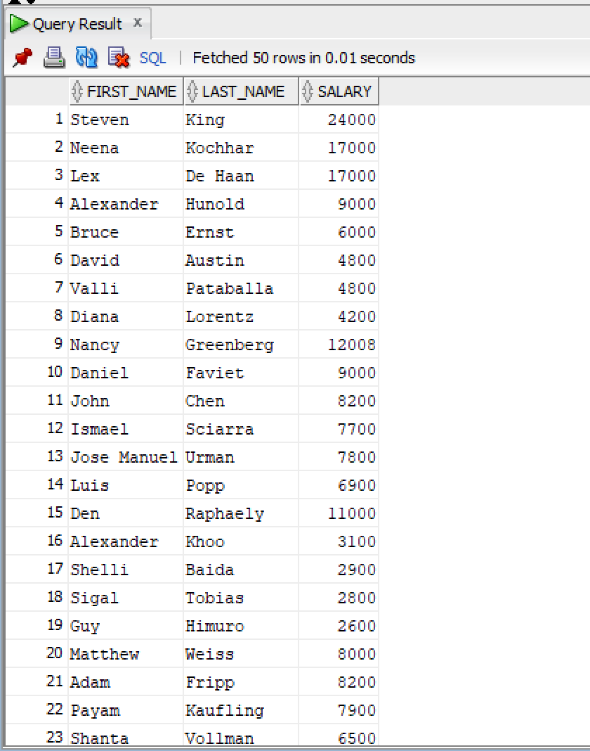

Q4)
SQL Query:
SELECT first_name, last_name, department_id
FROM HR.employees
WHERE department_id IN (
SELECT department_id
FROM HR.employees
WHERE job_id = 'PU_CLERK'
);
Snapshot of Query:
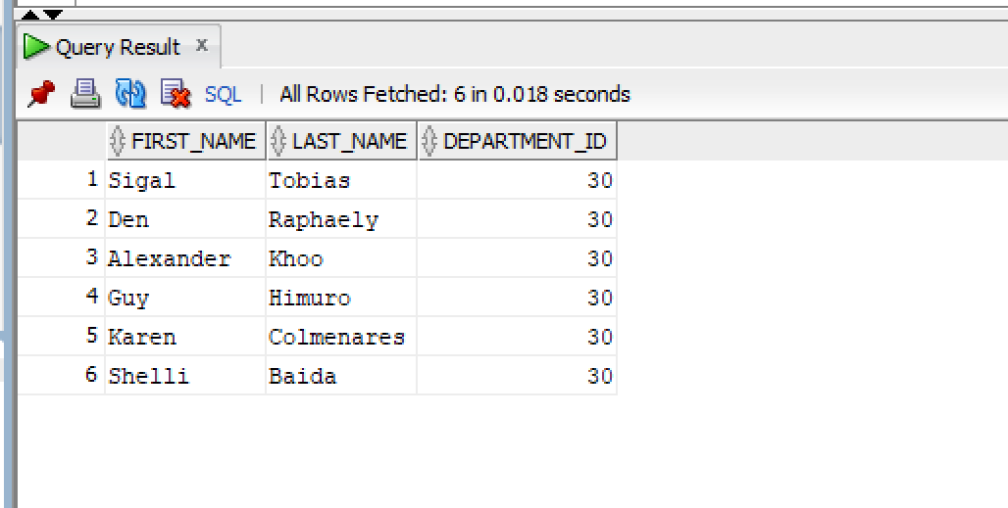

Q5)
SQL Query:
SELECT first_name, last_name, job_id
FROM HR.employees
WHERE job_id IN (
SELECT job_id
FROM HR.employees
WHERE department_id = 50
);
Snapshot of Query:
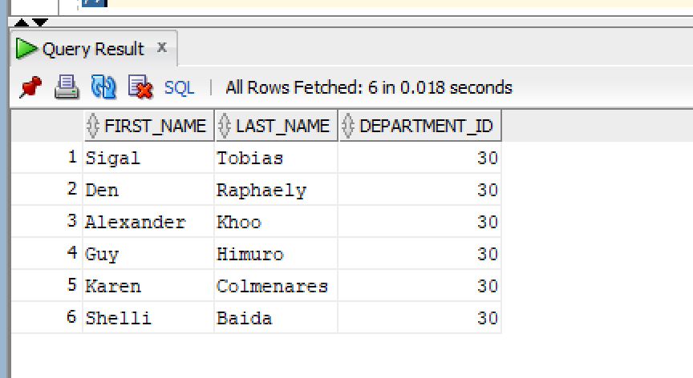

Q6)
SQL Query:
SELECT first_name, last_name, salary
FROM HR.employees
WHERE salary > ANY (
SELECT salary
FROM HR.employees
WHERE department_id = 60
);

Snapshot of Query:
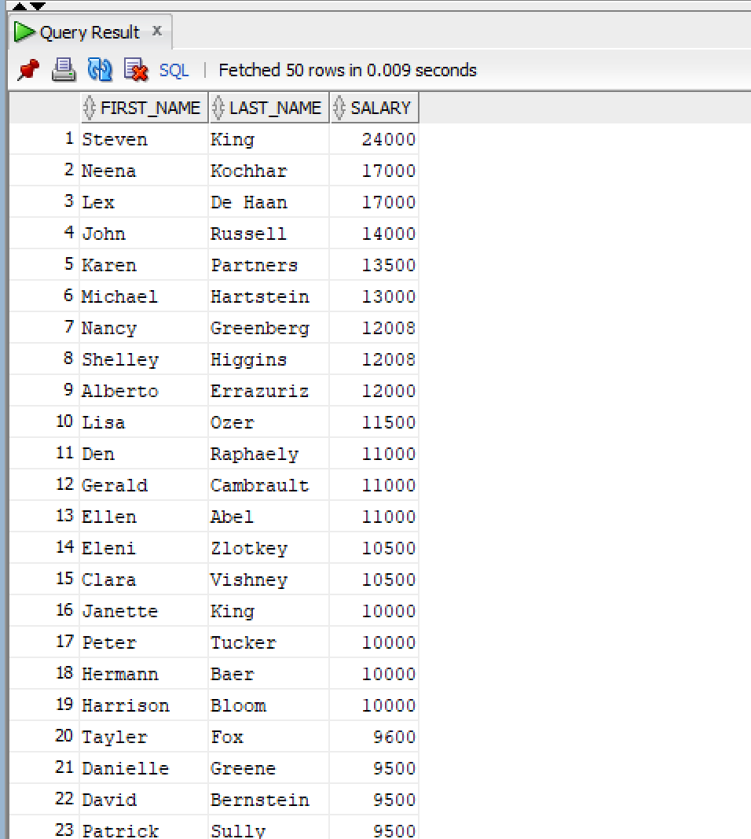

Q7)
SQL Query:
SELECT first_name, last_name, salary
FROM HR.employees
WHERE salary > ALL (
SELECT salary
FROM HR.employees
WHERE department_id = 90
);

Snapshot of Query:
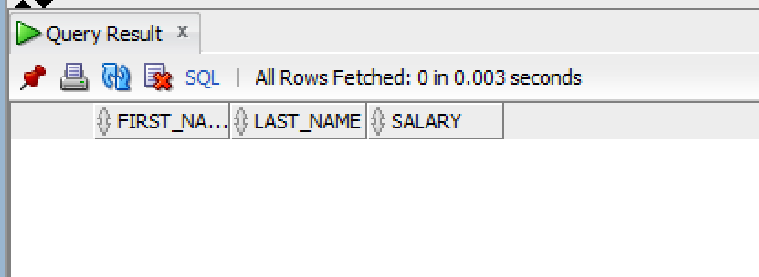

Q8)
SQL Query:
SELECT first_name, last_name, department_id
FROM HR.employees
WHERE department_id IN (
SELECT department_id
FROM HR.employees
GROUP BY department_id
HAVING COUNT(employee_id) > 1
);

Snapshot of Query:
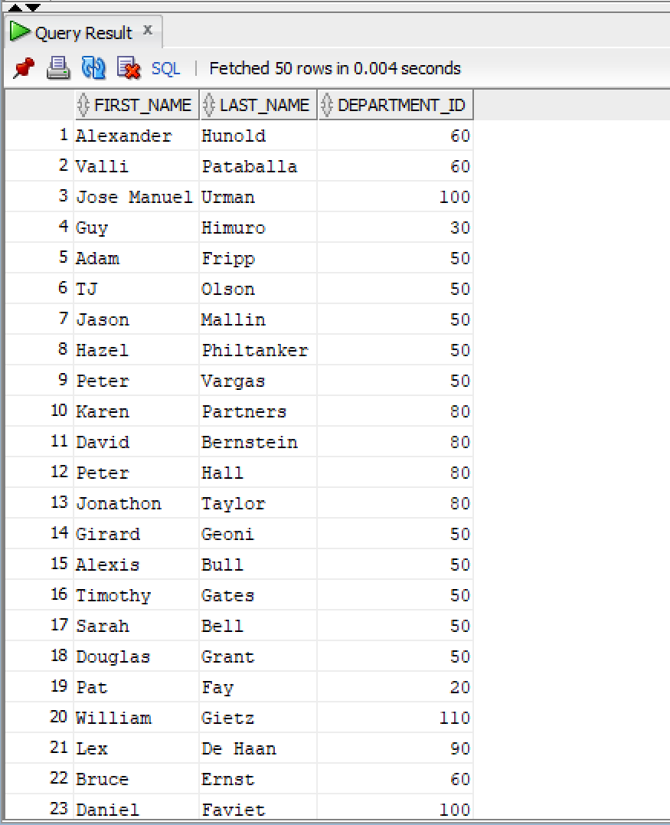

Q9)
SQL Query:
SELECT first_name, last_name, salary, department_id
FROM HR.employees e
WHERE salary > (
SELECT AVG(salary)
FROM HR.employees
WHERE department_id = e.department_id
);

Snapshot of Query:
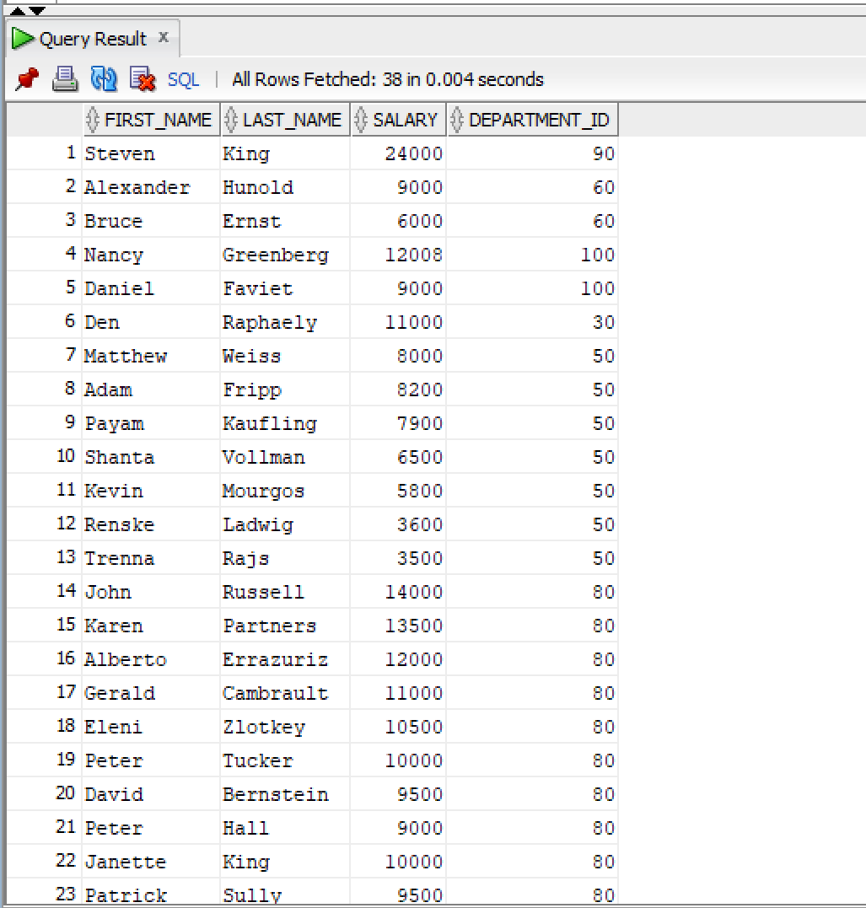

Q10)
SQL Query:
SELECT first_name, last_name, salary, department_id
FROM HR.employees
WHERE (department_id, salary) IN (
SELECT department_id, MAX(salary)
FROM HR.employees
GROUP BY department_id
);
Snapshot of Query:
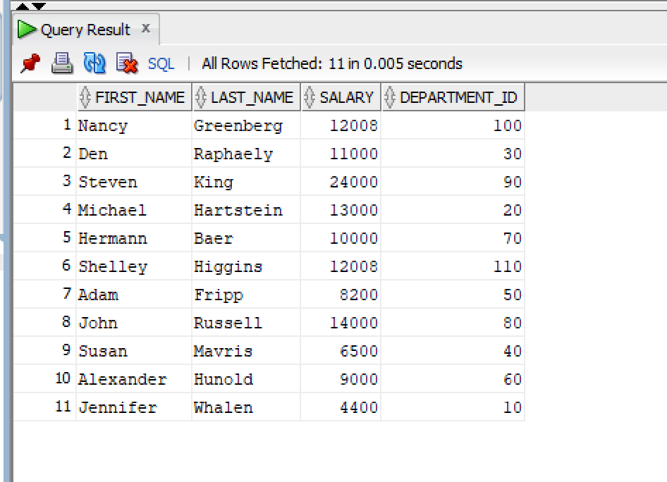

Q11)
SQL Query:
SELECT first_name, last_name, salary, department_id
FROM HR.employees
WHERE (department_id, salary) IN (
SELECT department_id, MIN(salary)
FROM HR.employees
GROUP BY department_id
);
Snapshot of Query:
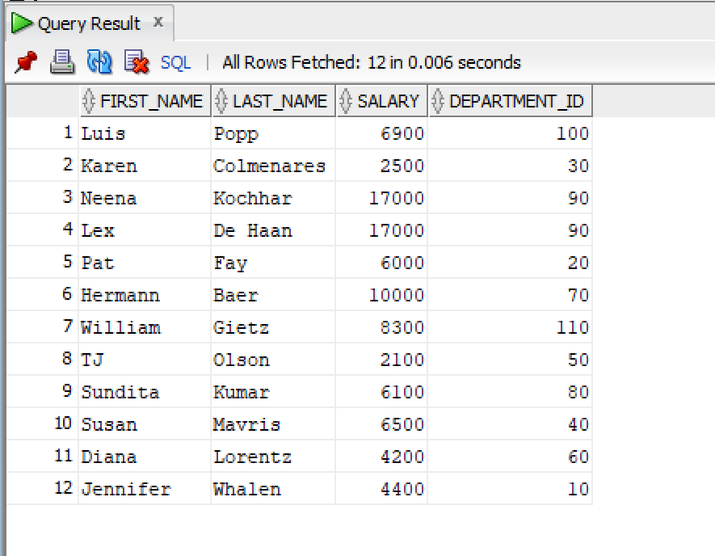

Q12)
SQL Query:

CREATING THE TAB;E
CREATE TABLE high_salary_employees AS
SELECT * FROM HR.employees
WHERE 1 = 0;

INSERTING DATA USING SUB QUERY
INSERT INTO high_salary_employees
SELECT *
FROM HR.employees
WHERE salary > 10000;

Snapshot of Query:
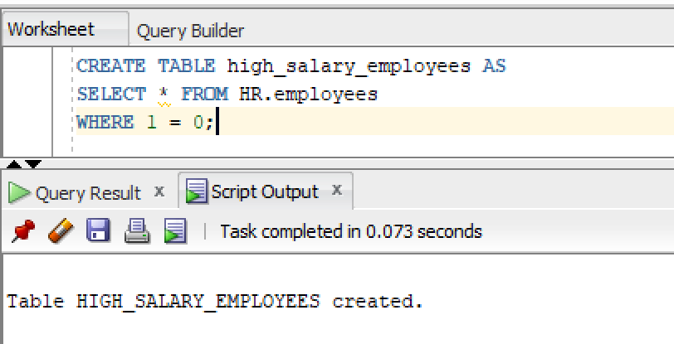
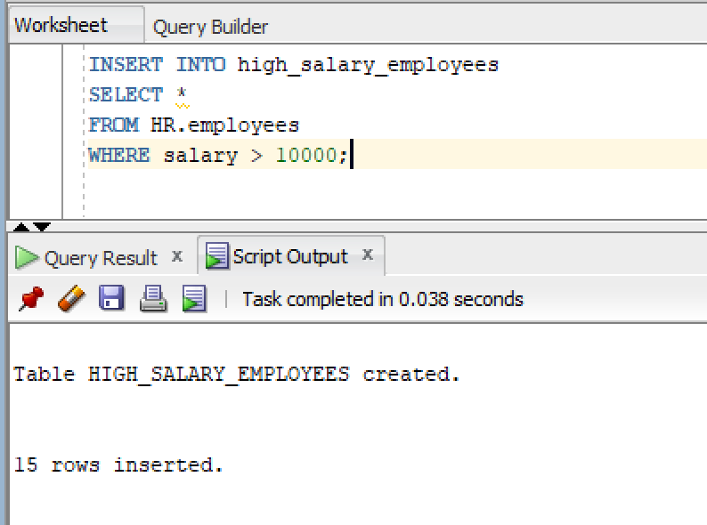

Q13)
SQL Query:
UPDATE HR.employees
SET salary = salary + (salary * 0.10)
WHERE job_id IN (
SELECT job_id
FROM HR.jobs
WHERE job_id = 'IT_PROG'
);
Snapshot of Query:
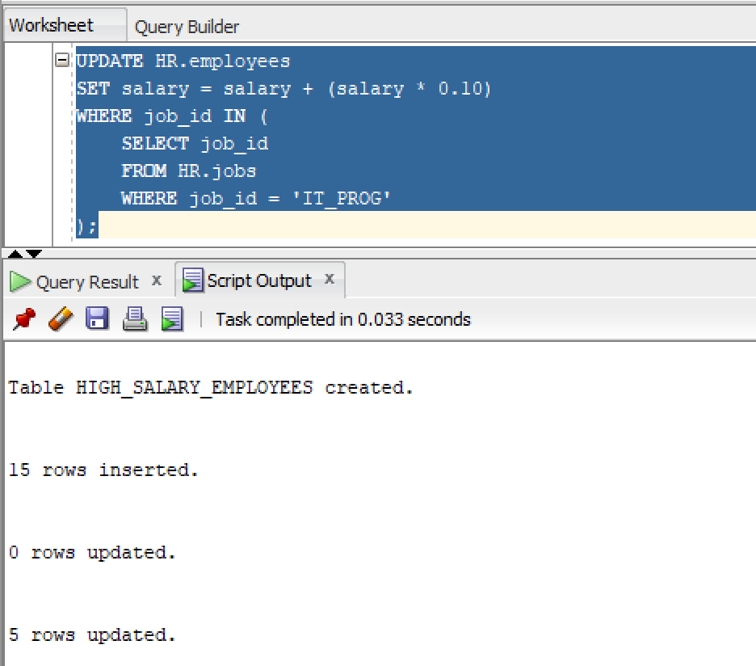
Q14)
SQL Query:

Created and Populated Our Table
CREATE TABLE temp_employees AS
SELECT * FROM HR.employees;

DELETING EMPLOYEES FROM OUT TEMPORARY TABLE

DELETE FROM temp_employees
WHERE salary < (
SELECT AVG(salary)
FROM temp_employees
);

Snapshot of Query:
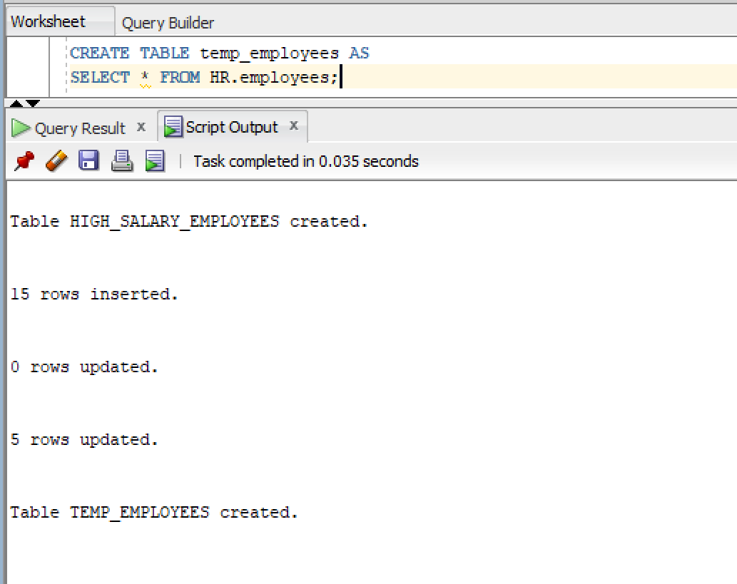

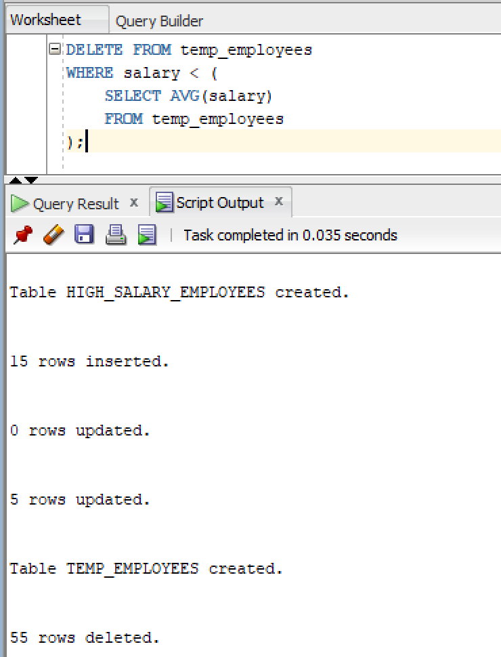

Q15)
SQL Query:
UPDATE HR.employees
SET department_id = (
SELECT department_id
FROM HR.departments
WHERE department_name = 'MK_MAN'
)
WHERE employee_id = 100;

Snapshot of Query:
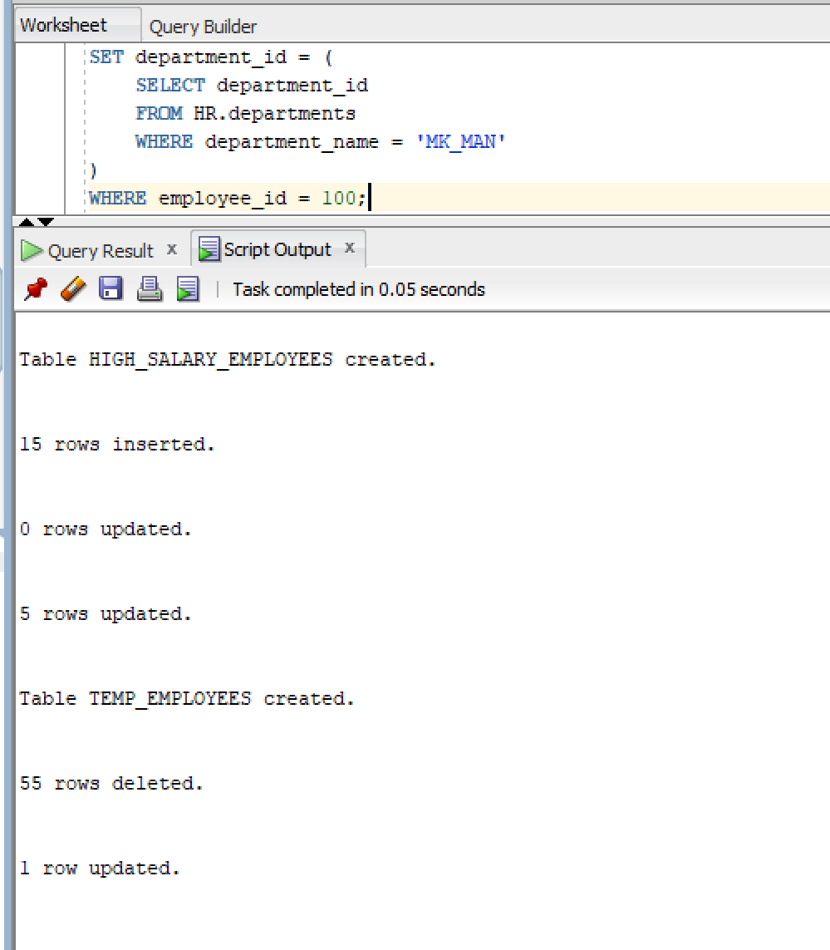

One-line description

1. What is a subquery in SQL?
A subquery as a mini-query nested inside the main SQL statement/query. It runs first to find a specific piece of information, and then hands that result to the main query.

2. What is the difference between single-row and multiple-row subqueries?
A single-row subquery gives back exactly one specific record. But, a multiple-row subquery returns a whole list of results for your main query to consider/evaluate.

3. What is a correlated subquery?
This is a subquery that relies on data from the main outer query to work. The subquery has to run from scratch for every single row the main query processes as they are tied together.

4. Why are subqueries used in DML statements?
Subqueries are used to update, insert, or delete data when we don't know the exact target values beforehand. They dynamically hunt the right records before applying the changes.

5. What operators are commonly used with multiple-row subqueries?
Operators like IN, ANY, or ALL are used to check how your data compares against the multiple rows returned by your subquery.

