Name: Muhammad Abu Bakar
NUID: 24K-0826
Section: BCS-243D
Syllabus: Database Systems Lab
Syllabus Code: CL2005
Instructor: Sir Osama Tahir

Q1)
SQL Query:
SELECT first_name, last_name, salary
FROM HR.EMPLOYEES
WHERE salary > (
SELECT AVG(salary)
FROM HR.employees
);

Snapshot of Query:
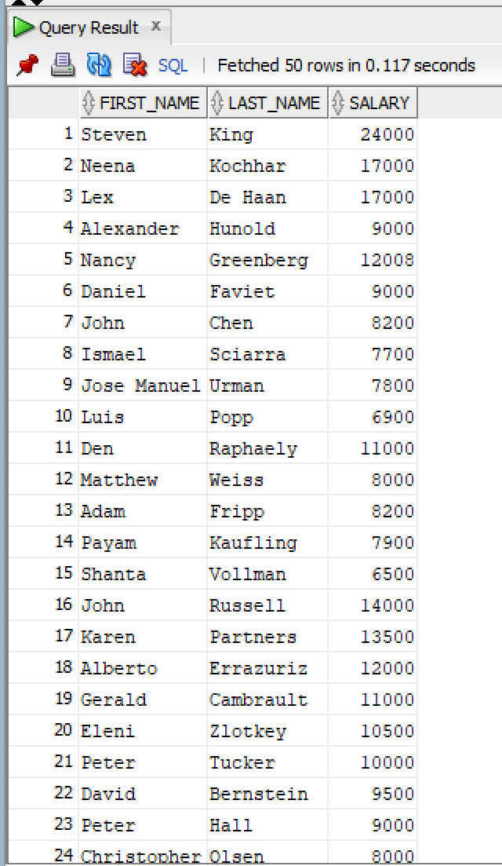
Q2)
SQL Query:
SELECT first_name, last_name, salary
FROM HR.employees
WHERE salary = (
SELECT MAX(salary)
FROM HR.employees
);
Snapshot of Query:
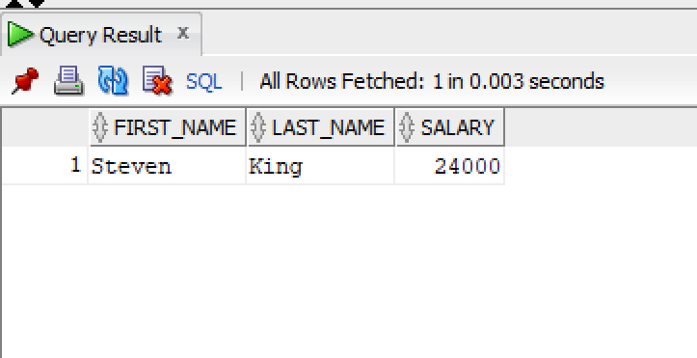

Q3)
SQL Query:
SELECT first_name, last_name
FROM HR.employees
WHERE department_id IN (
SELECT department_id
FROM HR.employees
WHERE first_name = 'David'
);

Snapshot of Query:
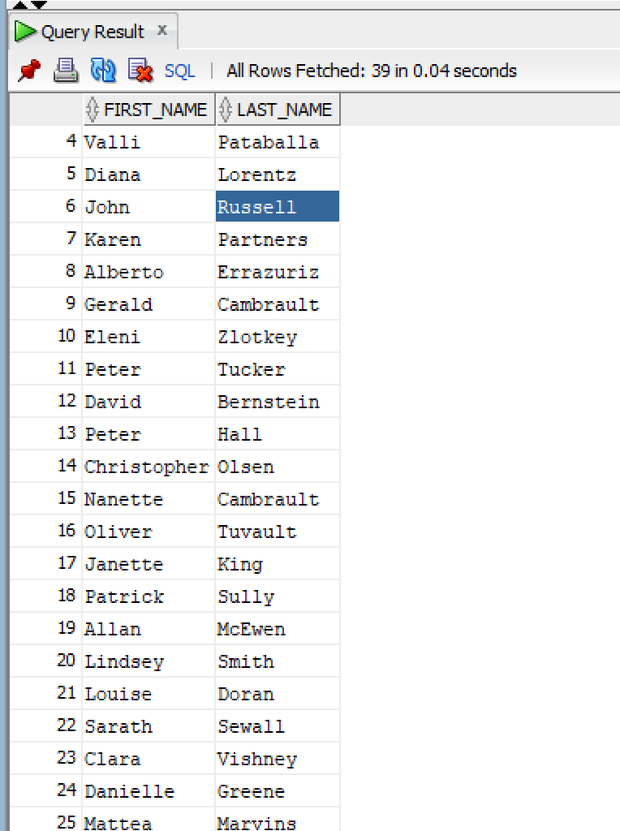

Q4)
SQL Query:
SELECT department_name
FROM HR.departments
WHERE department_id IN (
SELECT department_id
FROM HR.employees
GROUP BY department_id
HAVING AVG(salary) > 50000
);
Snapshot of Query:
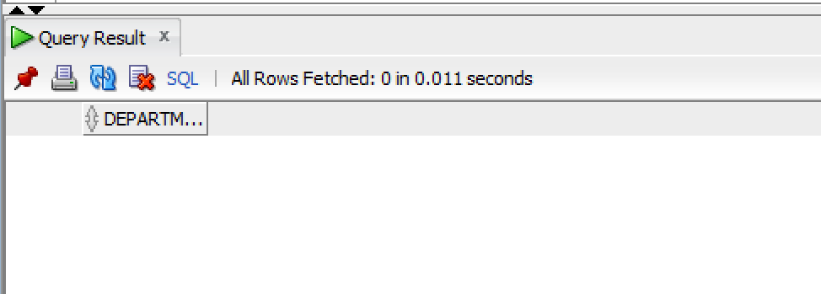

Q5)
SQL Query:
SELECT first_name, last_name, salary, department_id
FROM HR.employees e
WHERE salary > (
SELECT AVG(salary)
FROM HR.employees
WHERE department_id = e.department_id
);

Snapshot of Query:
