

Lab Task(s) Report – Lab 09

Name:

Muhammad Abu Bakar

NU ID:

24K-0826

May 13th, 2026

—

Syllabus:

Database Systems Lab

Syllabus Code: CL-2005

—

Instructor:

Sir Osama Tahir

Q1)

Part A - Creating Reuseable Domains:
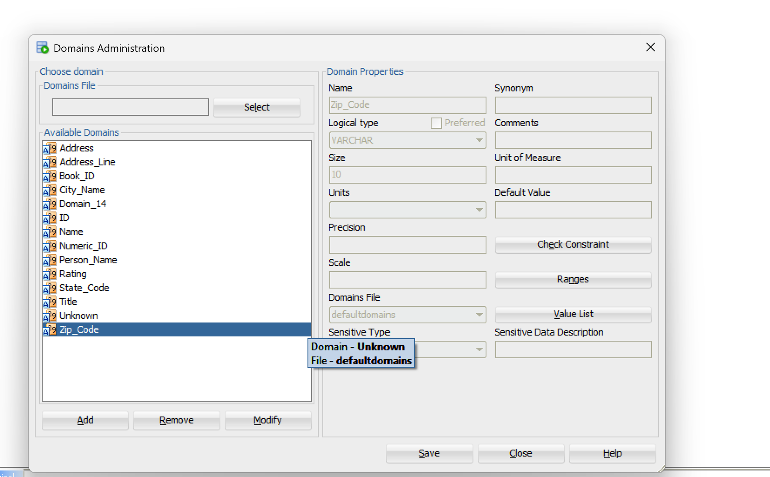

Part B - Logical Model:
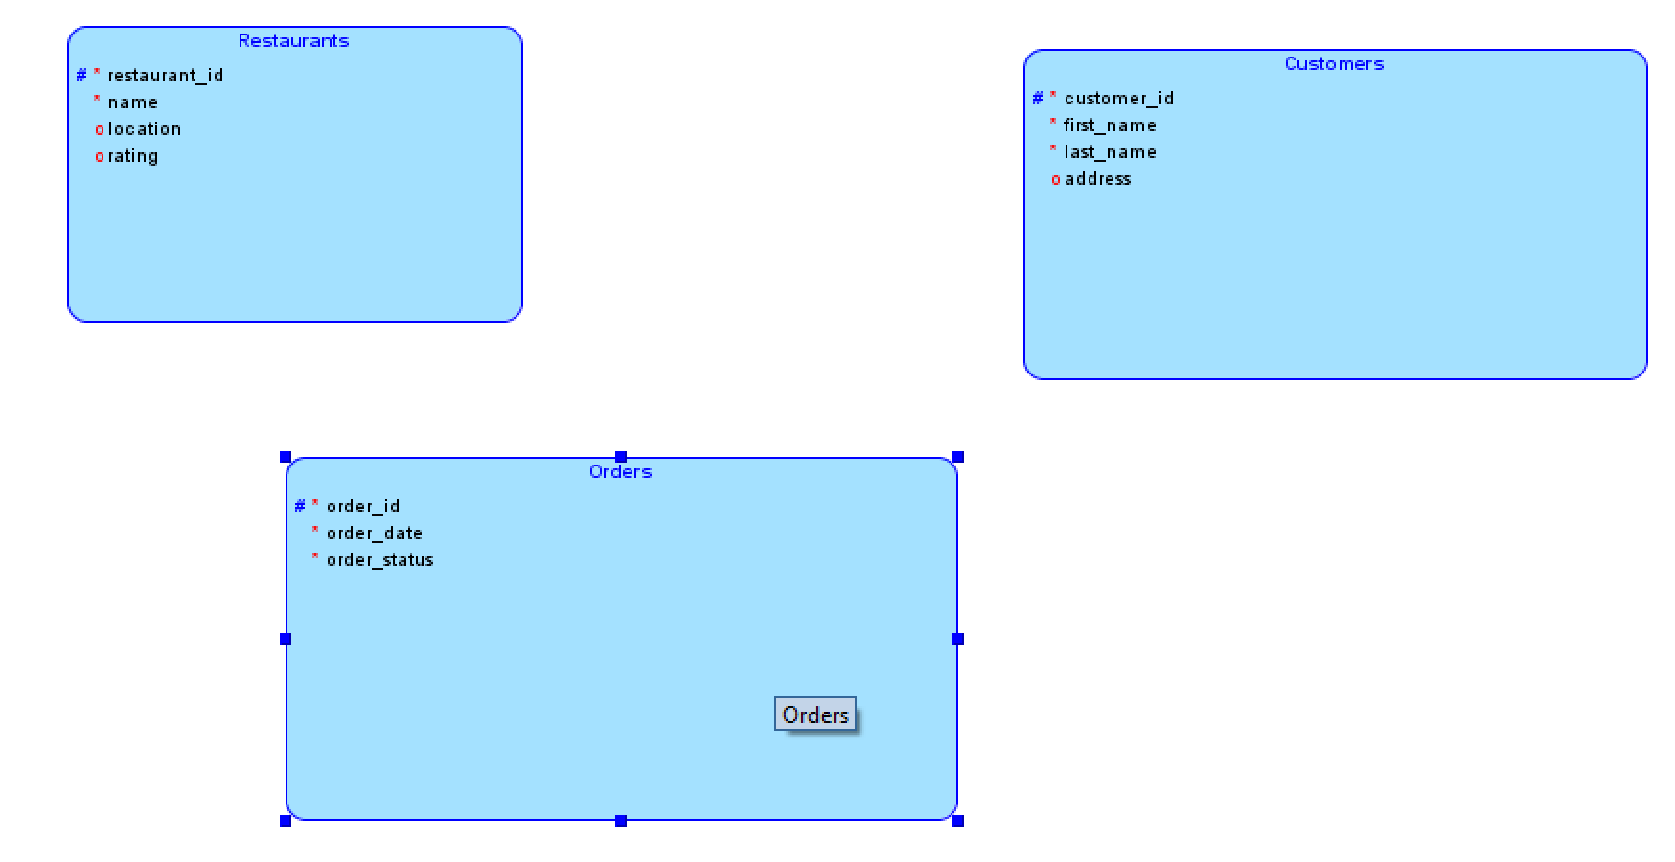

Part C - Relationships:
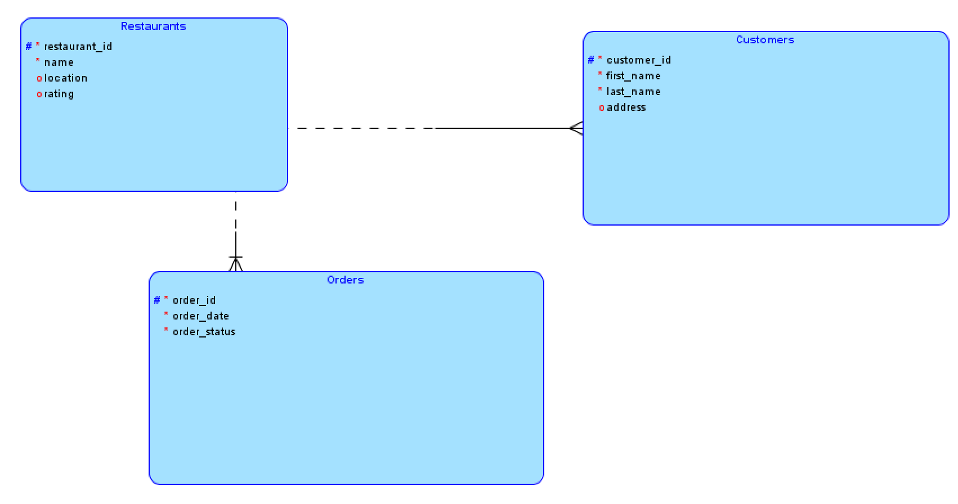

Relationships Justifications:

Restaurants->Orders (1:N):
One restaurant can receive multiple orders, but a specific order can only go to one restaurant.

Customers->Orders (1:N):
1 customer can request for multiple orders, but a specific order can only belong to 1 customer.

Part D – Relational Model:
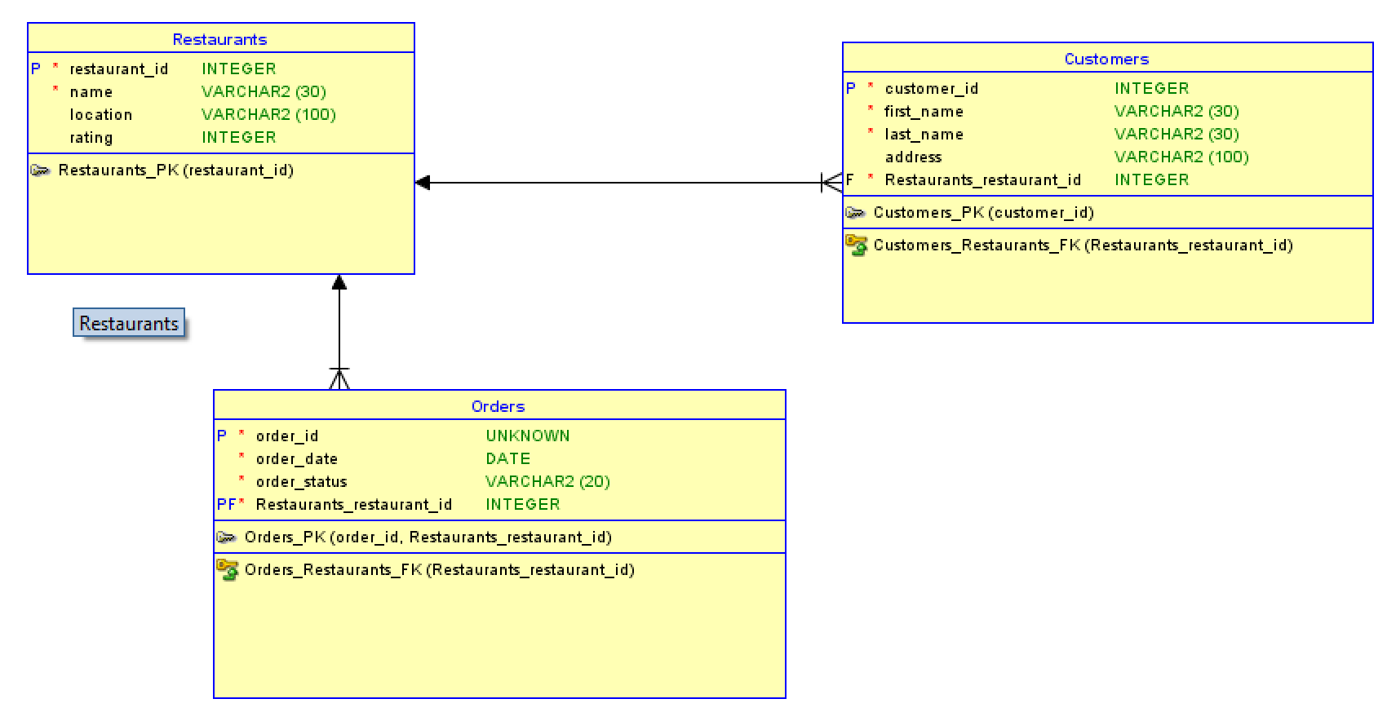

Part E – DDL Generation:
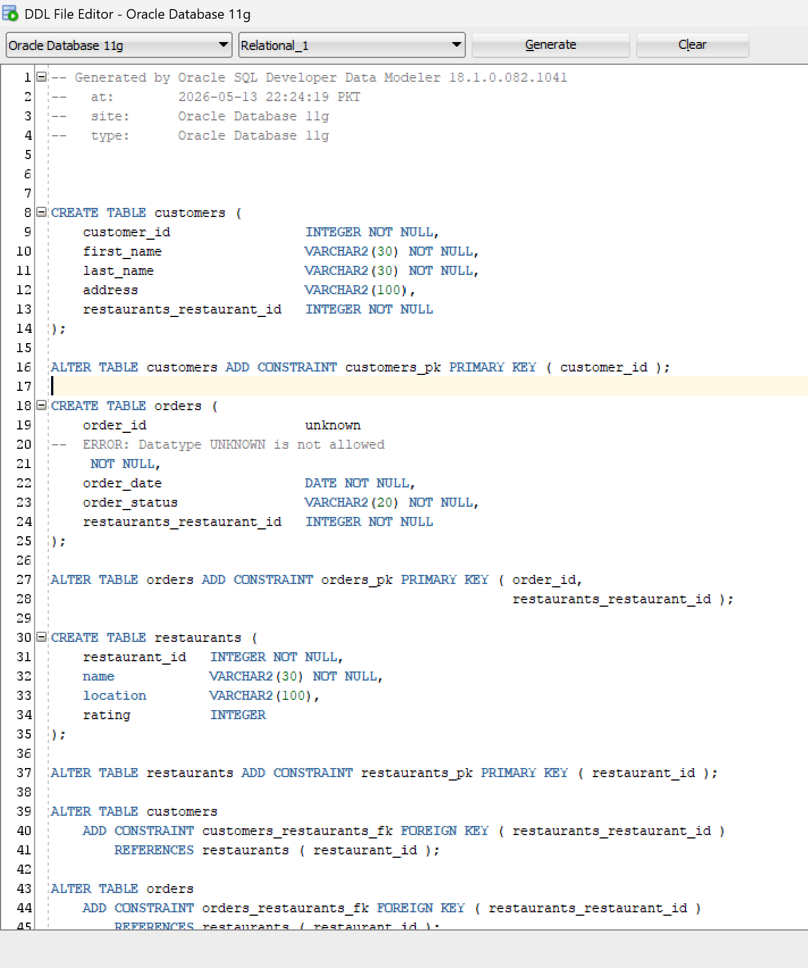

DDL Generated:

-- Generated by Oracle SQL Developer Data Modeler 18.1.0.082.1041
-- at: 2026-05-13 22:24:19 PKT
-- site: Oracle Database 11g
-- type: Oracle Database 11g

CREATE TABLE customers (
customer_id INTEGER NOT NULL,
first_name VARCHAR2(30) NOT NULL,
last_name VARCHAR2(30) NOT NULL,
address VARCHAR2(100),
restaurants_restaurant_id INTEGER NOT NULL
);

ALTER TABLE customers ADD CONSTRAINT customers_pk PRIMARY KEY ( customer_id );

CREATE TABLE orders (
order_id unknown
-- ERROR: Datatype UNKNOWN is not allowed
NOT NULL,
order_date DATE NOT NULL,
order_status VARCHAR2(20) NOT NULL,
restaurants_restaurant_id INTEGER NOT NULL
);

ALTER TABLE orders ADD CONSTRAINT orders_pk PRIMARY KEY ( order_id,
restaurants_restaurant_id );

CREATE TABLE restaurants (
restaurant_id INTEGER NOT NULL,
name VARCHAR2(30) NOT NULL,
location VARCHAR2(100),
rating INTEGER
);

ALTER TABLE restaurants ADD CONSTRAINT restaurants_pk PRIMARY KEY ( restaurant_id );

ALTER TABLE customers
ADD CONSTRAINT customers_restaurants_fk FOREIGN KEY ( restaurants_restaurant_id )
REFERENCES restaurants ( restaurant_id );

ALTER TABLE orders
ADD CONSTRAINT orders_restaurants_fk FOREIGN KEY ( restaurants_restaurant_id )
REFERENCES restaurants ( restaurant_id );

-- Oracle SQL Developer Data Modeler Summary Report:
--
-- CREATE TABLE 3
-- CREATE INDEX 0
-- ALTER TABLE 5
-- CREATE VIEW 0
-- ALTER VIEW 0
-- CREATE PACKAGE 0
-- CREATE PACKAGE BODY 0
-- CREATE PROCEDURE 0
-- CREATE FUNCTION 0
-- CREATE TRIGGER 0
-- ALTER TRIGGER 0
-- CREATE COLLECTION TYPE 0
-- CREATE STRUCTURED TYPE 0
-- CREATE STRUCTURED TYPE BODY 0
-- CREATE CLUSTER 0
-- CREATE CONTEXT 0
-- CREATE DATABASE 0
-- CREATE DIMENSION 0
-- CREATE DIRECTORY 0
-- CREATE DISK GROUP 0
-- CREATE ROLE 0
-- CREATE ROLLBACK SEGMENT 0
-- CREATE SEQUENCE 0
-- CREATE MATERIALIZED VIEW 0
-- CREATE SYNONYM 0
-- CREATE TABLESPACE 0
-- CREATE USER 0
--
-- DROP TABLESPACE 0
-- DROP DATABASE 0
--

-- REDACTION POLICY 0
--
-- ORDS DROP SCHEMA 0
-- ORDS ENABLE SCHEMA 0
-- ORDS ENABLE OBJECT 0
--
-- ERRORS 1
-- WARNINGS 0

Critical Thinking Questions

- Why is Order a separate entity?
It is a distinct entity with attributes that are owned by this particular entity, it’s attributes do
not belong the the profile of a customer or restaurant, as in if we imagine a customer or a restaurant having an attribute of order status it wouldn’t make sense.

- What happens if we store order info inside Customer?

Goes against the basic rules set out by Normalization, if a customer order 10 times than either we
would store 10 orders details/info in the same columns violating 1NF, or we would run into data
redundancy issues like repeating the rows with that same customer id, name and address 10 times for
the 10 orders made by that 1 customer.

- Can a restaurant exist without orders?
Yes, if we go about this logically a newly opened restaurant will have zero orders, In ER
modelling we show this as an optional relationship with a cardinality of (0, N) to the Orders.

4. What if an order contains multiple food items?

If an order contains multiple food items to maintain and follow normalization rules what we
can do is create a separate table for fooditems, but then again this creates a many-to-many
(M:N) relationship between these 2 tables then. Oracle’s Data Modeler would resolve this
By creating an associative entity/table to resolve this M:N thing, eg: Order Details to hold the
specific items and quantities for each order.

