

Lab Task(s) Report – Lab 12

Name:

Muhammad Abu Bakar

NU ID:

24K-0826

May 13th, 2026

—

Syllabus:

Database Systems Lab

Syllabus Code: CL-2005

—

Instructor:

Sir Osama Tahir

Q1)

MongoDB Shell Query Text:
use SchoolDB

Screenshot:
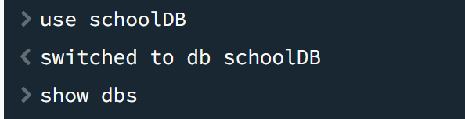

Q2)

MongoDB Shell Query Text:
db.createCollection("Students")
db.createCollection("Courses")

Screenshot:
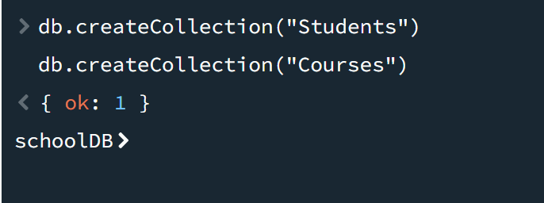

Q3)

MongoDB Shell Query Text:
db.Students.insertMany([
{ "_id": 1, "name": "Alice", "age": 20, "scores": { "math": 85, "science": 90 } },
{ "_id": 2, "name": "Bob", "age": 22, "scores": { "math": 78, "science": 82 } },
{ "_id": 3, "name": "Charlie", "age": 21, "scores": { "math": 92, "science": 88 } },
{ "_id": 4, "name": "Daisy", "age": 23, "scores": { "math": 68, "science": 74 } }
])

Screenshot:
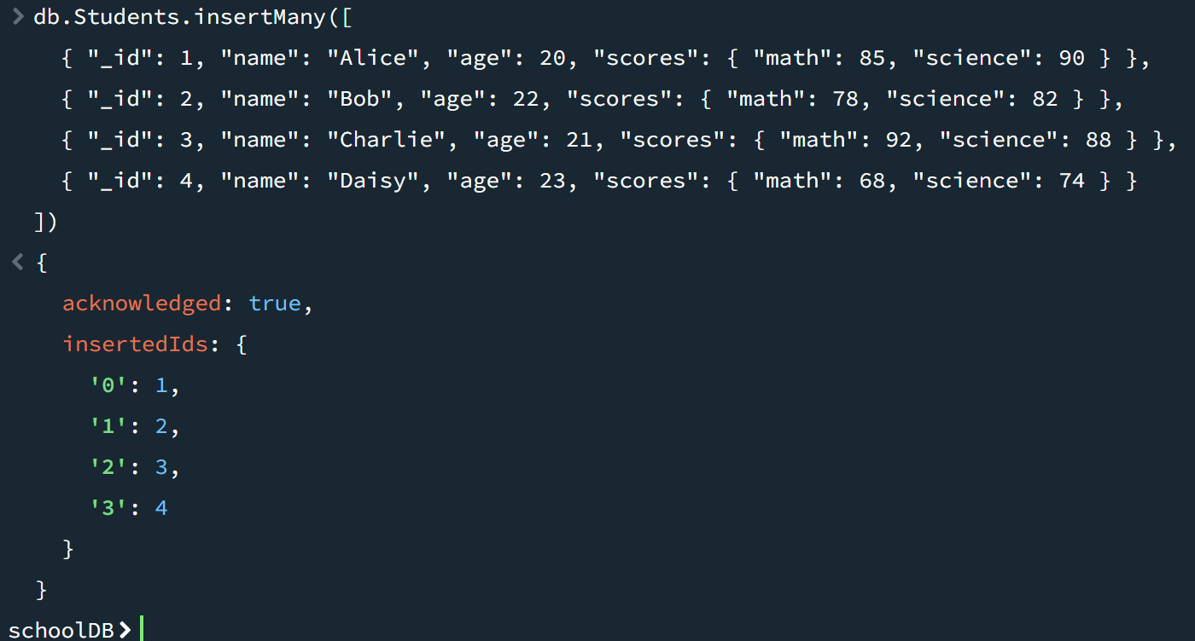

Q4)

MongoDB Shell Query Text:
db.Courses.insertMany([
{ "_id": 101, "courseName": "Mathematics", "instructor": "Dr. Smith", "studentsEnrolled": [1, 2, 3] },
{ "_id": 102, "courseName": "Science", "instructor": "Dr. Adams", "studentsEnrolled": [2, 3, 4] }
])

Screenshot:
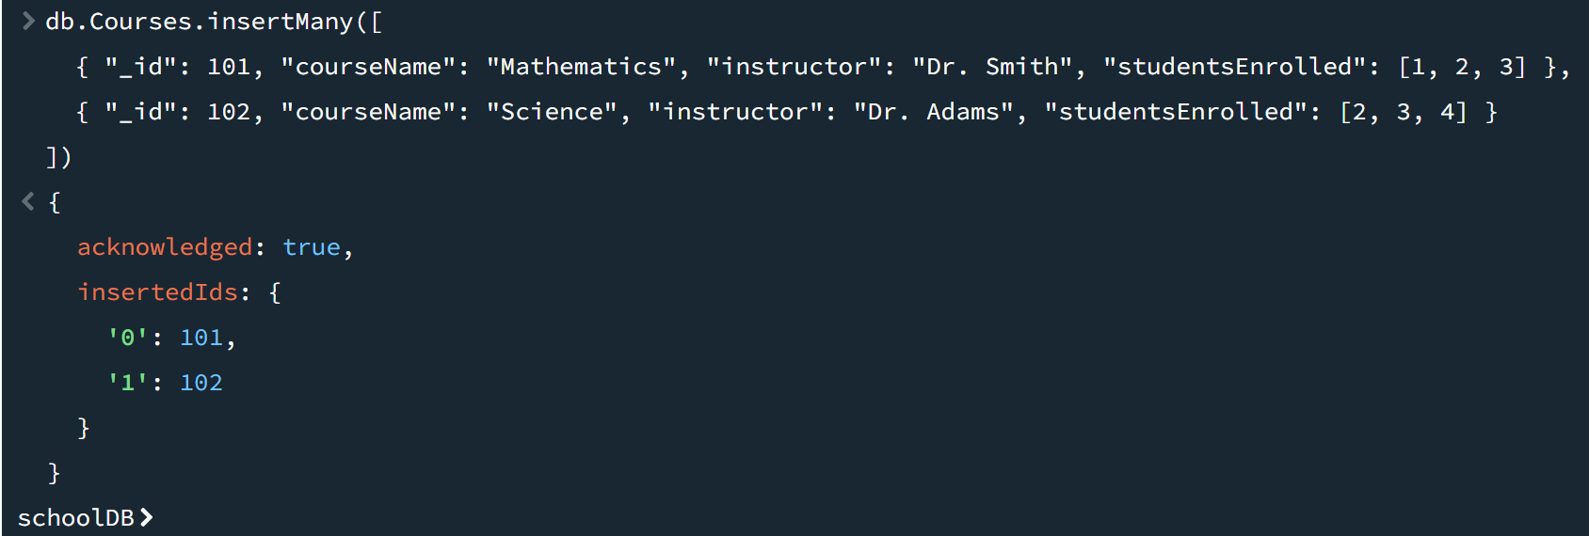

Q5 – Part 1)

MongoDB Shell Query Text:
db.Students.findOne({ "scores.math": { $gte: 85 }, "age": { $lt: 22 } })

Screenshot:
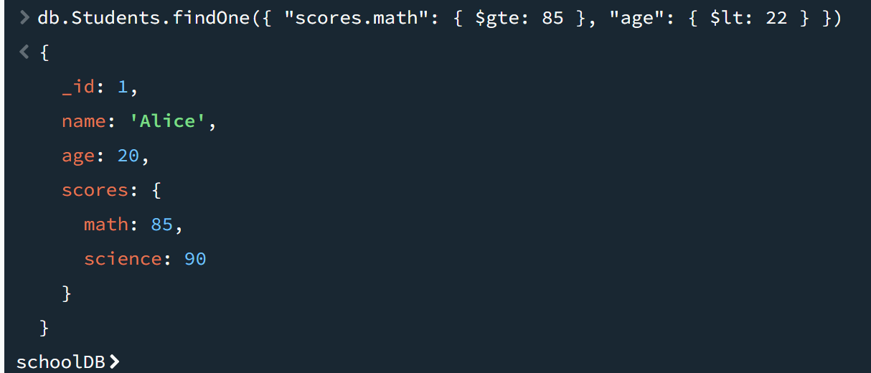

Q5 – Part 2)

MongoDB Shell Query Text:
db.Courses.findOne({ "studentsEnrolled": 3, "instructor": "Dr. Adams" })

Screenshot:
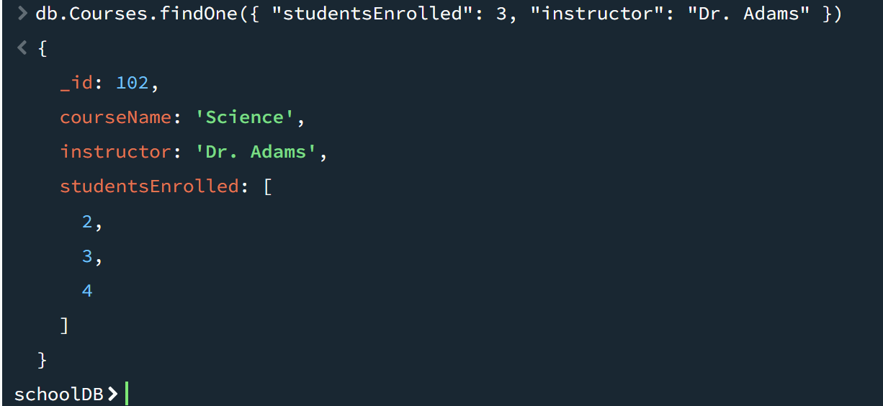

Q6 – Part 1)

MongoDB Shell Query Text:
db.Students.find({ "scores.math": { $gte: 80 }, "scores.science": { $lt: 90 } })

Screenshot:
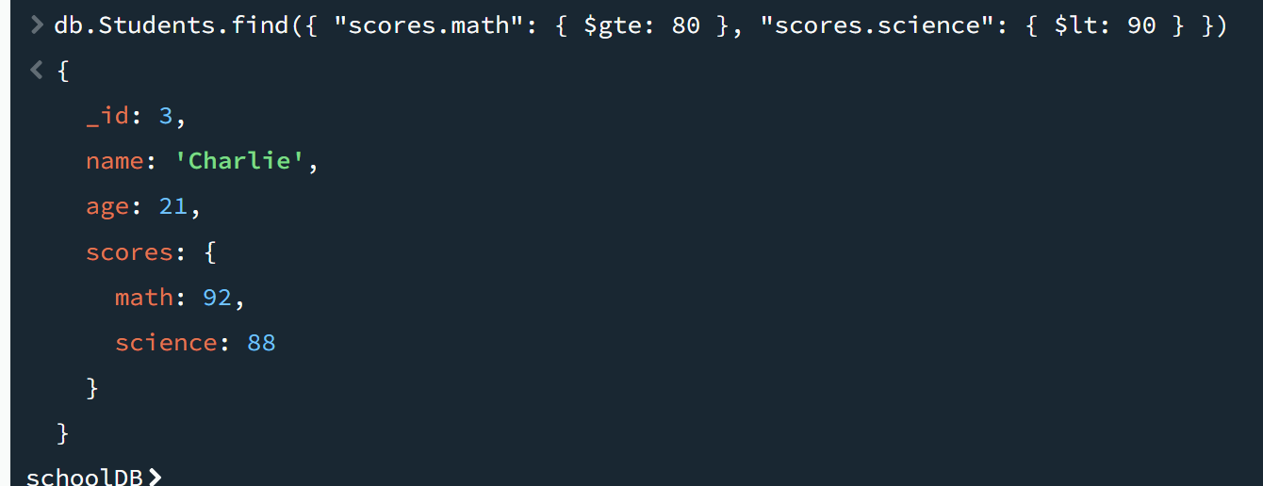

Q6 – Part 2)

MongoDB Shell Query Text:
db.Students.find({ $or: [ { "age": { $lt: 23 } }, { "scores.math": { $gte: 85 } } ] })

Screenshot:
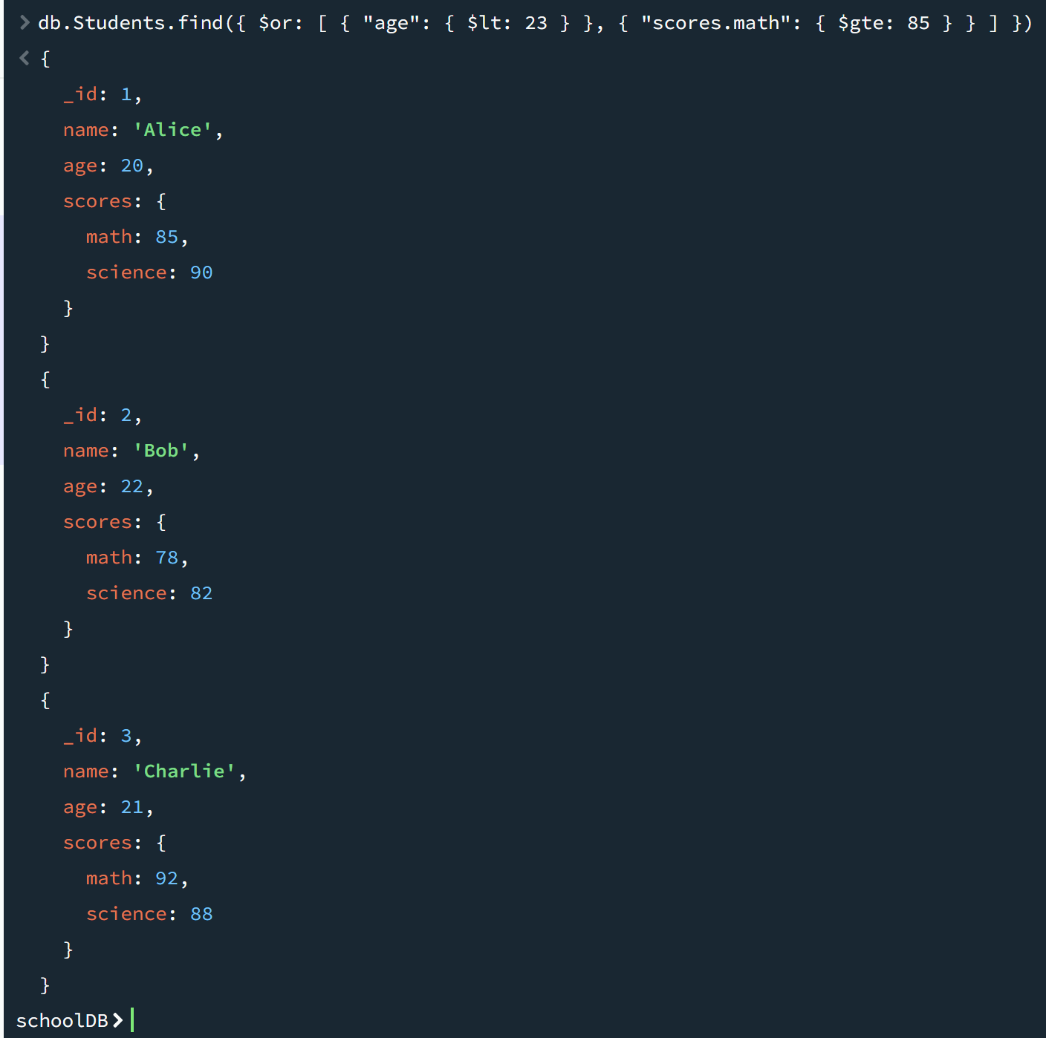

Q6 – Part 3)

MongoDB Shell Query Text:
db.Students.find({
"scores.science": { $gte: 80 },
$or: [ { "scores.math": { $lt: 75 } }, { "age": { $gt: 22 } } ]
})

Screenshot:
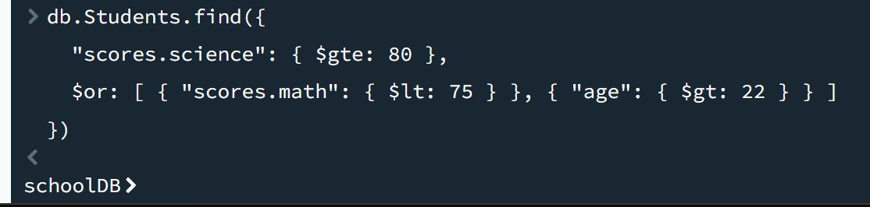

Q7)

MongoDB Shell Query Text:
db.Students.updateOne(
{ "name": "Bob", "scores.math": { $gte: 75 } },
{ $inc: { "scores.science": 1 } }
)

Screenshot:
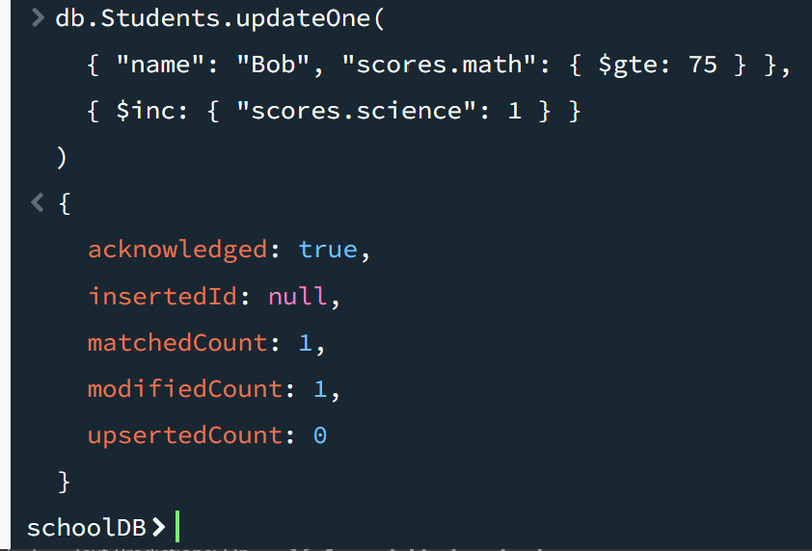

Q8)

MongoDB Shell Query Text:
db.Students.updateMany(
{ "scores.science": { $lt: 80 }, "age": { $gt: 22 } },
{ $inc: { "scores.math": 5 } }
)

Screenshot:
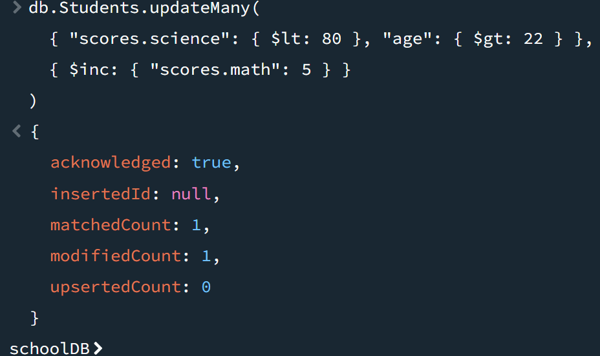

Q9)

MongoDB Shell Query Text:
db.Students.deleteOne({ "name": "Daisy", "scores.science": { $lt: 80 } })

Screenshot:
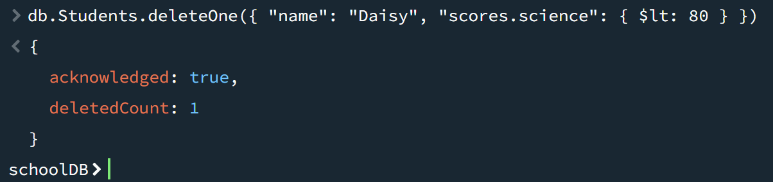

Q10)

MongoDB Shell Query Text:
db.Courses.deleteMany({
$or: [
{ "studentsEnrolled": 2 },
{ "instructor": "Dr. Smith" }
]
})

Screenshot:
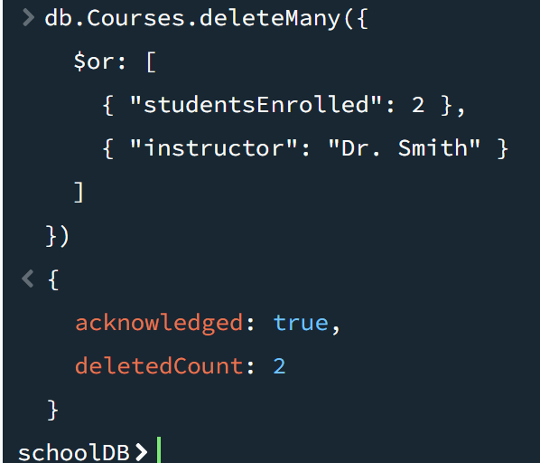

Q11)

MongoDB Shell Query Text:
db.Students.drop()

Screenshot:
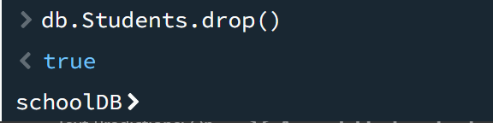

Q12)

MongoDB Shell Query Text:
db.Courses.drop()

Screenshot:
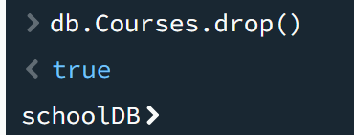

Q13)

MongoDB Shell Query Text:
db.dropDatabase()

Screenshot:
