24K-0826
MUHAMMAD ABU BAKAR
SIR WASEEM RAUF
COAL – ASSIGNMENT#03
Q1)
Code:

INCLUDE Irvine32.inc

.data
Dividend DWORD 0D4A4h
Divisor DWORD 0Ah
Threshold DWORD 5h
msgDiv BYTE "Dividend: ",0
msgDvs BYTE "Divisor: ",0
msgQuo BYTE "Quotient: ",0

.code
main PROC
mov edx, OFFSET msgDiv
call WriteString
mov eax, Dividend
call WriteHex
call Crlf

mov edx, OFFSET msgDvs
call WriteString
mov eax, Divisor
call WriteHex
call Crlf

mov eax, Dividend
mov ebx, Divisor

call CalcRecursiveDiv

mov edx, OFFSET msgQuo
call WriteString
call WriteHex
call Crlf

exit
main ENDP

CalcRecursiveDiv PROC
cmp eax, Threshold
jle BaseCase

sub eax, ebx
call CalcRecursiveDiv

inc eax
ret

BaseCase:
mov eax, 0
ret
CalcRecursiveDiv ENDP
END main

Screenshot:
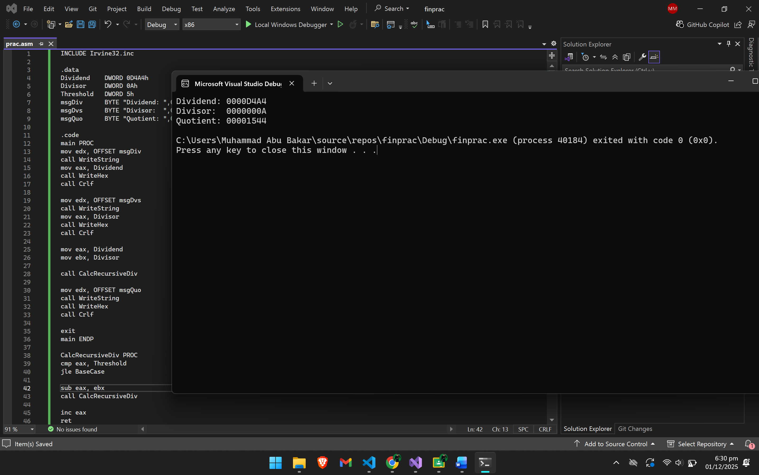
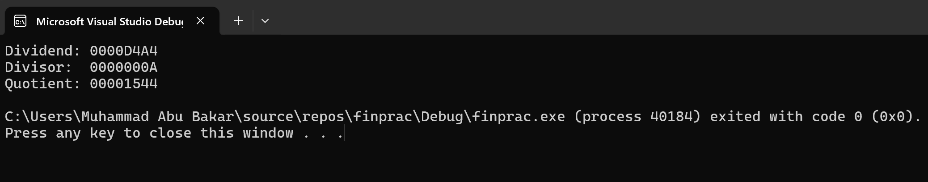

Q2
Code:
INCLUDE Irvine32.inc

.data
buffer BYTE 128 DUP(0)
byteCount DWORD ?
cntA DWORD 0
cntE DWORD 0
cntI DWORD 0
cntO DWORD 0
cntU DWORD 0
prompt BYTE "Enter a string: ",0
strHeader BYTE "Vowel Count",0
outA BYTE "a or A = ",0
outE BYTE "e or E = ",0
outI BYTE " i or I = ",0
outO BYTE " o or O = ",0
outU BYTE " u or U = ",0
tabSpace BYTE " ",0

.code
main PROC

mov edx, OFFSET prompt
call WriteString

mov edx, OFFSET buffer
mov ecx, SIZEOF buffer
call ReadString
mov byteCount, eax

mov esi, OFFSET buffer
mov ecx, byteCount

cmp ecx, 0
je PrintResults

ParseLoop:
mov al, [esi]

cmp al, 'A'
je FoundA
cmp al, 'a'
je FoundA

cmp al, 'E'
je FoundE
cmp al, 'e'
je FoundE

cmp al, 'I'
je FoundI
cmp al, 'i'
je FoundI

cmp al, 'O'
je FoundO
cmp al, 'o'
je FoundO

cmp al, 'U'
je FoundU
cmp al, 'u'
je FoundU

jmp NextChar

FoundA:
inc cntA
jmp NextChar
FoundE:
inc cntE
jmp NextChar
FoundI:
inc cntI
jmp NextChar
FoundO:
inc cntO
jmp NextChar
FoundU:
inc cntU
jmp NextChar

NextChar:
inc esi
loop ParseLoop

PrintResults:

call Crlf
mov edx, OFFSET strHeader
call WriteString
call Crlf

mov edx, OFFSET outA
call WriteString
mov eax, cntA
call WriteDec

mov edx, OFFSET outI
call WriteString
mov eax, cntI
call WriteDec

mov edx, OFFSET outU
call WriteString
mov eax, cntU
call WriteDec
call Crlf

mov edx, OFFSET outE
call WriteString
mov eax, cntE
call WriteDec

mov edx, OFFSET outO
call WriteString
mov eax, cntO
call WriteDec
call Crlf

exit
main ENDP
END main

Screenshot:
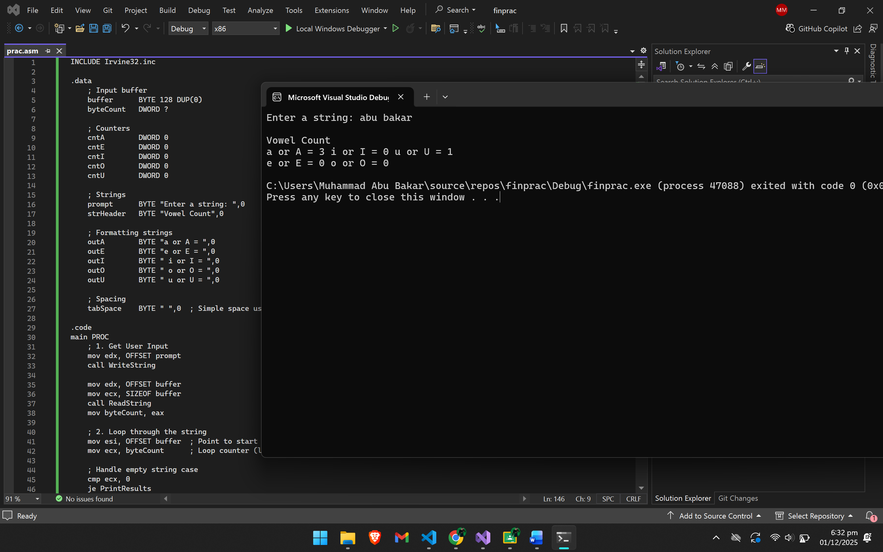
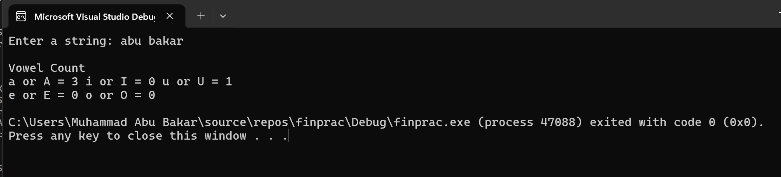

Q3)
Code:
INCLUDE Irvine32.inc

.data
myString BYTE "###FAST",0
charToTrim BYTE "#"

msgOriginal BYTE "Original string: ",0
msgTrimmed BYTE "Trimmed string: ",0

.code
main PROC
mov edx, OFFSET msgOriginal
call WriteString
mov edx, OFFSET myString
call WriteString
call Crlf

mov edx, OFFSET myString
mov al, charToTrim
call Str_trim_leading

mov edx, OFFSET msgTrimmed
call WriteString
mov edx, OFFSET myString
call WriteString
call Crlf

exit
main ENDP

Str_trim_leading PROC USES eax ebx esi edi
mov esi, edx
mov edi, edx
mov bl, al

ScanLoop:
mov al, [esi]
cmp al, 0
je StartCopy
cmp al, bl
jne StartCopy
inc esi
jmp ScanLoop

StartCopy:

CopyLoop:
mov al, [esi]
mov [edi], al
cmp al, 0
je Done
inc esi
inc edi
jmp CopyLoop

Done:
ret
Str_trim_leading ENDP
END main

Screenshot:
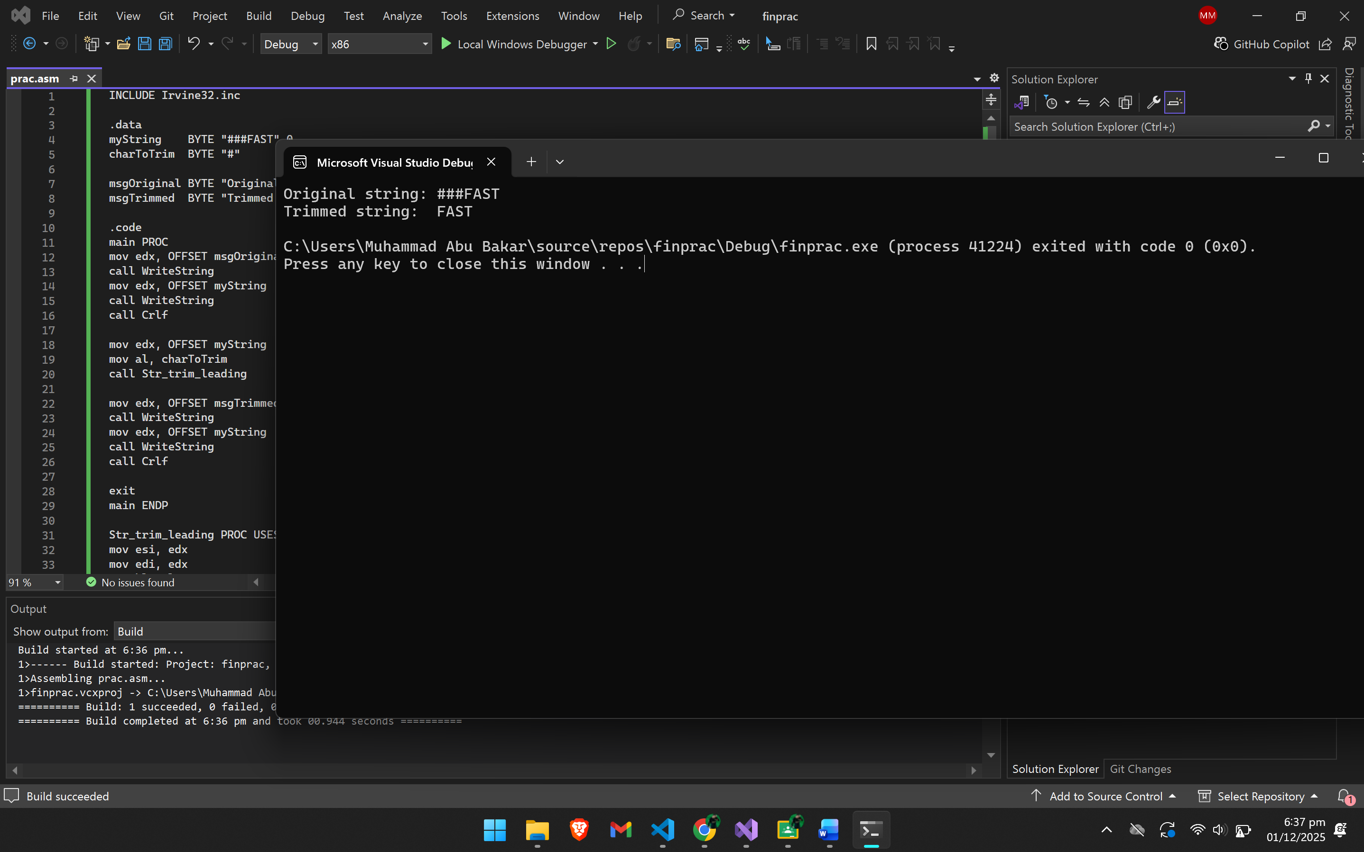
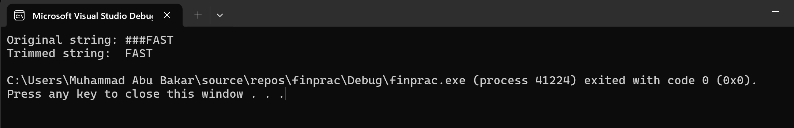

Q4)
Code:
INCLUDE Irvine32.inc

FindFive PROTO :PTR SDWORD, :DWORD

.data
array1 SDWORD 5, 5, 5, 5, 5, 10, 20
array2 SDWORD 1, 2, 5, 5, 5, 5, 5, 3
array3 SDWORD 5, 5, 5, 0, 5, 5, 5
array4 SDWORD 1, 2, 3, 4, 6, 7, 8

strTest1 BYTE "Test 1 (Start): ",0
strTest2 BYTE "Test 2 (Middle): ",0
strTest3 BYTE "Test 3 (Broken): ",0
strTest4 BYTE "Test 4 (None): ",0
strPass BYTE "Found sequence!",0
strFail BYTE "No sequence found.",0

.code
main PROC
mov edx, OFFSET strTest1
call WriteString
INVOKE FindFive, ADDR array1, LENGTHOF array1
call ShowResult

mov edx, OFFSET strTest2
call WriteString
INVOKE FindFive, ADDR array2, LENGTHOF array2
call ShowResult

mov edx, OFFSET strTest3
call WriteString
INVOKE FindFive, ADDR array3, LENGTHOF array3
call ShowResult

mov edx, OFFSET strTest4
call WriteString
INVOKE FindFive, ADDR array4, LENGTHOF array4
call ShowResult

exit
main ENDP

ShowResult PROC
cmp eax, 1
je IsFound
mov edx, OFFSET strFail
jmp DoPrint
IsFound:
mov edx, OFFSET strPass
DoPrint:
call WriteString
call Crlf
call Crlf
ret
ShowResult ENDP

FindFive PROC USES esi ecx ebx,
ptrArray:PTR SDWORD,
arrSize:DWORD

mov esi, ptrArray
mov ecx, arrSize
mov ebx, 0

cmp ecx, 5
jb NotFound

ScanLoop:
mov eax, [esi]
cmp eax, 5
jne ResetCount

inc ebx
cmp ebx, 5
je Found
jmp NextIter

ResetCount:
mov ebx, 0

NextIter:
add esi, 4
loop ScanLoop

NotFound:
mov eax, 0
jmp TheEnd

Found:
mov eax, 1

TheEnd:
ret
FindFive ENDP
END main

Screenshot:
