LSTM Text Classification — Model Results
Muhammad Adel
Cellula Assignment — Bidirectional LSTM (PyTorch)

1. Model Overview
A two-layer bidirectional LSTM with an embedding layer (128-d), hidden size 128, dropout 0.3 and masked mean pooling over real tokens, followed by a linear classifier. The input for each example is the query combined with the image description ("query SEP image description"), tokenized with NLTK and encoded to a fixed length of 160. The training set was class-balanced by random oversampling. Trained for 10 epochs with AdamW and Cross-Entropy loss; the checkpoint with the best validation macro F1 was selected.

2. Final Test Results
- Final Test Loss: 0.1823
- Final Test Macro F1: 0.8152 (81.52%)
- Test Accuracy: 0.94

3. Classification Report
Class | Precision | Recall | F1-score | Support
Non-Violent Crimes | 1.00 | 1.00 | 1.00 | 21
Safe | 0.91 | 0.95 | 0.93 | 88
Unknown S-Type | 0.20 | 0.11 | 0.14 | 9
Violent Crimes | 1.00 | 1.00 | 1.00 | 69
unsafe | 1.00 | 1.00 | 1.00 | 14
Accuracy |  |  | 0.94 | 201
Macro avg | 0.82 | 0.81 | 0.82 | 201
Weighted avg | 0.93 | 0.94 | 0.93 | 201

4. Training Curves
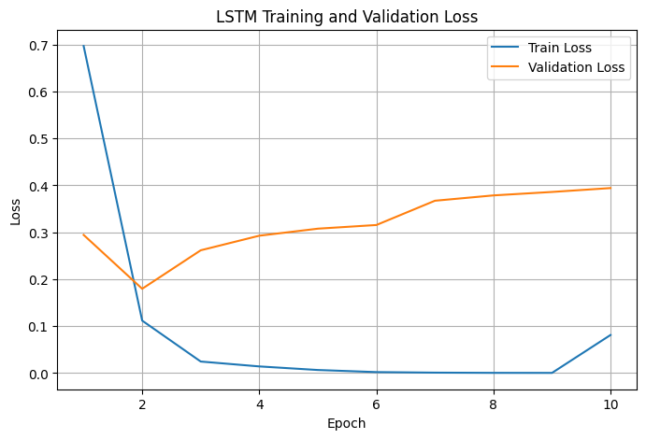
Figure 1. LSTM training and validation loss over 10 epochs.
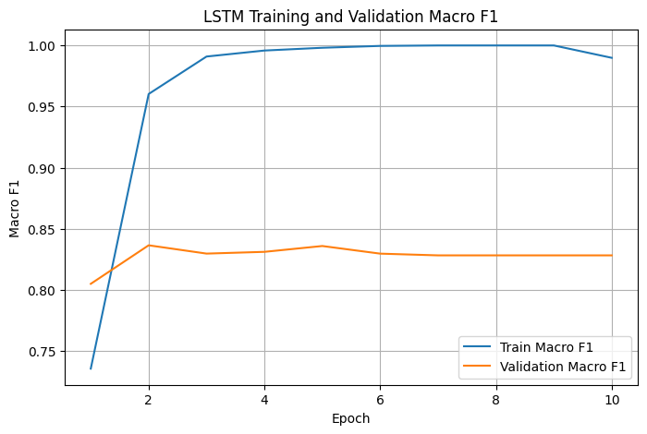
Figure 2. LSTM training and validation macro F1 over 10 epochs.

5. Confusion Matrix
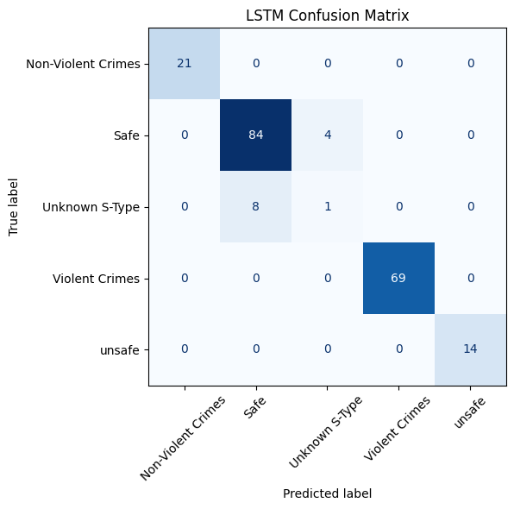
Figure 3. LSTM confusion matrix on the test set (201 examples).

6. Observations
- Non-Violent Crimes, Violent Crimes and unsafe are classified perfectly on the test set (F1 = 1.00).
- Safe is predicted very well (F1 = 0.93, recall 0.95); its only confusion is with Unknown S-Type (4 examples).
- Unknown S-Type is the weakest class (F1 = 0.14): 8 of its 9 test examples are absorbed into Safe, driven by its very small training support (86 rows before oversampling).
- Training loss falls to ~0 by epoch 6 while validation loss rises after epoch 2, indicating overfitting; the best-validation-F1 checkpoint (validation macro F1 ~0.836 at epoch 2) mitigates this.

