RNN Text Classification — Model Results
Muhammad Adel
Cellula Assignment — Bidirectional RNN (PyTorch)

1. Model Overview
A two-layer bidirectional vanilla RNN with an embedding layer (128-d), hidden size 128, dropout 0.3 and masked mean pooling over real tokens, followed by a linear classifier. The input for each example is the query combined with the image description ("query SEP image description"), tokenized with NLTK and encoded to a fixed length of 160. The training set was class-balanced by random oversampling. Trained for 10 epochs with AdamW and Cross-Entropy loss; the checkpoint with the best validation macro F1 was selected.

2. Final Test Results
- Final Test Loss: 0.3374
- Final Test Macro F1: 0.8227 (82.27%)
- Test Accuracy: 0.93

3. Classification Report
Class | Precision | Recall | F1-score | Support
Non-Violent Crimes | 0.95 | 1.00 | 0.98 | 21
Safe | 0.92 | 0.91 | 0.91 | 88
Unknown S-Type | 0.22 | 0.22 | 0.22 | 9
Violent Crimes | 1.00 | 1.00 | 1.00 | 69
unsafe | 1.00 | 1.00 | 1.00 | 14
Accuracy |  |  | 0.93 | 201
Macro avg | 0.82 | 0.83 | 0.82 | 201
Weighted avg | 0.93 | 0.93 | 0.93 | 201

4. Training Curves
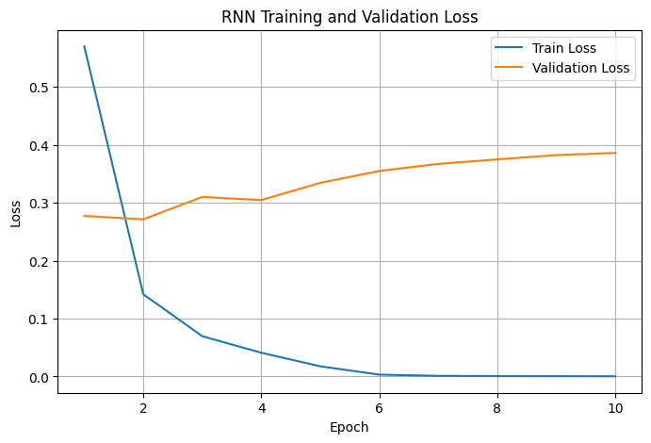
Figure 1. RNN training and validation loss over 10 epochs.
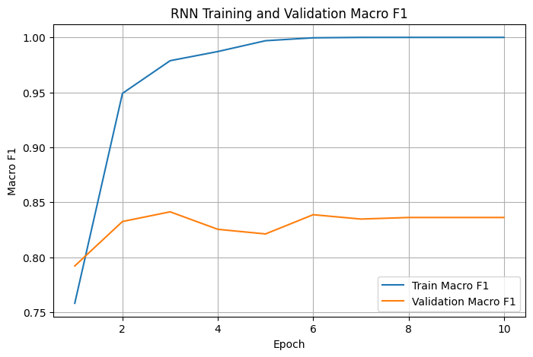
Figure 2. RNN training and validation macro F1 over 10 epochs.

5. Confusion Matrix
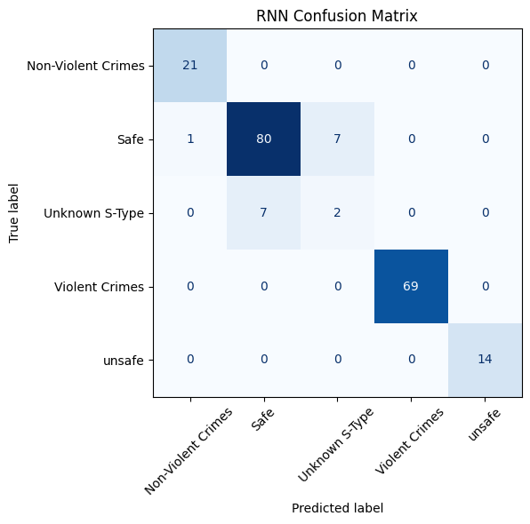
Figure 3. RNN confusion matrix on the test set (201 examples).

6. Observations
- Violent Crimes, unsafe and Non-Violent Crimes are classified perfectly or near-perfectly on the test set (F1 = 0.98–1.00).
- Safe is predicted well (F1 = 0.91); its main confusion is with Unknown S-Type (7 examples).
- Unknown S-Type is the weakest class (F1 = 0.22) due to very few training examples and its overlap with Safe.
- Training F1 reaches 1.00 by epoch 6 while validation loss rises after epoch 2, indicating some overfitting; the best-validation-F1 checkpoint mitigates this.

