Cellula Technologies - NLP Internship
Week 3 : Introduction to RAG and LangChain
Task 0 : Research about the BigBird Model
Muhammad Adel
Main paper: M. Zaheer et al., "Big Bird: Transformers for Longer Sequences", NeurIPS 2020 (arXiv:2007.14062)

Contents
1. Motivation: the quadratic problem of self-attention
2. BigBird architecture (random, window, global, block-sparse)
3. Why sparse attention still works (theory)
4. Complexity comparison: BERT vs Longformer vs BigBird
5. Measured experiment on my laptop (CPU)
6. Applications for long documents and reported results
7. How to use BigBird in code
8. Advantages
9. Limitations
10. Summary of performance characteristics
11. Conclusion and references

1. Motivation: the quadratic problem of self-attention
Transformers like BERT use full self-attention: every token builds a query and compares it with the key of every other token in the sequence. For an input X with n tokens the attention of one head is:
(1)
The product QK^T is an n x n matrix, so both the time and the memory of attention grow with n squared:
(2)
This is why BERT was trained with a hard limit of 512 tokens. If we double the length we pay 4 times more. Some numbers to feel the problem (one example, per head per layer):
Sequence length n | Attention scores n x n | BERT-base, 12 heads, float32, one layer
512 | 262,144 | 12.6 MB
4,096 | 16,777,216 | 805 MB
16,384 | 268,435,456 | 12.9 GB
Table 1: memory needed only to store the attention scores of one layer (n x n x 12 heads x 4 bytes).
Real documents are much longer than 512 tokens: scientific papers, contracts, medical records, books, or the many retrieved passages in a QA system. The usual workarounds are to truncate the text (we lose everything after token 512) or to cut it into chunks and process each one alone (we lose the connections between chunks). BigBird asks a different question: can we keep one single Transformer over the whole long sequence, but make attention cost linear instead of quadratic, without losing the power of full attention?

2. BigBird architecture

2.1 Attention seen as a graph
The paper describes attention as a directed graph D. Every token is a node, and an edge i -> j means that query i computes a score with key j. If N(i) is the set of neighbours of token i, the generalized attention is:
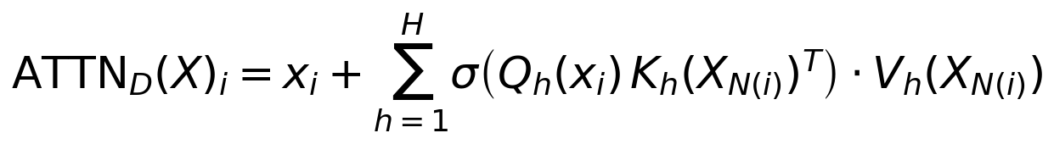 (3)
If D is the complete graph (every token connected to every token) we get the normal BERT attention. The idea of BigBird is to use a sparse graph with only O(n) edges, but chosen carefully so information can still travel between any two tokens quickly. The authors took the design from graph theory:
- Random graphs (Erdos-Renyi): the shortest path between any two nodes is only logarithmic in n, so information spreads fast even with few edges.
- Small world graphs (Watts-Strogatz): start from a ring where each node is connected to its neighbours, then add some random links. This keeps locality (neighbouring words matter most in language) and also keeps short paths.
BigBird attention is the union of three simple parts:

2.2 Random attention (r)
Each query attends to r keys chosen at random. These are the "shortcut" edges of the small world graph and they make the average path between two tokens short.

2.3 Sliding window (local) attention (w)
Each query attends to its w neighbours, from i - w/2 to i + w/2. This captures local context, which is the most important information in language (the words around a word).
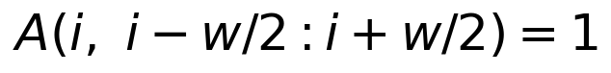

2.4 Global tokens (g)
A small set G of g tokens attend to all tokens, and all tokens attend to them. They work like a hub: any token can reach any other token in only 2 hops (token -> global -> token). The paper found that random + window alone was not enough to reach BERT quality, and global tokens are also the key part of the theory in section 3.
There are two ways to make global tokens:
- BigBird-ITC (Internal Transformer Construction): some existing tokens of the input are made global. In the released model the first and the last block (2 x 64 = 128 tokens) are global.
- BigBird-ETC (Extended Transformer Construction): extra tokens are added to the input (like [CLS] or the question tokens in QA) and these extra tokens are global. This adds more places to store context and gave the best QA results in the paper.
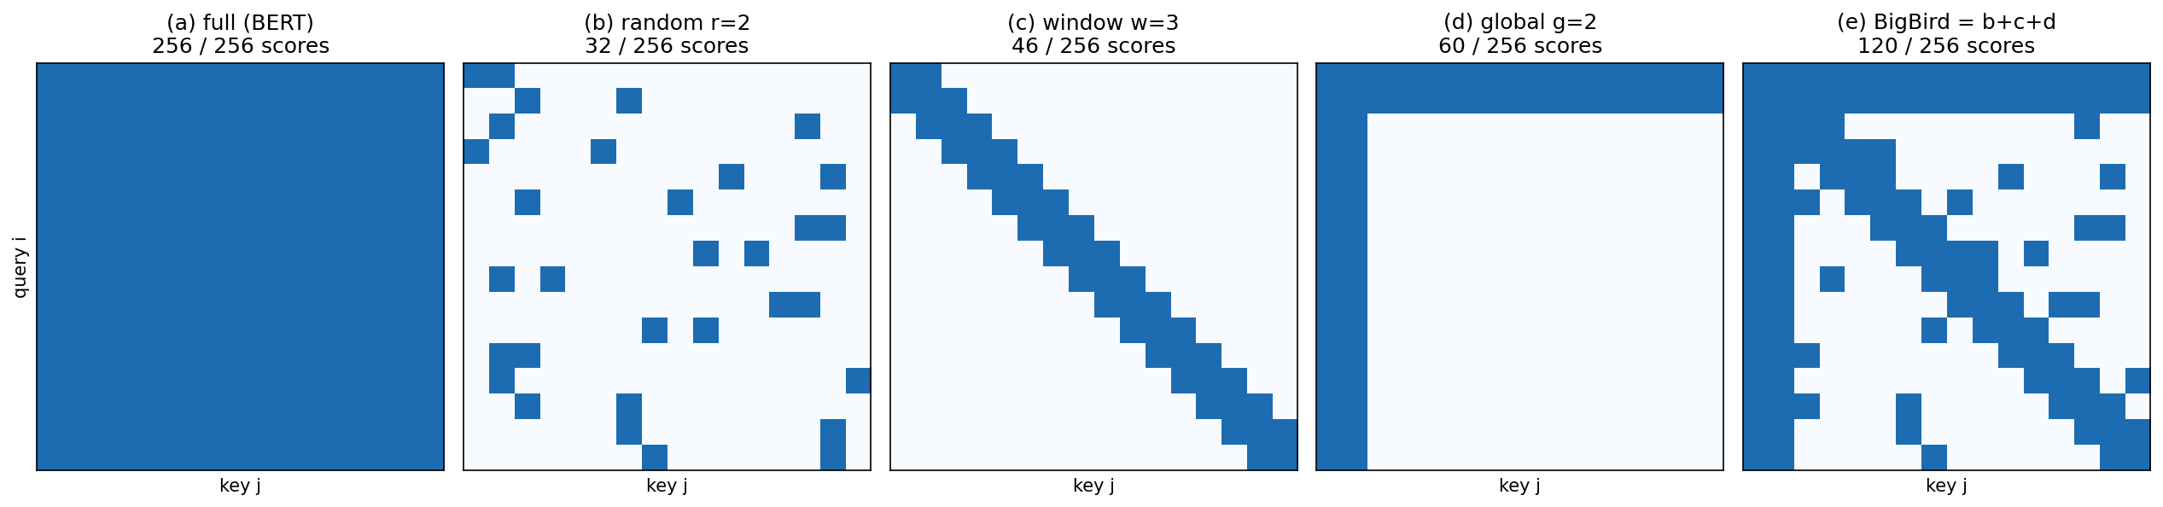
Figure 1: attention masks on 16 tokens, produced by my script bigbird_demo.py. A blue cell means query i computes a score with key j. BigBird (e) is the union of random (b), window (c) and global (d) and computes 120 of 256 scores here; for long sequences the fraction becomes much smaller.

2.5 Block-sparse implementation
GPUs and TPUs are fast at dense matrix multiplication and slow at scattered memory reads, so computing random single cells would not be faster in practice. BigBird therefore works on blocks: the sequence is split into blocks of b tokens (b = 64 in the released model), and the attention pattern is defined between blocks. For each query block the model computes:
- 3 window blocks (the block itself, the left and the right block) = 192 keys
- 2 global blocks (first and last block, ITC) = 128 keys
- 3 random blocks = 192 keys
So every query attends to (g + w + r) b = (2 + 3 + 3) x 64 = 512 keys, whatever the sequence length is. The keys are gathered into one compact dense tensor, and attention becomes a normal dense multiplication with cost:
(4)
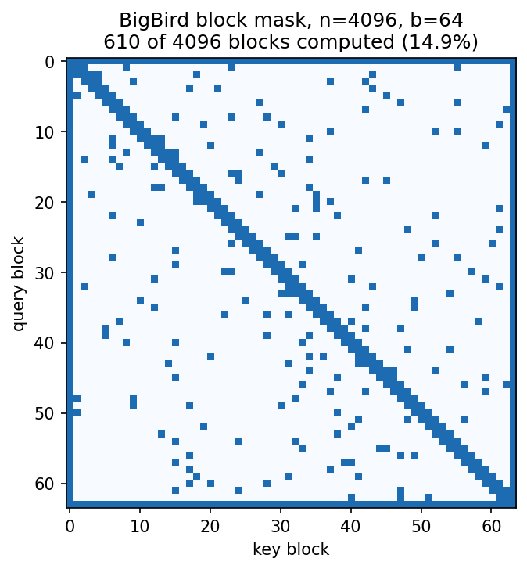
Figure 2: BigBird block mask for n = 4096 with b = 64 (64 x 64 blocks). Only 14.9% of the blocks are computed (the dense border is the global blocks, the diagonal is the window, the dots are random blocks).
Parameter | BigBird-ITC (base) | BigBird-ETC (base)
Block length b | 64 | 84
Global tokens g | 2 x b = 128 | 256
Window w | 3 x b = 192 | 3 x b
Random tokens r | 3 x b = 192 | 0
Max sequence length | 4096 | 4096
Layers / heads / hidden size | 12 / 12 / 768 | 12 / 12 / 768
Table 2: hyperparameters of the two base BigBird models (paper, Table 8).

2.6 Why all three parts are needed
Before the full model the authors tested each building block alone on 512 tokens, to compare with BERT:
Model (n = 512) | MLM | SQuAD | MNLI
BERT-base (full) | 64.2 | 88.5 | 83.4
Random only (R) | 60.1 | 83.0 | 80.2
Window only (W) | 58.3 | 76.4 | 73.1
Random + Window | 62.7 | 85.1 | 80.5
Table 3: building block comparison (paper, Table 1). Random + window is better than each one alone but still below BERT, which is why global tokens were added.

2.7 Pre-training
BigBird is an encoder like BERT/RoBERTa. It is pre-trained with the Masked Language Model (MLM) objective on 4096-token sequences, warm-starting from the public RoBERTa checkpoint, using Books, CC-News, Stories and Wikipedia. Thanks to the sparse pattern it was trained on chips with 16 GB memory with batch size 32 to 64. Lower bits per character (BPC) is better:
Model | Base BPC | Large BPC
RoBERTa (512 tokens) | 1.846 | 1.496
Longformer (4096 tokens) | 1.705 | 1.358
BigBird-ITC (4096 tokens) | 1.678 | 1.456
BigBird-ETC (4096 tokens) | 1.611 | 1.274
Table 4: MLM performance on a held-out set (paper, Table 10). Longer context helps, and BigBird-ETC is best.

3. Why sparse attention still works (theory)
Many earlier sparse attention models were heuristics without guarantees. BigBird is special because the paper proves three things:
- Universal approximator: with global tokens, sparse attention with only O(n) inner products can approximate any continuous sequence-to-sequence function, the same property that full Transformers have.
- Turing complete: under standard precision assumptions, BigBird (encoder-decoder) is Turing complete, like the full Transformer.
- There is a cost (no free lunch): the paper shows a task that one layer of full attention can solve, but any sparse attention with O(n) edges needs many more layers:
(5)
The task is: for every vector u_i find the vector u_j that is farthest from it (minimum inner product). Full attention compares all pairs directly, while sparse attention must pass the information through many hops. So sparse attention keeps the expressive power in theory, but some problems need more depth.

4. Complexity comparison: BERT vs Longformer vs BigBird
Longformer (Beltagy et al., 2020) is the closest model to BigBird. It uses a sliding window of size w around each token (512 in the released models, optionally dilated) plus global attention on a few task-specific tokens such as [CLS] or the question tokens. It has no random attention and no theoretical guarantees.
 | BERT | Longformer | BigBird
Attention pattern | full, every token to every token | sliding window + task global tokens | block window + global + random blocks
Time complexity | O(n^2 d) | O(n w d) | O(n (g+w+r) b d)
Memory for scores | O(n^2) | O(n w) | O(n (g+w+r) b)
Keys per query | n | w (+ global) | (g+w+r) b = 512
Max length (released) | 512 | 4096 | 4096 (8 x BERT)
Random attention | no | no | yes
Theory guarantees | universal, Turing complete | none | universal, Turing complete
Implementation | dense matmul | custom banded kernel / chunks | gather blocks + dense matmul
Table 5: comparison of the three models.
With the released settings both Longformer and BigBird look at about 512 keys per query, so their cost is of the same order and linear in n, while BERT is quadratic. My script counts the scores for each length:
n | BERT n^2 | Longformer 512 n | BigBird 512 n | BERT / BigBird
512 | 262,144 | 262,144 | 262,144 | 1x
1,024 | 1,048,576 | 524,288 | 524,288 | 2x
2,048 | 4,194,304 | 1,048,576 | 1,048,576 | 4x
4,096 | 16,777,216 | 2,097,152 | 2,097,152 | 8x
8,192 | 67,108,864 | 4,194,304 | 4,194,304 | 16x
16,384 | 268,435,456 | 8,388,608 | 8,388,608 | 32x
Table 6: attention scores per head per layer (output of bigbird_demo.py, step 3).
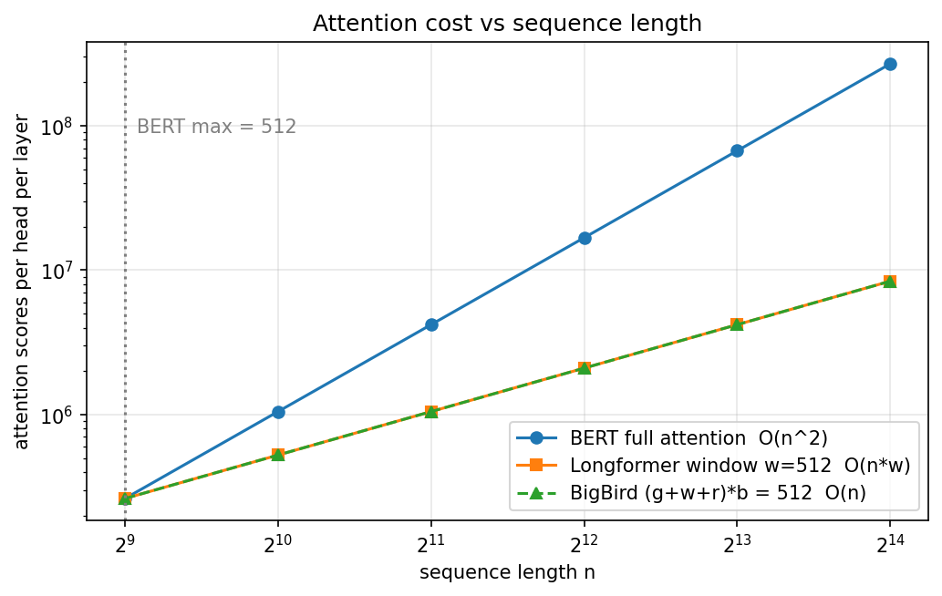
Figure 3: attention cost vs sequence length (log-log). BERT grows as n^2 (slope 2), Longformer and BigBird grow linearly (slope 1); the two lines overlap because both use 512 keys per query.
Note that at n = 512 there is no gain at all: 512 keys per query is the whole sequence. Sparse attention only pays off for long inputs, and the saving grows with n (8x at 4096, 32x at 16k).
Accuracy comparison with Longformer on question answering (base size models, dev sets):
Model | HotpotQA Ans | HotpotQA Sup | NQ LA | TriviaQA | WikiHop
RoBERTa | 73.5 | 83.4 | - | 74.3 | 72.4
Longformer | 74.3 | 84.4 | - | 75.2 | 75.0
BigBird-ITC | 75.7 | 86.8 | 70.8 | 79.5 | 75.9
BigBird-ETC | 75.5 | 87.1 | 73.9 | 78.7 | 75.9
Table 7: QA dev results, F1 (accuracy for WikiHop) (paper, Table 2). BigBird beats Longformer on every dataset.

5. Measured experiment on my laptop (CPU)
To check the theory in practice, I measured the Hugging Face implementation of BigBird on my CPU. I used a small random-weight model (2 layers, hidden 256, 4 heads, block size 64, 3 random blocks, seed 42) so no download is needed, and I timed the forward pass with attention_type = "original_full" (BERT style) and "block_sparse" (BigBird). Each value is the average of 3 runs after one warm-up run.
Sequence length | original_full (ms) | block_sparse (ms) | Speed-up
1,024 | 228 | 217 | 1.1x
2,048 | 558 | 433 | 1.3x
4,096 | 3,325 | 903 | 3.7x
8,192 | 8,646 | 1,878 | 4.6x
Table 8: measured CPU forward time (bigbird_demo.py, step 4).
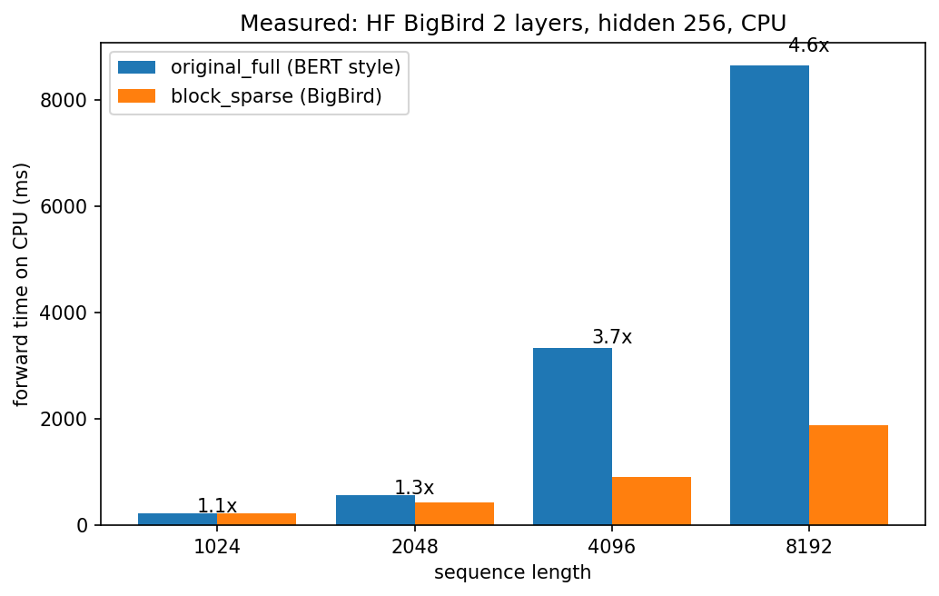
Figure 4: measured forward time. Full attention time explodes with length, block sparse grows almost linearly (about 2x per doubling).
Observations:
- For short inputs (1024) the two are almost the same: the extra work of gathering blocks cancels the saving. In another run block_sparse was even slower at 1024, so timings at short lengths are noisy.
- From 2048 tokens the gap grows quickly: 3.7x faster at 4096 and 4.6x at 8192. The block_sparse time roughly doubles when n doubles (linear), while original_full grows about 2.4 to 6 times (quadratic attention part plus the linear feed-forward part).
- This matches the Hugging Face advice that block_sparse is only useful above about 1024 tokens. For short inputs the library even switches back to original_full automatically (when the sequence is shorter than the global + sliding + random blocks, about (5 + 2r) b = 704 tokens).

6. Applications for long documents and reported results

6.1 Question answering over long evidence
In QA the answer can be far from the question, in a long Wikipedia page or across several documents. With ETC the question tokens are global, so every evidence token is connected to the question directly. On the test leaderboards BigBird-ETC became the new state of the art for Natural Questions long answer (77.8), TriviaQA (84.5 full, 92.4 verified) and WikiHop (82.3), and was third on HotpotQA.

6.2 Long document classification
Dataset | Excess fraction (> 512 tokens) | RoBERTa (512) | BigBird (4096) | Previous SoTA
IMDb | 0.14 | 95.0 | 95.2 | 97.4
Yelp-5 | 0.04 | 71.75 | 72.16 | 73.28
Arxiv | 1.00 | 87.42 | 92.31 | 87.96
Patents | 0.90 | 67.07 | 69.30 | 69.01
Hyperpartisan | 0.53 | 87.8 | 92.2 | 90.6
Table 9: classification F1 micro (paper, Table 15). The gain is large exactly where documents are long (Arxiv +5 points), and small for short reviews (IMDb, Yelp).

6.3 Summarization of long documents
For encoder-decoder tasks BigBird uses sparse attention only in the encoder (the long input) and full attention in the decoder (the summary is short, around 200 tokens). BigBird-Pegasus (large) improved ROUGE-1 over Pegasus:
Model | arXiv R-1 | PubMed R-1 | BigPatent R-1
Pegasus large (reported) | 44.21 | 45.97 | 52.29
BigBird-Pegasus large | 46.63 | 46.32 | 60.64
Table 10: summarization of long documents (paper, Table 4).

6.4 Genomics
DNA sequences are extremely long, so the authors pre-trained BigBird on the human genome (DNA split into BPE tokens, about 8.78 base pairs per token). For promoter region prediction it reached 99.9 F1 compared with 95.6 for the previous best (DeePromoter), and it also improved chromatin-profile prediction.

6.5 Where I would use it
- Legal contracts and policies, medical and clinical notes, scientific papers, patents, long support tickets or chat histories, where the important sentence can be anywhere.
- In a RAG system (like my Task 1): a long-context reader or re-ranker can read many retrieved chunks together in one pass (up to 4096 tokens) instead of one chunk at a time, so it can connect facts from different chunks.
- Any long non-text sequence that has local structure plus some long-range links (DNA, logs).

7. How to use BigBird in code
BigBird is available in Hugging Face transformers. The pretrained checkpoints are google/bigbird-roberta-base, google/bigbird-roberta-large and google/bigbird-base-trivia-itc (QA), and google/bigbird-pegasus-large-arxiv for summarization. Fine-tuning a long document classifier looks like this:
from transformers import AutoTokenizer, BigBirdForSequenceClassification
tokenizer = AutoTokenizer.from_pretrained("google/bigbird-roberta-base")
model = BigBirdForSequenceClassification.from_pretrained(
"google/bigbird-roberta-base",
num_labels=2,
attention_type="block_sparse", # or "original_full" for short texts
block_size=64, # b
num_random_blocks=3, # r
)
inputs = tokenizer(long_text, truncation=True, max_length=4096, return_tensors="pt")
logits = model(**inputs).logits

The part of my script that builds the BigBird mask (Figure 1) is only a few lines of numpy:
random_mask = np.zeros((n, n))
for i in range(n):
keys = np.random.choice(n, r, replace=False)
random_mask[i, keys] = 1
window_mask = np.zeros((n, n))
for i in range(n):
for j in range(i - w // 2, i + w // 2 + 1):
if 0 <= j < n:
window_mask[i, j] = 1
global_mask = np.zeros((n, n))
global_mask[:g, :] = 1 # global tokens look at everything
global_mask[:, :g] = 1 # everything looks at the global tokens
bigbird_mask = np.maximum(np.maximum(random_mask, window_mask), global_mask)

And the benchmark of section 5:
config = BigBirdConfig(hidden_size=256, num_hidden_layers=2, num_attention_heads=4,
intermediate_size=1024, max_position_embeddings=8192,
block_size=64, num_random_blocks=3)
for attn in ['original_full', 'block_sparse']:
config.attention_type = attn
model = BigBirdModel(config).eval()
for L in [1024, 2048, 4096, 8192]:
ids = torch.randint(5, config.vocab_size, (1, L))
with torch.no_grad():
model(ids) # warm up
start = time.time()
for _ in range(3):
model(ids)
print(attn, L, (time.time() - start) / 3 * 1000, 'ms')

The full script is Task0/bigbird_demo.py in the project folder.

8. Advantages
- Linear cost: attention cost goes from O(n^2) to O(n), so it handles 4096 tokens (8x BERT) on the same hardware (16 GB chips).
- Theory: proven universal approximator and Turing complete, so dropping most edges does not reduce what the model can represent.
- Hardware friendly: the block design turns sparse attention into dense matrix multiplications, so no special kernels are needed.
- Easy to adopt: same MLM pre-training as BERT/RoBERTa (warm-started from RoBERTa), and it can switch to full attention for short inputs, so it works as a "longer BERT".
- Strong results: state of the art in 2020 on long-document QA (Natural Questions, TriviaQA, WikiHop), long summarization (arXiv, PubMed, BigPatent) and long classification (Arxiv, Hyperpartisan), plus a new use case in genomics.
- Flexible global tokens: ETC lets us choose which tokens are global (for example the question), which is very useful for QA.

9. Limitations
- No gain for short texts: at 512 tokens it computes the same as BERT, and with the gather overhead it can be slower (seen in my measurement at 1024). GLUE-style short tasks do not benefit.
- Sparse needs more layers for some tasks: the paper itself proves some problems need many more layers with sparse attention than with full attention.
- More hyperparameters: block size, number of random and global blocks, ITC vs ETC; the sequence length must be a multiple of the block size (padding is added).
- Approximation: random blocks mean some token pairs never interact directly in a layer, only through hops; and the random pattern is not learned.
- Limited length: the released models stop at 4096 tokens, far from the 100k+ context windows of modern LLMs.
- Decoder side: the Hugging Face block_sparse mode does not support causal (decoder) use; for generation BigBird keeps full attention in the decoder, so it is mainly a long encoder.
- Still heavy: a 4096-token input is 8x more work than 512 tokens; on CPU a base model is slow to fine-tune.

10. Summary of performance characteristics
Aspect | BigBird behaviour
Speed | Linear in n; slower or equal at short n, much faster at long n (3.7x at 4096 in my CPU test)
Memory | Attention memory O(n); trained at 4096 tokens on 16 GB chips
Short-text accuracy | About the same as BERT/RoBERTa (sparse attention does not hurt)
Long-text accuracy | Clear gains: Arxiv classification +5 points, BigPatent ROUGE-1 +8 points, new SOTA on NQ, TriviaQA, WikiHop
Pre-training quality | Best MLM BPC (1.611 base ETC) vs RoBERTa 1.846 and Longformer 1.705
Best use | Encoder for documents between about 1k and 4k tokens: QA, classification, summarization encoder
Table 11: summary.

11. Conclusion
BigBird solves the quadratic cost of self-attention by replacing the full attention graph with a sparse one built from three parts: a sliding window for local context, a few global tokens that connect everything, and some random links that keep paths short. Implemented on blocks of 64 tokens, every query looks at only 512 keys, so the cost becomes linear and the model reads 4096 tokens, 8 times more than BERT. Unlike most sparse models it comes with proofs that it keeps the power of full attention, and in experiments it beats Longformer and RoBERTa on long-document QA, classification and summarization. My own CPU measurement confirms the trade-off: no gain for short inputs, but a growing speed-up for long ones (3.7x at 4096 tokens, 4.6x at 8192).

References
- M. Zaheer et al., "Big Bird: Transformers for Longer Sequences", NeurIPS 2020. https://arxiv.org/abs/2007.14062
- I. Beltagy, M. Peters, A. Cohan, "Longformer: The Long-Document Transformer", 2020. https://arxiv.org/abs/2004.05150
- A. Vaswani et al., "Attention Is All You Need", NeurIPS 2017. https://arxiv.org/abs/1706.03762
- J. Devlin et al., "BERT: Pre-training of Deep Bidirectional Transformers", 2018. https://arxiv.org/abs/1810.04805
- V. Gupta, "Understanding BigBird's Block Sparse Attention", Hugging Face blog, 2021. https://huggingface.co/blog/big-bird
- D. Watts, S. Strogatz, "Collective dynamics of small-world networks", Nature, 1998.

