
Punjab University College of Information Technology

Pick and Drop Services
For Female Students

SUBMITTED TO
Ma’am Amina Mirza
SUBMITTED BY
BSEF19M006 – Muhammad Adil
BSEF19M043 – Abubakar Dar
BSEF19M053 – Haris Amir

Deliverable 2

Domain Model

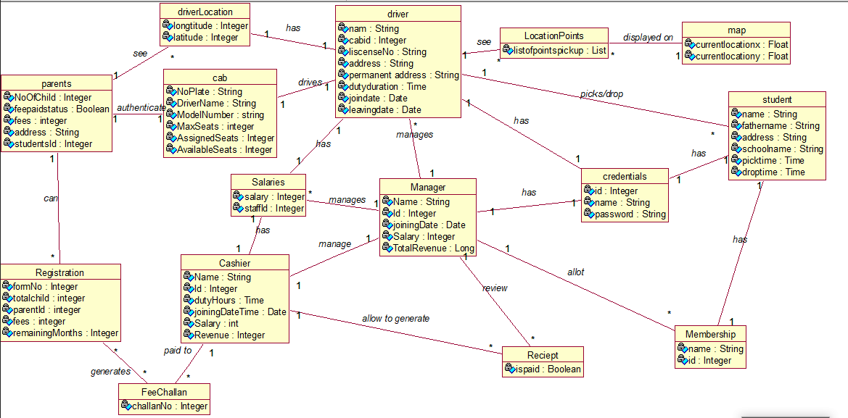

Design Class Diagram

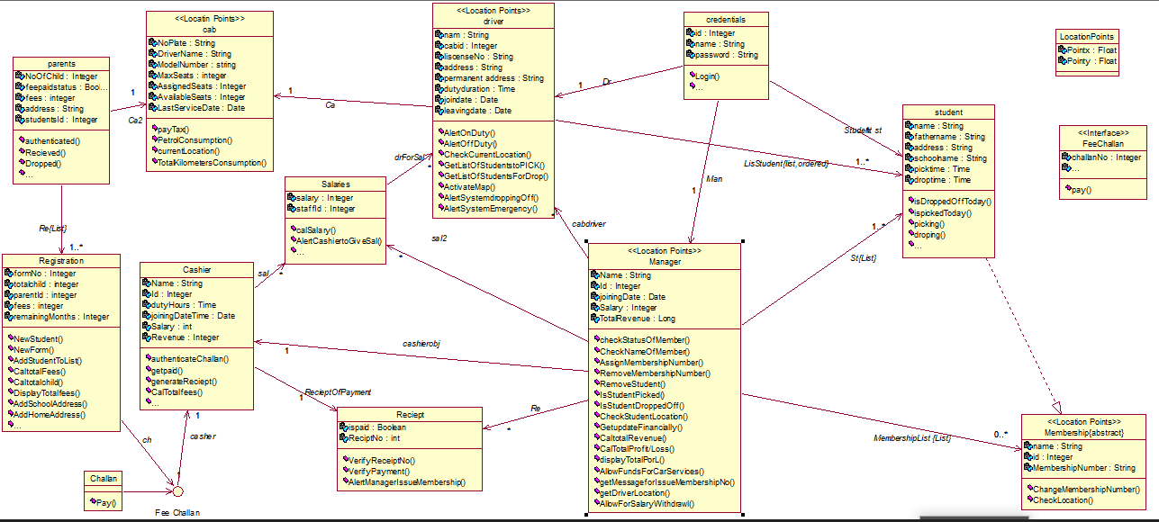

System Sequence Diagrams
Parent SSD
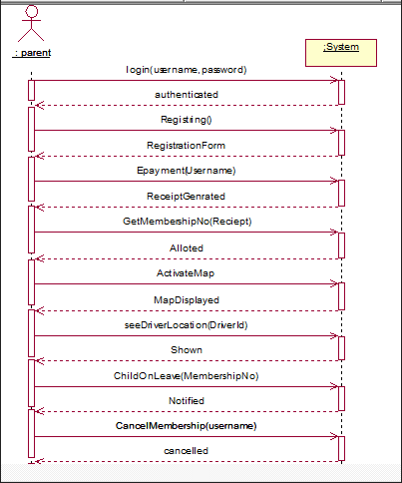

Cashier SSD
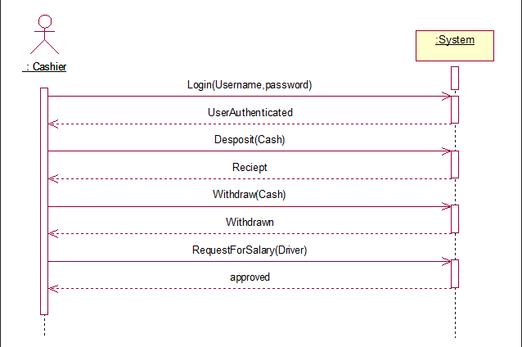
Driver SSD
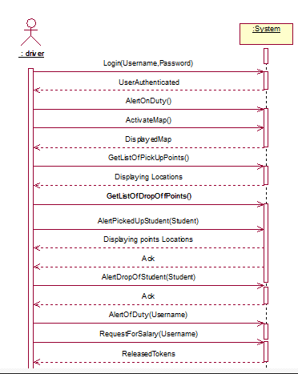

Sequence Diagram
Registering a Student
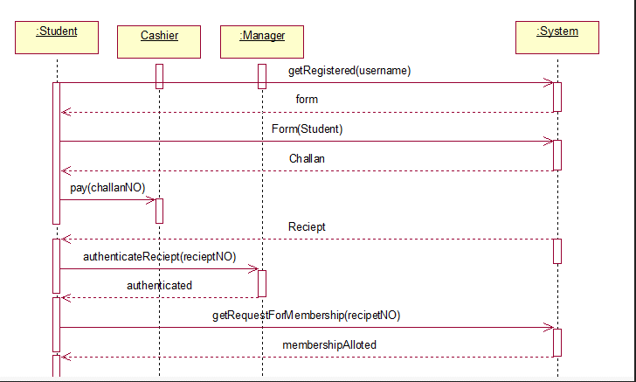
Picking a Student
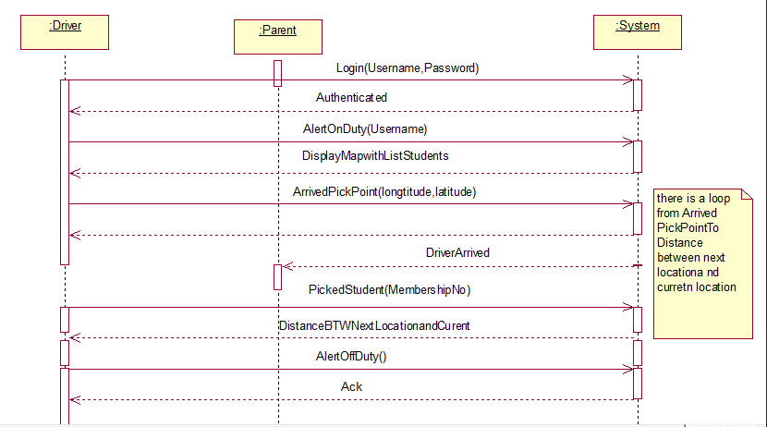
Dropping a Student
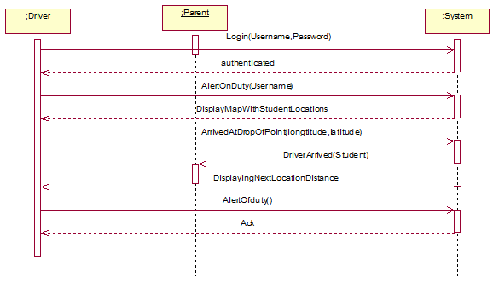
Collaboration Diagram
Registering a Student
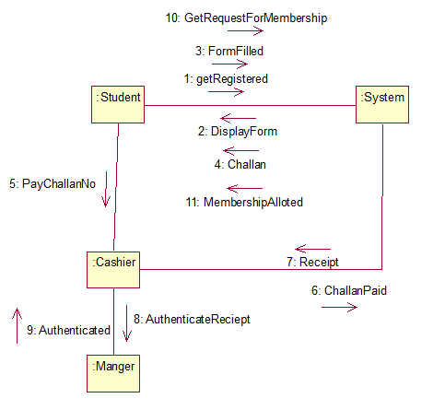
Picking a Student
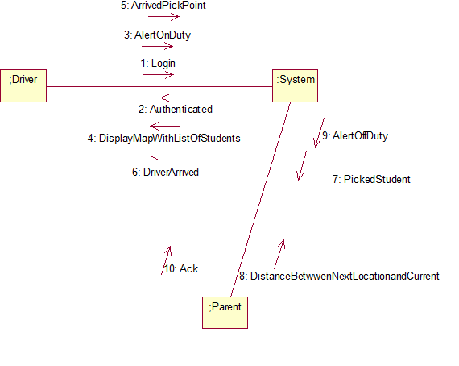
Dropping a Student
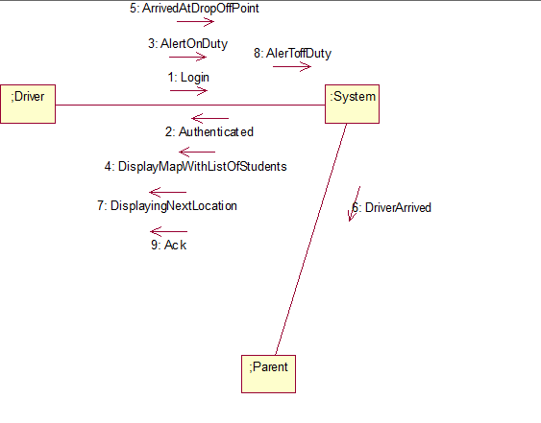

Use Case Contract

Operation:
Registering()
Cross Reference:
Use Case: Registering a Student
Precondition:
A parent wants to register their child for our service.
Post condition:
- Registration form is given to manager.
- All the entered information is valid.
- Service is available in their residential area.

Wire Frames
Home Page
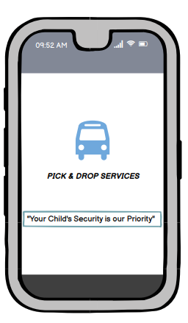

Sign in/Sign up
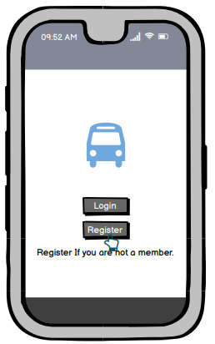

Registration Selection Page
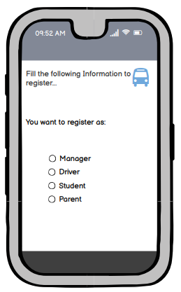

Registration Form Page 1
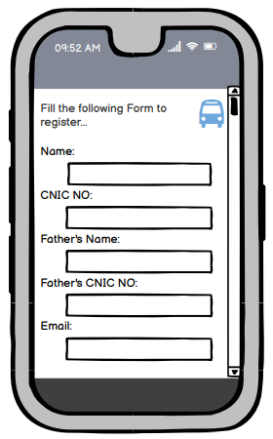

Registration Form Page 2
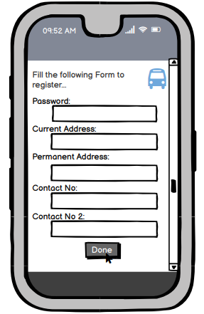

Login Page
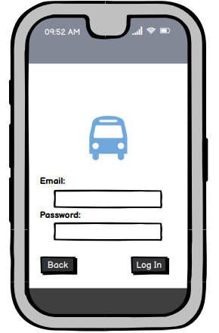
Driver Activity Page
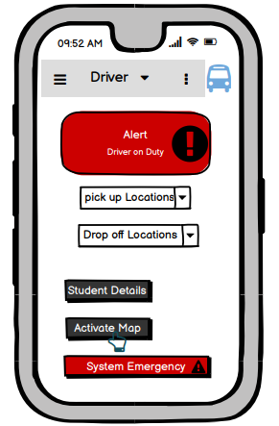

Driver Map Page
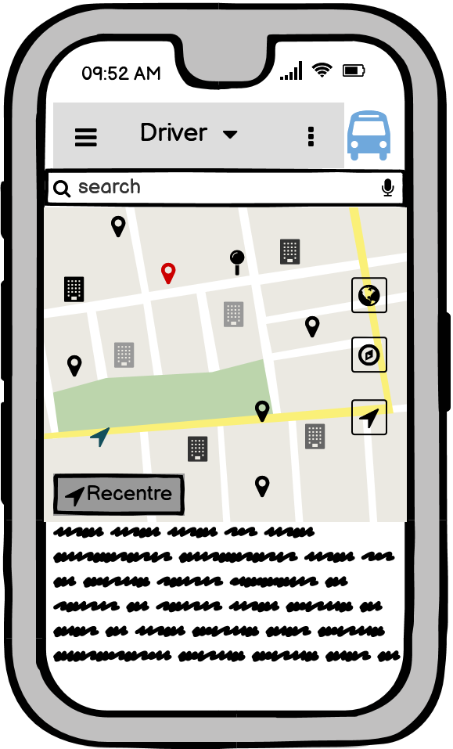

Parent Activity Page
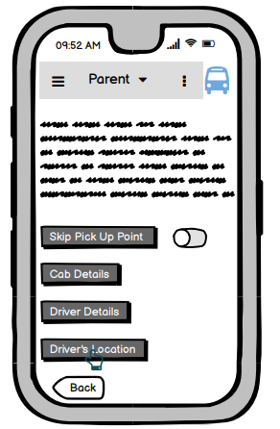

Parent MAP Page
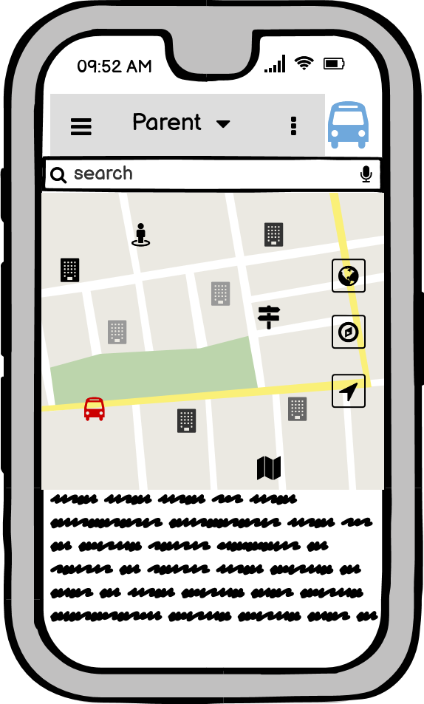

Student Activity Page
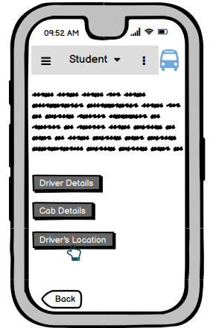

Student Map Page
