MD. AFRIDI
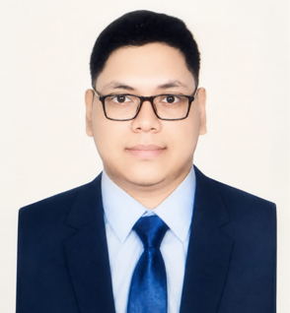
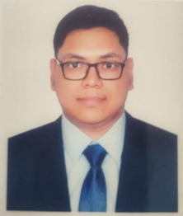

Address  Contact No  Email  Linkdin  Github Link  Kaggle link | : Ashish Lane, West Rampura, Dhaka-1219  : +88 01817436963  : mohammadafridi1190@gmail.com  : www.linkedin.com/in/muhammad-afridi  : https://github.com/MuhammadAfridi1234?tab=repositories  : https://www.kaggle.com/mikeafridi
PROFESSIONAL SUMMARY

Motivated and detail-oriented aspiring AI Automation Engineer with working knowledge of Python, NumPy, and Pandas, along with hands-on experience in system automation. Passionate about building intelligent automation solutions and eager to contribute to real-world AI-driven workflows. Quick learner with strong problem-solving skills and a growing interest in tools like APIs, automation platforms, and AI agents.

EDUCATIONAL QUALIFICATION
Bachelor of Computer Science & Engineering October 2022 – Ongoing
East West University Dhaka, Bangladesh
Major: Data Science CGPA: 3.58 out of 4.00 (Last semester)
Higher School Certificate (HSC) 2019 – 2021
Dhaka Imperial College, Dhaka, Bangladesh GPA: 5.00 out of 5.00

Secondary School Certificate (SSC) 2017 – 2019
Rajdhani Ideal School, Dhaka, Bangladesh GPA: 4.94 out of 5.00

PRACTICAL PROJECT EXPERIENCE

- DNA Pattern matching (Data Structure and Algorithm): Developed an efficient data structure and algorithm to identify and match DNA patterns for computational biology use cases.
- Movie Database System (Oracle Apex): Designed and implemented a database driven application for managing and retrieving movie information.
- Taxi price regression (Data Science): Built and trained a regression model to predict taxi fares based on real world data.
- Turmeric Plant disease (Machine Learning): Developed a deep learning model to automate the identification of turmeric diseases to support precision agriculture.

RESEARCH RELATED PROJECT
- Fusion of plant disease Classification: Betel Leaf Disease Diagnosis Dataset (Digital image processing).
- Android Malware Detection Using a Hybrid Static-Dynamic Deep learning framework.
- Constructive and Non-Constructive Self Supervised Learning on multi-channel gesture classification.

OTHER PROJECT
- Digital Farming Assistant: software Requirement Specification Report and project management entrepreneurship.
- Development of a multi-campus subnet-based University Network Architecture.

SCHOLERSHIPS AND AWARDS
- 2023-2026 East West University Medha Lalon Scholarship (For excellent academic performance)
- 2024 East West University IT Olympiad Competition Certificate ( For CSE Fest 2024 )
- 2024 East West University Tele War Competition Certificate ( For National Telco Warfare 2024)

TECHNICAL SKILLS AND SOFT SKILLS
Technical Skills:
- Languages: Python, C, C++, Java, HTML/CSS, SQL
- Frameworks: Pytorch
- Developer Tools: Git, VS Code, Code blocks, Eclipse ,Netbeans
- Software’s: Cisco packet tracer, Matlab, Microsoft word ,Excel, PowerPoint
- Libraries: Pandas, NumPy, Matplotlib
- Operating Systems: Linux, Windows

Soft Skills:

- Strong problem-solving and analytical mindset.
- Fast learner with adaptability to new tools.
- Understanding of automation workflows and system integration.
- Attention to detail and structured thinking.
- Team collaboration and communication skills.

AI & Automation Concepts:

- Basic understanding of AI/ML concepts.
- Workflow automation fundamentals.
- API integration (REST APIs – basic understanding).
- Database Tools: SQL Plus, Oracle APEX.

REFERENCES AND SUPERVISOR

Dr. Maheen Islam
Chairperson, Associate Professor
Department of Computer Science & Engineering
East West University
maheen@ewubd.edu

I hereby declare that the information provided in this resume is true and correct to the best of my knowledge and belief. I take full responsibility for the accuracy of the particulars mentioned herein.


Md. Afridi

