**HTML (Hyper Text Markup Language)**

**Hypertext:** A document/text on which when we click then it opens another document and when we click on any text of that document then moves on another document and so on.

**Examples:** Links like permalinks in WordPress.

A **markup language** is a computer language that uses [tags](https://techterms.com/definition/tag) to define elements within a document. It is human-readable, meaning markup files contain standard words, rather than typical programming [syntax](https://techterms.com/definition/syntax). While several markup languages exist, the two most popular are [HTML](https://techterms.com/definition/html) and [XML](https://techterms.com/definition/xml).

HTML is a markup language used for creating [webpages](https://techterms.com/definition/webpage). The contents of each webpage are defined by HTML tags. Basic page tags, such as <head>, <body>, and <div> define sections of the page, while tags such as <table>, <form>, <image>, and <a> define elements within the page. Most elements require a beginning and end tag, with the content placed between the tags. For example, a link to the TechTerms.com home page may use the following HTML code:

<a href="https://techterms.com">TechTerms.com</a>

XML is used for storing structured [data](https://techterms.com/definition/data), rather than formatting information on a page. While HTML documents use predefined tags (like the examples above), XML files use custom tags to define elements. For example, an XML file that stores information about computer models may include the following section:

<computer>  
  <manufacturer>Dell</manufacturer>  
  <model>XPS 17</model>  
  <components>  
    <processor>2.00 GHz Intel Core i7</processor>  
    <ram>6GB</ram>  
    <storage>1TB</storage>  
  </components>  
</computer>

XML is called the "Extensible Markup Language" since custom tags can be used to support a wide range of elements. Each XML file is saved in a standard text format, which makes it easy for software programs to [parse](https://techterms.com/definition/parse) or read the data. Therefore, XML is a common choice for exporting structured data and for sharing data between multiple programs.

**NOTE:** Since both HTML and XML files are saved in a [plain text](https://techterms.com/definition/plaintext) format, they can be viewed in a standard text editor. You can also view the HTML source of an open webpage by selecting the "View Source" option. This feature is found in the View menu of most Web browsers.

**Codepen.io:**

<https://codepen.io/>

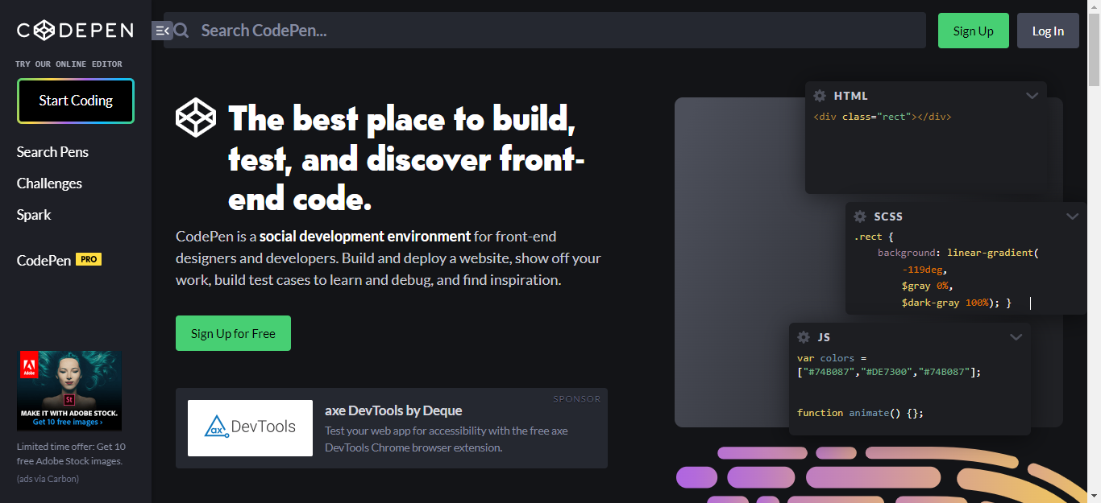

Format

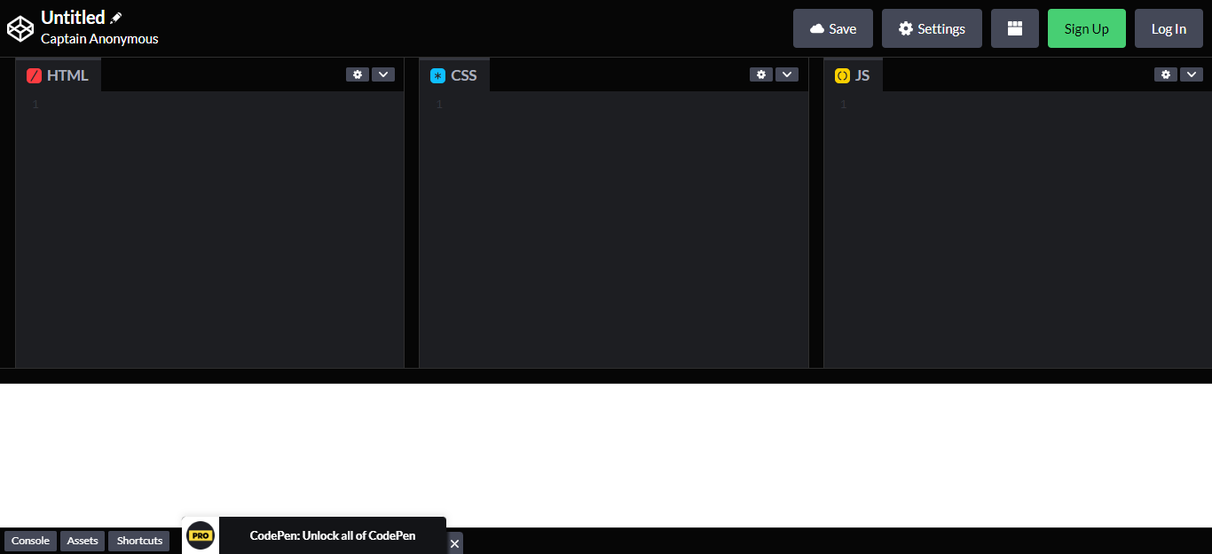

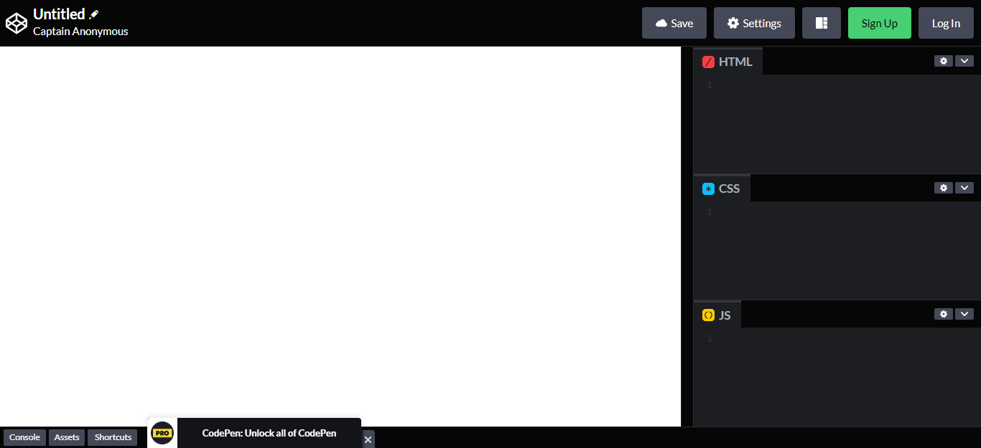

**Gutenberg.Org**

<https://www.gutenberg.org/ebooks/1661>

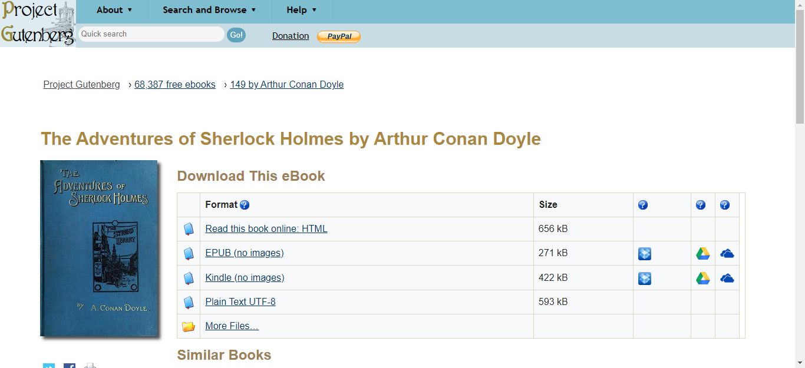

Basic HTML

|  |  |
| --- | --- |
| Tag | Description |
| [<!DOCTYPE>](https://www.w3schools.com/tags/tag_doctype.asp) | Defines the document type |
| [<html>](https://www.w3schools.com/tags/tag_html.asp) | Defines an HTML document |
| [<head>](https://www.w3schools.com/tags/tag_head.asp) | Contains metadata/information for the document |
| [<title>](https://www.w3schools.com/tags/tag_title.asp) | Defines a title for the document |
| [<body>](https://www.w3schools.com/tags/tag_body.asp) | Defines the document's body |
| [<h1> to <h6>](https://www.w3schools.com/tags/tag_hn.asp) | Defines HTML headings |
| [<p>](https://www.w3schools.com/tags/tag_p.asp) | Defines a paragraph |
| [<br>](https://www.w3schools.com/tags/tag_br.asp) | Inserts a single line break |
| [<hr>](https://www.w3schools.com/tags/tag_hr.asp) | Defines a thematic change in the content |
| [<!--...-->](https://www.w3schools.com/tags/tag_comment.asp) | Defines a comment |

Formatting

|  |  |
| --- | --- |
| **Tag** | **Description** |
| [<acronym>](https://www.w3schools.com/tags/tag_acronym.asp) | Not supported in HTML5. Use <abbr> instead. Defines an acronym |
| [<abbr>](https://www.w3schools.com/tags/tag_abbr.asp) | Defines an abbreviation or an acronym |
| [<address>](https://www.w3schools.com/tags/tag_address.asp) | Defines contact information for the author/owner of a document/article |
| [<b>](https://www.w3schools.com/tags/tag_b.asp) | Defines bold text |
| [<bdi>](https://www.w3schools.com/tags/tag_bdi.asp) | Isolates a part of text that might be formatted in a different direction from other text outside it |
| [<bdo>](https://www.w3schools.com/tags/tag_bdo.asp) | Overrides the current text direction |
| [<big>](https://www.w3schools.com/tags/tag_big.asp) | Not supported in HTML5. Use CSS instead. Defines big text |
| [<blockquote>](https://www.w3schools.com/tags/tag_blockquote.asp) | Defines a section that is quoted from another source |
| [<center>](https://www.w3schools.com/tags/tag_center.asp) | Not supported in HTML5. Use CSS instead. Defines centered text |
| [<cite>](https://www.w3schools.com/tags/tag_cite.asp) | Defines the title of a work |
| [<code>](https://www.w3schools.com/tags/tag_code.asp) | Defines a piece of computer code |
| [<del>](https://www.w3schools.com/tags/tag_del.asp) | Defines text that has been deleted from a document |
| [<dfn>](https://www.w3schools.com/tags/tag_dfn.asp) | Specifies a term that is going to be defined within the content |
| [<em>](https://www.w3schools.com/tags/tag_em.asp) | Defines emphasized text |
| [<font>](https://www.w3schools.com/tags/tag_font.asp) | Not supported in HTML5. Use CSS instead. Defines font, color, and size for text |
| [<i>](https://www.w3schools.com/tags/tag_i.asp) | Defines a part of text in an alternate voice or mood |
| [<ins>](https://www.w3schools.com/tags/tag_ins.asp) | Defines a text that has been inserted into a document |
| [<kbd>](https://www.w3schools.com/tags/tag_kbd.asp) | Defines keyboard input |
| [<mark>](https://www.w3schools.com/tags/tag_mark.asp) | Defines marked/highlighted text |
| [<meter>](https://www.w3schools.com/tags/tag_meter.asp) | Defines a scalar measurement within a known range (a gauge) |
| [<pre>](https://www.w3schools.com/tags/tag_pre.asp) | Defines preformatted text |
| [<progress>](https://www.w3schools.com/tags/tag_progress.asp) | Represents the progress of a task |
| [<q>](https://www.w3schools.com/tags/tag_q.asp) | Defines a short quotation |
| [<rp>](https://www.w3schools.com/tags/tag_rp.asp) | Defines what to show in browsers that do not support ruby annotations |
| [<rt>](https://www.w3schools.com/tags/tag_rt.asp) | Defines an explanation/pronunciation of characters (for East Asian typography) |
| [<ruby>](https://www.w3schools.com/tags/tag_ruby.asp) | Defines a ruby annotation (for East Asian typography) |
| [<s>](https://www.w3schools.com/tags/tag_s.asp) | Defines text that is no longer correct |
| [<samp>](https://www.w3schools.com/tags/tag_samp.asp) | Defines sample output from a computer program |
| [<small>](https://www.w3schools.com/tags/tag_small.asp) | Defines smaller text |
| [<strike>](https://www.w3schools.com/tags/tag_strike.asp) | Not supported in HTML5. Use <del> or <s> instead. Defines strikethrough text |
| [<strong>](https://www.w3schools.com/tags/tag_strong.asp) | Defines important text |
| [<sub>](https://www.w3schools.com/tags/tag_sub.asp) | Defines subscripted text |
| [<sup>](https://www.w3schools.com/tags/tag_sup.asp) | Defines superscripted text |
| [<template>](https://www.w3schools.com/tags/tag_template.asp) | Defines a container for content that should be hidden when the page loads |
| [<time>](https://www.w3schools.com/tags/tag_time.asp) | Defines a specific time (or datetime) |
| [<tt>](https://www.w3schools.com/tags/tag_tt.asp) | Not supported in HTML5. Use CSS instead. Defines teletype text |
| [<u>](https://www.w3schools.com/tags/tag_u.asp) | Defines some text that is unarticulated and styled differently from normal text |
| [<var>](https://www.w3schools.com/tags/tag_var.asp) | Defines a variable |
| [<wbr>](https://www.w3schools.com/tags/tag_wbr.asp) | Defines a possible line-break |

ADVERTISEMENT

Forms and Input

|  |  |
| --- | --- |
| **Tag** | **Description** |
| [<form>](https://www.w3schools.com/tags/tag_form.asp) | Defines an HTML form for user input |
| [<input>](https://www.w3schools.com/tags/tag_input.asp) | Defines an input control |
| [<textarea>](https://www.w3schools.com/tags/tag_textarea.asp) | Defines a multiline input control (text area) |
| [<button>](https://www.w3schools.com/tags/tag_button.asp) | Defines a clickable button |
| [<select>](https://www.w3schools.com/tags/tag_select.asp) | Defines a drop-down list |
| [<optgroup>](https://www.w3schools.com/tags/tag_optgroup.asp) | Defines a group of related options in a drop-down list |
| [<option>](https://www.w3schools.com/tags/tag_option.asp) | Defines an option in a drop-down list |
| [<label>](https://www.w3schools.com/tags/tag_label.asp) | Defines a label for an <input> element |
| [<fieldset>](https://www.w3schools.com/tags/tag_fieldset.asp) | Groups related elements in a form |
| [<legend>](https://www.w3schools.com/tags/tag_legend.asp) | Defines a caption for a <fieldset> element |
| [<datalist>](https://www.w3schools.com/tags/tag_datalist.asp) | Specifies a list of pre-defined options for input controls |
| [<output>](https://www.w3schools.com/tags/tag_output.asp) | Defines the result of a calculation |

Frames

|  |  |
| --- | --- |
| **Tag** | **Description** |
| [<frame>](https://www.w3schools.com/tags/tag_frame.asp) | Not supported in HTML5. Defines a window (a frame) in a frameset |
| [<frameset>](https://www.w3schools.com/tags/tag_frameset.asp) | Not supported in HTML5. Defines a set of frames |
| [<noframes>](https://www.w3schools.com/tags/tag_noframes.asp) | Not supported in HTML5. Defines an alternate content for users that do not support frames |
| [<iframe>](https://www.w3schools.com/tags/tag_iframe.asp) | Defines an inline frame |

Images

|  |  |
| --- | --- |
| **Tag** | **Description** |
| [<img>](https://www.w3schools.com/tags/tag_img.asp) | Defines an image |
| [<map>](https://www.w3schools.com/tags/tag_map.asp) | Defines a client-side image map |
| [<area>](https://www.w3schools.com/tags/tag_area.asp) | Defines an area inside an image map |
| [<canvas>](https://www.w3schools.com/tags/tag_canvas.asp) | Used to draw graphics, on the fly, via scripting (usually JavaScript) |
| [<figcaption>](https://www.w3schools.com/tags/tag_figcaption.asp) | Defines a caption for a <figure> element |
| [<figure>](https://www.w3schools.com/tags/tag_figure.asp) | Specifies self-contained content |
| [<picture>](https://www.w3schools.com/tags/tag_picture.asp) | Defines a container for multiple image resources |
| [<svg>](https://www.w3schools.com/tags/tag_svg.asp) | Defines a container for SVG graphics |

Audio / Video

|  |  |
| --- | --- |
| **Tag** | **Description** |
| [<audio>](https://www.w3schools.com/tags/tag_audio.asp) | Defines sound content |
| [<source>](https://www.w3schools.com/tags/tag_source.asp) | Defines multiple media resources for media elements (<video>, <audio> and <picture>) |
| [<track>](https://www.w3schools.com/tags/tag_track.asp) | Defines text tracks for media elements (<video> and <audio>) |
| [<video>](https://www.w3schools.com/tags/tag_video.asp) | Defines a video or movie |

Links

|  |  |
| --- | --- |
| **Tag** | **Description** |
| [<a>](https://www.w3schools.com/tags/tag_a.asp) | Defines a hyperlink |
| [<link>](https://www.w3schools.com/tags/tag_link.asp) | Defines the relationship between a document and an external resource (most used to link to style sheets) |
| [<nav>](https://www.w3schools.com/tags/tag_nav.asp) | Defines navigation links |

Lists

|  |  |
| --- | --- |
| **Tag** | **Description** |
| [<ul>](https://www.w3schools.com/tags/tag_ul.asp) | Defines an unordered list |
| [<ol>](https://www.w3schools.com/tags/tag_ol.asp) | Defines an ordered list |
| [<li>](https://www.w3schools.com/tags/tag_li.asp) | Defines a list item |
| [<dir>](https://www.w3schools.com/tags/tag_dir.asp) | Not supported in HTML5. Use <ul> instead. Defines a directory list |
| [<dl>](https://www.w3schools.com/tags/tag_dl.asp) | Defines a description list |
| [<dt>](https://www.w3schools.com/tags/tag_dt.asp) | Defines a term/name in a description list |
| [<dd>](https://www.w3schools.com/tags/tag_dd.asp) | Defines a description of a term/name in a description list |

Tables

|  |  |
| --- | --- |
| **Tag** | **Description** |
| [<table>](https://www.w3schools.com/tags/tag_table.asp) | Defines a table |
| [<caption>](https://www.w3schools.com/tags/tag_caption.asp) | Defines a table caption |
| [<th>](https://www.w3schools.com/tags/tag_th.asp) | Defines a header cell in a table |
| [<tr>](https://www.w3schools.com/tags/tag_tr.asp) | Defines a row in a table |
| [<td>](https://www.w3schools.com/tags/tag_td.asp) | Defines a cell in a table |
| [<thead>](https://www.w3schools.com/tags/tag_thead.asp) | Groups the header content in a table |
| [<tbody>](https://www.w3schools.com/tags/tag_tbody.asp) | Groups the body content in a table |
| [<tfoot>](https://www.w3schools.com/tags/tag_tfoot.asp) | Groups the footer content in a table |
| [<col>](https://www.w3schools.com/tags/tag_col.asp) | Specifies column properties for each column within a <colgroup> element |
| [<colgroup>](https://www.w3schools.com/tags/tag_colgroup.asp) | Specifies a group of one or more columns in a table for formatting |

Styles and Semantics

|  |  |
| --- | --- |
| **Tag** | **Description** |
| [<style>](https://www.w3schools.com/tags/tag_style.asp) | Defines style information for a document |
| [<div>](https://www.w3schools.com/tags/tag_div.asp) | Defines a section in a document |
| [<span>](https://www.w3schools.com/tags/tag_span.asp) | Defines a section in a document |
| [<header>](https://www.w3schools.com/tags/tag_header.asp) | Defines a header for a document or section |
| [<footer>](https://www.w3schools.com/tags/tag_footer.asp) | Defines a footer for a document or section |
| [<main>](https://www.w3schools.com/tags/tag_main.asp) | Specifies the main content of a document |
| [<section>](https://www.w3schools.com/tags/tag_section.asp) | Defines a section in a document |
| [<article>](https://www.w3schools.com/tags/tag_article.asp) | Defines an article |
| [<aside>](https://www.w3schools.com/tags/tag_aside.asp) | Defines content aside from the page content |
| [<details>](https://www.w3schools.com/tags/tag_details.asp) | Defines additional details that the user can view or hide |
| [<dialog>](https://www.w3schools.com/tags/tag_dialog.asp) | Defines a dialog box or window |
| [<summary>](https://www.w3schools.com/tags/tag_summary.asp) | Defines a visible heading for a <details> element |
| [<data>](https://www.w3schools.com/tags/tag_data.asp) | Adds a machine-readable translation of a given content |

Meta Info

|  |  |
| --- | --- |
| **Tag** | **Description** |
| [<head>](https://www.w3schools.com/tags/tag_head.asp) | Defines information about the document |
| [<meta>](https://www.w3schools.com/tags/tag_meta.asp) | Defines metadata about an HTML document |
| [<base>](https://www.w3schools.com/tags/tag_base.asp) | Specifies the base URL/target for all relative URLs in a document |
| [<basefont>](https://www.w3schools.com/tags/tag_basefont.asp) | Not supported in HTML5. Use CSS instead. Specifies a default color, size, and font for all text in a document |

Programming

|  |  |
| --- | --- |
| **Tag** | **Description** |
| [<script>](https://www.w3schools.com/tags/tag_script.asp) | Defines a client-side script |
| [<noscript>](https://www.w3schools.com/tags/tag_noscript.asp) | Defines an alternate content for users that do not support client-side scripts |
| [<applet>](https://www.w3schools.com/tags/tag_applet.asp) | Not supported in HTML5. Use <embed> or <object> instead. Defines an embedded applet |
| [<embed>](https://www.w3schools.com/tags/tag_embed.asp) | Defines a container for an external (non-HTML) application |
| [<object>](https://www.w3schools.com/tags/tag_object.asp) | Defines an embedded object |
| [<param>](https://www.w3schools.com/tags/tag_param.asp) | Defines a parameter for an object |